ALKBH10B mediated epitranscriptomic regulation enhances drought tolerance of Arabidopsis thaliana via hormonal cross-talk and sustained photosynthesis

Yasira Shoaib¹, Rongpeng Han², Sabarna Bhattacharyya¹, Alexandra Finkenauer¹, Katharina Gutbrod³, Peter Dörmann³, Hunseung Kang^{2*}, Ute C. Vothknecht^{1*}, and Fatima Chigri¹

¹ Institute for Cellular and Molecular Botany (IZMB), University of Bonn, Kirschallee 1, 53115 Bonn, Germany
² Department of Applied Biology, College of Agriculture and Life Sciences, Chonnam National University, Gwangju 61186, Korea
³ Institute of Molecular Physiology and Biotechnology of Plants (IMBIO), University of Bonn, Karlrobert-Kreiten-Straße 13, 53115, Bonn, Germany

*Correspondence:
Ute C. Vothknecht, vothknecht@uni-bonn.de, Orcid ID 0000-0002-8930-0127
Hunseung Kang, hskang@chonnam.ac.kr

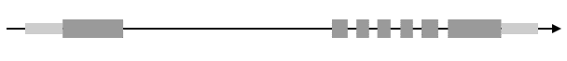
Fig. S1 Characterisation of ALKBH10B transgenic lines and cloning of a pALKBH10B::FLUC construct. A Schematic representation of the T-DNA insertion in the ALKBH10B mutant (Salk_004215c) B Transcript abundance in alkbh10b-1 null mutant and 35S:ALKBH10B overexpression lines (OX-1) using RT-qPCR. C Schematic representation of the pALKBH10B::FLUC cassette in the LB: Left border; RB: Right border. pro10B: 1000 bps upstream of the start codon of ALKBH10B
Relative expression
WT
10b-1
OX-1
pro10B
LB
KpnI
ApaI
RB
Luciferase
Basta^{R}
A
B
(Salk_004215c)
AT4G02940
C
5‘
3‘
alkbh10b-1
(10b-1)
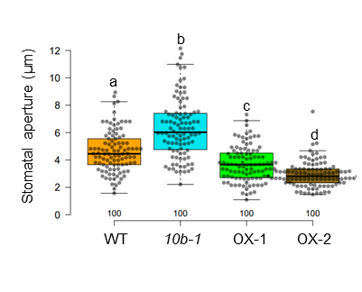
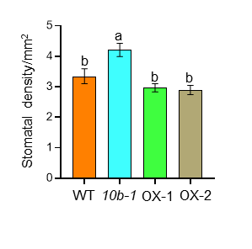
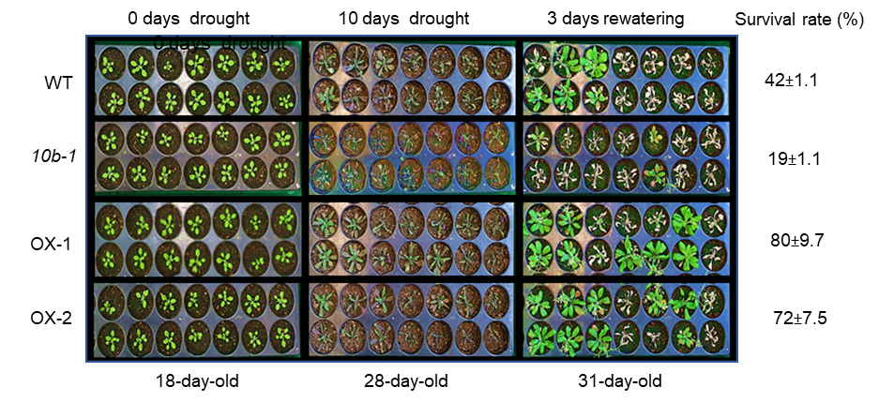
C
Fig. S2 Phenotyping of WT, alkbh10b-1, and two independent lines of 35S:ALKBH10B (OX-1 and OX-2) under drought stress. A Drought stress was applied to 18-day-old plants by with-holding water for 10 days and survival rate was measured after 3 days of rewatering. B Stomatal density and c aperture measured in 21-days old plants under control conditions. Values are the means ± S.E of three biological replicates each consisting of two technical replicates. Data were analysed through one-way analysis of variance (ANOVA) (P<0.05), followed by Multiple comparison analysis (Tukey‘s honest significant difference [HSD test]).
B
A
B
A
a
a
a
a
a
a
Control
Drought
SA-content
ng/g FW
WT
OX-1
alkbh10b-1
a
a
a
6h
3h
24h
Fig. S3 Effect of salicylic acid (SA) on the expression of ALKBH10B and analysis of its content in WT, alkbh10b-1 and OX-1. A Relative expression of ALKBH10B in WT plants grown on ½ MS plates for 21 days and treated with either water (mock) or 50 µM SA for 3, 6 and 24 hours quantified through RT-qPCR. Data represent mean ± SE of 3 biological replicates (n=3). B Analysis of SA levels in WT, alkbh10b-1 and OX-1 grown under control and drought stress conditions. Data represent mean ± SE of 5 biological replicates (n=5) each containing pooled extracts from 2 plants. The data were analysed through two-way Anova followed by Tukey Post-Hoc HSD test (P< 0.05)
Relative expression
ALKBH10B
b
a
a
50 µM SA
Mock

Samples | Replicates | Total reads | Aligned reads | Aligned reads (%)
WT C | 1 | 9651540 | 8160377 | 84.55
 | 2 | 10239533 | 8941160 | 87.32
 | 3 | 10152705 | 8852143 | 87.19
alkbh10b-1 C | 1 | 9851158 | 8618778 | 87.49
 | 2 | 8323243 | 7722258 | 84.93
 | 3 | 9067730 | 7911594 | 87.25
OX-1 C | 1 | 9562982 | 8284411 | 86.63
 | 2 | 8627557 | 7429189 | 86.11
 | 3 | 10828200 | 9645760 | 89.08
WT D | 1 | 10159554 | 8678291 | 85.42
 | 2 | 9144232 | 7872269 | 86.09
 | 3 | 10813648 | 9018582 | 83.40
alkbh10b-1 D | 1 | 10469305 | 9008836 | 86.05
 | 2 | 11204970 | 9710227 | 86.66
 | 3 | 8218264 | 7009357 | 85.29
OX-1 D | 1 | 9147531 | 7876938 | 86.11
 | 2 | 8747080 | 7514616 | 85.91
 | 3 | 10023597 | 87065493 | 86.85
Table S2. Summary of total reads and aligned reads in RNA seq samples under control and drought conditions. For each treatment, three biological replicates were performed and each contained RNA pooled from two individual plants. After quality control, reads were aligned against the TAIR 10 Arabidopsis genome assembly.

