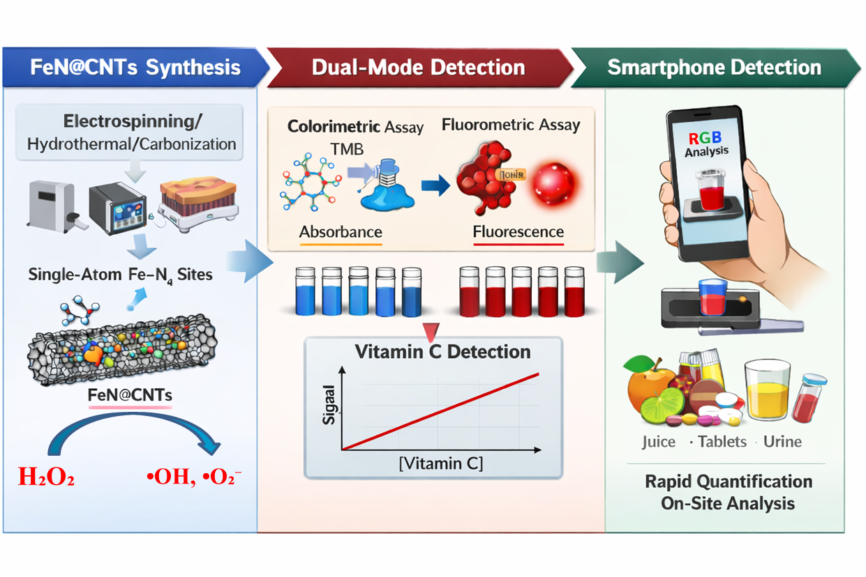
Scheme 1 Schematic diagram for preparation of FeN@CNTs nanozyme for multimode detection of vitamin C.

