Electronic Supplementary Material
Electrospun FeN@CNT single-atom nanozyme for triple-mode ROS-mediated colorimetric and fluorometric detection of vitamin C
Ali M. Alaseemª, Razan Orfaliª, Glowi Alasiri^{b}, Ramadan Ali^{c}, Al-Montaser Bellah H. Ali^{d}, Mohamed M. El-Wekil^{e*}
ª Department of pharmacology College of Medicine, Imam Mohammad Ibn Saud Islamic University (IMSIU), Riyadh 13317, Saudi Arabia
^{b} Department of Biochemistry, College of Medicine, Imam Mohammad Ibn Saud Islamic University (IMSIU), Riyadh, 13317, Saudi Arabia.
^{c} Department of Pharmaceutical Chemistry, Faculty of Pharmacy, University of Tabuk, Tabuk 71491, Saudi Arabia
^{d} Department of Pharmaceutical Analytical Chemistry, Faculty of Pharmacy, Assiut University, Assiut, 71526, Egypt
^{e} Pharmaceutical Chemistry Department, Faculty of Pharmacy, Badr University in Assiut (BUA), 2014101, Assiut, Egypt
Correspondence
* mohamed.elwakeel@pharm.aun.edu.eg, mohamed.mohamoud@ymail.com

Instruments
The surface morphology and structural features of the synthesized nanomaterials were initially examined by field-emission scanning electron microscopy (FE-SEM, Hitachi Regulus 8100, Japan). Nitrogen adsorption–desorption measurements were performed at 77 K to evaluate the textural properties of the material, with the specific surface area calculated using the Brunauer–Emmett–Teller (BET) method. Prior to analysis, FeN@CNTs (~100 mg) was thoroughly degassed at 250 °C for 6 h to remove residual adsorbates. Adsorption data collected over a relative pressure (P/P₀) range of 10⁻⁸–1 enabled comprehensive assessment of micro- and mesoporous features, providing critical insight into the hierarchical pore structure and its relevance to catalytic performance. The generation of reactive oxygen species (ROS), particularly hydroxyl radicals (•OH), was verified by electron paramagnetic resonance (EPR) spectroscopy using a Bruker EMXplus spectrometer (Germany). 5, 5-Dimethyl-1-pyrroline-N-oxide (DMPO) was employed as a spin-trapping agent, enabling direct detection of radical intermediates and providing mechanistic evidence for the nanozyme’s catalytic activity. Powder X-ray diffraction (XRD) analysis was carried out using a Rigaku SmartLab SE diffractometer (Japan) to evaluate the crystallinity and phase purity of the material. Approximately 90 mg of the sample was analyzed over a 2θ range of 5°–50°, allowing reliable phase identification and structural verification. Ultraviolet–visible (UV–vis) absorption and photoluminescence (PL) spectra were acquired using a Shimadzu UV-1601 PC spectrophotometer and a Shimadzu RF-5301 PC spectrofluorometer, respectively, to systematically evaluate the optical absorption characteristics and emission behavior of the materials. The elemental composition and oxidation states of surface elements were investigated through X-ray photoelectron spectroscopy (XPS; PHI 5700 ESCA, Physical Electronics, USA).

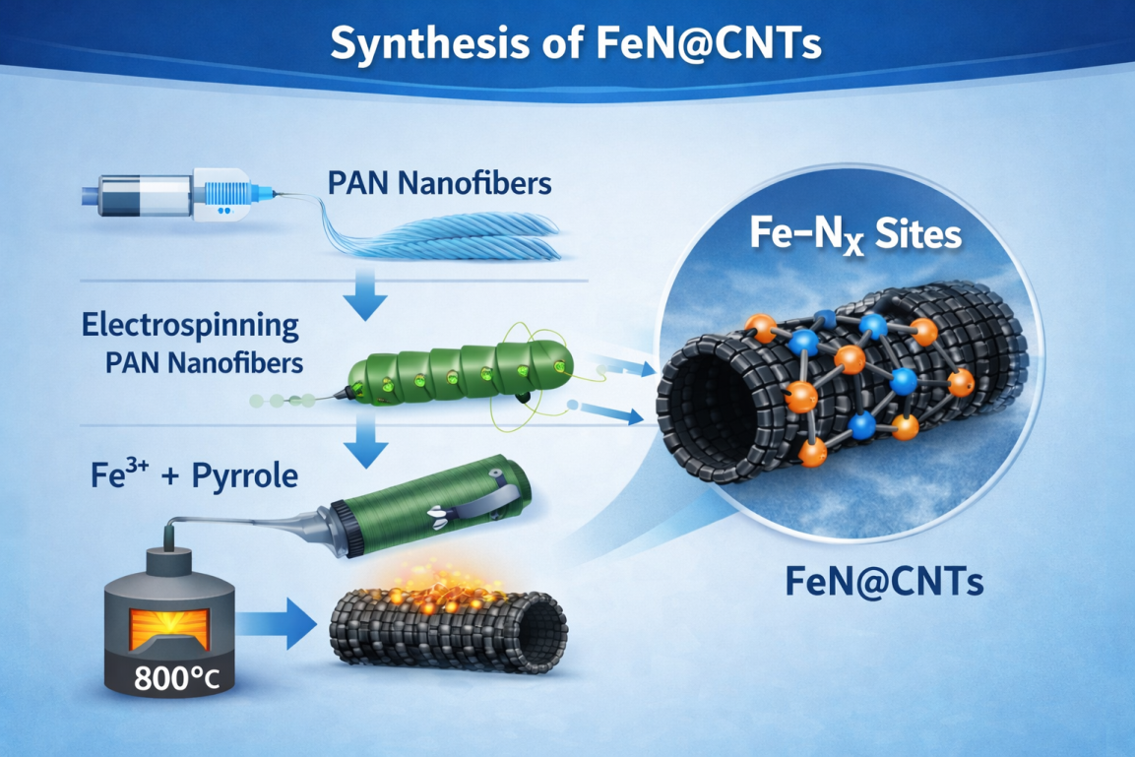

Scheme S1 Schematic diagram for preparation of FeN@CNTs nanozyme .

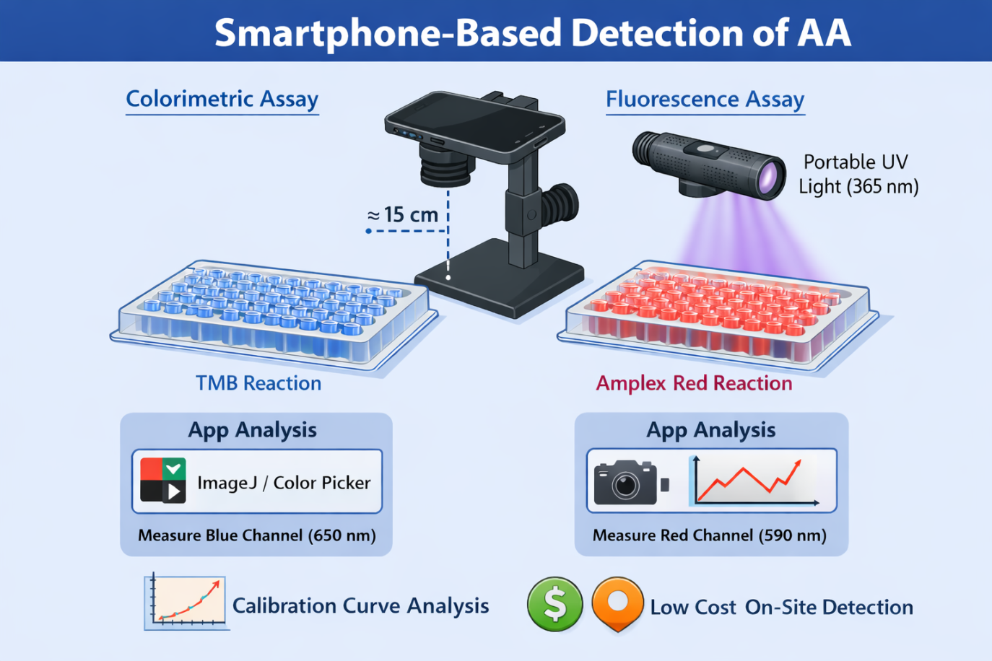

Scheme S2 Schematic diagram for preparation of multimode detection of vitamin C.

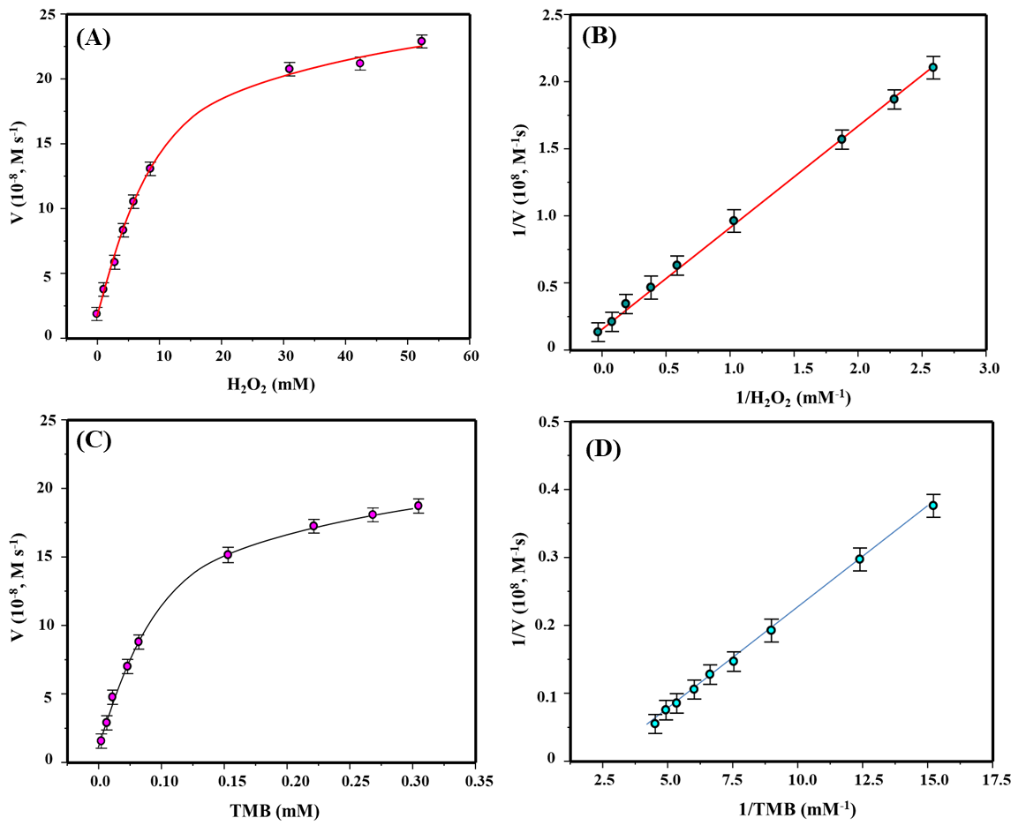

Fig. S1 Enzymatic reaction kinetics curves of FeN@CNTs nanozyme when (A) H₂O₂ and (B) TMB as substrate, respectively. Lineweaver-Burk inverse equation curve of FeN@CNTs nanozyme when (C) H₂O₂ and (D) TMB as substrate, respectively.

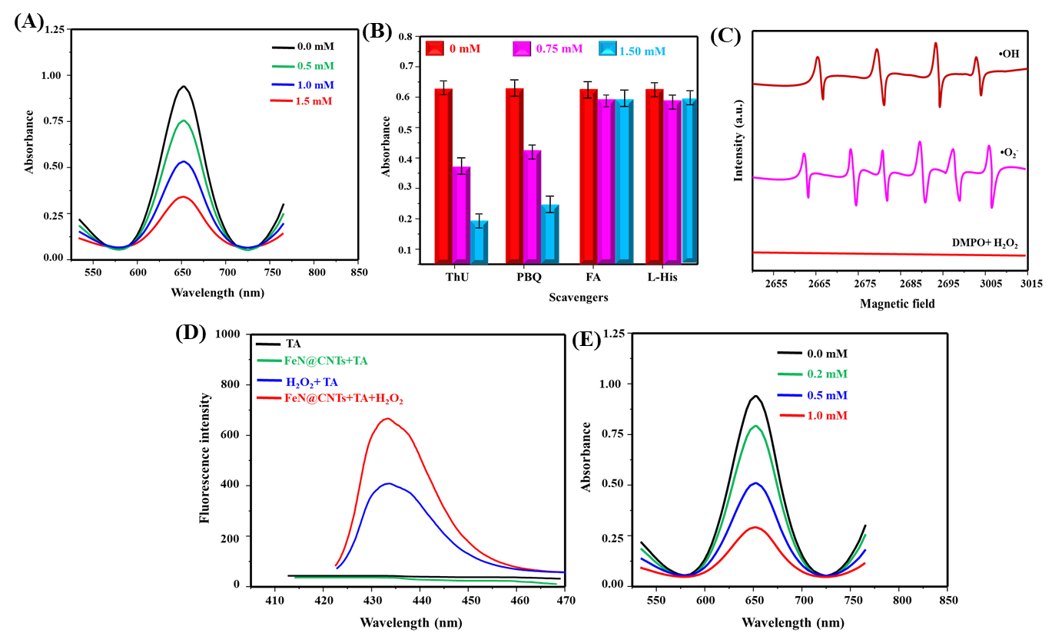

Fig. S1 (A) Effect of EDTA concentration on UV–vis spectra of FeN@CNTs +TMB + H₂O₂.(B) Impact of various ROS scavengers on UV–vis absorbance. (C) ESR spectra confirming •OH and •O₂⁻ generation via DMPO adducts. (D) Fluorescence spectra showing •OH detection using the TA probe. (E) UV–vis spectra demonstrating SOD-induced suppression of catalytic activity.

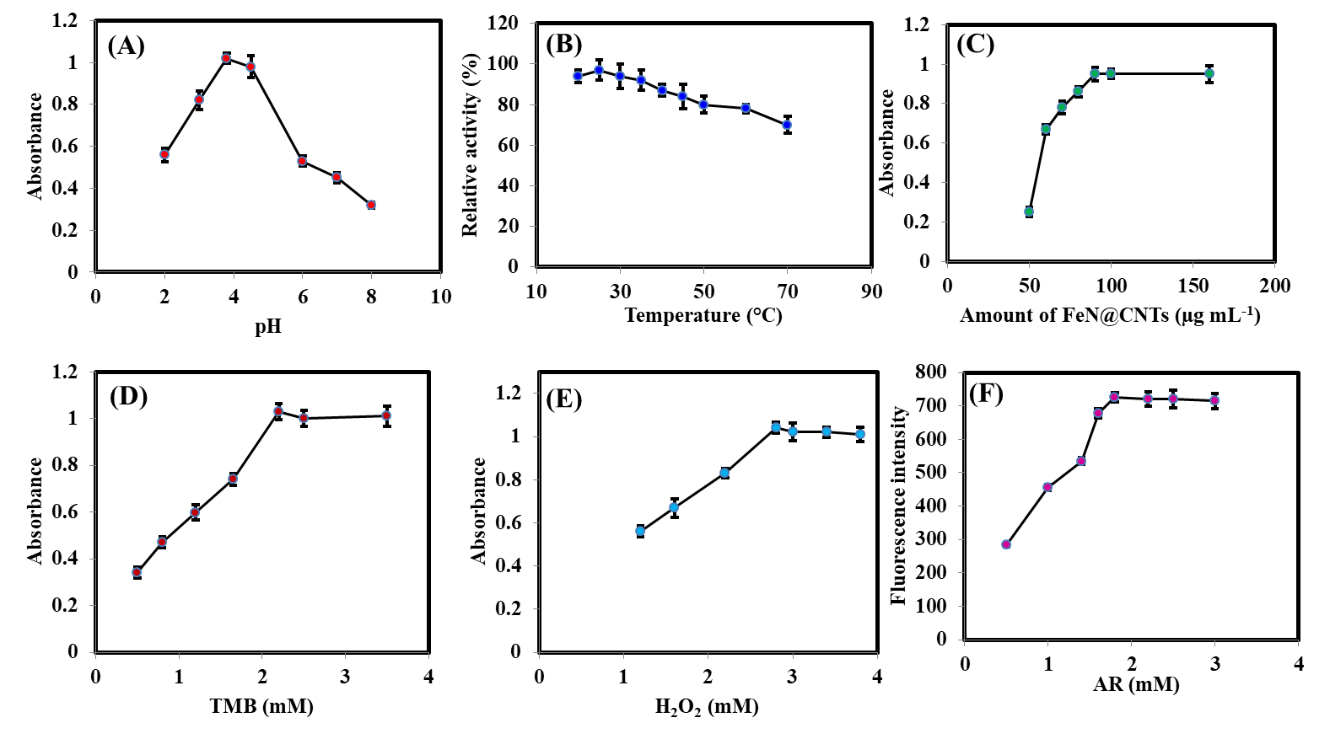

Fig.S2 Optimization of reaction conditions: (A) pH, (B) reaction temperature, (C) FeN@CNTs nanozyme concentration, (D) TMB concentration, (E) H₂O₂ concentration, and (F) AR concentration. All measurements were performed in triplicate.

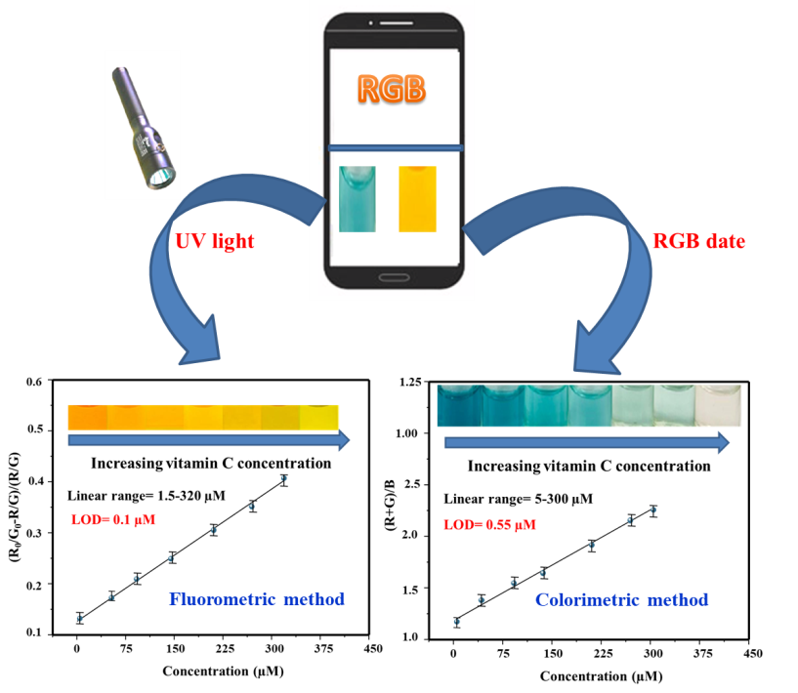

Fig.S3 Smartphone-based colorimetric and fluorometric methods for detection of vitamin C.

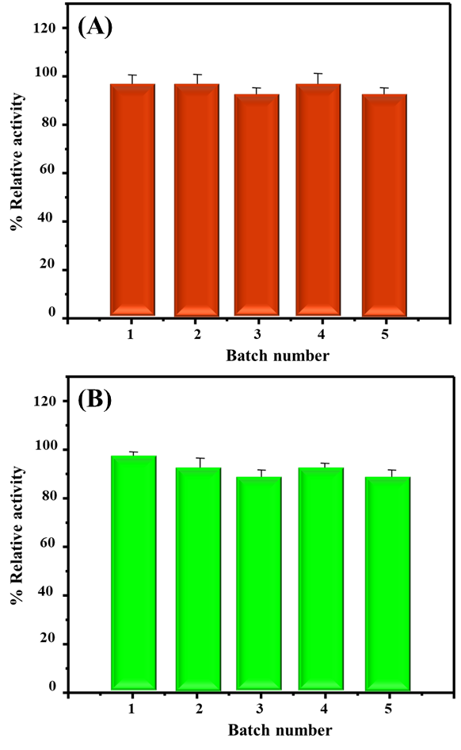

Fig.S4 Batch-to-batch reproducibility across five independent syntheses under (A) colorimetric and (B) fluorometric assays. All measurements were performed in triplicate.

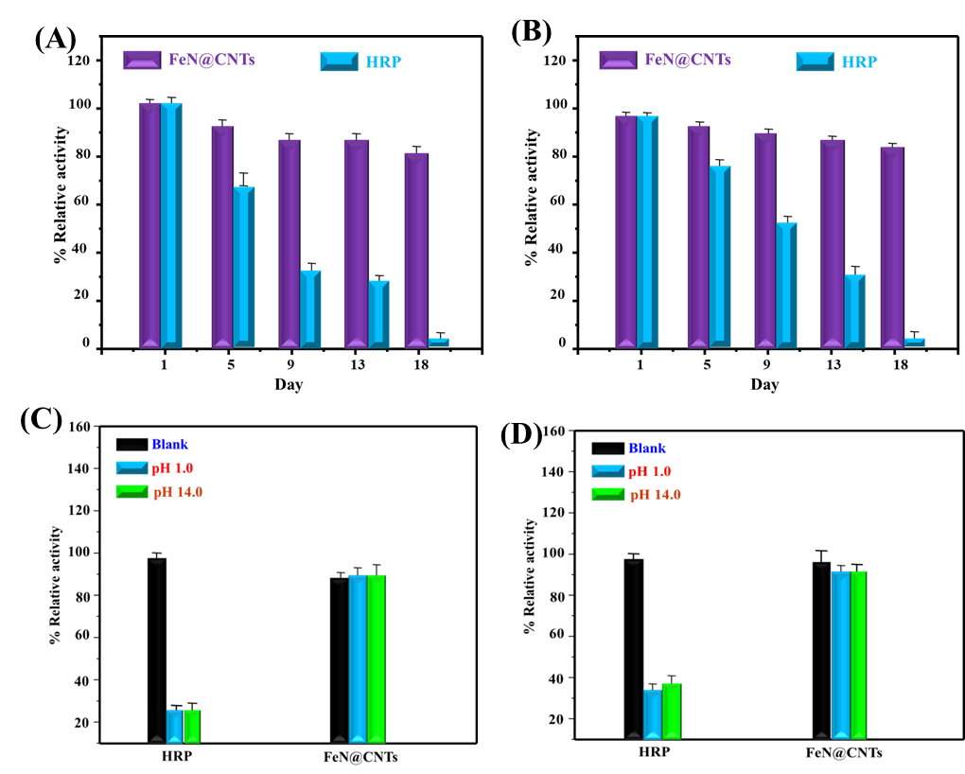

Fig.S5 Comparative stability of FeN@CNTs nanozyme and HRP: (A, B) Catalytic activity retention after 18-day storage at room temperature in colorimetric and fluorometric modes; (C, D) Tolerance to extreme pH after 120 min incubation. All assays were conducted in triplicate.

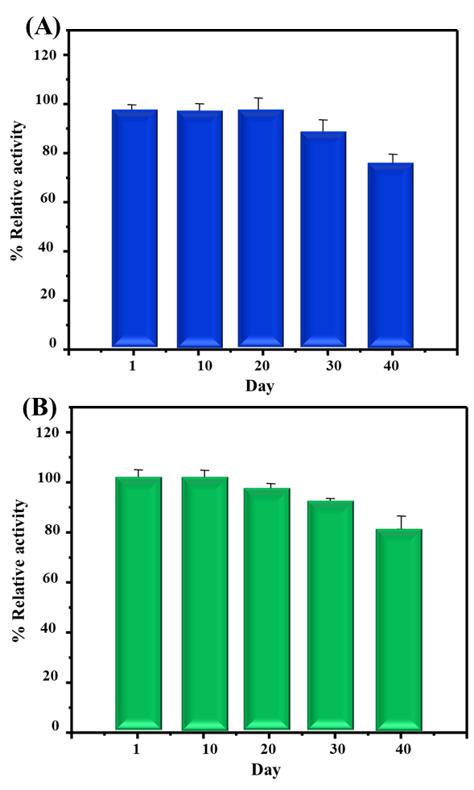

Fig.S6 Fig. S6 Operational stability of FeN@CNTs nanozyme over 40 days in aqueous conditions for (A) colorimetric and (B) fluorometric detection. All assays were conducted in triplicate.

Table S1. Comparison of K_{m} and V_{max} between Cu@NPCNSs and other nanocatalysts.

Table S1. Comparison of Km and Vmax between Fe/N@C-dots and other nanocatalysts.
Enzyme | K_{m} (mM) |  | V_{max} (10⁻⁸ M s⁻¹) |  | Reference
Enzyme | TMB | H₂O₂ | TMB | H₂O₂ | Reference
HRP | 0.434 | 3.702 | 10.000 | 8.710 | [1]
NH₂-MIL-88(Fe) | 0.219 | 0.029 | 4.104 | 2.519 | [2]
Ag/Fe₃O₄@h-BN | 0.162 | 0.494 | 7.21 | 10.25 | [3]
FeOOH | 2.81 | 3.85 | 0.54 | 0.33 | [4]
Fe-CDs | 0.0086 | 0.00672 | 2.035 | 2.817 | [5]
BSA@Pt NPs | 0.17 | 104 | 23.0 | 24.1 | [6]
Co₃O₄ | 0.511 | 140.56 | 12.41 | 3.43 | [7]
CeO₂/Co₃O₄ HNs | 0.495 | 1.225 | 27.06 | 8.87 | [8]
Au-NCs | 3.59 | 16.71 | 0.86 | 1.3 | [9]
AuPtCo | 0.137 | 2.593 | 1.79 | 10.16 | [10]
PDA@Cu-CeO₂ | 0.197 | 0.196 | 77,0000 | 128,0000 | [11]
CeO₂ NSs | 8.17 | 4.33 | 3400 | 1450 | [12]
FeN@CNTs | 0.176 | 1.87 | 18.02 | 20.17 | This work

References
- L. Gao, J. Zhuang, L. Nie, J. Zhang, Y. Zhang, N. Gu, T. Wang, J. Feng, D. Yang, S. Perrett, X. Yan, Intrinsic peroxidase-like activity of ferromagnetic nanoparticles, Nat Nanotechnol 2 (2007) 577–583. https://doi.org/10.1038/nnano.2007.260.
- K. Ren, Y. Li, Q. Liu, Rapid on-site colorimetric detection of arsenic(V) by NH2-MIL-88(Fe) nanozymes-based ultraviolet-visible spectroscopic and smartphone-assisted sensing platforms, Anal Chim Acta 1336 (2025) 343523. https://doi.org/10.1016/j.aca.2024.
- Z. Xin, K. Duan, Q. Zhuo, Q. He, X. Zhang, C. Zheng, X. Han, T. Han, Z. Fu, X. Xu, X. Zhao, Novel nanozyme Ag/Fe3O4@h-BN with peroxidase-mimicking and oxidase-mimicking activities for dye degradation, As(V) removal and detection, Chemical Engineering Journal 461 (2023) 141589. https://doi.org/10.1016/j.cej.2023.
- D.J. Sarkar, R. Raja, B.K. Das, S. Bhattacharyya, S. Pal, S. Mukherjee, Peroxidase mimic feroxyhyte (FeOOH) nanoparticles enabled highly specific colorimetric detection of arsenate in water and fish, Spectrochim Acta A Mol Biomol Spectrosc 339 (2025) 126299. https://doi.org/10.1016/j.saa.2025.
- M. Xie, F. Li, Y. Li, K. Qian, Y. Liang, B. Lei, Y. Liu, J. Cui, Y. Xiao, Iron-doped carbon dots nanozyme scavenged reactive oxygen species system for inhibiting effectively the uptake of arsenic in lettuce, Chemical Engineering Journal 506 (2025) 159956. https://doi.org/10.1016/j.cej.2025.
- B. Karatas, H. E. Ş. Kara, Peroxidase mimetic BSA-stabilized Pt nanozyme for colorimetric determination of arsenic. Journal of Photochemistry and Photobiology A: Chemistry, 471 ( 2026), Article 116732.
- N. Alizadeh, A. Salimi, R. Hallaj, Mimicking peroxidase-like activity of Co₃O₄-CeO₂ nanosheets integrated paper-based analytical devices for detection of glucose with smartphone. Sens. Actuators B Chem., 288 (2019), pp. 44-52.
- W. Zhang, Y. Lan, D-F. Chai, J. Lv, G. Dong, D. Guo, A novel “On-Off” colorimetric sensor for ascorbic acid and hydrogen peroxide based on peroxidase activity of CeO₂/Co₃O₄ hollow nanocubes. J. Mol. Struct., 1302 (2024), Article 137507.
- L. Hu, H. Liao, L. Feng, M. Meng, W. Fu, Accelerating the peroxidase-like activity of gold nanoclusters at neutral ph for colorimetric detection of heparin and heparinase activity. Anal. Chem., 90 (10) (2018), pp. 6247-6252.
- X. Zhou, C. Fan, Q. Tian, C. Han, Z. Yin, Z. Dong, S. Bi, Trimetallic AuPtCo nanopolyhedrons with peroxidase-and catalase-like catalytic activity for glow-type chemiluminescence bioanalysis. Anal. Chem., 94 (2) (2021), pp. 847-855.
- Y. Mao, L. Wang, K. Zhang, H. Zhang, J. Yang, Polydopamine on Copper-Doped cerium dioxide nanosheets as peroxidase mimics for the intelligent detection of cholesterol. Langmuir, 39 (48) (2023), pp. 17286-17294.
- A. Kumar, R. Singh, A. Pathak, D. Guin, C. S. P. Tripathi, CeO₂ nanosheets with prominent peroxidase-mimicking activity for the colorimetric sensing of H₂O₂, glucose, and ascorbic acid. Next Nanotechnol., 8 (2025), Article 100239.

