Supplementary Materials

This supplementary material provides all additional data that support the findings presented in the main manuscript. This supplementary material is intended to provide transparency and ensuring that all aspects of the study are accessible for peer review and future research.

Table S1: Biometric data. All 17 animals were 90 days old.
 | Female
 | Weight (g) |  |  | Area (cm²)
ID | Total | Rigth RAM | Left RAM | Rigth RAM | Left RAM
1 | 306 | 0.041 | 0.171 | 0.33 | 1.08
2 | 280 | 0.059 | 0.106 | 0.51 | 0.90
3 | 294 | 0.112 | 0.045 | 0.50 | 0.72
4 | 283 | 0.109 | 0.073 | 0.48 | 0.52
5 | 300 | 0.169 | 0.144 | 0.75 | 0.60
6 | 263 | 0.350 | 0.254 | 0.54 | 0.85
7 | 277 | 0.116 | 0.204 | 0.60 | 0.85
Mean | 286.14 | 0.1366 | 0.1421 | 0.5300 | 0.7886
SD | 13.71 | 0.0953 | 0.0681 | 0.1178 | 0.1762
Median | 283,00 | 0.1120 | 0.1440 | 0.5100 | 0.8500
 | Male
 | Weight (g) |  |  | Area (cm²)
ID | Total | Rigth RAM | Left RAM | Rigth RAM | Left RAM
1 | 474ª | 0.055^{b} | 0.077 | 0.30 | 0.28
2 | 373 ª | 0.093 ^{b} | 0.024 | 0.32 | 0.10
3 | 491 ª | 0.111 ^{b} | 0.044 | 0.48 | 0.42
4 | 473 ª | 0.082 ^{b} | 0.044 | 0.32 | 0.33
5 | 489 ª | 0.066 ^{b} | 0.111 | 0.41 | 0.53
6 | 451 ª | 0.062 ^{b} | 0.486 | 0.38 | 0.28
7 | 449 ª | 0.046 ^{b} | 0.114 | 0.35 | 0.40
8 | 466 ª | 0.130 ^{b} | 0.063 | 0.58 | 0.56
9 | 494 ª | 0.0629 ^{b} | 0.034 | 0.40 | 0.21
10 | 477 ª | 0.116 ^{b} | 0.086 | 0.42 | 0.33
Mean | 463.70 | 0.139 | 0.109 | 0.396 | 0.342
SD | 33.59 | 0.028 | 0.129 | 0.080 | 0.132
Median | 473.50 | 0.087 | 0.069 | 0.388 | 0.330
ª p<0.001 male vs female; ^{b} p<0.05 male vs female

Table S2: Data from the functional and myo-mechanical assessment of muscle response.

 | Female
 | % average of Contration Force (mN) |  | Time to Peak (TTP) (ms) |  | Rate of Force Development (RFD) (mN/s) |  | Half-Relaxation Time (HRT) (ms) |  | TMaxSlope (ms) |  | TMinSlope (ms)
ID | Rigth RAM | Left RAM | Rigth RAM | Left RAM | Rigth RAM | Left RAM | Rigth RAM | Left RAM | Rigth RAM | Left RAM | Rigth RAM | Left RAM
1 | 80.65 | 64.20 | 353.1 | 264.2ª | 10.07ª | 22.71 | 20 | 17 | 328.8 | 282.9 | 405.8 | 150.7
2 | 76.95 | 98.50 | 171.8 | 184.8 ª | 24.18 ª | 43.06 | 15 | 19 | 184.6 | 189.2 | 188.6 | 227.1
3 | 83.70 | 80.170 | 299.6 | 189.7 ª | 13.09 ª | 46.20 | 14 | 28 | 260.6 | 198.2 | 365.8 | 202.3
4 | 87.57 | 98.40 | 274.5 | 166.8 ª | 12.97 ª | 117.00 | 16 | 19 | 243.2 | 208.2 | 317.2 | 182.7
5 | 21.80 | 98.80 | 205.1 | 193.7 ª | 101.50 ª | 31.90 | 14 | 22 | 207.3 | 192.6 | 168.3 | 207.1
6 | 38.20 | 88.90 | 148.0 | 132.6 ª | 424.90 ª | 451.20 | 12 | 13 | 121.0 | 143.3 | 167.0 | 153.0
7 | 76.80 | 94.31 | 240.1 | 200.5 ª | 28.77 ª | 37.28 | 35 | 32 | 228.9 | 217.8 | 277.1 | 241.2
Mean | 66.52 | 89.04 | 241.74 | 190.33 | 87.93 | 107.05 | 18.00 | 21.43 | 224.91 | 204.60 | 269.97 | 194.87
SD | 23.77 | 11.93 | 67.45 | 36.82 | 140.70 | 143.41 | 7.31 | 6.07 | 59.94 | 38.73 | 90.61 | 32.17
Median | 76.95 | 94.31 | 240.1 | 189.7 | 24.18 | 43.06 | 15 | 19 | 228.9 | 198.2 | 277.1 | 202.3
 | Male
 | % average of Contration Force (mN) |  | Time to Peak (TTP) (ms) |  | Rate of Force Development (RFD) (mN/s) |  | Half-Relaxation Time (HRT) (ms) |  | TmaxSlope (ms) |  | TminSlope (ms)
ID | Rigth RAM | Left RAM | Rigth RAM | Left RAM | Rigth RAM | Left RAM | Rigth RAM | Left RAM | Rigth RAM | Left RAM | Rigth RAM | Left RAM
1 | 96.83 | 98.7 | 145.1 | 110.9 | 103.10ª | 16.73 | 38^{b} | 43^{c} | 145.10 | 82.48 | 149.20 | 118.80
2 | 99.10 | 64.26 | 184.4 | 299.0 | 118.20 ª | 58.85 | 35 ^{b} | 54 ^{c} | 184.40 | 315.20 | 286.90 | 87.56
3 | 81.31 | 95.91 | 160.5 | 169.9 | 125.00 ª | 57.40 | 46 ^{b} | 44 ^{c} | 159.40 | 168.20 | 174.50 | 179.30
4 | 90.63 | 19.41 | 255.5 | 133.4 | 42.95 ª | 39.92 | 62 ^{b} | 58 ^{c} | 248.30 | 127.90 | 190.20 | 135.50
5 | 96.30 | 97.4 | 170.7 | 162.1 | 48.41 ª | 123.70 | 78 ^{b} | 39 ^{c} | 176.90 | 174.40 | 179.80 | 167.80
6 | 99.30 | 29.24 | 175.7 | 215.7 | 146.10 ª | 17.91 | 56 ^{b} | 77 ^{c} | 88.21 | 162.70 | 106.60 | 244.40
7 | 97.16 | 99.75 | 230.8 | 199.3 | 21.87 ª | 22.77 | 63 ^{b} | 59 ^{c} | 160.80 | 175.80 | 334.30 | 243.10
8 | 97.68 | 97.61 | 226.4 | 249.5 | 33.07 ª | 22.70 | 67 ^{b} | 71 ^{c} | 181.40 | 192.30 | 279.00 | 324.20
9 | 57.70 | 80.17 | 263.2 | 249.2 | 20.43 ª | 19.49 | 49 ^{b} | 58 ^{c} | 189.40 | 162.20 | 356.02 | 353.70
10 | 57.70 | 80.17 | 230.2 | 242.3 | 44.73 ª | 23.31 | 79 ^{b} | 70 ^{c} | 171.50 | 196.70 | 310.04 | 309.70
Mean | 87.37 | 76.26 | 204.25 | 203.13 | 70.39 | 40.28 | 57.30 | 57.30 | 170.54 | 175.79 | 236.71 | 216.41
SD | 15.68 | 28.22 | 39.65 | 55.97 | 44.95 | 31.60 | 14.55 | 12.12 | 37.94 | 56.18 | 82.10 | 87.80
Median | 96.57 | 88.04 | 205.4 | 207.5 | 46.57 | 23.04 | 59 | 58 | 174.2 | 171.3 | 234.6 | 211.2
ª P<0.05 female vs male; ^{b} p < 0.001 male vs female

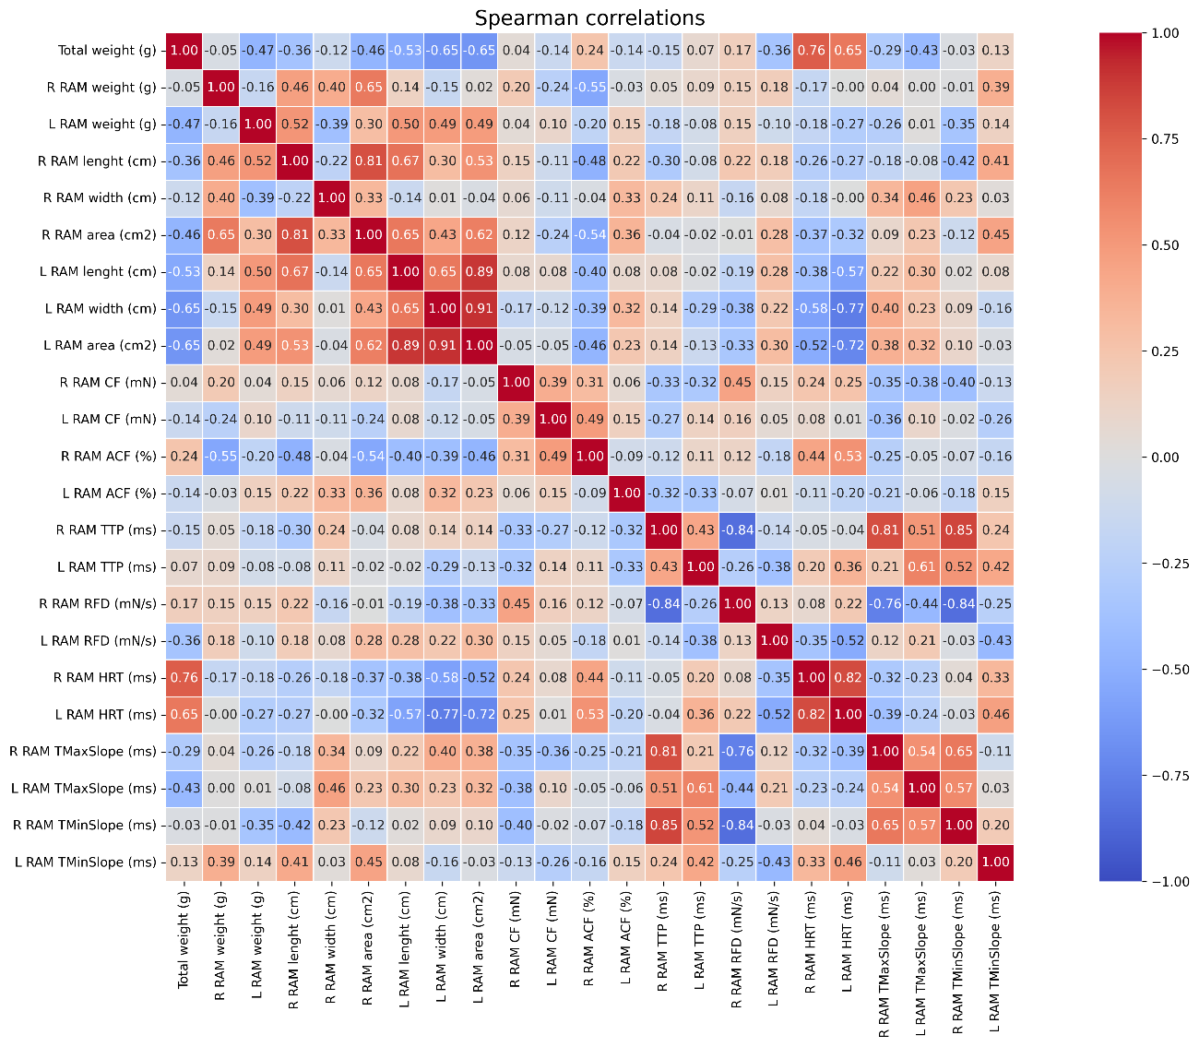
Figure S1. Spearman’s Rank Correlation Matrix for Morphological, Functional, and Kinetic Parameters (Pooled Data).
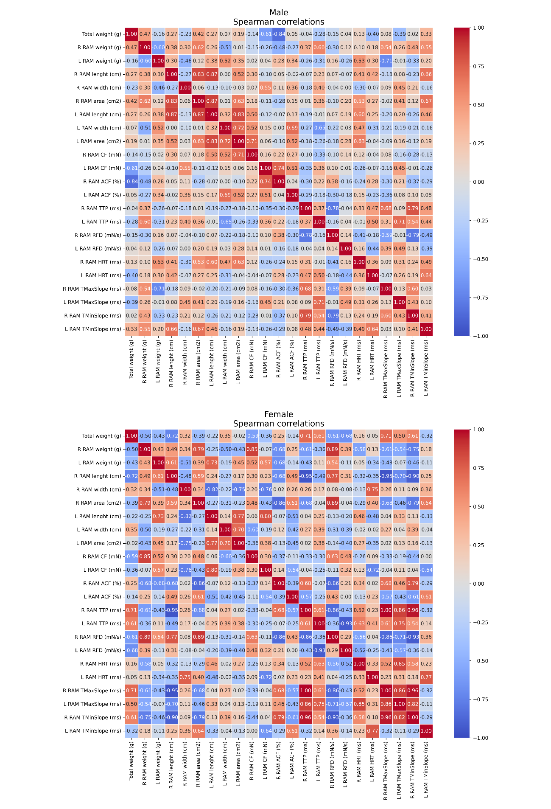
Figure S2. Spearman’s Rank Correlation Matrices for Morphological, Functional, and Kinetic Parameters by Sex (Pooled Data).

