Supporting Information

Breaking the Performance Trade-off: Unprecedented Polymer Alloys with Heterogeneously Dispersed Nanodomains via Reactive Processing
Author 1 ^{1,2*}, Author 2 ^{1,2}, Author 3 ^{1,2}, Author 4 ³, Author 5 ^{1,2*}
¹ University A, ² University B, ³ University C

Table of contents
Figure S1 | Chemical equation between ethylene acrylic ester-glycidyl methacrylate terpolymer (EGMA) and poly (L-lactide) (PLLA) during reactive processing: (a) Without catalyst: In-situ ring-opening reaction between epoxide groups of EGMA and terminal carboxyl groups of PLLA, (b) with the addition of N, N-dimethyl stearyl amide (DMSA): In-situ ring-opening reaction between epoxide groups of EGMA and terminal carboxyl/hydroxyl groups of PLLA
Figure S2 | Statistical data of the diameter of EGMA droplets or nano-domains in of (a) conventional alloys (POM/EGMA 90/10, w/w), (b)-(d) m-EGMA incorporated alloys featuring “heterogeneously dispersed nano-domains (hDNs)” architecture with various composition ratio of POM/m-EGMA ranging from (b) 90/10, (c) 70/30, to (d) 50/50. The weight ratio of EGMA/PLLA was fixed as 10/20 with addition of 0.3wt% DMSA. More than 400 nano-domains were taken into statistical estimations.
Figure S3 | SEM images of “heterogeneously dispersed nano-domains” (hDNs)-structured POM alloys with various composition ratio of POM/e-EGMA ranging from (a) 90/10, (b) 70/30, to (c) 50/50. The weight ratio of EGMA/PLLA was fixed as 10/20 with addition of 0.3wt% DMSA.
Figure S4 | SEM images of conventional POM alloys featuring “sea-island” morphology: (a) POM/EGMA 70/30 (w/w) alloys and (b) POM/m-EGMA (0% DMSA) 70/30 alloys. Note that m-EGMA (0% DMSA) referred to the elastomer with weight ratio of 10/20 (EGMA/PLLA) without addition of catalyst.
Figure S5 | TEM images of conventional POM alloys featuring “sea-island” morphology with various compositional ratio of POM/m-EGMA (0DMSA) ranging from (a) 90/10, (b) 70/30, to (d) 50/50. Note that m-EGMA (0% DMSA) referred to the elastomer with weight ratio of 10/20 (EGMA/PLLA) without addition of catalyst.
Figure S6 | Digital photos and SEM images of representative specimen after the notched izod impact tests: (a) POM/EGMA 90/10 alloy, (b) POM/m-EGMA (0DMSA) 70/10 alloy demonstrating conventional droplet/matrix morphology, and (c) POM/m-EGMA 70/10 alloy featuring “heterogeneously dispersed nano-domains” (hDNs) microstructure. Note that the concentration of EGMA in the three POM alloys was fixed as 10 wt%. The weigh ratio of EGMA/PLLA was fixed as 10/20 in m-EGMA (0DMSA) and m-EGMA.
Figure S7 | Linear rheological behaviors of POM, m-EGMA, and POM alloys featuring conventional droplet/matrix and “heterogeneously dispersed nano-domains” (hDNs) microstructure. (a) Storage modulus (G'_{(ω)}), (b) Complex viscosity (|η*_{(ω)}|) against angular frequency, and (c) Weighted relaxation spectrum estimated from SAOS experiments at 190 ºC.
Figure S8 | Representative criteria estimated from SAOS experiments: (a) van Gurp-Palmen plots, (b) Cole-Cole plots, (c) Han plots, and (d) plots on |η*_{(ω)}| versus |G*_{(ω)}| of POM, m-EGMA, and POM alloys featuring conventional droplet/matrix and “heterogeneously dispersed nano-domain” (hDNs) microstructure.
Figure S9 | FT-IR spectrum of pristine POM, EGMA, and PLLA.
Figure S10 | Torque evolution curves of m-EGMA without or with addition of catalyst (DMSA). The melt processing was conducted at 190 ºC with a rotation speed of 50 r/min for 10 min.
Figure S11 | FT-IR spectrum of m-EGMA (0.3DMSA) after selective extraction of free PLLA chains by chloroform using Soxhlet apparatus at 110 ºC for 36 h. The weigh ratio of EGMA/PLLA was 10/20.
Figure S12 | (a) TGA and (DTG) curves of EGMA, PLLA, and m-EGMA after selective extraction of free PLLA chains by chloroform. The weigh ratio of EGMA/PLLA in m-EGMA was fixed as 10/20 containing various concentration of DMSA from 0.3 wt%, 0.6 wt%, 1.2 wt%, to 2.4 wt%.
Figure S13 | Schematic illustrations and TEM images of m-EGMA with or without addition of DMSA. The weigh ratio of EGMA/PLLA in m-EGMA was fixed as 10/20.
Figure S14 | Representative stress-strain curves of POM and hDNs-structured POM/m-EGMA alloys. The weigh ratio of EGMA/PLLA in m-EGMA was fixed as 10/20 containing various concentration of DMSA from 0.3 wt%, 0.6 wt%, 1.2 wt%, to 2.4 wt%.
Figure S15 | SEM images of POM/(EGMA/PLLA) 70/(10/20) alloys with different concentration of DMSA: (a) 0 wt%, (b) 0.3 wt%, (c) 0.6 wt%, (d) 1.2 wt%, and (e) 2.4 wt%.
Figure S16 | TEM images of m-EGMA (EGMA/PLLA 10/20, 0.3 wt% DMSA) (a) before, and (b) after selective extraction of free PLLA chains by chloroform using Soxhlet apparatus at 110 ºC for 36 h.
Figure S17 | Notched impact strength of “heterogeneously dispersed nano-domains” (hDNs)-structured alloys incorporating various compositional ratio of PLLA in m-EGMA. The EGMA loadings in the obtained alloys was fixed as 10 wt%. The concentration of DMSA in m-EGMA was fixed as 0.3 wt%.
Figure S18 | Representative stress-strain curves of “heterogeneously dispersed nano-domains” (hDNs)-structured alloys incorporating various compositional ratio of PLLA in m-EGMA. The EGMA loadings in the obtained alloys was fixed as 10 wt%. The concentration of DMSA in m-EGMA was fixed as 0.3 wt%.
Figure S19 | SEM images of “heterogeneously dispersed nano-domains” (hDNs)-structured alloys incorporating various compositional ratio of PLLA in m-EGMA from (a) 89/(10/1), (b) 87/(10/3), (c) 85/(10/5), (d) 80/(10/10), (e) 75/(10/15), (f) 70/(10/20), (g) 65/(10/25), to (h) 60/(10/30). The concentration of DMSA in m-EGMA was fixed as 0.3 wt%.
Figure S20 | Statistical data of the diameter of EGMA nano-domains in “heterogeneously dispersed nano-domains” (hDNs)-structured alloys incorporating various compositional ratio of PLLA in m-EGMA from (a) 89/(10/1), (b) 87/(10/3), (c) 85/(10/5), (d) 80/(10/10), (e) 75/(10/15), (f) 70/(10/20), (g) 65/(10/25), to (h) 60/(10/30). The concentration of DMSA in m-EGMA was fixed as 0.3 wt%.
Figure S21 | Averaged diameter of EGMA nano-domains in “heterogeneously dispersed nano-domains” (hDNs)-structured alloys as a function of PLLA loadings in m-EGMA.
Figure S22 | DSC thermograms of “heterogeneously dispersed nano-domains” (hDNs)-structured alloys incorporating various compositional ratio of PLLA in m-EGMA collected at (a) first heating, (b) cooling, and (c) second heating procedure with the heating/cooling rate of 10 ºC/min.
Figure S23 | SEM images of “heterogeneously dispersed nano-domains” (hDNs)-structured alloys as a function of EGMA loadings in m-EGMA, that is POM/(EGMA/PLLA) from (a) 70/(0/20), (b) 70/(5/20), (c) 70/(10/20), to (d) 70/(15/20).
Figure S24 | SEM images of representative hDNs-structured alloy POM/(EGMA/PLLA) 70/(10/20) captured at different processing times at 190 oC with a rotation speed of 50 r/min: from (a) 0.5min, (b) 2 min, (c) 5 min, (d) 10 min, to (e) 20min.
Table S1 | Mechanical parameters of POM, conventional POM/m-EGMA (0DMSA) alloys featuring droplet/matrix morphology and POM/m-EGMA (0.3DMSA) alloys featuring “heterogeneously dispersed nano-domains” microstructure.
Table S2 | Performance comparison in terms of notched impact strength, elongation at break, and tensile strength of POM alloys.
Table S3 | The content of EGMA and PLLA in m-EGMA containing various concentration of DMSA before and after selective extraction of free PLLA chains calculated from TGA measurements.
Table S4 | Mechanical parameters of POM/(EGMA/PLLA) 70/(10/20) alloys with different concentration of DMSA: (a) 0 wt%, (b) 0.3 wt%, (c) 0.6 wt%, (d) 1.2 wt%, and (e) 2.4 wt%.
Table S5 | Mechanical parameters of “heterogeneously dispersed nano-domains” (hNDs)-structured alloys incorporating various compositional ratio of PLLA in m-EGMA from. The concentration of DMSA in m-EGMA was fixed as 0.3 wt%.
Table S6 | Mechanical parameters of “heterogeneously dispersed nano-domains” (hNDs)-structured alloys as a function of EGMA loadings in m-EGMA.

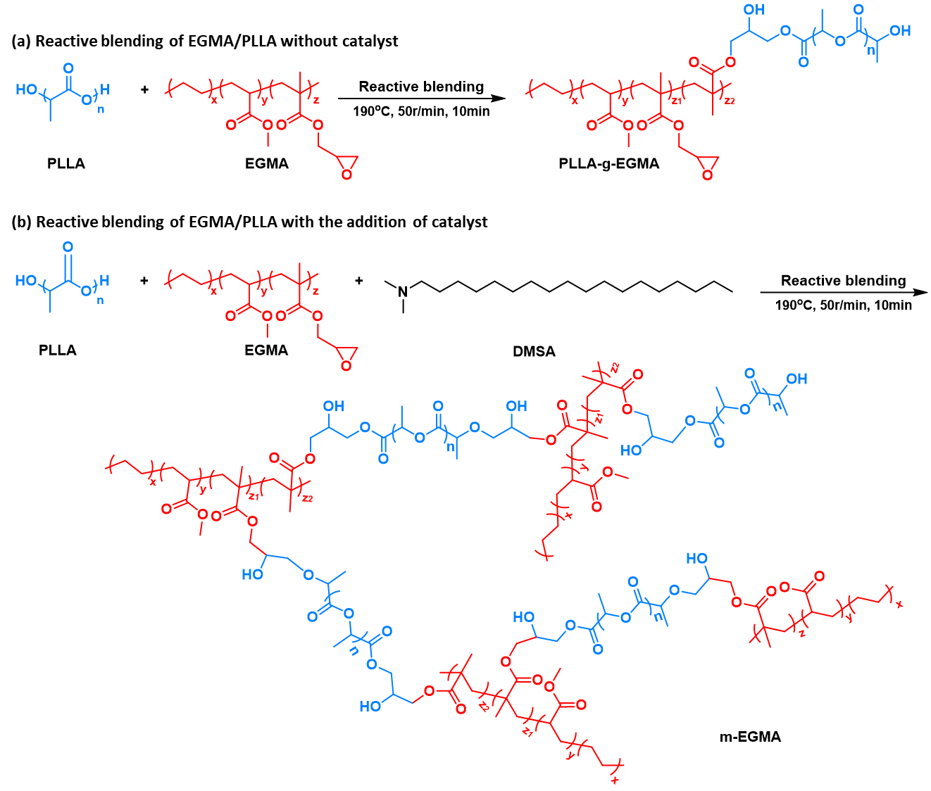

Figure S1. Chemical equation between ethylene acrylic ester-glycidyl methacrylate terpolymer (EGMA) and poly (L-lactide) (PLLA) during reactive processing: (a) Without catalyst: In-situ ring-opening reaction between epoxide groups of EGMA and terminal carboxyl groups of PLLA, (b) with the addition of N, N-dimethyl stearyl amide (DMSA): In-situ ring-opening reaction between epoxide groups of EGMA and terminal carboxyl/hydroxyl groups of PLLA.

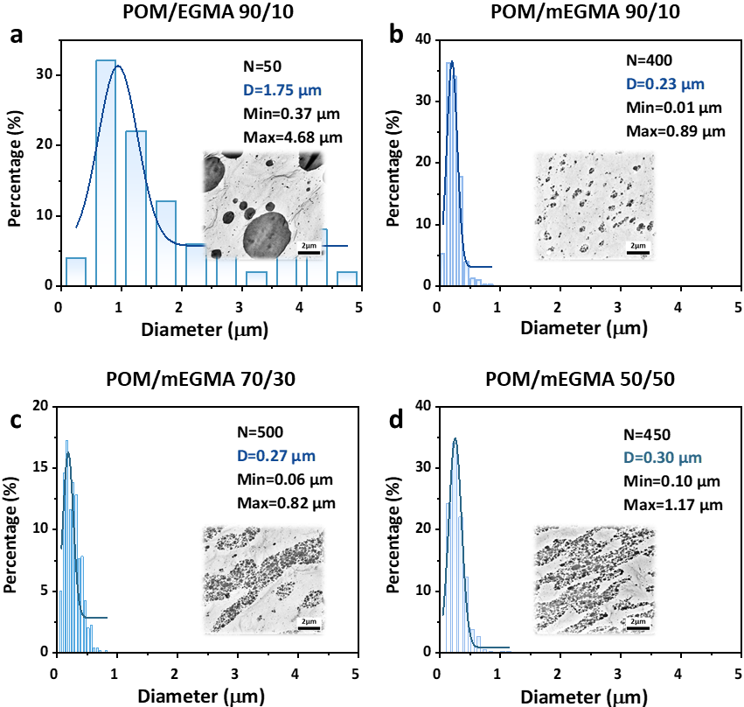

Figure S2. Statistical data of the diameter of EGMA droplets or nano-domains in of (a) conventional alloys (POM/EGMA 90/10, w/w), (b)-(d) m-EGMA incorporated alloys featuring “heterogeneously dispersed nano-domains” (hDNs) architecture with various composition ratio of POM/m-EGMA ranging from (b) 90/10, (c) 70/30, to (d) 50/50. The weight ratio of EGMA/PLLA was fixed as 10/20 with addition of 0.3wt% DMSA. More than 400 nano-domains were taken into statistical estimations.

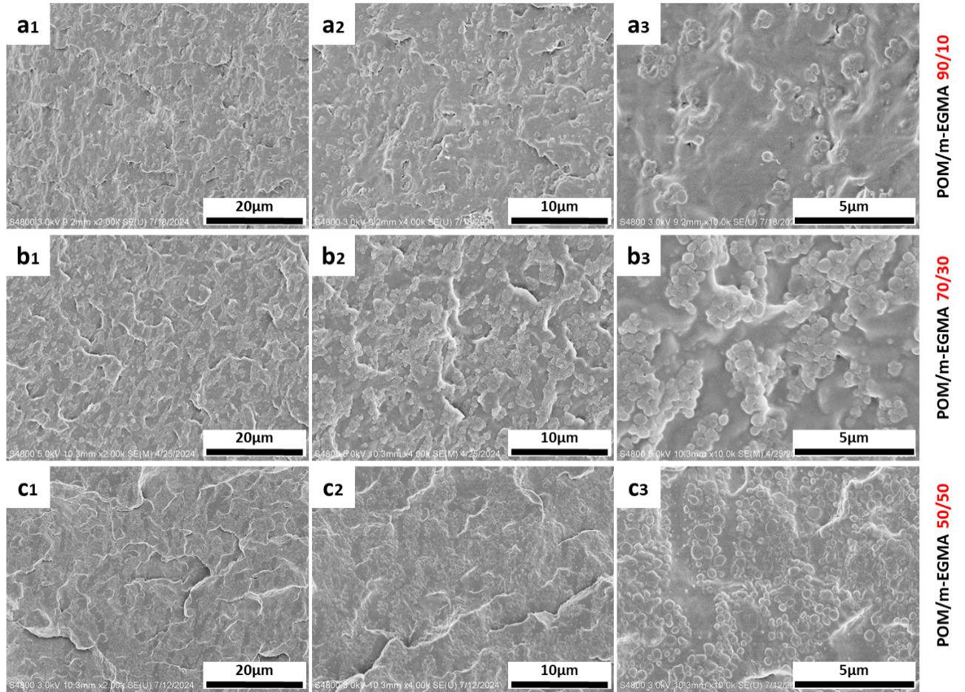

Figure S3. SEM images of “heterogeneously dispersed nano-domains” (hDNs)-structured POM alloys with various composition ratio of POM/e-EGMA ranging from (a) 90/10, (b) 70/30, to (c) 50/50. The weight ratio of EGMA/PLLA was fixed as 10/20 with addition of 0.3wt% DMSA.

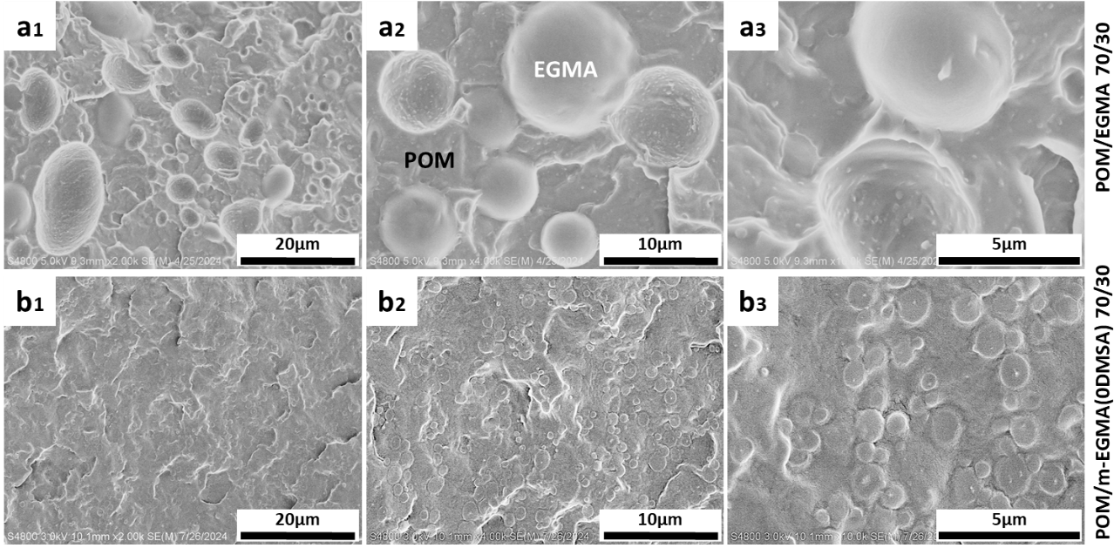

Figure S4. SEM images of conventional POM alloys featuring “sea-island” morphology: (a) POM/EGMA 70/30 (w/w) alloys and (b) POM/m-EGMA (0% DMSA) 70/30 alloys. Note that m-EGMA (0% DMSA) referred to the elastomer with weight ratio of 10/20 (EGMA/PLLA) without addition of catalyst.

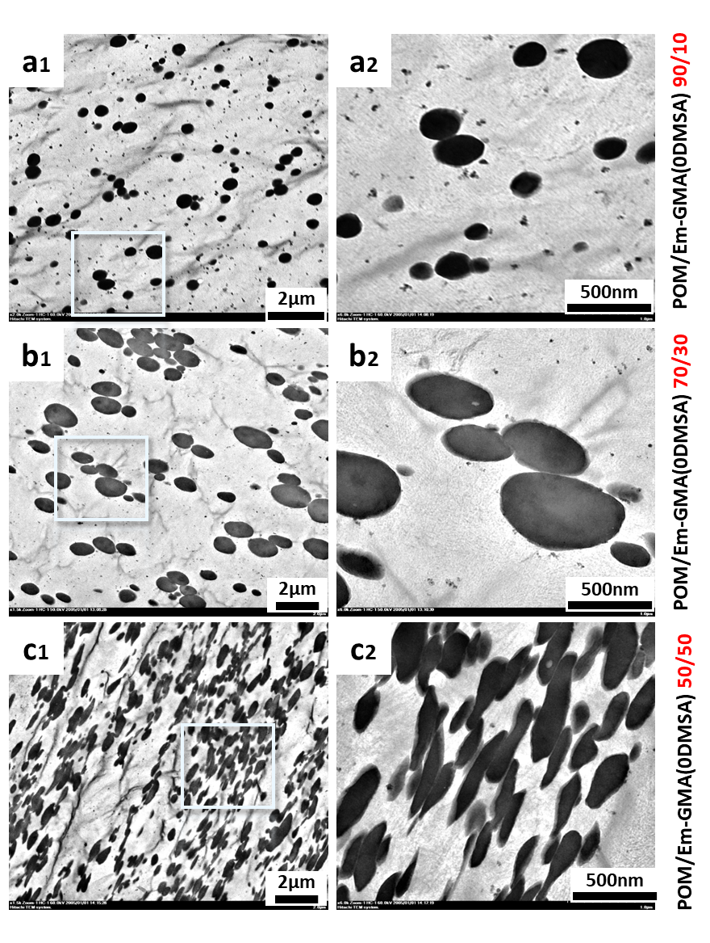

Figure S5. TEM images of conventional POM alloys featuring “sea-island” morphology with various compositional ratio of POM/m-EGMA (0DMSA) ranging from (a) 90/10, (b) 70/30, to (d) 50/50. Note that m-EGMA (0% DMSA) referred to the elastomer with weight ratio of 10/20 (EGMA/PLLA) without addition of catalyst.

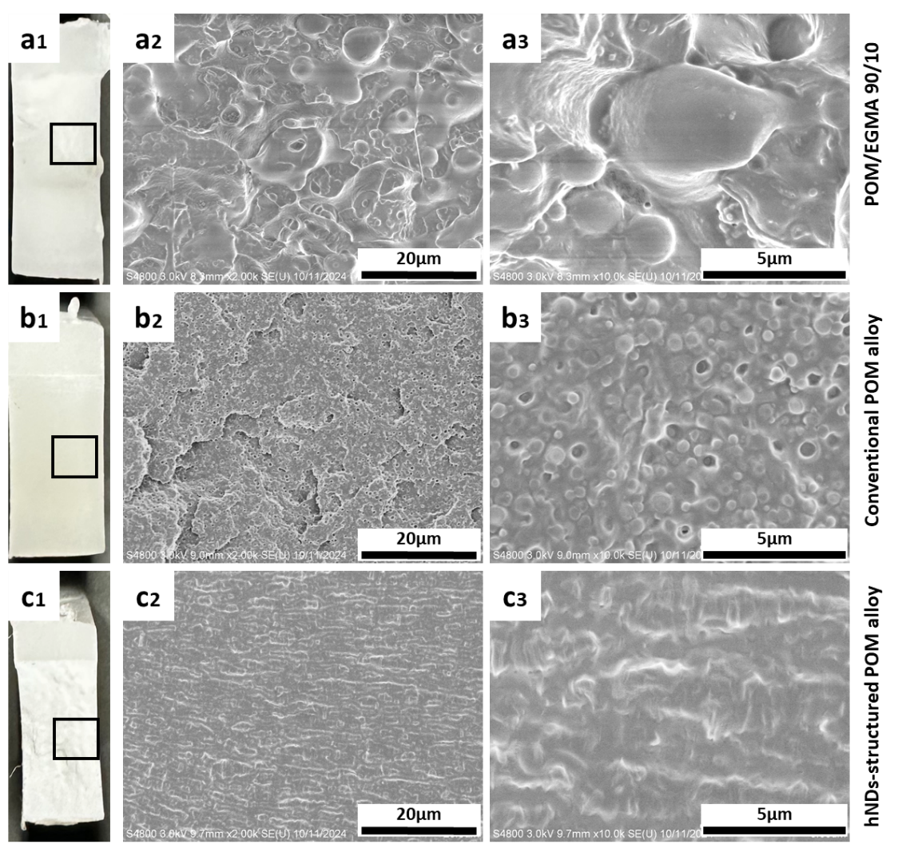

Figure S6. Digital photos and SEM images of representative specimen after the notched izod impact tests: (a) POM/EGMA 90/10 alloy, (b) POM/m-EGMA (0DMSA) 70/10 alloy demonstrating conventional droplet/matrix morphology, and (c) POM/m-EGMA 70/10 alloy featuring “heterogeneously dispersed nano-domains” (hDNs) microstructure. Note that the concentration of EGMA in the three POM alloys was fixed as 10 wt%. The weigh ratio of EGMA/PLLA was fixed as 10/20 in m-EGMA (0DMSA) and m-EGMA.

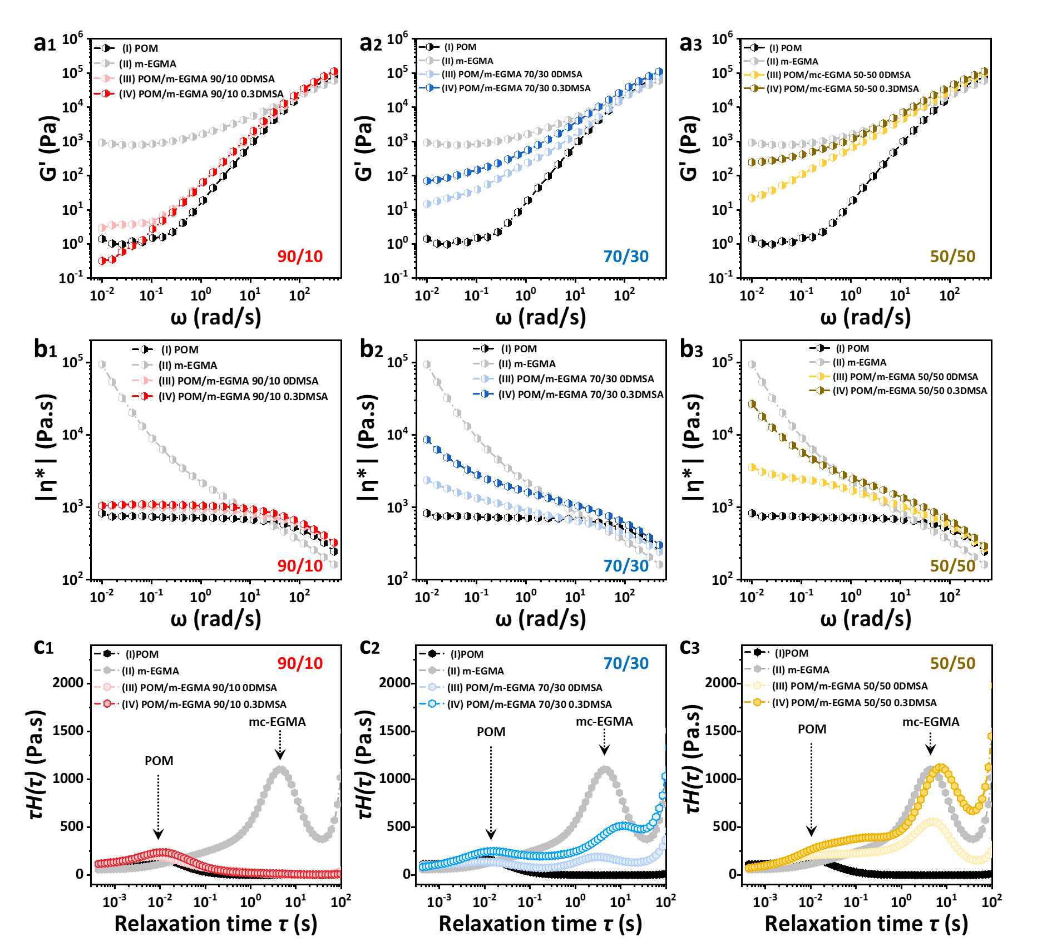

Figure S7. Linear rheological behaviors of POM, m-EGMA, and POM alloys featuring conventional droplet/matrix and “heterogeneously dispersed nano-domains” (hDNs) microstructure. (a) Storage modulus (G'_{(ω)}), (b) Complex viscosity (|η*_{(ω)}|) against angular frequency, and (c) Weighted relaxation spectrum estimated from SAOS experiments at 190 ºC.

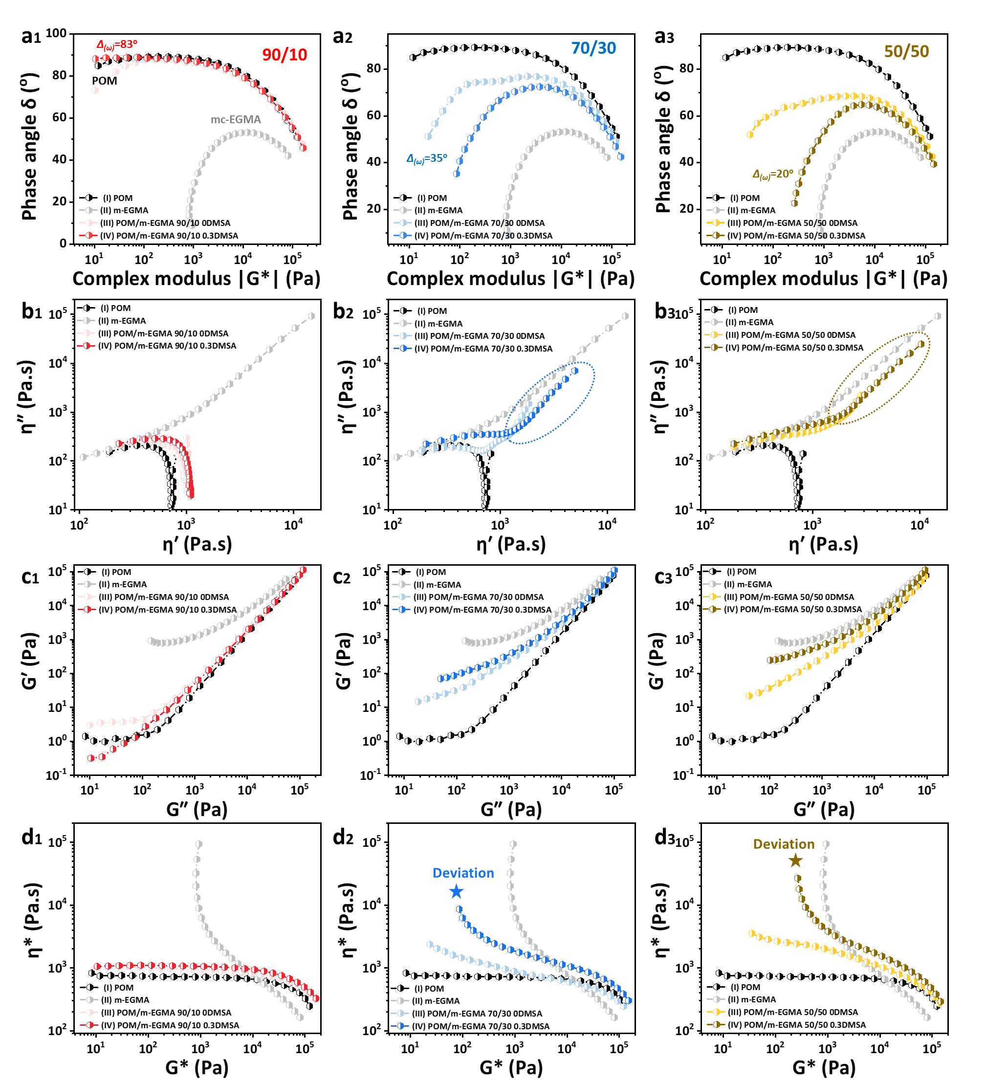

Figure S8. Representative criteria estimated from SAOS experiments: (a) van Gurp-Palmen plots, (b) Cole-Cole plots, (c) Han plots, and (d) plots on |η*_{(ω)}| versus |G*_{(ω)}| of POM, m-EGMA, and POM alloys featuring conventional droplet/matrix and “heterogeneously dispersed nano-domain” (hDNs) microstructure.

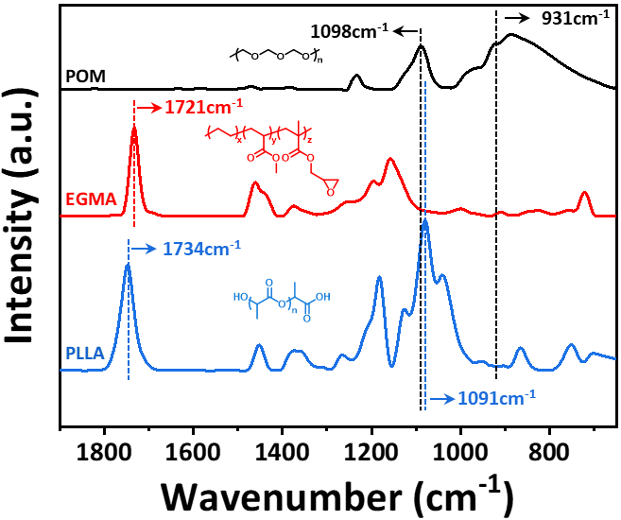

Figure S9. FT-IR spectrum of pristine POM, EGMA, and PLLA.

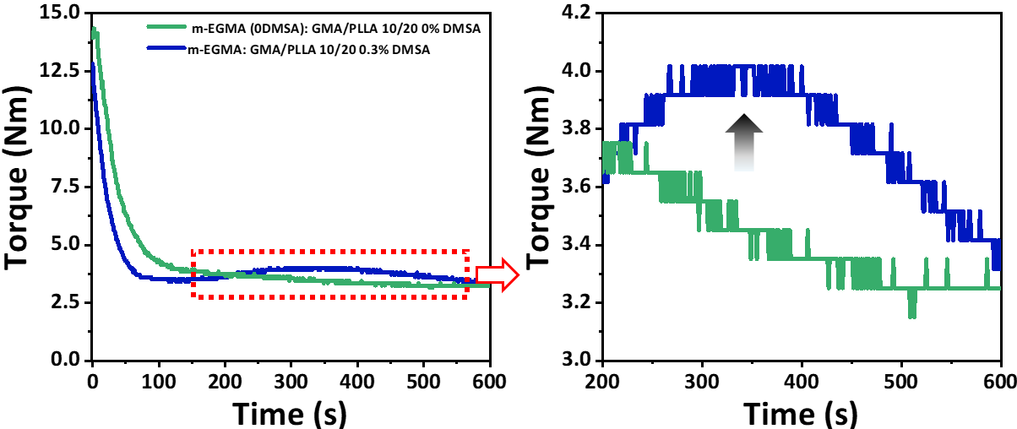

Figure S10. Torque evolution curves of m-EGMA without or with addition of catalyst (DMSA). The melt processing was conducted at 190 ºC with a rotation speed of 50 r/min for 10 min.

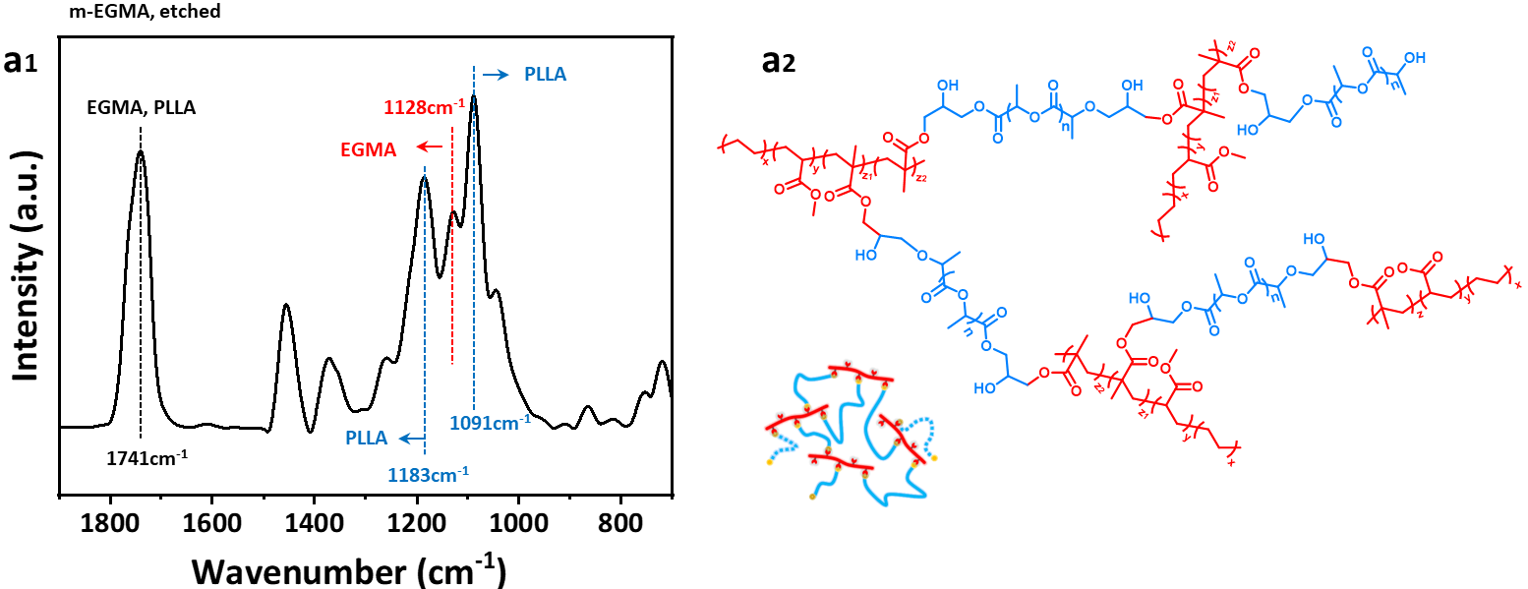

Figure S11. FT-IR spectrum of m-EGMA (0.3DMSA) after selective extraction of free PLLA chains by chloroform using Soxhlet apparatus at 110 ºC for 36 h. The weigh ratio of EGMA/PLLA was 10/20.

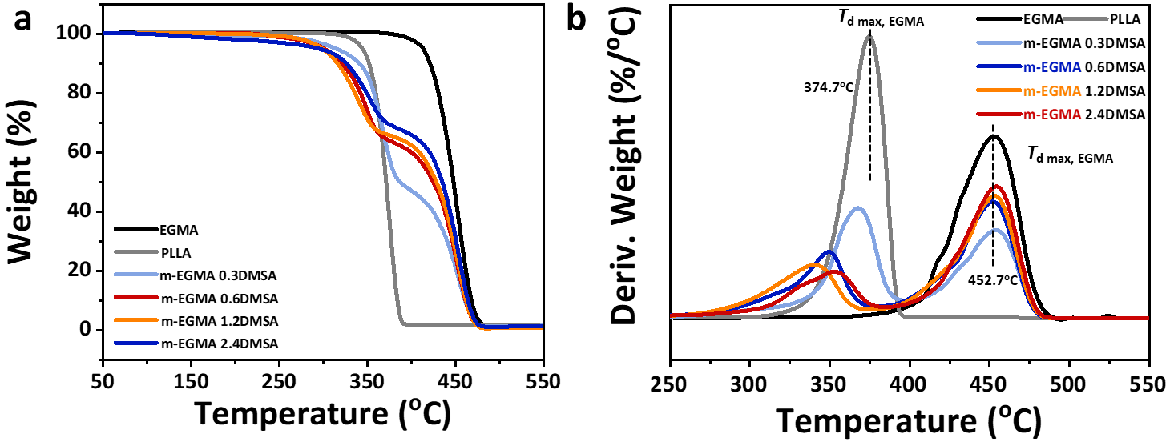

Figure S12. (a) TGA and (DTG) curves of EGMA, PLLA, and m-EGMA after selective extraction of free PLLA chains by chloroform. The weigh ratio of EGMA/PLLA in m-EGMA was fixed as 10/20 containing various concentration of DMSA from 0.3 wt%, 0.6 wt%, 1.2 wt%, to 2.4 wt%.

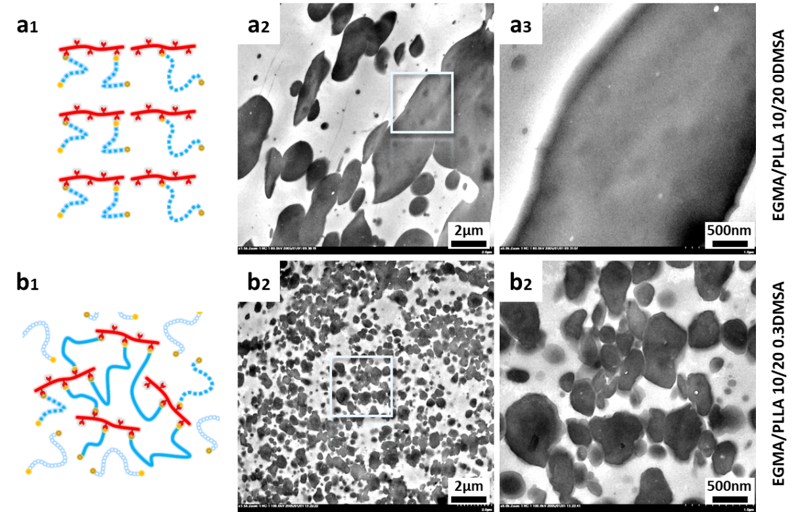

Figure S13. Schematic illustrations and TEM images of m-EGMA with or without addition of DMSA. The weigh ratio of EGMA/PLLA in m-EGMA was fixed as 10/20.

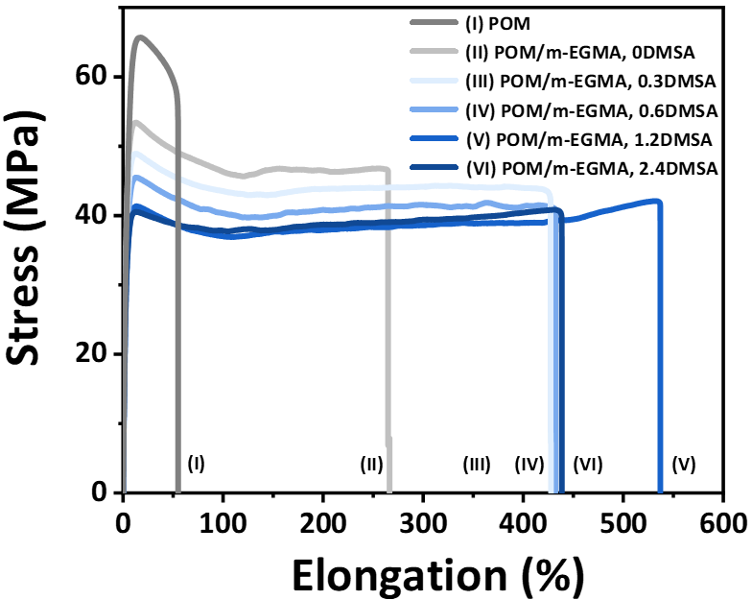

Figure S14. Representative stress-strain curves of POM and hDNs-structured POM/m-EGMA alloys. The weigh ratio of EGMA/PLLA in m-EGMA was fixed as 10/20 containing various concentration of DMSA from 0.3 wt%, 0.6 wt%, 1.2 wt%, to 2.4 wt%.

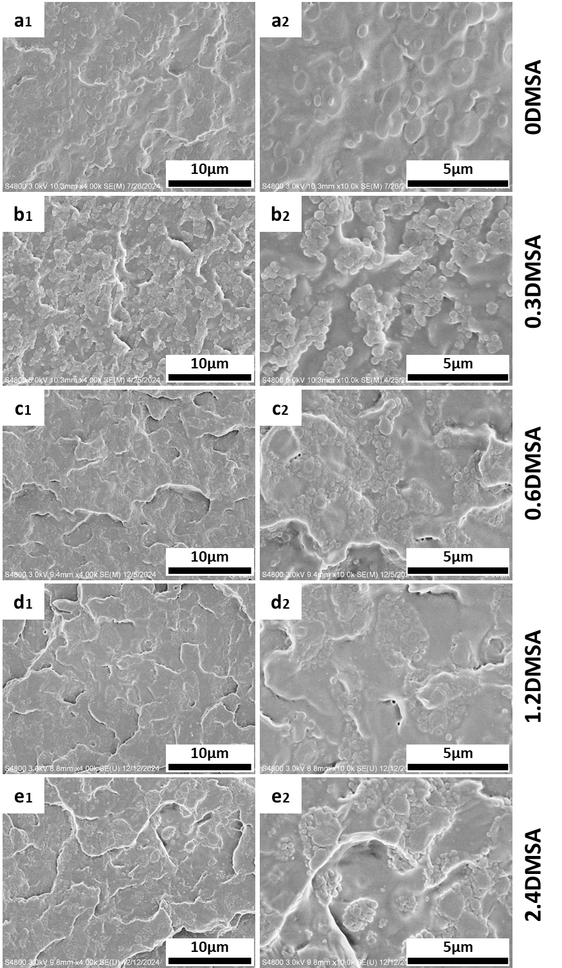

Figure S15. SEM images of POM/(EGMA/PLLA) 70/(10/20) alloys with different concentration of DMSA: (a) 0 wt%, (b) 0.3 wt%, (c) 0.6 wt%, (d) 1.2 wt%, and (e) 2.4 wt%.

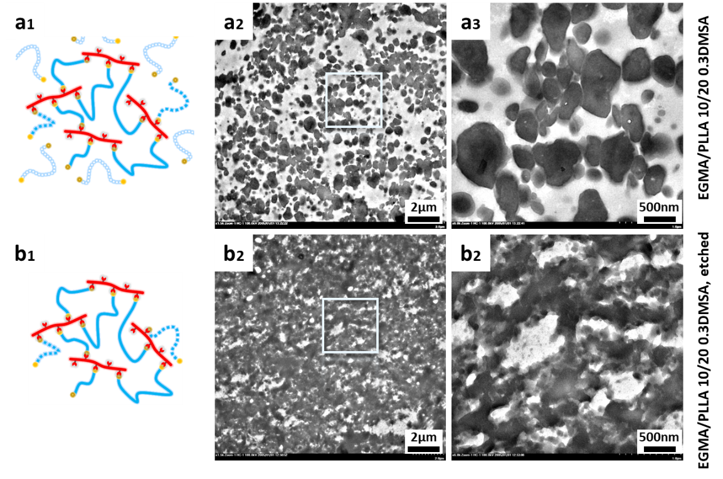

Figure S16. TEM images of m-EGMA (EGMA/PLLA 10/20, 0.3 wt% DMSA) (a) before, (b) after selective extraction of free PLLA chains by CHCl₃ by Soxhlet apparatus at 110 ºC for 36 h.

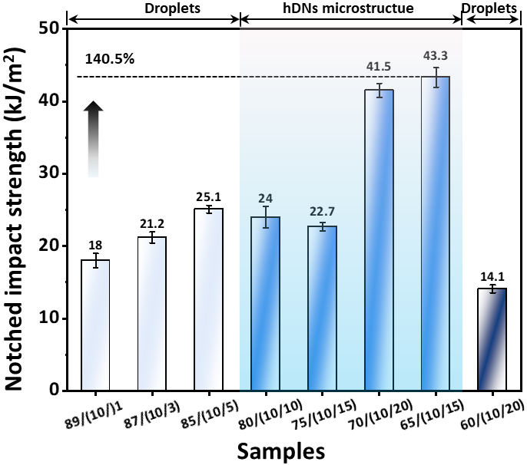

Figure S17. Notched impact strength of “heterogeneously dispersed nano-domains” (hDNs)-structured alloys incorporating various compositional ratio of PLLA in m-EGMA. The EGMA loadings in the obtained alloys was fixed as 10 wt%. The content of DMSA in m-EGMA was fixed as 0.3 wt%.

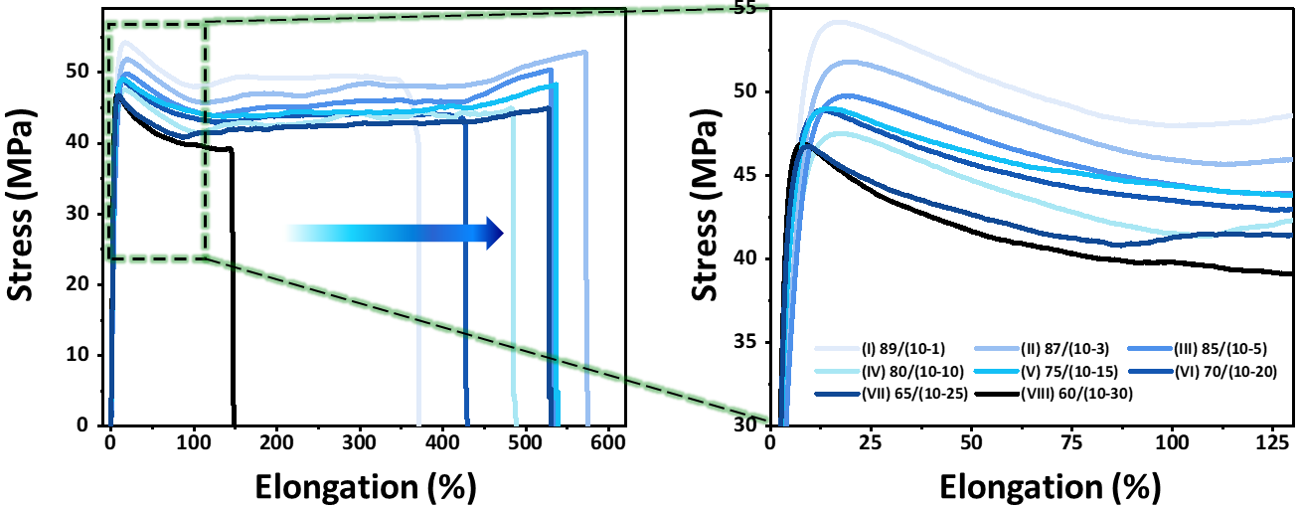

Figure S18. Representative stress-strain curves of “heterogeneously dispersed nano-domains” (hDNs)-structured alloys incorporating various compositional ratio of PLLA in m-EGMA. The EGMA loadings in the obtained alloys was fixed as 10 wt%. The concentration of DMSA in m-EGMA was fixed as 0.3 wt%.

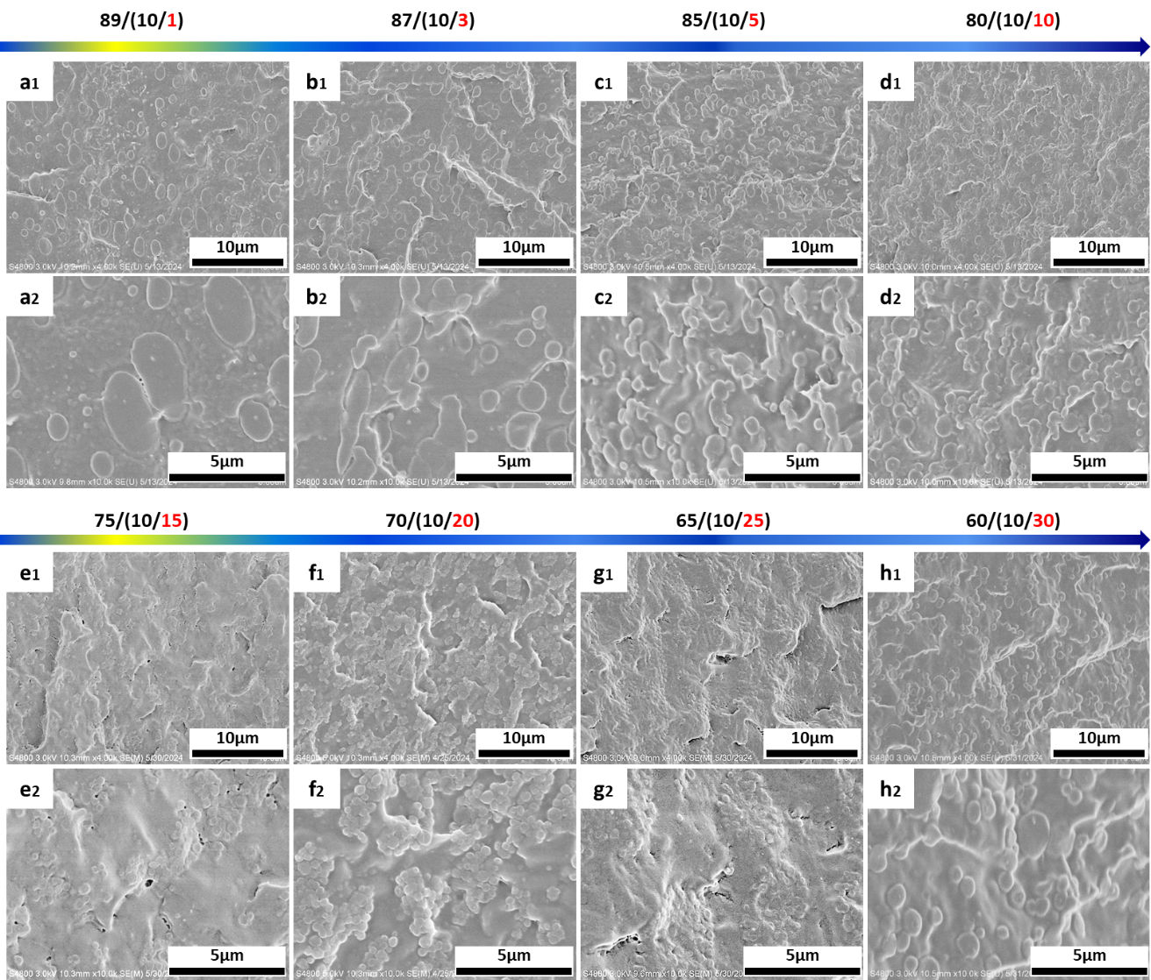

Figure S19. SEM images of “heterogeneously dispersed nano-domains” (hDNs)-structured alloys incorporating various compositional ratio of PLLA in m-EGMA from (a) 89/(10/1), (b) 87/(10/3), (c) 85/(10/5), (d) 80/(10/10), (e) 75/(10/15), (f) 70/(10/20), (g) 65/(10/25), to (h) 60/(10/30). The concentration of DMSA in m-EGMA was fixed as 0.3 wt%.

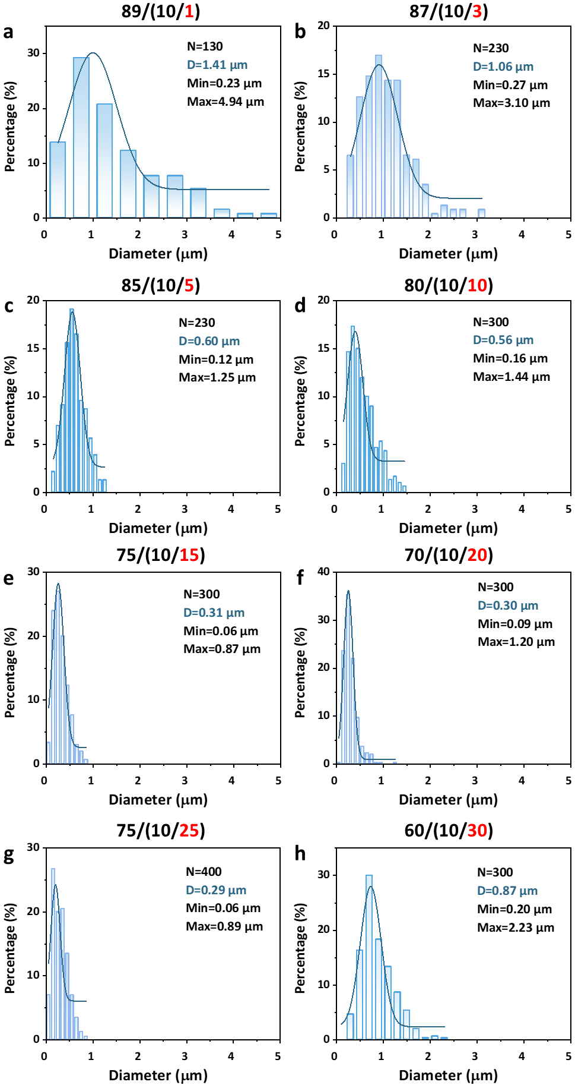

Figure S20. Statistical data of the diameter of EGMA nano-domains in “heterogeneously dispersed nano-domains” (hDNs)-structured alloys incorporating various compositional ratio of PLLA in m-EGMA from (a) 89/(10/1), (b) 87/(10/3), (c) 85/(10/5), (d) 80/(10/10), (e) 75/(10/15), (f) 70/(10/20), (g) 65/(10/25), to (h) 60/(10/30). The concentration of DMSA in m-EGMA was fixed as 0.3 wt%.

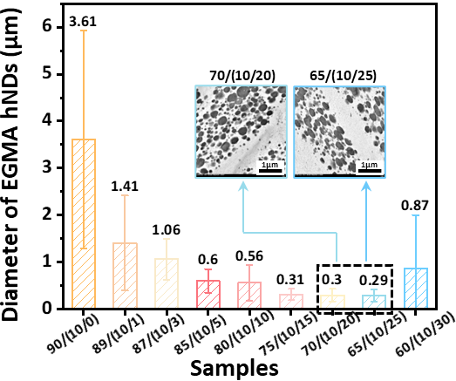

Figure S21. Averaged diameter of EGMA nano-domains in “heterogeneously dispersed nano-domains” (hDNs)-structured alloys as a function of PLLA loadings in m-EGMA.

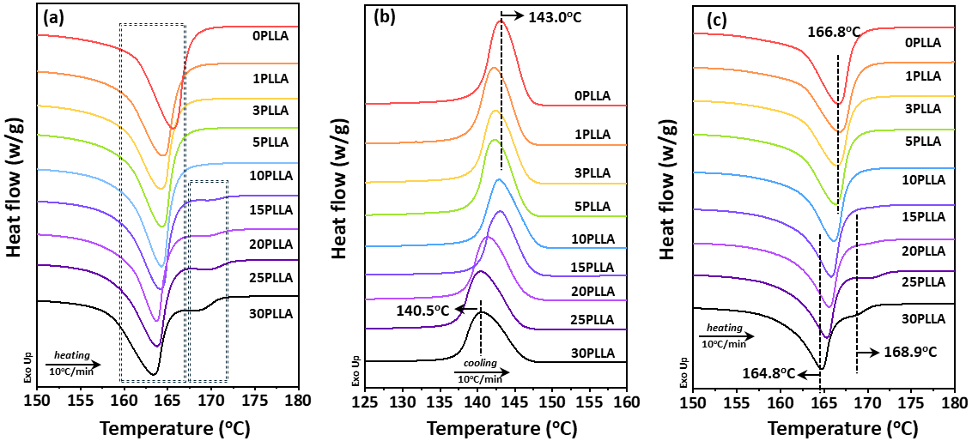

Figure S22. DSC thermograms of “heterogeneously dispersed nano-domains” (hDNs)-structured alloys incorporating various compositional ratio of PLLA in m-EGMA collected at (a) first heating, (b) cooling, and (c) second heating procedure with the heating/cooling rate of 10 oC/min.

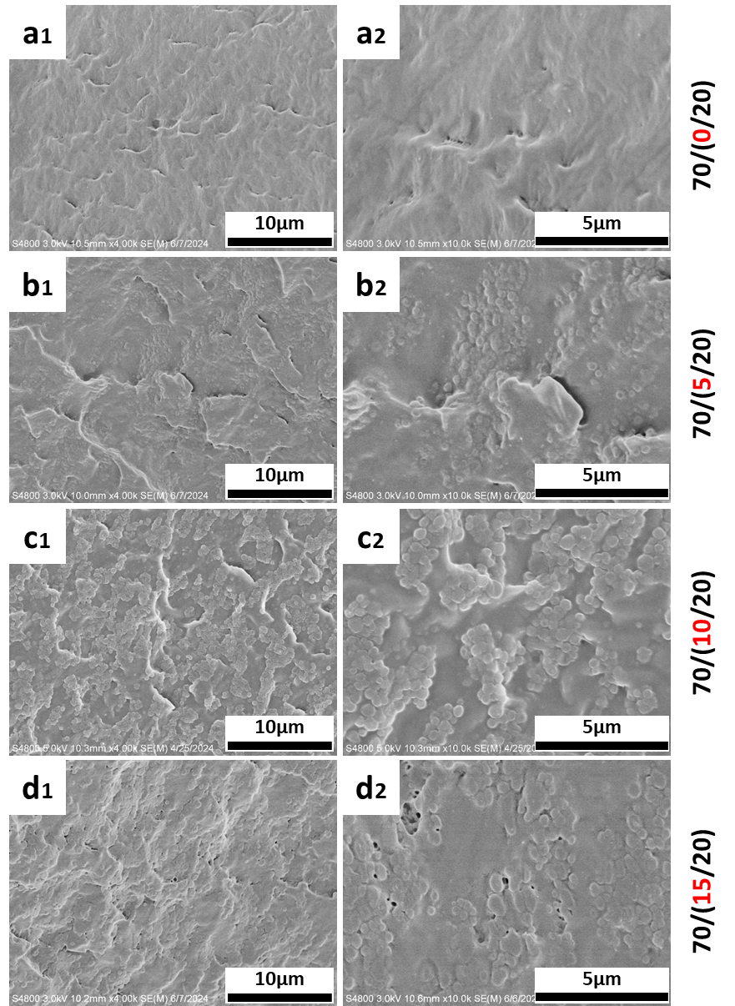

Figure S23. SEM images of “heterogeneously dispersed nano-domains” (hDNs)-structured alloys as a function of EGMA loadings in m-EGMA, that is POM/(EGMA/PLLA) from (a) 70/(0/20), (b) 70/(5/20), (c) 70/(10/20), to (d) 70/(15/20).

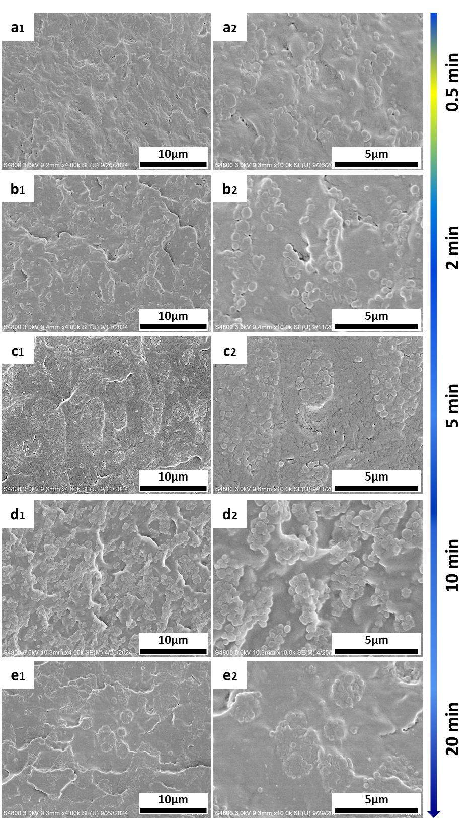

Figure S24. SEM images of representative hDNs-structured alloy POM/(EGMA/PLLA) 70/(10/20) captured at different processing times at 190 ºC with a rotation speed of 50 r/min: from (a) 0.5min, (b) 2 min, (c) 5 min, (d) 10 min, to (e) 20min.

Table S1. Mechanical parameters of POM, conventional POM/m-EGMA (0DMSA) alloys featuring droplet/matrix morphology and POM/m-EGMA (0.3DMSA) alloys featuring “heterogeneously dispersed nano-domains” microstructure.
 | Young’s modulus/GPa | Tensile strength/MPa | Elongation at break/% | Notched impact strength/kJ/m²
POM | 1.38 ± 0.03 | 66 ± 0.1 | 56 ± 8 | 12.3 ± 1.7
90/10 conventional | 1.23 ± 0.01 | 55 ± 0.5 | 76 ± 13 | 13.4 ± 0.5
90/10 hNDs | 1.37 ± 0.05 | 59 ± 0.6 | 73 ± 8 | 19.5 ± 0.4
70/30 conventional | 1.37 ± 0.02 | 50 ± 0.6 | 217 ± 30 | 17.7 ± 0.9
70/30 hNDs | 1.36 ± 0.02 | 50 ± 1.0 | 429 ± 173 | 41.5 ± 1.0
50/50 conventional | 1.31 ± 0.04 | 38 ± 0.5 | 221 ± 21 | 28.9 ± 1.1
50/50 hNDs | 1.36 ± 0.05 | 44 ± 1.4 | 428 ± 86 | 58.6 ± 3.5

Table S2. Performance comparison in terms of notched impact strength, elongation at break, and tensile strength of POM alloys.
Code | Elastomer/inorganic filled modified POM alloys | Elongation at break | Tensile strength  (MPa) | Notched impact strength (kJ/m²) | Ref.ª
1 | POM | 56 | 66 | 12.3
2 | POM/E-MA-GMA | 95 | - | 8.08 | [1]
3 | POM/CB | 30 | 57.9 | 8.29 | [2]
3 | POM/CB/1.5NCC | 31 | 59.7 | 10.11 | [2]
3 | POM/CB/3NCC | 33 | 62.4 | 9.96 | [2]
3 | POM/CB/4.5NCC | 30 | 60.9 | 7.39 | [2]
4 | POM/5%GCE | 40 | 45 | 13 | [3]
4 | POM/10%GCE | 63 | 42 | 13.5 | [3]
4 | POM/20%GCE | 72 | 31 | 15.5 | [3]
4 | POM/30%GCE | 76 | 26.8 | 16.7 | [3]
5 | POM/PTFE plasma 0min | 7 | 26 | 8.9 | [4]
5 | POM/PTFE plasma 5min | 7.5 | 27 | 11.6 | [4]
5 | POM/PTFE plasma 15min | 8.3 | 29 | 11.0 | [4]
5 | POM/PTFE plasma 30min | 8.5 | 28 | 10.3 | [4]
6 | POM/APP | - | 40.7 | 2.6 | [5]
6 | POM/MC-APP | - | 45.5 | 3.1 | [5]
6 | POM/GW-APP | - | 42.2 | 2.8 | [5]
6 | POM/MF-APP | - | 42.5 | 2.2 | [5]
7 | POM/SGF-HT | 1.9 | 78 | - | [6]
7 | POM/SGF-NC | 1.6 | 83.9 | - | [6]
7 | POM/SGF-WD | 3 | 85.2 | - | [6]
8 | PLA/PCL/POM 80/20/1 | 154.4 | 45.0 | - | [7]
8 | PLA/PCL/POM 80/20/2 | 202.7 | 46.4 | - | [7]
8 | PLA/PCL/POM 80/20/3 | 312.8 | 44.1 | - | [7]
8 | PLA/PCL/POM 70/30/1 | 218.8 | 37.5 | - | [7]
8 | PLA/PCL/POM 70/30/2 | 315.9 | 38.4 | - | [7]
8 | PLA/PCL/POM70/30/3 | 334.8 | 41.2 | - | [7]
9 | POM/RCF 5% | 3.1 | 91 | 4.3 | [8]
9 | POM/RCF 10% | 3.0 | 120 | 5.9 | [8]
10 | POM40/PLA40/EBA20-CE | 17.6 | 40 | 4.9 | [9]
10 | POM/EBA20 | 16 | 34 | 5.6 | [9]
10 | POM40/PLA40/EBA20 | 15 | 35 | 4.9 | [9]
10 | POM/EBA20-CE | 16.3 | 33 | 4.8 | [9]
11 | POM/0.1GNP | 47 | 57.3 | 14.7 | [10]
11 | POM/0.5GNP | 55.2 | 61.9 | 17.6 | [10]
11 | POM/1GNP | 52 | 59.7 | 11.7 | [10]
12 | POM/graphite | 11.8 | 59 | 5.6 | [11]
12 | POM/graphite/T-1 | 17.9 | 58 | 5.6 | [11]
12 | POM/graphite/T-2 | 25.5 | 57 | 5.9 | [11]
13 | POM/PEO 90/10 5 (injection speed) | 82.3 | 46.2 | 7.9 | [12]
13 | POM/PEO 90/10 | 89.7 | 46.5 | 7.8 | [12]
13 | POM/PEO 90/10 20 | 88.3 | 46.0 | 8.8 | [12]
13 | POM/PEO 90/10 50 | 89.5 | 46.2 | 10.8 | [12]
13 | POM/PEO 90/10 80 | 85.0 | 46.8 | 11.3 | [12]
13 | POM/PEO 90/10 120 | 86.5 | 45.7 | 10.5 | [12]
14 | POM/MBS/TPU 80/15/0 | 108.67 | 44.63 | 28.25 | [13]
14 | POM/MBS/TPU 80/15/5 | 193.35 | 39.85 | 37.19 | [13]
14 | POM/MBS/TPU 80/15/10 | 222.51 | 38.90 | 40.83 | [13]
15 | POM/10TPU | 64.5 | 47.1 | 37.5 (119.05J/m) | [14]
15 | POM/20TPU | 85.0 | 41.2 | 43.2 (137.01J/m) | [14]
16 | POM/TUP 90/10 170ºC | 42.9 | 47.1 | 9.4 | [15]
16 | POM/TUP 90/10 180ºC | 32.5 | 48.1 | 11.7 | [15]
16 | POM/TUP 90/10 190ºC | 37.3 | 47.5 | 14.4 | [15]
16 | POM/TUP 90/10 200ºC | 40.0 | 47.8 | 12.0 | [15]
17 | POM/TPU Irradiated (3wt%) | 18.9 | 53.1 | 11.2 | [16]
17 | POM/TPU Irradiated (6wt%) | 20.1 | 53.9 | 11.0 | [16]
17 | POM/TPU Irradiated (9wt%) | 18.6 | 50.0 | 10.8 | [16]
18 | This work | 429 | 49 | 41.5
18 | This work | 620 | 44 | 52.9
18 | This work | 530 | 47 | 43.3
ª References:
1. Sun, A., Luo, F., Chen, R., Shih, T. M. & Guo, S. Toward supertough and heat-resistant binary blend: polyoxymethylene/elastomer via in-situ graft copolymer formation during one-pot reactive melt blending. J. Polym. Res. 30, 101 (2023).
2. Mohsenzadeh, R., Soudmand, B. H. & Shelesh‐Nezhad, K. Synergetic impacts of two rigid nano-scale inclusions on the mechanical and thermal performance of POM/carbon black/CaCO₃ ternary nanocomposite systems. Polym. Composites 43, 3041-3056 (2022).
3. Babar, S., Ebenezer, K., Mishra, D., Patil, H. B., Nikam, P. & Rao, A. R. Synthesis of castor oil-based glycidyl carbamate polyurethane elastomer and its effect on toughening of polyoxymethylene. J. Mater. Sci. 58, 7209-7226 (2023).
4. Huang, C. Y. & Tseng, C. I. The effect of interface modification between POM and PTFE on the properties of POM/PTFE composites. J. Appl. Polym. Sci. 78, 800-807 (2000).
5. Kang, X., Liu, Y., Chen, N., Feng, W., Liu, B., Xu, Y., Li, J., Ding, T. & Fang, X. Influence of modified ammonium polyphosphate on the fire behavior and mechanical properties of polyformaldehyde. J. Appl. Polym. Sci. 138, 50156 (2021).
6. Zhang, L., Zhuo, X., Shi, H., Yu, S., Tian, H., Chen, J., Hao, Y., Chen, L., Liu, W. & Xie, Y. Effects of glass fiber reinforcing and thermal post-reatment on the mechanical properties and crystallization behaviors of polyoxymethylene. J. Appl. Polym. Sci. 140, 1-11 (2023).
7. Song, Z., Huang, X., Lu, X., Lv, Q., Xu, N., Pang, S., Pan, L. & Li, T. Improvement of microstructures and properties of poly (lactic acid)/poly (ε-caprolactone) blends compatibilized with polyoxymethylene. J. Appl. Polym. Sci. 135, 46536 (2018).
8. Qian, Z., Wang, Y., Li, J., Wang, X. & Wu, D. Development of sustainable polyoxymethylene-based composites with recycled carbon fibre: mechanical enhancement, morphology, and crystallization kinetics. J. Reinf. Plast. Comp. 33, 294-309 (2014).
9. Andrzejewski, J., Skórczewska, K. & Kloziński, A. Improving the toughness and thermal resistance of polyoxymethylene/poly (lactic acid) blends: Evaluation of structure–properties correlation for reactive processing. Polymers 12, 307 (2020).
10. Rustamov, I., Xiang, L., Xia, Y. & Peng, W. Tribological and mechanical endowments of polyoxymethylene by liquid‐phase exfoliated graphene nanofiller. Polym. Int. 74, 231-245 (2025).
11. Zhao, X. & Ye, L. Study on the thermal conductive polyoxymethylene/graphite composites. J. Appl. Polym. Sci. 111, 759-767 (2009).
12. Bai, S. & Wang, Q. Effect of injection speed on phase morphology, crystallization behavior, and mechanical properties of polyoxymethylene/poly (ethylene oxide) crystalline/crystalline blend in injection processing. Polym. Eng. Sci. 52, 1938-1944 (2012).
13. Yang, J., Yang, W., Wang, X., Dong, M., Liu, H., Wujcik, E. K., Shao, W., Wu, S., Ding, T. & Guo, Z. Synergistically toughening polyoxymethylene by methyl methacrylate-butadiene-styrene copolymer and thermoplastic polyurethane. Macromol. Chem. Phys. 220, 1800567 (2019).
14. Chang, F. C. & Yang, M. Y. Mechanical fracture behavior of polyacetal and thermoplastic polyurethane elastomer toughened polyacetal. Polym. Eng. Sci. 30, 543-552 (1990).
15. Cheng, Z., & Wang, Q. Morphology control of polyoxy-methylene/thermoplastic polyurethane blends by adjusting their viscosity ratio. Polym. Int. 55, 1075-1080 (2006).
16. Ren, X. C., Chen, L., Zhao, H. J., Dan, Y. & Cai, X. F. Acrylate elastomer toughened and UV stabilized polyoxymethylene. J. Macromol. Sci. B. 46, 411-421 (2007).

Table S3. The content of EGMA and PLLA in m-EGMA containing various concentration of DMSA before and after selective extraction of free PLLA chains calculated from TGA measurements.
EGMA/PLLA 10/20 | 0.3DMSA | 0.6DMSA | 1.2DMSA | 2.4DMSA
EGMA(before extraction)/g | 0.12 | 0.12 | 0.13 | 0.11
EGMA(after extraction)/g | 0.03 | 0.04 | 0.07 | 0.08
PLLA(before extraction)/g | 0.24 | 0.24 | 0.26 | 0.22
PLLA(after extraction)/g | 0.01 | 0.01 | 0.02 | 0.02

Table S4. Mechanical parameters of POM/(EGMA/PLLA) 70/(10/20) alloys with different concentration of DMSA: (a) 0 wt%, (b) 0.3 wt%, (c) 0.6 wt%, (d) 1.2 wt%, and (e) 2.4 wt%.
 | Young’s modulus/GPa | Tensile strength/MPa | Elongation at break/% | Notched impact strength/kJ/m²
0DMSA | 1.36 ± 0.02 | 53 ± 0.4 | 266 ± 5 | 17.7 ± 0.9
0.3DMSA | 1.36 ± 0.02 | 50 ± 1.0 | 429 ± 173 | 41.5 ± 1.0
0.6DMSA | 1.31 ± 0.05 | 45 ± 0.5 | 432 ± 54 | 42.4 ± 0.8
1.2DMSA | 1.23 ± 0.02 | 41 ± 0.4 | 537 ± 36 | 21.2 ± 0.3
2.4DMSA | 1.18 ± 0.03 | 41 ± 0.3 | 439 ± 52 | 16.6 ± 0.6

Table S5. Mechanical parameters of “heterogeneously dispersed nano-domains” (hDNs)-structured alloys incorporating various compositional ratio of PLLA in m-EGMA from. The concentration of DMSA in m-EGMA was fixed as 0.3 wt%.
 | Young’s modulus/GPa | Tensile strength/MPa | Elongation at break/% | Notched impact strength/kJ/m²
90/10/0 | 1.11 ± 0.02 | 54 ± 0.3 | 102 ± 29 | 16.2 ± 0.3
89/10/1 | 1.15 ± 0.03 | 54 ± 0.4 | 371 ± 76 | 18.0 ± 1.0
87/10/3 | 1.01 ± 0.03 | 53 ± 1.8 | 575 ± 115 | 21.2 ± 0.8
85/10/5 | 1.03 ± 0.06 | 50 ± 1.0 | 533 ± 20 | 25.1 ± 0.5
80/10/10 | 1.19 ± 0.02 | 48 ± 0.4 | 489 ± 114 | 24.0 ± 1.5
75/10/15 | 1.42 ± 0.03 | 49 ± 0.4 | 539 ± 37 | 22.7 ± 0.6
70/10/20 | 1.36 ± 0.02 | 50 ± 1.0 | 429 ± 173 | 41.5 ± 1.0
65/10/25 | 1.52 ± 0.07 | 47 ± 0.4 | 530 ± 113 | 43.3 ± 1.3
60/10/30 | 1.48 ± 0.02 | 47 ± 1.0 | 150 ± 24 | 14.1 ± 0.5

Table S6. Mechanical parameters of “heterogeneously dispersed nano-domains” (hDNs)-structured alloys as a function of EGMA loadings in m-EGMA.
 | Young’s modulus/GPa | Tensile strength/MPa | Elongation at break/% | Notched impact strength/kJ/m²
70/0/20 | 1.59 ± 0.06 | 62 ± 0.7 | 68 ± 9 | 8.7 ± 0.8
70/5/20 | 1.44 ± 0.05 | 54 ± 0.9 | 280 ± 113 | 16.8 ± 0.5
70/10/20 | 1.36 ± 0.02 | 50 ± 1.0 | 429 ± 173 | 41.5 ± 1.0
70/15/20 | 1.13 ± 0.04 | 44 ± 0.8 | 620 ± 153 | 52.9 ± 3.1

