Comparative efficacy of exercise modes on inflammatory adipocytokines in patients with breast cancer: a systematic review with pairwise and network meta-analyses
Running title: Exercise Training and Chronic Low-grade Inflammation in Patients with Breast Cancer
Mousa Khalafi¹, Mohammad Hossein Sakhaei^{*2}, Faeghe Ghasemi³, Saeid Fatolahi⁴, Kosar Omidian⁵, Michael E. Symonds⁶, Hadi Rohani⁷, Sara K Rosenkranz⁸, Katsuhiko Suzuki⁹, Ayda Sadat Zakeri¹, Marziyeh Mohammadiyan¹, Shima Mojtaahedi², Hossein Rafiei^{10*}
¹Department of Sport Sciences, Faculty of Humanities, University of Kashan, Kashan, Iran
²Department of Exercise Physiology, Faculty of Physical Education and Sport Sciences, University of Tehran, Tehran, Iran
³Department of Exercise Physiology, Faculty of Sport Sciences, University of Guilan, Guilan, Iran
⁴Department of Physical Education and Sport Sciences, Faculty of Humanities, Tarbiat Modares University, Tehran, Iran
⁵College of Pharmacy and Nutrition, University of Saskatchewan, Saskatoon, Saskatchewan, Canada
⁶Centre for Perinatal Research, Academic Unit of Population and Lifespan Sciences, School of Medicine, University of Nottingham, Nottingham, UK
⁷Department of Exercise Physiology, Sport Sciences Research Institute, Tehran, Iran
⁸Department of Kinesiology and Nutrition Sciences, University of Nevada Las Vegas, Las Vegas, NV, USA
⁹Faculty of Sport Sciences, Waseda University, Tokorozawa, Saitama, Japan

¹⁰Department of Nutrition and Dietetics, Saint Louis University, Saint Louis, MO, USA

*Correspondence:

Department of Exercise Physiology, Faculty of Physical Education and Sport Sciences, University of Tehran, Tehran, Iran. Email:

Hossein Rafiei, Department of Nutrition and Dietetics, Saint Louis University, Saint Louis, MO, USA. Email: hossein.rafiei@health.slu.edu

Supplementary table 1. Search strategy
pubmed | (("Exercise"[Title/Abstract] OR "exercise training"[Title/Abstract] OR "physical activity"[Title/Abstract] OR "aerobic training"[Title/Abstract] OR "aerobic exercise"[Title/Abstract] OR "resistance training"[Title/Abstract] OR "resistance exercise"[Title/Abstract] OR "endurance training"[Title/Abstract] OR "endurance exercise"[Title/Abstract] OR "strength training"[Title/Abstract] OR "strength exercise"[Title/Abstract] OR "combined exercise"[Title/Abstract] OR "combined training"[Title/Abstract] OR "concurrent training"[Title/Abstract] OR "concurrent exercise"[Title/Abstract] OR "interval training"[Title/Abstract] OR "interval exercise"[Title/Abstract] OR "caloric restriction"[Title/Abstract] OR "weight loss"[Title/Abstract] OR "diet"[Title/Abstract] OR "dietary"[Title/Abstract] OR "lifestyle intervention"[Title/Abstract] OR "lifestyle"[Title/Abstract]) AND ("adipokine"[Title/Abstract] OR "adipocytokine"[Title/Abstract] OR "adiponectin"[Title/Abstract] OR "leptin"[Title/Abstract] OR "cytokine"[Title/Abstract] OR "cytokines"[Title/Abstract] OR "interleukin"[Title/Abstract] OR "interleukin-6"[Title/Abstract] OR "interleukin-6"[Title/Abstract] OR "interleukin-1"[Title/Abstract] OR "interleukin-1beta"[Title/Abstract] OR "IL-6"[Title/Abstract] OR "IL-1beta"[Title/Abstract] OR "interleukin-10"[Title/Abstract] OR "interleukin-10"[Title/Abstract] OR "IL-10"[Title/Abstract] OR "tumor Necrosis Factor alpha"[Title/Abstract] OR "tnf alpha"[Title/Abstract] OR "tnf alpha"[Title/Abstract] OR "inflammation"[Title/Abstract] OR "inflammatory"[Title/Abstract] OR "pro-inflammatory"[Title/Abstract] OR "anti-inflammatory"[Title/Abstract]) AND ("Breast Neoplasms"[Title/Abstract] OR "Breast Neoplasms"[Title/Abstract] OR "Breast Neoplasm"[Title/Abstract] OR "Breast Tumors"[Title/Abstract] OR "Breast Tumor"[Title/Abstract] OR "Breast Cancer"[Title/Abstract] OR "Mammary Cancer"[Title/Abstract] OR "Mammary Cancers"[Title/Abstract] OR "Malignant Neoplasm of Breast"[Title/Abstract] OR "Breast Malignant Neoplasm"[Title/Abstract] OR "Breast Malignant Neoplasms"[Title/Abstract] OR "Malignant Tumor of Breast"[Title/Abstract] OR "Breast Malignant Tumor"[Title/Abstract] OR "Breast Malignant Tumors"[Title/Abstract] OR "Cancer of Breast"[Title/Abstract] OR "Cancer of the Breast"[Title/Abstract] OR "Human Mammary Carcinomas"[Title/Abstract] OR "Human Mammary Carcinoma"[Title/Abstract] OR "Human Mammary Neoplasms"[Title/Abstract] OR "Breast Carcinoma"[Title/Abstract] OR "Breast Carcinomas"[Title/Abstract]) AND ("Random"[Title/Abstract] OR "Randomly"[Title/Abstract] OR "Randomized"[Title/Abstract] OR "random*"[Title/Abstract] OR "Randomized controlled trial"[Title/Abstract] OR "Randomized clinical trial"[Title/Abstract] OR "Randomized control"[Title/Abstract] OR "Randomized trial"[Title/Abstract] OR "Randomized clinical"[Title/Abstract])) AND ((humans[Filter]) AND (english[Filter])) | 187
scopus | ( TITLE-ABS-KEY ( "Exercise" OR "exercise training" OR "physical activity" OR "aerobic training" OR "aerobic exercise" OR "resistance training" OR "resistance exercise" OR "endurance training" OR "endurance exercise" OR "strength training" OR "strength exercise" OR "combined exercise" OR "combined training" OR "concurrent training" OR "concurrent exercise" OR "interval training" OR "interval exercise" OR "caloric restriction" OR "weight loss" OR "diet" OR "dietary" OR "lifestyle intervention" OR "lifestyle" ) AND TITLE-ABS-KEY ( "adipokine" OR "adipocytokine" OR "adiponectin" OR "leptin" OR "cytokine" OR "cytokines" OR "interleukin" OR "interleukin 6" OR "interleukin-6" OR "interleukin-1" OR "interleukin-1β" OR "IL-6" OR "IL-1β" OR "interleukin 10" OR "interleukin-10" OR "IL-10" OR "tumor Necrosis Factor alpha" OR "TNF-α" OR "TNF α" OR "inflammation" OR "inflammatory" OR "pro-inflammatory" OR "anti-inflammatory" ) AND TITLE-ABS-KEY ( "Breast Neoplasms" OR "Breast Neoplasms" OR "Breast Neoplasm" OR "Breast Tumors" OR "Breast Tumor" OR "Breast Cancer" OR "Mammary Cancer" OR "Mammary Cancers" OR "Malignant Neoplasm of Breast" OR "Breast Malignant Neoplasm" OR "Breast Malignant Neoplasms" OR "Malignant Tumor of Breast" OR "Breast Malignant Tumor" OR "Breast Malignant Tumors" OR "Cancer of Breast" OR "Cancer of the Breast" OR "Human Mammary Carcinomas" OR "Human Mammary Carcinoma" OR "Human Mammary Neoplasm" OR "Human Mammary Neoplasms" OR "Breast Carcinoma" OR "Breast Carcinomas" ) AND TITLE-ABS-KEY ( "Random" OR "Randomly" OR "Randomized" OR "Random*" OR "Randomized controlled trial" OR "Randomized clinical trial" OR "Randomized control" OR "Randomized trial" OR "Randomized clinical" ) ) AND ( LIMIT-TO ( DOCTYPE , "ar" ) ) AND ( LIMIT-TO ( LANGUAGE , "English" ) ) AND ( LIMIT-TO ( EXACTKEYWORD , "Human" ) ) | 362
Web of science | (((TS=(“Exercise” OR “exercise training” OR “physical activity” OR “aerobic training” or “aerobic exercise” OR “resistance training” OR “resistance exercise” OR “endurance training” OR “endurance exercise” OR “strength training” OR “strength exercise” OR “combined exercise” OR “combined training” OR “concurrent training” OR “concurrent exercise” OR “interval training” OR “interval exercise” OR “caloric restriction" OR "weight loss" OR "diet" OR "dietary" OR “lifestyle intervention” OR “lifestyle”)) AND TS=( "adipokine" OR "adipocytokine” OR "adiponectin" OR "leptin" OR "cytokine" OR "cytokines" OR "interleukin" OR "interleukin 6" OR "interleukin-6" OR "interleukin-1" OR "interleukin-1β" OR "IL-6" OR "IL-1β" OR "interleukin 10" OR "interleukin-10" OR "IL-10" OR "tumor Necrosis Factor alpha" OR "TNF-α" OR "TNF α" OR "inflammation" OR "inflammatory" OR "pro-inflammatory" OR "anti-inflammatory")) AND TS=( "Breast Neoplasms" OR "Breast Neoplasms" OR "Breast Neoplasm" OR "Breast Tumors" OR "Breast Tumor" OR "Breast Cancer" OR "Mammary Cancer" OR "Mammary Cancers" OR "Malignant Neoplasm of Breast" OR "Breast Malignant Neoplasm" OR "Breast Malignant Neoplasms" OR "Malignant Tumor of Breast" OR "Breast Malignant Tumor" OR "Breast Malignant Tumors" OR "Cancer of Breast" OR "Cancer of the Breast" OR "Human Mammary Carcinomas" OR "Human Mammary Carcinoma" OR "Human Mammary Neoplasm" OR "Human Mammary Neoplasms" OR "Breast Carcinoma" OR "Breast Carcinomas”)) AND TS=( "Random" OR "Randomly" OR "Randomized" OR "Random*" OR "Randomized controlled trial" OR "Randomized clinical trial" OR "Randomized control" OR "Randomized trial" OR "Randomized clinical") | 422

Supplementary table 3. League table reporting the comparative effects for all interventions for the IL-6
AT | -0.2116 (-0.8302 to 0.4070) | -0.2035 (-1.7993 to 1.3922) | 0.2456 (-0.9464 to 1.4375) | . | .
-0.3550 (-0.9542 to 0.2443) | CON | 0.4704 (-0.1416 to 1.0823) | 1.1530 ( 0.1863 to 2.1198) | 0.3271 (-0.5652 to 1.2194) | -0.1787 (-1.3697 to 1.0124)
0.1099 (-0.6976 to 0.9174) | 0.4649 (-0.1352 to 1.0650) | CT | . | . | .
0.7296 (-0.2269 to 1.6860) | 1.0846 ( 0.1825 to 1.9867) | 0.6197 (-0.4526 to 1.6919) | HIIT | . | .
-0.0279 (-1.1027 to 1.0469) | 0.3271 (-0.5652 to 1.2194) | -0.1378 (-1.2131 to 0.9375) | -0.7575 (-2.0263 to 0.5114) | RT | .
-0.5337 (-1.8670 to 0.7996) | -0.1787 (-1.3697 to 1.0124) | -0.6436 (-1.9773 to 0.6901) | -1.2633 (-2.7574 to 0.2309) | -0.5058 (-1.9940 to 0.9824) | yoga-taichi
Network meta-analysis combined with direct and indirect measures is presented in the lower-left portion, and pairwise meta-analysis (only direct measures) is presented in the upper-right portion.

Supplementary table 4 Node-splitting method in comparison between direct and indirect evidence of different specific intervention for IL-6
comparison | k | prop | nma | direct | indir. | Diff | z | p-value
AT:CON | 7 | 0.94 | -0.355 | -0.212 | -2.535 | 2.324 | 1.83 | 0.0674
AT:CT | 1 | 0.26 | 0.11 | -0.204 | 0.218 | -0.421 | -0.45 | 0.6553
AT:HIIT | 2 | 0.64 | 0.73 | 0.246 | 1.605 | -1.359 | -1.33 | 0.1822
CT:CON | 7 | 0.96 | -0.465 | -0.47 | -0.328 | -0.142 | -0.09 | 0.9291
HIIT:CON | 3 | 0.87 | -1.085 | -1.153 | -0.624 | -0.53 | -0.39 | 0.6995
Notes: p>0.05 indicates that indirect comparisons were consistent with direct comparisons.

Supplementary table 5. League table reporting the comparative effects for all interventions for the TNF-α
AT | -0.2169 (-0.6293 to 0.1955) | 0.4156 (-0.6265 to 1.4576) | 0.4463 (-0.3853 to 1.2778) | .
-0.2266 (-0.6312 to 0.1781) | CON | 0.6384 ( 0.1606 to 1.1163) | 0.6297 (-0.2039 to 1.4634) | -0.3258 (-1.0090 to 0.3575)
0.4237 (-0.1570 to 1.0044) | 0.6503 ( 0.1852 to 1.1154) | CT | . | .
0.4228 (-0.3277 to 1.1733) | 0.6494 (-0.1017 to 1.4004) | -0.0009 (-0.8720 to 0.8702) | HIIT | .
-0.5523 (-1.3464 to 0.2417) | -0.3258 (-1.0090 to 0.3575) | -0.9760 (-1.8026 to -0.1495) | -0.9751 (-1.9905 to 0.0402) | RT
Network meta-analysis combined with direct and indirect measures is presented in the lower-left portion, and pairwise meta-analysis (only direct measures) is presented in the upper-right portion.

Supplementary table 6. Node-splitting method in comparison between direct and indirect evidence of different specific intervention for TNF-α
comparison | k | prop | nma | direct | indir. | Diff | z | p-value
AT:CON | 7 | 0.96 | -0.227 | -0.217 | -0.478 | 0.261 | 0.24 | 0.8114
AT:CT | 1 | 0.31 | 0.424 | 0.416 | 0.427 | -0.012 | -0.02 | 0.9853
AT:HIIT | 2 | 0.81 | 0.423 | 0.446 | 0.32 | 0.127 | 0.13 | 0.8977
CT:CON | 5 | 0.95 | -0.65 | -0.638 | -0.862 | 0.224 | 0.21 | 0.8329
HIIT:CON | 2 | 0.81 | -0.649 | -0.63 | -0.734 | 0.104 | 0.11 | 0.9153
Notes: p>0.05 indicates that indirect comparisons were consistent with direct comparisons.

Supplementary table 7. League table reporting the comparative effects for all interventions for the IL-10
AT | 0.1849 (-0.3902 to 0.7600) | . | -0.1132 (-0.6919 to 0.4655) | .
0.2098 (-0.3289 to 0.7486) | CON | 0.1997 (-0.1769 to 0.5764) | -0.3478 (-0.7531 to 0.0574) | 0.1693 (-0.5088 to 0.8475)
0.4096 (-0.2478 to 1.0669) | 0.1997 (-0.1769 to 0.5764) | CT | . | .
-0.1386 (-0.6792 to 0.4021) | -0.3484 (-0.7537 to 0.0568) | -0.5482 (-1.1014 to 0.0051) | HIIT | .
0.3792 (-0.4869 to 1.2453) | 0.1693 (-0.5088 to 0.8475) | -0.0304 (-0.8061 to 0.7454) | 0.5178 (-0.2722 to 1.3078) | RT
Network meta-analysis combined with direct and indirect measures is presented in the lower-left portion, and pairwise meta-analysis (only direct measures) is presented in the upper-right portion.

Supplementary table 8. Node-splitting method in comparison between direct and indirect evidence of different specific intervention for IL-10
comparison | k | prop | nma | direct | indir. | Diff | z | p-value
AT:CON | 2 | 0.88 | 0.210 | 0.185 | 0.389 | -0.204 | -0.24 | 0.8079
AT:HIIT | 2 | 0.87 | -0.139 | -0.113 | -0.313 | 0.200 | 0.24 | 0.8093
Notes: p>0.05 indicates that indirect comparisons were consistent with direct comparisons.

Supplementary table 9. League table reporting the comparative effects for all interventions for the CRP
AT | -0.2031 (-1.3749 to 0.9688) | . | . | .
-0.2031 (-1.3749 to 0.9688) | CON | 0.7504 (-0.3920 to 1.8928) | 0.3627 (-0.7829 to 1.5083) | 0.3327 (-1.9854 to 2.6509)
0.5474 (-1.0892 to 2.1839) | 0.7504 (-0.3920 to 1.8928) | CT | . | .
0.1596 (-1.4792 to 1.7984) | 0.3627 (-0.7829 to 1.5083) | -0.3877 (-2.0056 to 1.2301) | RT | .
0.1297 (-2.4678 to 2.7272) | 0.3327 (-1.9854 to 2.6509) | -0.4177 (-3.0020 to 2.1667) | -0.0299 (-2.6157 to 2.5558) | yoga-taichi
Network meta-analysis combined with direct and indirect measures is presented in the lower-left portion, and pairwise meta-analysis (only direct measures) is presented in the upper-right portion.

Supplementary table 10. League table reporting the comparative effects for all interventions for the leptin
AT | -0.3695 (-0.7736 to 0.0345) | . | 0.2716 (-0.3196 to 0.8627) | .
-0.3452 (-0.7490 to 0.0586) | CON | 0.6259 ( 0.3683 to 0.8835) | 0.9596 ( 0.3447 to 1.5744) | 0.1016 (-0.1508 to 0.3539)
0.2807 (-0.1982 to 0.7596) | 0.6259 ( 0.3683 to 0.8835) | CT | . | .
0.4056 (-0.1514 to 0.9627) | 0.7508 ( 0.1813 to 1.3204) | 0.1250 (-0.5001 to 0.7500) | HIIT | .
-0.2436 (-0.7198 to 0.2325) | 0.1016 (-0.1508 to 0.3539) | -0.5243 (-0.8849 to -0.1637) | -0.6493 (-1.2722 to -0.0263) | RT
Network meta-analysis combined with direct and indirect measures is presented in the lower-left portion, and pairwise meta-analysis (only direct measures) is presented in the upper-right portion.

Supplementary table 11. Node-splitting method in comparison between direct and indirect evidence of different specific intervention for leptin
comparison | k | prop | nma | direct | indir. | Diff | z | p-value
AT:CON | 3 | 1.00 | -0.490 | -0.493 | . | . | . | .
AT:HIIT | 2 | 0.91 | 0.326 | 0.202 | 1.657 | -1.455 | -0.44 | 0.6585
HIIT:CON | 2 | 0.91 | -0.816 | -0.946 | 0.548 | -1.494 | -0.46 | 0.6478
Notes: p>0.05 indicates that indirect comparisons were consistent with direct comparisons.

Supplementary table 12. League table reporting the comparative effects for all interventions for the adiponectin
AT | 0.2462 (-1.2023 to 1.6947) | . | -0.3508 (-2.1437 to 1.4421) | .
0.2460 (-1.2025 to 1.6945) | CON | -0.9023 (-2.1458 to 0.3412) | -0.7739 (-2.5694 to 1.0216) | 0.3001 (-1.4401 to 2.0403)
-0.6563 (-2.5654 to 1.2527) | -0.9023 (-2.1458 to 0.3412) | CT | . | .
-0.4388 (-2.1529 to 1.2752) | -0.6848 (-2.4007 to 1.0310) | 0.2175 (-1.9016 to 2.3365) | HIIT | .
0.5461 (-1.7181 to 2.8103) | 0.3001 (-1.4401 to 2.0403) | 1.2024 (-0.9364 to 3.3412) | 0.9849 (-1.4589 to 3.4288) | RT
Network meta-analysis combined with direct and indirect measures is presented in the lower-left portion, and pairwise meta-analysis (only direct measures) is presented in the upper-right portion.

Supplementary table 13. Node-splitting method in comparison between direct and indirect evidence of different specific intervention for adiponectin
comparison | k | prop | nma | direct | indir. | Diff | z | p-value
AT:HIIT | 2 | 0.91 | -0.439 | -0.351 | -1.374 | 1.023 | 0.33 | 0.7429
HIIT:CON | 2 | 0.91 | 0.685 | 0.774 | -0.252 | 1.026 | 0.33 | 0.7414
Notes: p>0.05 indicates that indirect comparisons were consistent with direct comparisons.

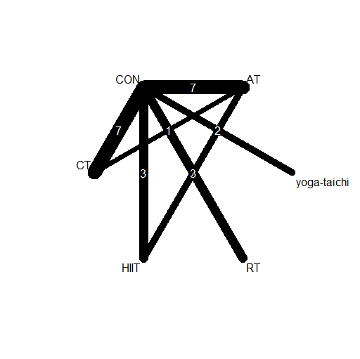Supplementary Figure 1. Network geometric map of studies investigating the effect of exercise training on IL-6
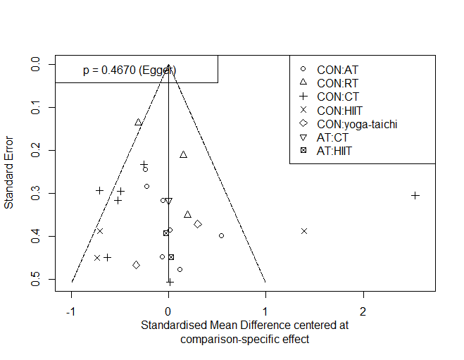Supplementary Figure 2. Network meta-analysis of funnel plots for IL-6

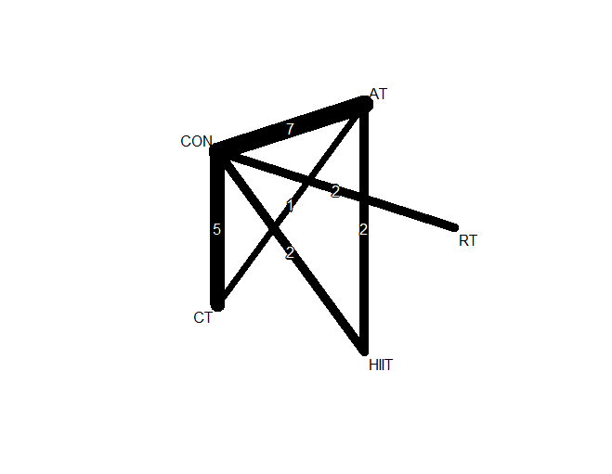Supplementary Figure 3. Network geometric map of studies investigating the effect of exercise training on TNF-α
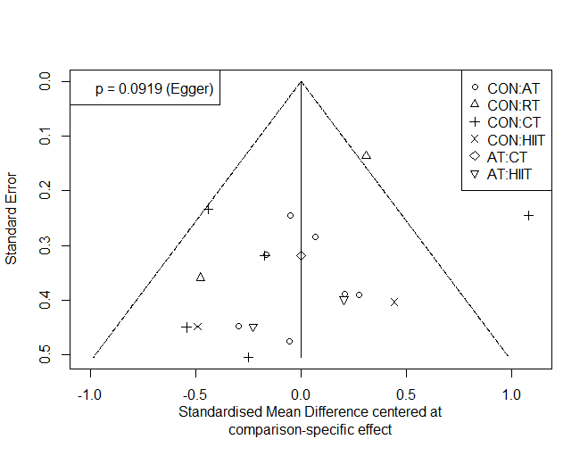Supplementary Figure 4. Network meta-analysis of funnel plots for TNF-α

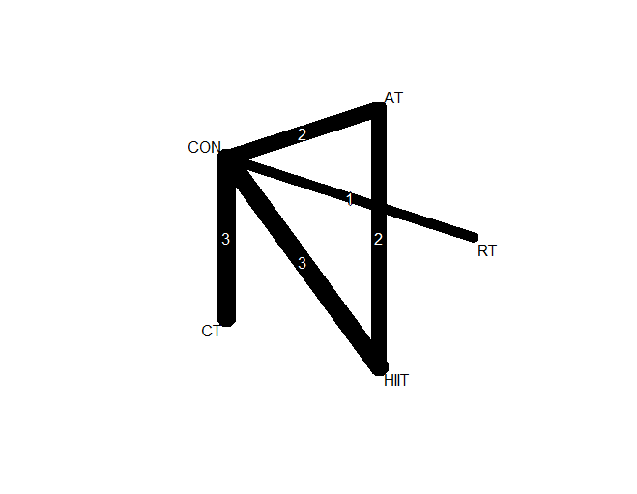Supplementary Figure 5. Network geometric map of studies investigating the effect of exercise training on IL-10
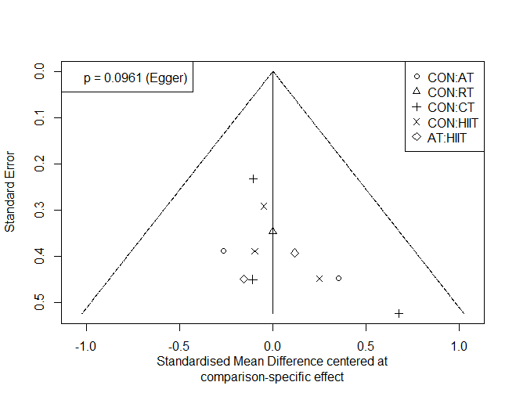 Supplementary Figure 6. Network meta-analysis of funnel plots for IL-10

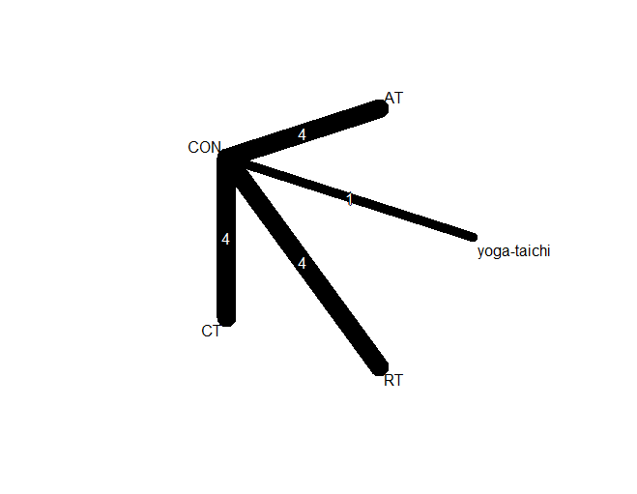Supplementary Figure 7. Network geometric map of studies investigating the effect of exercise training on CRP
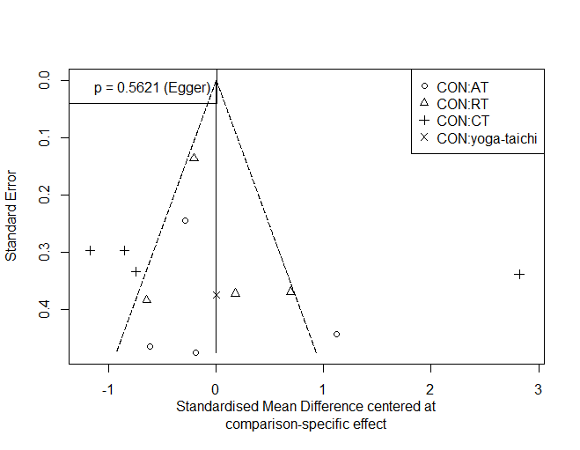 Supplementary Figure 8. Network meta-analysis of funnel plots for CRP

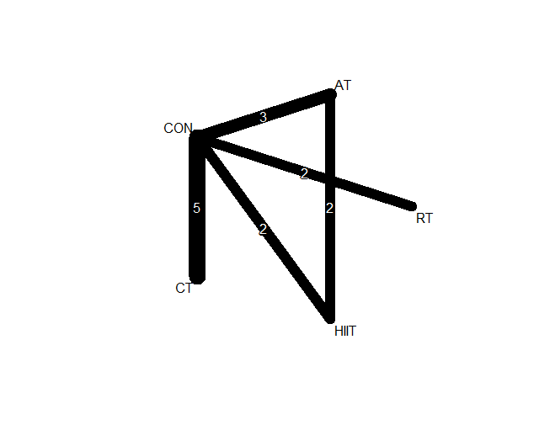Supplementary Figure 9. Network geometric map of studies investigating the effect of exercise training on leptin
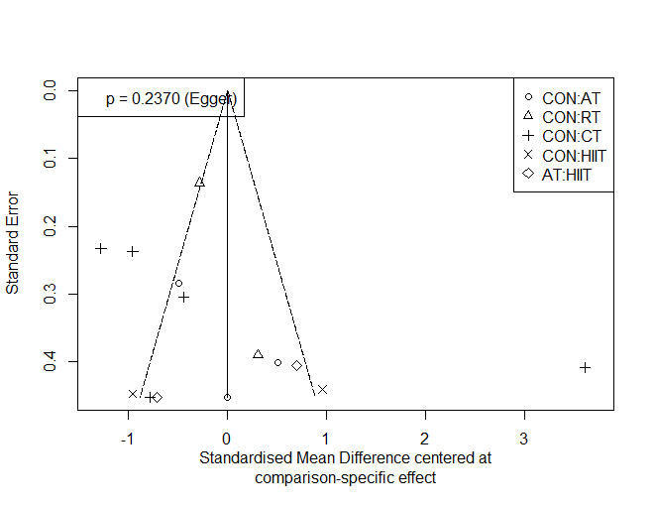 Supplementary Figure 10. Network meta-analysis of funnel plots for leptin

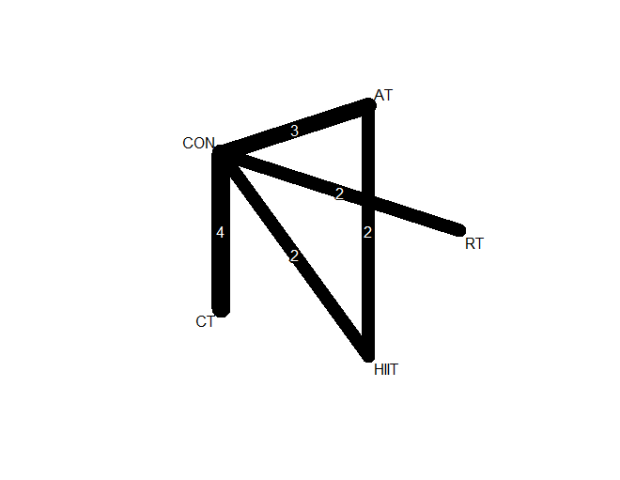Supplementary Figure 11. Network geometric map of studies investigating the effect of exercise training on adiponectin
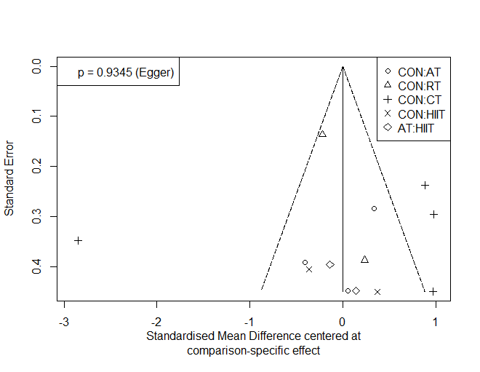 Supplementary Figure 12. Network meta-analysis of funnel plots for adiponectin

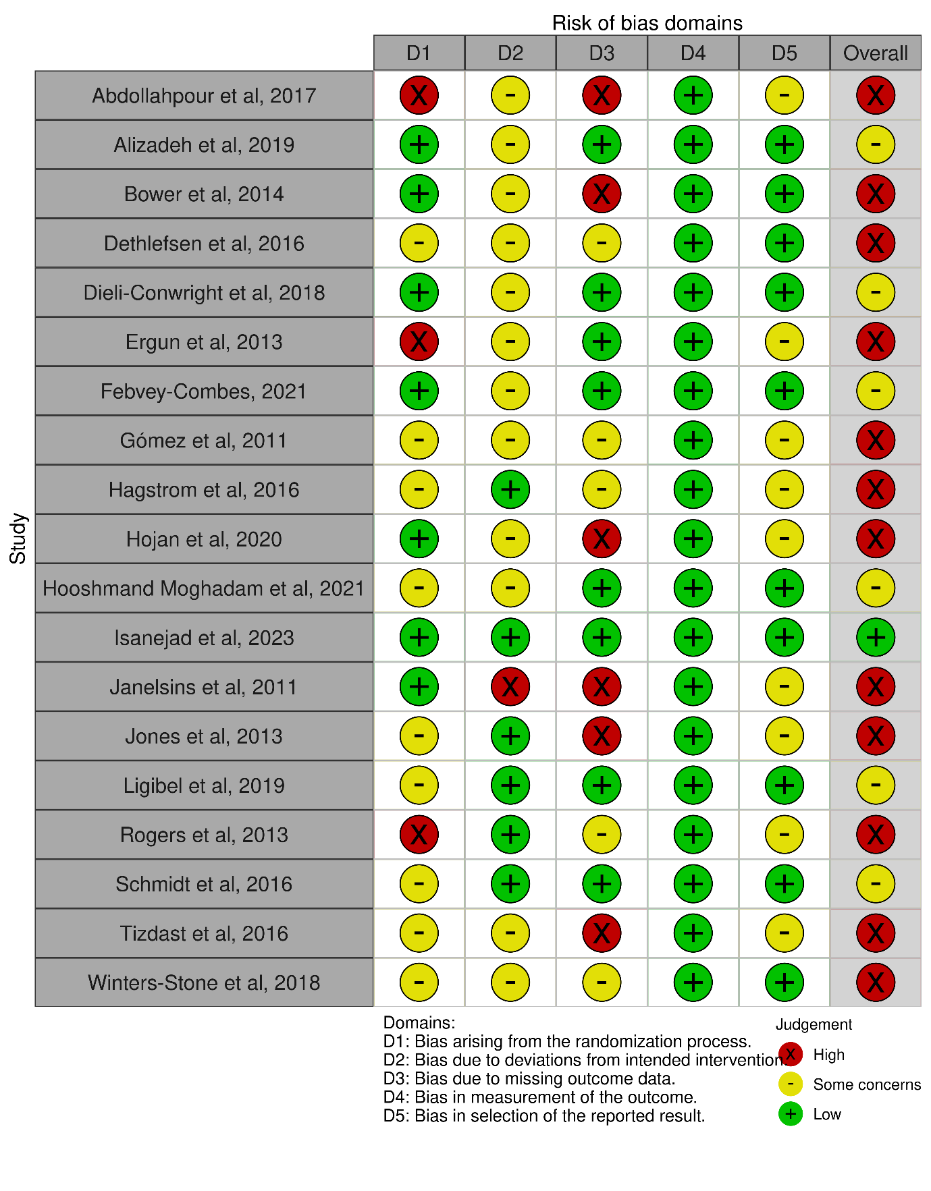 Supplementary Figures 13. The Cochrane Risk of Bias Tool (RoB 2) assessment for randomized trials reporting IL-6.

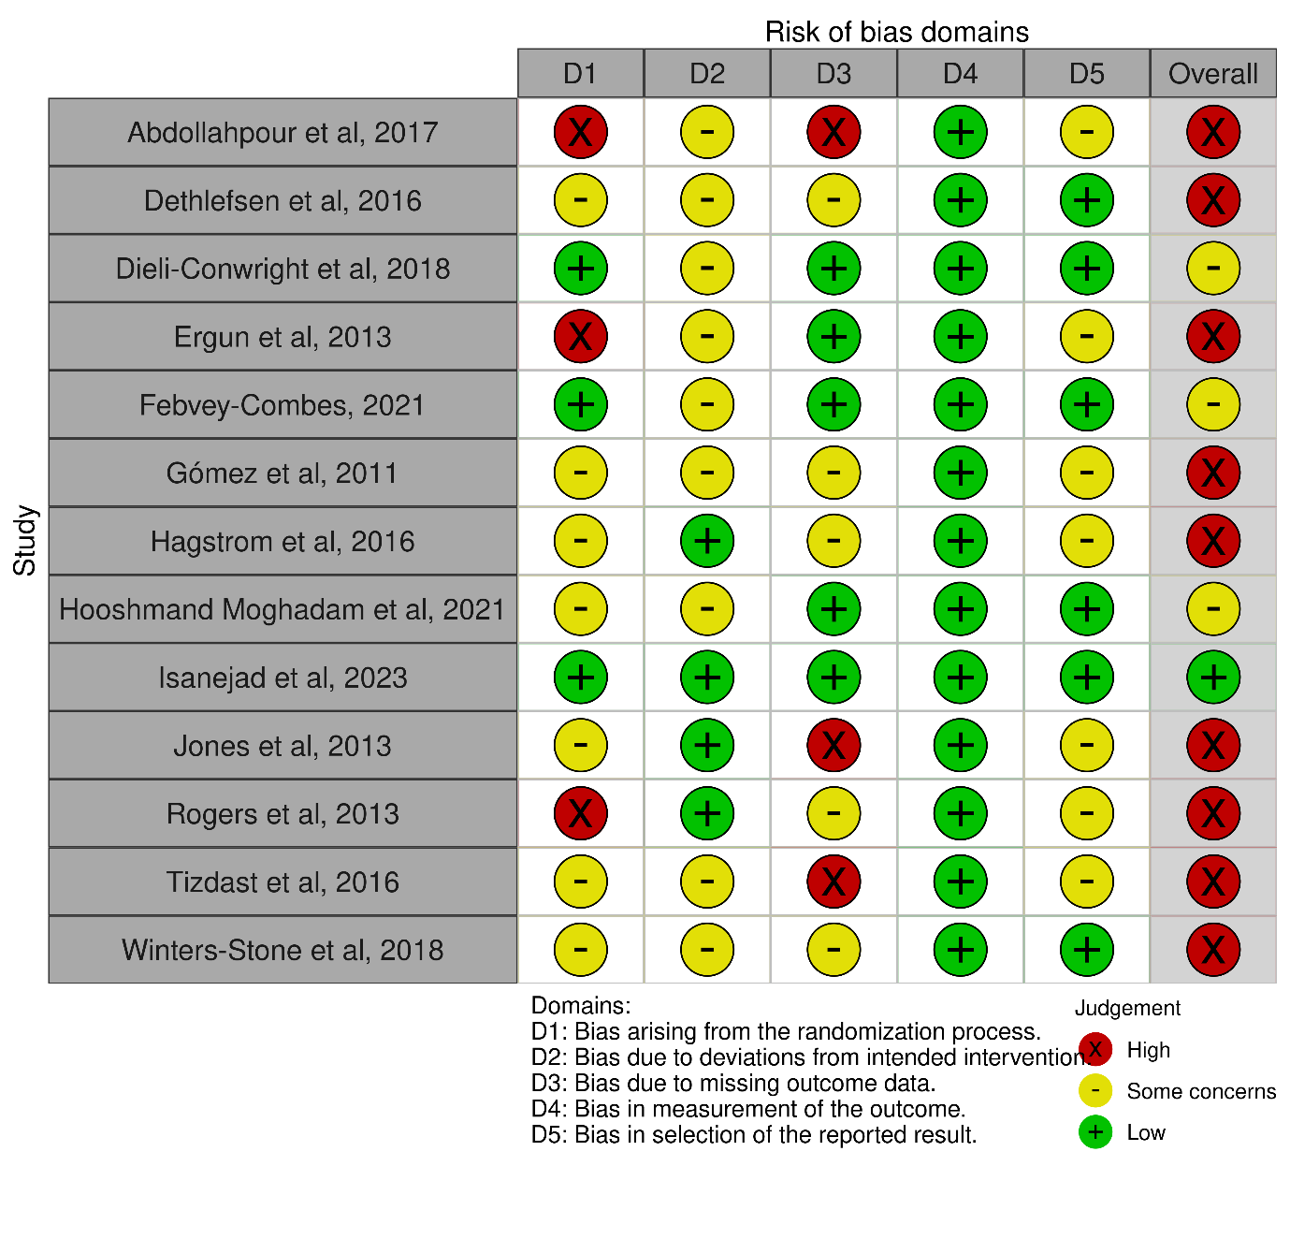Supplementary Figures 14. The Cochrane Risk of Bias Tool (RoB 2) assessment for randomized trials reporting TNF-α

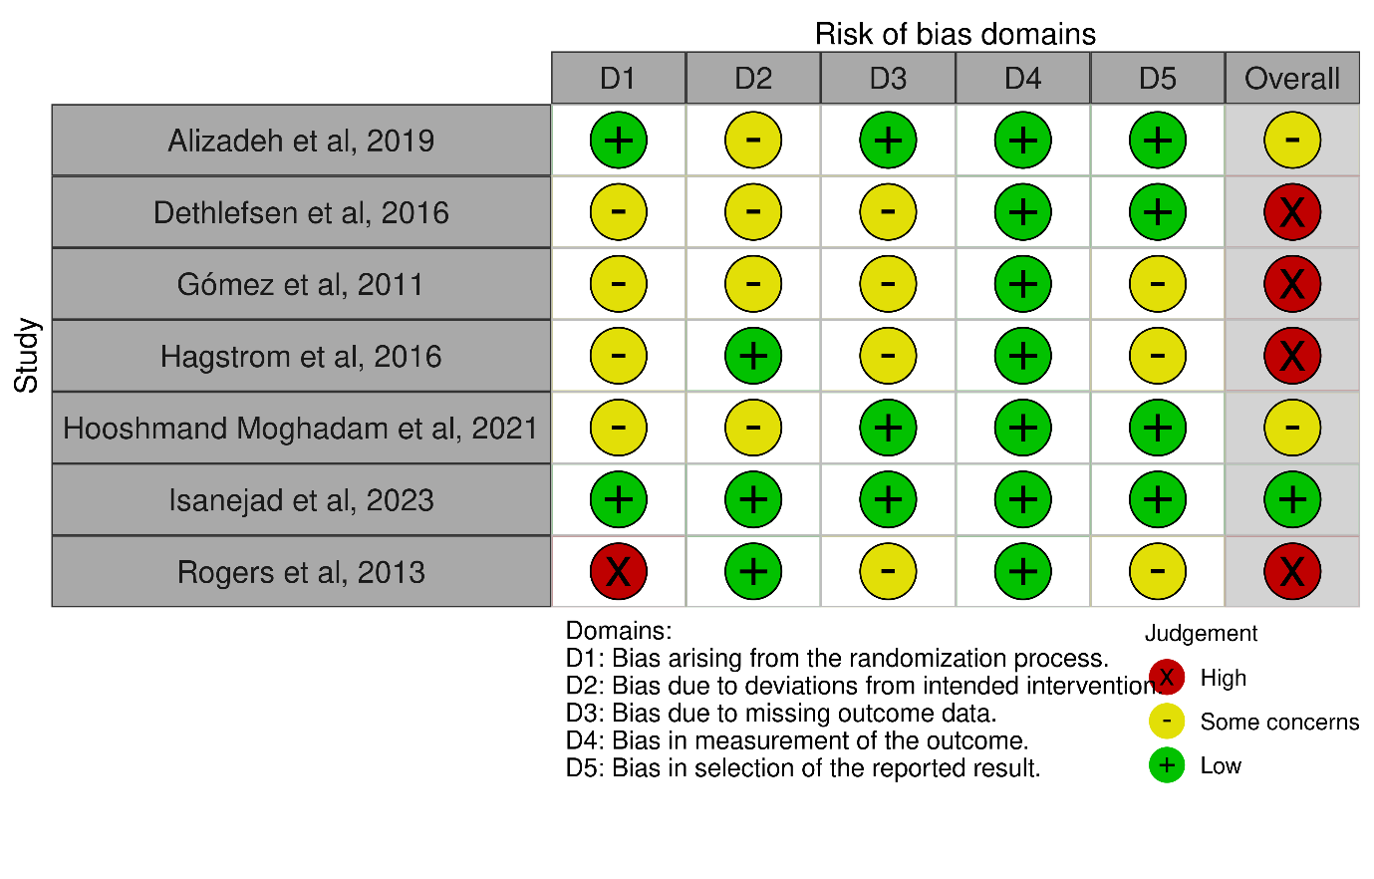Supplementary Figures 15. The Cochrane Risk of Bias Tool (RoB 2) assessment for randomized trials reporting IL-10

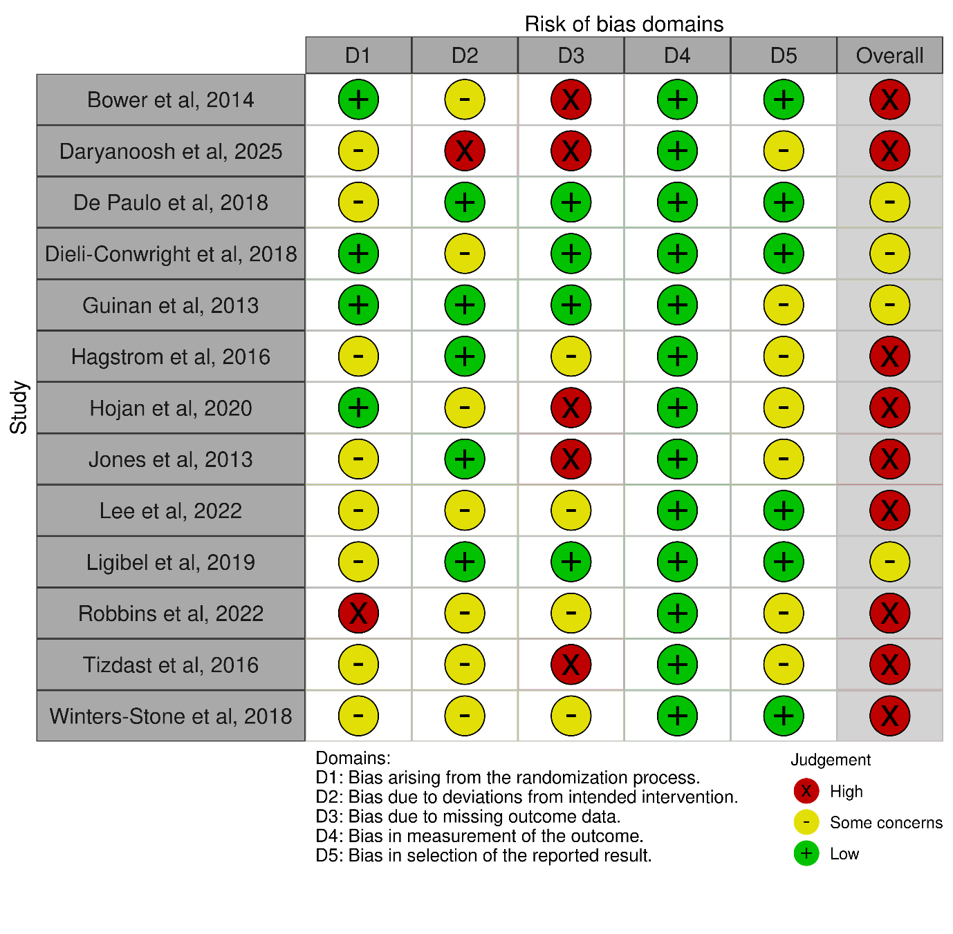Supplementary Figures 16. The Cochrane Risk of Bias Tool (RoB 2) assessment for randomized trials reporting CRP

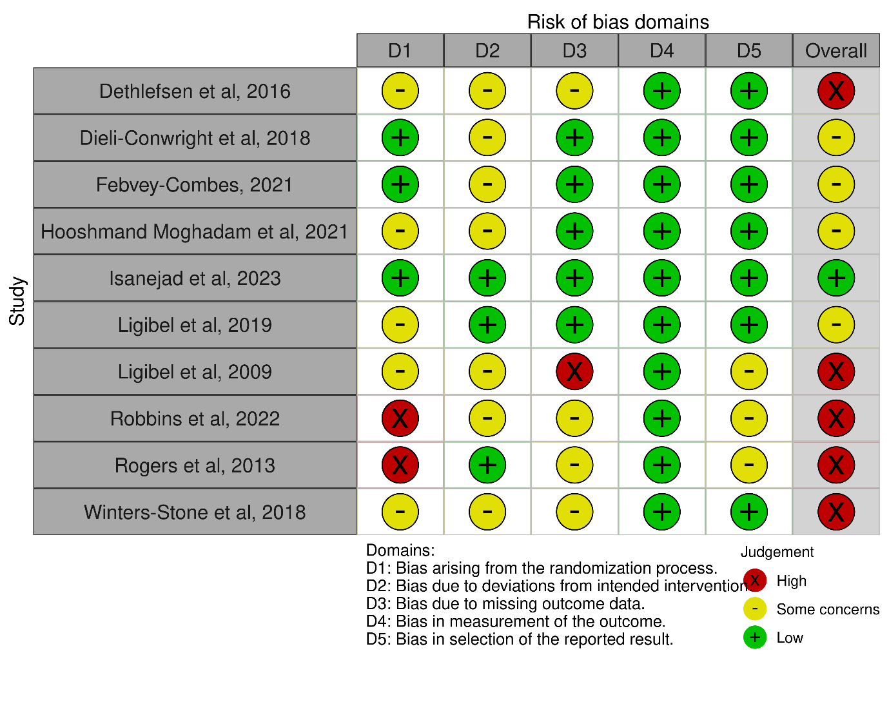Supplementary Figures 17. The Cochrane Risk of Bias Tool (RoB 2) assessment for randomized trials reporting leptin
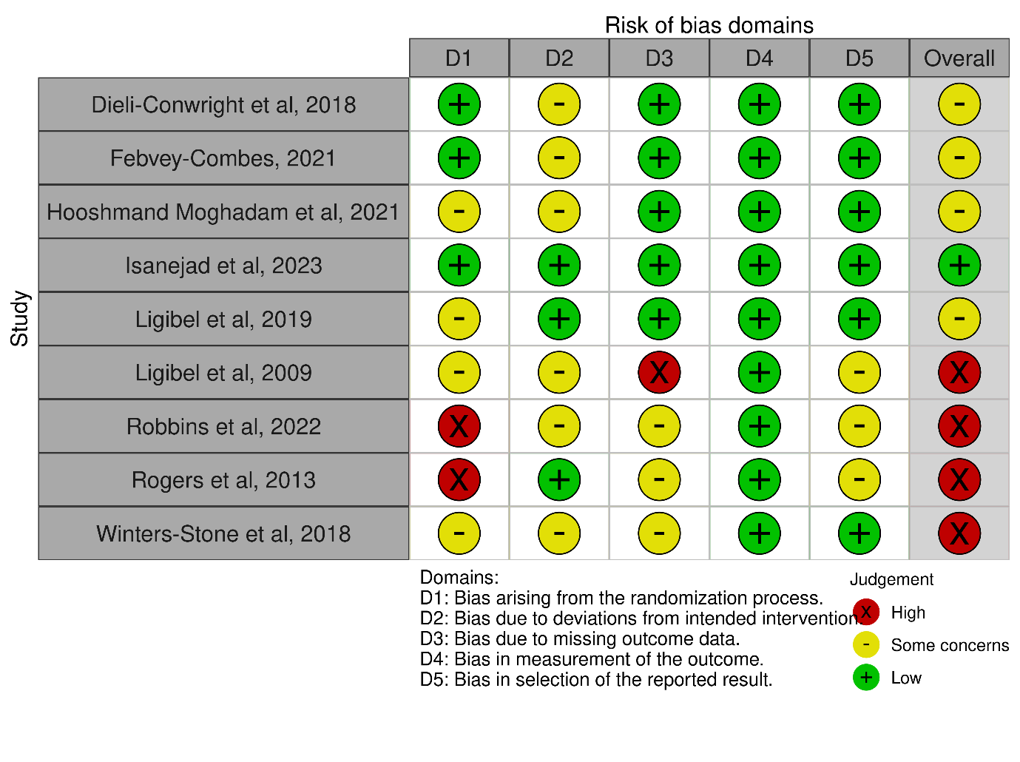Supplementary Figures 18. The Cochrane Risk of Bias Tool (RoB 2) assessment for randomized trials reporting adiponectin

