Supplementary figures

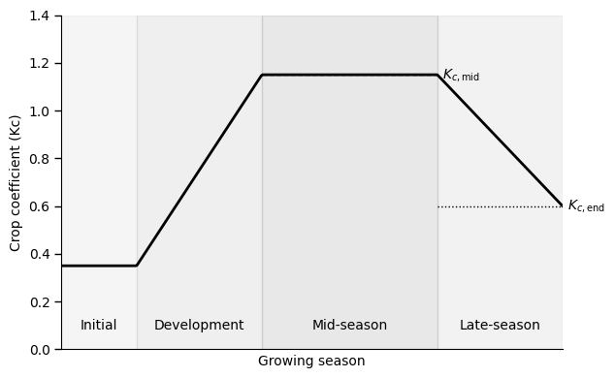
Figure S1 Schematic crop coefficient curve (Kc) over crop growth stages, based on FAO methodology (FAO, 1977)
The vertical axis represents the single crop coefficient (Kc) for a general crop, while the horizontal axis shows four main growing stages: initial, crop development, mid-season, and late-season. In our CLEWs model we considered the first three as crop growing season and the late-season as crop harvesting season.

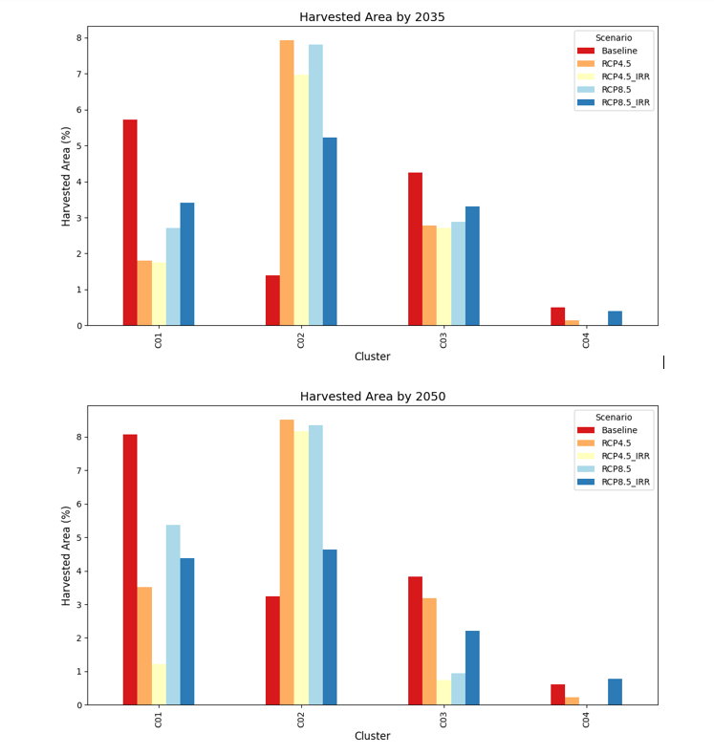
Figure S2 Harvested area across clusters and scenarios
The vertical axis represents the share of harvested area as ratio of total harvested area over total land of each cluster, while the horizontal axis represents the results for each cluster (C01, C02, C03, C04) and scenario for the years 2035 and 2050

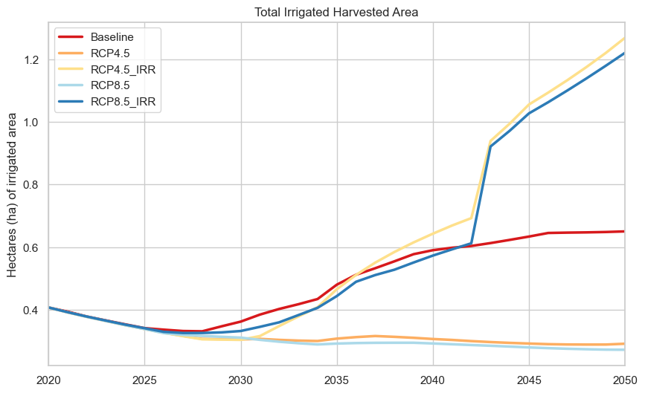

Figure S3 Total irrigated harvested area across all clusters.
The vertical axis represents the total irrigated harvested area (ha) for each modelled year shown on the horizontal axis. Under the climate change scenarios (RCP4.5 and RCP8.5), the irrigated area is generally lower than in the baseline scenario. Among the climate scenarios with irrigation expansion, RCP4.5_IRR reaches the highest irrigated area, exceeding RCP8.5_IRR.

