Supplementary Material

Supplementary Figure 1 Subset analysis gene expression liver

Supplementary Figure 2 Subgroup analysis gene expression liver

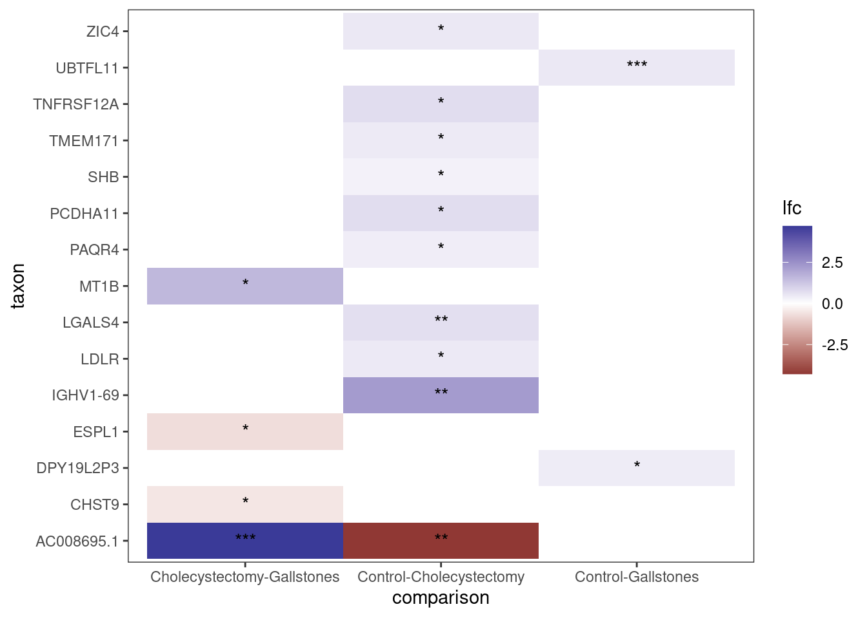

Supplementary Figure 3 Gene expression visceral adipose tissue

