Supplementary

Research strategy
PUBMED
(("Neoplasms"[MeSH] OR neoplasm* OR tumor* OR carcinoma*) AND ("Antidepressive Agents"[MeSH] OR "Antidepressive Agent"[Title/Abstract] OR "Antipsychotic Agents"[MeSH] OR "Antipsychotic Agent"[Title/Abstract] OR "Tranquilizing Agents"[MeSH])) AND humans[Filter] AND English [Filter]

EMBASE
(('neoplasm'/exp OR 'neoplasm' OR neoplasm:ti,ab,kw OR 'neoplasm'/de) AND 'antidepressant agent':ti,ab,kw OR 'antidepressant agent'/de OR 'neuroleptic agent':ti,ab,kw OR 'neuroleptic agent'/de OR 'tranquilizer':ti,ab,kw) AND 'tranquilizer'/de AND english:la AND 'human'/de NOT editorial:it NOT 'conference abstract':it NOT letter:it

SCOPUS
TITLE-ABS-KEY ( cancer* OR neoplasm* OR malignant* OR tumour* OR tumor* OR carcinoma* OR adenocarcinoma* ) AND TITLE-ABS-KEY ( antidepressant AND agent OR neuroleptic AND agent OR antipsychotic AND agent OR tranquilizing AND agent ) AND ( LIMIT-TO ( EXACTKEYWORD , "Human" ) ) AND ( LIMIT-TO ( LANGUAGE , "English" ) ) AND ( LIMIT-TO ( DOCTYPE , "ar" ) OR LIMIT-TO ( DOCTYPE , "re" ) )

Supplementary Table 1. Quality assessment for studies using the Newcastle–Ottawa Quality Assessment Scale: cohort studies and case-control studies
 | Selection |  |  |  | Comparability | Outcome
Author | Representativeness | Selection | Selection of controls | Definition of controls | Variables(s) | Ascertainment of exposure | Same method of ascertainment for cases and controls | Non-response rate | Overall
Ashbury et al. | * | * | * |  | ** | * |  |  | 6
Azoulay et al. | * | * | * |  | * |  | * |  | 5
Boursi et al. | * | * | * | * | * |  |  | * | 6
Brown et al. | * | * |  | * | ** | * | * |  | 7
Chien et al. | * | * | * | * | * | * |  |  | 6
Chubak et al. | * | * | * |  | * |  | * |  | 5
Coogan et al. 2005 | * | * |  | * | ** | * |  |  | 6
Coogan et al. 2008 | * | * |  | * | ** |  | * |  | 6
Cotterchio et al. | * | * | * |  | ** | * |  |  | 6
Fulton-Kehoe et al. | * | * | * |  | ** | * |  |  | 6
González-Pérez et al. | * | * | * | * | ** | * |  |  | 7
Haque et al. | * | * | * | * | * | * | * |  | 7
Haukka et al. | * | * | * | * | * | * |  |  | 6
Kato et al. | * | * |  | * | ** | * | * |  | 7
Kelly et al. | * | * |  | * | ** | * |  |  | 6
Lash et al. | * | * | * |  | * | * | * |  | 6
Mansi et al. | * | * | * |  | * | * | * |  | 6
Moorman et al. | * | * | * |  | * | * |  |  | 5
Sharpe et al. | * | * | * |  | * | * | * |  | 6
Steingart et al. | * | * | * | * | ** | * |  |  | 7
Tamim et al. | * | * | * | * | * | * |  |  | 6
Wang et al. | * | * | * | * | ** | * |  |  | 7
Weiss et al. | * | * | * |  | * | * | * |  | 6
Wernli et al. | * | * | * |  | ** |  | * |  | 6

NOTE: For each study, a maximum of one star for each numbered item within the Selection and Exposure categories was awarded. A maximum of two stars was given for Comparability. The total number of stars earned (maximum score of 9) was a measure of study quality.
The Newcastle–Ottawa Scale (NOS) was used to assess the quality of the included studies. For case–control studies, stars are awarded within the Selection domain when the case definition is adequately validated, cases are representative, community controls are used, and controls have no history of the outcome. In the Comparability domain, one star is given if analyses are adjusted for breast cancer and an additional star if further confounders are controlled. In the Exposure domain, stars are assigned for secure ascertainment of exposure (e.g., medical or surgical records), blinded interviews, consistent methods of exposure assessment between cases and controls, and similar response rates. For cohort studies, the Selection domain awards stars when the exposed cohort is representative of the average population, the nonexposed cohort is drawn from the same community, exposure is ascertained from secure records or structured interviews, and the outcome is absent at baseline. In the Comparability domain, one star is given if analyses adjust for breast cancer and an additional star if further confounders are included. In the Outcome domain, stars are awarded for independent or record-based outcome assessment, sufficient length of follow-up, and adequate follow-up of the cohort. Higher numbers of stars indicate better methodological quality.

ANY AD EVER
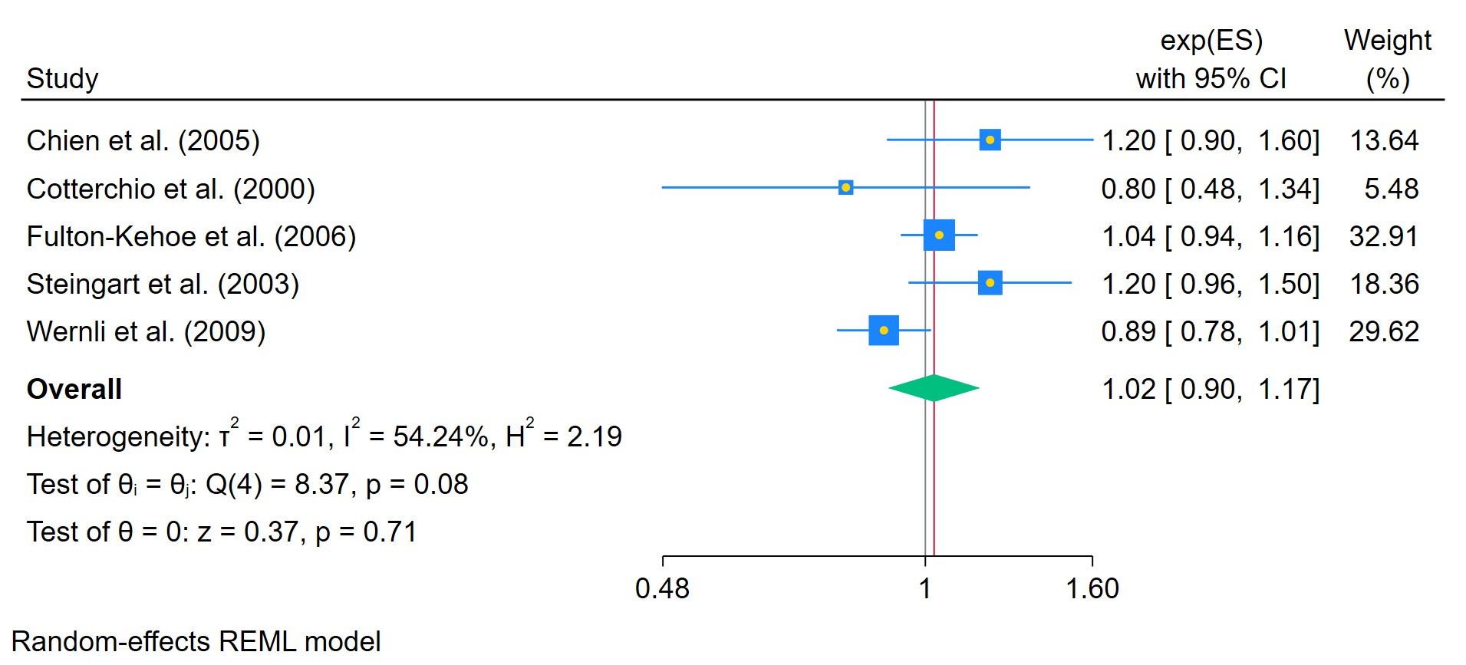
Figure 1. Any ADs use
The area of each square is proportional to the sample size of the respective study, with horizontal lines through the squares representing the 95% confidence interval (C.I.) for that study. In the pooled analysis, the diamond symbol represents the pooled estimate, with the right and left points of the diamond indicating the 95% C.I. for the overall analysis
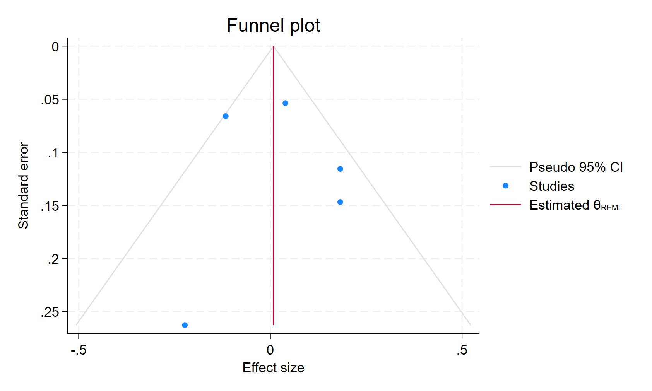
Figure 2. Funnel plot - Any ADs use
Each blue dot represents a single study, plotted with its effect size on the x-axis and its standard error on the y-axis. The vertical red line represents the overall effect estimate derived from the random-effects model using restricted maximum likelihood (REML). The pseudo 95% confidence interval region, shown as gray diagonal lines, outlines the expected spread of studies in the absence of bias or between-study heterogeneity.

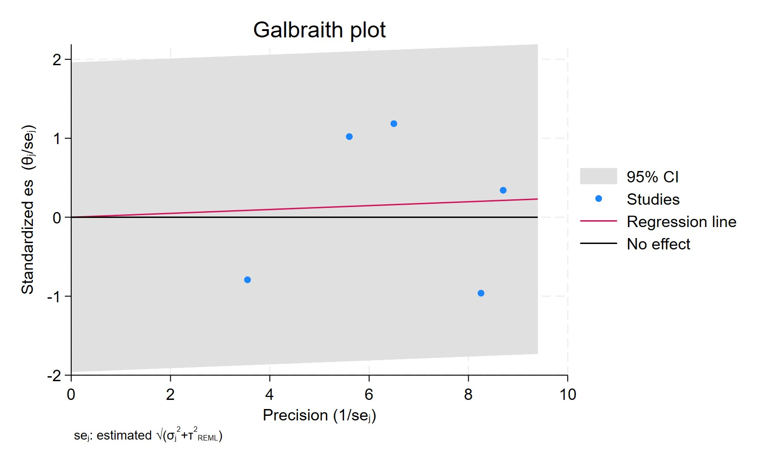
Figure 3. Galbraith plot - Any ADs use
Each study is represented as a point, where the x-axis denotes the precision (defined as the inverse of the standard error), and the y-axis indicates the standardized effect size. The red regression line represents the overall summary effect estimated from the random-effects model, and the gray shaded area corresponds to the confidence interval at 95% around regression line. The horizontal black ––line at y = 0 corresponds to the line of no effect, serving as a reference.
CURRENT AD USERS
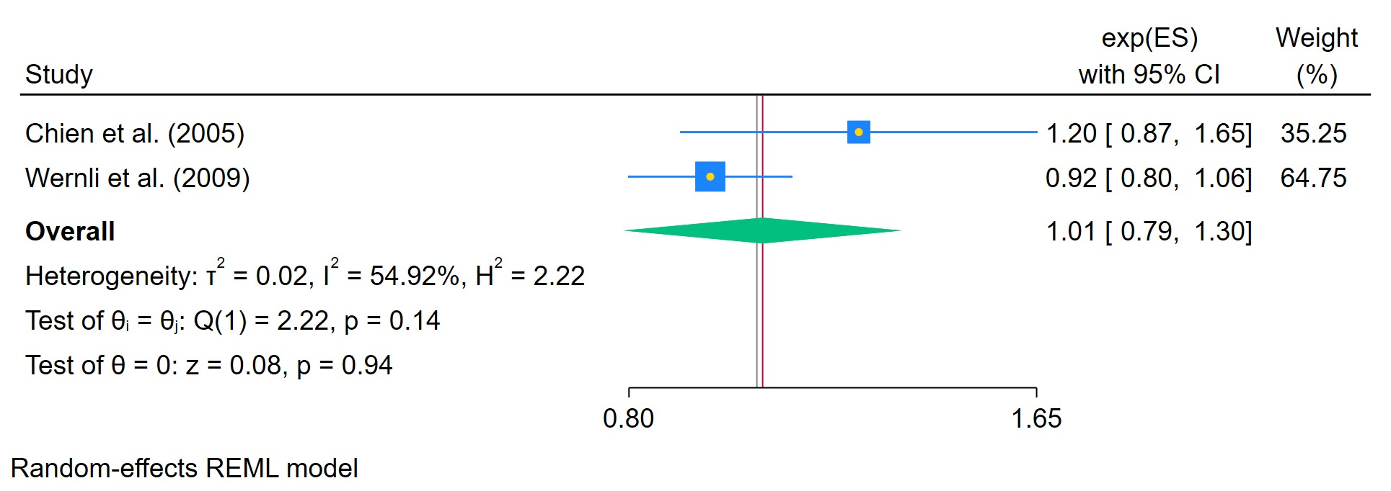
Figure 4. ADs use in current patients
The area of each square is proportional to the sample size of the respective study, with horizontal lines through the squares representing the 95% confidence interval (C.I.) for that study. In the pooled analysis, the diamond symbol represents the pooled estimate, with the right and left points of the diamond indicating the 95% C.I. for the overall analysis

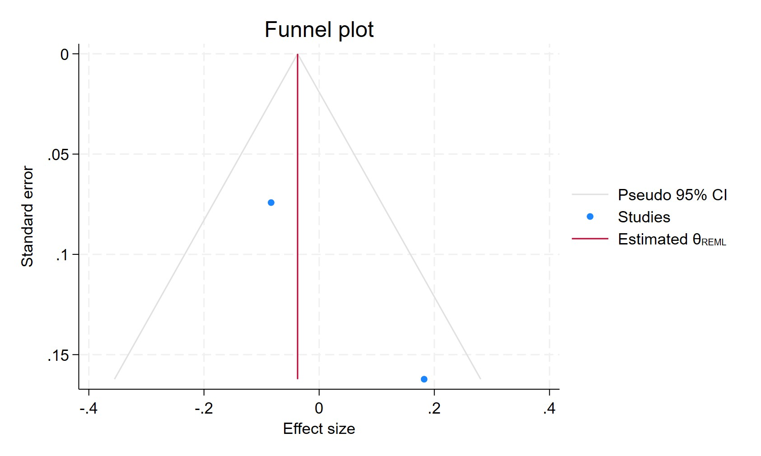
Figure 5. Funnel plot - ADs use in current patients
Each blue dot represents a single study, plotted with its effect size on the x-axis and its standard error on the y-axis. The vertical red line represents the overall effect estimate derived from the random-effects model using restricted maximum likelihood (REML). The pseudo 95% confidence interval region, shown as gray diagonal lines, outlines the expected spread of studies in the absence of bias or between-study heterogeneity.

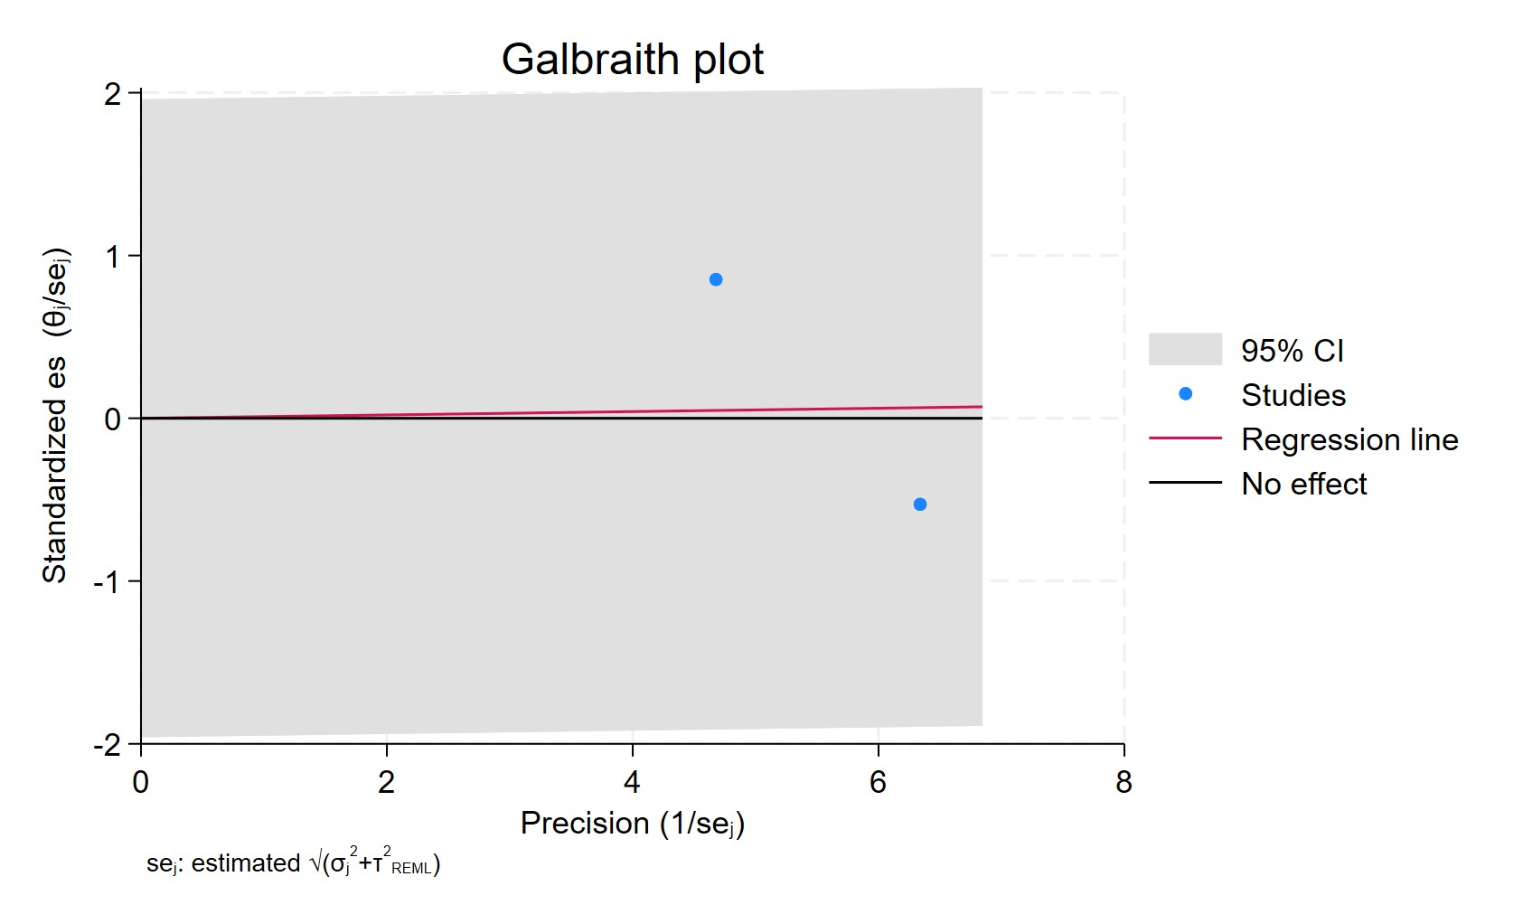
Figure 6. Galbraith plot - ADs use in current patients
Each study is represented as a point, where the x-axis denotes the precision (defined as the inverse of the standard error), and the y-axis indicates the standardised effect size. The red regression line represents the overall summary effect estimated from the random-effects model, and the gray shaded area corresponds to the confidence interval at 95% around regression line. The horizontal black line at y = 0 corresponds to the line of no effect, serving as a reference.

FORMERS AD USERS
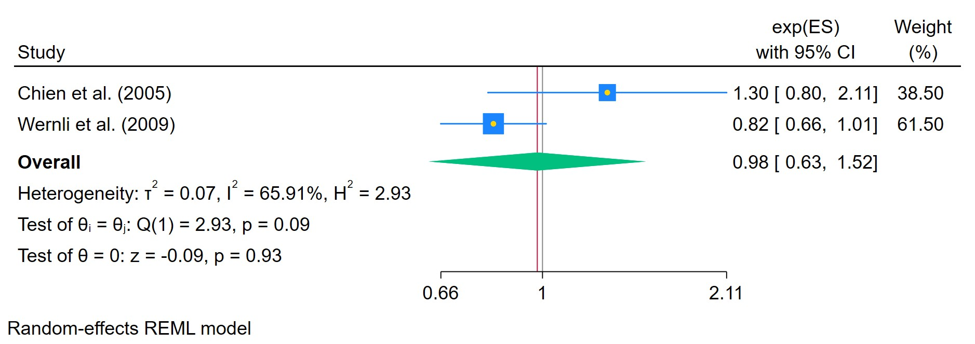
Figure 7. Former ADs users
The area of each square is proportional to the sample size of the respective study, with horizontal lines through the squares representing the 95% confidence interval (C.I.) for that study. In the pooled analysis, the diamond symbol represents the pooled estimate, with the right and left points of the diamond indicating the 95% C.I. for the overall analysis

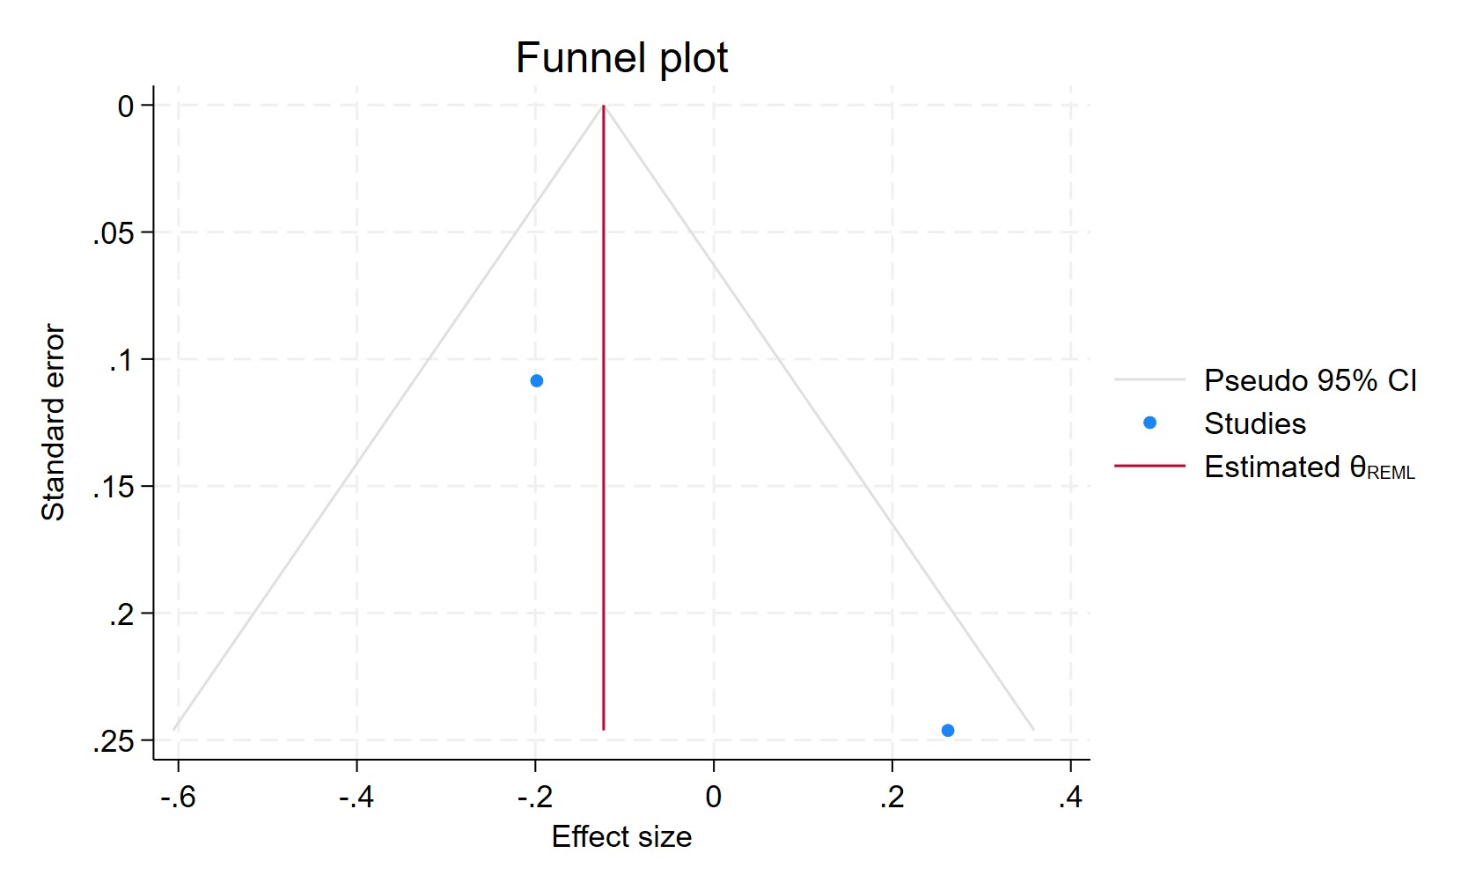
Figure 8. Funnel plot - Former ADs users
Each blue dot represents a single study, plotted with its effect size on the x-axis and its standard error on the y-axis. The vertical red line represents the overall effect estimate derived from the random-effects model using restricted maximum likelihood (REML). The pseudo 95% confidence interval region, shown as gray diagonal lines, outlines the expected spread of studies in the absence of bias or between-study heterogeneity.

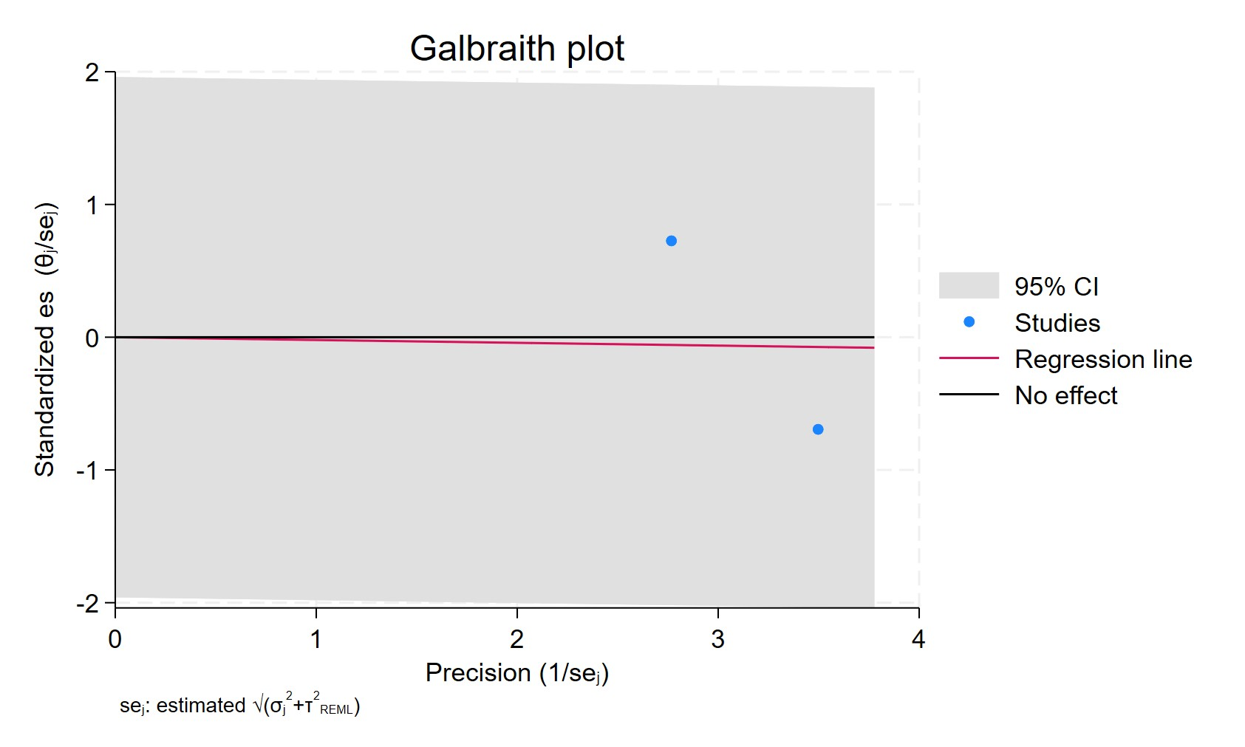
Figure 9. Galbraith plot - Former ADs users
Each study is represented as a point, where the x-axis denotes the precision (defined as the inverse of the standard error), and the y-axis indicates the standardized effect size. The red regression line represents the overall summary effect estimated from the random-effects model, and the gray shaded area corresponds to the confidence interval at 95% around regression line. The horizontal black line at y = 0 corresponds to the line of no effect, serving as a reference.

AD USE LESS 2 YEAR
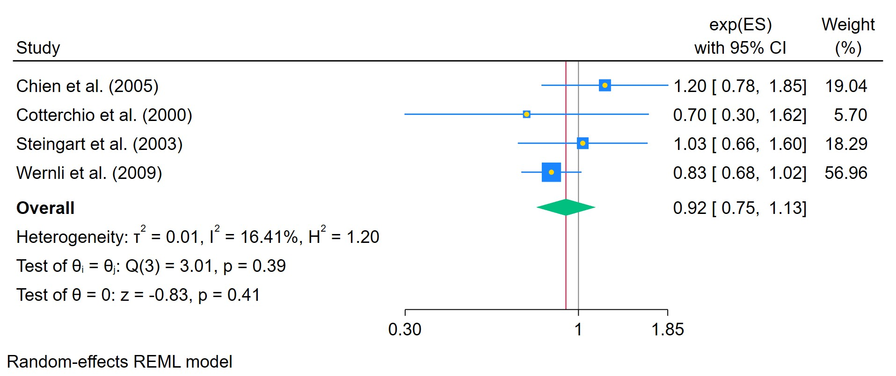
Figure 10. Former ADs users
The area of each square is proportional to the sample size of the respective study, with horizontal lines through the squares representing the 95% confidence interval (C.I.) for that study. In the pooled analysis, the diamond symbol represents the pooled estimate, with the right and left points of the diamond indicating the 95% C.I. for the overall analysis

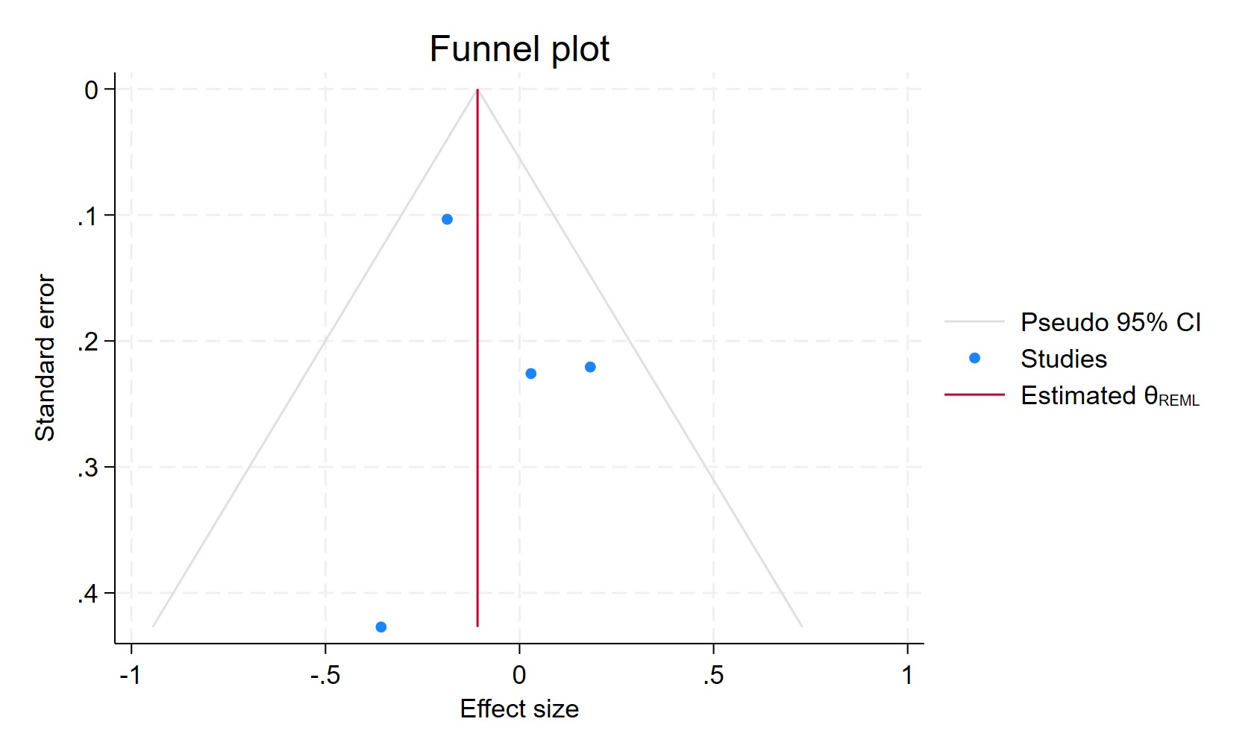
Figure 11. Funnel plot - Former ADs users
Each blue dot represents a single study, plotted with its effect size on the x-axis and its standard error on the y-axis. The vertical red line represents the overall effect estimate derived from the random-effects model using restricted maximum likelihood (REML). The pseudo 95% confidence interval region, shown as gray diagonal lines, outlines the expected spread of studies in the absence of bias or between-study heterogeneity.

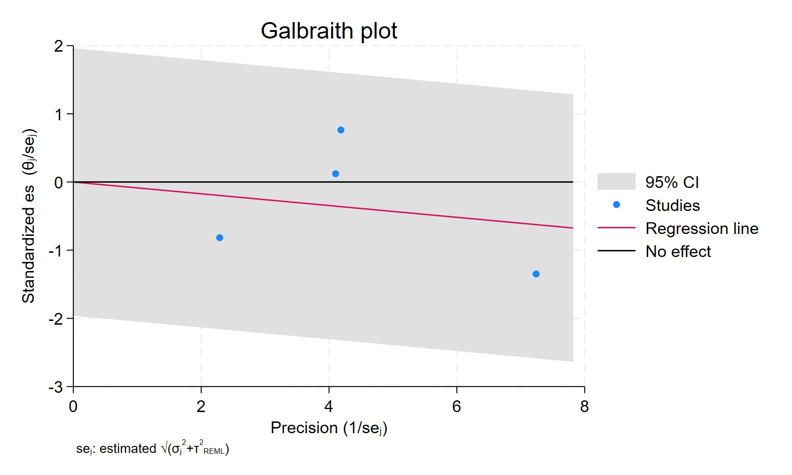
Figure 12. Galbraith plot - Former ADs users
Each study is represented as a point, where the x-axis denotes the precision (defined as the inverse of the standard error), and the y-axis indicates the standardized effect size. The red regression line represents the overall summary effect estimated from the random-effects model, and the gray shaded area corresponds to the confidence interval at 95% around regression line. The horizontal black line at y = 0 corresponds to the line of no effect, serving as a reference.

AD USE MORE THAN 2 YEARS
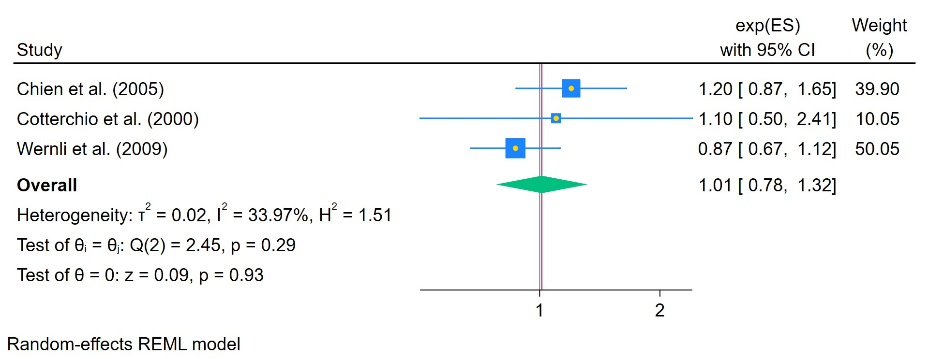
Figure 13. ADs use for more than 2 years
The area of each square is proportional to the sample size of the respective study, with horizontal lines through the squares representing the 95% confidence interval (C.I.) for that study. In the pooled analysis, the diamond symbol represents the pooled estimate, with the right and left points of the diamond indicating the 95% C.I. for the overall analysis

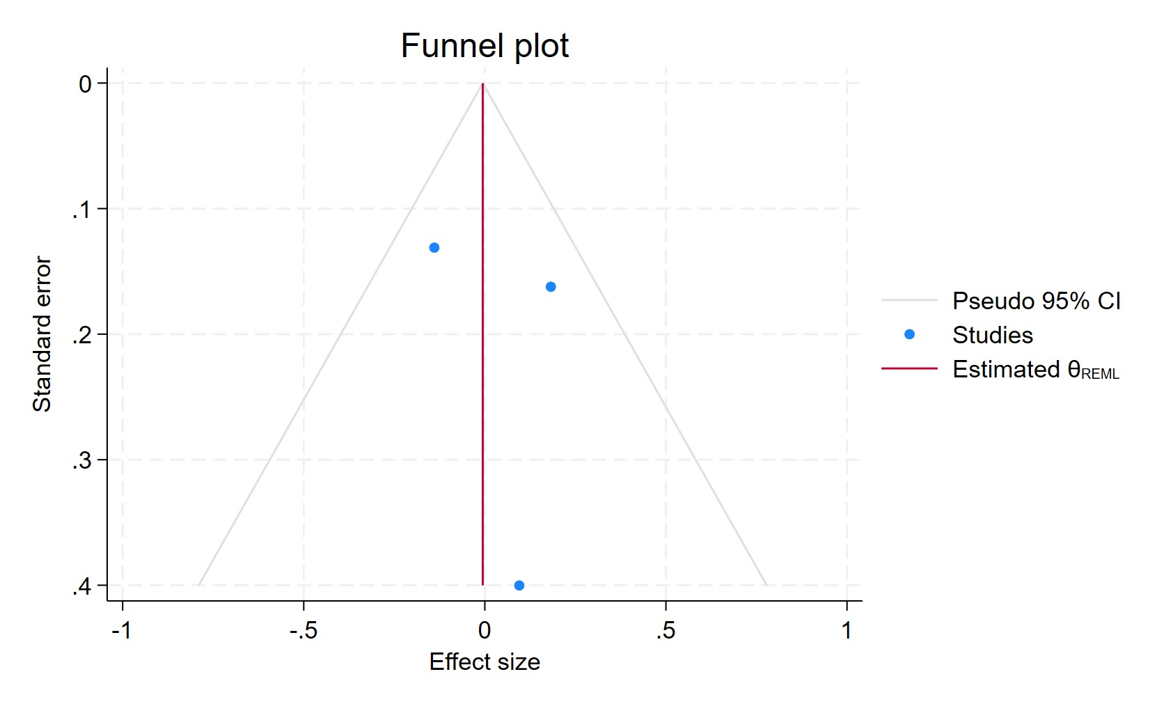
Figure 14. Funnel plot - ADs use for more than 2 years
Each blue dot represents a single study, plotted with its effect size on the x-axis and its standard error on the y-axis. The vertical red line represents the overall effect estimate derived from the random-effects model using restricted maximum likelihood (REML). The pseudo 95% confidence interval region, shown as gray diagonal lines, outlines the expected spread of studies in the absence of bias or between-study heterogeneity.

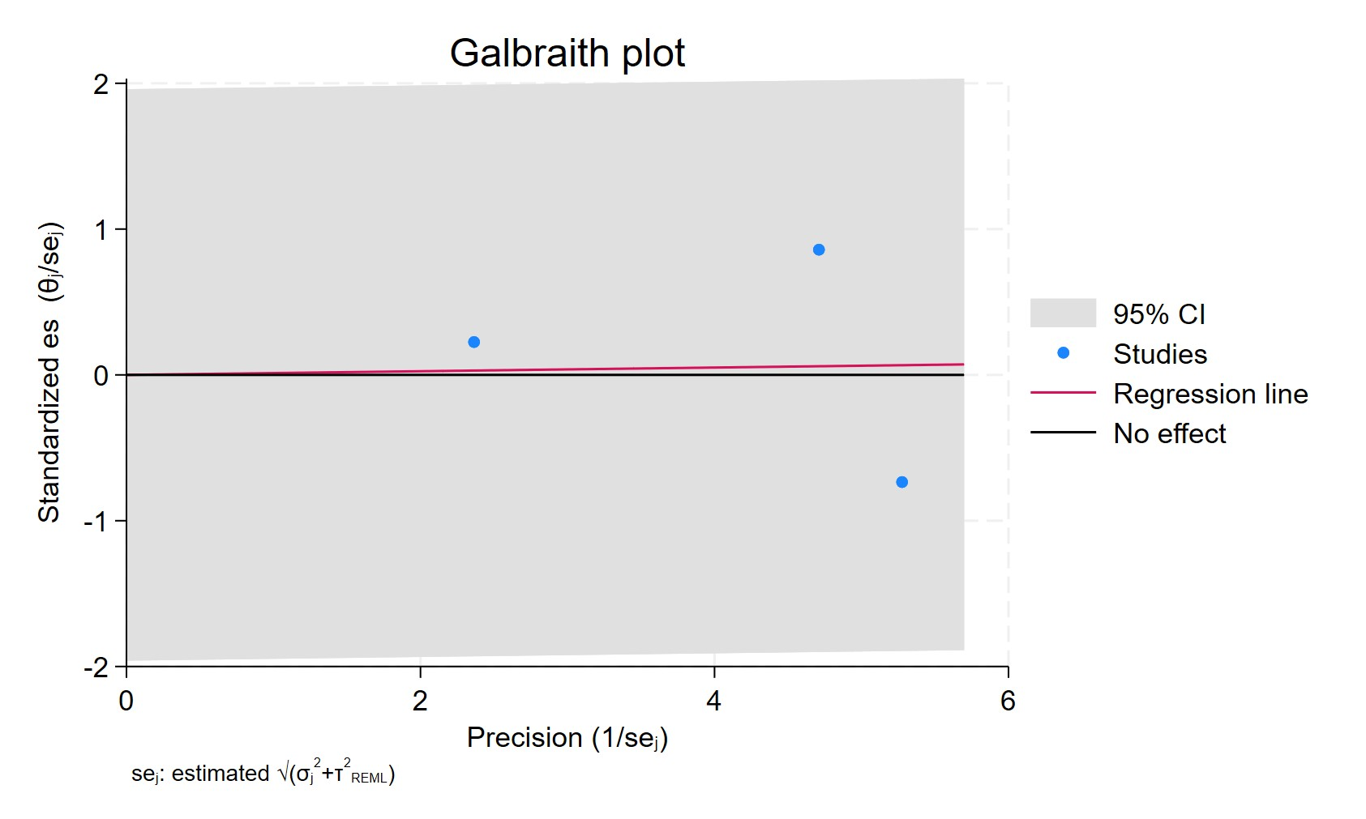
Figure 15. Galbraith plot - ADs use for more than 2 years
Each study is represented as a point, where the x-axis denotes the precision (defined as the inverse of the standard error), and the y-axis indicates the standardized effect size. The red regression line represents the overall summary effect estimated from the random-effects model, and the gray shaded area corresponds to the confidence interval at 95% around regression line. The horizontal black line at y = 0 corresponds to the line of no effect, serving as a reference.

AD ER POSITIVE
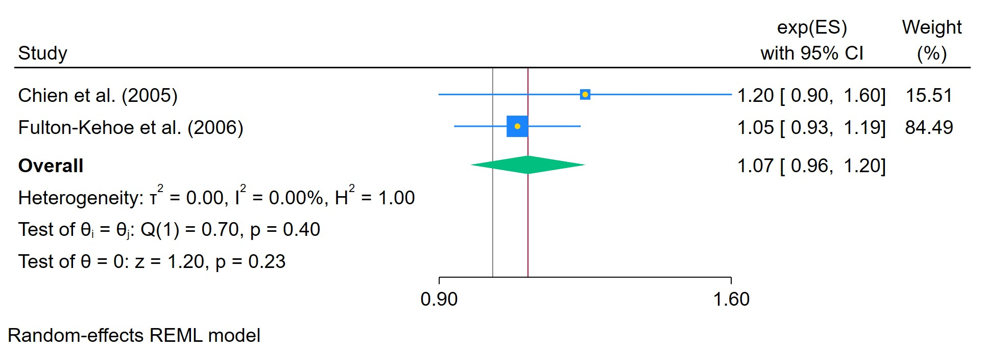
Figure 16. ADs use in ER positive breast cancer
The area of each square is proportional to the sample size of the respective study, with horizontal lines through the squares representing the 95% confidence interval (C.I.) for that study. In the pooled analysis, the diamond symbol represents the pooled estimate, with the right and left points of the diamond indicating the 95% C.I. for the overall analysis

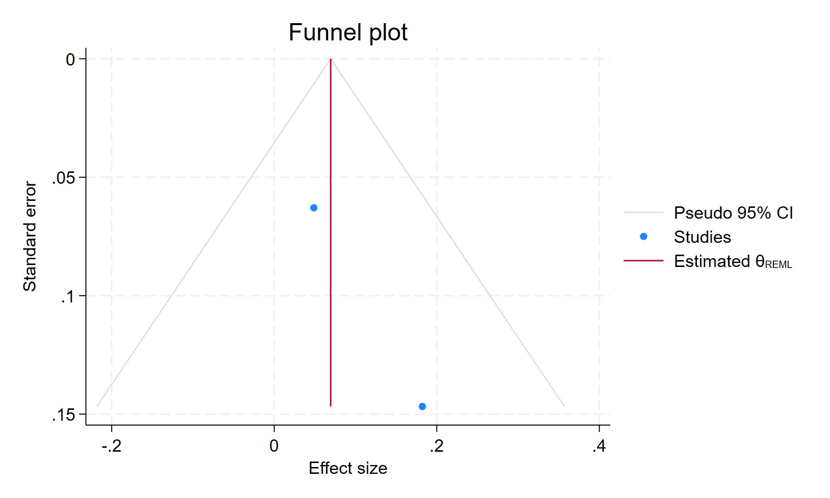
Figure 17. Funnel plot - ADs use in ER positive breast cancer
Each blue dot represents a single study, plotted with its effect size on the x-axis and its standard error on the y-axis. The vertical red line represents the overall effect estimate derived from the random-effects model using restricted maximum likelihood (REML). The pseudo 95% confidence interval region, shown as gray diagonal lines, outlines the expected spread of studies in the absence of bias or between-study heterogeneity.

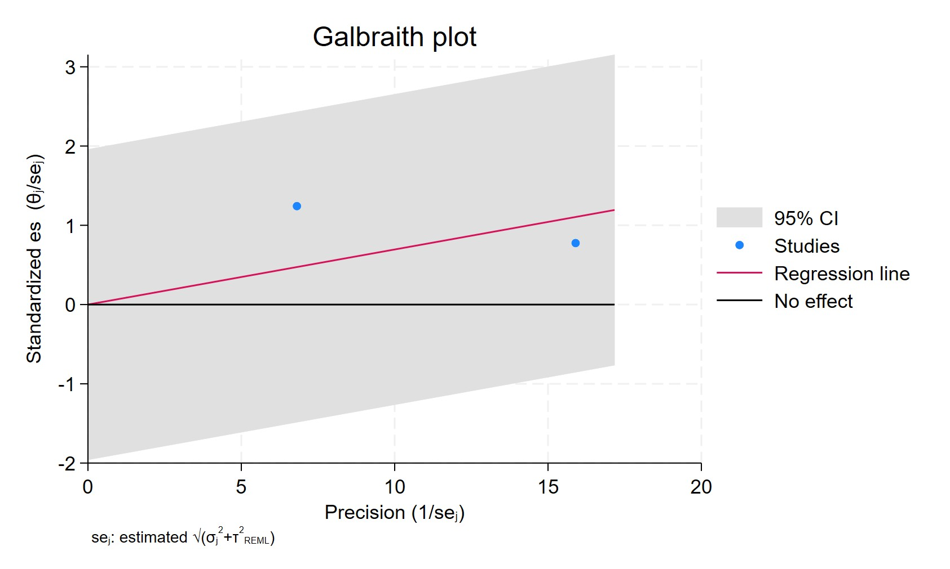
Figure 18. Galbraith plot - ADs use in ER positive breast cancer
Each study is represented as a point, where the x-axis denotes the precision (defined as the inverse of the standard error), and the y-axis indicates the standardized effect size. The red regression line represents the overall summary effect estimated from the random-effects model, and the gray shaded area corresponds to the confidence interval at 95% around regression line. The horizontal black line at y = 0 corresponds to the line of no effect, serving as a reference.

ANY AD ER NEGATIVE
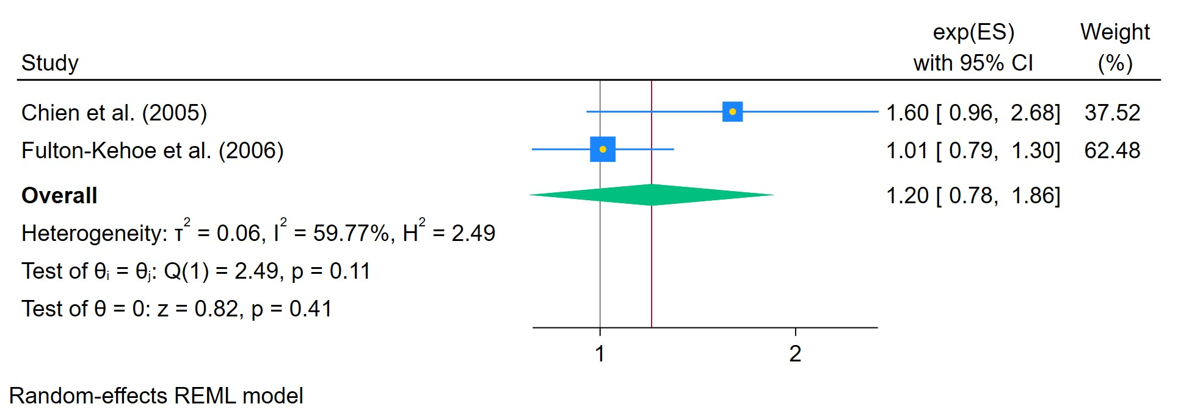
Figure 19. ADs use in ER negative breast cancer
The area of each square is proportional to the sample size of the respective study, with horizontal lines through the squares representing the 95% confidence interval (C.I.) for that study. In the pooled analysis, the diamond symbol represents the pooled estimate, with the right and left points of the diamond indicating the 95% C.I. for the overall analysis

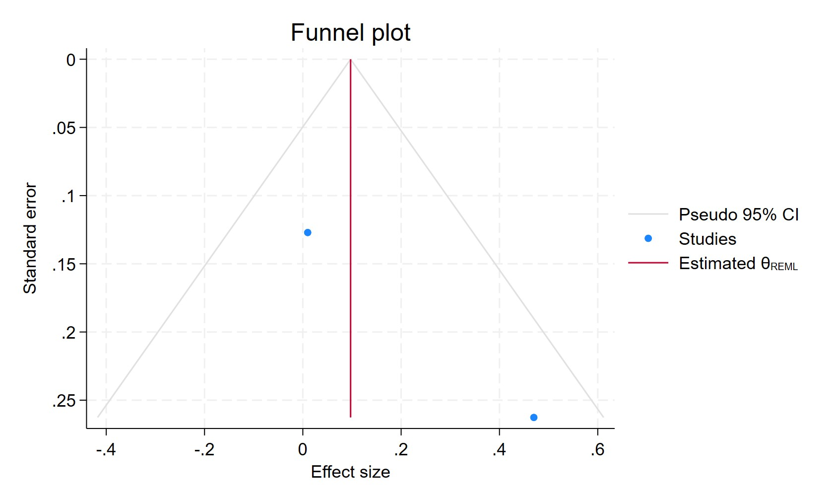
Figure 20. Funnel plot - ADs use in ER negative breast cancer
Each blue dot represents a single study, plotted with its effect size on the x-axis and its standard error on the y-axis. The vertical red line represents the overall effect estimate derived from the random-effects model using restricted maximum likelihood (REML). The pseudo 95% confidence interval region, shown as gray diagonal lines, outlines the expected spread of studies in the absence of bias or between-study heterogeneity.

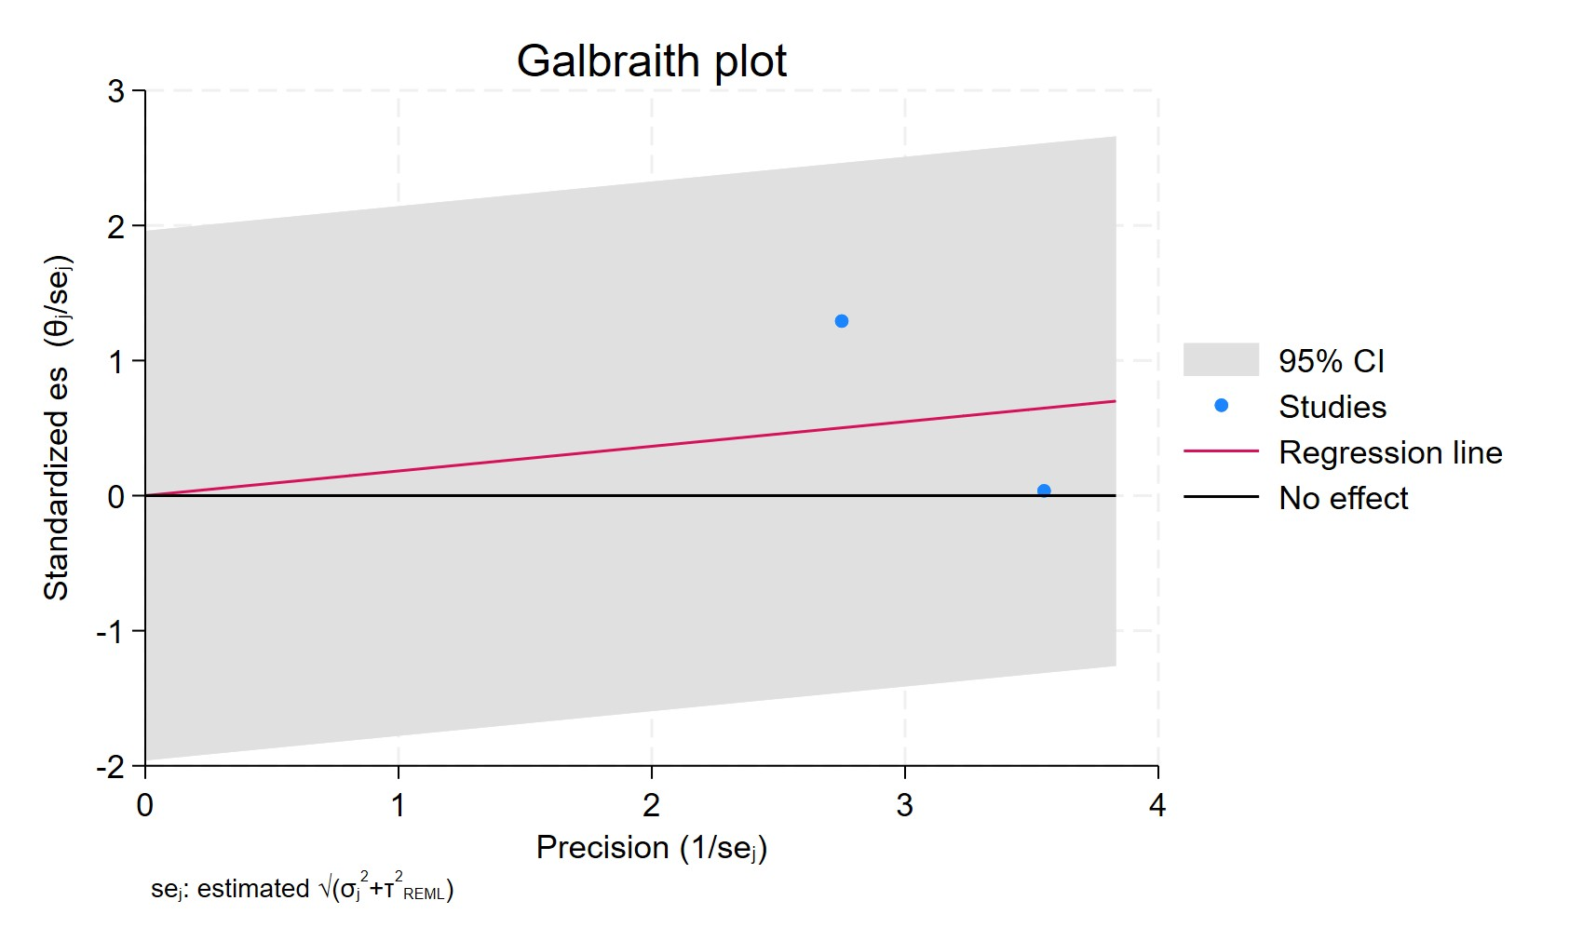
Figure 21. Galbraith plot - ADs use in ER negative breast cancer
Each study is represented as a point, where the x-axis denotes the precision (defined as the inverse of the standard error), and the y-axis indicates the standardized effect size. The red regression line represents the overall summary effect estimated from the random-effects model, and the gray shaded area corresponds to the confidence interval at 95% around regression line. The horizontal black line at y = 0 corresponds to the line of no effect, serving as a reference.

TCA EVER USE
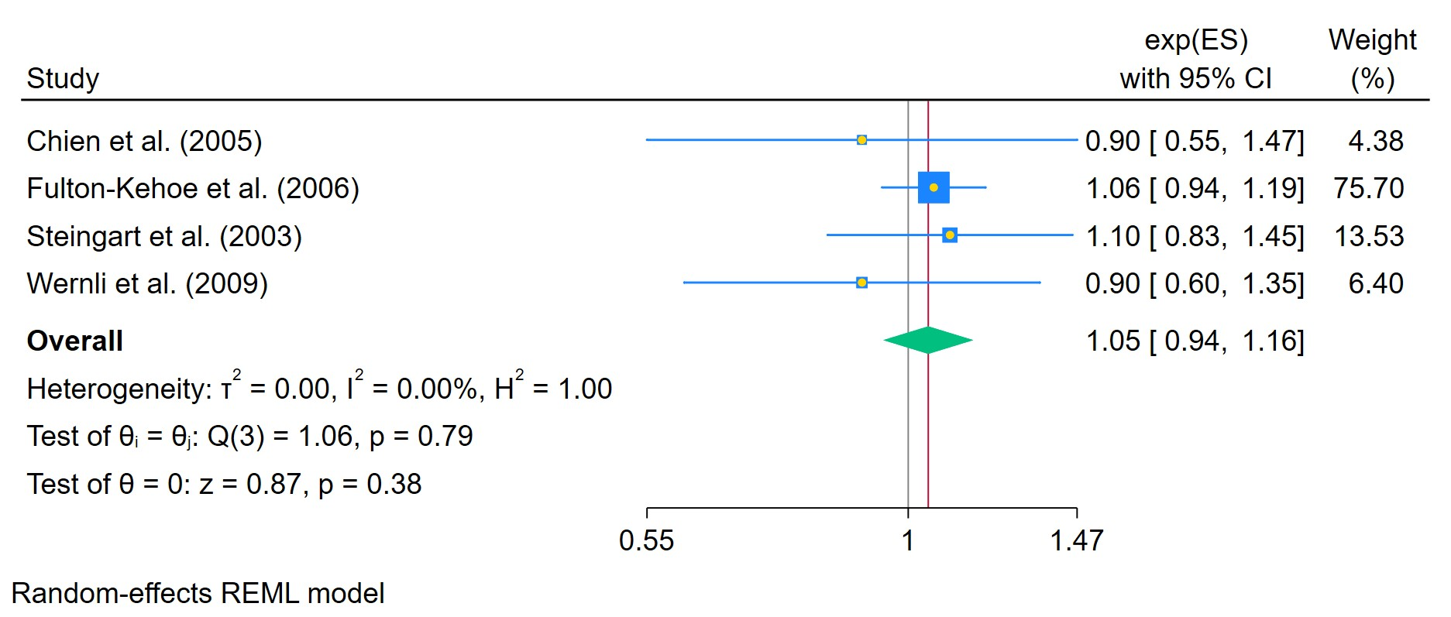
Figure 22. TCAs ever use - OR
The area of each square is proportional to the sample size of the respective study, with horizontal lines through the squares representing the 95% confidence interval (C.I.) for that study. In the pooled analysis, the diamond symbol represents the pooled estimate, with the right and left points of the diamond indicating the 95% C.I. for the overall analysis

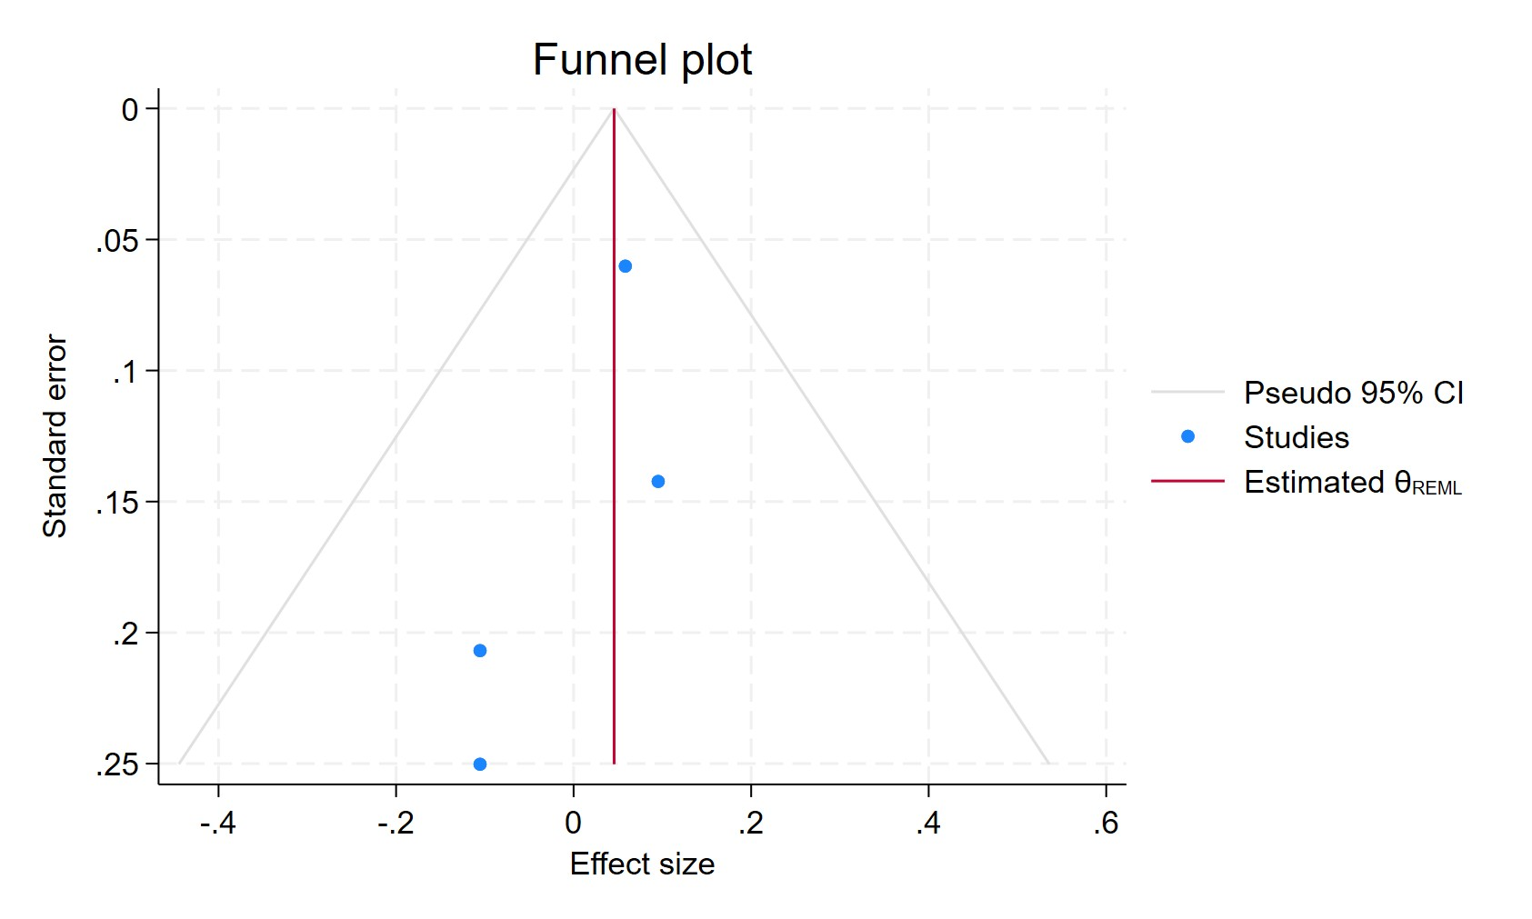
Figure 23. Funnel plot - TCAs ever use - OR
Each blue dot represents a single study, plotted with its effect size on the x-axis and its standard error on the y-axis. The vertical red line represents the overall effect estimate derived from the random-effects model using restricted maximum likelihood (REML). The pseudo 95% confidence interval region, shown as gray diagonal lines, outlines the expected spread of studies in the absence of bias or between-study heterogeneity.

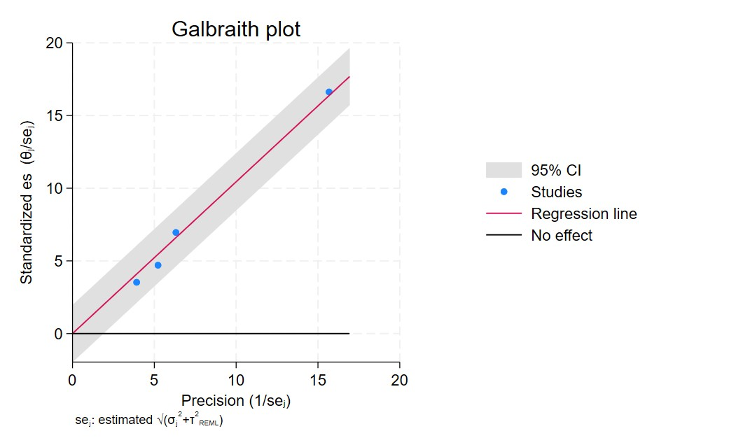
Figure 24. Galbraith plot - TCAs ever use - OR
Each study is represented as a point, where the x-axis denotes the precision (defined as the inverse of the standard error), and the y-axis indicates the standardized effect size. The red regression line represents the overall summary effect estimated from the random-effects model, and the gray shaded area corresponds to the confidence interval at 95% around regression line. The horizontal black line at y = 0 corresponds to the line of no effect, serving as a reference.

EVER USE TCA HAZARD RATIO
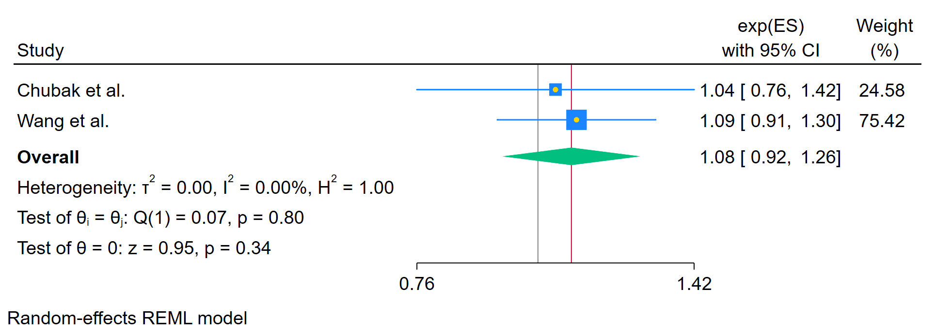
Figure 25. TCAs ever use - Hazard ratio
The area of each square is proportional to the sample size of the respective study, with horizontal lines through the squares representing the 95% confidence interval (C.I.) for that study. In the pooled analysis, the diamond symbol represents the pooled estimate, with the right and left points of the diamond indicating the 95% C.I. for the overall analysis

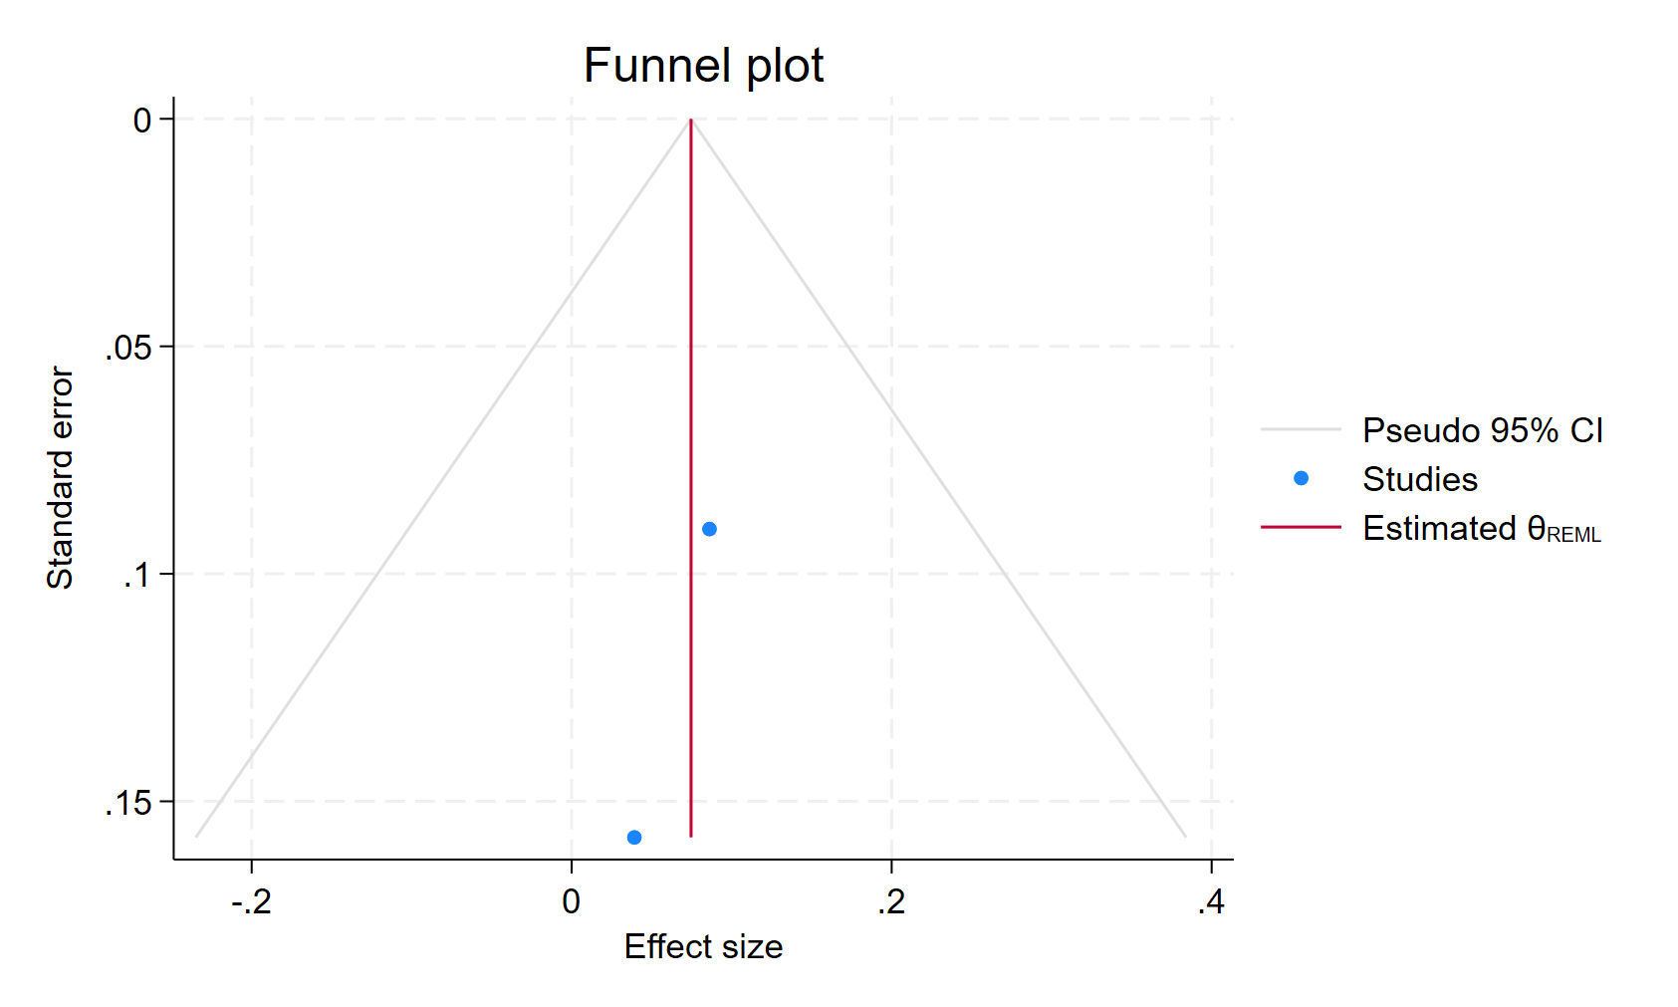
Figure 26. Funnel plot - TCAs ever use - Hazard ratio
Each blue dot represents a single study, plotted with its effect size on the x-axis and its standard error on the y-axis. The vertical red line represents the overall effect estimate derived from the random-effects model using restricted maximum likelihood (REML). The pseudo 95% confidence interval region, shown as gray diagonal lines, outlines the expected spread of studies in the absence of bias or between-study heterogeneity.

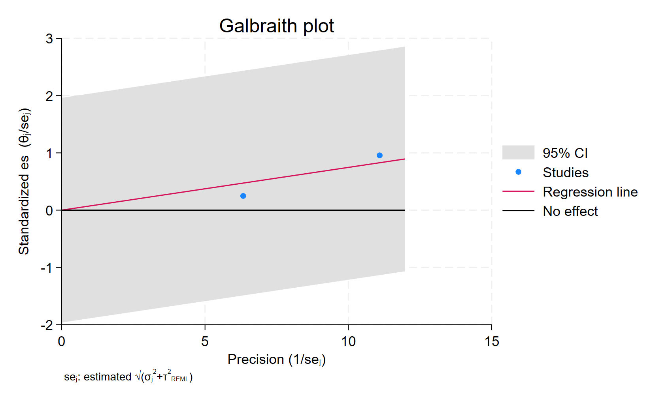
Figure 27. Galbraith plot - TCAs ever use - Hazard ratio
Each study is represented as a point, where the x-axis denotes the precision (defined as the inverse of the standard error), and the y-axis indicates the standardized effect size. The red regression line represents the overall summary effect estimated from the random-effects model, and the gray shaded area corresponds to the confidence interval at 95% around regression line. The horizontal black line at y = 0 corresponds to the line of no effect, serving as a reference.

TCA CURRENT USERS
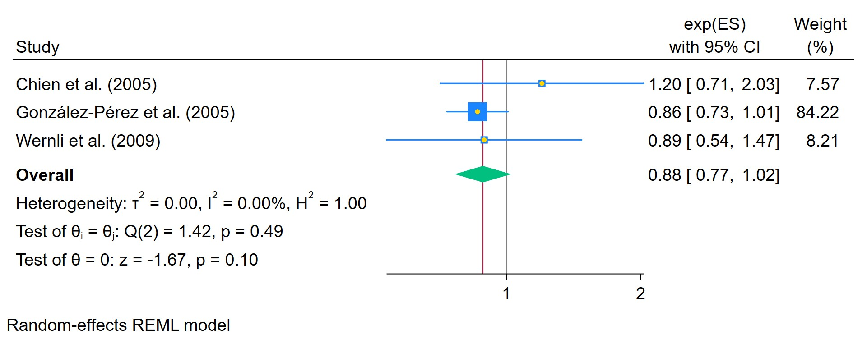
Figure 28. TCAs in current users
The area of each square is proportional to the sample size of the respective study, with horizontal lines through the squares representing the 95% confidence interval (C.I.) for that study. In the pooled analysis, the diamond symbol represents the pooled estimate, with the right and left points of the diamond indicating the 95% C.I. for the overall analysis

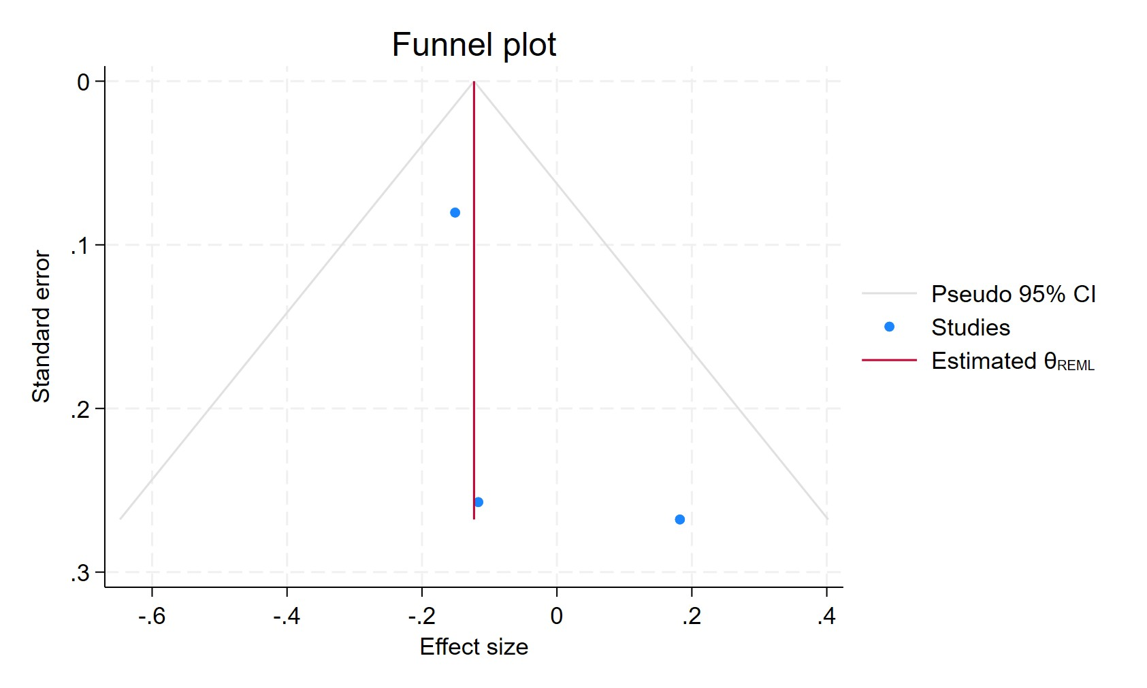
Figure 29. Funnel plot - TCAs in current users
Each blue dot represents a single study, plotted with its effect size on the x-axis and its standard error on the y-axis. The vertical red line represents the overall effect estimate derived from the random-effects model using restricted maximum likelihood (REML). The pseudo 95% confidence interval region, shown as gray diagonal lines, outlines the expected spread of studies in the absence of bias or between-study heterogeneity.

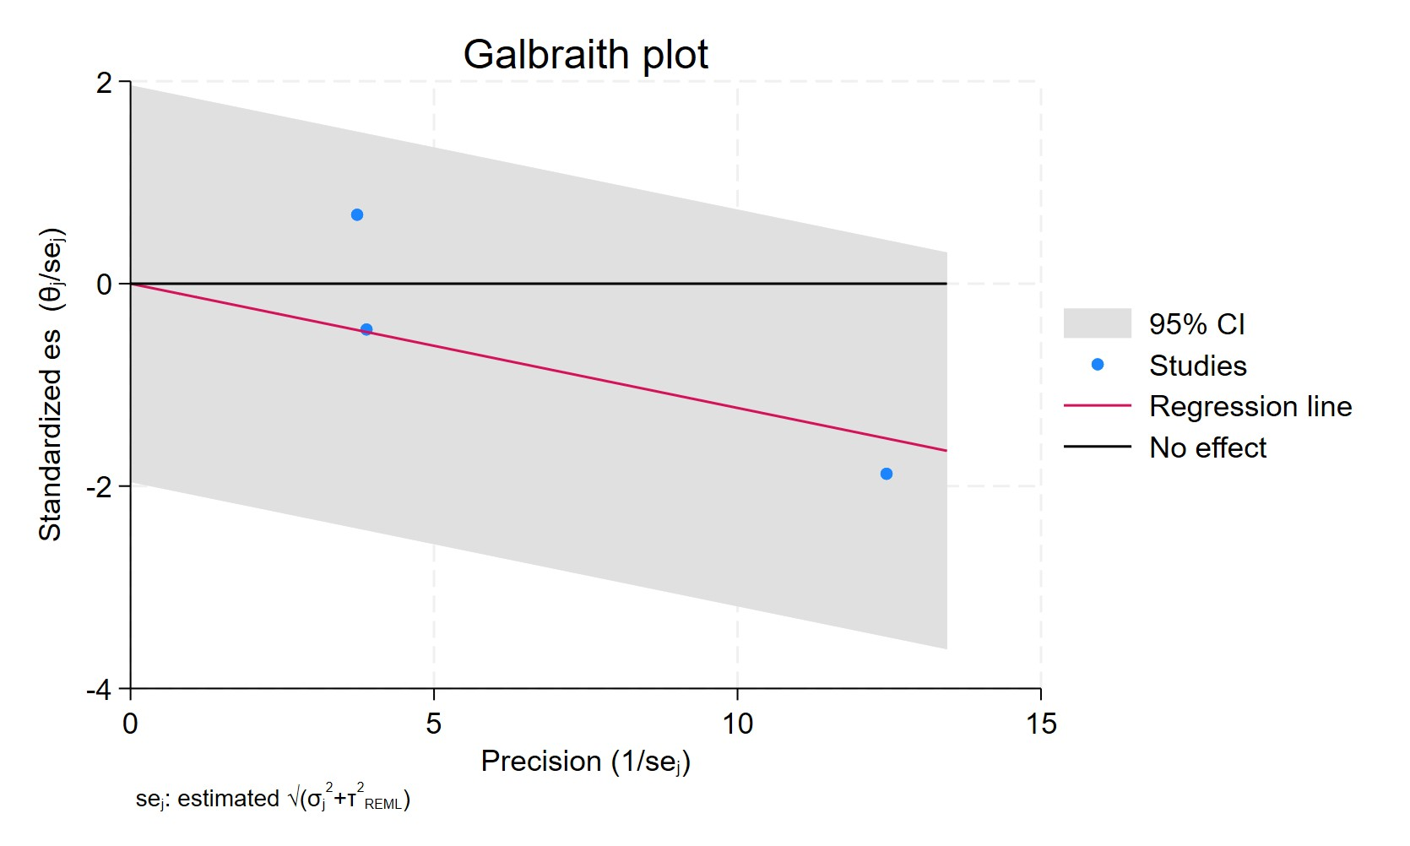
Figure 30. Galbraith plot - TCAs in current users
Each study is represented as a point, where the x-axis denotes the precision (defined as the inverse of the standard error), and the y-axis indicates the standardized effect size. The red regression line represents the overall summary effect estimated from the random-effects model, and the gray shaded area corresponds to the confidence interval at 95% around regression line. The horizontal black line at y = 0 corresponds to the line of no effect, serving as a reference.

TCA FORMERS USERS
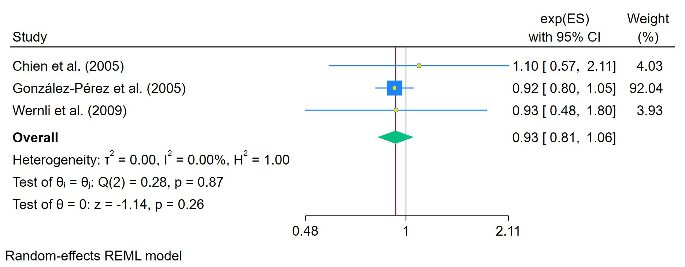
Figure 31. TCAs in former users
The area of each square is proportional to the sample size of the respective study, with horizontal lines through the squares representing the 95% confidence interval (C.I.) for that study. In the pooled analysis, the diamond symbol represents the pooled estimate, with the right and left points of the diamond indicating the 95% C.I. for the overall analysis

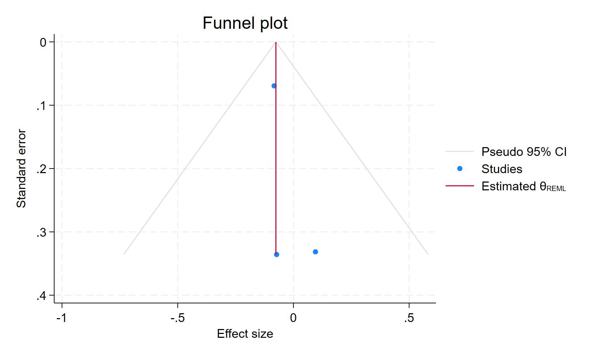
Figure 32. Funnel plot - TCAs in former users
Each blue dot represents a single study, plotted with its effect size on the x-axis and its standard error on the y-axis. The vertical red line represents the overall effect estimate derived from the random-effects model using restricted maximum likelihood (REML). The pseudo 95% confidence interval region, shown as gray diagonal lines, outlines the expected spread of studies in the absence of bias or between-study heterogeneity.

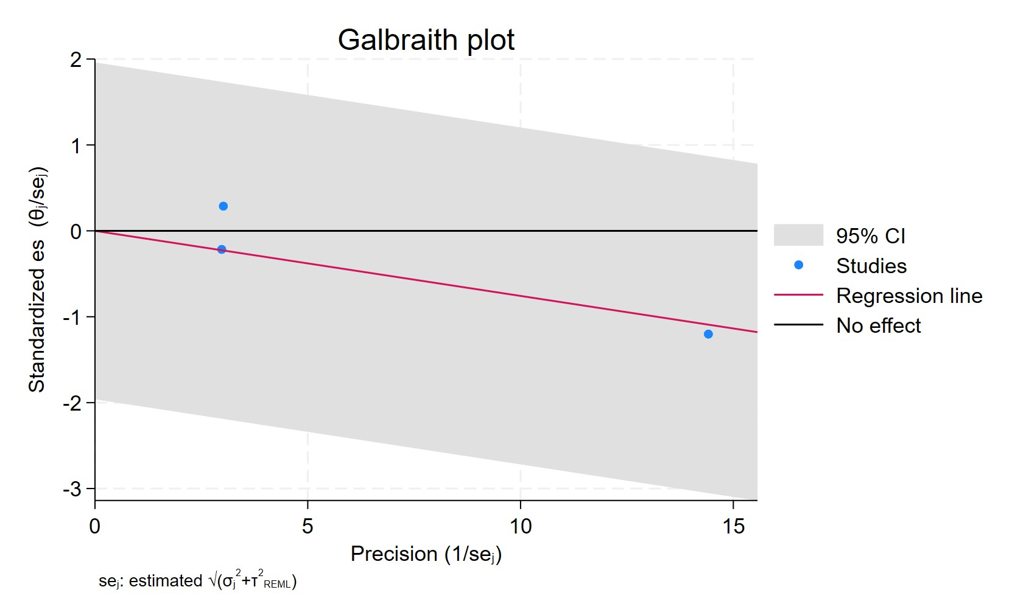
Figure 33. Galbraith plot - TCAs in former users
Each study is represented as a point, where the x-axis denotes the precision (defined as the inverse of the standard error), and the y-axis indicates the standardized effect size. The red regression line represents the overall summary effect estimated from the random-effects model, and the gray shaded area corresponds to the confidence interval at 95% around regression line. The horizontal black line at y = 0 corresponds to the line of no effect, serving as a reference.

TCA USERS LESS THAN 2 YEARS
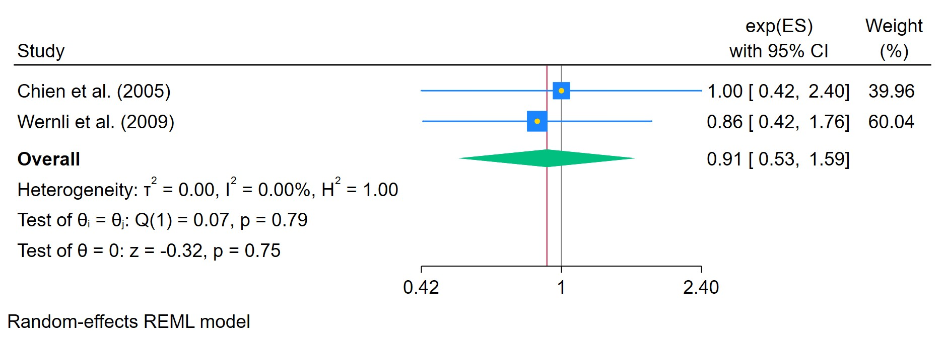
Figure 34. TCAs used for less than 2 years
The area of each square is proportional to the sample size of the respective study, with horizontal lines through the squares representing the 95% confidence interval (C.I.) for that study. In the pooled analysis, the diamond symbol represents the pooled estimate, with the right and left points of the diamond indicating the 95% C.I. for the overall analysis

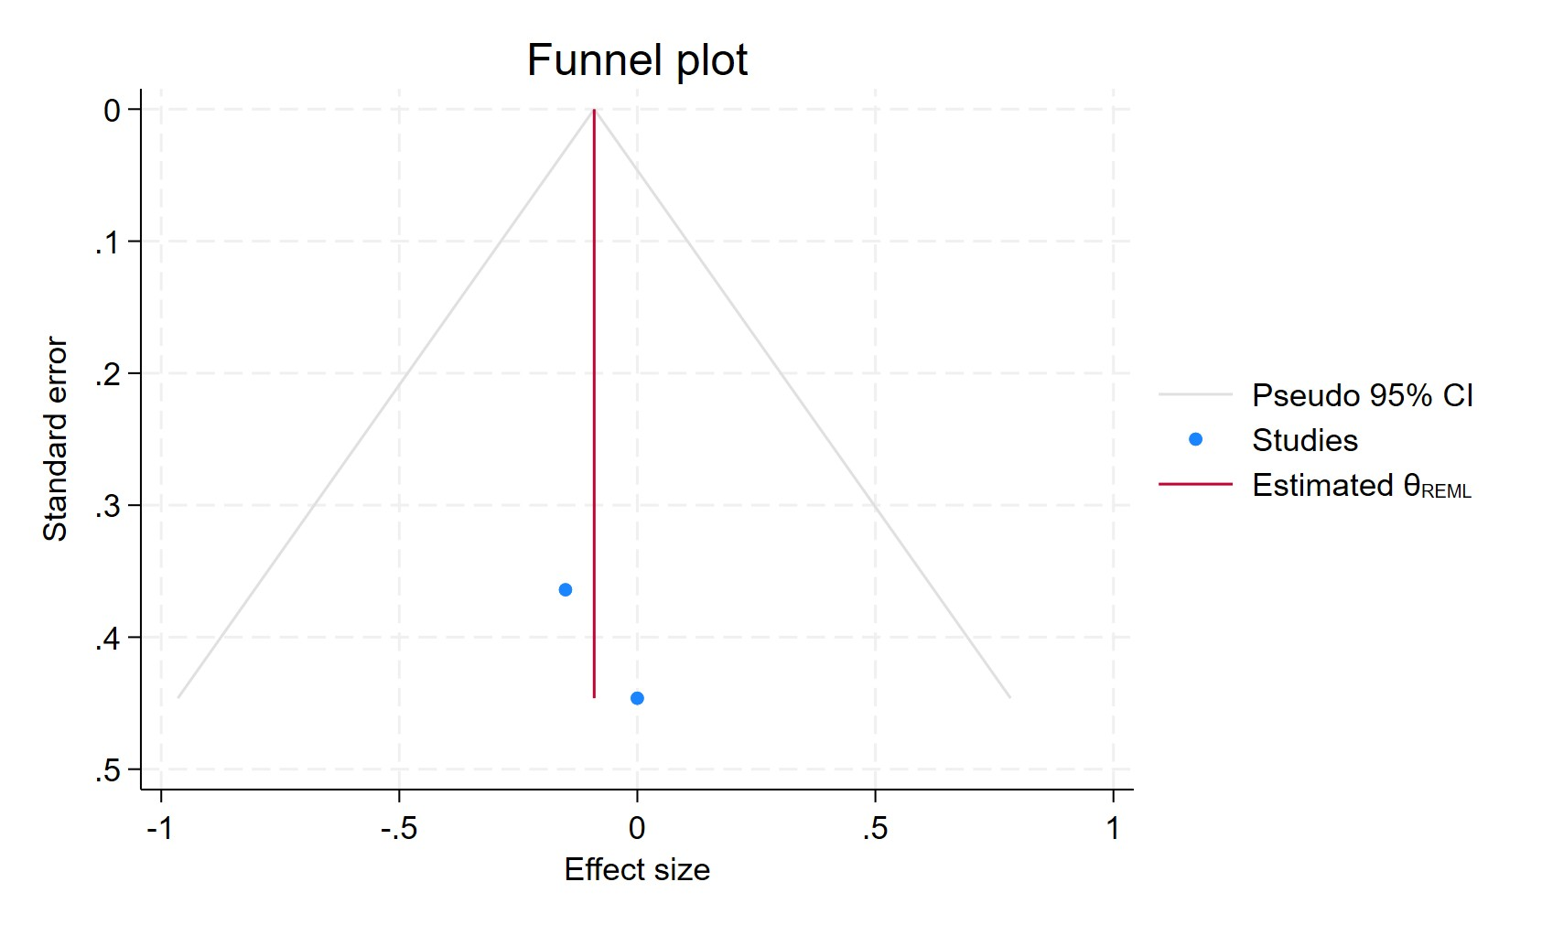
Figure 35. Funnel plot - TCAs used for less than 2 years
Each blue dot represents a single study, plotted with its effect size on the x-axis and its standard error on the y-axis. The vertical red line represents the overall effect estimate derived from the random-effects model using restricted maximum likelihood (REML). The pseudo 95% confidence interval region, shown as gray diagonal lines, outlines the expected spread of studies in the absence of bias or between-study heterogeneity.

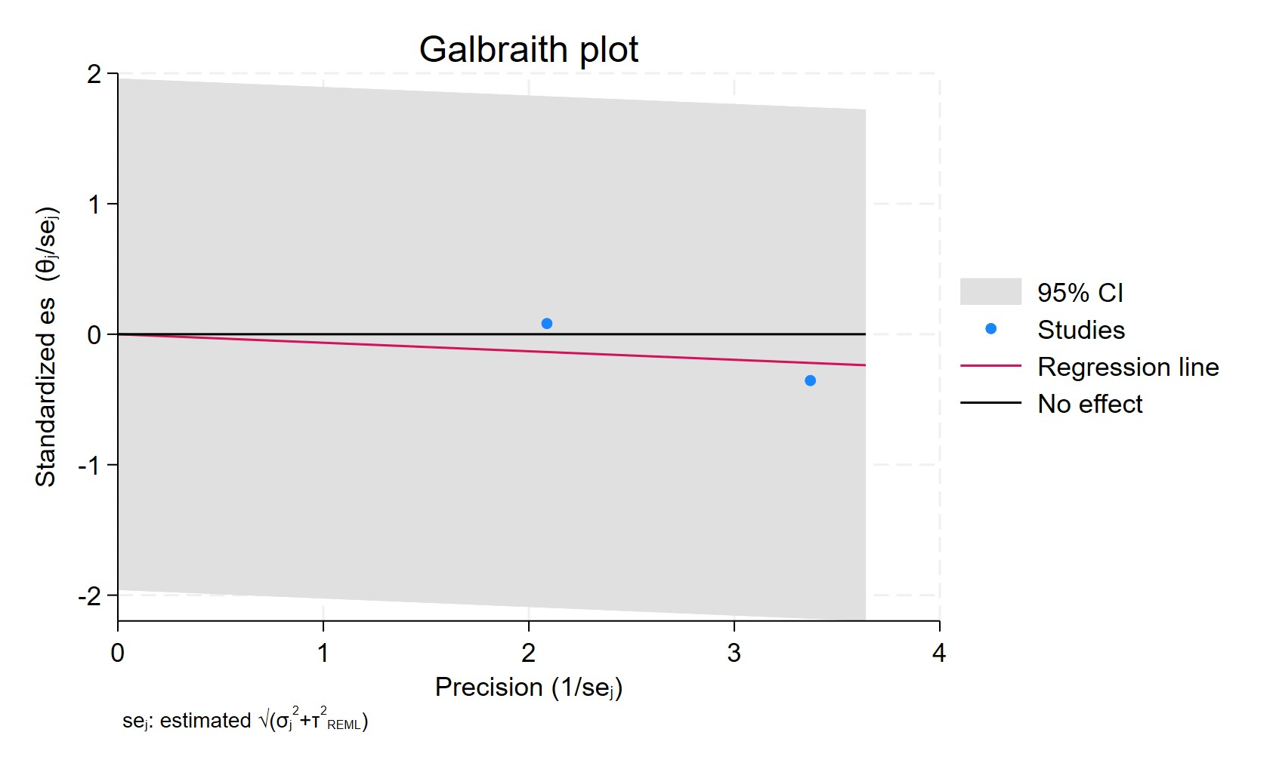
Figure 36. Galbraith plot - TCAs used for less than 2 years
Each study is represented as a point, where the x-axis denotes the precision (defined as the inverse of the standard error), and the y-axis indicates the standardized effect size. The red regression line represents the overall summary effect estimated from the random-effects model, and the gray shaded area corresponds to the confidence interval at 95% around regression line. The horizontal black line at y = 0 corresponds to the line of no effect, serving as a reference.

TCA USERS MORE THAN 2 YEARS
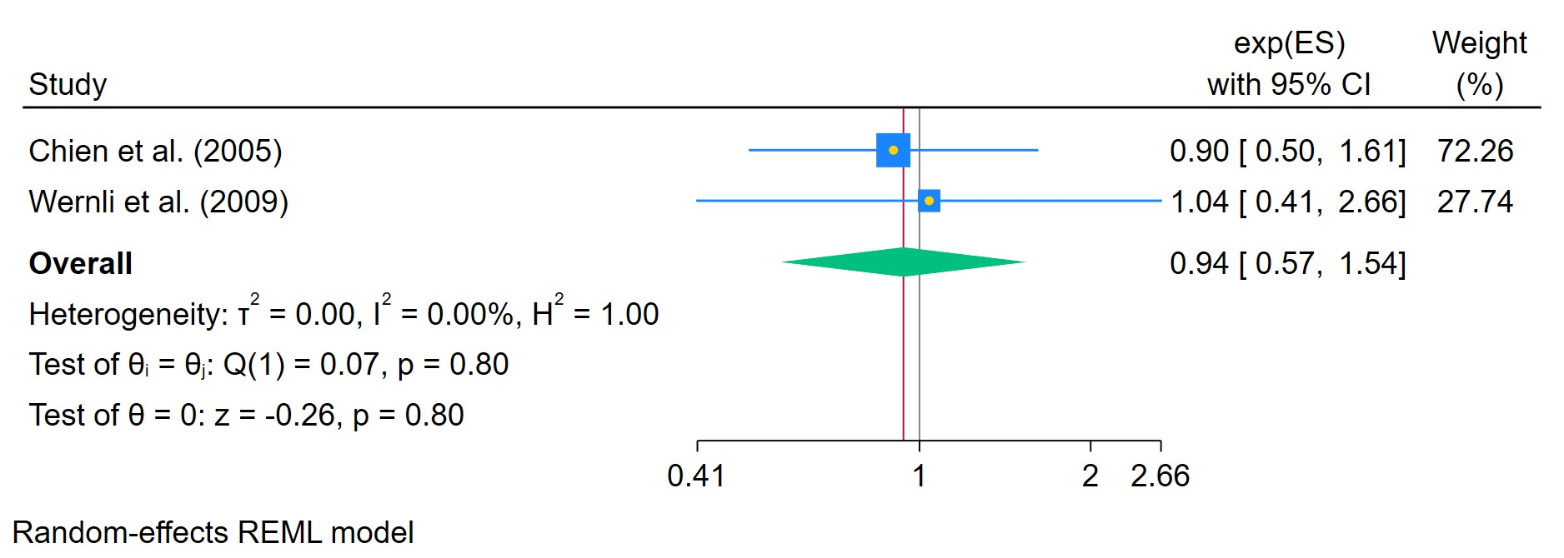
Figure 37. TCAs used for more than 2 years
The area of each square is proportional to the sample size of the respective study, with horizontal lines through the squares representing the 95% confidence interval (C.I.) for that study. In the pooled analysis, the diamond symbol represents the pooled estimate, with the right and left points of the diamond indicating the 95% C.I. for the overall analysis

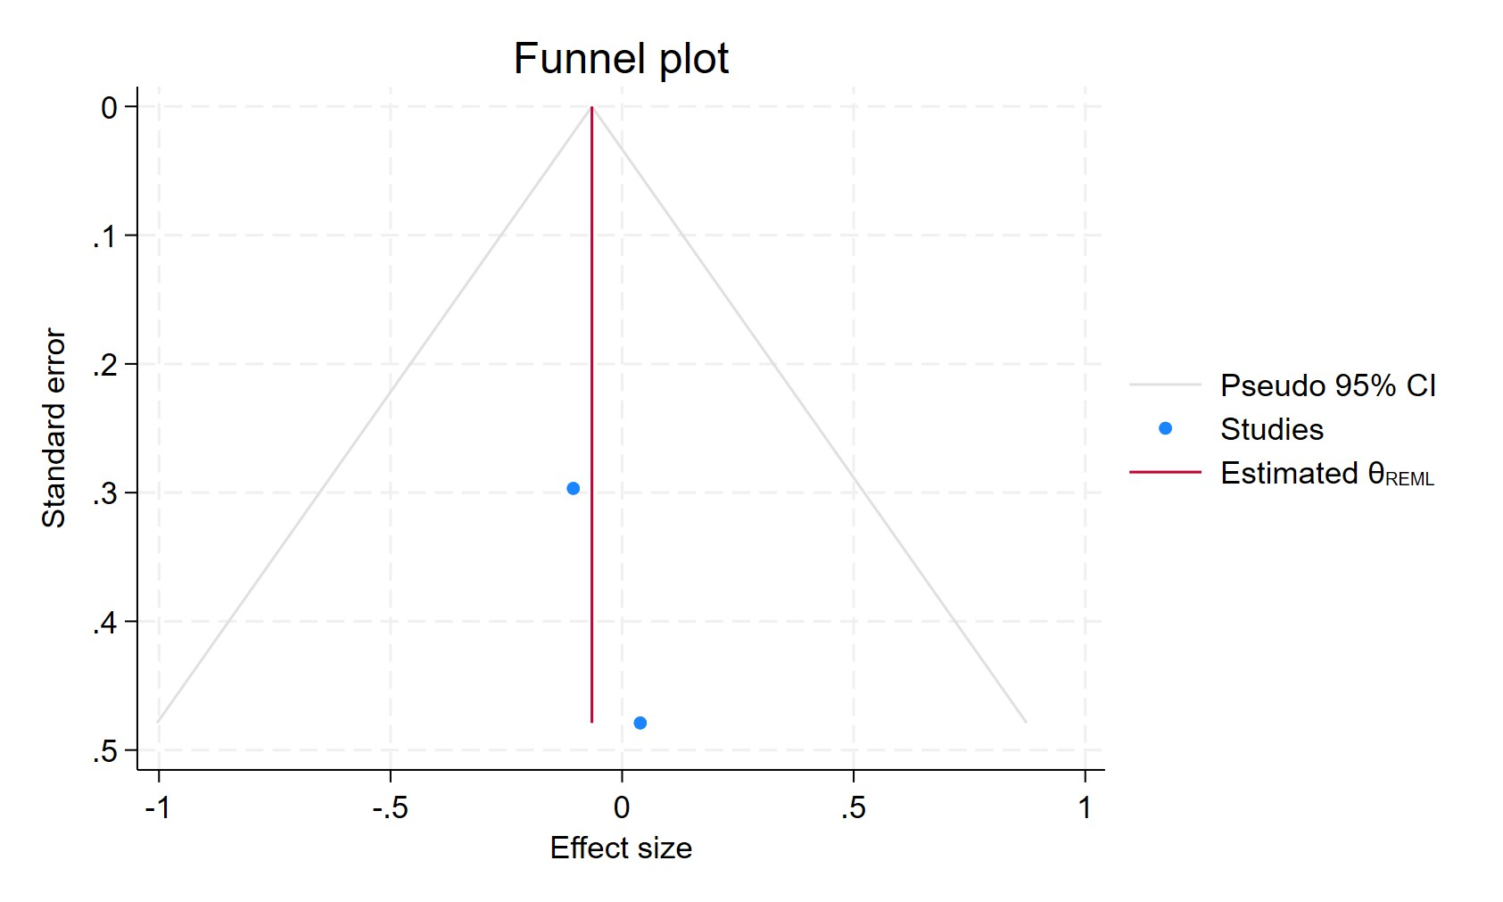
Figure 38. Funnel plot - TCAs used for more than 2 years
Each blue dot represents a single study, plotted with its effect size on the x-axis and its standard error on the y-axis. The vertical red line represents the overall effect estimate derived from the random-effects model using restricted maximum likelihood (REML). The pseudo 95% confidence interval region, shown as gray diagonal lines, outlines the expected spread of studies in the absence of bias or between-study heterogeneity.

Figure 39. Galbraith plot - TCAs used for more than 2 years
Each study is represented as a point, where the x-axis denotes the precision (defined as the inverse of the standard error), and the y-axis indicates the standardized effect size. The red regression line represents the overall summary effect estimated from the random-effects model, and the gray shaded area corresponds to the confidence interval at 95% around regression line. The horizontal black line at y = 0 corresponds to the line of no effect, serving as a reference.

TCA USERS CUMULATIVE DURATION 0-1 YEAR
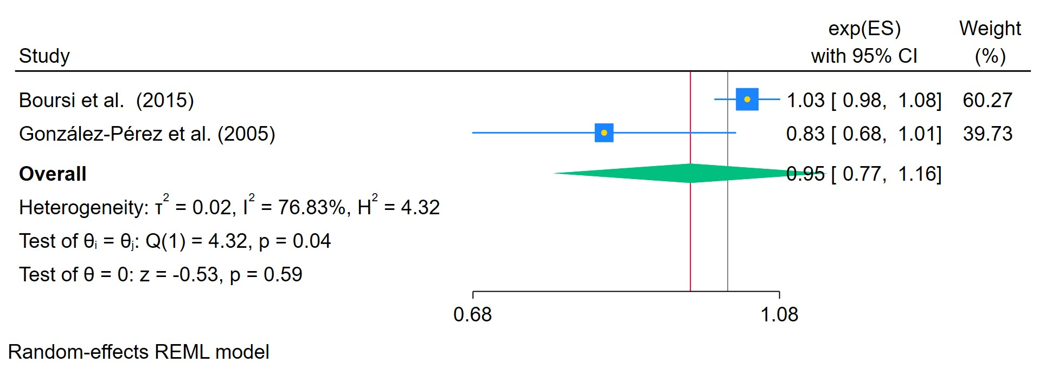
Figure 40. Cumulative TCAs duration 0-1 year
The area of each square is proportional to the sample size of the respective study, with horizontal lines through the squares representing the 95% confidence interval (C.I.) for that study. In the pooled analysis, the diamond symbol represents the pooled estimate, with the right and left points of the diamond indicating the 95% C.I. for the overall analysis

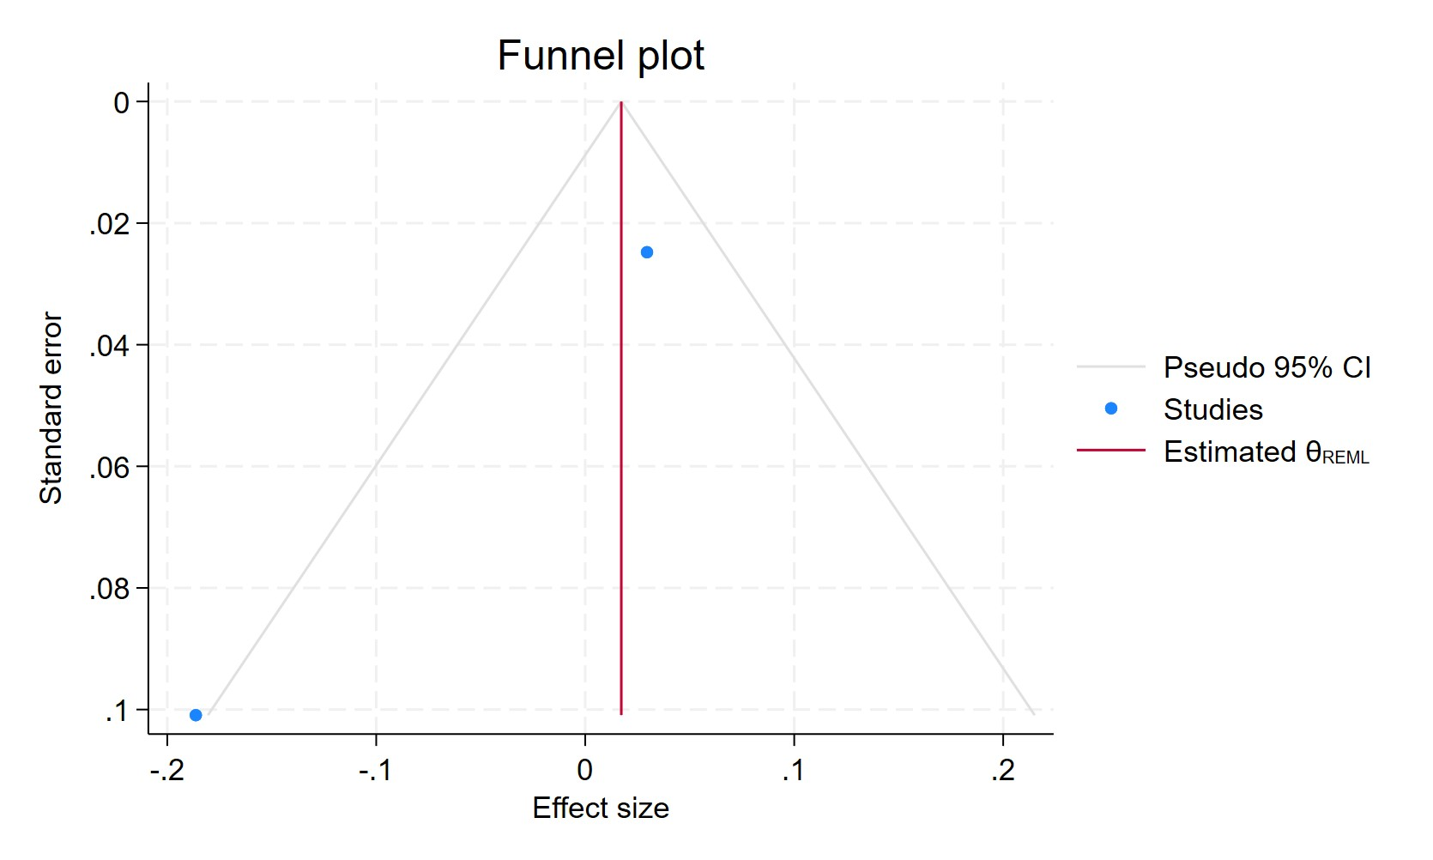
Figure 41. Funnel plot - Cumulative TCAs duration 0-1year

Each blue dot represents a single study, plotted with its effect size on the x-axis and its standard error on the y-axis. The vertical red line represents the overall effect estimate derived from the random-effects model using restricted maximum likelihood (REML). The pseudo 95% confidence interval region, shown as gray diagonal lines, outlines the expected spread of studies in the absence of bias or between-study heterogeneity.

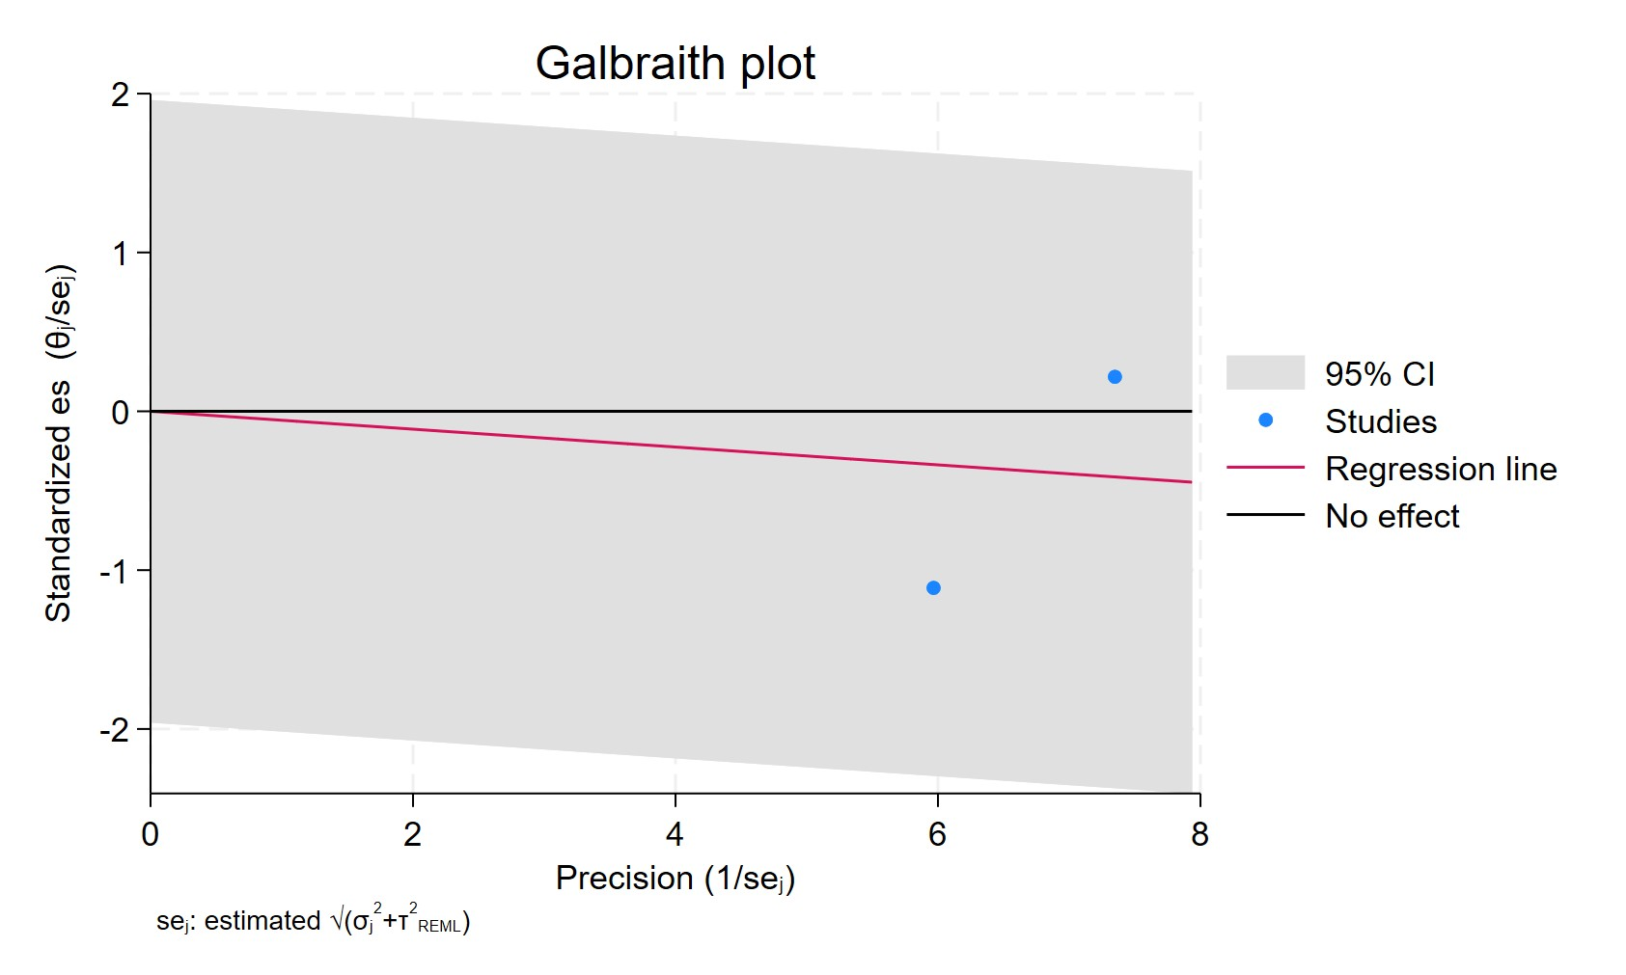
Figure 42. Galbraith plot - Cumulative TCAs duration 0-1year
Each study is represented as a point, where the x-axis denotes the precision (defined as the inverse of the standard error), and the y-axis indicates the standardized effect size. The red regression line represents the overall summary effect estimated from the random-effects model, and the gray shaded area corresponds to the confidence interval at 95% around regression line. The horizontal black line at y = 0 corresponds to the line of no effect, serving as a reference.

TCA USERS CUMUALTIVE DURATION 1-3 YEARS
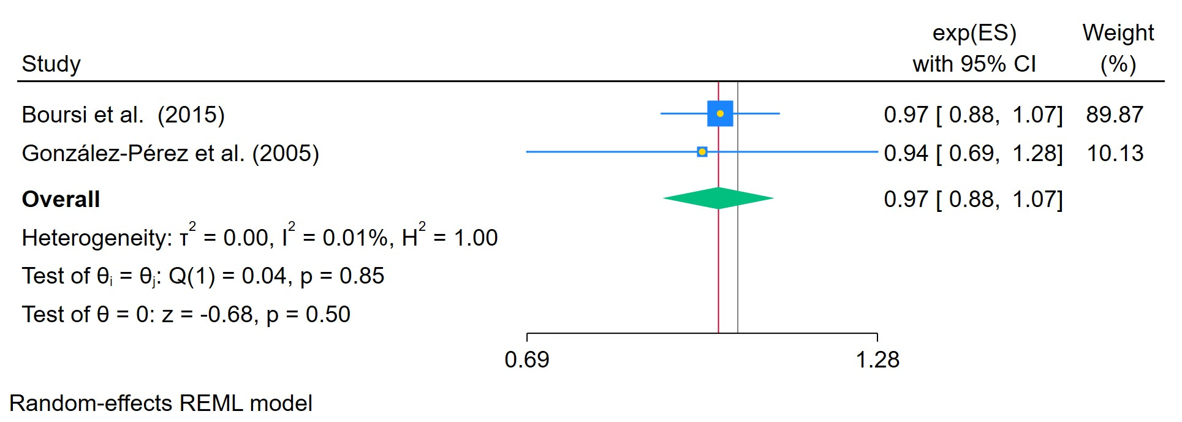
Figure 43. Cumulative TCAs duration 1-3 years
The area of each square is proportional to the sample size of the respective study, with horizontal lines through the squares representing the 95% confidence interval (C.I.) for that study. In the pooled analysis, the diamond symbol represents the pooled estimate, with the right and left points of the diamond indicating the 95% C.I. for the overall analysis

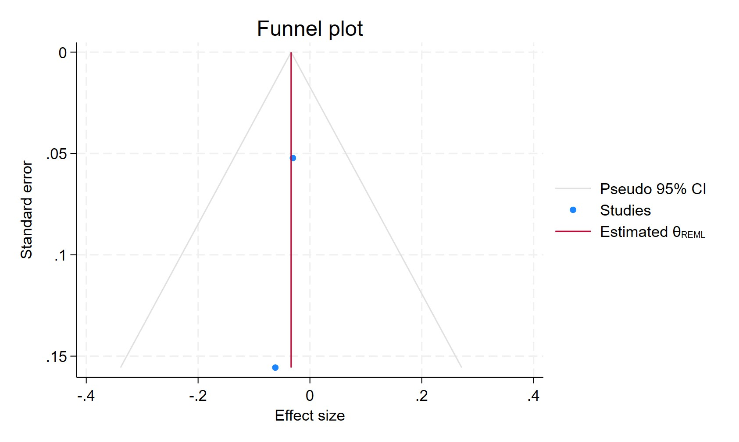
Figure 44. Funnel plot - Cumulative TCAs duration 1-3 years
Each blue dot represents a single study, plotted with its effect size on the x-axis and its standard error on the y-axis. The vertical red line represents the overall effect estimate derived from the random-effects model using restricted maximum likelihood (REML). The pseudo 95% confidence interval region, shown as gray diagonal lines, outlines the expected spread of studies in the absence of bias or between-study heterogeneity.

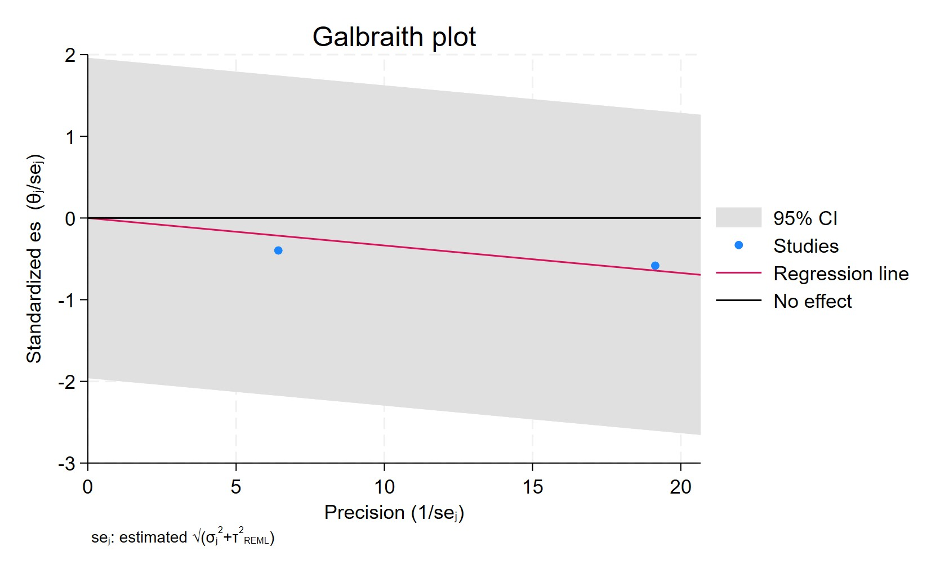
Figure 45. Galbraith plot - Cumulative TCAs duration 1-3 years
Each study is represented as a point, where the x-axis denotes the precision (defined as the inverse of the standard error), and the y-axis indicates the standardized effect size. The red regression line represents the overall summary effect estimated from the random-effects model, and the gray shaded area corresponds to the confidence interval at 95% around regression line. The horizontal black line at y = 0 corresponds to the line of no effect, serving as a reference.

TCA CUMUALTIVE USERS MORE 3 YEARS

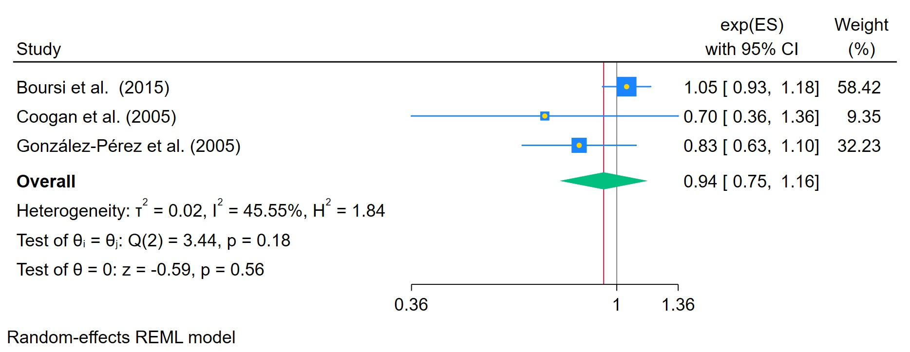
Figure 46. Cumulative TCAs duration for more than 3 years
The area of each square is proportional to the sample size of the respective study, with horizontal lines through the squares representing the 95% confidence interval (C.I.) for that study. In the pooled analysis, the diamond symbol represents the pooled estimate, with the right and left points of the diamond indicating the 95% C.I. for the overall analysis

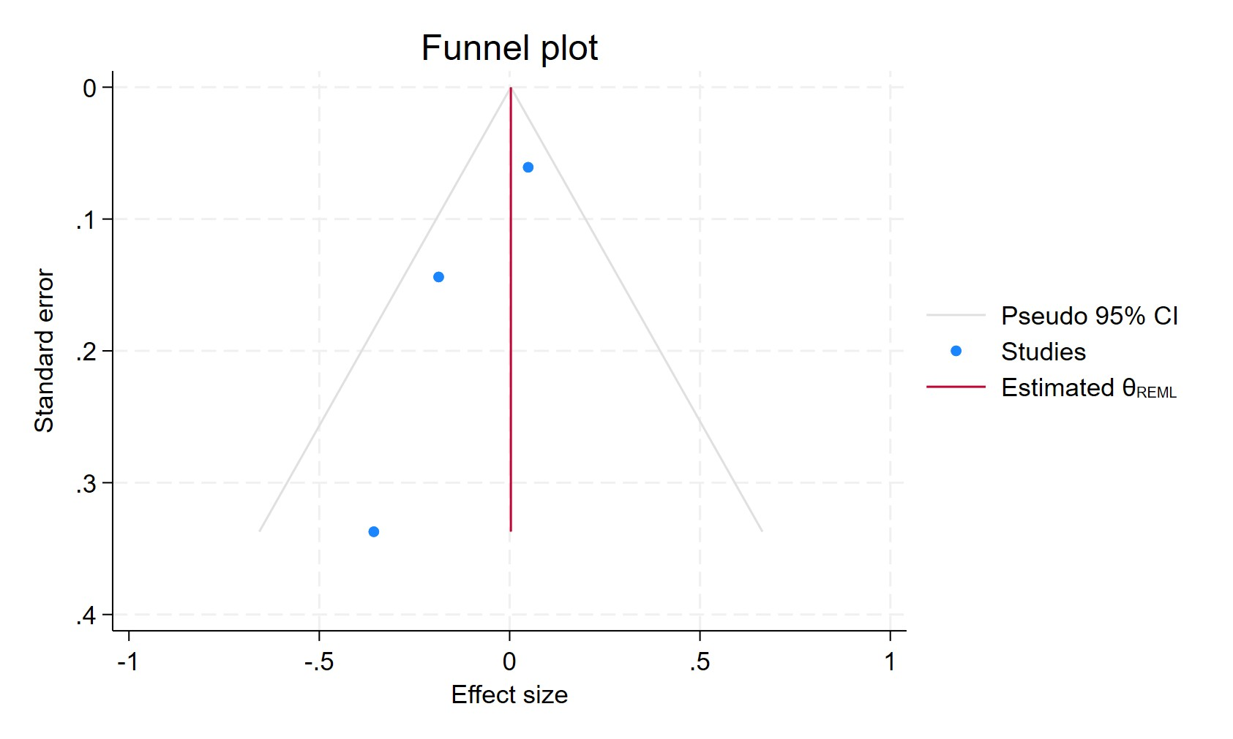
Figure 47. Funnel plot - Cumulative TCAs duration for more than 3 years
Each blue dot represents a single study, plotted with its effect size on the x-axis and its standard error on the y-axis. The vertical red line represents the overall effect estimate derived from the random-effects model using restricted maximum likelihood (REML). The pseudo 95% confidence interval region, shown as gray diagonal lines, outlines the expected spread of studies in the absence of bias or between-study heterogeneity.

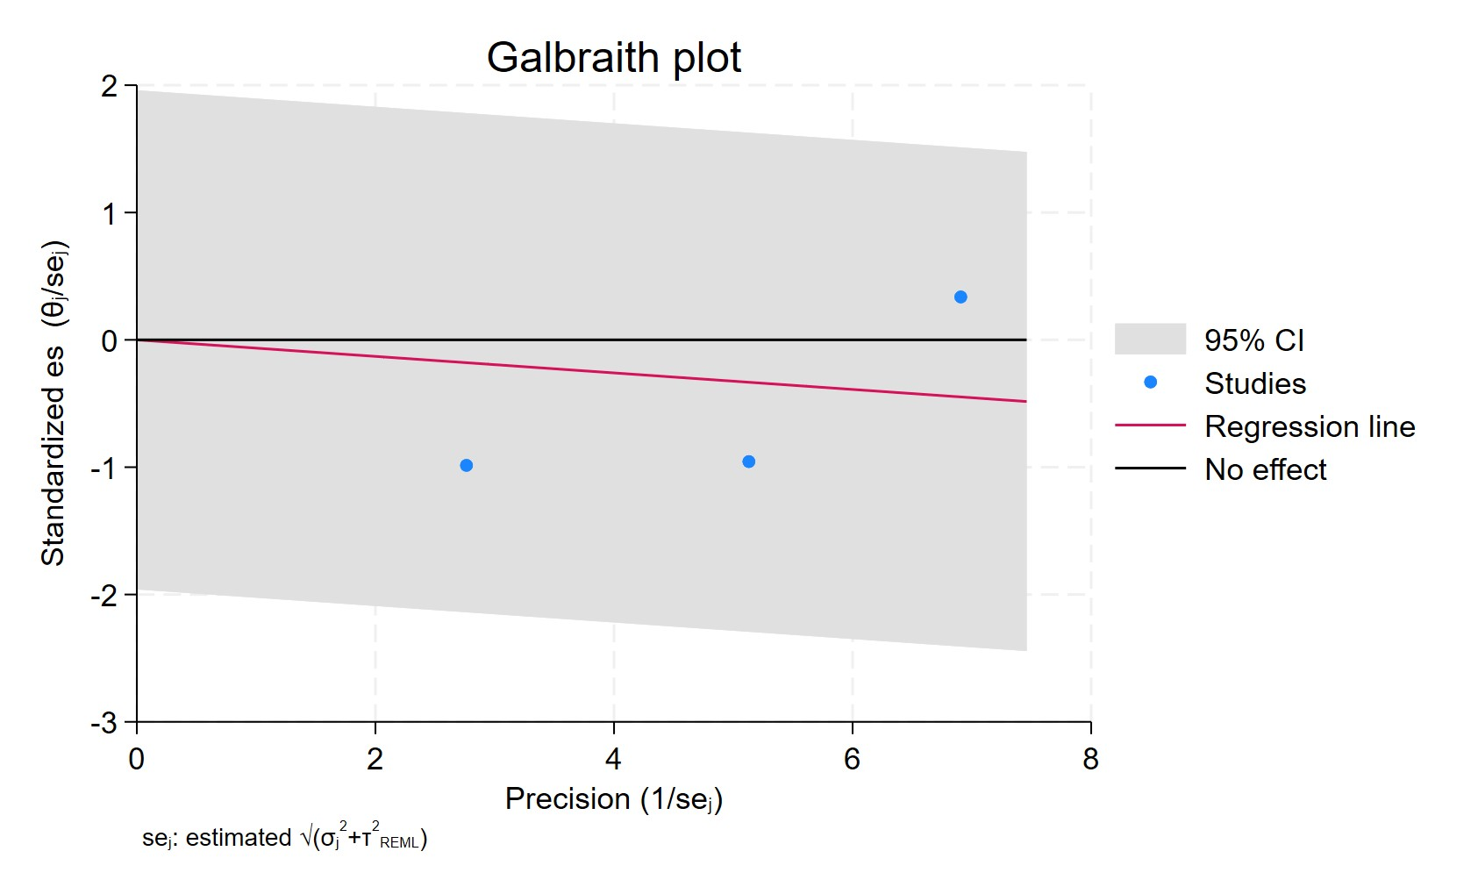
Figure 48. Galbraith plot - Cumulative TCAs duration for more than 3 years
Each study is represented as a point, where the x-axis denotes the precision (defined as the inverse of the standard error), and the y-axis indicates the standardized effect size. The red regression line represents the overall summary effect estimated from the random-effects model, and the gray shaded area corresponds to the confidence interval at 95% around regression line. The horizontal black line at y = 0 corresponds to the line of no effect, serving as a reference.

TCA USERS ER POSITIVE

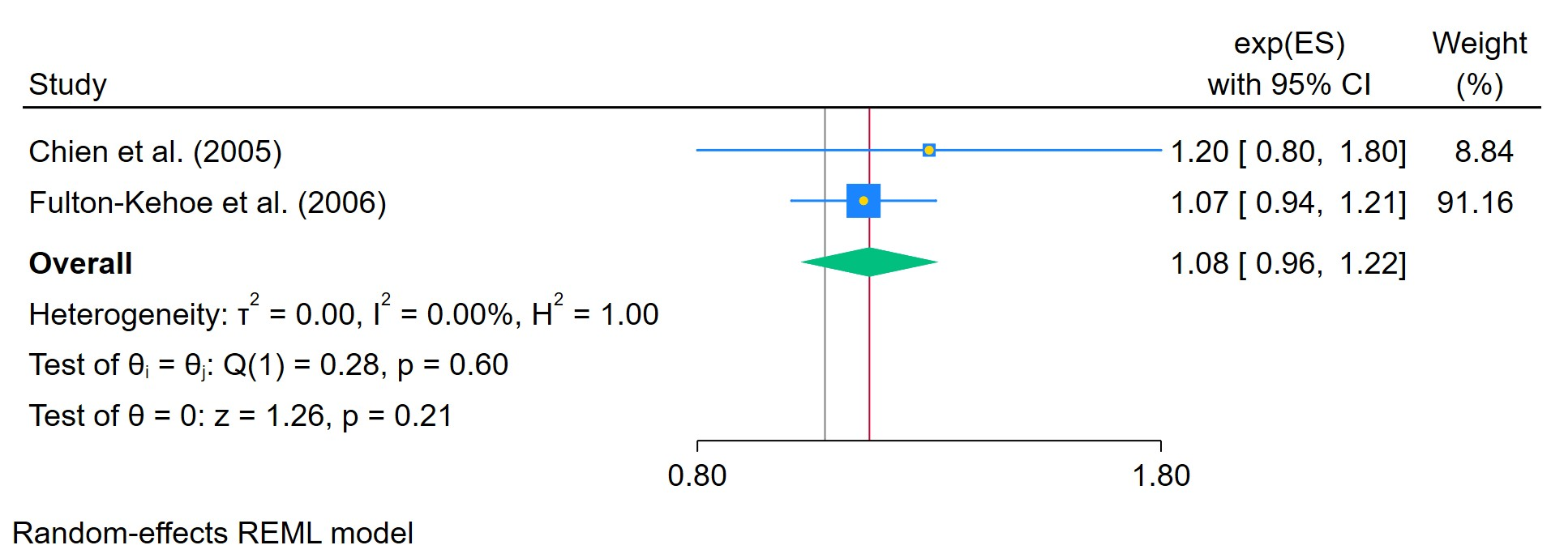
Figure 49. TCAs used in ER positive cancer
The area of each square is proportional to the sample size of the respective study, with horizontal lines through the squares representing the 95% confidence interval (C.I.) for that study. In the pooled analysis, the diamond symbol represents the pooled estimate, with the right and left points of the diamond indicating the 95% C.I. for the overall analysis

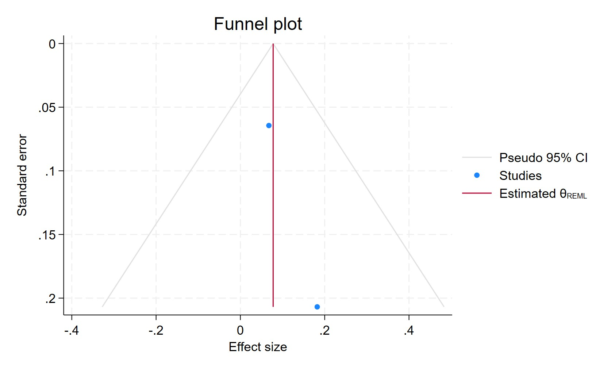
Figure 50. Funnel plot - TCAs used in ER positive cancer
Each blue dot represents a single study, plotted with its effect size on the x-axis and its standard error on the y-axis. The vertical red line represents the overall effect estimate derived from the random-effects model using restricted maximum likelihood (REML). The pseudo 95% confidence interval region, shown as gray diagonal lines, outlines the expected spread of studies in the absence of bias or between-study heterogeneity.

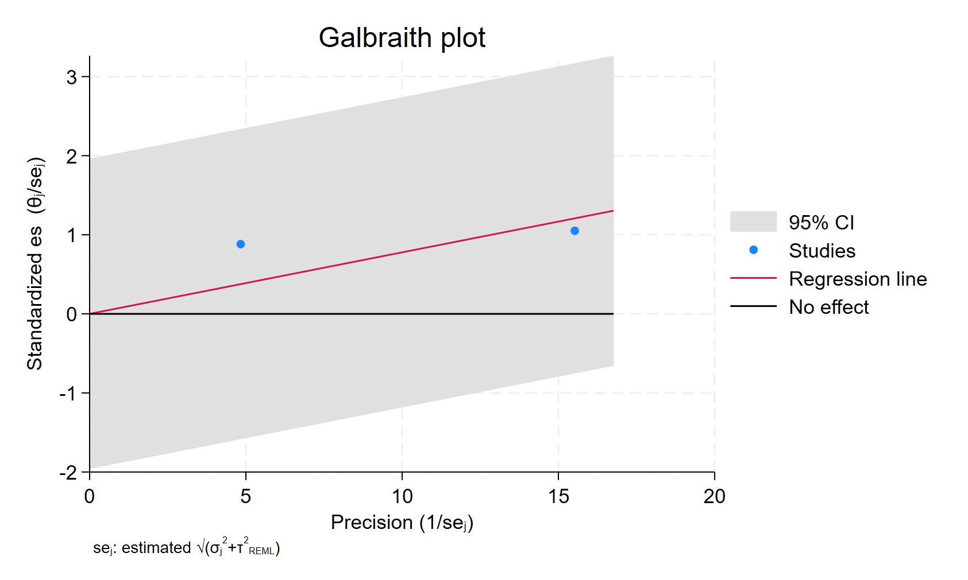
Figure 51. Galbraith plot - TCAs used in ER positive cancer
Each study is represented as a point, where the x-axis denotes the precision (defined as the inverse of the standard error), and the y-axis indicates the standardized effect size. The red regression line represents the overall summary effect estimated from the random-effects model, and the gray shaded area corresponds to the confidence interval at 95% around regression line. The horizontal black line at y = 0 corresponds to the line of no effect, serving as a reference.

TCA USERS ER NEGATIVE
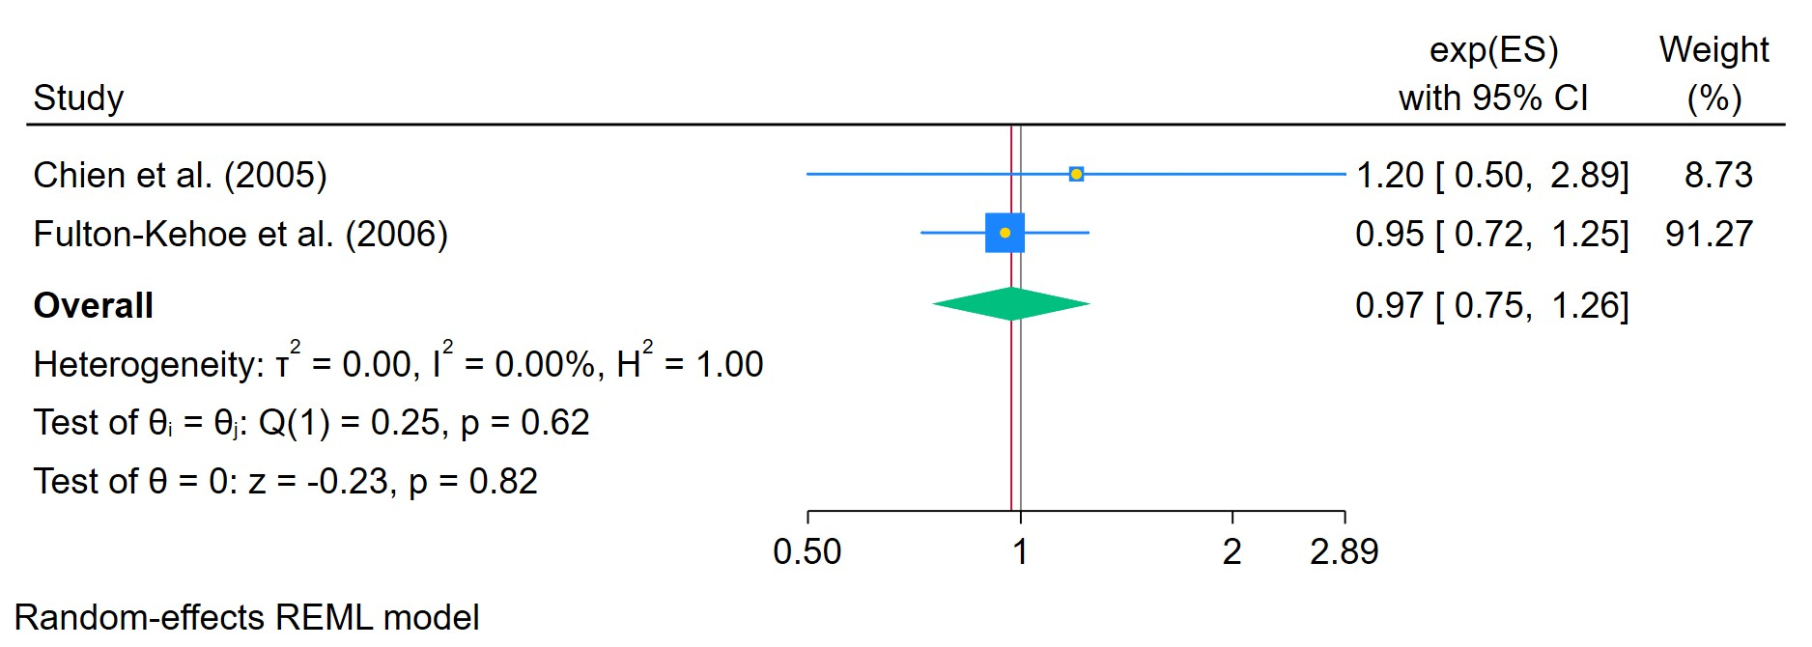
Figure 52. TCAs used in ER negative breast cancer
The area of each square is proportional to the sample size of the respective study, with horizontal lines through the squares representing the 95% confidence interval (C.I.) for that study. In the pooled analysis, the diamond symbol represents the pooled estimate, with the right and left points of the diamond indicating the 95% C.I. for the overall analysis

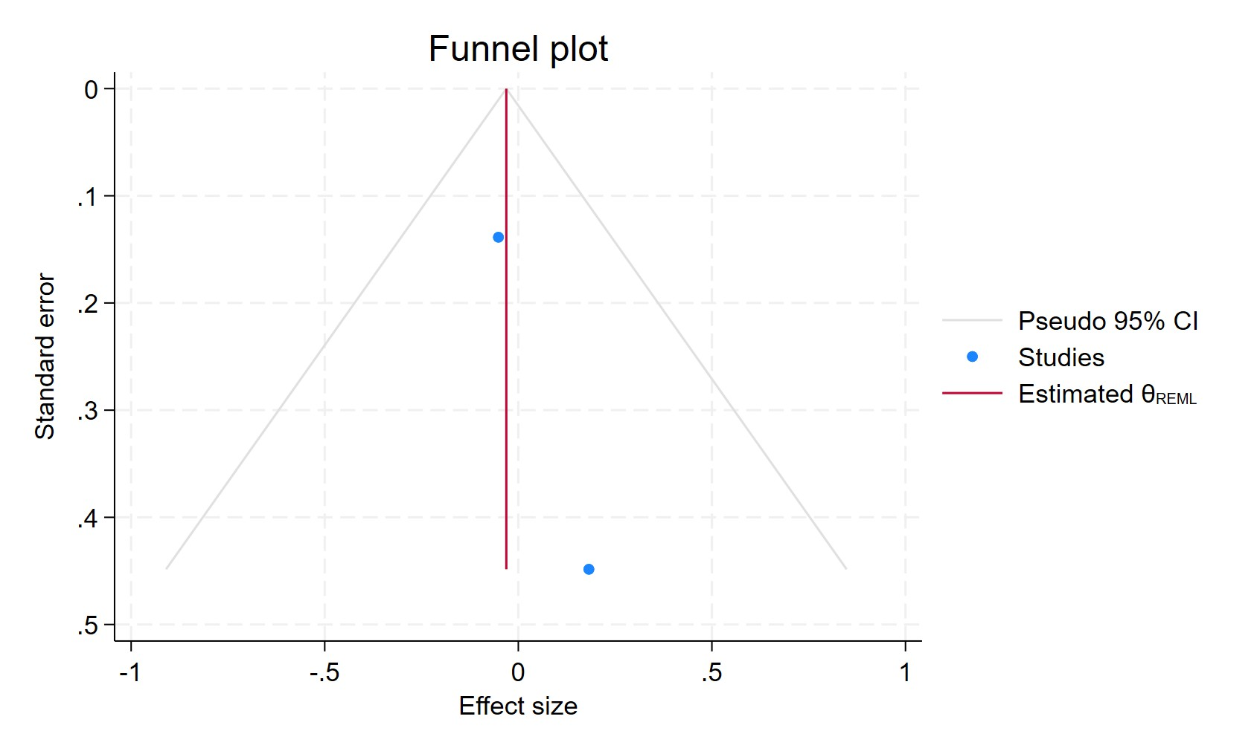
Figure 53. Funnel plot - TCAs used in ER negative breast cancer
Each blue dot represents a single study, plotted with its effect size on the x-axis and its standard error on the y-axis. The vertical red line represents the overall effect estimate derived from the random-effects model using restricted maximum likelihood (REML). The pseudo 95% confidence interval region, shown as gray diagonal lines, outlines the expected spread of studies in the absence of bias or between-study heterogeneity.

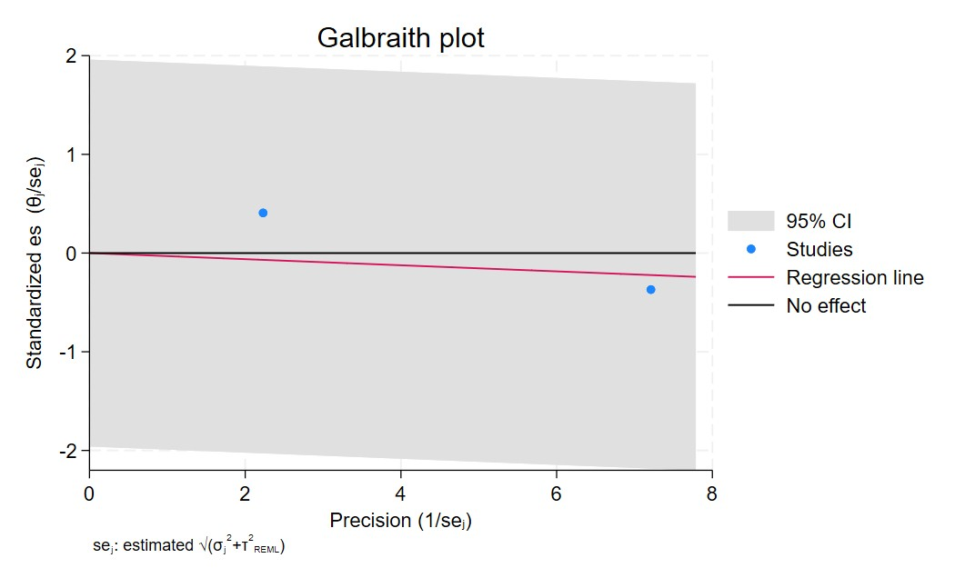
Figure 54. Galbraith plot - TCAs used in ER negative breast cancer
Each study is represented as a point, where the x-axis denotes the precision (defined as the inverse of the standard error), and the y-axis indicates the standardized effect size. The red regression line represents the overall summary effect estimated from the random-effects model, and the gray shaded area corresponds to the confidence interval at 95% around regression line. The horizontal black line at y = 0 corresponds to the line of no effect, serving as a reference.

AMITRIPTILINE USERS OR
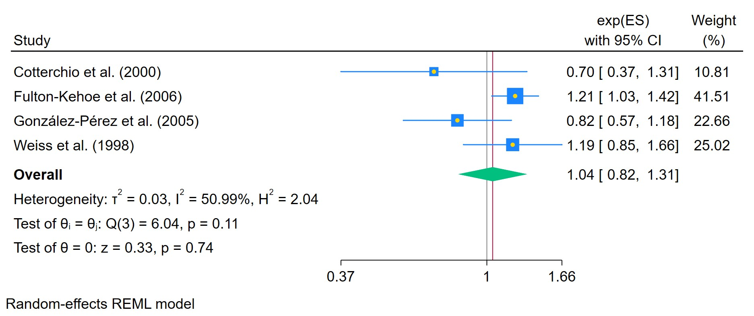
Figure 55. Amitriptyline ever used - Odds Ratio
The area of each square is proportional to the sample size of the respective study, with horizontal lines through the squares representing the 95% confidence interval (C.I.) for that study. In the pooled analysis, the diamond symbol represents the pooled estimate, with the right and left points of the diamond indicating the 95% C.I. for the overall analysis

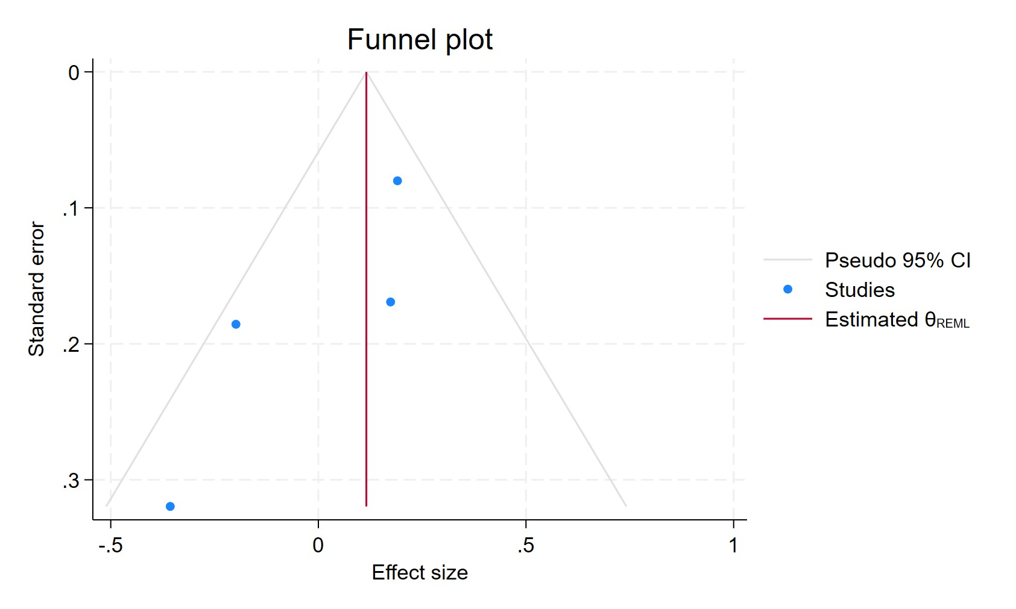
Figure 56. Funnel plot - Amitriptyline ever used - Odds Ratio
Each blue dot represents a single study, plotted with its effect size on the x-axis and its standard error on the y-axis. The vertical red line represents the overall effect estimate derived from the random-effects model using restricted maximum likelihood (REML). The pseudo 95% confidence interval region, shown as gray diagonal lines, outlines the expected spread of studies in the absence of bias or between-study heterogeneity.

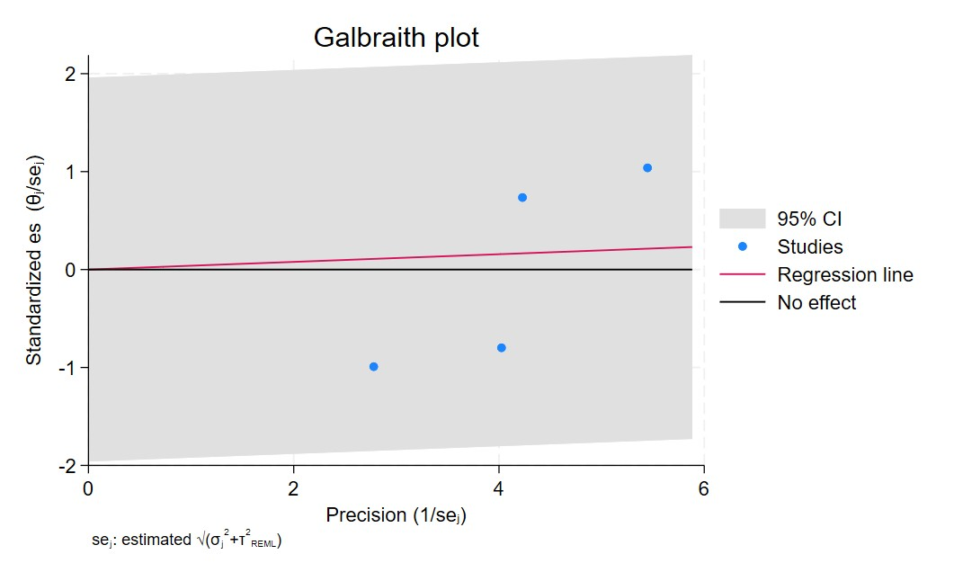
Figure 57. Galbraith plot - Amitriptyline ever used - Odds Ratio
Each study is represented as a point, where the x-axis denotes the precision (defined as the inverse of the standard error), and the y-axis indicates the standardized effect size. The red regression line represents the overall summary effect estimated from the random-effects model, and the gray shaded area corresponds to the confidence interval at 95% around regression line. The horizontal black line at y = 0 corresponds to the line of no effect, serving as a reference.

AMYTRIPTILINE USERS HAZARD RATIO

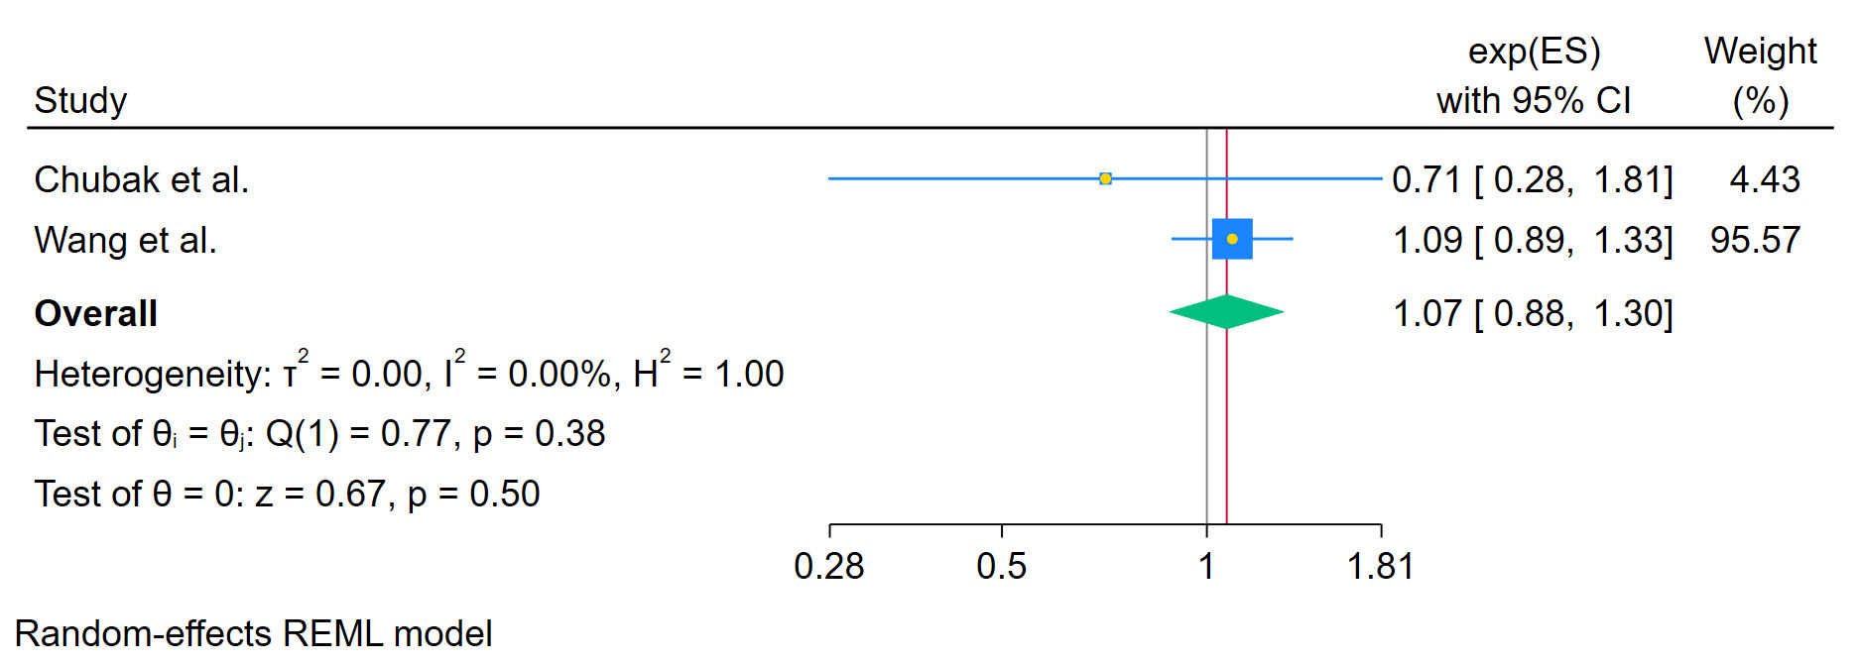
Figure 58. Amitriptyline ever used - Hazard Ratio
The area of each square is proportional to the sample size of the respective study, with horizontal lines through the squares representing the 95% confidence interval (C.I.) for that study. In the pooled analysis, the diamond symbol represents the pooled estimate, with the right and left points of the diamond indicating the 95% C.I. for the overall analysis

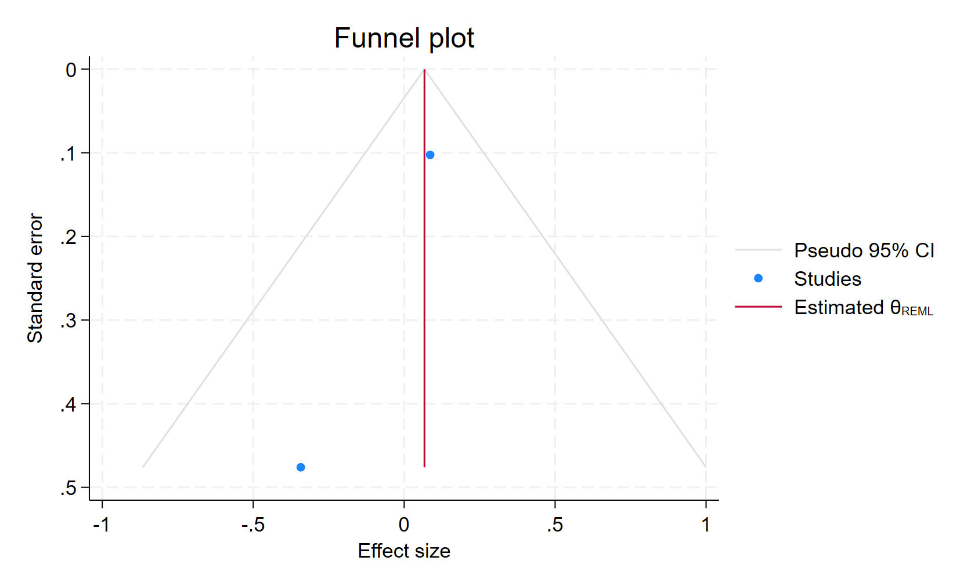
Figure 59. Funnel plot - Amitriptyline ever used - Hazard Ratio
Each blue dot represents a single study, plotted with its effect size on the x-axis and its standard error on the y-axis. The vertical red line represents the overall effect estimate derived from the random-effects model using restricted maximum likelihood (REML). The pseudo 95% confidence interval region, shown as gray diagonal lines, outlines the expected spread of studies in the absence of bias or between-study heterogeneity.

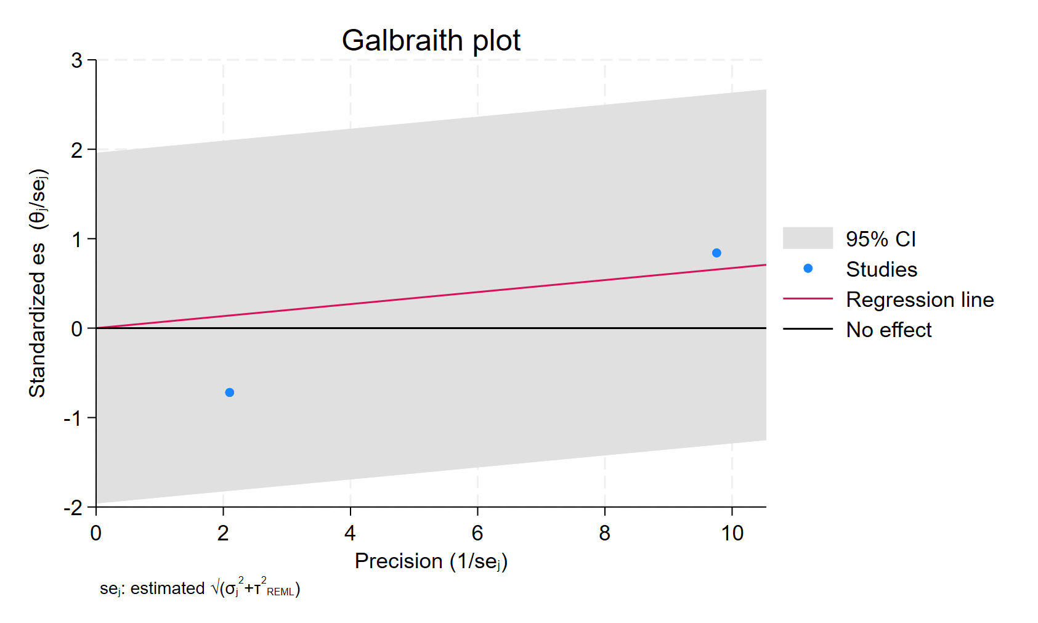
Figure 60. Galbraith plot - Amitriptyline ever used - Hazard Ratio
Each study is represented as a point, where the x-axis denotes the precision (defined as the inverse of the standard error), and the y-axis indicates the standardized effect size. The red regression line represents the overall summary effect estimated from the random-effects model, and the gray shaded area corresponds to the confidence interval at 95% around regression line. The horizontal black line at y = 0 corresponds to the line of no effect, serving as a reference.

DOXEPINE USERS
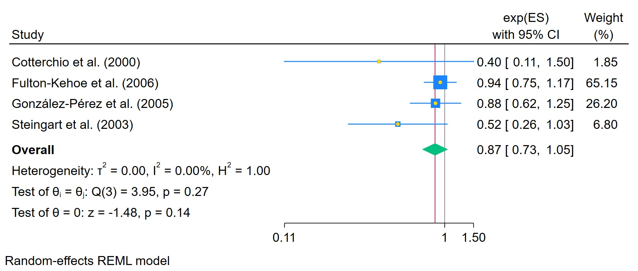
Figure 61. Doxepine ever used
The area of each square is proportional to the sample size of the respective study, with horizontal lines through the squares representing the 95% confidence interval (C.I.) for that study. In the pooled analysis, the diamond symbol represents the pooled estimate, with the right and left points of the diamond indicating the 95% C.I. for the overall analysis

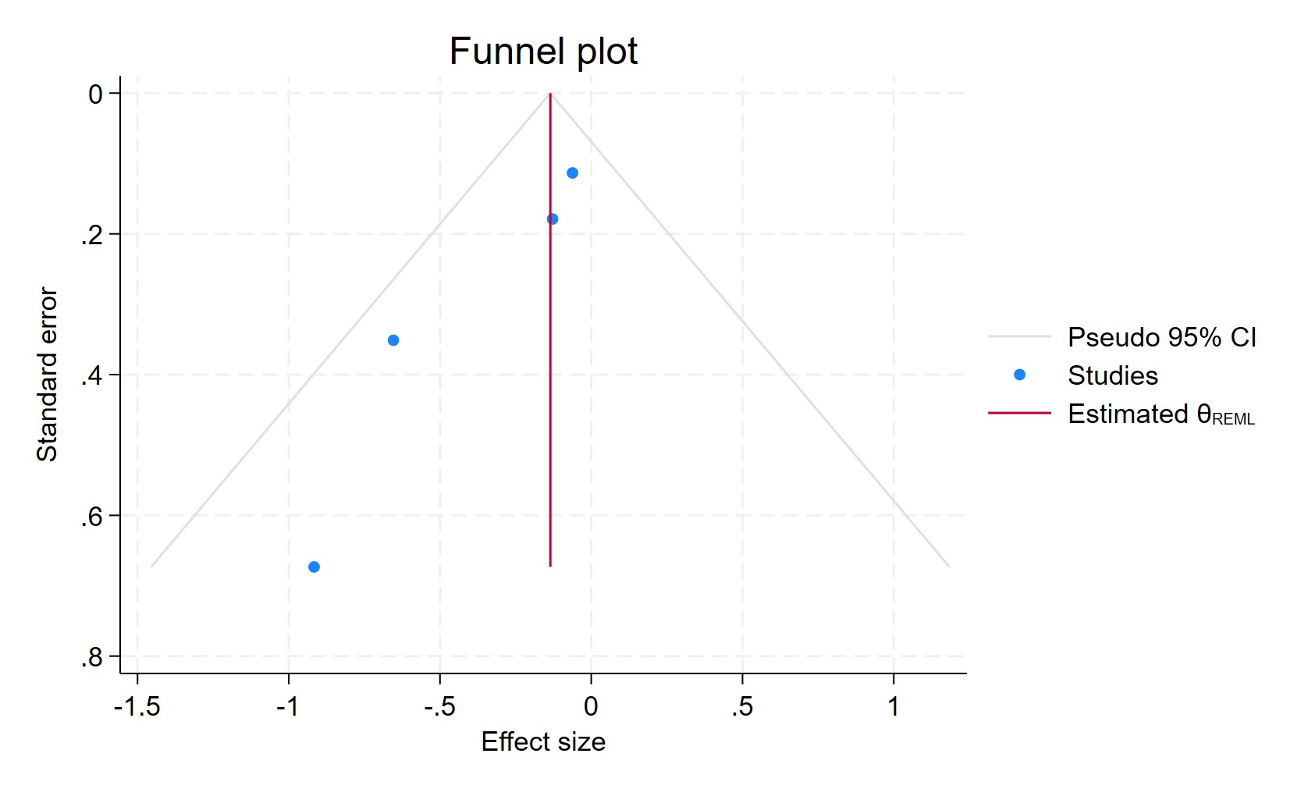
Figure 62. Funnel plot - Doxepine ever used
Each blue dot represents a single study, plotted with its effect size on the x-axis and its standard error on the y-axis. The vertical red line represents the overall effect estimate derived from the random-effects model using restricted maximum likelihood (REML). The pseudo 95% confidence interval region, shown as gray diagonal lines, outlines the expected spread of studies in the absence of bias or between-study heterogeneity.

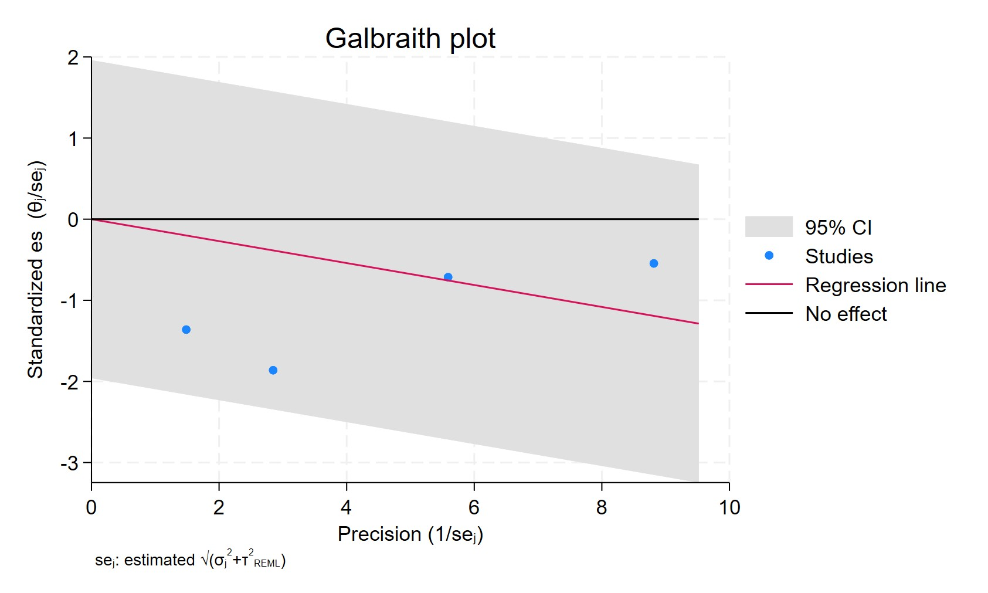
Figure 63. Galbraith plot - Doxepine ever used
Each study is represented as a point, where the x-axis denotes the precision (defined as the inverse of the standard error), and the y-axis indicates the standardized effect size. The red regression line represents the overall summary effect estimated from the random-effects model, and the gray shaded area corresponds to the confidence interval at 95% around regression line. The horizontal black line at y = 0 corresponds to the line of no effect, serving as a reference.

IMIPRAMINE EVER USERS
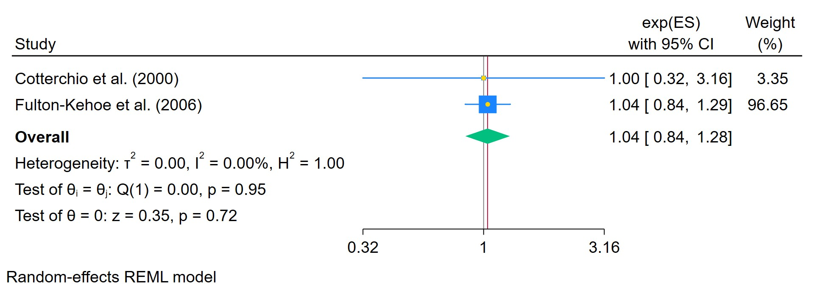
Figure 64. Imipramine ever used
The area of each square is proportional to the sample size of the respective study, with horizontal lines through the squares representing the 95% confidence interval (C.I.) for that study. In the pooled analysis, the diamond symbol represents the pooled estimate, with the right and left points of the diamond indicating the 95% C.I. for the overall analysis

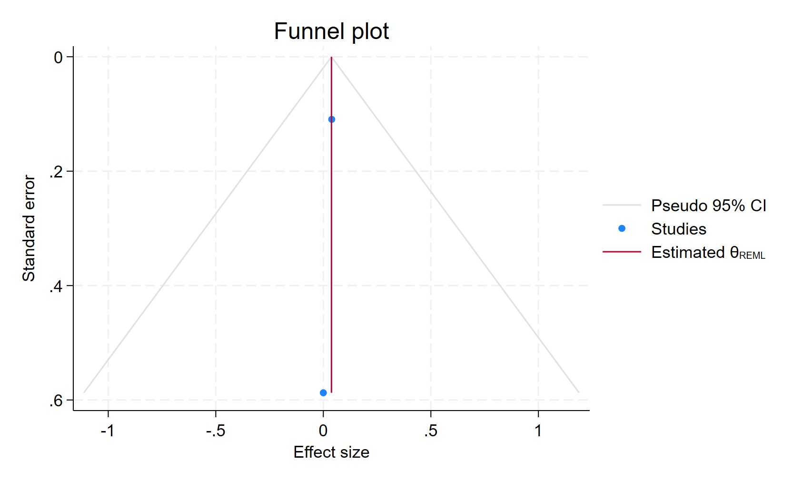
Figure 65. Funnel plot - Imipramine ever used
Each blue dot represents a single study, plotted with its effect size on the x-axis and its standard error on the y-axis. The vertical red line represents the overall effect estimate derived from the random-effects model using restricted maximum likelihood (REML). The pseudo 95% confidence interval region, shown as gray diagonal lines, outlines the expected spread of studies in the absence of bias or between-study heterogeneity.

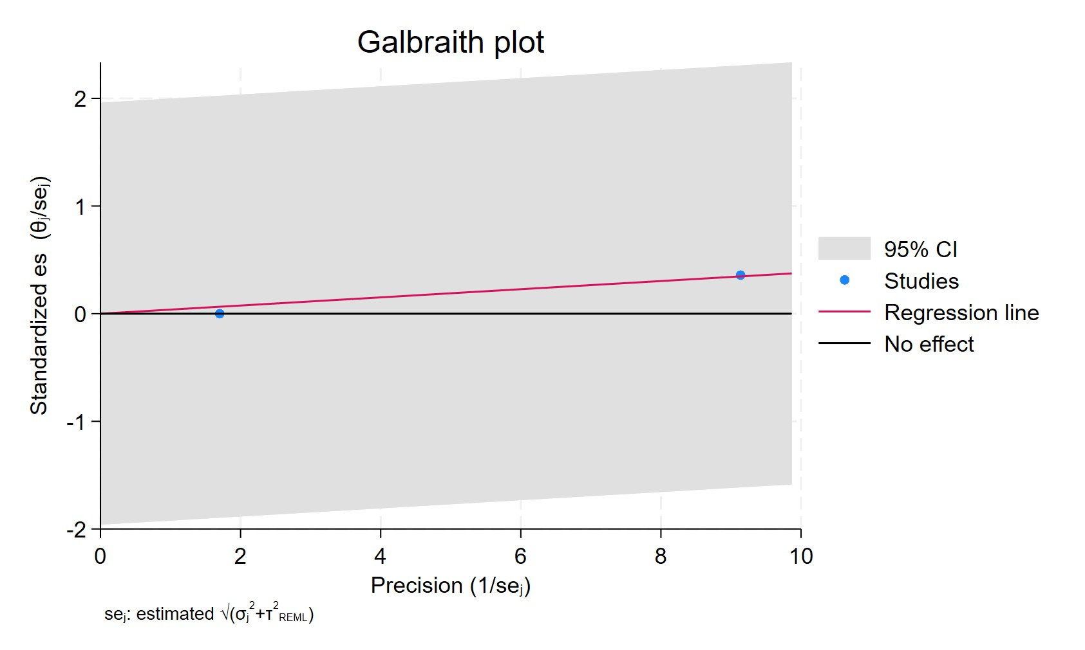
Figure 66. Galbraith plot - Imipramine ever used
Each study is represented as a point, where the x-axis denotes the precision (defined as the inverse of the standard error), and the y-axis indicates the standardized effect size. The red regression line represents the overall summary effect estimated from the random-effects model, and the gray shaded area corresponds to the confidence interval at 95% around regression line. The horizontal black line at y = 0 corresponds to the line of no effect, serving as a reference.

EVER USED SSRI
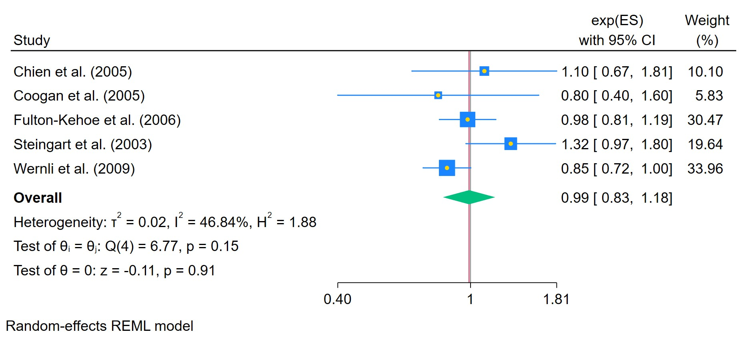
Figure 67. SSRIs ever used
The area of each square is proportional to the sample size of the respective study, with horizontal lines through the squares representing the 95% confidence interval (C.I.) for that study. In the pooled analysis, the diamond symbol represents the pooled estimate, with the right and left points of the diamond indicating the 95% C.I. for the overall analysis

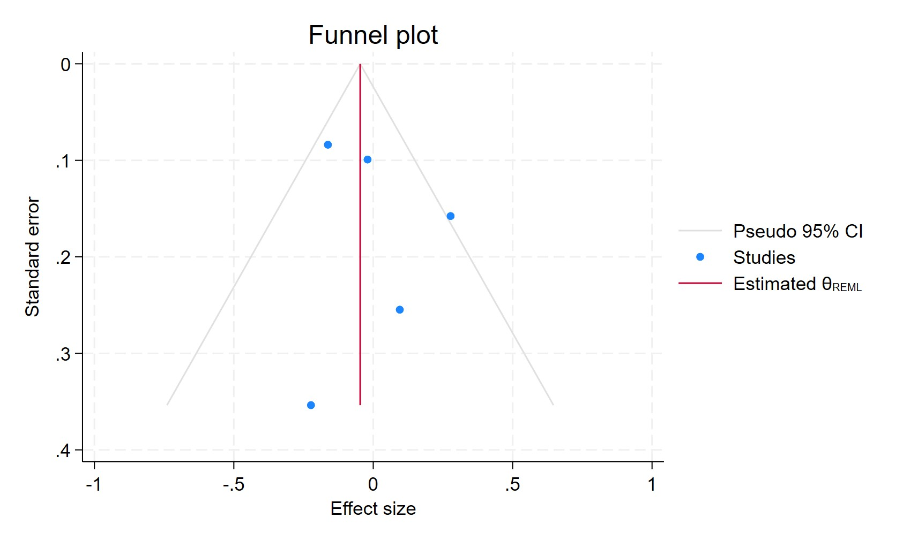
Figure 68. Funnel plot - SSRIs ever used
Each blue dot represents a single study, plotted with its effect size on the x-axis and its standard error on the y-axis. The vertical red line represents the overall effect estimate derived from the random-effects model using restricted maximum likelihood (REML). The pseudo 95% confidence interval region, shown as gray diagonal lines, outlines the expected spread of studies in the absence of bias or between-study heterogeneity.

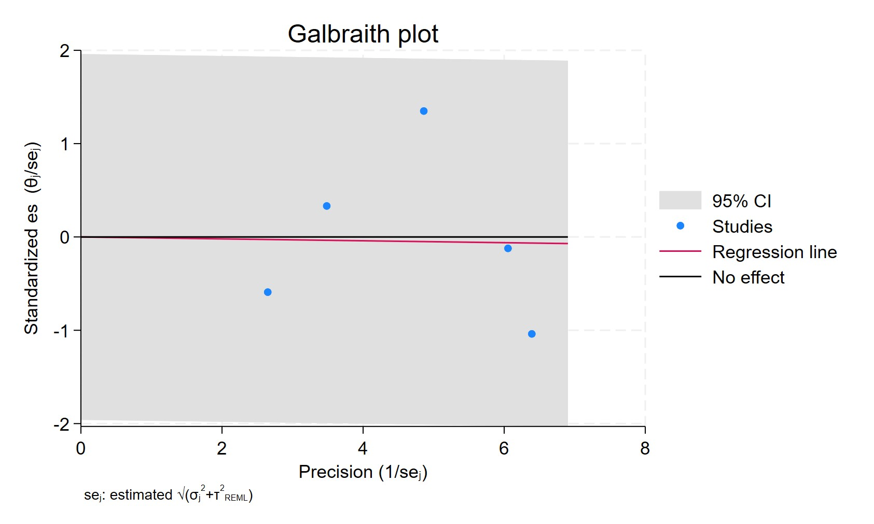
Figure 69. Galbraith plot - SSRIs ever used
Each study is represented as a point, where the x-axis denotes the precision (defined as the inverse of the standard error), and the y-axis indicates the standardized effect size. The red regression line represents the overall summary effect estimated from the random-effects model, and the gray shaded area corresponds to the confidence interval at 95% around regression line. The horizontal black line at y = 0 corresponds to the line of no effect, serving as a reference.

SSRI USERS IN DEPRESSIVE SYNTOMS HAZARD RATIO
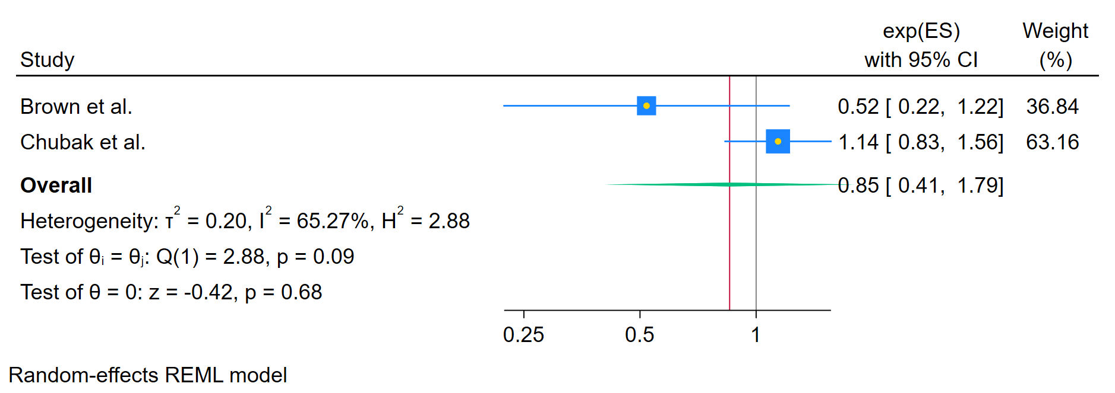
Figure 70. SSRIs used in patients with depressive syntoms
The area of each square is proportional to the sample size of the respective study, with horizontal lines through the squares representing the 95% confidence interval (C.I.) for that study. In the pooled analysis, the diamond symbol represents the pooled estimate, with the right and left points of the diamond indicating the 95% C.I. for the overall analysis

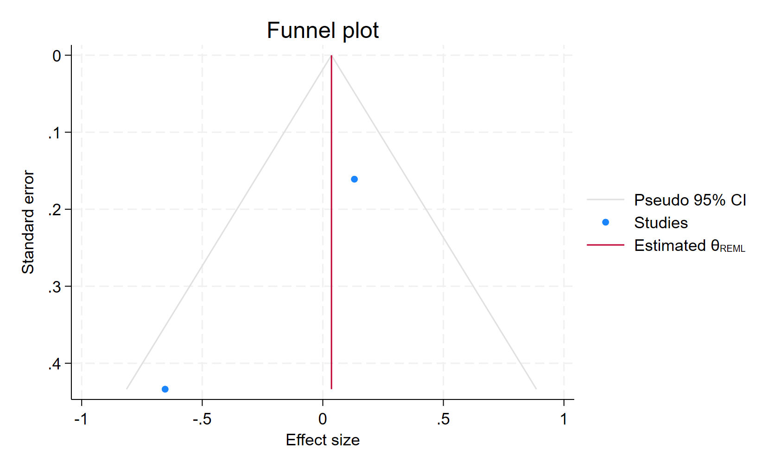
Figure 71. Funnel plot - SSRIs used in patients with depressive syntoms
Each blue dot represents a single study, plotted with its effect size on the x-axis and its standard error on the y-axis. The vertical red line represents the overall effect estimate derived from the random-effects model using restricted maximum likelihood (REML). The pseudo 95% confidence interval region, shown as gray diagonal lines, outlines the expected spread of studies in the absence of bias or between-study heterogeneity.

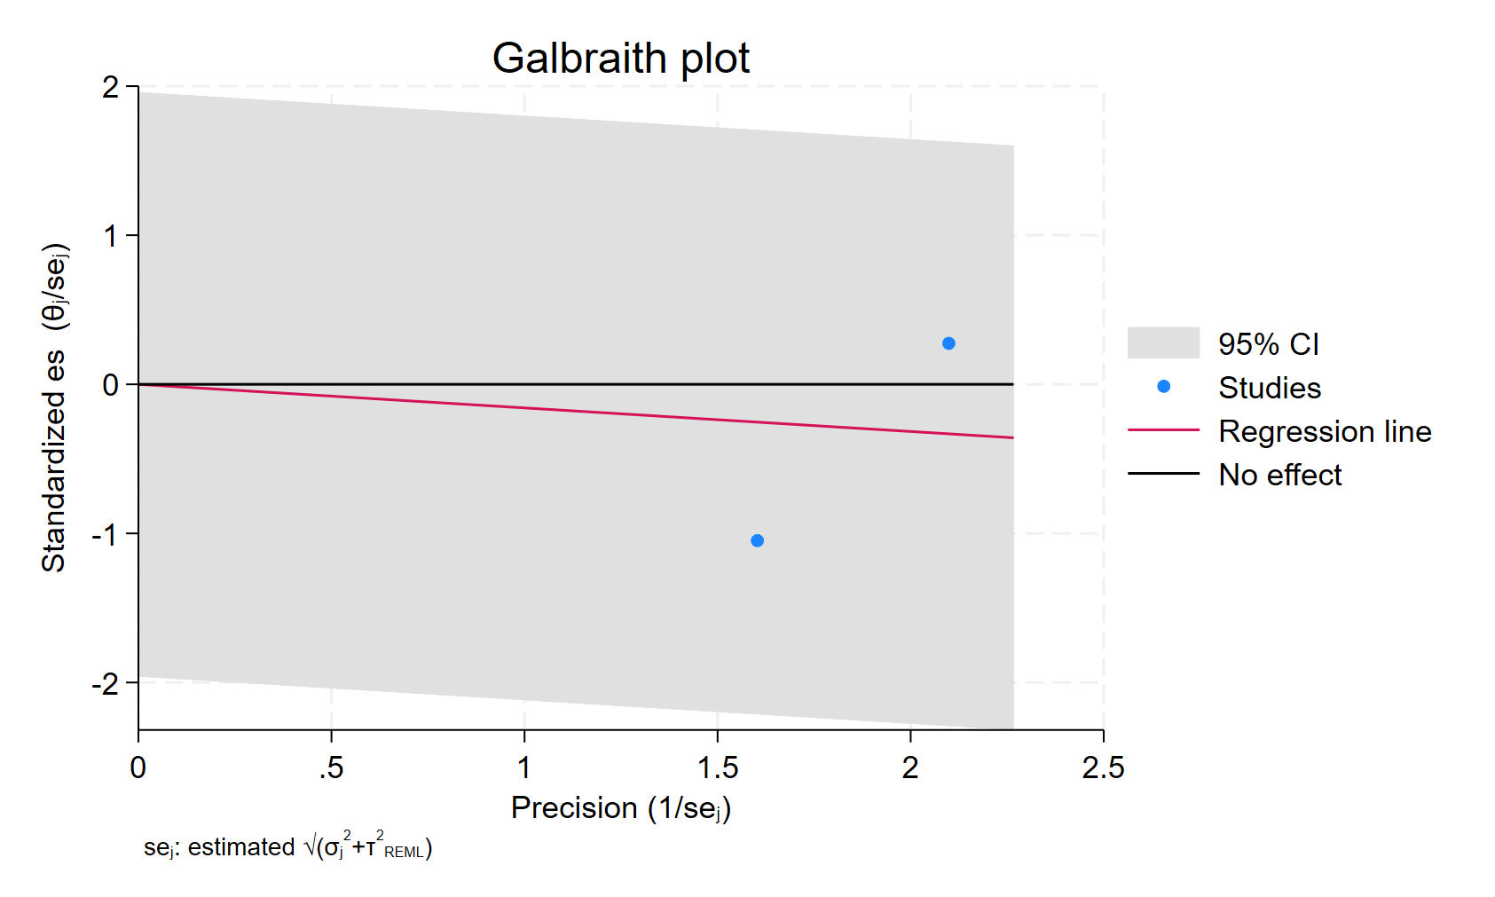
Figure 72. Galbraith plot - SSRIs used in patients with depressive syntoms
Each study is represented as a point, where the x-axis denotes the precision (defined as the inverse of the standard error), and the y-axis indicates the standardized effect size. The red regression line represents the overall summary effect estimated from the random-effects model, and the gray shaded area corresponds to the confidence interval at 95% around regression line. The horizontal black line at y = 0 corresponds to the line of no effect, serving as a reference.

SSRI USER IN FORMER PATIENTS
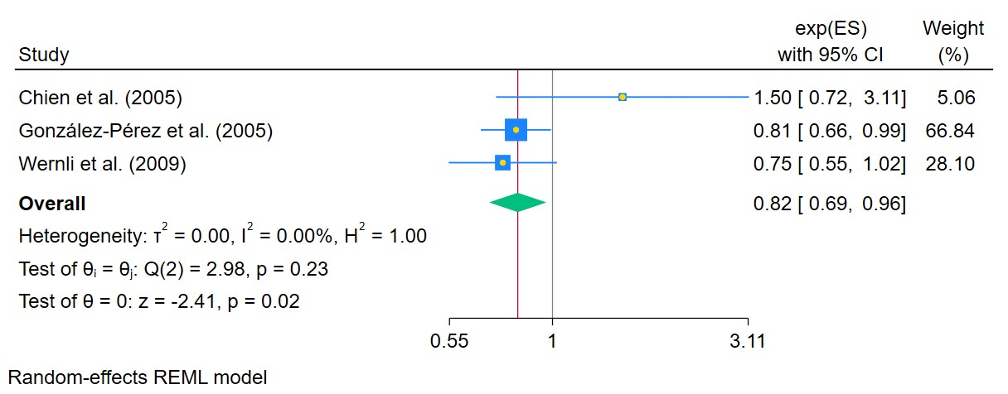
Figure 73. SSRIs used in former patients
The area of each square is proportional to the sample size of the respective study, with horizontal lines through the squares representing the 95% confidence interval (C.I.) for that study. In the pooled analysis, the diamond symbol represents the pooled estimate, with the right and left points of the diamond indicating the 95% C.I. for the overall analysis

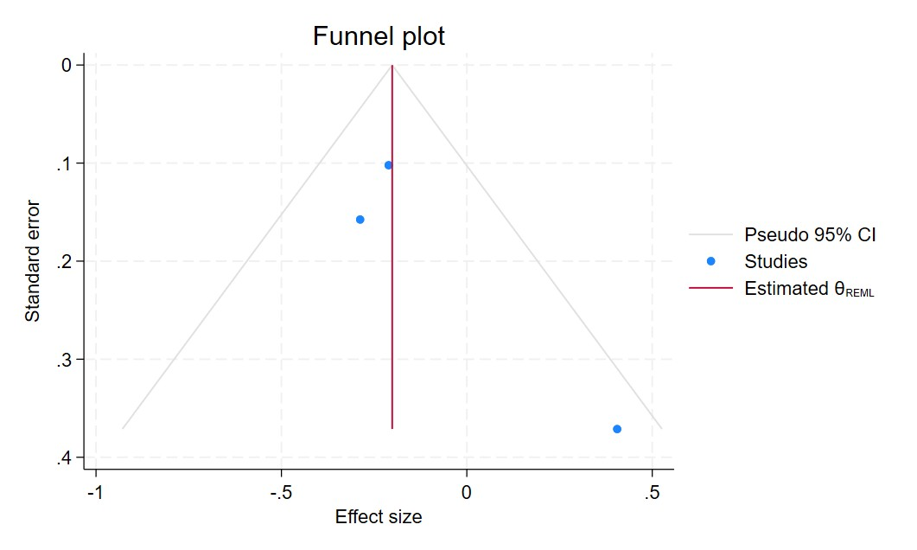
Figure 74. Funnel plot - SSRIs used in former patients
Each blue dot represents a single study, plotted with its effect size on the x-axis and its standard error on the y-axis. The vertical red line represents the overall effect estimate derived from the random-effects model using restricted maximum likelihood (REML). The pseudo 95% confidence interval region, shown as gray diagonal lines, outlines the expected spread of studies in the absence of bias or between-study heterogeneity.

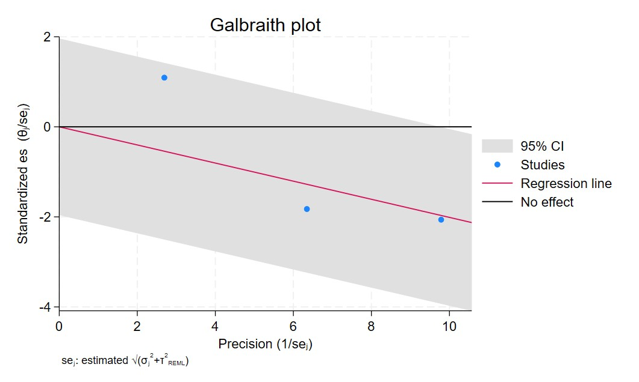
Figure 75. Galbraith plot - SSRIs used in former patients
Each study is represented as a point, where the x-axis denotes the precision (defined as the inverse of the standard error), and the y-axis indicates the standardized effect size. The red regression line represents the overall summary effect estimated from the random-effects model, and the gray shaded area corresponds to the confidence interval at 95% around regression line. The horizontal black line at y = 0 corresponds to the line of no effect, serving as a reference.

CURRENT SSRI USERS LESS THAN 1 YEAR
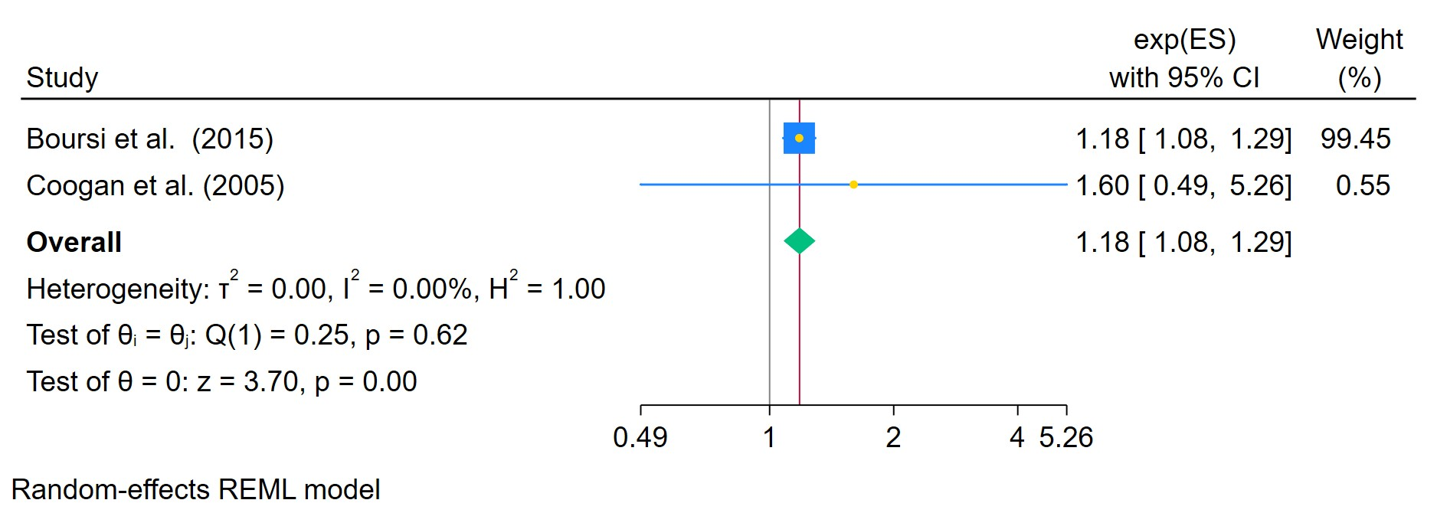
Figure 76. SSRIs used for less than 1 year in current patients
The area of each square is proportional to the sample size of the respective study, with horizontal lines through the squares representing the 95% confidence interval (C.I.) for that study. In the pooled analysis, the diamond symbol represents the pooled estimate, with the right and left points of the diamond indicating the 95% C.I. for the overall analysis

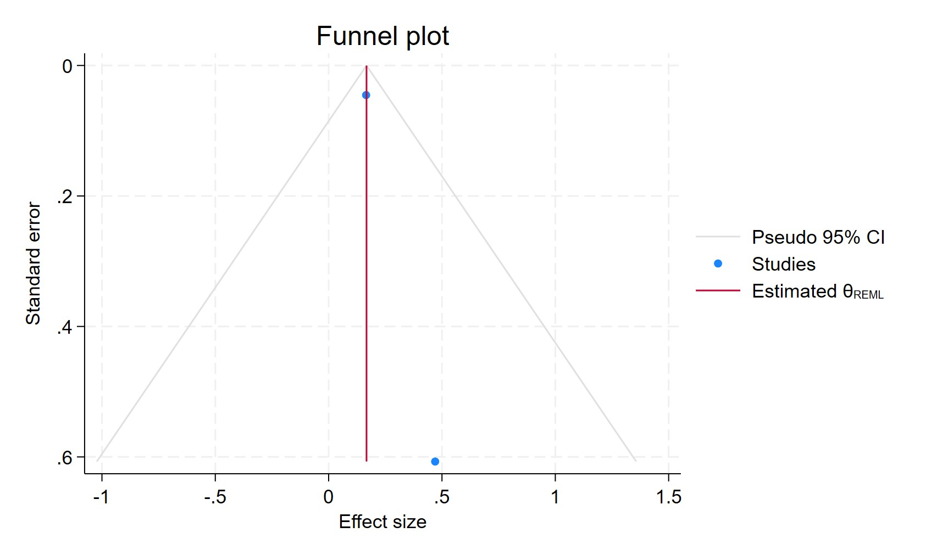
Figure 77. Funnel plot - SSRIs used for less than 1 year in current patients
Each blue dot represents a single study, plotted with its effect size on the x-axis and its standard error on the y-axis. The vertical red line represents the overall effect estimate derived from the random-effects model using restricted maximum likelihood (REML). The pseudo 95% confidence interval region, shown as gray diagonal lines, outlines the expected spread of studies in the absence of bias or between-study heterogeneity.

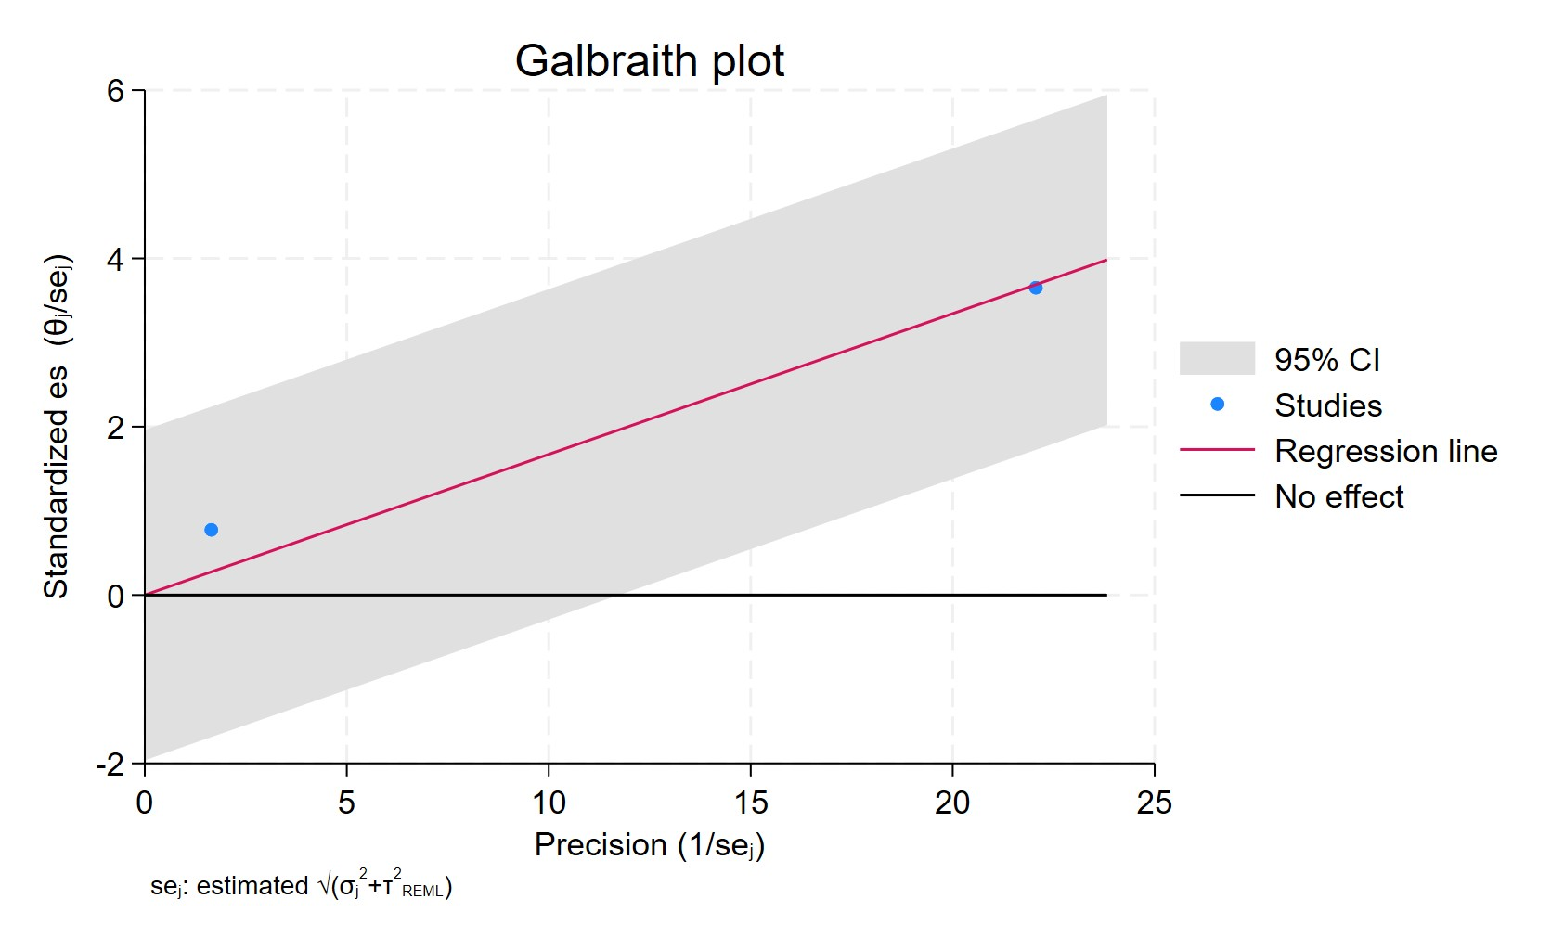
Figure 78. Galbraith plot - SSRIs used for less than 1 year in current patients
Each study is represented as a point, where the x-axis denotes the precision (defined as the inverse of the standard error), and the y-axis indicates the standardized effect size. The red regression line represents the overall summary effect estimated from the random-effects model, and the gray shaded area corresponds to the confidence interval at 95% around regression line. The horizontal black line at y = 0 corresponds to the line of no effect, serving as a reference.

SSRI USERS FOR LESS THAN 2 YEARS
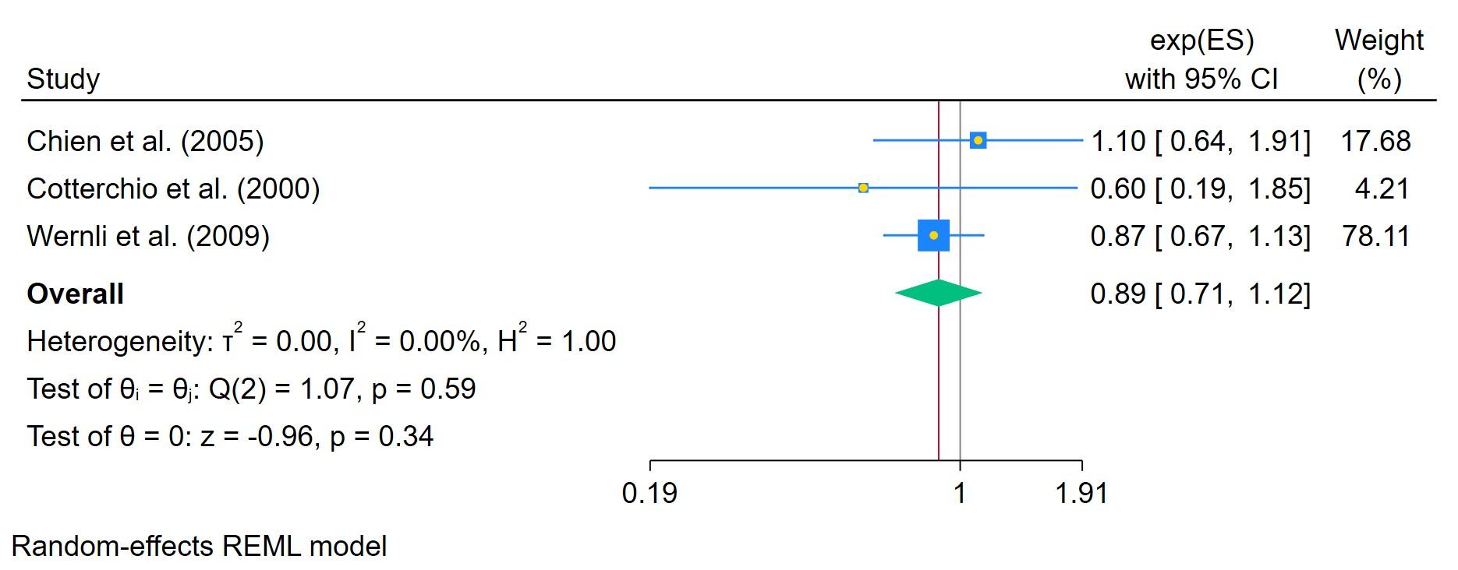
Figure 79. SSRIs used for less than 2 years
The area of each square is proportional to the sample size of the respective study, with horizontal lines through the squares representing the 95% confidence interval (C.I.) for that study. In the pooled analysis, the diamond symbol represents the pooled estimate, with the right and left points of the diamond indicating the 95% C.I. for the overall analysis

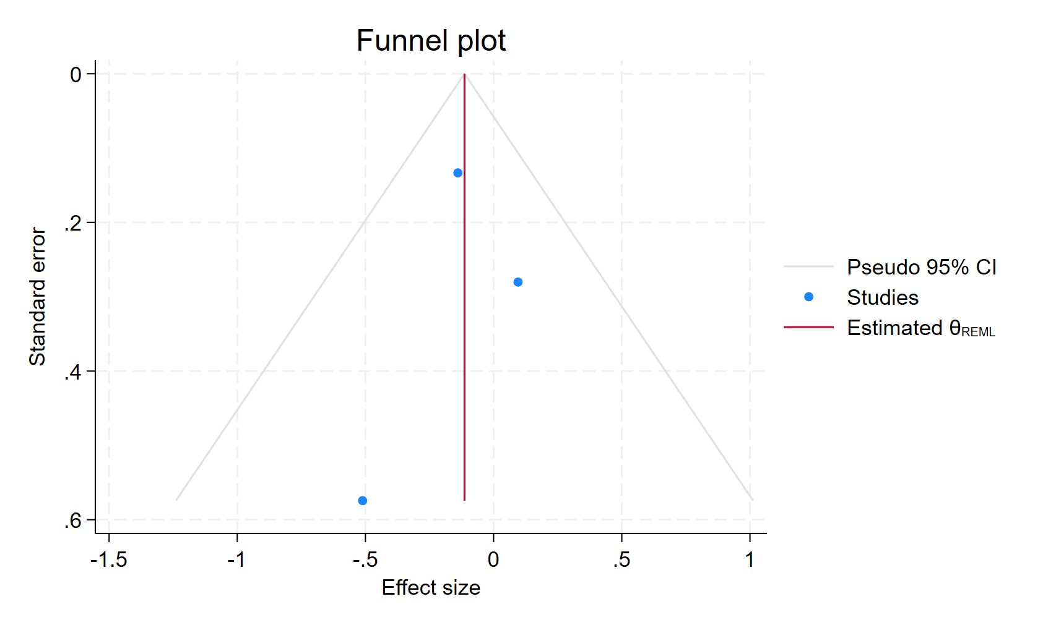
Figure 80. Funnel plot - SSRIs used for less than 2 years
Each blue dot represents a single study, plotted with its effect size on the x-axis and its standard error on the y-axis. The vertical red line represents the overall effect estimate derived from the random-effects model using restricted maximum likelihood (REML). The pseudo 95% confidence interval region, shown as gray diagonal lines, outlines the expected spread of studies in the absence of bias or between-study heterogeneity.

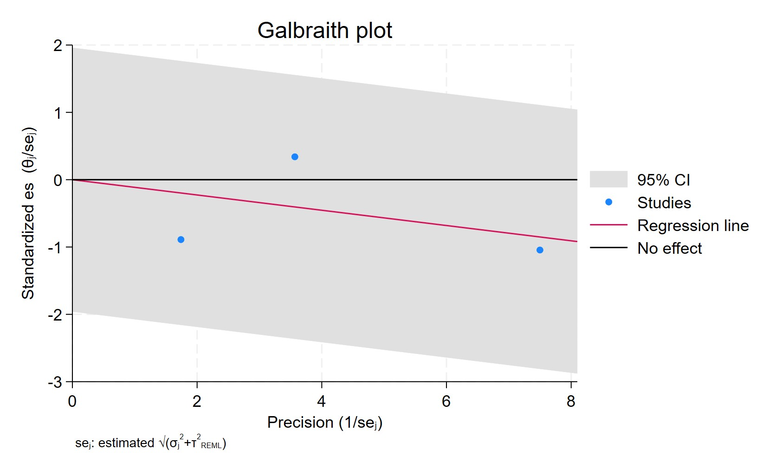
Figure 81. Galbraith plot - SSRIs used for less than 2 years
Each study is represented as a point, where the x-axis denotes the precision (defined as the inverse of the standard error), and the y-axis indicates the standardized effect size. The red regression line represents the overall summary effect estimated from the random-effects model, and the gray shaded area corresponds to the confidence interval at 95% around regression line. The horizontal black line at y = 0 corresponds to the line of no effect, serving as a reference.

SSRI USERS MORE THAN 2 YEARS
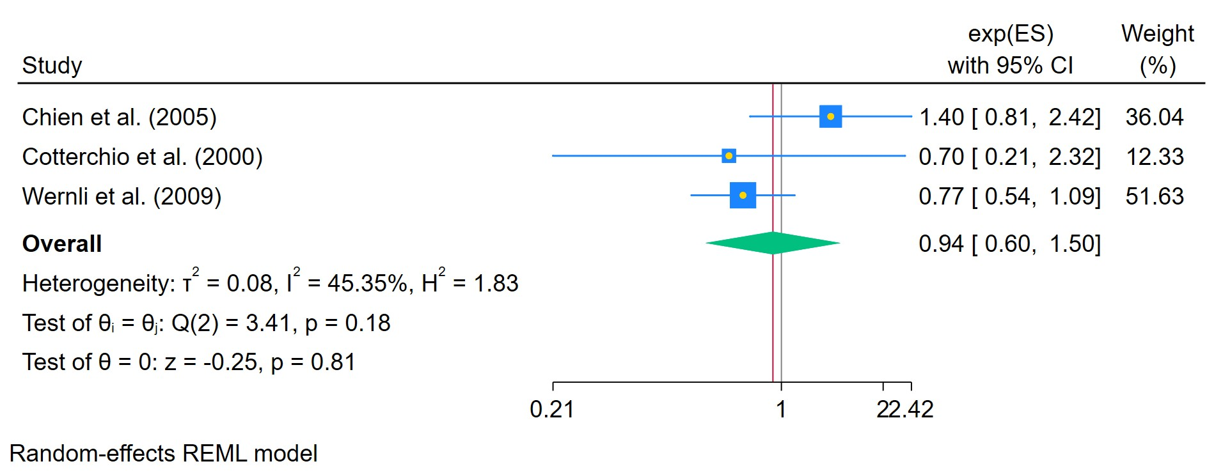
Figure 82. SSRIs used for more than 2 years
The area of each square is proportional to the sample size of the respective study, with horizontal lines through the squares representing the 95% confidence interval (C.I.) for that study. In the pooled analysis, the diamond symbol represents the pooled estimate, with the right and left points of the diamond indicating the 95% C.I. for the overall analysis

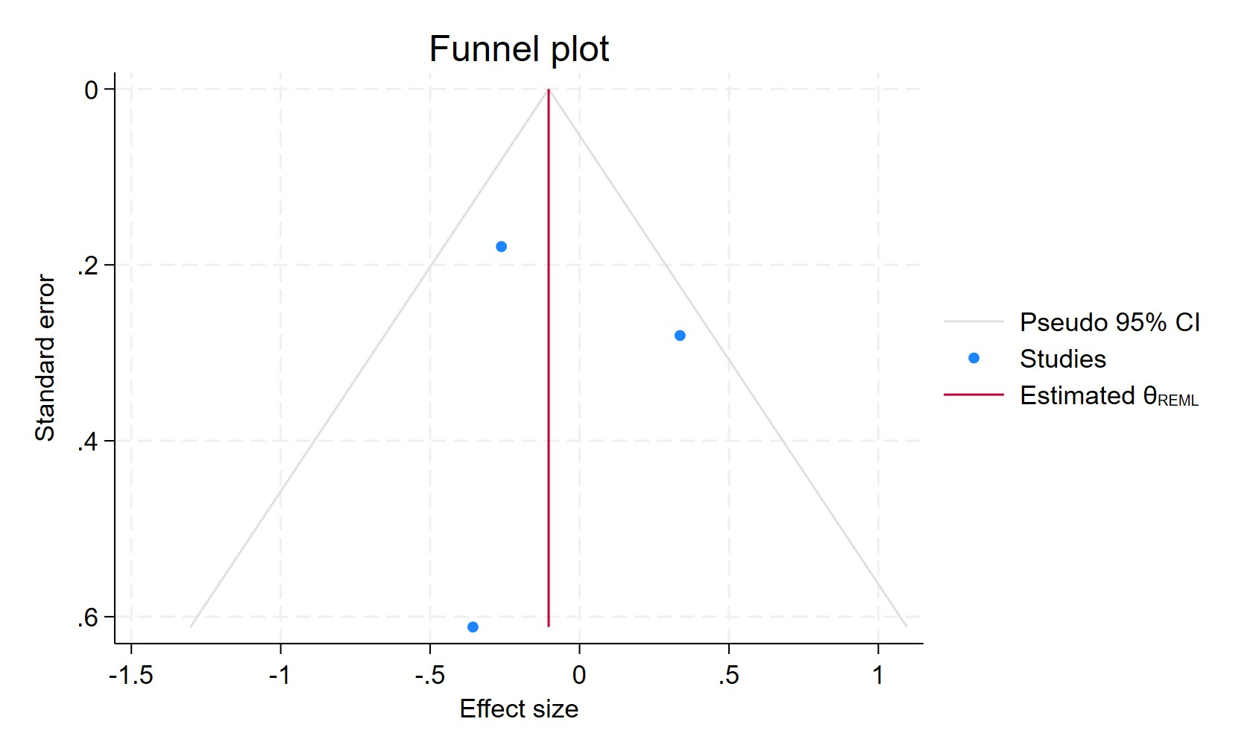
Figure 83. Funnel plot - SSRIs used for more than 2 years
Each blue dot represents a single study, plotted with its effect size on the x-axis and its standard error on the y-axis. The vertical red line represents the overall effect estimate derived from the random-effects model using restricted maximum likelihood (REML). The pseudo 95% confidence interval region, shown as gray diagonal lines, outlines the expected spread of studies in the absence of bias or between-study heterogeneity.

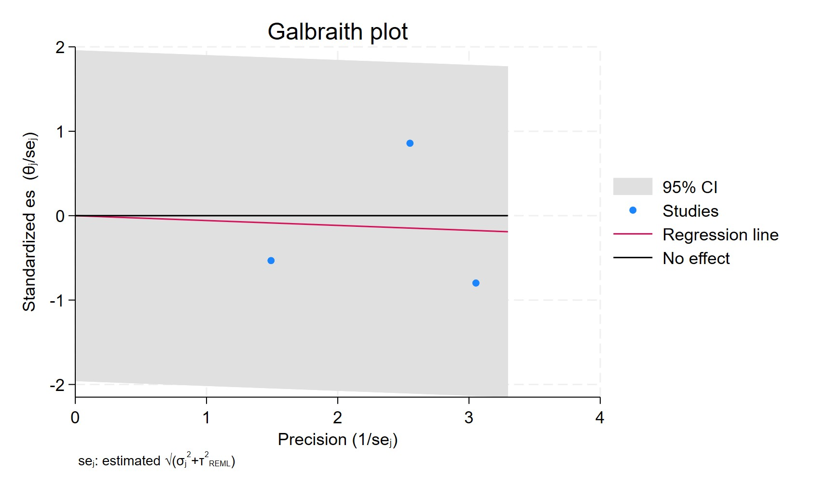
Figure 84. Galbraith plot - SSRIs used for more than 2 years
Each study is represented as a point, where the x-axis denotes the precision (defined as the inverse of the standard error), and the y-axis indicates the standardized effect size. The red regression line represents the overall summary effect estimated from the random-effects model, and the gray shaded area corresponds to the confidence interval at 95% around regression line. The horizontal black line at y = 0 corresponds to the line of no effect, serving as a reference.

SSRI CUMULATIVE DURATION 0-1 YEARS
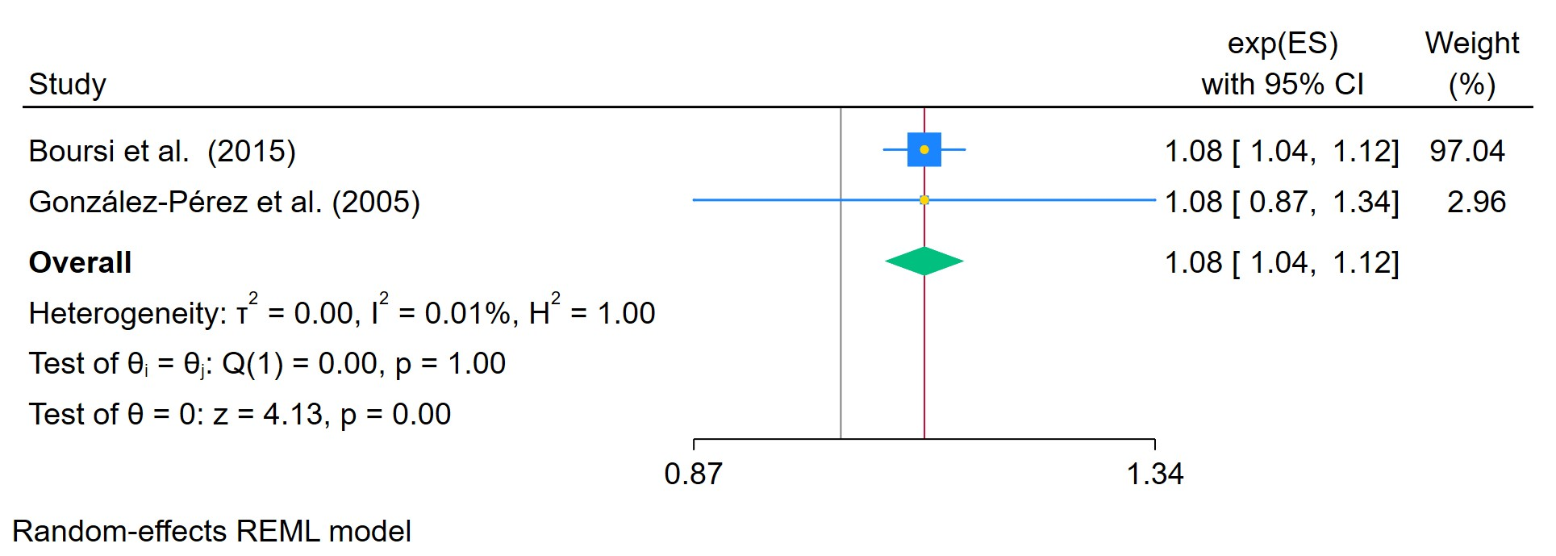
Figure 85. SSRIs used for a period between 0-1 year
The area of each square is proportional to the sample size of the respective study, with horizontal lines through the squares representing the 95% confidence interval (C.I.) for that study. In the pooled analysis, the diamond symbol represents the pooled estimate, with the right and left points of the diamond indicating the 95% C.I. for the overall analysis

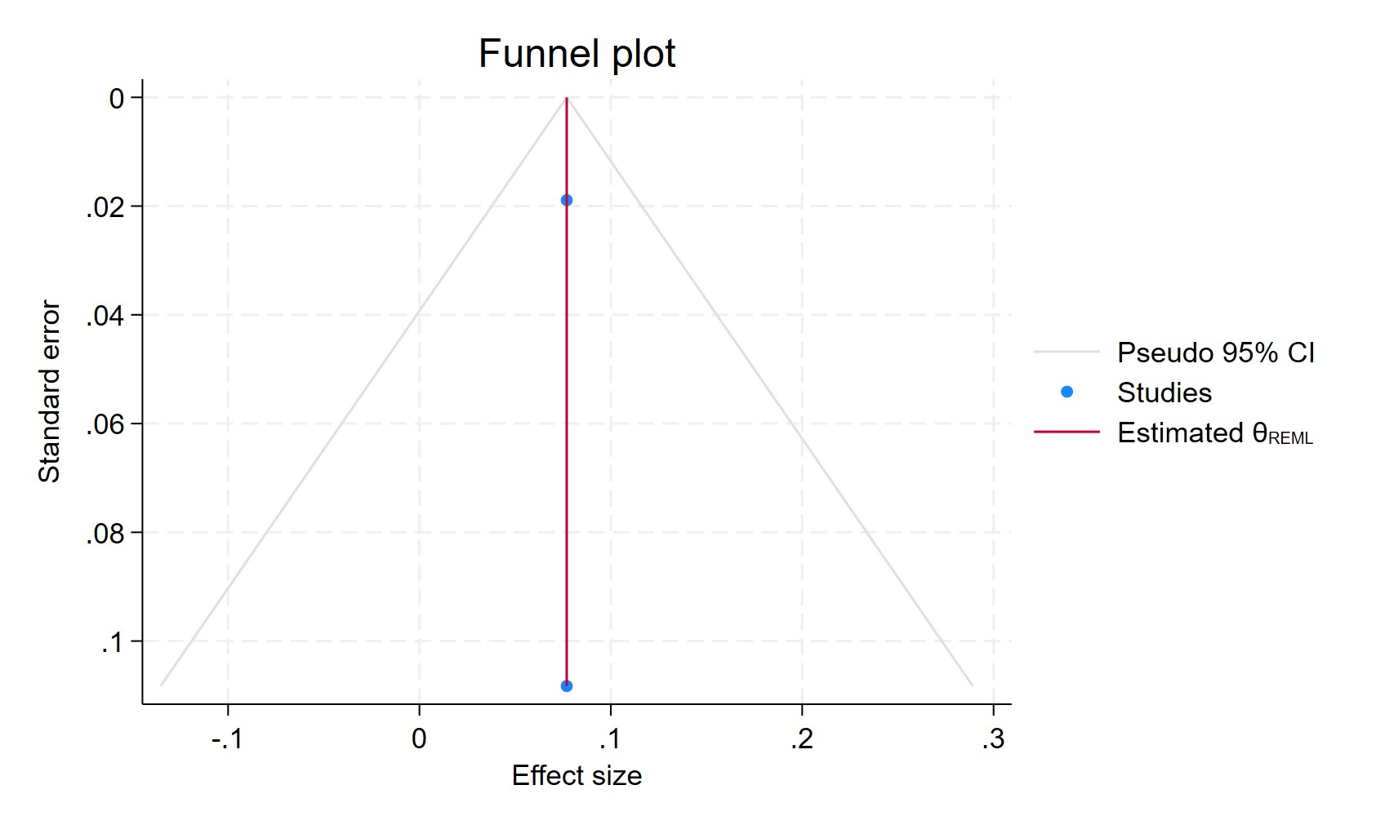
Figure 86. Funnel plot -SSRIs used for a period between 0-1 year
Each blue dot represents a single study, plotted with its effect size on the x-axis and its standard error on the y-axis. The vertical red line represents the overall effect estimate derived from the random-effects model using restricted maximum likelihood (REML). The pseudo 95% confidence interval region, shown as gray diagonal lines, outlines the expected spread of studies in the absence of bias or between-study heterogeneity.

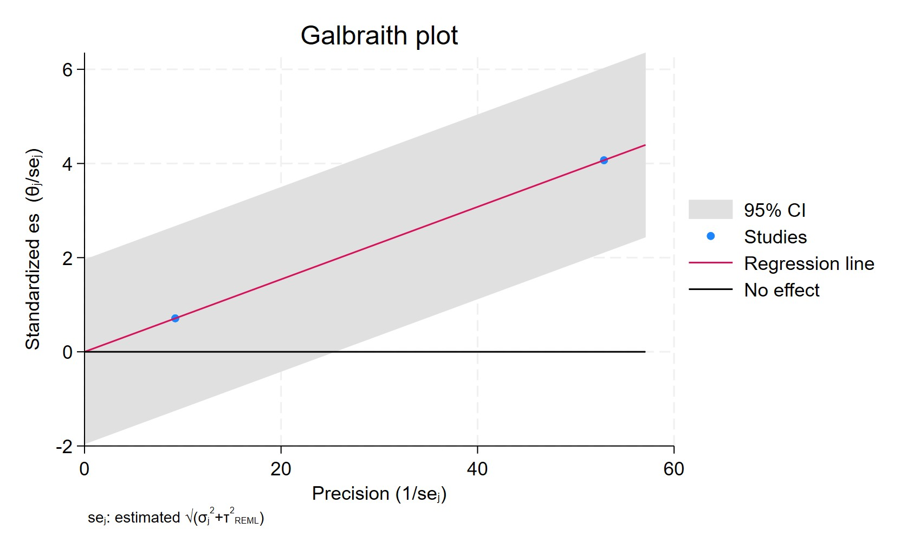
Figure 87. Galbraith plot - SSRIs used for a period between 0-1 year
Each study is represented as a point, where the x-axis denotes the precision (defined as the inverse of the standard error), and the y-axis indicates the standardized effect size. The red regression line represents the overall summary effect estimated from the random-effects model, and the gray shaded area corresponds to the confidence interval at 95% around regression line. The horizontal black line at y = 0 corresponds to the line of no effect, serving as a reference.

SSRI CUMULATIVE DURATION 1-3 YEARS
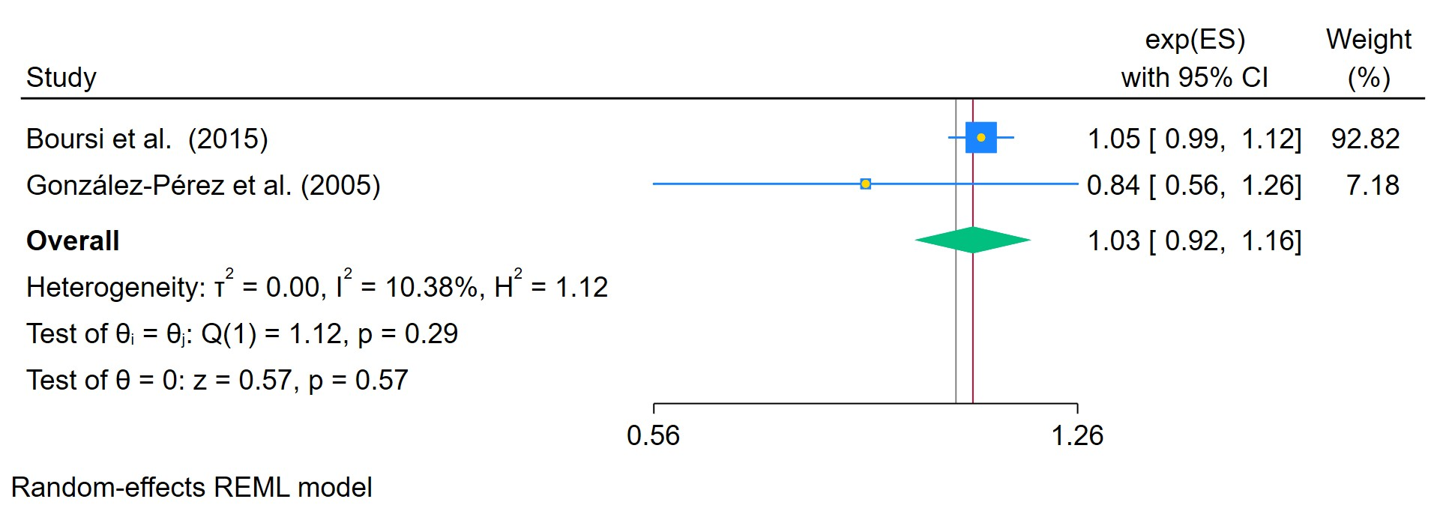
Figure 88. SSRIs used for a period between 1-3 years
The area of each square is proportional to the sample size of the respective study, with horizontal lines through the squares representing the 95% confidence interval (C.I.) for that study. In the pooled analysis, the diamond symbol represents the pooled estimate, with the right and left points of the diamond indicating the 95% C.I. for the overall analysis

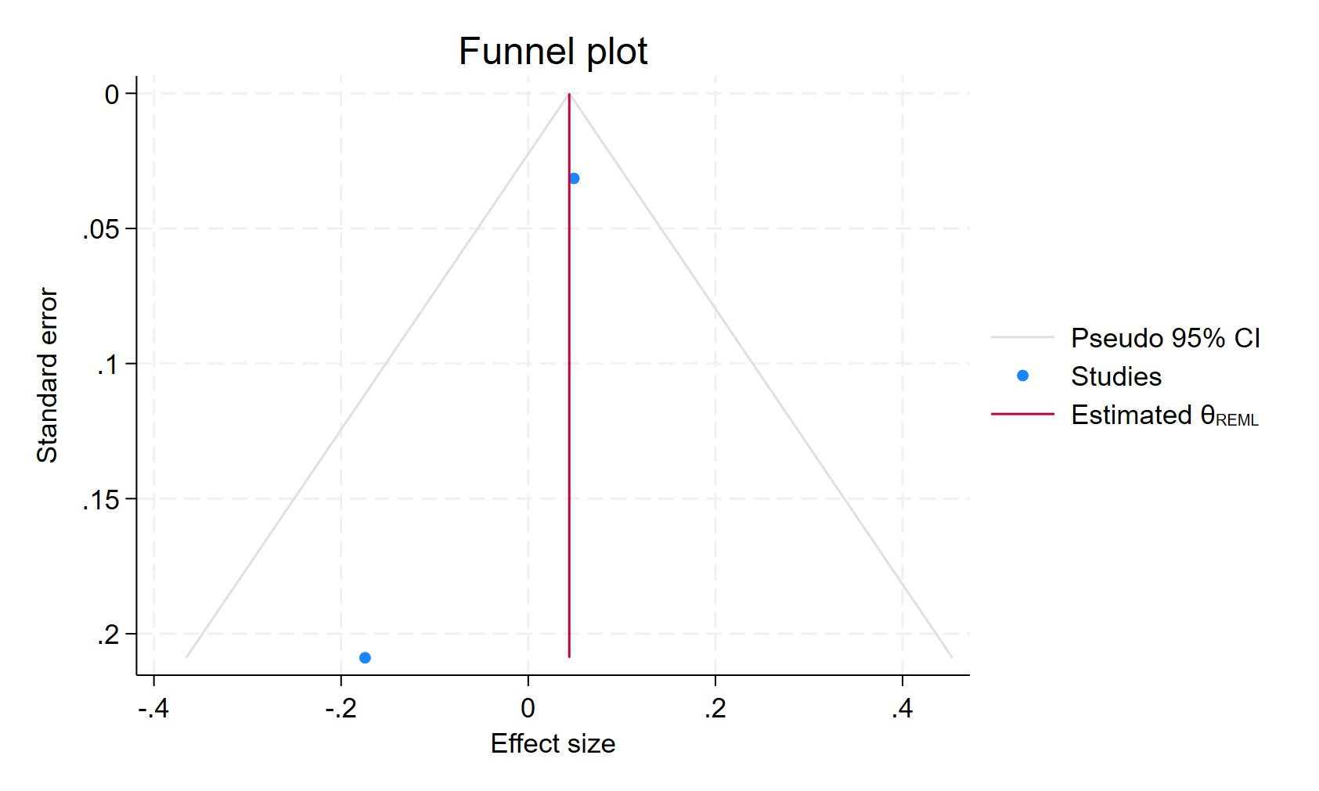
Figure 89. Funnel plot - SSRIs used for a period between 1-3 years
Each blue dot represents a single study, plotted with its effect size on the x-axis and its standard error on the y-axis. The vertical red line represents the overall effect estimate derived from the random-effects model using restricted maximum likelihood (REML). The pseudo 95% confidence interval region, shown as gray diagonal lines, outlines the expected spread of studies in the absence of bias or between-study heterogeneity.

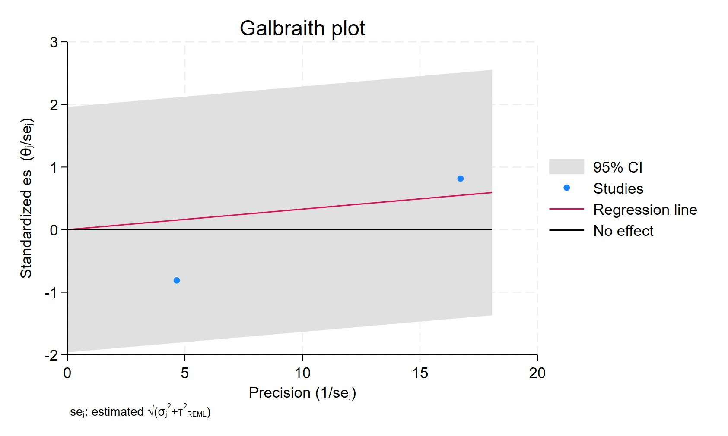
Figure 90. Galbraith plot - SSRIs used for a period between 1-3 years
Each study is represented as a point, where the x-axis denotes the precision (defined as the inverse of the standard error), and the y-axis indicates the standardized effect size. The red regression line represents the overall summary effect estimated from the random-effects model, and the gray shaded area corresponds to the confidence interval at 95% around regression line. The horizontal black line at y = 0 corresponds to the line of no effect, serving as a reference.

SSRI CUMUALTIVE DURATION MORE THAN 3 YEARS
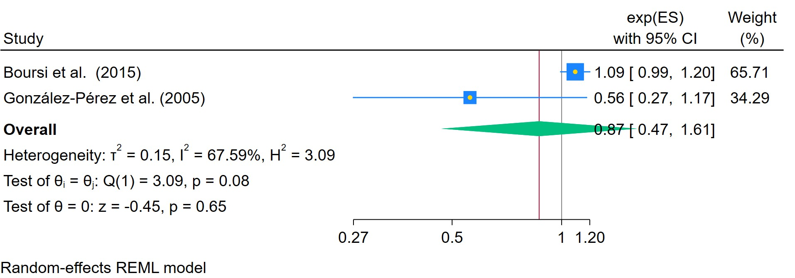
Figure 91. SSRIs used for more than 3 years
The area of each square is proportional to the sample size of the respective study, with horizontal lines through the squares representing the 95% confidence interval (C.I.) for that study. In the pooled analysis, the diamond symbol represents the pooled estimate, with the right and left points of the diamond indicating the 95% C.I. for the overall analysis

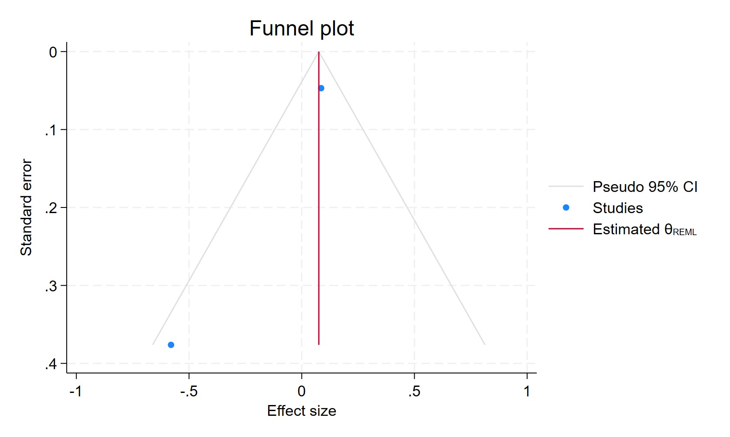
Figure 92. Funnel plot - SSRIs used for more than 3 years
Each blue dot represents a single study, plotted with its effect size on the x-axis and its standard error on the y-axis. The vertical red line represents the overall effect estimate derived from the random-effects model using restricted maximum likelihood (REML). The pseudo 95% confidence interval region, shown as gray diagonal lines, outlines the expected spread of studies in the absence of bias or between-study heterogeneity.

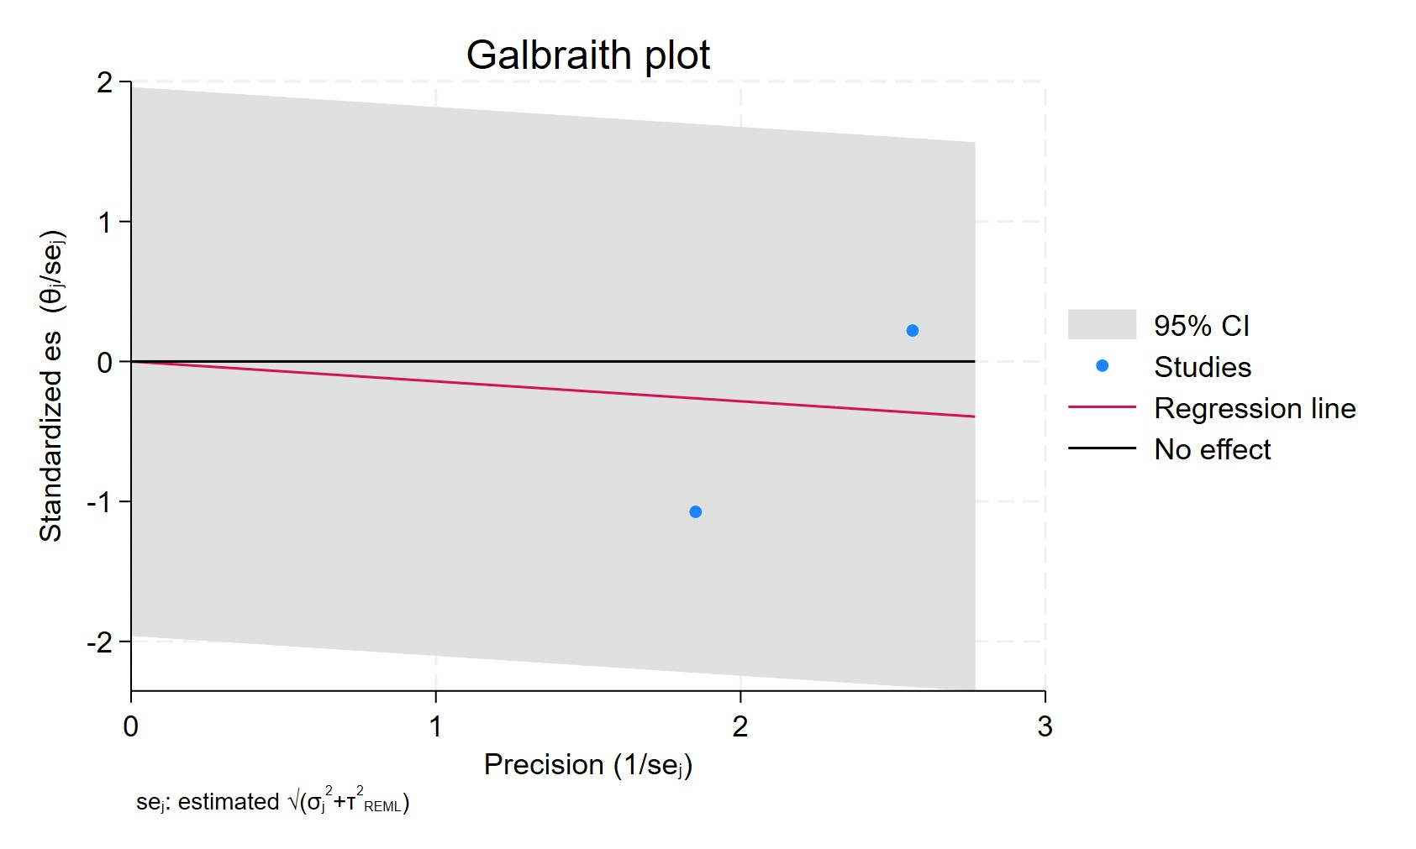
Figure 93. Galbraith plot - SSRIs used for more than 3 years
Each study is represented as a point, where the x-axis denotes the precision (defined as the inverse of the standard error), and the y-axis indicates the standardized effect size. The red regression line represents the overall summary effect estimated from the random-effects model, and the gray shaded area corresponds to the confidence interval at 95% around regression line. The horizontal black line at y = 0 corresponds to the line of no effect, serving as a reference.

SSRI USERS IN ER POSITIVE
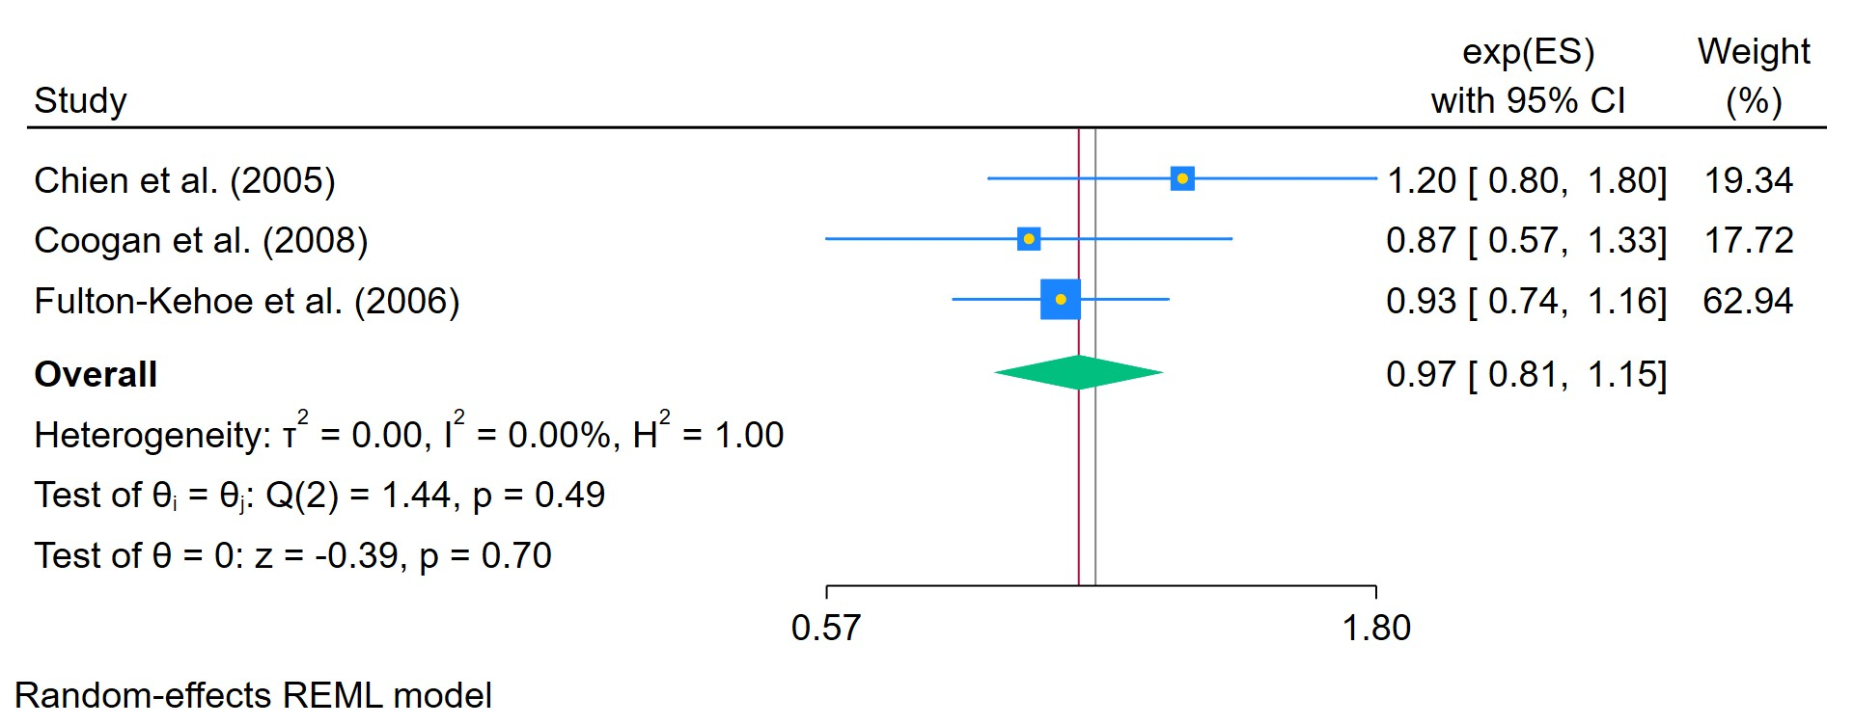
Figure 94. SSRIs used in ER positive breast cancer
The area of each square is proportional to the sample size of the respective study, with horizontal lines through the squares representing the 95% confidence interval (C.I.) for that study. In the pooled analysis, the diamond symbol represents the pooled estimate, with the right and left points of the diamond indicating the 95% C.I. for the overall analysis

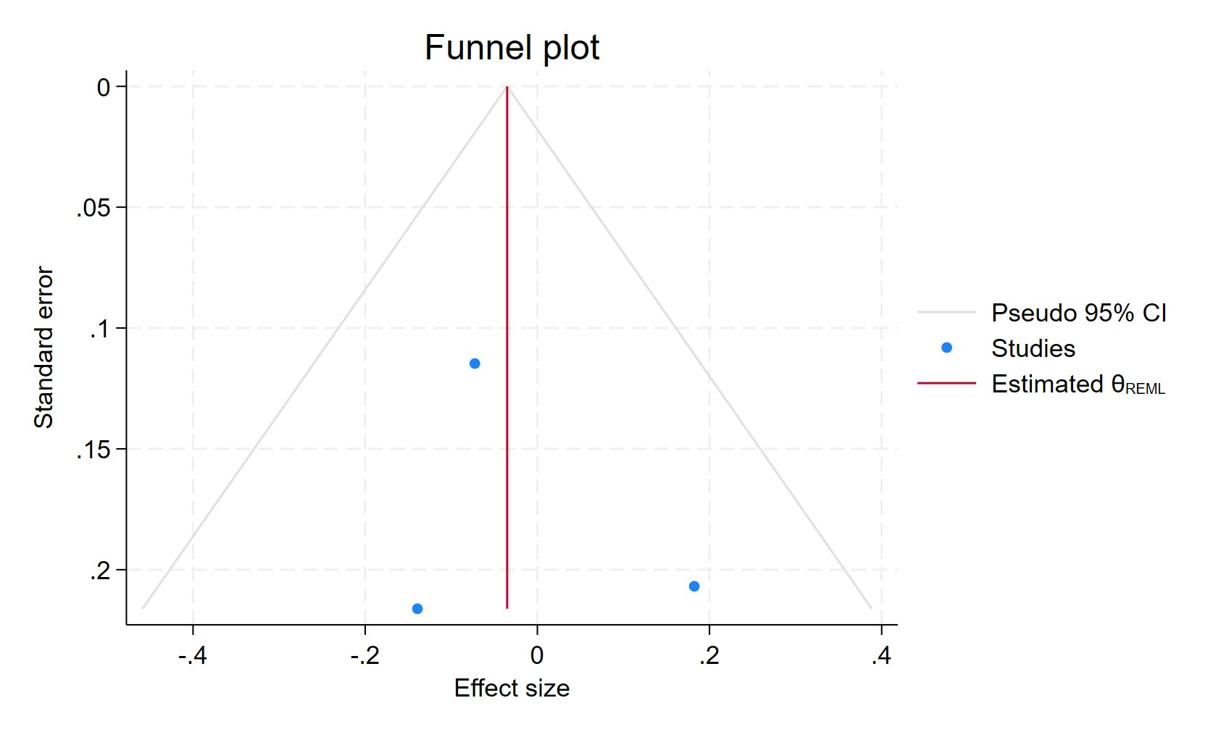
Figure 95. Funnel plot - SSRIs used in ER positive breast cancer
Each blue dot represents a single study, plotted with its effect size on the x-axis and its standard error on the y-axis. The vertical red line represents the overall effect estimate derived from the random-effects model using restricted maximum likelihood (REML). The pseudo 95% confidence interval region, shown as gray diagonal lines, outlines the expected spread of studies in the absence of bias or between-study heterogeneity.

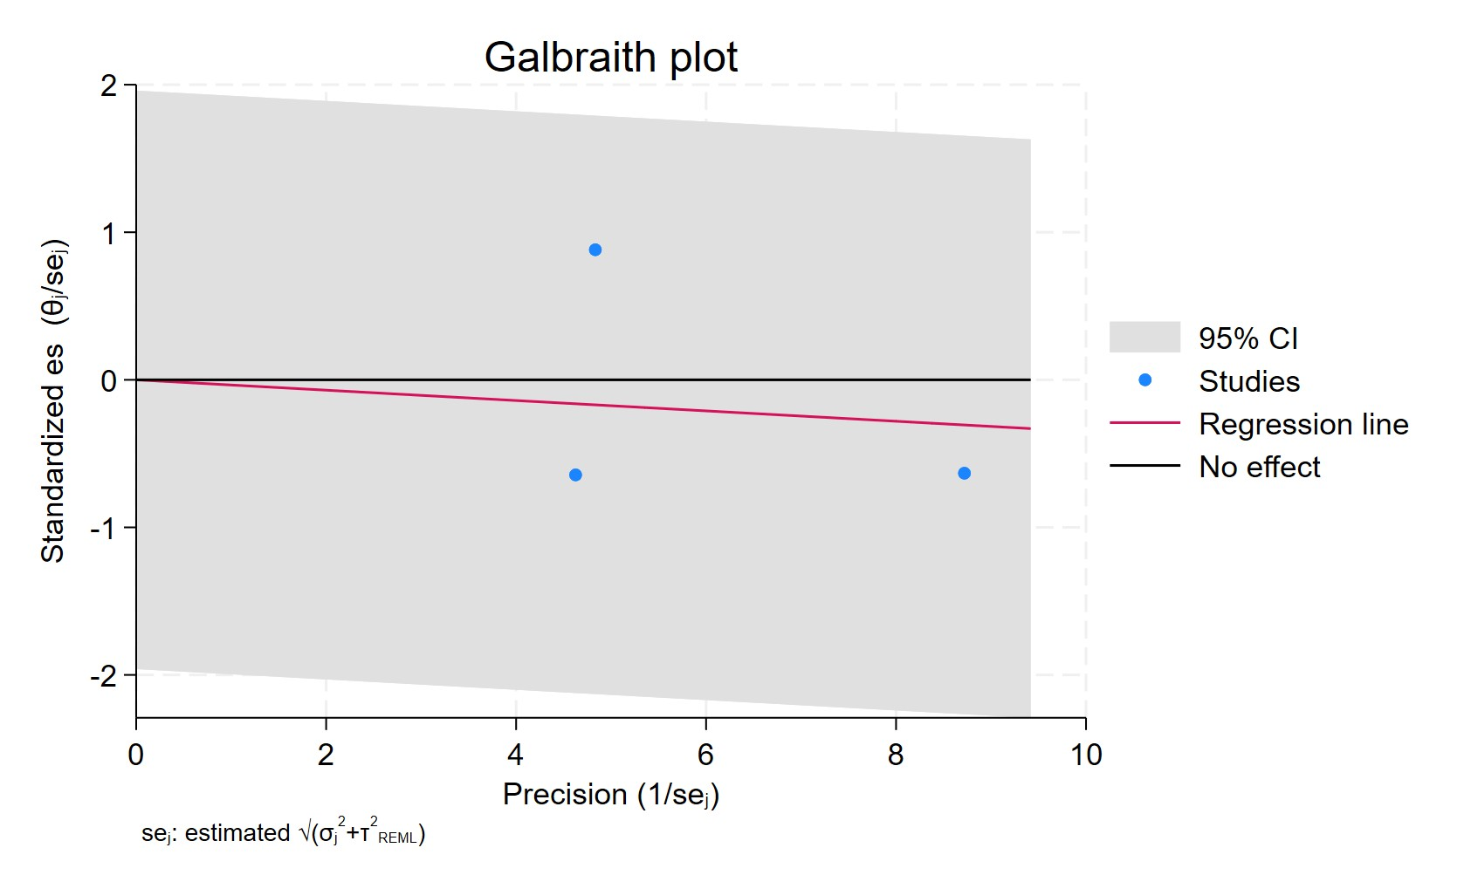
Figure 96. Galbraith plot - SSRIs used in ER positive breast cancer
Each study is represented as a point, where the x-axis denotes the precision (defined as the inverse of the standard error), and the y-axis indicates the standardized effect size. The red regression line represents the overall summary effect estimated from the random-effects model, and the gray shaded area corresponds to the confidence interval at 95% around regression line. The horizontal black line at y = 0 corresponds to the line of no effect, serving as a reference.

SSRI ER POSITIVE PR POSITIVE
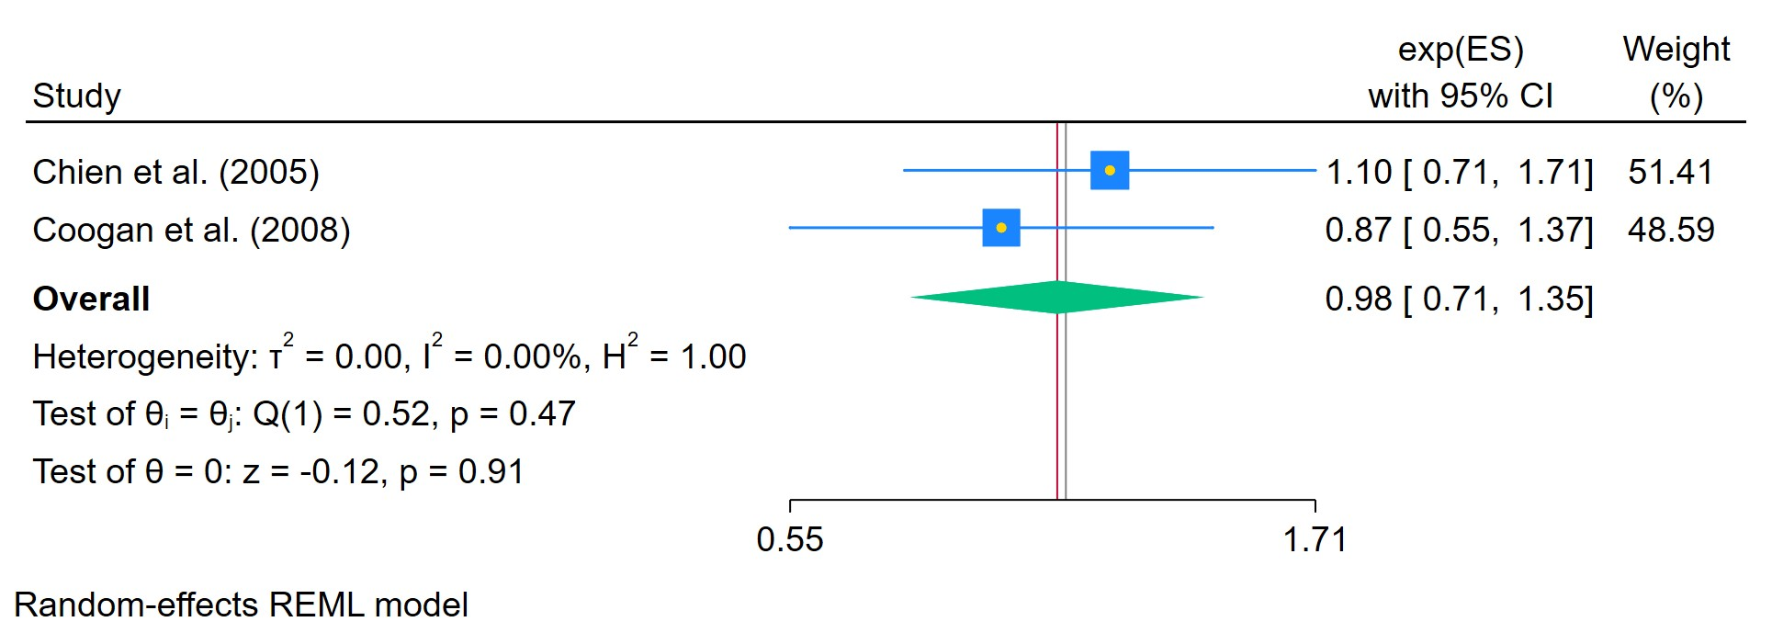
Figure 97. SSRIs used in ER positive PR positive in breast cancer
The area of each square is proportional to the sample size of the respective study, with horizontal lines through the squares representing the 95% confidence interval (C.I.) for that study. In the pooled analysis, the diamond symbol represents the pooled estimate, with the right and left points of the diamond indicating the 95% C.I. for the overall analysis

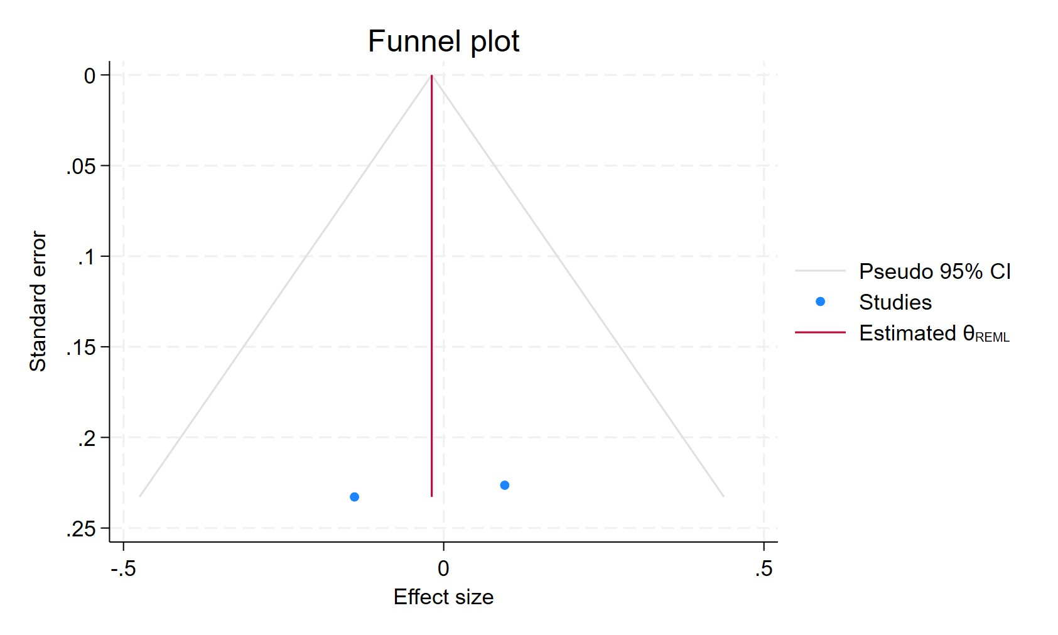
Figure 98. Funnel plot - SSRIs used in ER positive PR positive in breast cancer
Each blue dot represents a single study, plotted with its effect size on the x-axis and its standard error on the y-axis. The vertical red line represents the overall effect estimate derived from the random-effects model using restricted maximum likelihood (REML). The pseudo 95% confidence interval region, shown as gray diagonal lines, outlines the expected spread of studies in the absence of bias or between-study heterogeneity.

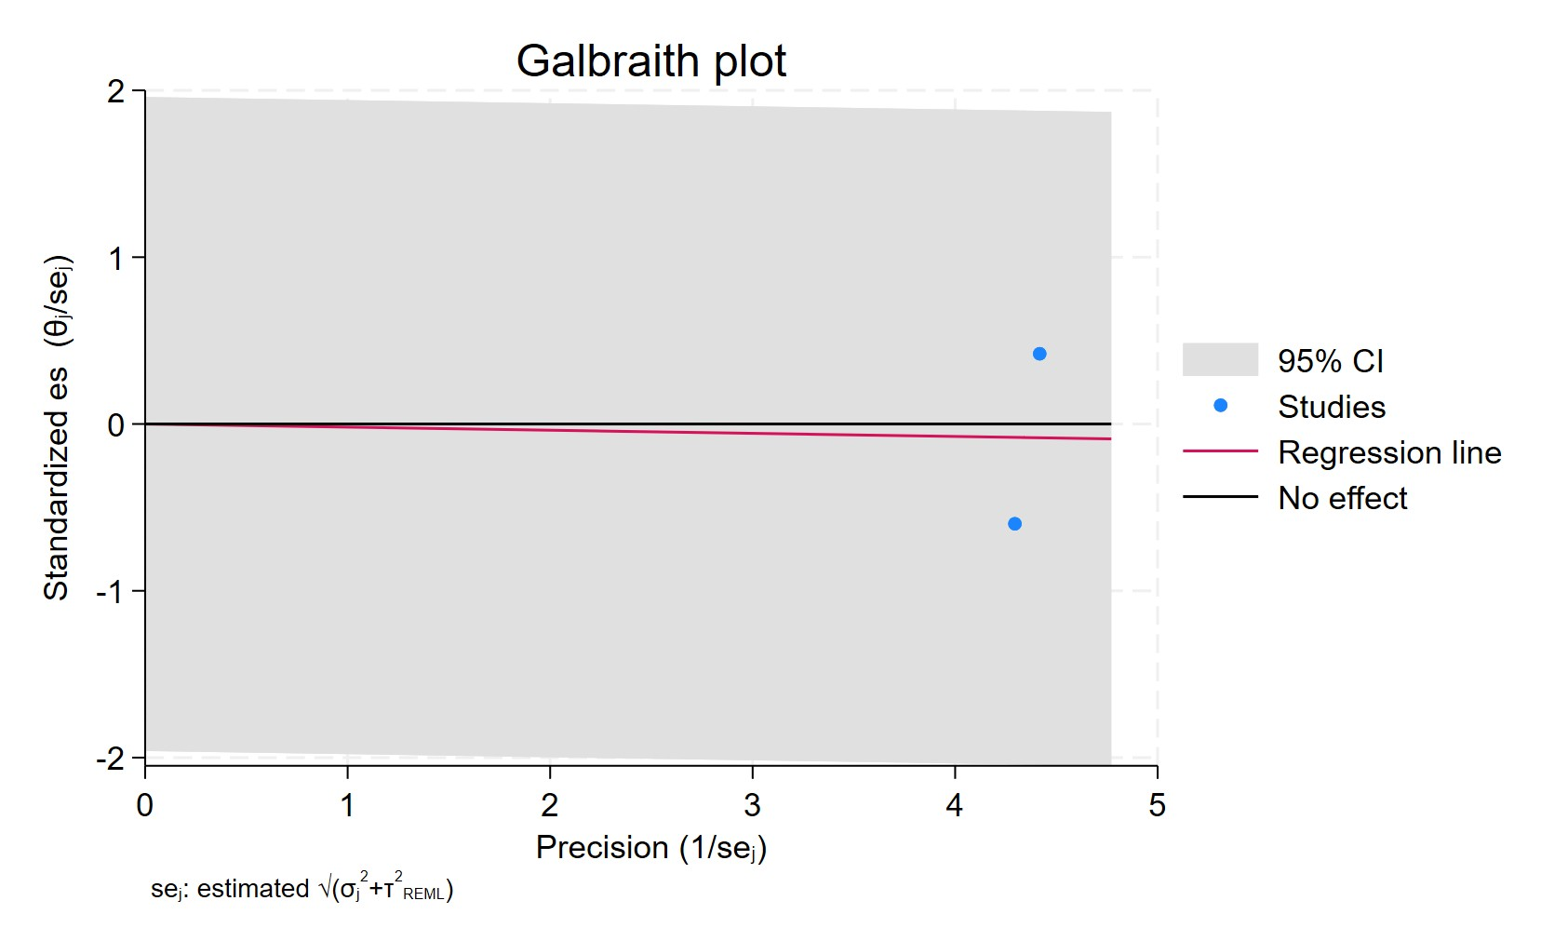
Figure 99. Galbraith plot - SSRIs used in ER positive PR positive in breast cancer
Each study is represented as a point, where the x-axis denotes the precision (defined as the inverse of the standard error), and the y-axis indicates the standardized effect size. The red regression line represents the overall summary effect estimated from the random-effects model, and the gray shaded area corresponds to the confidence interval at 95% around regression line. The horizontal black line at y = 0 corresponds to the line of no effect, serving as a reference.

SSRI ER POSITIVE PR NEGATIVE
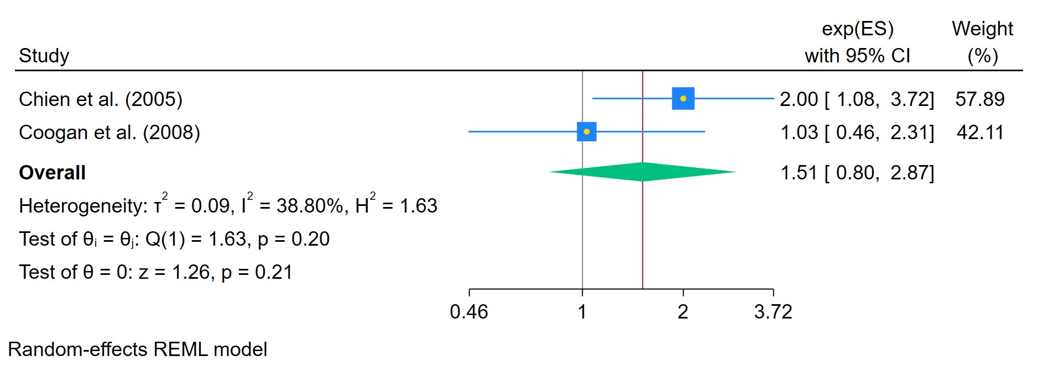
Figure 100. SSRIs used in ER positive PR negative in breast cancer
The area of each square is proportional to the sample size of the respective study, with horizontal lines through the squares representing the 95% confidence interval (C.I.) for that study. In the pooled analysis, the diamond symbol represents the pooled estimate, with the right and left points of the diamond indicating the 95% C.I. for the overall analysis

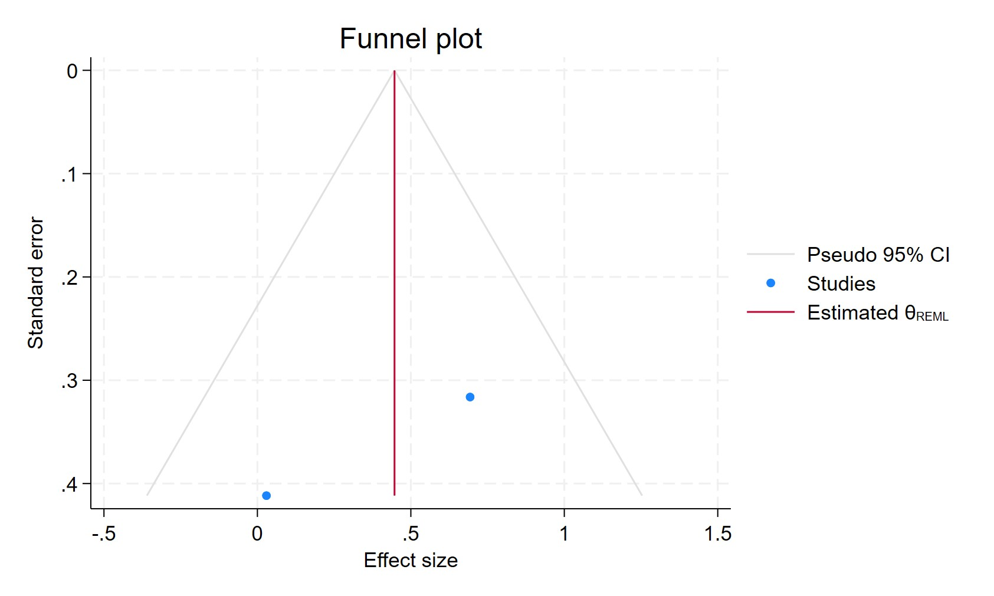
Figure 101. Funnel plot - SSRIs used in ER positive PR negative in breast cancer
Each blue dot represents a single study, plotted with its effect size on the x-axis and its standard error on the y-axis. The vertical red line represents the overall effect estimate derived from the random-effects model using restricted maximum likelihood (REML). The pseudo 95% confidence interval region, shown as gray diagonal lines, outlines the expected spread of studies in the absence of bias or between-study heterogeneity.

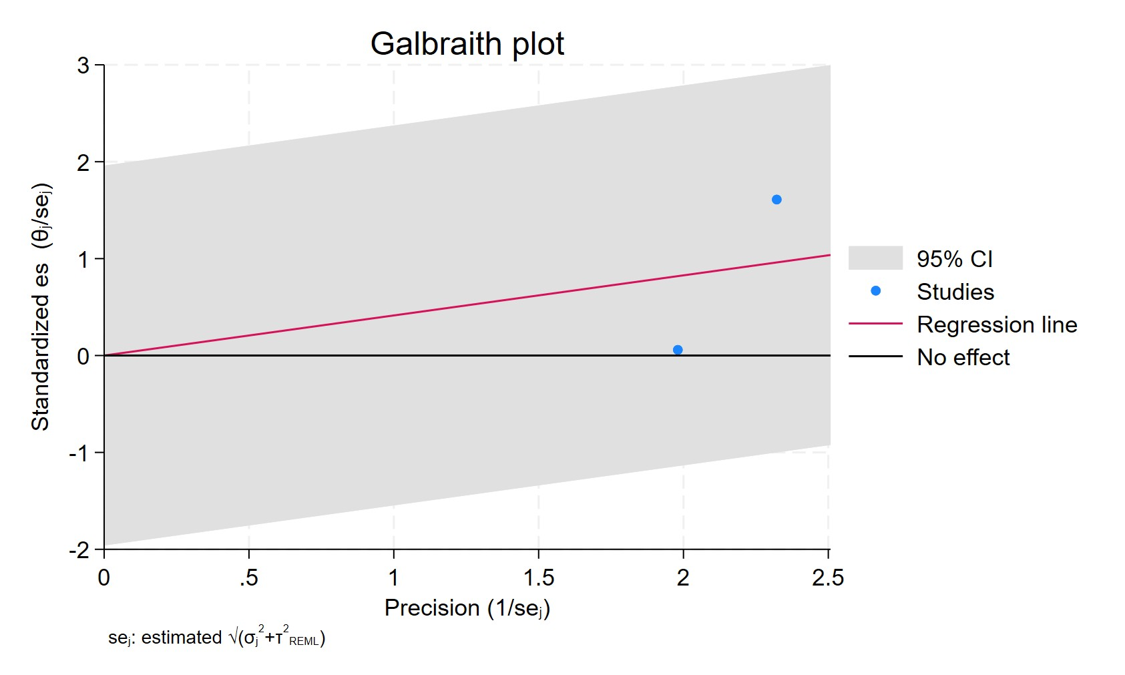
Figure 102. Galbraith plot - SSRIs used in ER positive PR negative in breast cancer
Each study is represented as a point, where the x-axis denotes the precision (defined as the inverse of the standard error), and the y-axis indicates the standardized effect size. The red regression line represents the overall summary effect estimated from the random-effects model, and the gray shaded area corresponds to the confidence interval at 95% around regression line. The horizontal black line at y = 0 corresponds to the line of no effect, serving as a reference.

SSRI PR POSITIVE
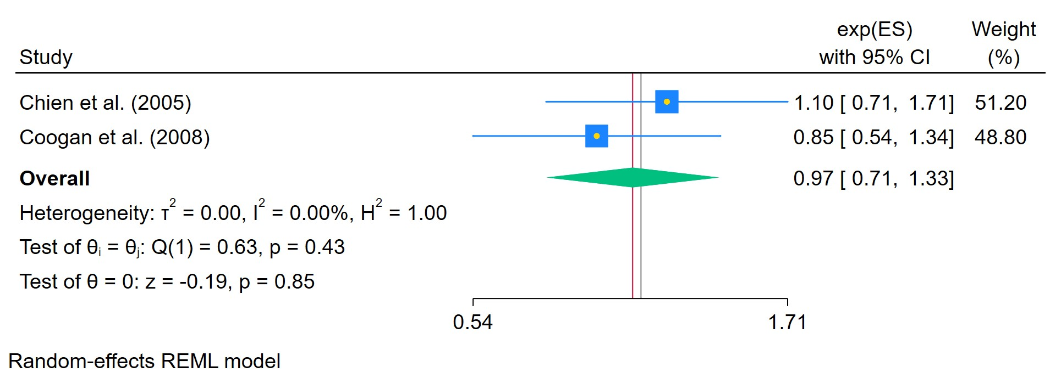
Figure 103. SSRIs used in PR positive breast cancer
The area of each square is proportional to the sample size of the respective study, with horizontal lines through the squares representing the 95% confidence interval (C.I.) for that study. In the pooled analysis, the diamond symbol represents the pooled estimate, with the right and left points of the diamond indicating the 95% C.I. for the overall analysis

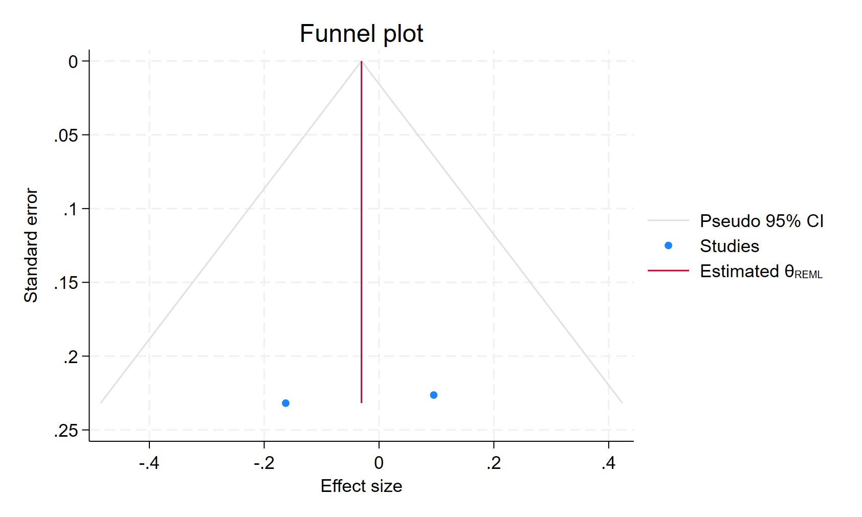
Figure 104. Funnel plot - SSRIs used in PR positive breast cancer
Each blue dot represents a single study, plotted with its effect size on the x-axis and its standard error on the y-axis. The vertical red line represents the overall effect estimate derived from the random-effects model using restricted maximum likelihood (REML). The pseudo 95% confidence interval region, shown as gray diagonal lines, outlines the expected spread of studies in the absence of bias or between-study heterogeneity.

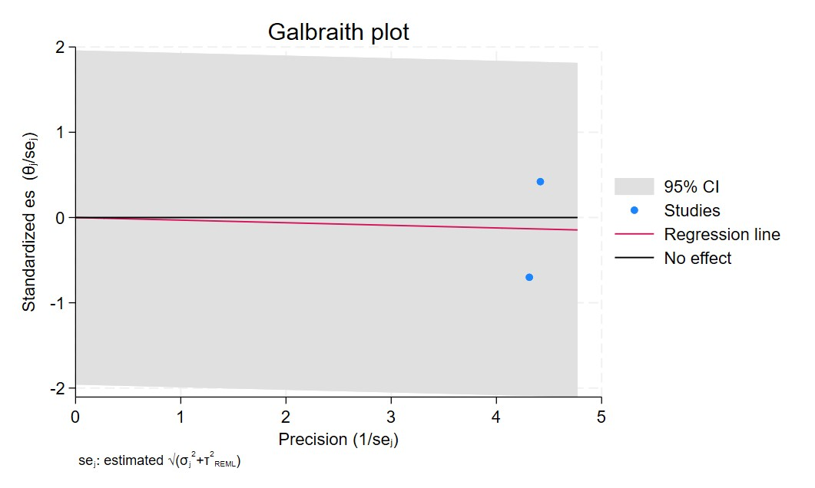
Figure 105. Galbraith plot - SSRIs used in PR positive breast cancer
Each study is represented as a point, where the x-axis denotes the precision (defined as the inverse of the standard error), and the y-axis indicates the standardized effect size. The red regression line represents the overall summary effect estimated from the random-effects model, and the gray shaded area corresponds to the confidence interval at 95% around regression line. The horizontal black line at y = 0 corresponds to the line of no effect, serving as a reference.

SSRI PR NEGATIVE
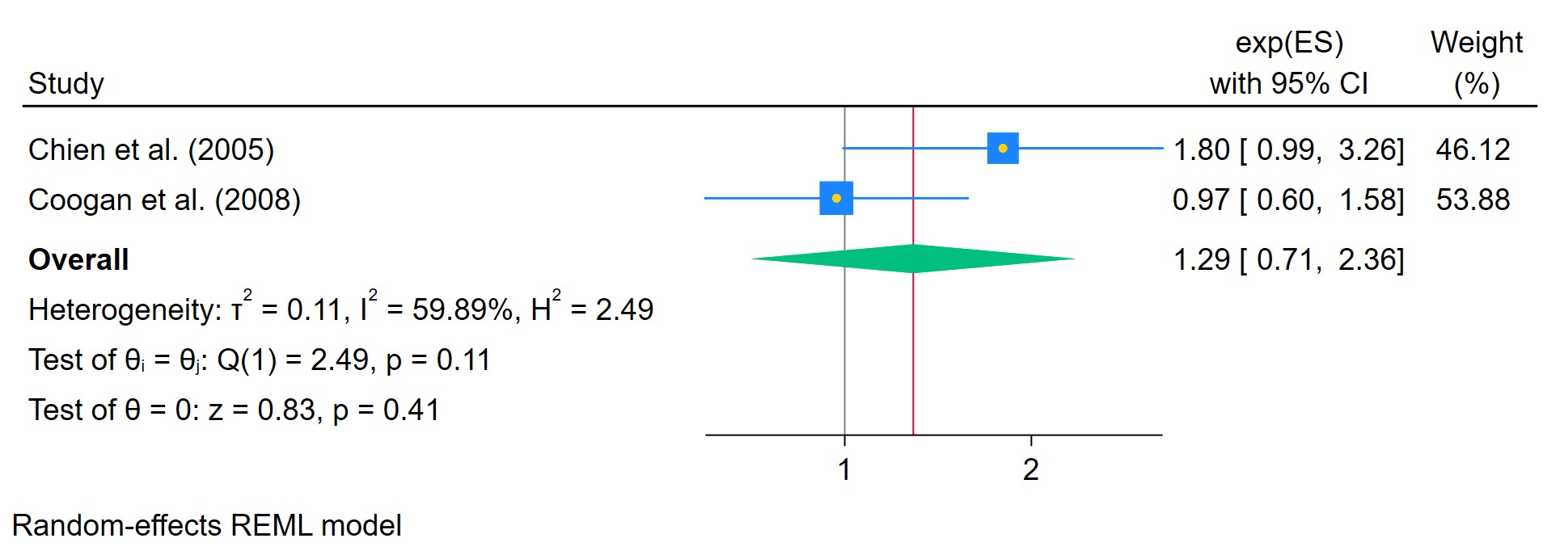
Figure 106. SSRIs used in PR negative breast cancer
The area of each square is proportional to the sample size of the respective study, with horizontal lines through the squares representing the 95% confidence interval (C.I.) for that study. In the pooled analysis, the diamond symbol represents the pooled estimate, with the right and left points of the diamond indicating the 95% C.I. for the overall analysis

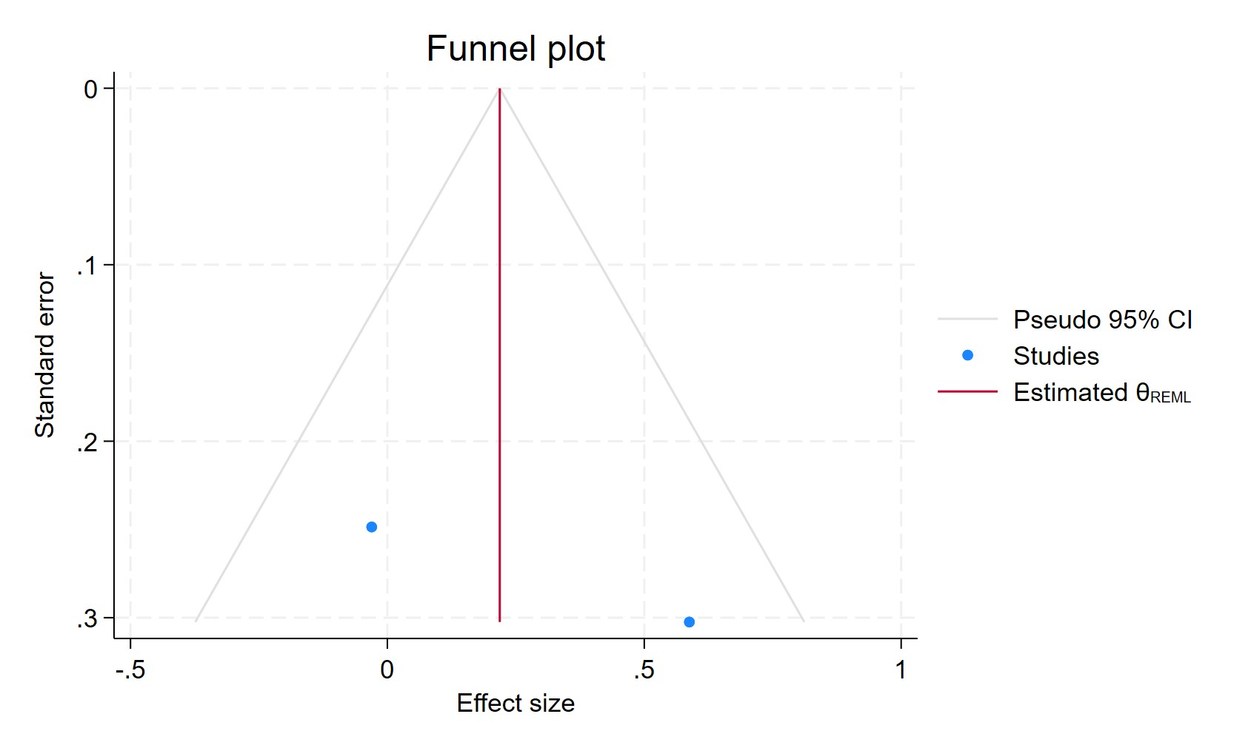
Figure 107. Funnel plot - SSRIs used in PR negative breast cancer
Each blue dot represents a single study, plotted with its effect size on the x-axis and its standard error on the y-axis. The vertical red line represents the overall effect estimate derived from the random-effects model using restricted maximum likelihood (REML). The pseudo 95% confidence interval region, shown as gray diagonal lines, outlines the expected spread of studies in the absence of bias or between-study heterogeneity.

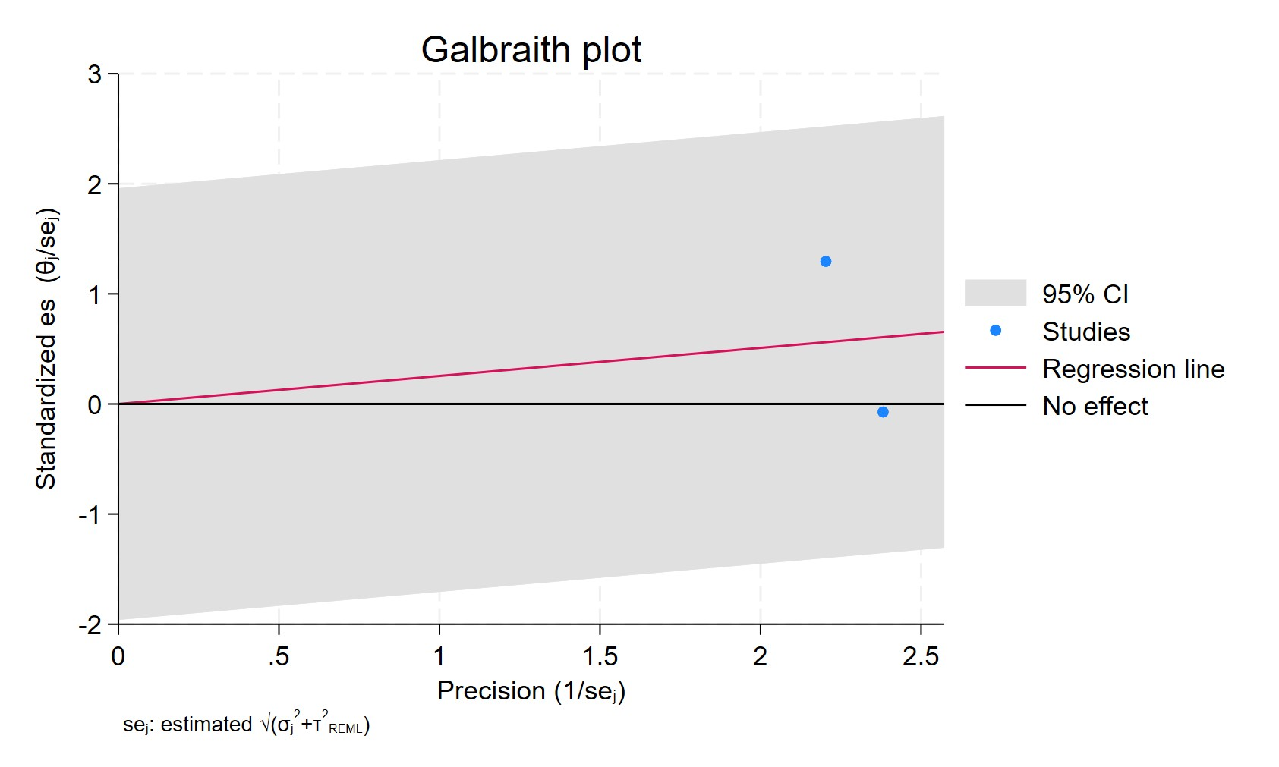
Figure 108. Galbraith plot - SSRIs used in PR negative breast cancer
Each study is represented as a point, where the x-axis denotes the precision (defined as the inverse of the standard error), and the y-axis indicates the standardized effect size. The red regression line represents the overall summary effect estimated from the random-effects model, and the gray shaded area corresponds to the confidence interval at 95% around regression line. The horizontal black line at y = 0 corresponds to the line of no effect, serving as a reference.

FLUOXETINE USERS ODDS RATIO
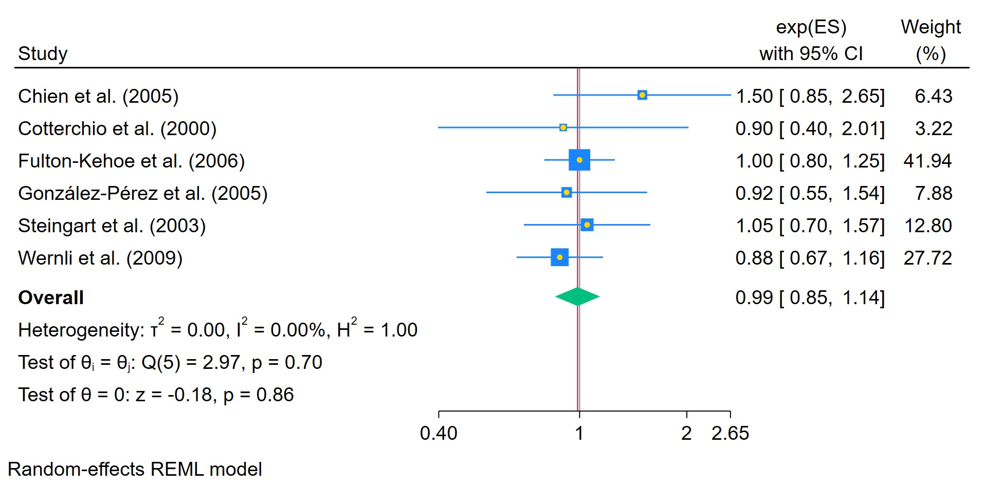
Figure 109. Fluoxetine ever used - Odds Ratio
The area of each square is proportional to the sample size of the respective study, with horizontal lines through the squares representing the 95% confidence interval (C.I.) for that study. In the pooled analysis, the diamond symbol represents the pooled estimate, with the right and left points of the diamond indicating the 95% C.I. for the overall analysis

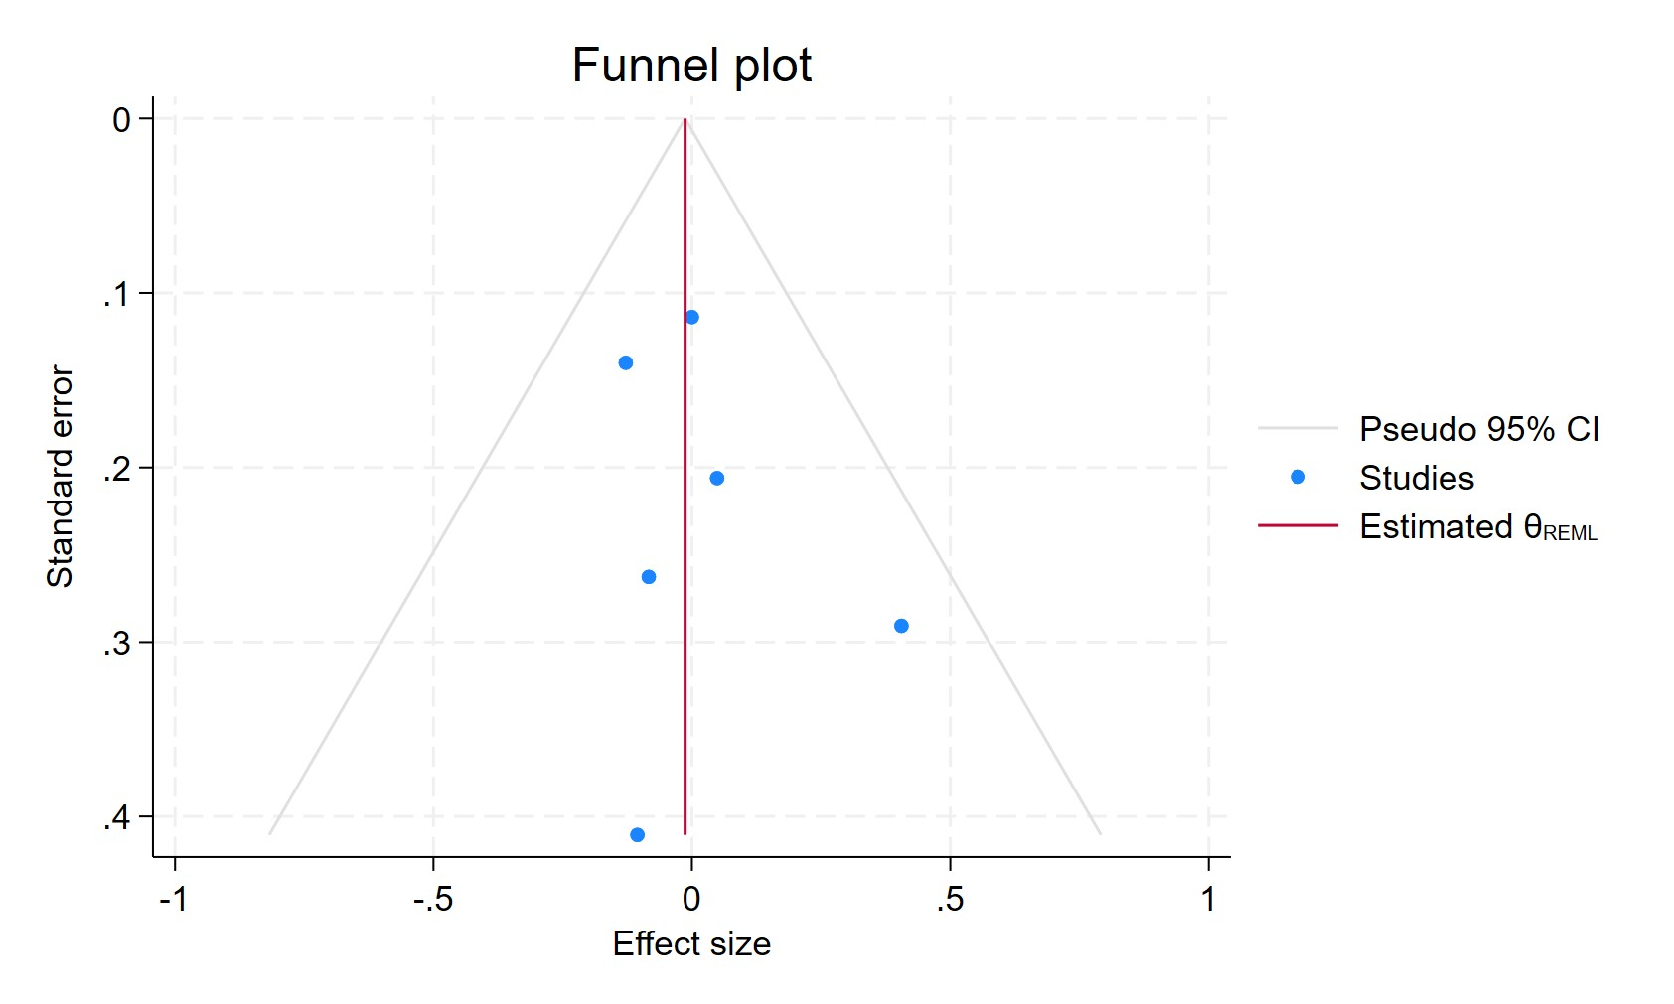
Figure 110. Funnel plot - Fluoxetine ever used - Odds Ratio
Each blue dot represents a single study, plotted with its effect size on the x-axis and its standard error on the y-axis. The vertical red line represents the overall effect estimate derived from the random-effects model using restricted maximum likelihood (REML). The pseudo 95% confidence interval region, shown as gray diagonal lines, outlines the expected spread of studies in the absence of bias or between-study heterogeneity.

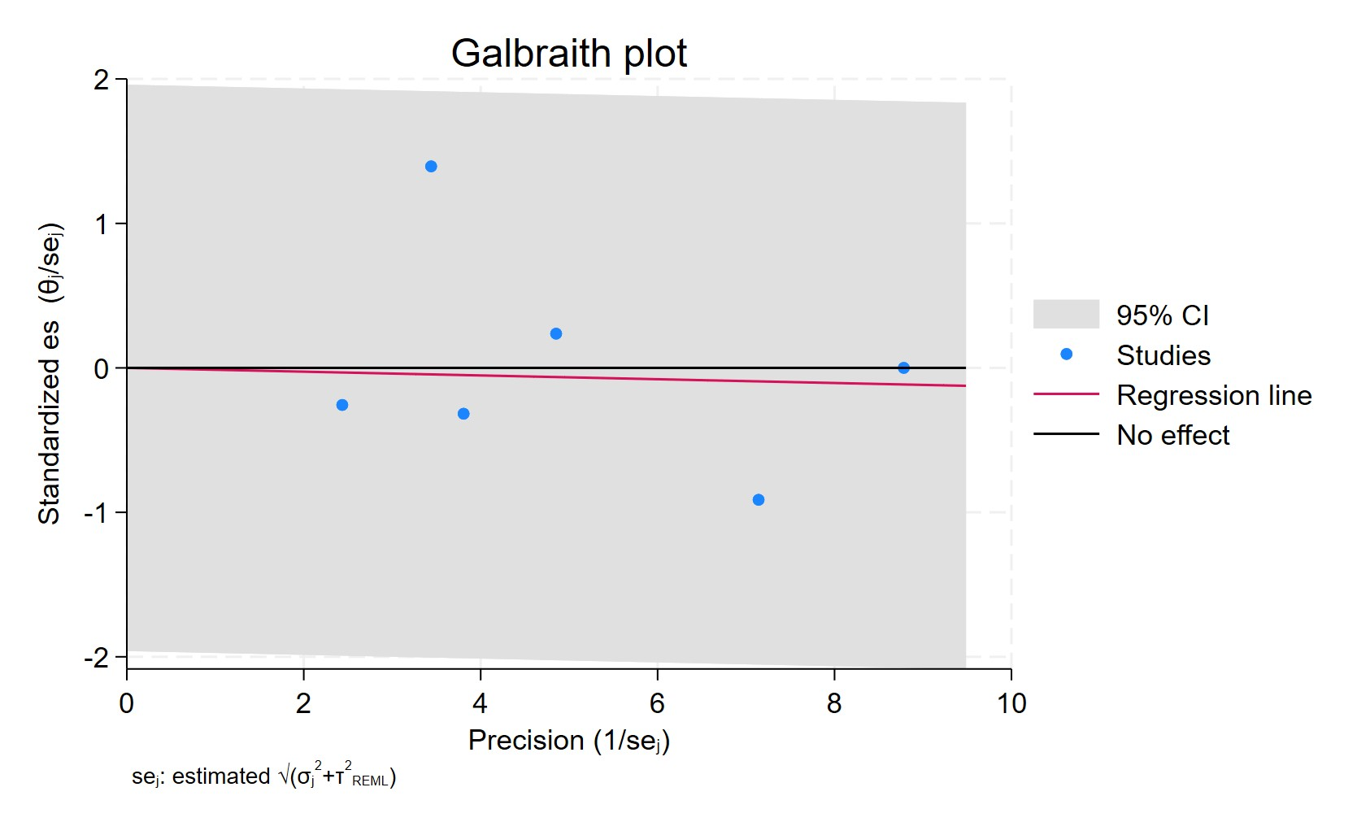
Figure 111. Galbraith plot - Fluoxetine ever used - Odds Ratio
Each study is represented as a point, where the x-axis denotes the precision (defined as the inverse of the standard error), and the y-axis indicates the standardized effect size. The red regression line represents the overall summary effect estimated from the random-effects model, and the gray shaded area corresponds to the confidence interval at 95% around regression line. The horizontal black line at y = 0 corresponds to the line of no effect, serving as a reference.

FLUOXETINE USERS HAZARD RATIO
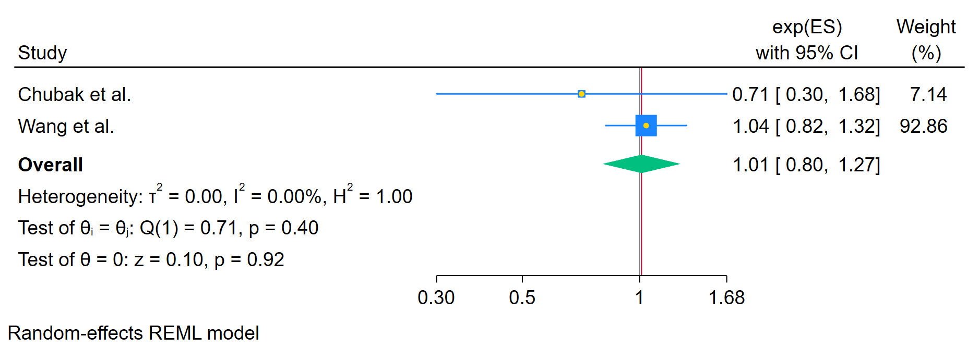
Figure 112. Fluoxetine ever used - Hazard Ratio
The area of each square is proportional to the sample size of the respective study, with horizontal lines through the squares representing the 95% confidence interval (C.I.) for that study. In the pooled analysis, the diamond symbol represents the pooled estimate, with the right and left points of the diamond indicating the 95% C.I. for the overall analysis

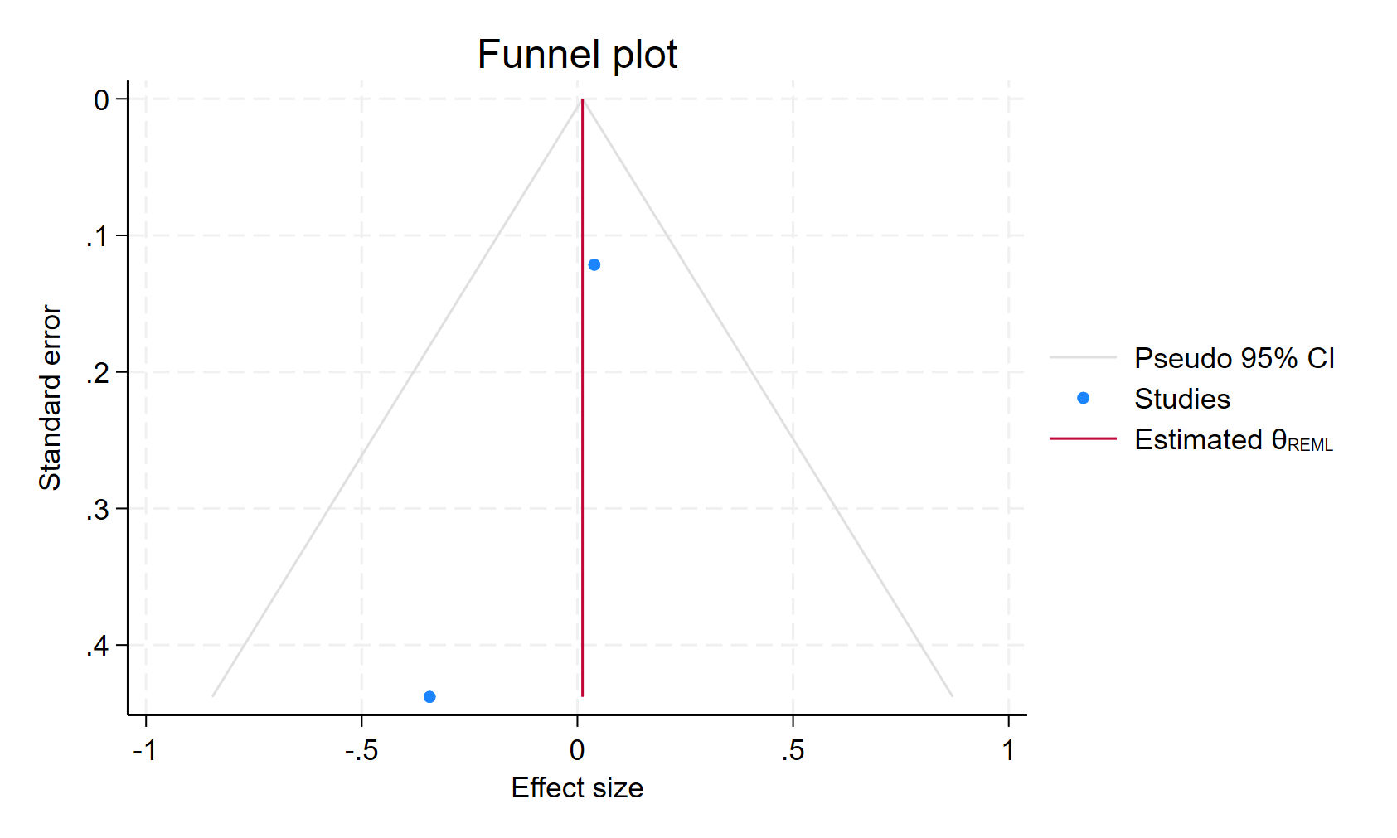
Figure 113. Funnel plot - Fluoxetine ever used - Hazard Ratio
Each blue dot represents a single study, plotted with its effect size on the x-axis and its standard error on the y-axis. The vertical red line represents the overall effect estimate derived from the random-effects model using restricted maximum likelihood (REML). The pseudo 95% confidence interval region, shown as gray diagonal lines, outlines the expected spread of studies in the absence of bias or between-study heterogeneity.

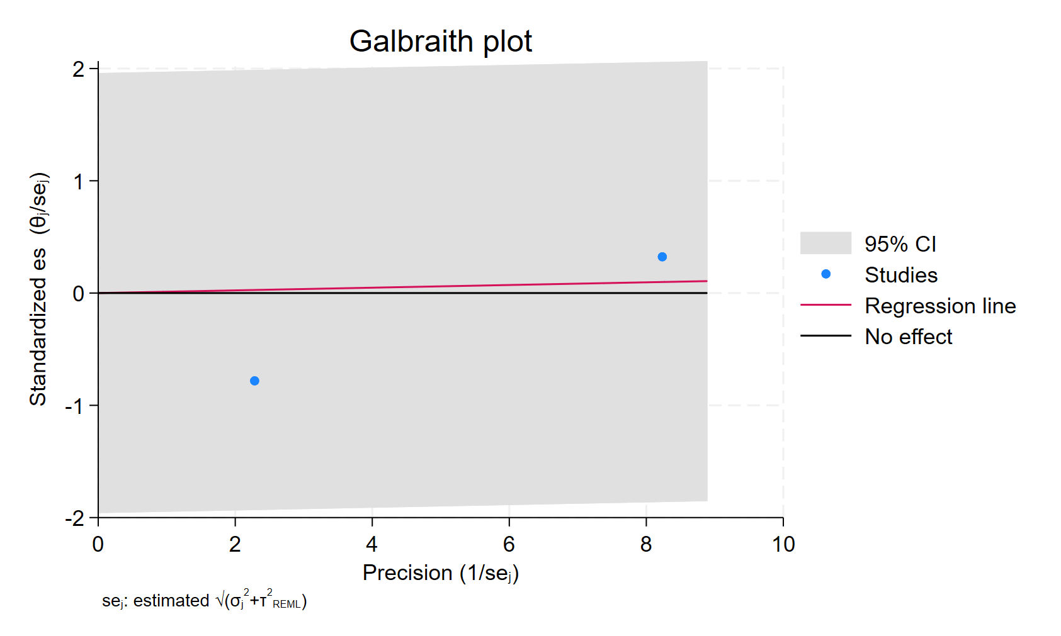
Figure 114. Galbraith plot - Fluoxetine ever used - Hazard Ratio
Each study is represented as a point, where the x-axis denotes the precision (defined as the inverse of the standard error), and the y-axis indicates the standardized effect size. The red regression line represents the overall summary effect estimated from the random-effects model, and the gray shaded area corresponds to the confidence interval at 95% around regression line. The horizontal black line at y = 0 corresponds to the line of no effect, serving as a reference.

FLUOXETINE CURRENT USERS
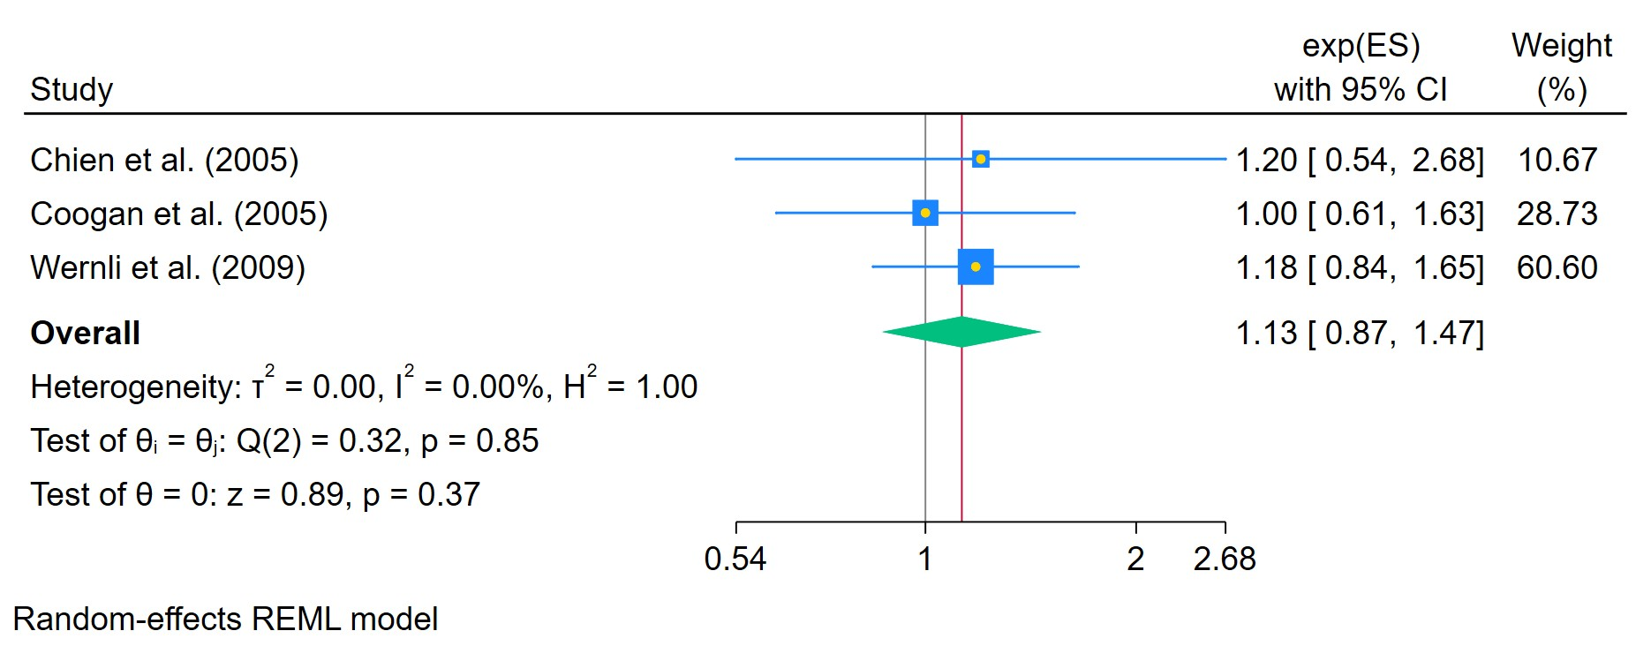
Figure 115. Fluoxetine use in current patients
The area of each square is proportional to the sample size of the respective study, with horizontal lines through the squares representing the 95% confidence interval (C.I.) for that study. In the pooled analysis, the diamond symbol represents the pooled estimate, with the right and left points of the diamond indicating the 95% C.I. for the overall analysis

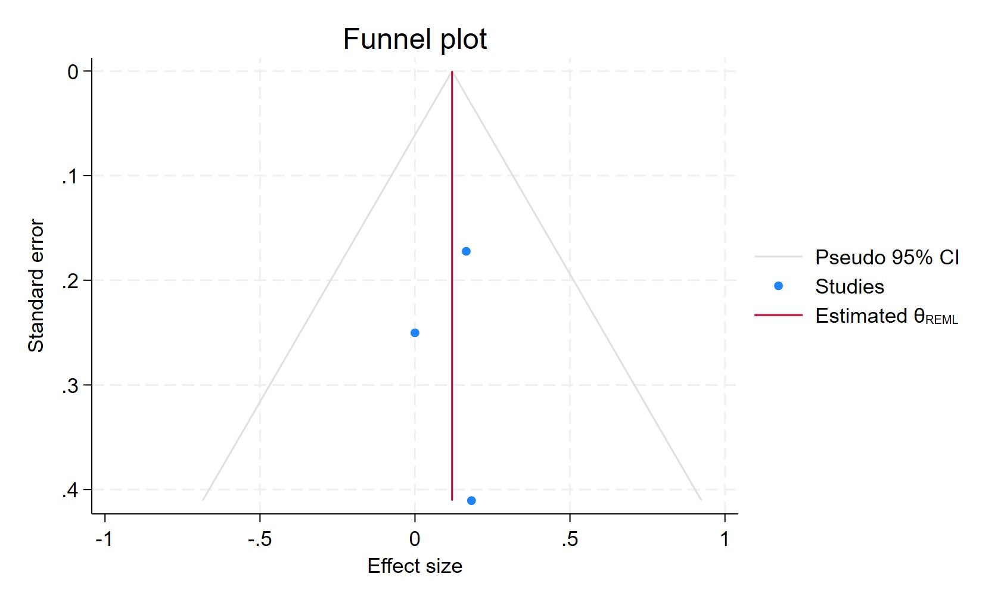
Figure 116. Funnel plot - Fluoxetine use in current patients
Each blue dot represents a single study, plotted with its effect size on the x-axis and its standard error on the y-axis. The vertical red line represents the overall effect estimate derived from the random-effects model using restricted maximum likelihood (REML). The pseudo 95% confidence interval region, shown as gray diagonal lines, outlines the expected spread of studies in the absence of bias or between-study heterogeneity.

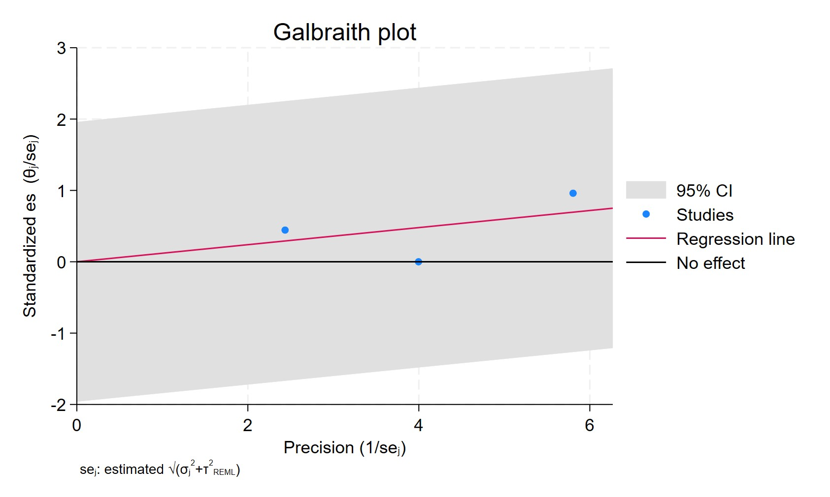
Figure 117. Galbraith plot - Fluoxetine use in current patients
Each study is represented as a point, where the x-axis denotes the precision (defined as the inverse of the standard error), and the y-axis indicates the standardized effect size. The red regression line represents the overall summary effect estimated from the random-effects model, and the gray shaded area corresponds to the confidence interval at 95% around regression line. The horizontal black line at y = 0 corresponds to the line of no effect, serving as a reference.

FLUOXETINE USERS - FORMERS
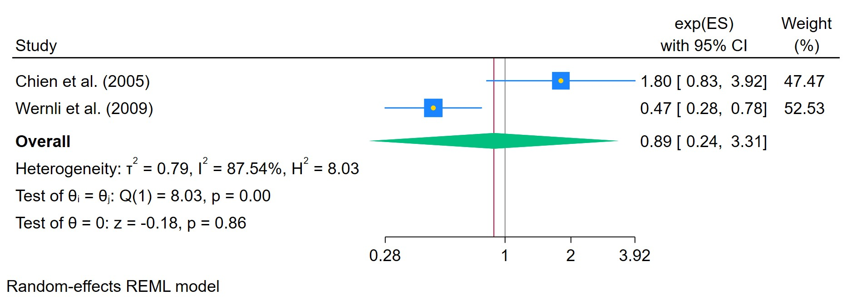
Figure 118. Fluoxetine use in former patients

The area of each square is proportional to the sample size of the respective study, with horizontal lines through the squares representing the 95% confidence interval (C.I.) for that study. In the pooled analysis, the diamond symbol represents the pooled estimate, with the right and left points of the diamond indicating the 95% C.I. for the overall analysis

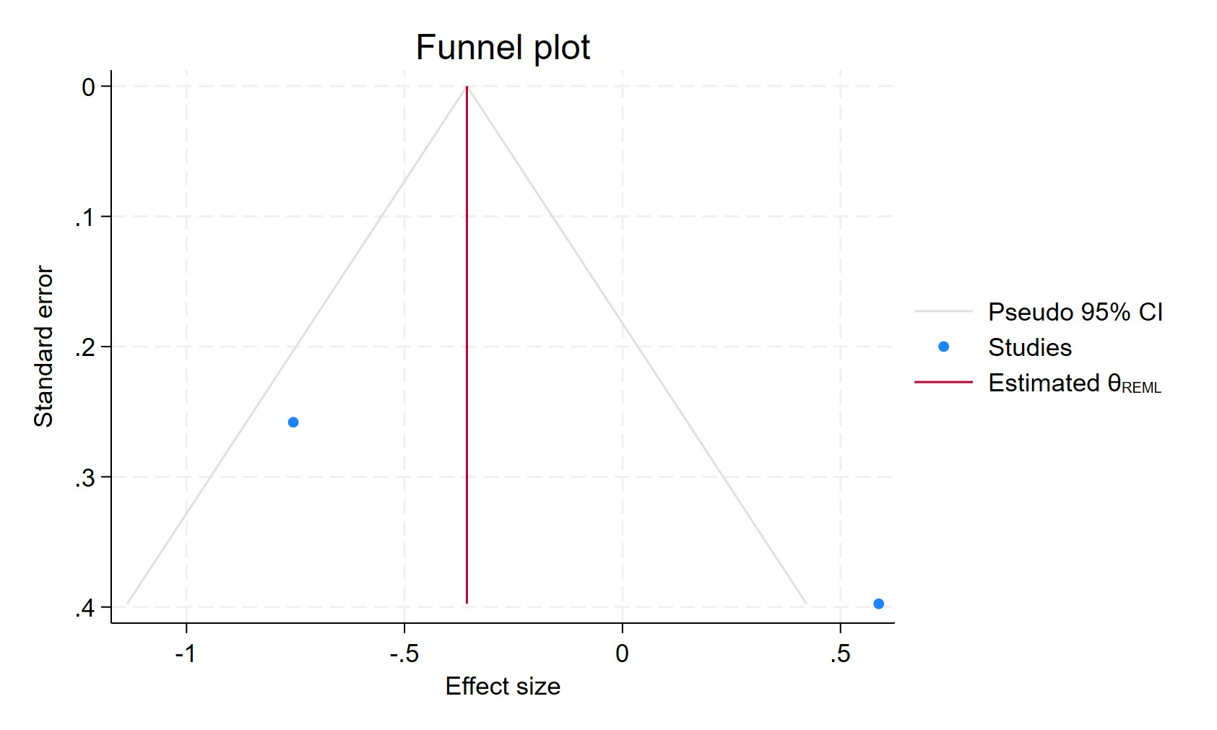
Figure 119. Funnel plot - Fluoxetine use in former patients

Each blue dot represents a single study, plotted with its effect size on the x-axis and its standard error on the y-axis. The vertical red line represents the overall effect estimate derived from the random-effects model using restricted maximum likelihood (REML). The pseudo 95% confidence interval region, shown as gray diagonal lines, outlines the expected spread of studies in the absence of bias or between-study heterogeneity.

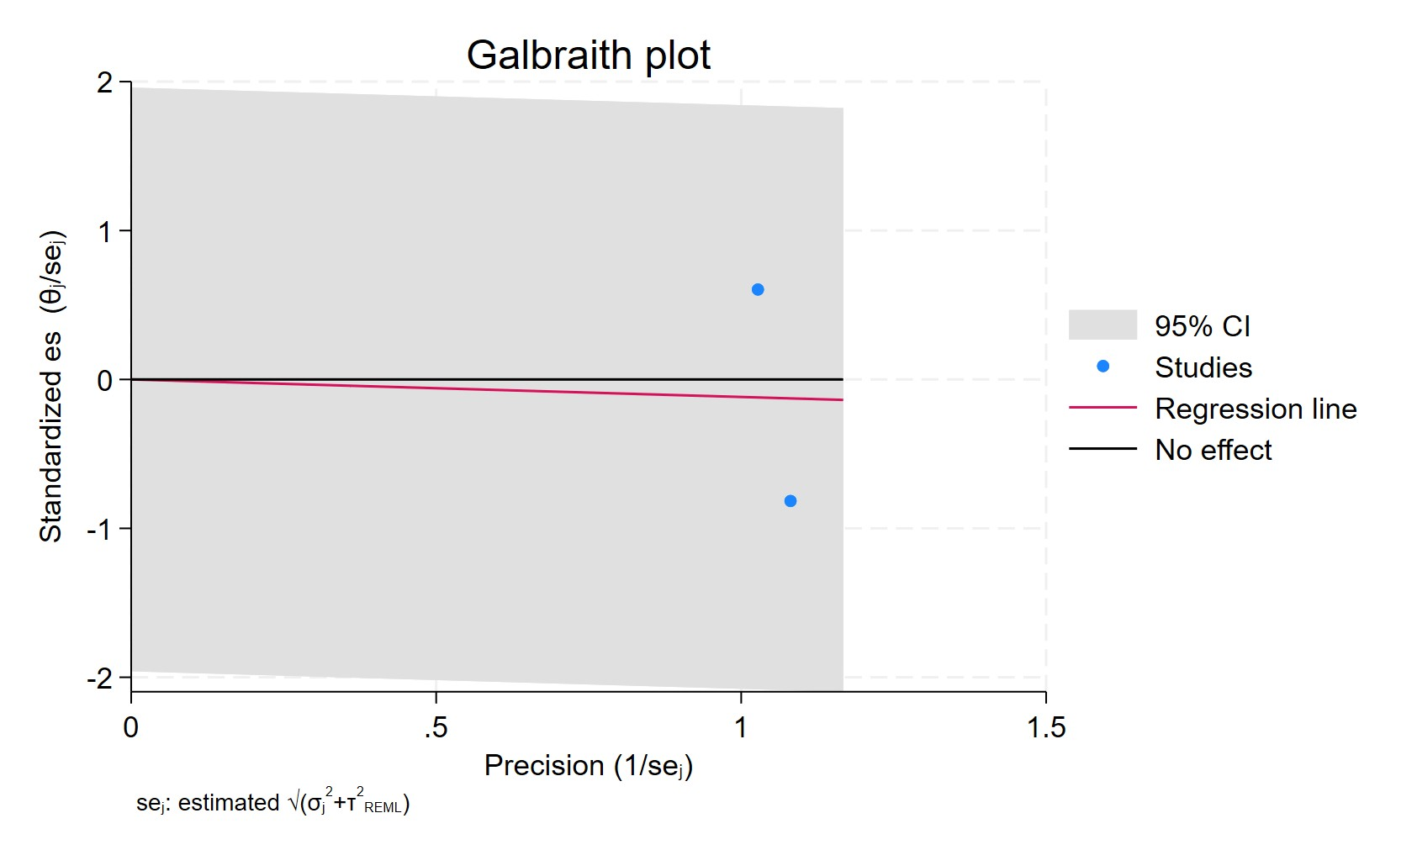
Figure 120. Galbraith plot - Fluoxetine use in former patients
Each study is represented as a point, where the x-axis denotes the precision (defined as the inverse of the standard error), and the y-axis indicates the standardized effect size. The red regression line represents the overall summary effect estimated from the random-effects model, and the gray shaded area corresponds to the confidence interval at 95% around regression line. The horizontal black line at y = 0 corresponds to the line of no effect, serving as a reference.

FLUOXETINE CUMULATIVE USERS LESS THAN 2 YEAARS
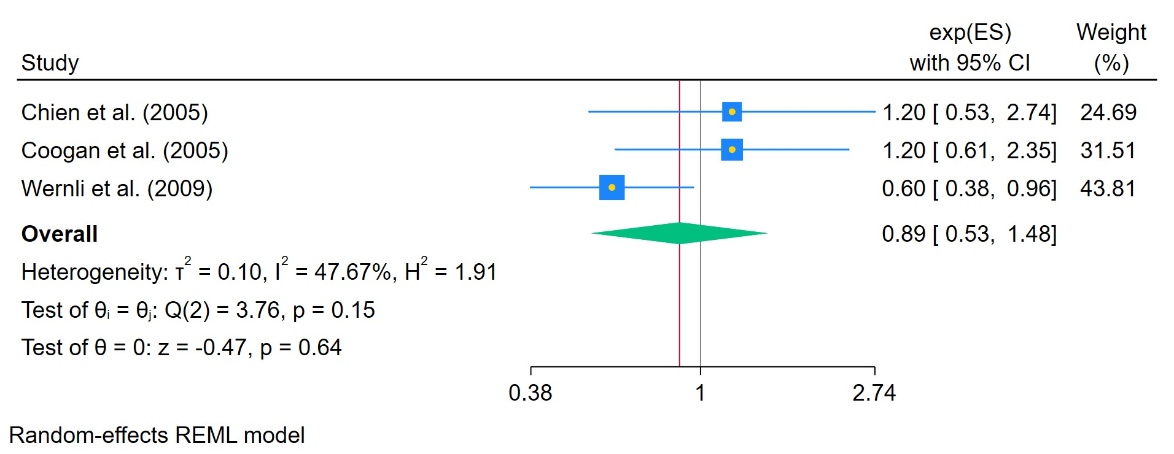
Figure 121. Cumulative fluoxetine use for less than 2 years
The area of each square is proportional to the sample size of the respective study, with horizontal lines through the squares representing the 95% confidence interval (C.I.) for that study. In the pooled analysis, the diamond symbol represents the pooled estimate, with the right and left points of the diamond indicating the 95% C.I. for the overall analysis

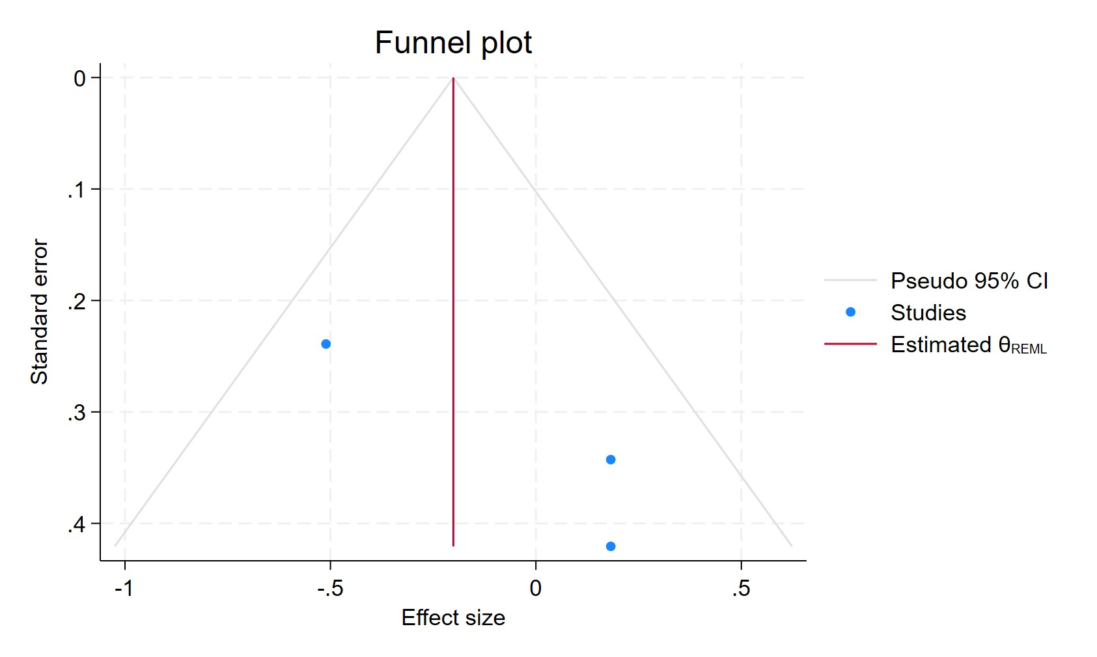
Figure 122. Funnel plot- Cumulative fluoxetine use for less than 2 years
Each blue dot represents a single study, plotted with its effect size on the x-axis and its standard error on the y-axis. The vertical red line represents the overall effect estimate derived from the random-effects model using restricted maximum likelihood (REML). The pseudo 95% confidence interval region, shown as gray diagonal lines, outlines the expected spread of studies in the absence of bias or between-study heterogeneity.

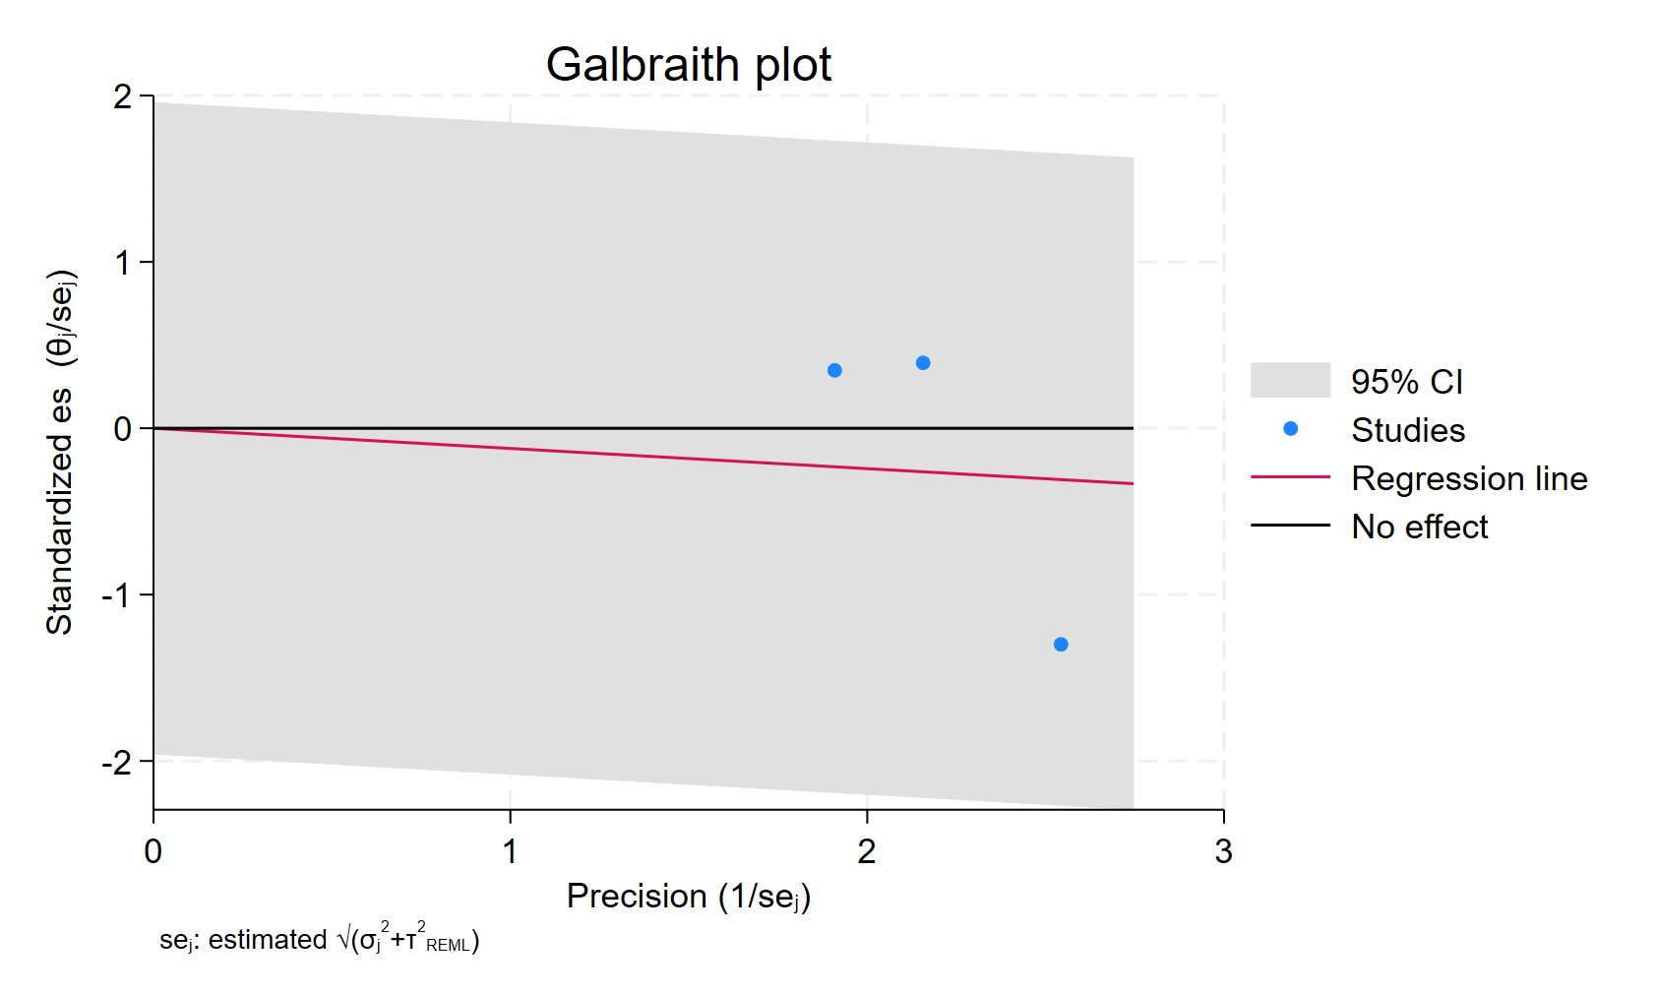
Figure 123. Galbraith plot - Cumulative fluoxetine use for less than 2 years
Each study is represented as a point, where the x-axis denotes the precision (defined as the inverse of the standard error), and the y-axis indicates the standardized effect size. The red regression line represents the overall summary effect estimated from the random-effects model, and the gray shaded area corresponds to the confidence interval at 95% around regression line. The horizontal black line at y = 0 corresponds to the line of no effect, serving as a reference.

FLUOXETINE CUMULATIVE DURATION MORE THAN 2 YEARS
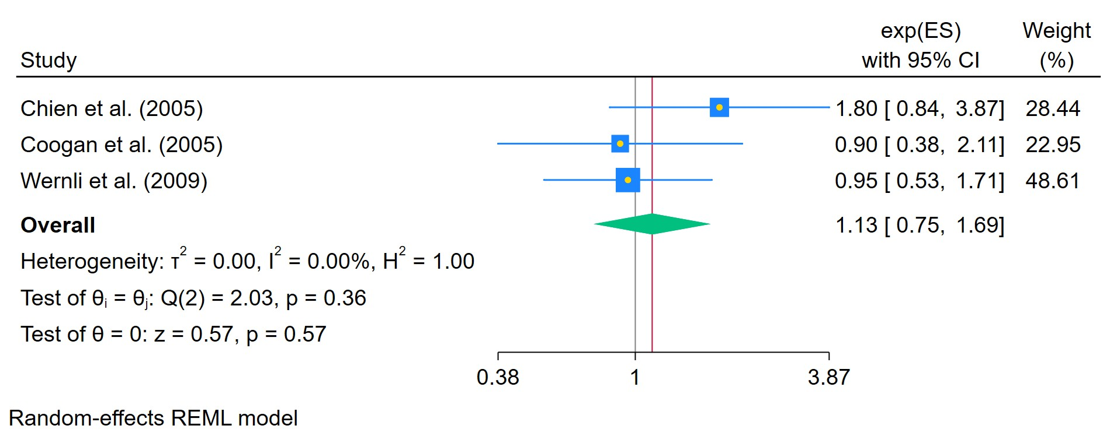
Figure 124. Cumulative fluoxetine use for more than 2 years

The area of each square is proportional to the sample size of the respective study, with horizontal lines through the squares representing the 95% confidence interval (C.I.) for that study. In the pooled analysis, the diamond symbol represents the pooled estimate, with the right and left points of the diamond indicating the 95% C.I. for the overall analysis

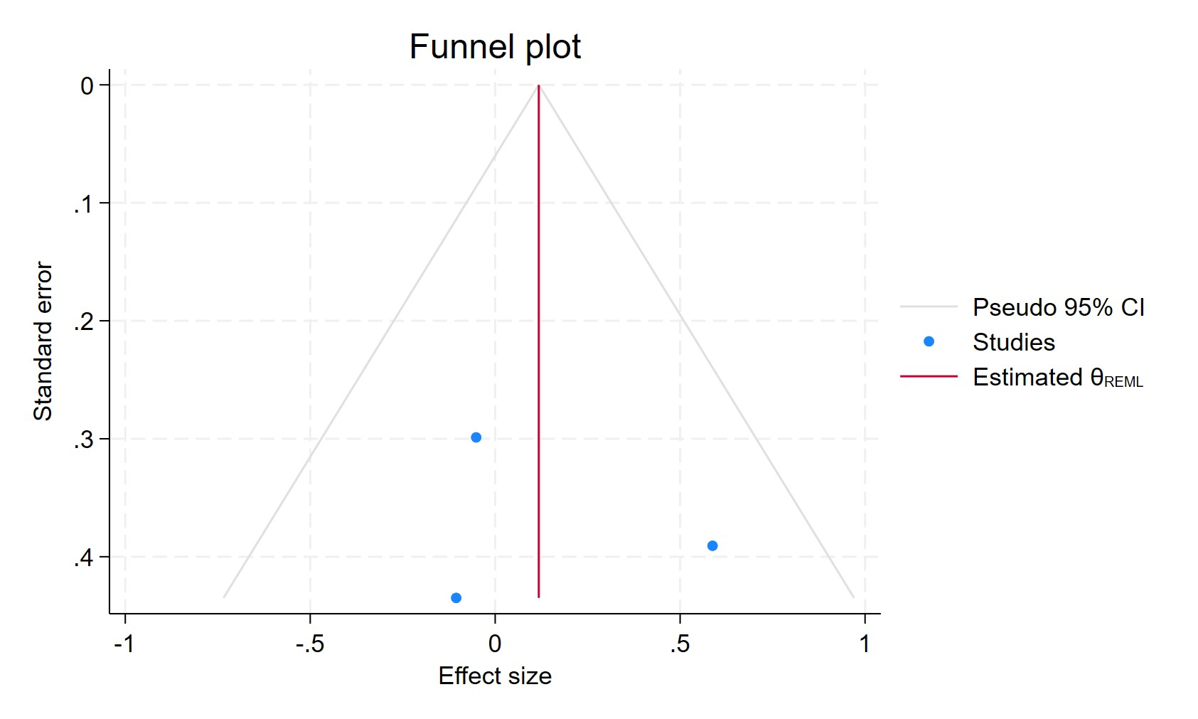
Figure 125. Funnel plot - Cumulative fluoxetine use for more than 2 years
Each blue dot represents a single study, plotted with its effect size on the x-axis and its standard error on the y-axis. The vertical red line represents the overall effect estimate derived from the random-effects model using restricted maximum likelihood (REML). The pseudo 95% confidence interval region, shown as gray diagonal lines, outlines the expected spread of studies in the absence of bias or between-study heterogeneity.

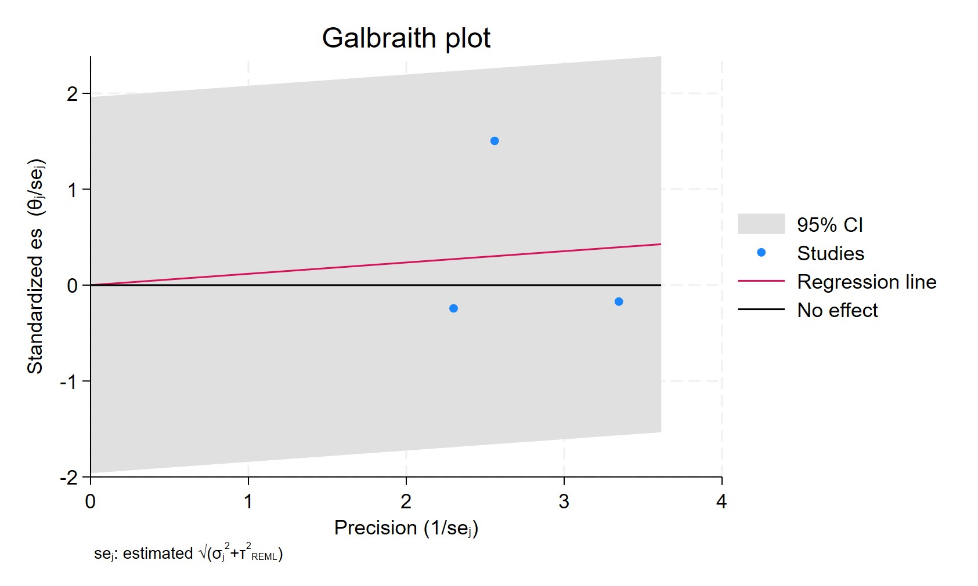
Figure 126. Galbraith plot - Cumulative fluoxetine use for more than 2 years
Each study is represented as a point, where the x-axis denotes the precision (defined as the inverse of the standard error), and the y-axis indicates the standardized effect size. The red regression line represents the overall summary effect estimated from the random-effects model, and the gray shaded area corresponds to the confidence interval at 95% around regression line. The horizontal black line at y = 0 corresponds to the line of no effect, serving as a reference.

PAROXETINE EVER USE
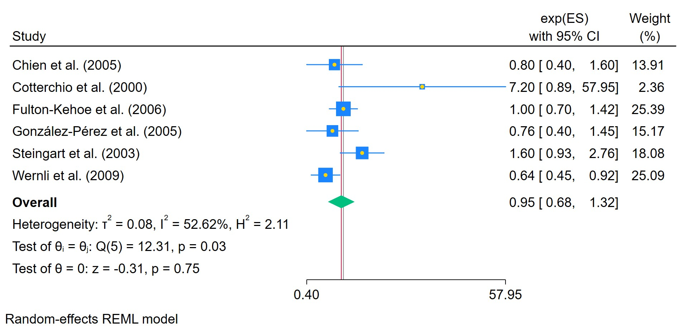
Figure 127. Ever used paroxetine
The area of each square is proportional to the sample size of the respective study, with horizontal lines through the squares representing the 95% confidence interval (C.I.) for that study. In the pooled analysis, the diamond symbol represents the pooled estimate, with the right and left points of the diamond indicating the 95% C.I. for the overall analysis

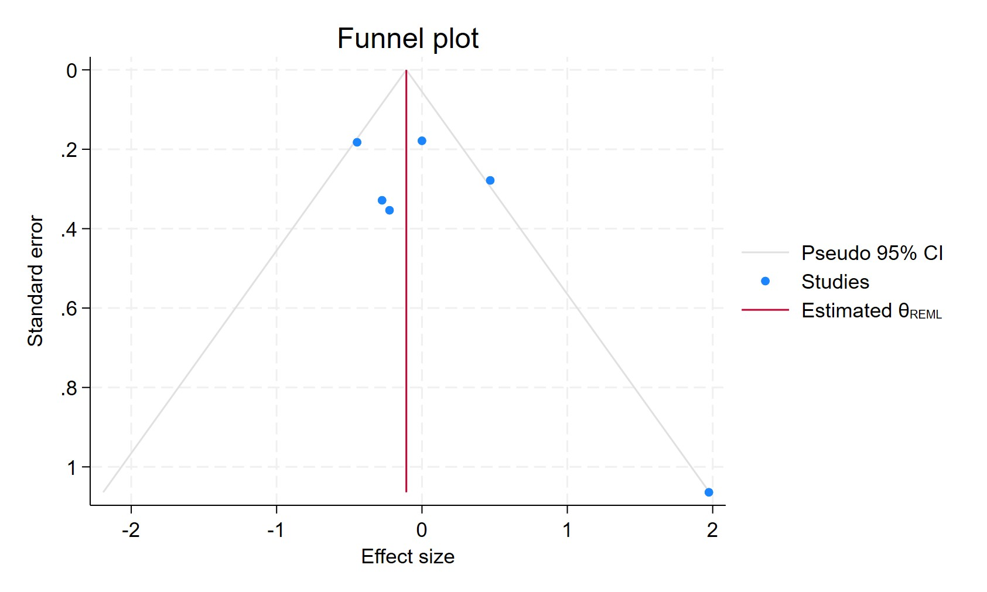
Figure 128. Funnel plot - Ever used paroxetine
Each blue dot represents a single study, plotted with its effect size on the x-axis and its standard error on the y-axis. The vertical red line represents the overall effect estimate derived from the random-effects model using restricted maximum likelihood (REML). The pseudo 95% confidence interval region, shown as gray diagonal lines, outlines the expected spread of studies in the absence of bias or between-study heterogeneity.

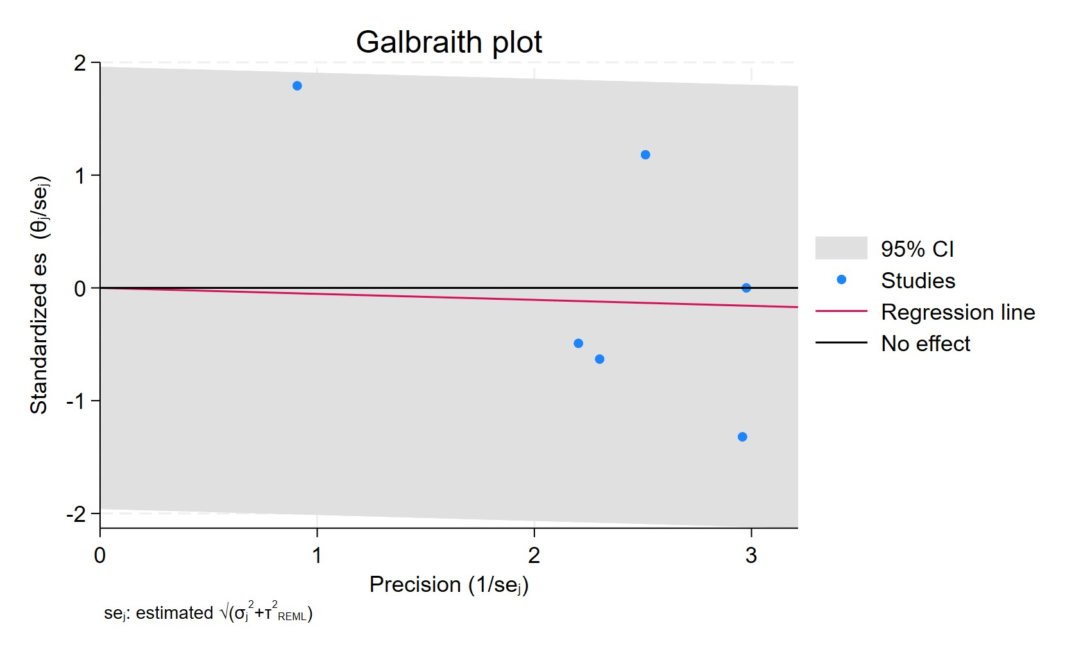
Figure 129. Galbraith plot - Ever used paroxetine
Each study is represented as a point, where the x-axis denotes the precision (defined as the inverse of the standard error), and the y-axis indicates the standardized effect size. The red regression line represents the overall summary effect estimated from the random-effects model, and the gray shaded area corresponds to the confidence interval at 95% around regression line. The horizontal black line at y = 0 corresponds to the line of no effect, serving as a reference.

PAROXETINE CURRENT USERS
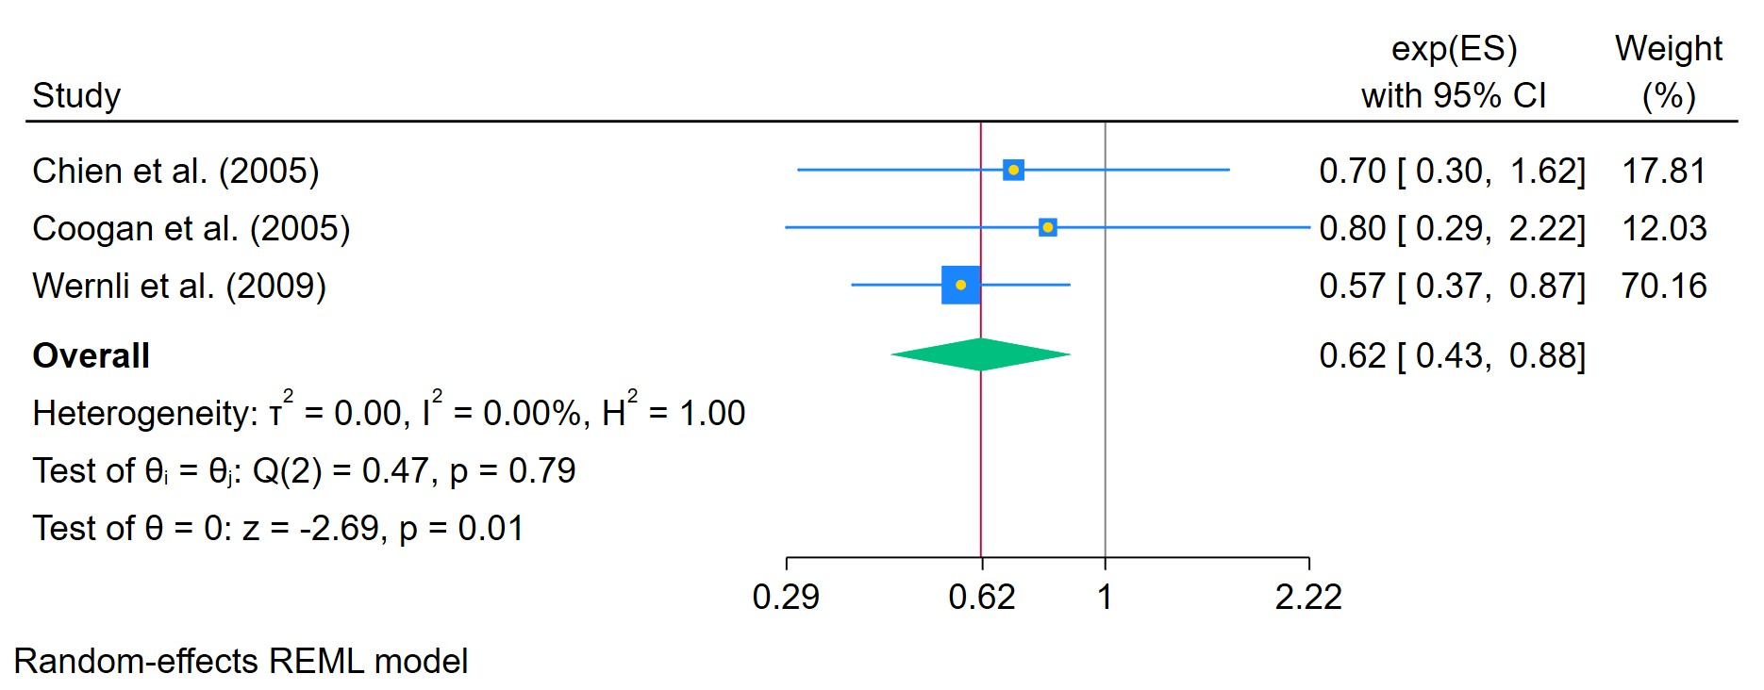
Figure 130. Paroxetine use in current patients
The area of each square is proportional to the sample size of the respective study, with horizontal lines through the squares representing the 95% confidence interval (C.I.) for that study. In the pooled analysis, the diamond symbol represents the pooled estimate, with the right and left points of the diamond indicating the 95% C.I. for the overall analysis

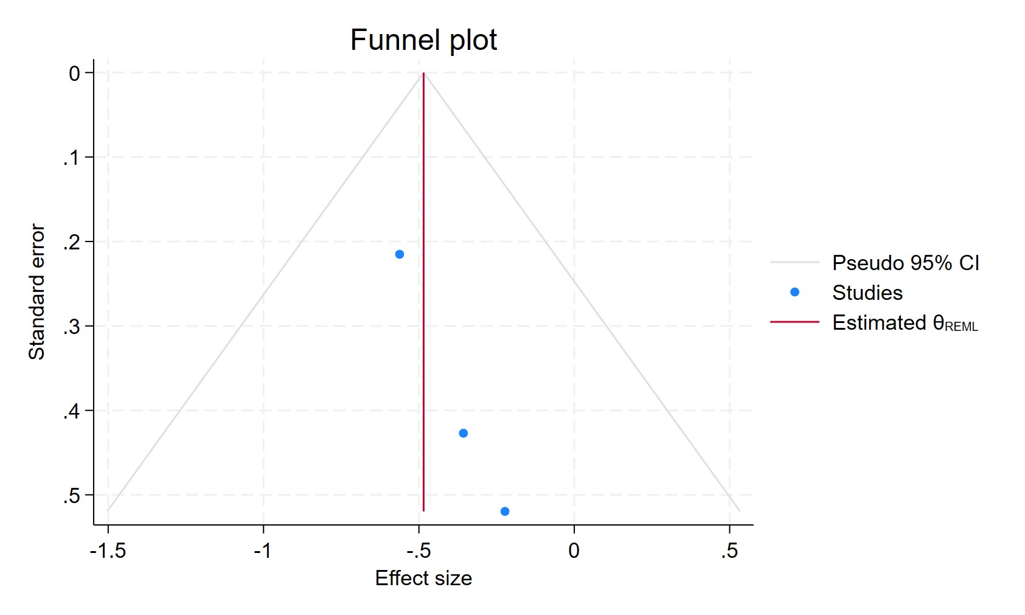
Figure 131. Funnel plot - Paroxetine use in current patients
Each blue dot represents a single study, plotted with its effect size on the x-axis and its standard error on the y-axis. The vertical red line represents the overall effect estimate derived from the random-effects model using restricted maximum likelihood (REML). The pseudo 95% confidence interval region, shown as gray diagonal lines, outlines the expected spread of studies in the absence of bias or between-study heterogeneity.

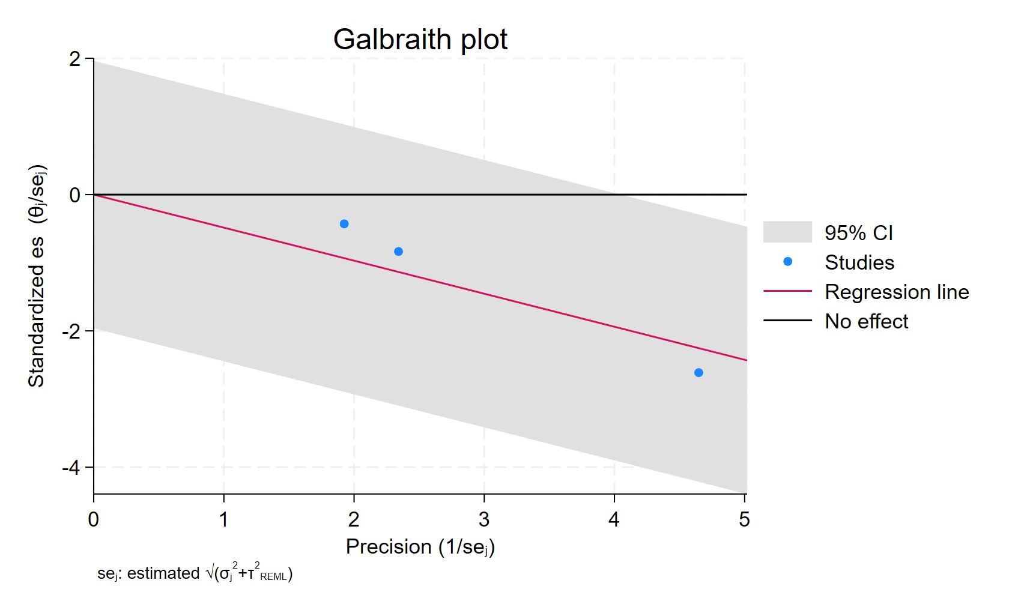
Figure 132. Galbraith plot - Paroxetine use in current patients
Each study is represented as a point, where the x-axis denotes the precision (defined as the inverse of the standard error), and the y-axis indicates the standardized effect size. The red regression line represents the overall summary effect estimated from the random-effects model, and the gray shaded area corresponds to the confidence interval at 95% around regression line. The horizontal black line at y = 0 corresponds to the line of no effect, serving as a reference.

PAROXETINE FORMERS USERS
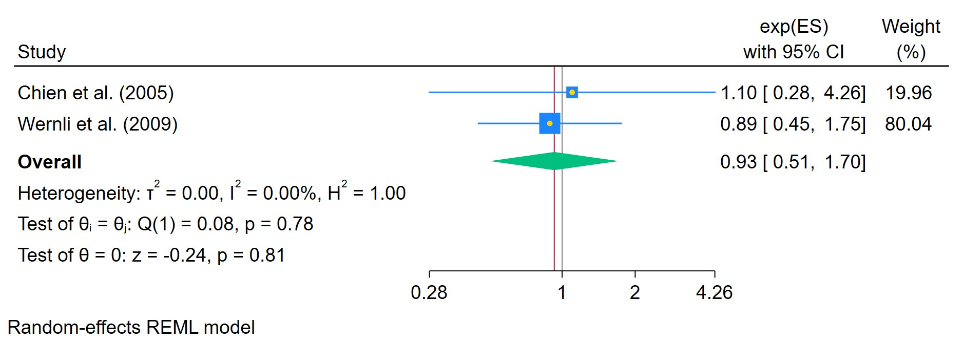
Figure 133. Paroxetine use in former patients
The area of each square is proportional to the sample size of the respective study, with horizontal lines through the squares representing the 95% confidence interval (C.I.) for that study. In the pooled analysis, the diamond symbol represents the pooled estimate, with the right and left points of the diamond indicating the 95% C.I. for the overall analysis

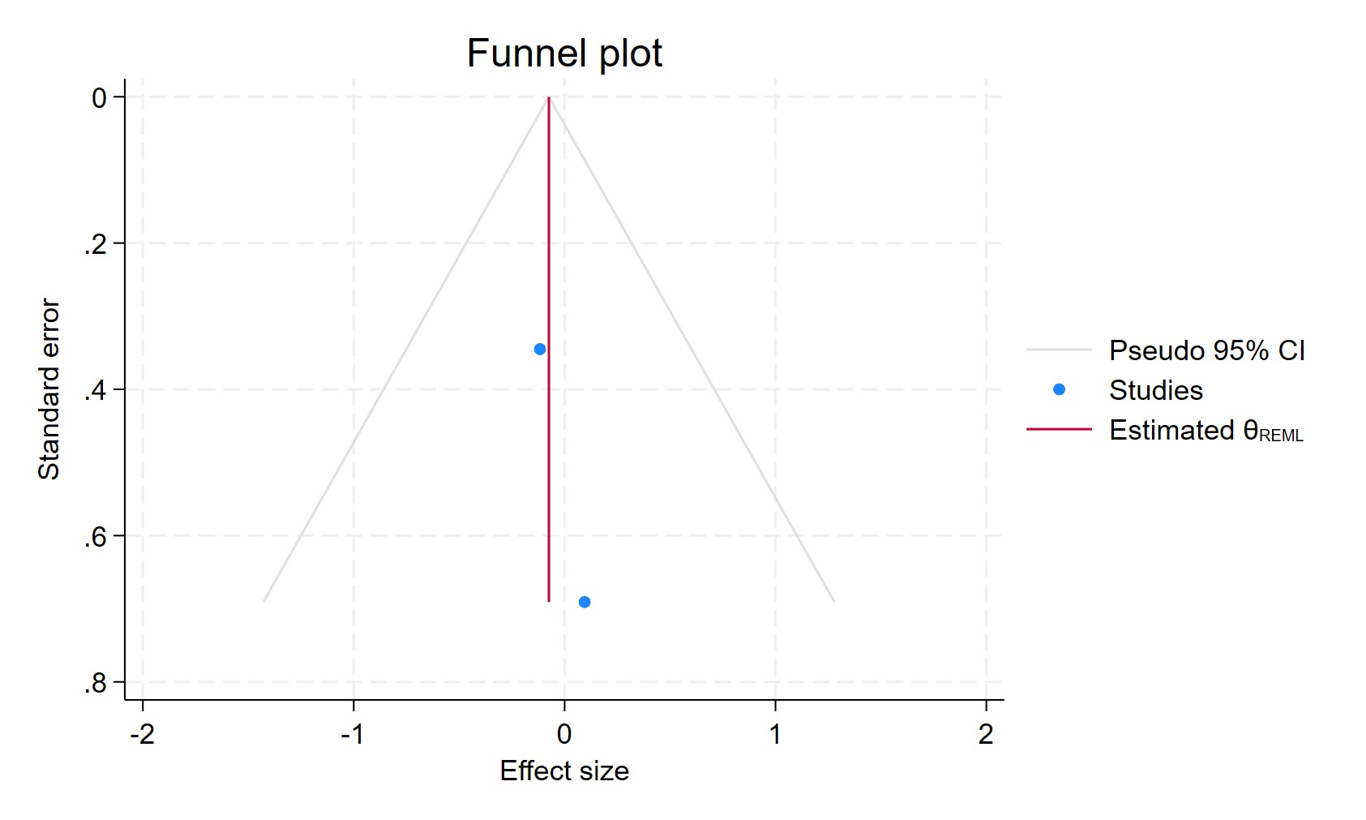
Figure 134. Funnel plot - Paroxetine use in former patients

Each blue dot represents a single study, plotted with its effect size on the x-axis and its standard error on the y-axis. The vertical red line represents the overall effect estimate derived from the random-effects model using restricted maximum likelihood (REML). The pseudo 95% confidence interval region, shown as gray diagonal lines, outlines the expected spread of studies in the absence of bias or between-study heterogeneity.

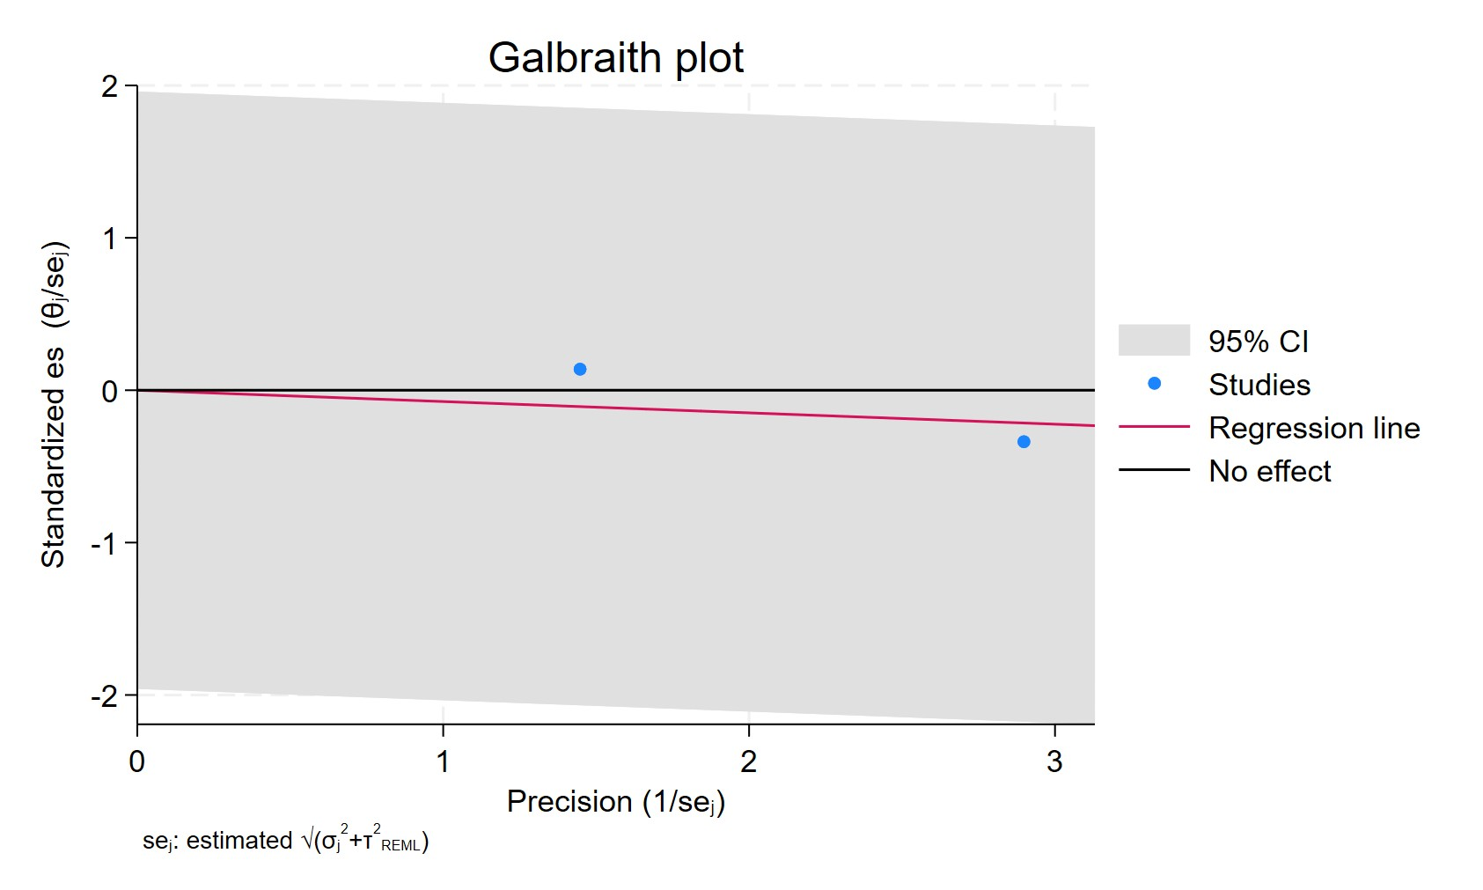
Figure 135. Galbraith plot - Paroxetine use in former patients
Each study is represented as a point, where the x-axis denotes the precision (defined as the inverse of the standard error), and the y-axis indicates the standardized effect size. The red regression line represents the overall summary effect estimated from the random-effects model, and the gray shaded area corresponds to the confidence interval at 95% around regression line. The horizontal black line at y = 0 corresponds to the line of no effect, serving as a reference.

PAROXETINE DURATION FOR LESS THAN 2 YEARS
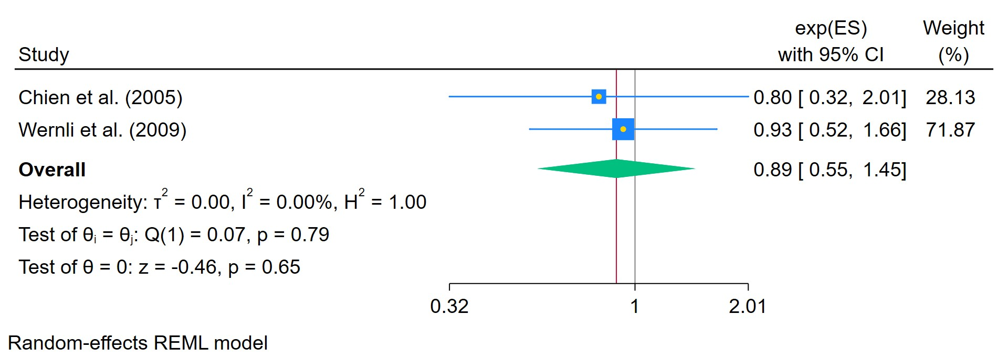
Figure 136. Paroxetine use for less than 2 years
The area of each square is proportional to the sample size of the respective study, with horizontal lines through the squares representing the 95% confidence interval (C.I.) for that study. In the pooled analysis, the diamond symbol represents the pooled estimate, with the right and left points of the diamond indicating the 95% C.I. for the overall analysis

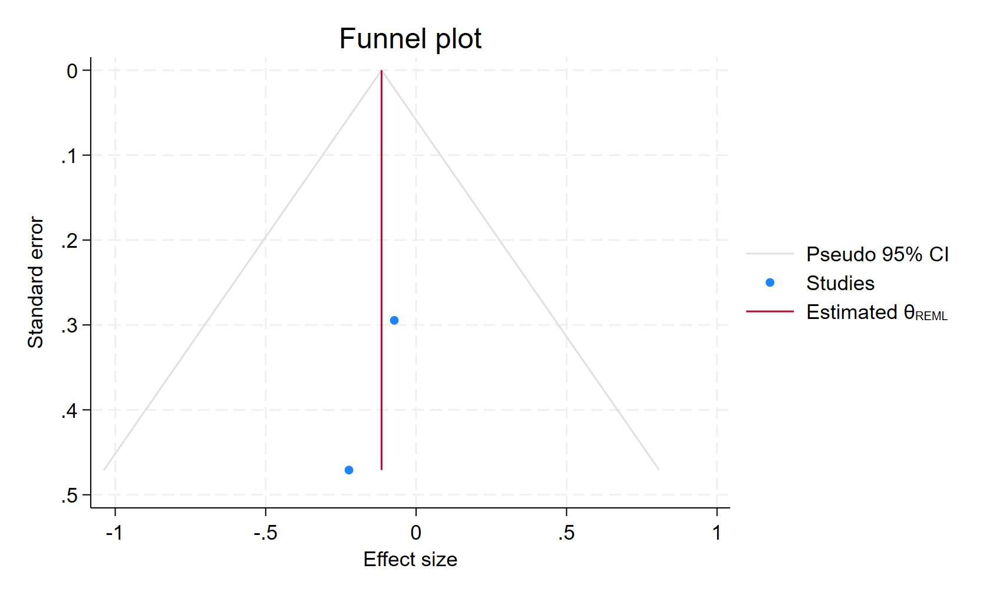
Figure 137. Funnel plot - Paroxetine use for less than 2 years
Each blue dot represents a single study, plotted with its effect size on the x-axis and its standard error on the y-axis. The vertical red line represents the overall effect estimate derived from the random-effects model using restricted maximum likelihood (REML). The pseudo 95% confidence interval region, shown as gray diagonal lines, outlines the expected spread of studies in the absence of bias or between-study heterogeneity.

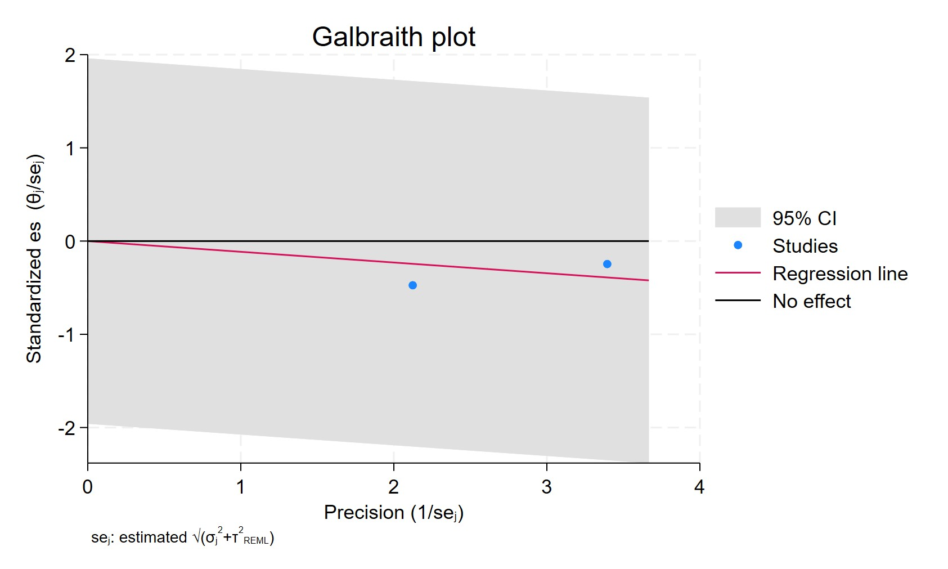
Figure 138. Galbraith plot - Paroxetine use for less than 2 years
Each study is represented as a point, where the x-axis denotes the precision (defined as the inverse of the standard error), and the y-axis indicates the standardized effect size. The red regression line represents the overall summary effect estimated from the random-effects model, and the gray shaded area corresponds to the confidence interval at 95% around regression line. The horizontal black line at y = 0 corresponds to the line of no effect, serving as a reference.

PAROXETINE USERS FOR MORE THAN 2 YEARS

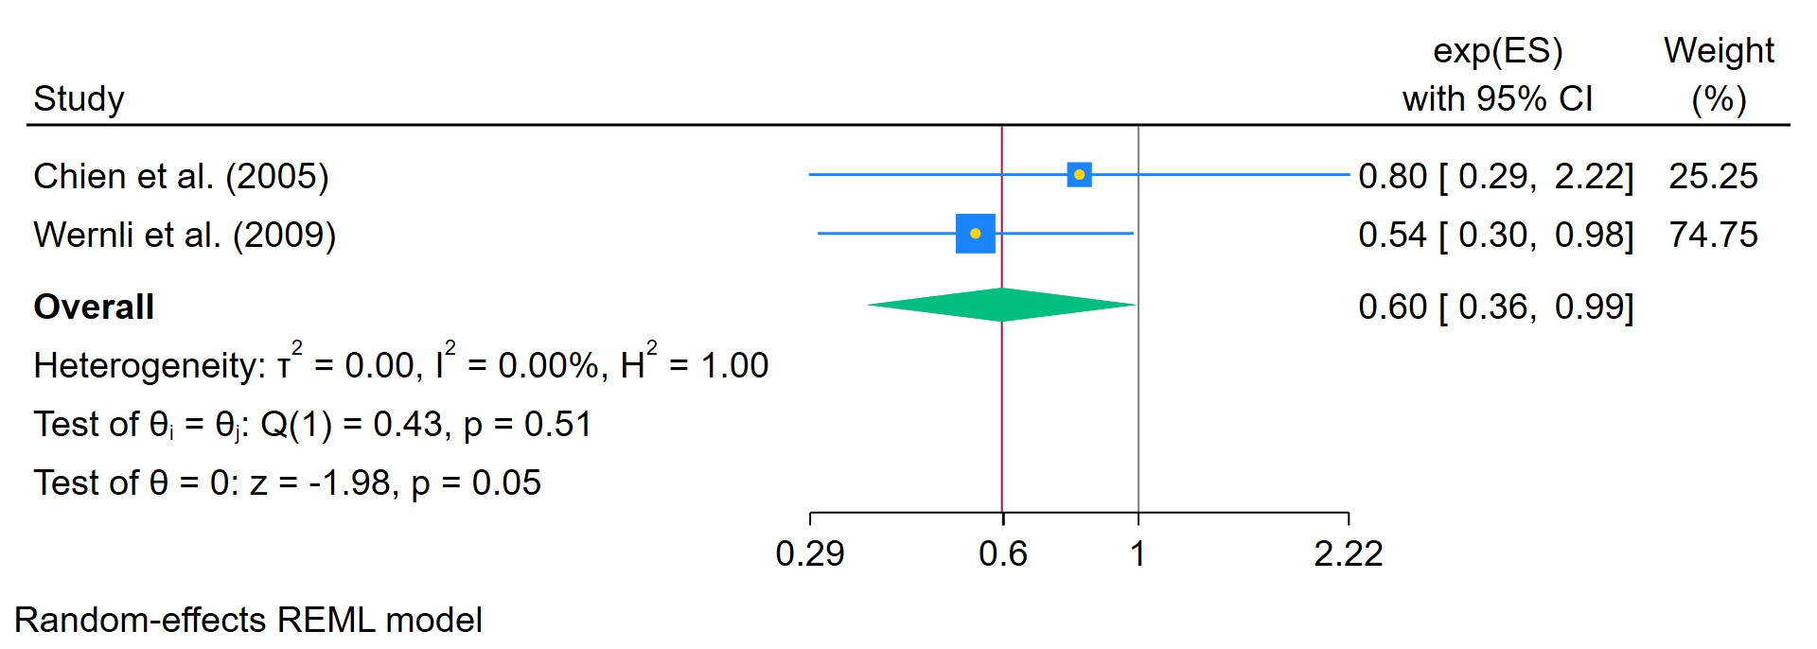
Figure 139. Paroxetine use for more than 2 years
The area of each square is proportional to the sample size of the respective study, with horizontal lines through the squares representing the 95% confidence interval (C.I.) for that study. In the pooled analysis, the diamond symbol represents the pooled estimate, with the right and left points of the diamond indicating the 95% C.I. for the overall analysis

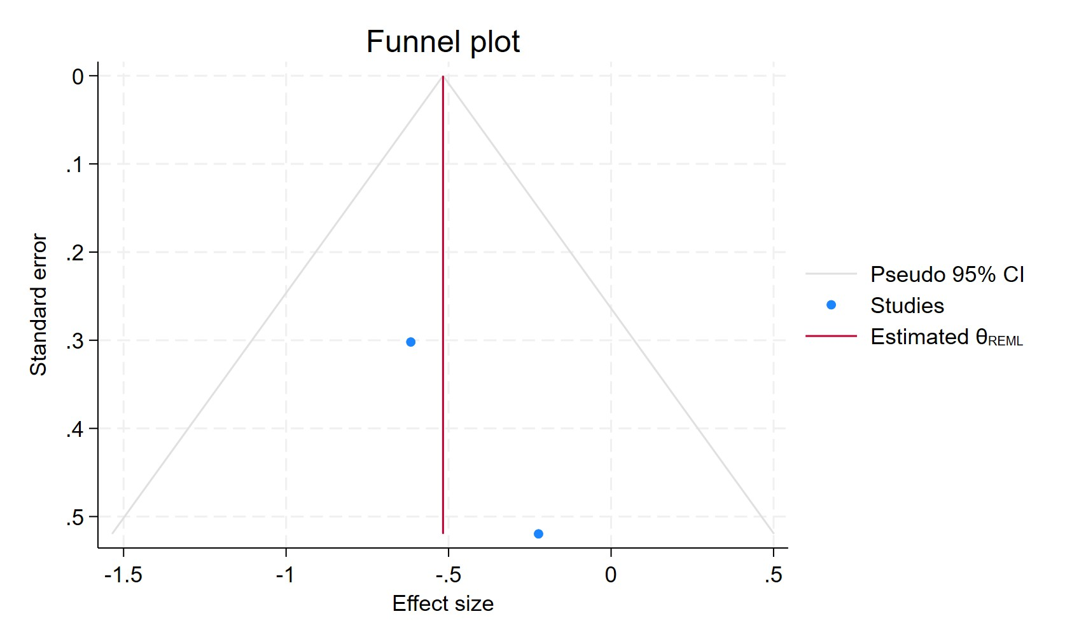
Figure 140. Funnel plot - Paroxetine use for more than 2 years
Each blue dot represents a single study, plotted with its effect size on the x-axis and its standard error on the y-axis. The vertical red line represents the overall effect estimate derived from the random-effects model using restricted maximum likelihood (REML). The pseudo 95% confidence interval region, shown as gray diagonal lines, outlines the expected spread of studies in the absence of bias or between-study heterogeneity.

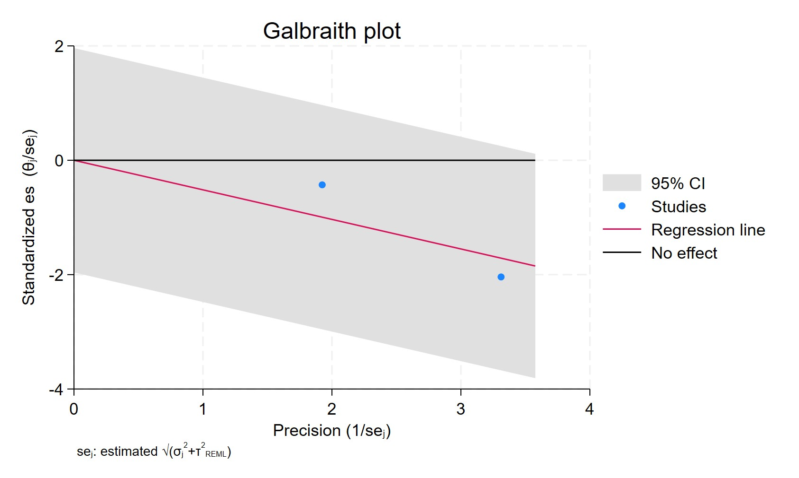
Figure 141. Galbraith plot - Paroxetine use for more than 2 years
Each study is represented as a point, where the x-axis denotes the precision (defined as the inverse of the standard error), and the y-axis indicates the standardized effect size. The red regression line represents the overall summary effect estimated from the random-effects model, and the gray shaded area corresponds to the confidence interval at 95% around regression line. The horizontal black line at y = 0 corresponds to the line of no effect, serving as a reference.

PAROXETINE MORE THAN 11 PRESCRIPTIONS
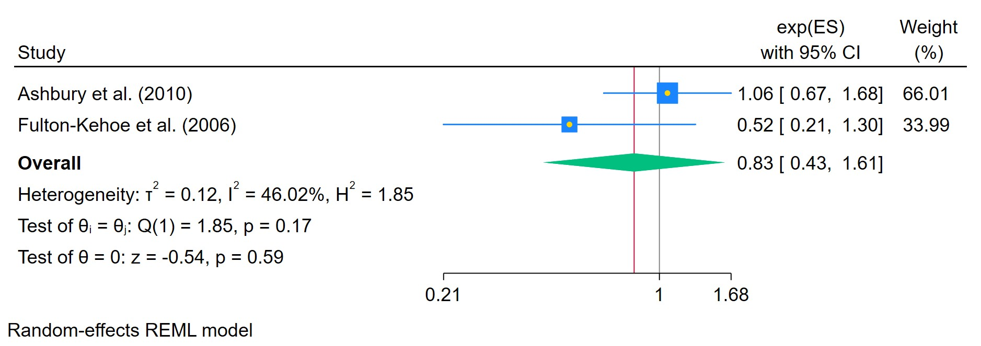
Figure 142. Paroxetine use in patients with more than 11 prescriptions
The area of each square is proportional to the sample size of the respective study, with horizontal lines through the squares representing the 95% confidence interval (C.I.) for that study. In the pooled analysis, the diamond symbol represents the pooled estimate, with the right and left points of the diamond indicating the 95% C.I. for the overall analysis

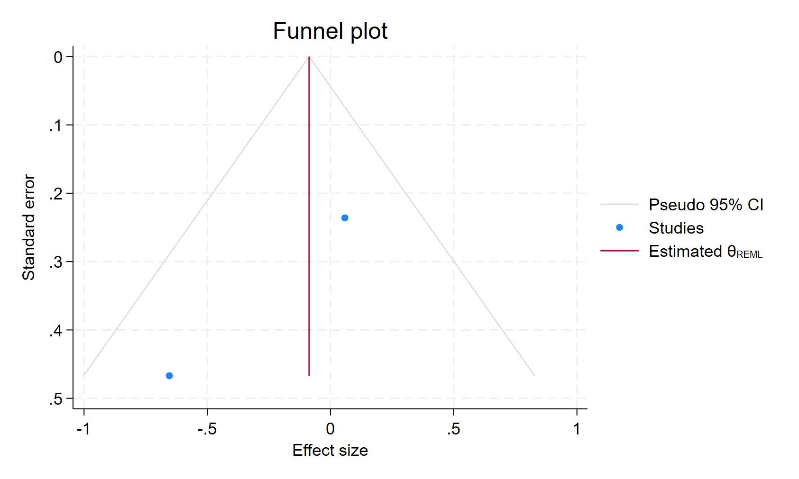
Figure 143. Funnel plot - Paroxetine use in patients with more than 11 prescriptions
Each blue dot represents a single study, plotted with its effect size on the x-axis and its standard error on the y-axis. The vertical red line represents the overall effect estimate derived from the random-effects model using restricted maximum likelihood (REML). The pseudo 95% confidence interval region, shown as gray diagonal lines, outlines the expected spread of studies in the absence of bias or between-study heterogeneity.

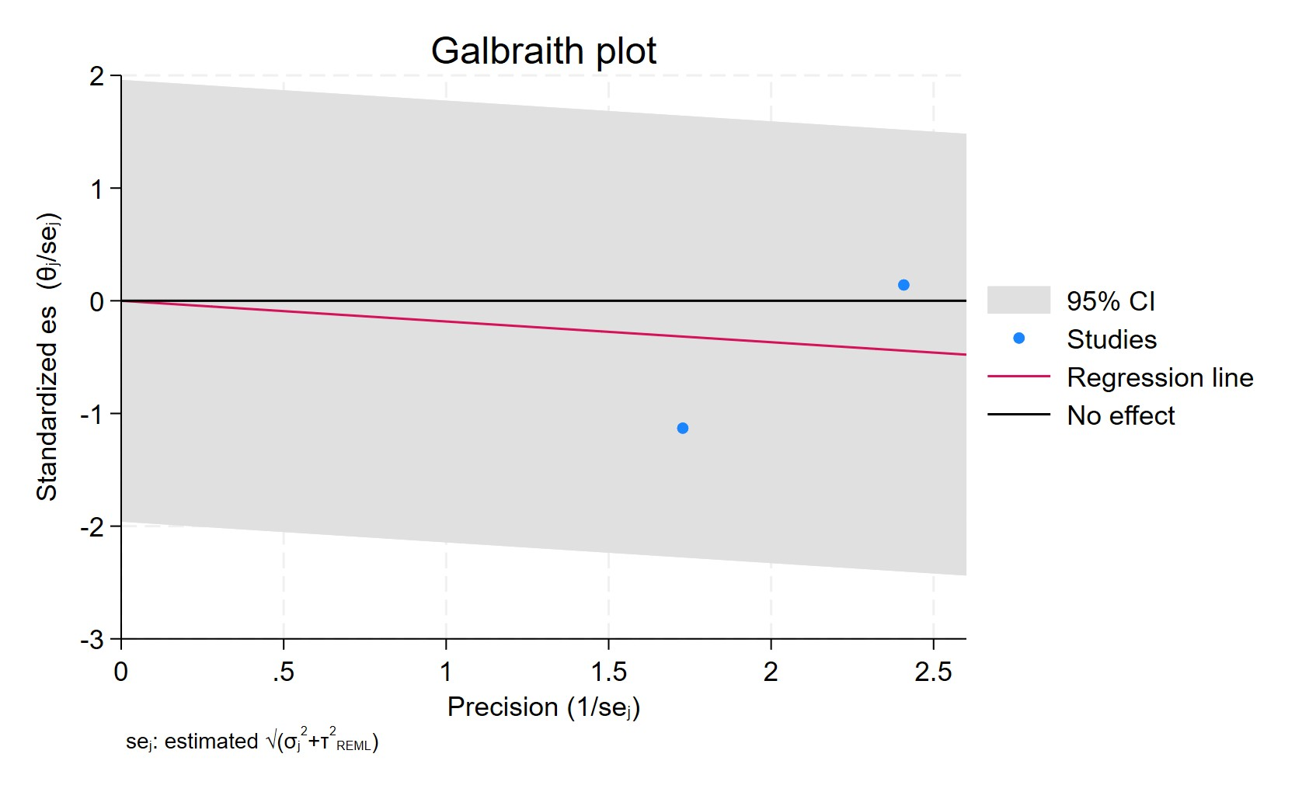
Figure 144. Galbraith plot - Paroxetine use in patients with more than 11 prescriptions
Each study is represented as a point, where the x-axis denotes the precision (defined as the inverse of the standard error), and the y-axis indicates the standardized effect size. The red regression line represents the overall summary effect estimated from the random-effects model, and the gray shaded area corresponds to the confidence interval at 95% around regression line. The horizontal black line at y = 0 corresponds to the line of no effect, serving as a reference.

SERTRALINE EVER USED
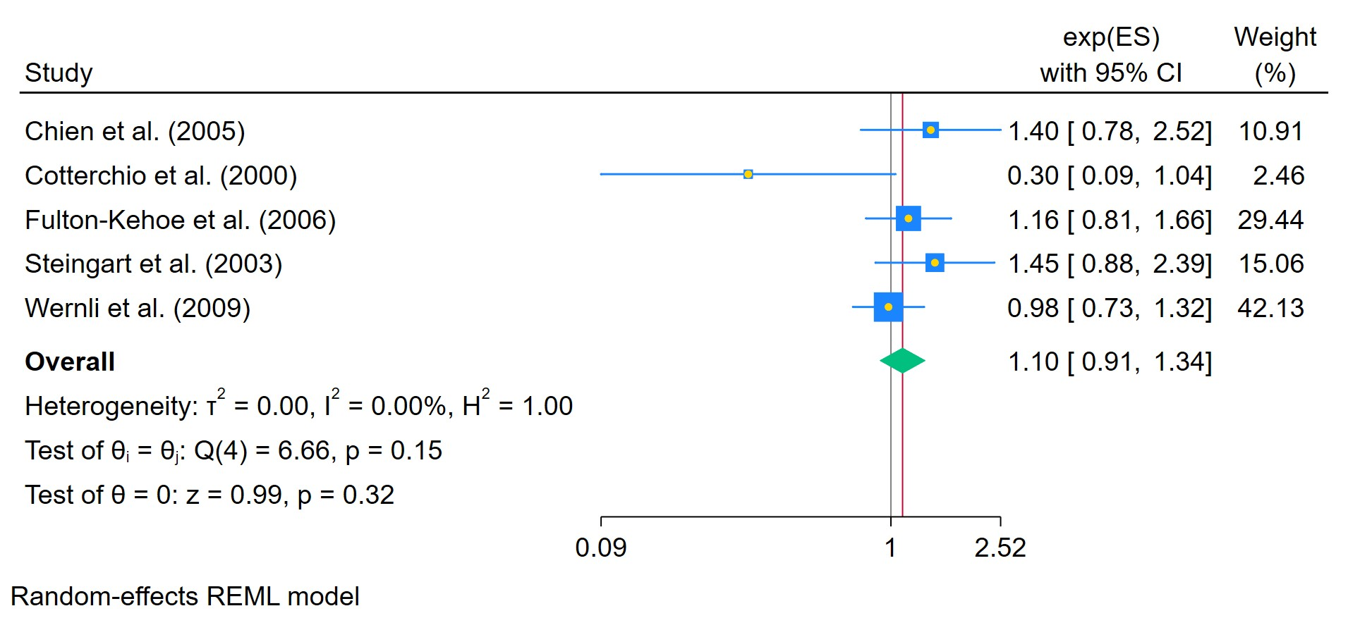
Figure 145. Sertraline ever used
The area of each square is proportional to the sample size of the respective study, with horizontal lines through the squares representing the 95% confidence interval (C.I.) for that study. In the pooled analysis, the diamond symbol represents the pooled estimate, with the right and left points of the diamond indicating the 95% C.I. for the overall analysis

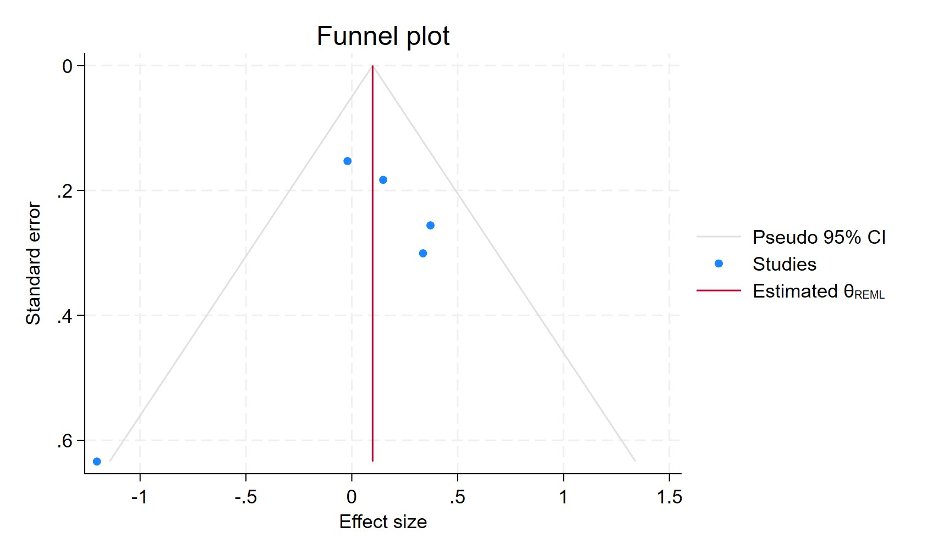
Figure 146. Funnel plot - Sertraline ever used
Each blue dot represents a single study, plotted with its effect size on the x-axis and its standard error on the y-axis. The vertical red line represents the overall effect estimate derived from the random-effects model using restricted maximum likelihood (REML). The pseudo 95% confidence interval region, shown as gray diagonal lines, outlines the expected spread of studies in the absence of bias or between-study heterogeneity.

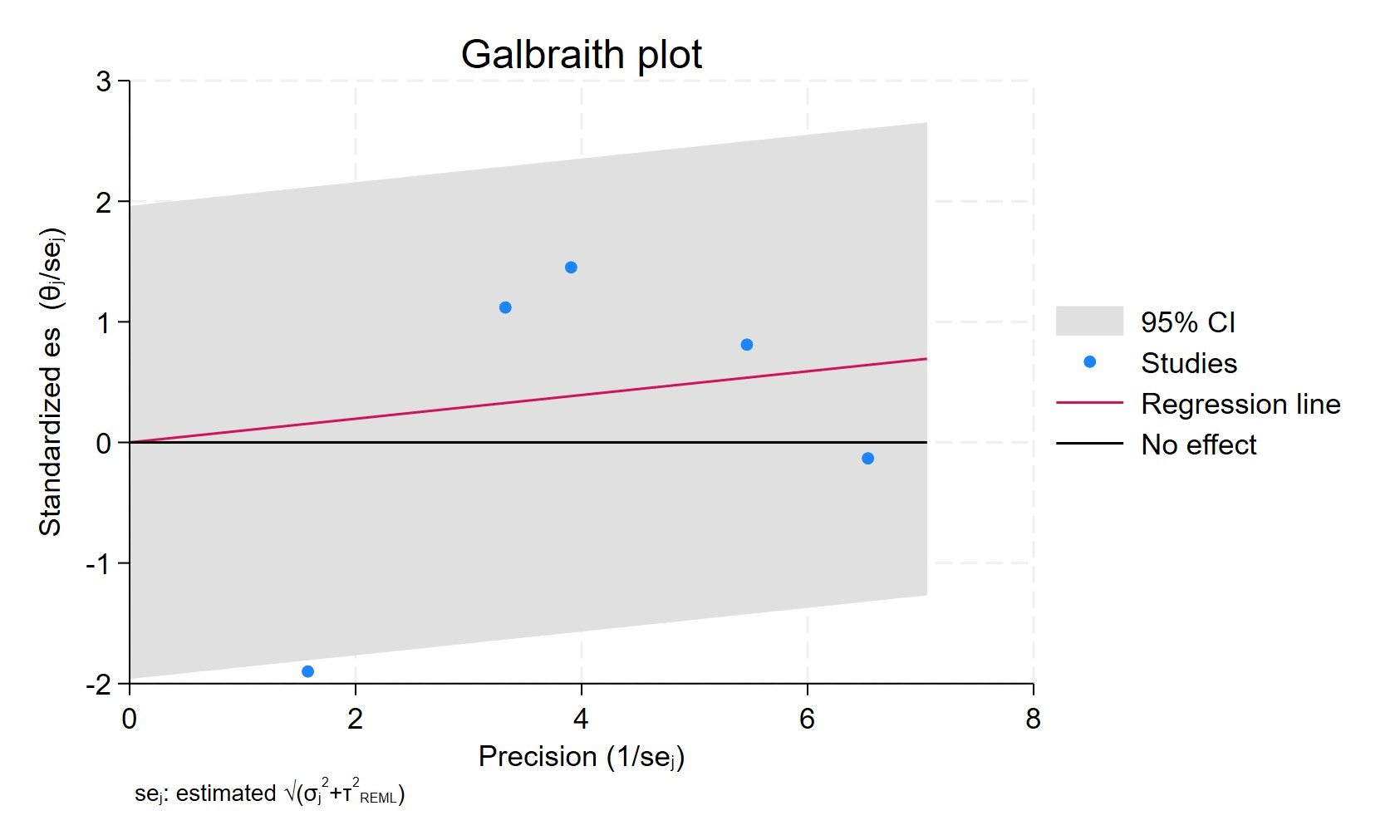
Figure 147. Galbraith plot - Sertraline ever used
Each study is represented as a point, where the x-axis denotes the precision (defined as the inverse of the standard error), and the y-axis indicates the standardized effect size. The red regression line represents the overall summary effect estimated from the random-effects model, and the gray shaded area corresponds to the confidence interval at 95% around regression line. The horizontal black line at y = 0 corresponds to the line of no effect, serving as a reference.

SERTRALINE CURRENT USERS
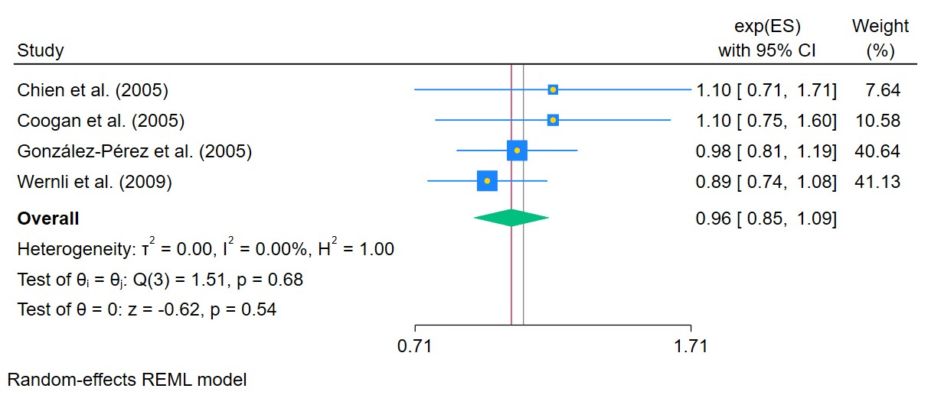
Figure 148. Use of sertraline in current patients
The area of each square is proportional to the sample size of the respective study, with horizontal lines through the squares representing the 95% confidence interval (C.I.) for that study. In the pooled analysis, the diamond symbol represents the pooled estimate, with the right and left points of the diamond indicating the 95% C.I. for the overall analysis

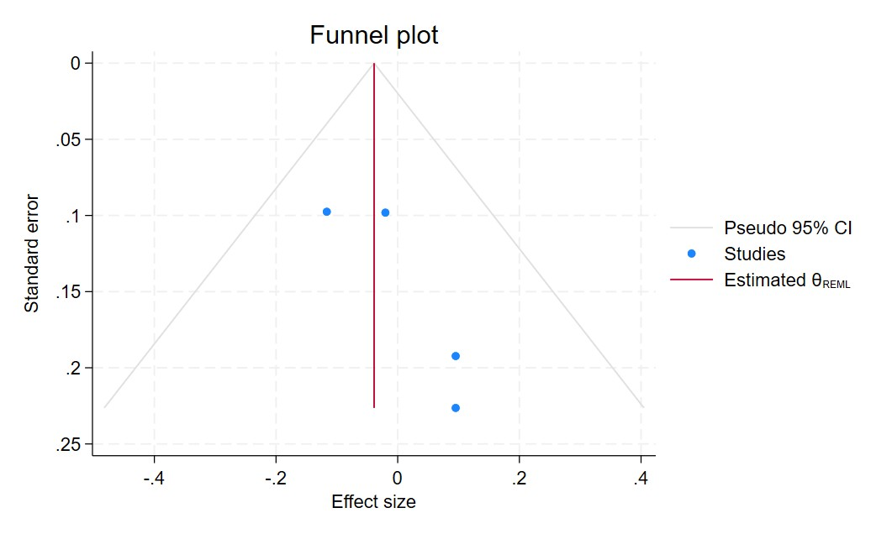
Figure 149. Funnel plot - Use of sertraline in current patients
Each blue dot represents a single study, plotted with its effect size on the x-axis and its standard error on the y-axis. The vertical red line represents the overall effect estimate derived from the random-effects model using restricted maximum likelihood (REML). The pseudo 95% confidence interval region, shown as gray diagonal lines, outlines the expected spread of studies in the absence of bias or between-study heterogeneity.

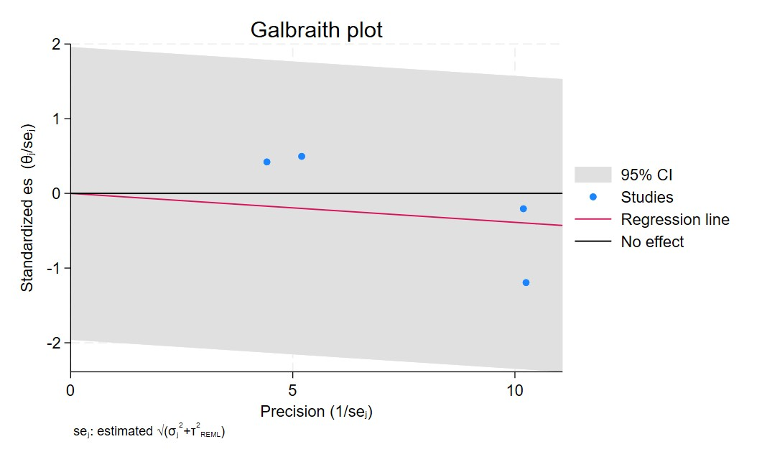
Figure 150. Galbraith plot - Use of sertraline in current patients
Each study is represented as a point, where the x-axis denotes the precision (defined as the inverse of the standard error), and the y-axis indicates the standardized effect size. The red regression line represents the overall summary effect estimated from the random-effects model, and the gray shaded area corresponds to the confidence interval at 95% around regression line. The horizontal black line at y = 0 corresponds to the line of no effect, serving as a reference.

SSRI USERS FORMERS
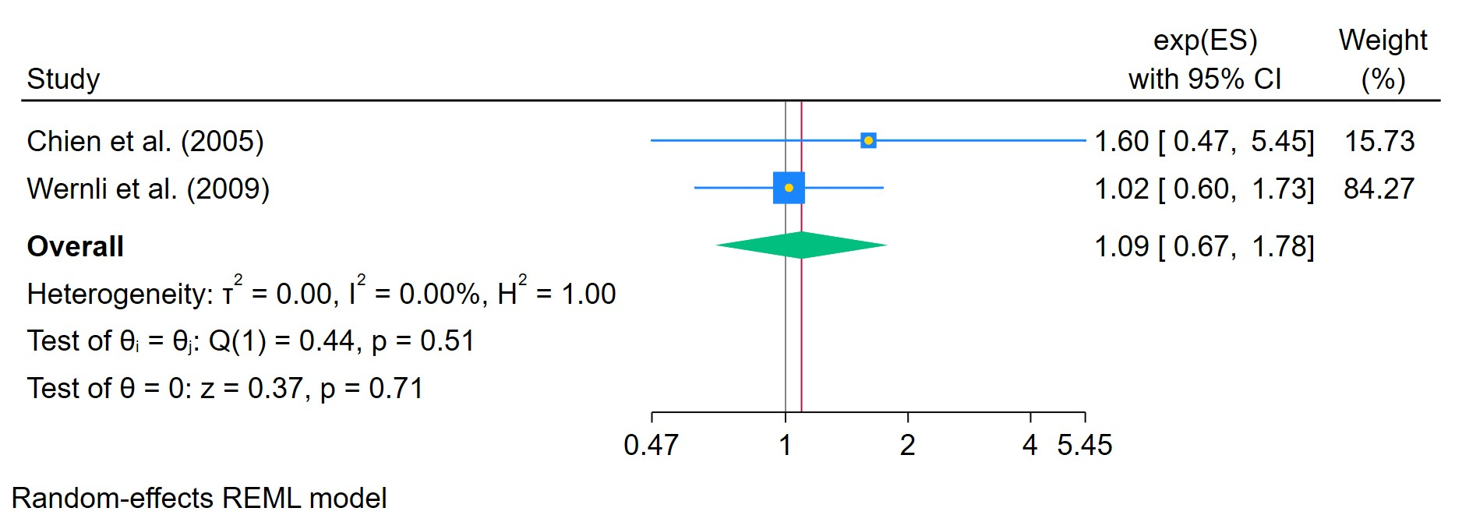
Figure 151. Use of sertraline in former patients
The area of each square is proportional to the sample size of the respective study, with horizontal lines through the squares representing the 95% confidence interval (C.I.) for that study. In the pooled analysis, the diamond symbol represents the pooled estimate, with the right and left points of the diamond indicating the 95% C.I. for the overall analysis

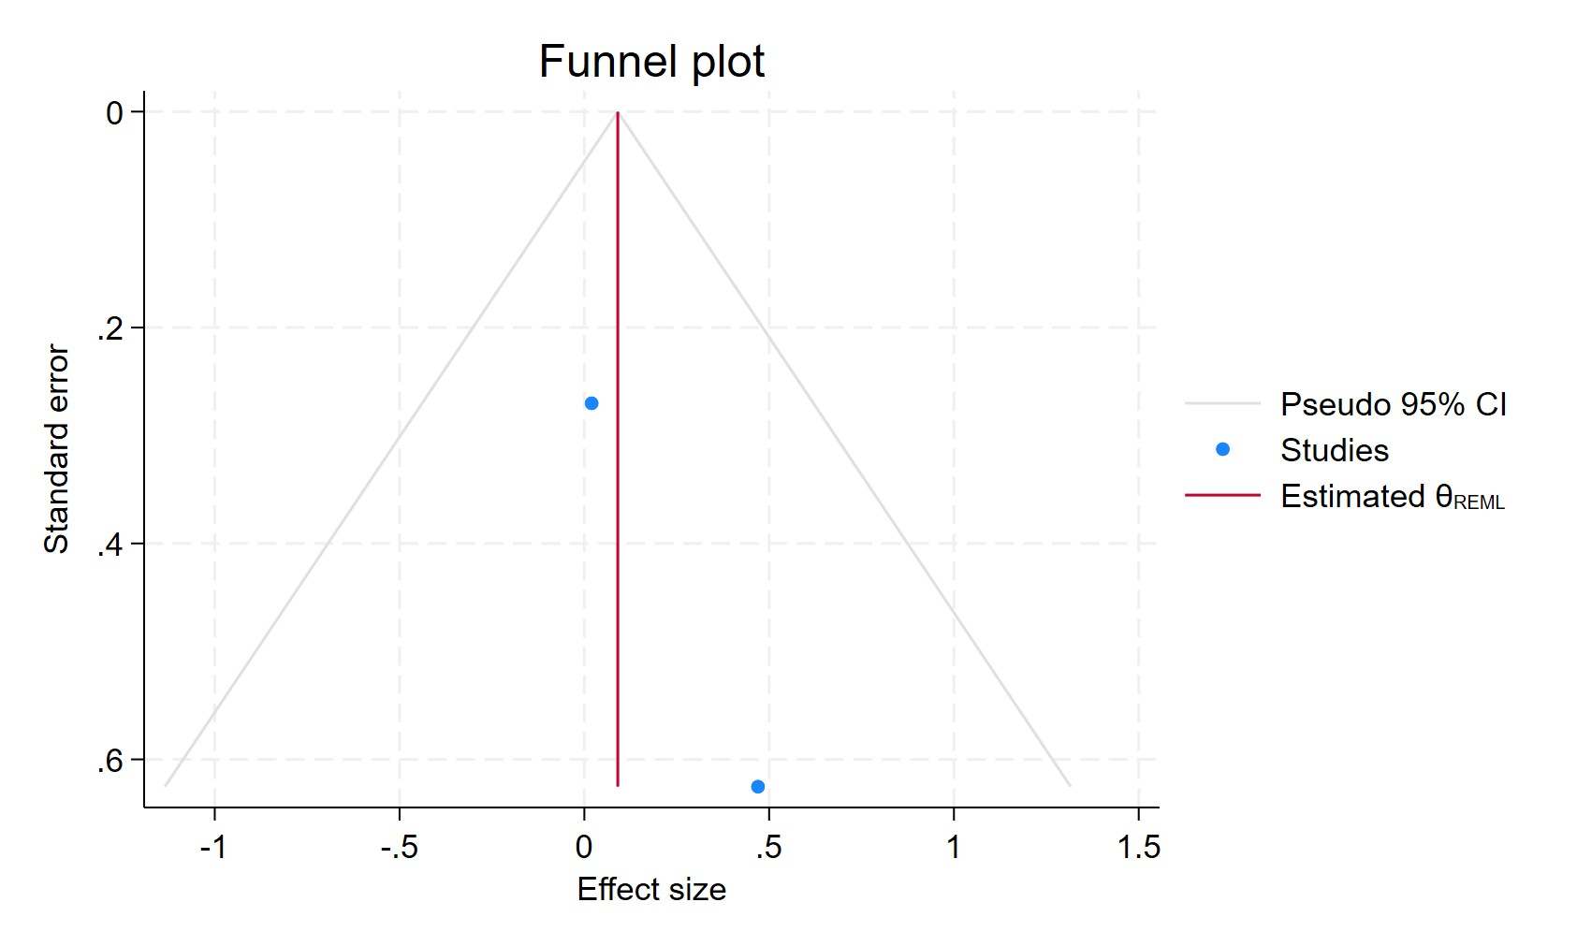
Figure 152. Funnel plot - Use of sertraline in former patients
Each blue dot represents a single study, plotted with its effect size on the x-axis and its standard error on the y-axis. The vertical red line represents the overall effect estimate derived from the random-effects model using restricted maximum likelihood (REML). The pseudo 95% confidence interval region, shown as gray diagonal lines, outlines the expected spread of studies in the absence of bias or between-study heterogeneity.

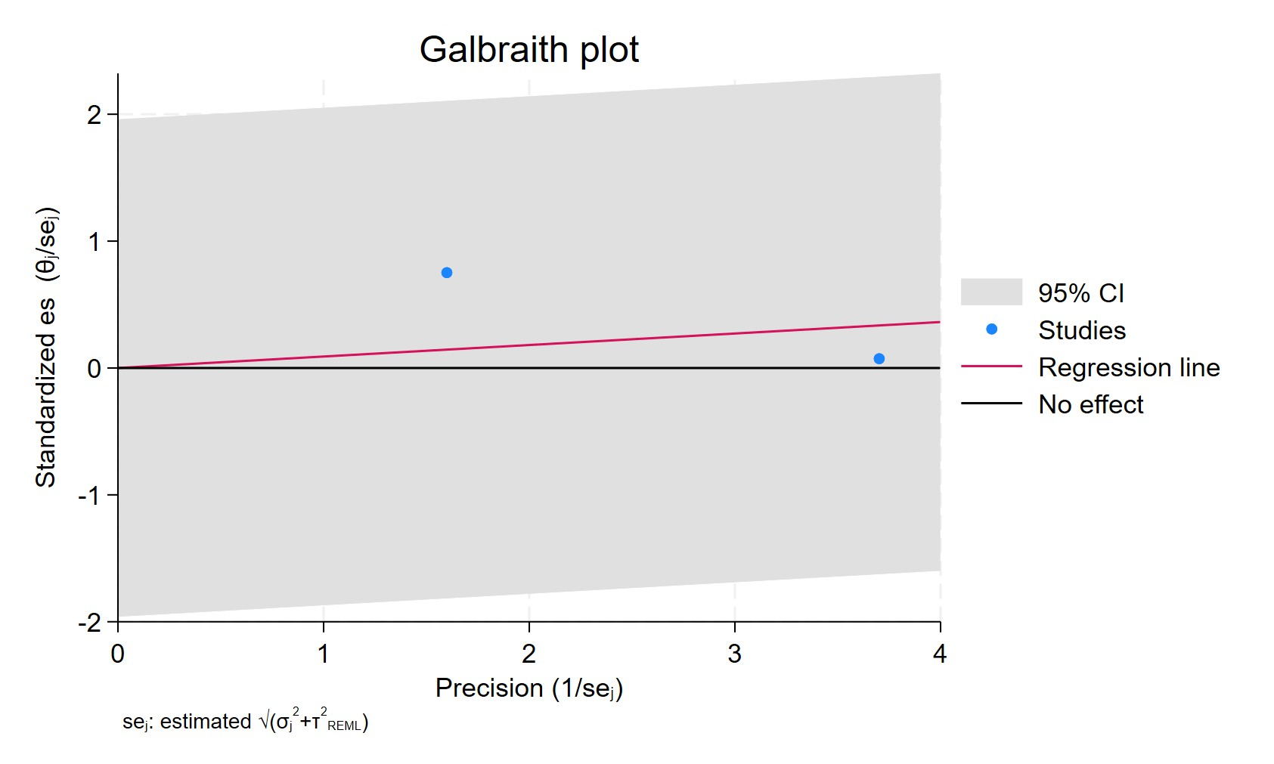
Figure 153. Galbraith plot - Use of sertraline in former patients
Each study is represented as a point, where the x-axis denotes the precision (defined as the inverse of the standard error), and the y-axis indicates the standardized effect size. The red regression line represents the overall summary effect estimated from the random-effects model, and the gray shaded area corresponds to the confidence interval at 95% around regression line. The horizontal black line at y = 0 corresponds to the line of no effect, serving as a reference.

SERTRALINE USE FOR MORE THAN 2 YEARS
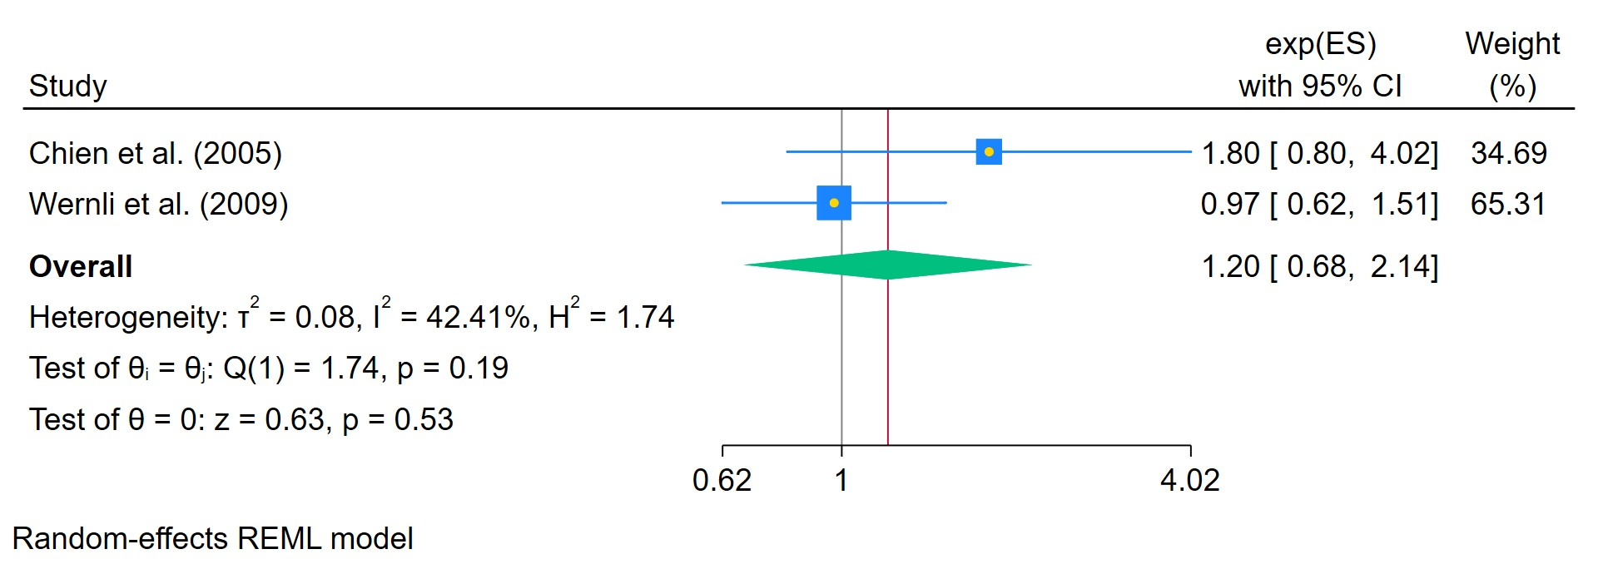
Figure 154. Use of sertraline for less than 2 years
The area of each square is proportional to the sample size of the respective study, with horizontal lines through the squares representing the 95% confidence interval (C.I.) for that study. In the pooled analysis, the diamond symbol represents the pooled estimate, with the right and left points of the diamond indicating the 95% C.I. for the overall analysis

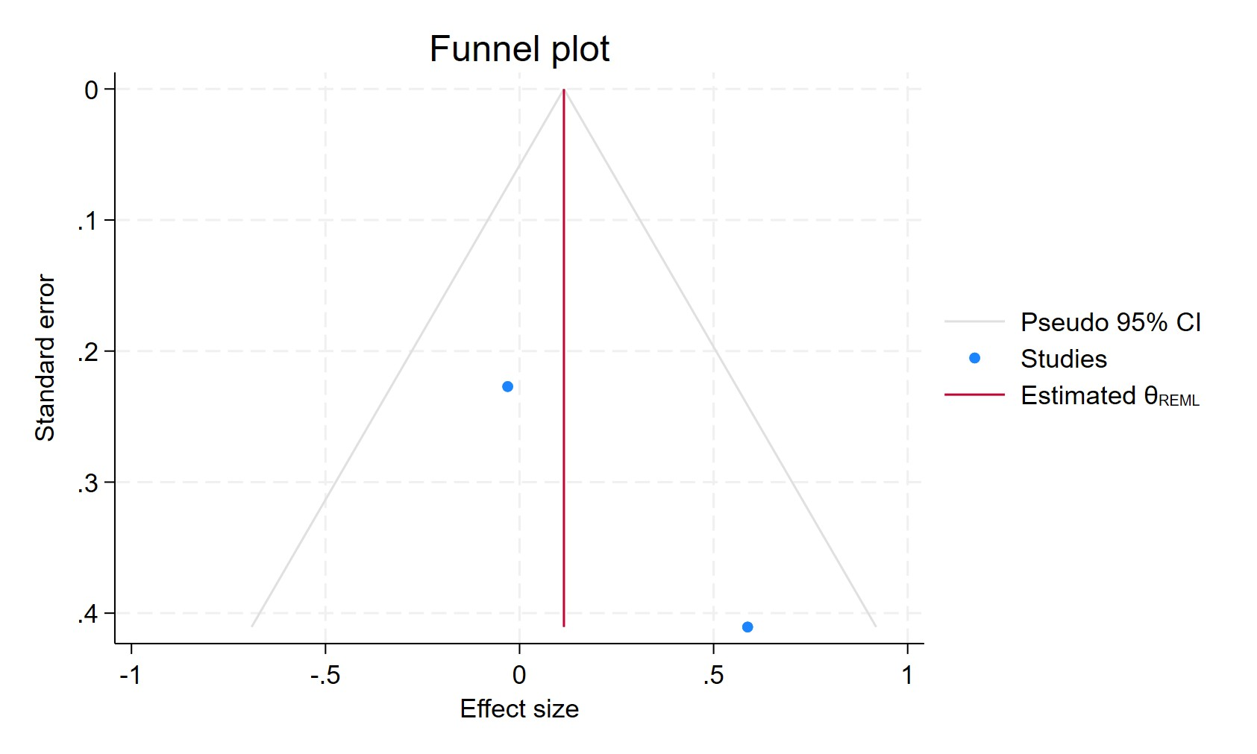
Figure 155. Funnel plot - Use of sertraline for less than 2 years
Each blue dot represents a single study, plotted with its effect size on the x-axis and its standard error on the y-axis. The vertical red line represents the overall effect estimate derived from the random-effects model using restricted maximum likelihood (REML). The pseudo 95% confidence interval region, shown as gray diagonal lines, outlines the expected spread of studies in the absence of bias or between-study heterogeneity.

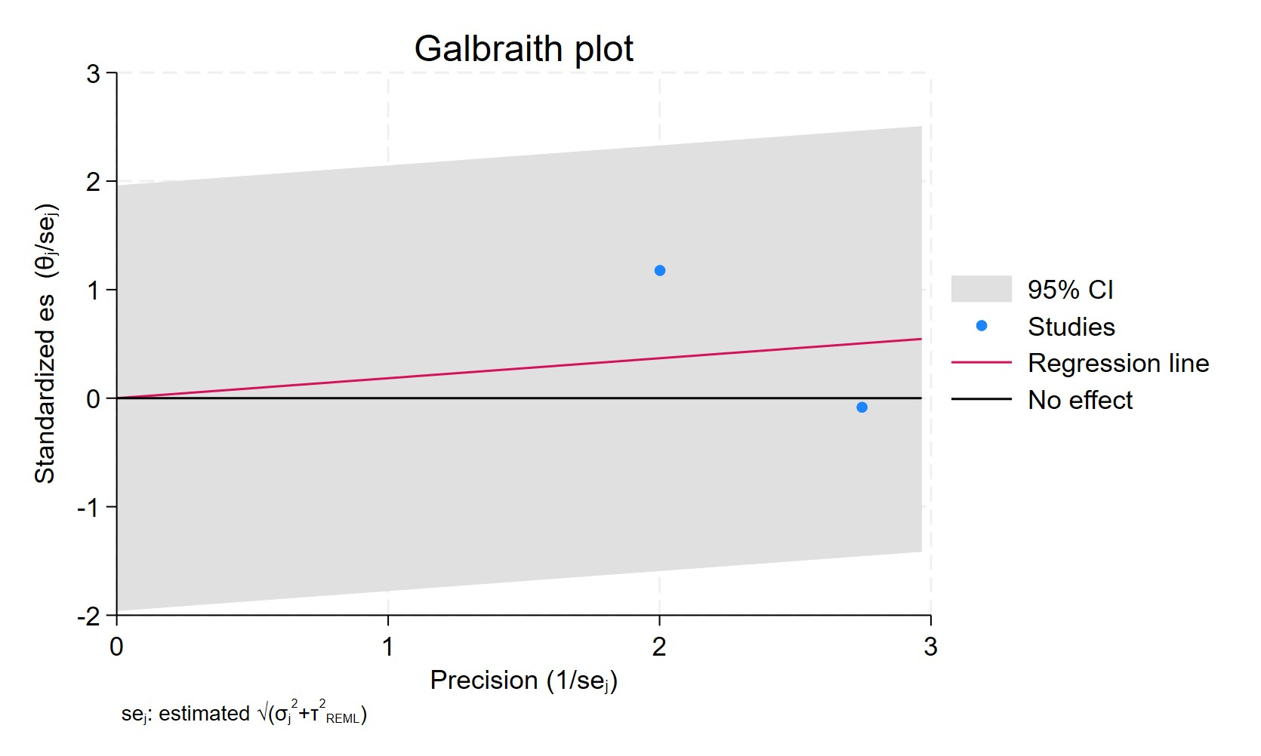
Figure 156. Galbraith plot - Use of sertraline for less than 2 years
Each study is represented as a point, where the x-axis denotes the precision (defined as the inverse of the standard error), and the y-axis indicates the standardized effect size. The red regression line represents the overall summary effect estimated from the random-effects model, and the gray shaded area corresponds to the confidence interval at 95% around regression line. The horizontal black line at y = 0 corresponds to the line of no effect, serving as a reference.

SERTRALINE USE FOR MORE THAN 2 YEARS
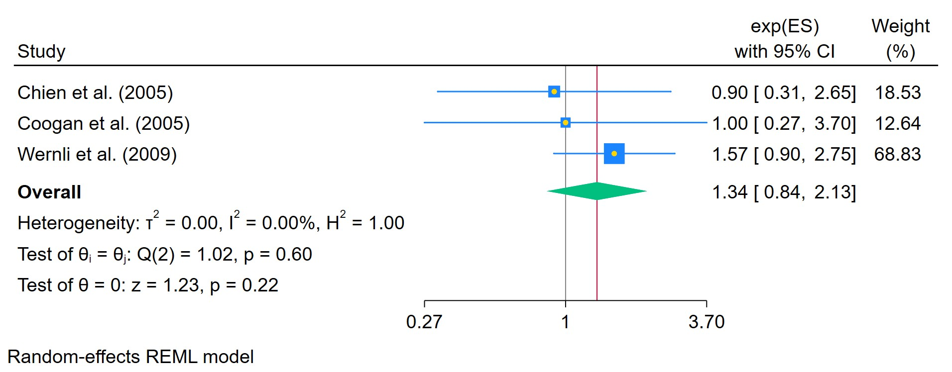
Figure 157. Use of sertraline for more than 2 years
The area of each square is proportional to the sample size of the respective study, with horizontal lines through the squares representing the 95% confidence interval (C.I.) for that study. In the pooled analysis, the diamond symbol represents the pooled estimate, with the right and left points of the diamond indicating the 95% C.I. for the overall analysis

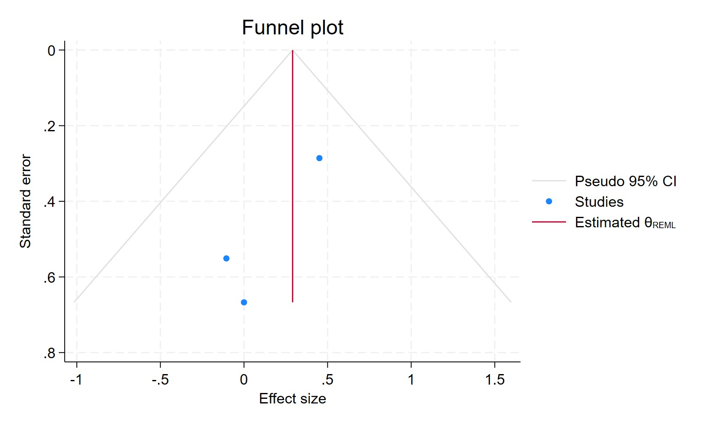
Figure 158. Funnel plot - Use of sertraline for more than 2 years
Each blue dot represents a single study, plotted with its effect size on the x-axis and its standard error on the y-axis. The vertical red line represents the overall effect estimate derived from the random-effects model using restricted maximum likelihood (REML). The pseudo 95% confidence interval region, shown as gray diagonal lines, outlines the expected spread of studies in the absence of bias or between-study heterogeneity.

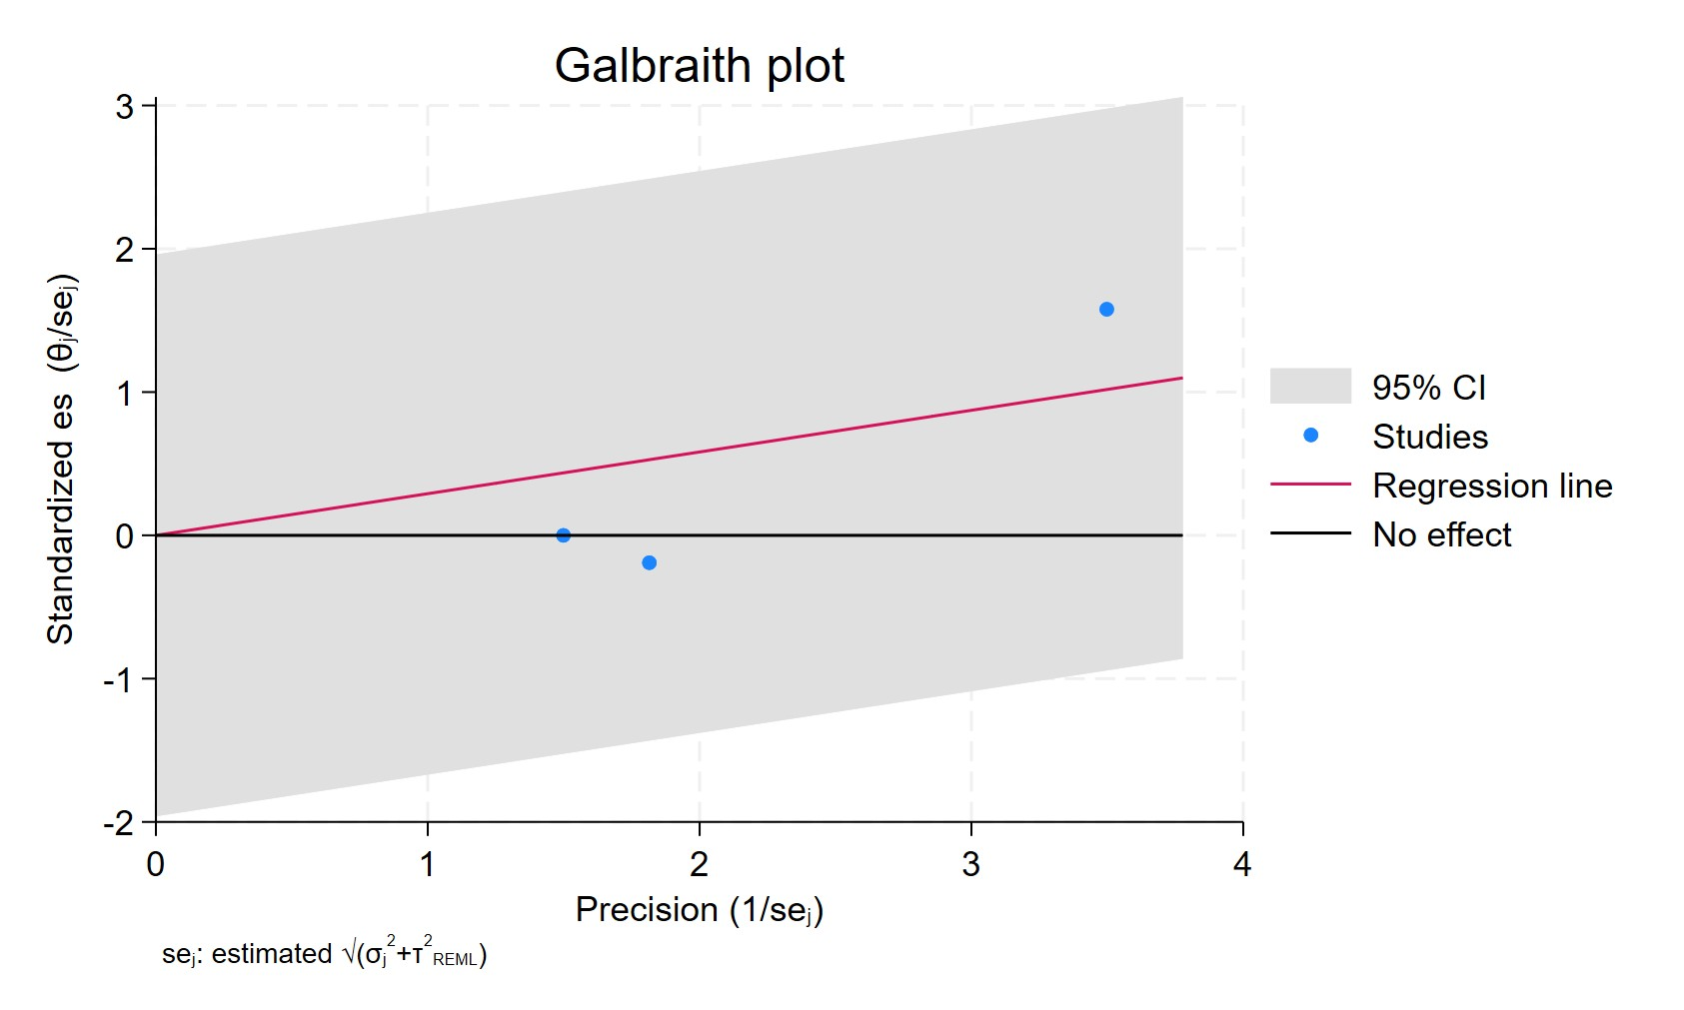
Figure 159. Galbraith plot - Use of sertraline for more than 2 years
Each study is represented as a point, where the x-axis denotes the precision (defined as the inverse of the standard error), and the y-axis indicates the standardized effect size. The red regression line represents the overall summary effect estimated from the random-effects model, and the gray shaded area corresponds to the confidence interval at 95% around regression line. The horizontal black line at y = 0 corresponds to the line of no effect, serving as a reference.

SERTRALINE USER WITH MORE THAN 11 PRESCRIPTIONS
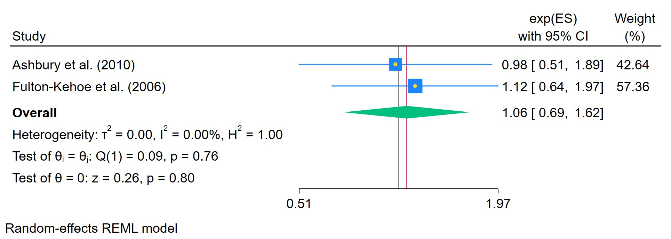
Figure 160. Use of sertraline in patients with more than 11 prescriptions
The area of each square is proportional to the sample size of the respective study, with horizontal lines through the squares representing the 95% confidence interval (C.I.) for that study. In the pooled analysis, the diamond symbol represents the pooled estimate, with the right and left points of the diamond indicating the 95% C.I. for the overall analysis

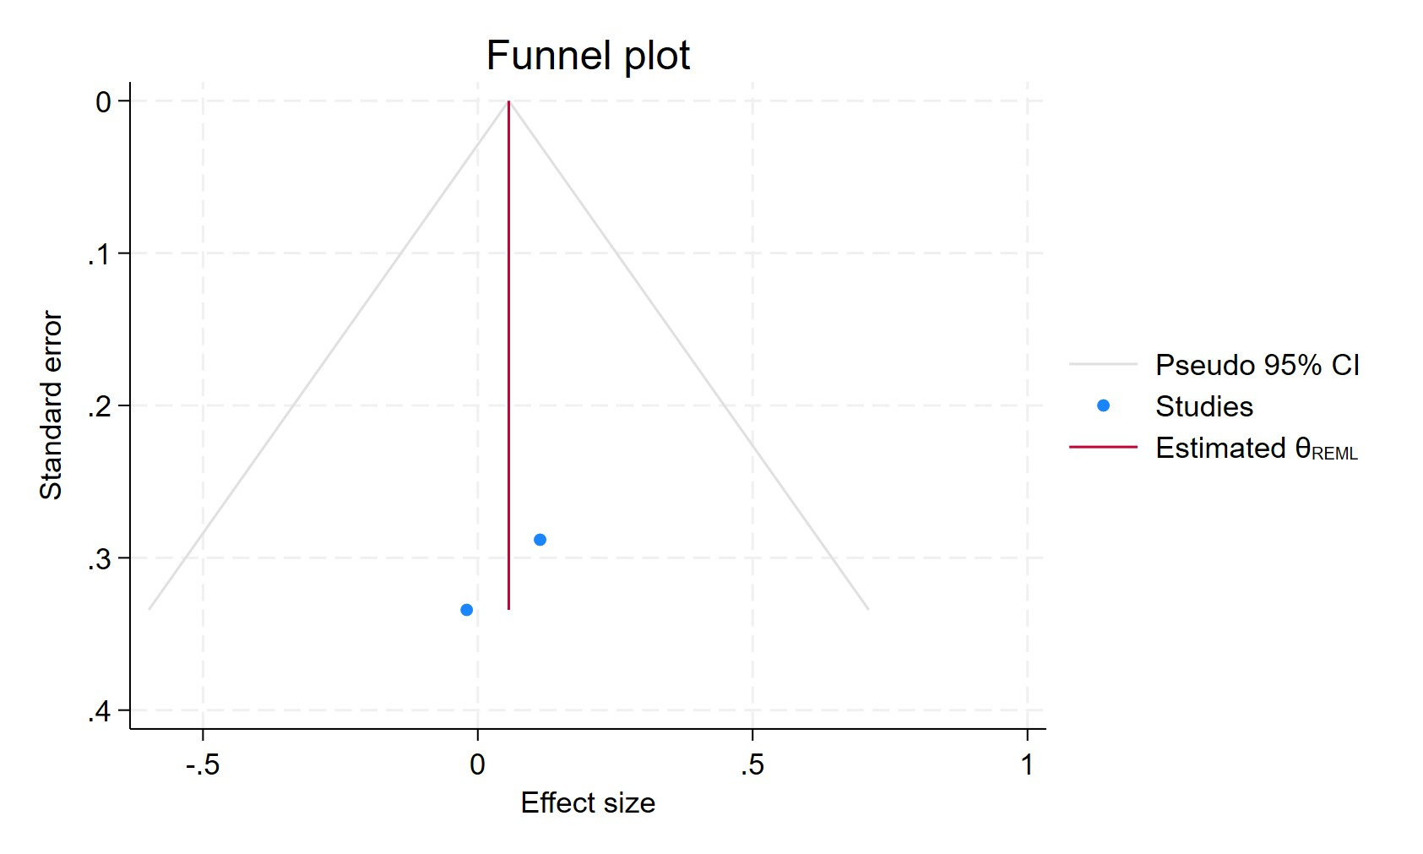
Figure 161. Funnel plot - Use of sertraline in patients with more than 11 prescriptions
Each blue dot represents a single study, plotted with its effect size on the x-axis and its standard error on the y-axis. The vertical red line represents the overall effect estimate derived from the random-effects model using restricted maximum likelihood (REML). The pseudo 95% confidence interval region, shown as gray diagonal lines, outlines the expected spread of studies in the absence of bias or between-study heterogeneity.

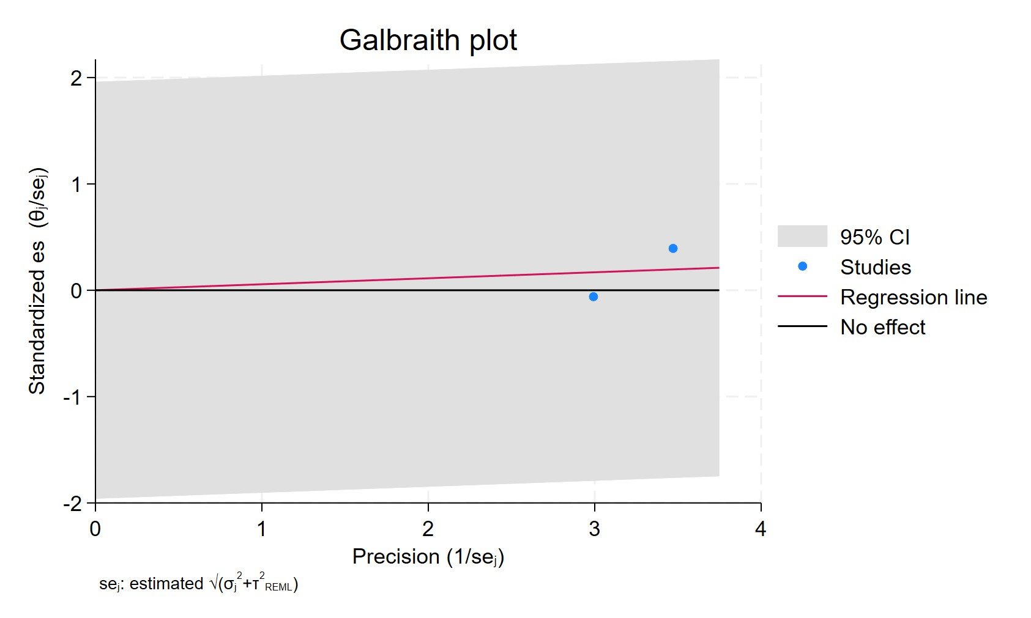
Figure 162. Galbraith plot - Use of sertraline in patients with more than 11 prescriptions
Each study is represented as a point, where the x-axis denotes the precision (defined as the inverse of the standard error), and the y-axis indicates the standardized effect size. The red regression line represents the overall summary effect estimated from the random-effects model, and the gray shaded area corresponds to the confidence interval at 95% around regression line. The horizontal black line at y = 0 corresponds to the line of no effect, serving as a reference.

OTHERS
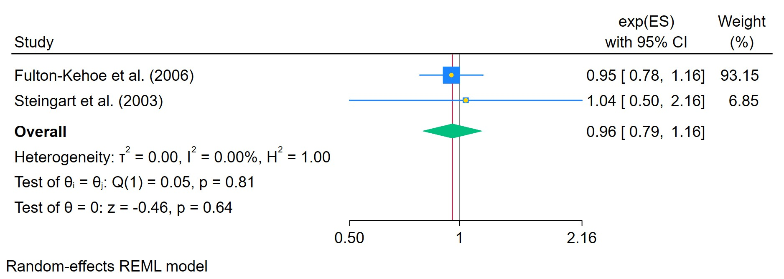
Figure 163. Ever used Atypical ADs
The area of each square is proportional to the sample size of the respective study, with horizontal lines through the squares representing the 95% confidence interval (C.I.) for that study. In the pooled analysis, the diamond symbol represents the pooled estimate, with the right and left points of the diamond indicating the 95% C.I. for the overall analysis

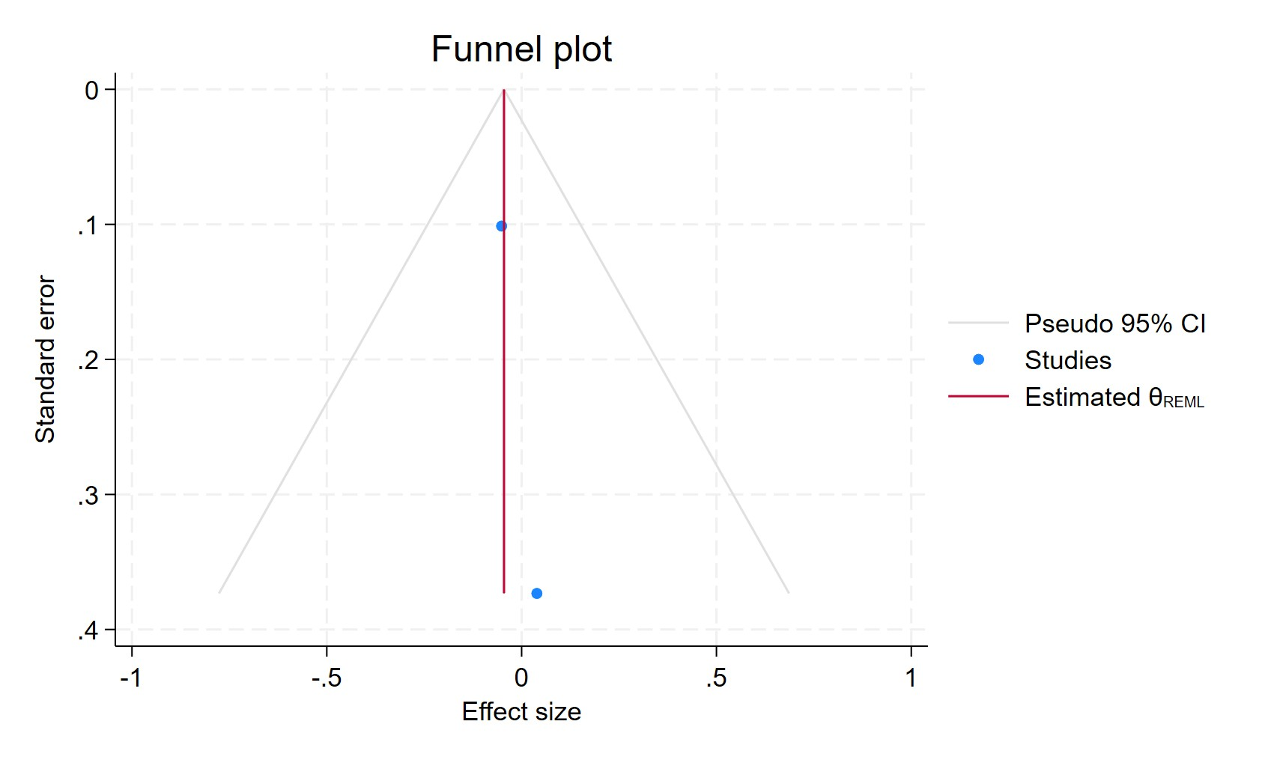
Figure 164. Funnel plot - Ever used Atypical ADs
Each blue dot represents a single study, plotted with its effect size on the x-axis and its standard error on the y-axis. The vertical red line represents the overall effect estimate derived from the random-effects model using restricted maximum likelihood (REML). The pseudo 95% confidence interval region, shown as gray diagonal lines, outlines the expected spread of studies in the absence of bias or between-study heterogeneity.

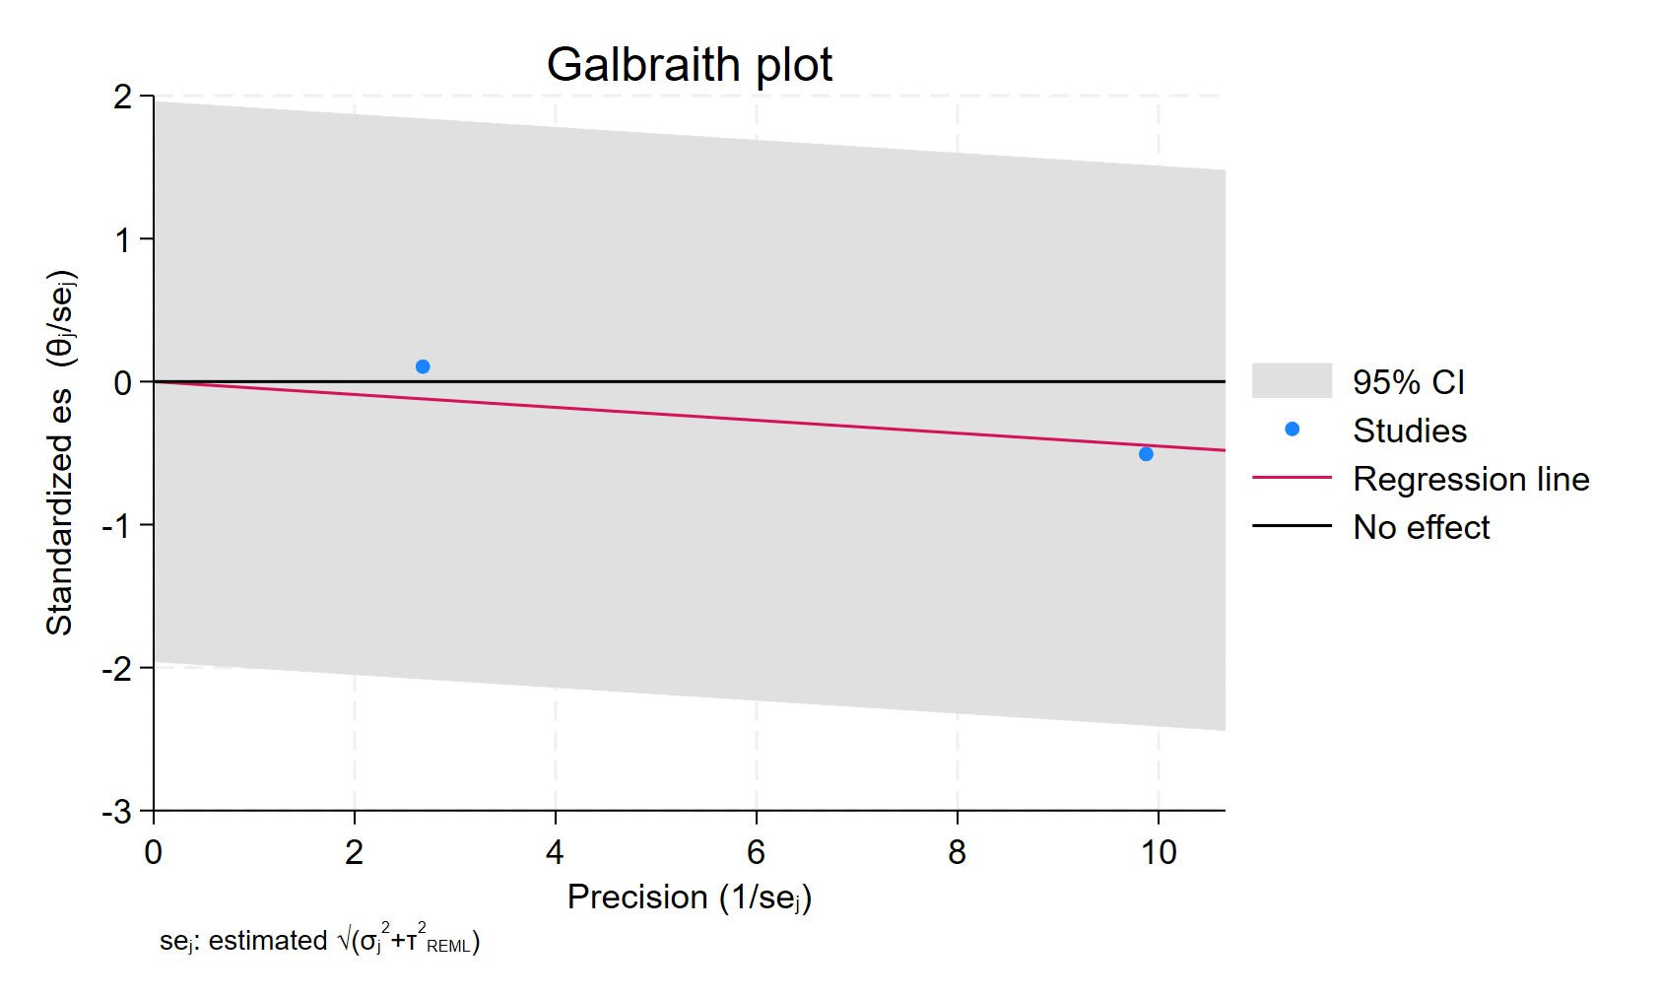
Figure 165. Galbraith plot - Ever used Atypical ADs
Each study is represented as a point, where the x-axis denotes the precision (defined as the inverse of the standard error), and the y-axis indicates the standardized effect size. The red regression line represents the overall summary effect estimated from the random-effects model, and the gray shaded area corresponds to the confidence interval at 95% around regression line. The horizontal black line at y = 0 corresponds to the line of no effect, serving as a reference.

SNRI USERS WITH MORE THAN 3 YEARS
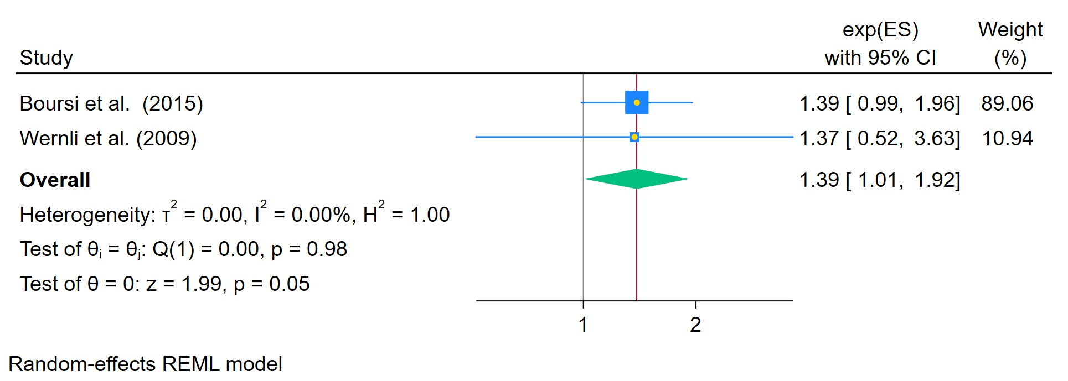
Figure 166. Use of SNRI for more than 3 years
The area of each square is proportional to the sample size of the respective study, with horizontal lines through the squares representing the 95% confidence interval (C.I.) for that study. In the pooled analysis, the diamond symbol represents the pooled estimate, with the right and left points of the diamond indicating the 95% C.I. for the overall analysis

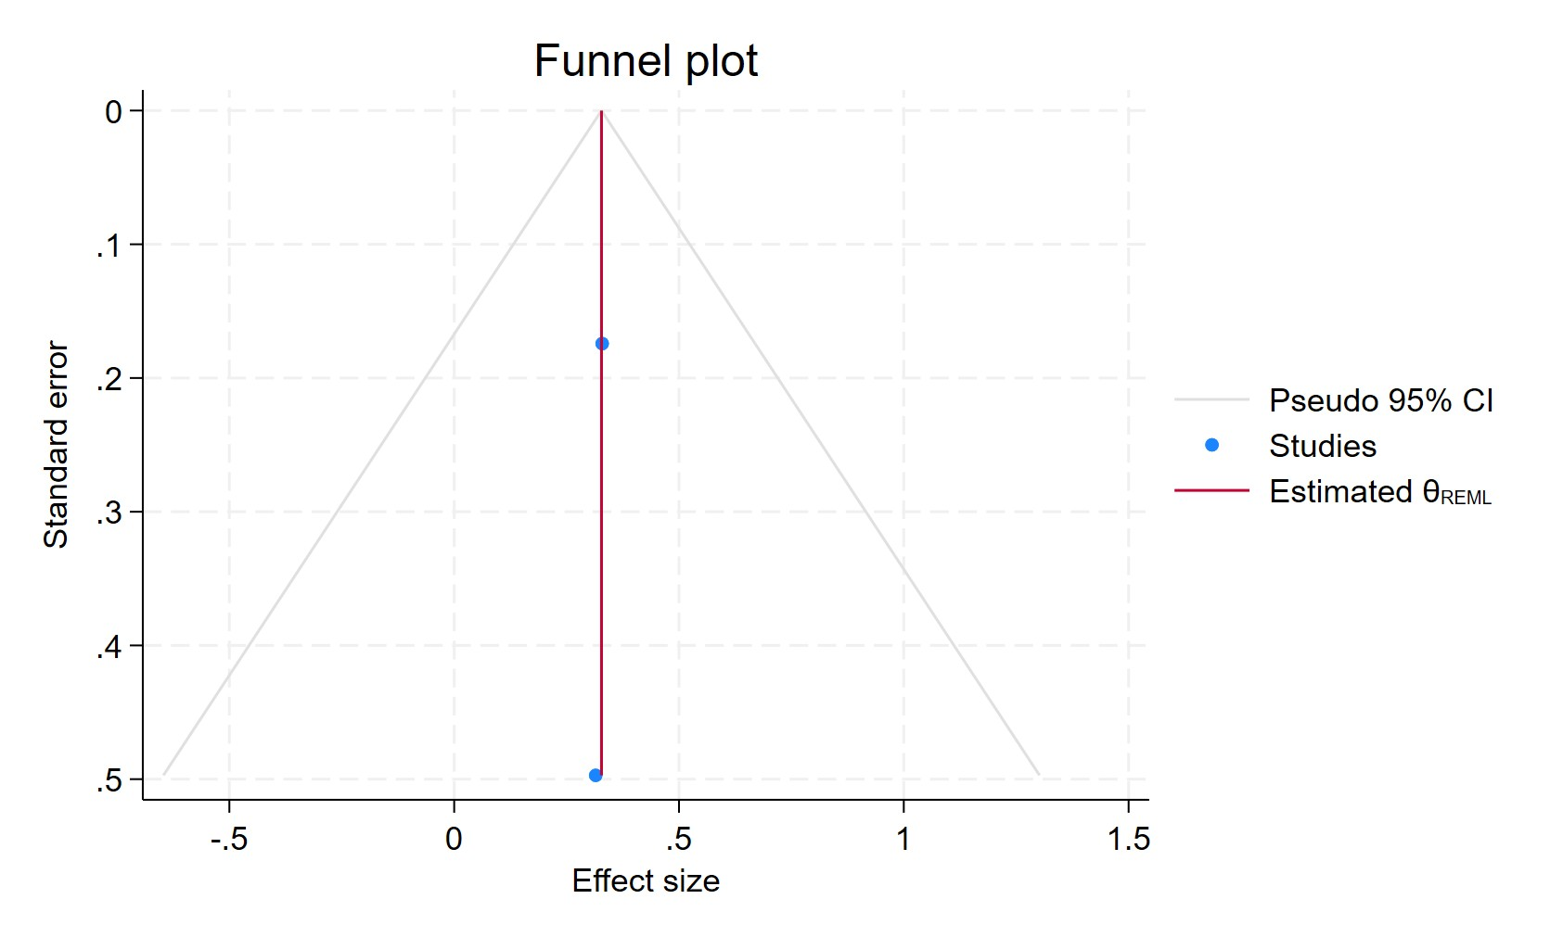
Figure 167. Funnel plot - Use of SNRI for more than 3 years
Each blue dot represents a single study, plotted with its effect size on the x-axis and its standard error on the y-axis. The vertical red line represents the overall effect estimate derived from the random-effects model using restricted maximum likelihood (REML). The pseudo 95% confidence interval region, shown as gray diagonal lines, outlines the expected spread of studies in the absence of bias or between-study heterogeneity.

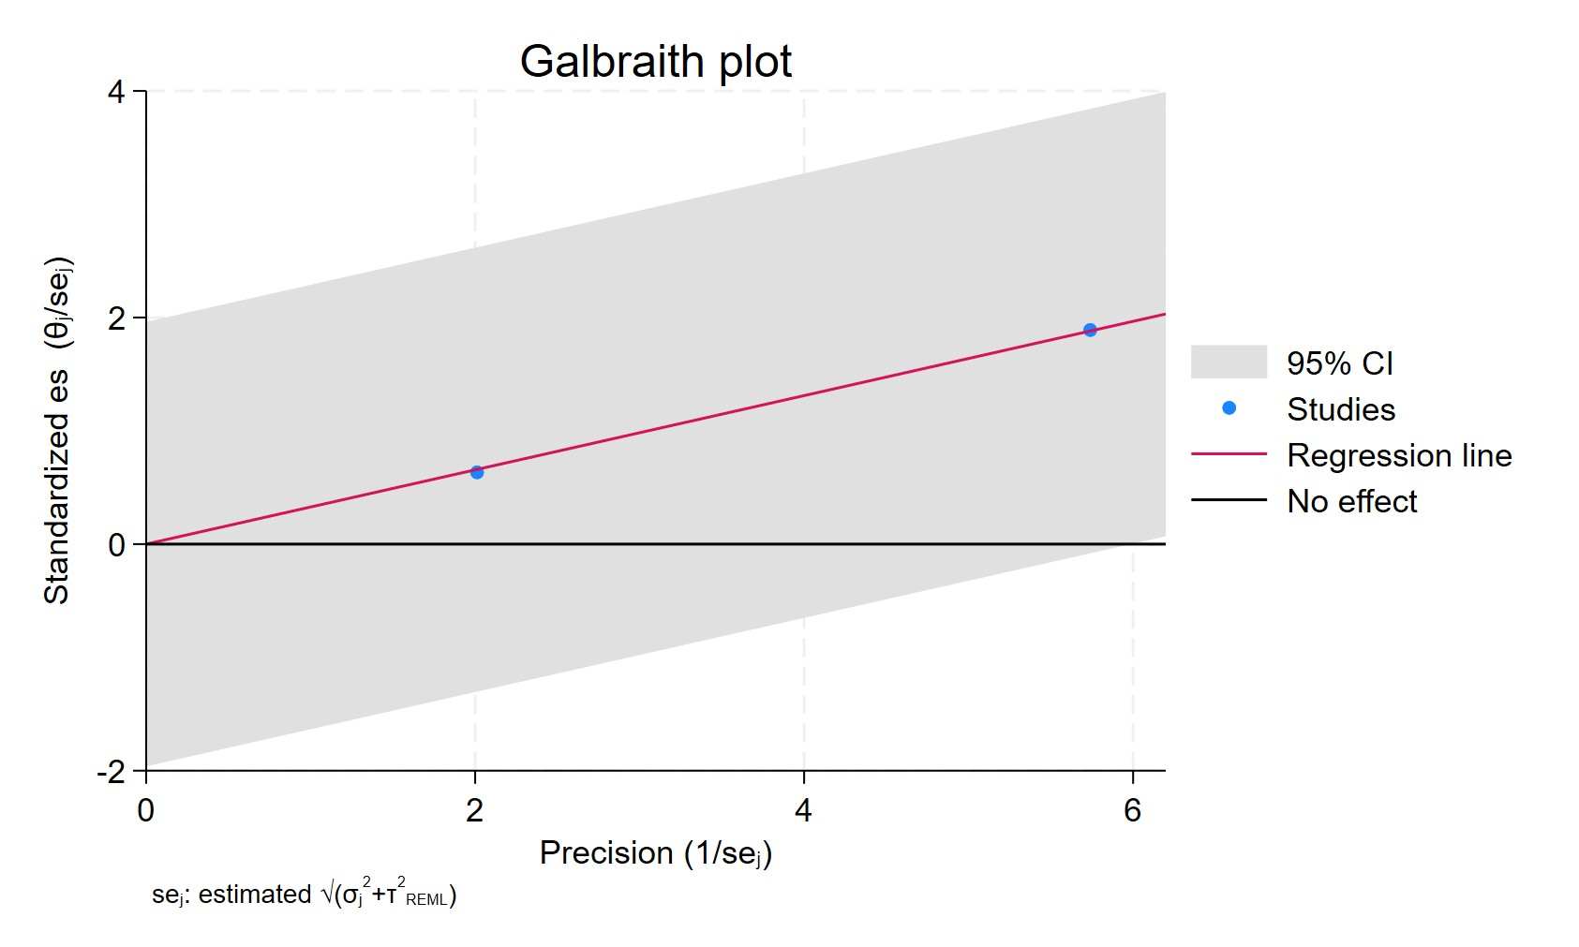
Figure 169. Galbraith plot - Use of SNRI for more than 3 years
Each study is represented as a point, where the x-axis denotes the precision (defined as the inverse of the standard error), and the y-axis indicates the standardized effect size. The red regression line represents the overall summary effect estimated from the random-effects model, and the gray shaded area corresponds to the confidence interval at 95% around regression line. The horizontal black line at y = 0 corresponds to the line of no effect, serving as a reference.

BUPROPRIONE USERS HAZARD RATIO
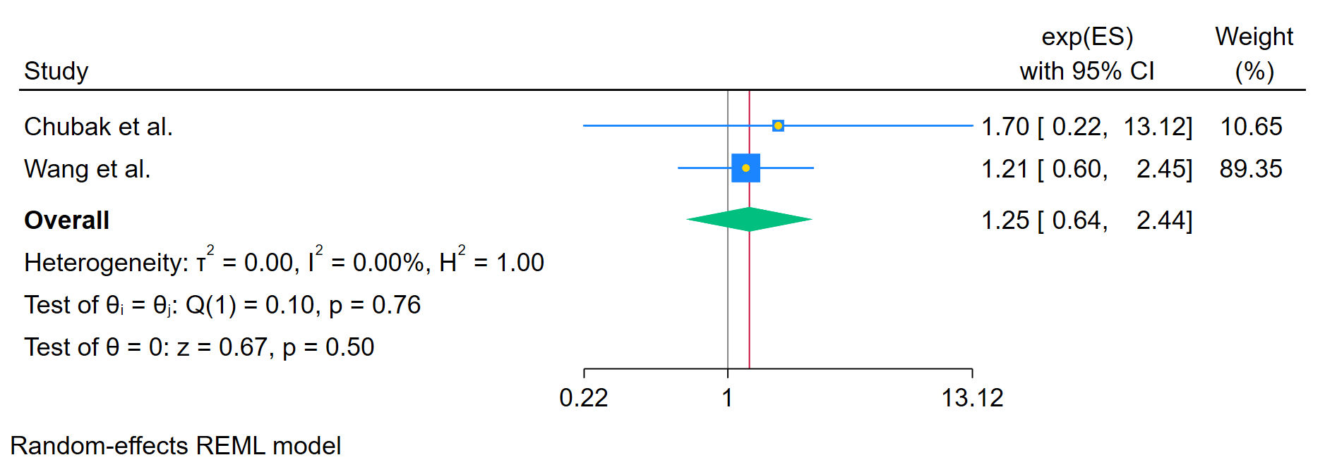
Figure 170. Ever used Buproprione - Hazard Ratio
The area of each square is proportional to the sample size of the respective study, with horizontal lines through the squares representing the 95% confidence interval (C.I.) for that study. In the pooled analysis, the diamond symbol represents the pooled estimate, with the right and left points of the diamond indicating the 95% C.I. for the overall analysis

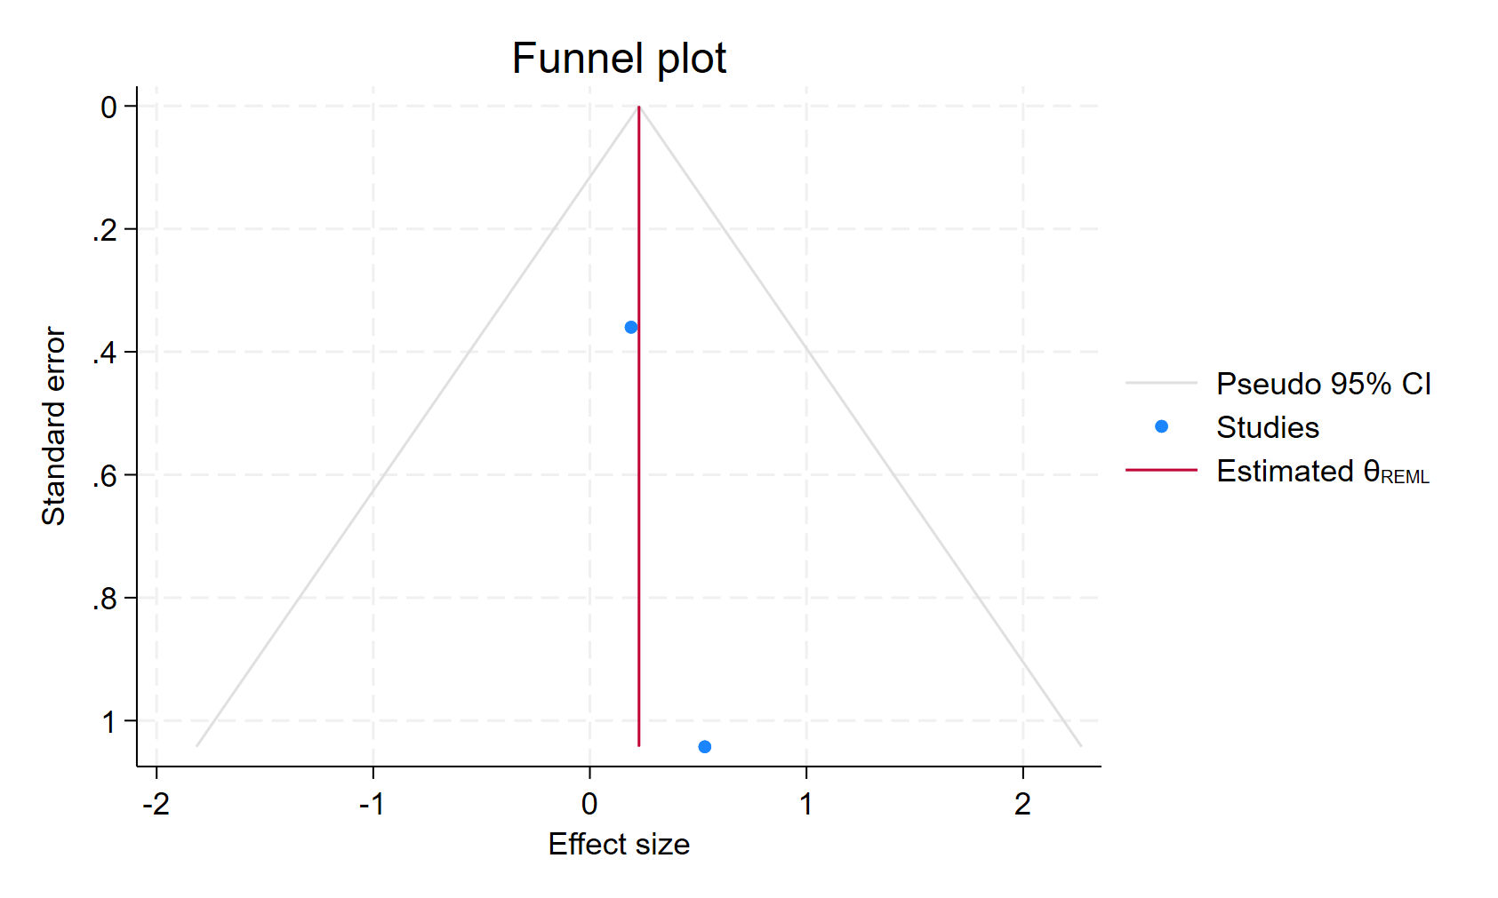
Figure 171. Funnel plot - Ever used Buproprione - Hazard Ratio
Each blue dot represents a single study, plotted with its effect size on the x-axis and its standard error on the y-axis. The vertical red line represents the overall effect estimate derived from the random-effects model using restricted maximum likelihood (REML). The pseudo 95% confidence interval region, shown as gray diagonal lines, outlines the expected spread of studies in the absence of bias or between-study heterogeneity.

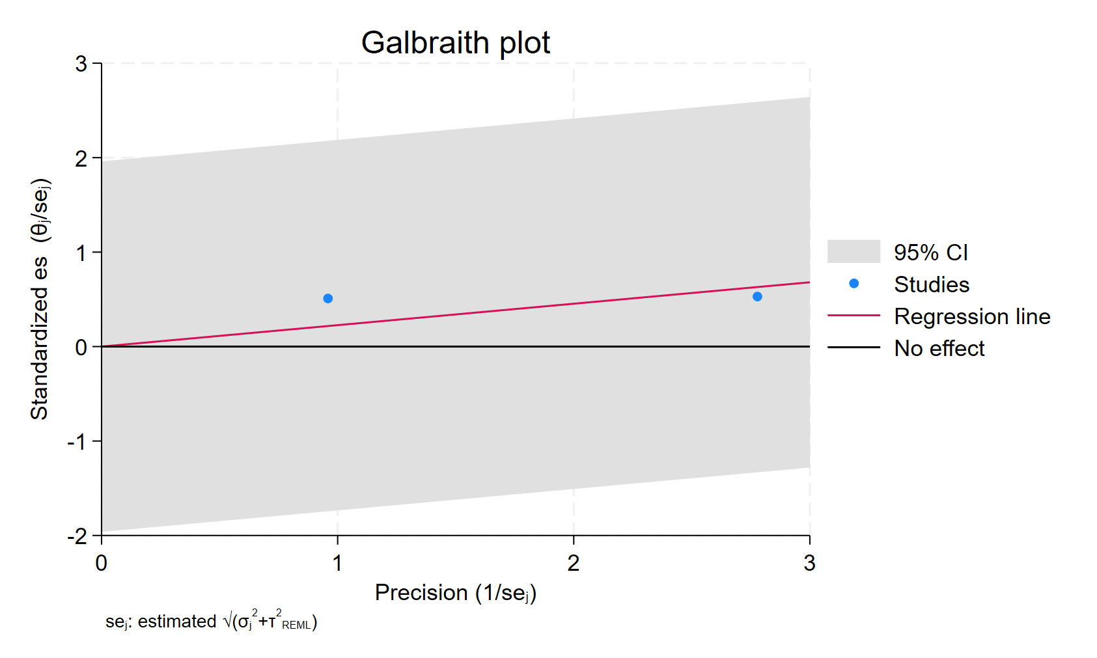
Figure 172. Galbraith plot - Ever used Buproprione - Hazard Ratio
Each study is represented as a point, where the x-axis denotes the precision (defined as the inverse of the standard error), and the y-axis indicates the standardized effect size. The red regression line represents the overall summary effect estimated from the random-effects model, and the gray shaded area corresponds to the confidence interval at 95% around regression line. The horizontal black line at y = 0 corresponds to the line of no effect, serving as a reference.

