Supplementary information:
Sustainability of aviation fuel technology depends on geography, energy, and feedstock choice: 50-year development scenarios
Eleanor L. Borrill^{1,2,3}*, Ruoyang Yuan^{1,3}, Lenny S. C. Koh^{2,3}*
Corresponding authors: elborrill1@sheffield.ac.uk; s.c.l.koh@sheffield.ac.uk
- School of Mechanical, Aerospace, and Civil Engineering, University of Sheffield, Sheffield, UK
- Management School, University of Sheffield, Sheffield, UK
- Energy Institute, University of Sheffield, Sheffield, UK

Contents
Supplementary Results 2
Supplementary Methods 6
Hydroprocessed Esters and Fatty Acids (HEFA) 6
Hydrothermal Liquefaction (HTL) 6
Municipal Solid Waste (MSW) Gasification 7
Agricultural Residue Gasification 7
Fischer-Tropsch (FT) Synthesis 8
Municipal Solid Waste (MSW) Fermentation 9
Agricultural Residue Fermentation 10
Alcohol-to-Jet (ATJ) 10
References 12

Supplementary Results
Fig. S1. Normalised environmental impact results for all evaluated SAF pathway-scenarios, grouped by feedstock. Results for the SSP2-NPi scenario (‘middle-of-the-road’) are shown as coloured bars, while SSP1-NPi (‘sustainable’) and SSP5-NPi (‘fossil-fuelled-development’) scenarios are indicated as error bars with marker shapes of circles and crosses, respectively. Panels correspond to feedstocks: (a) UCO, (b)i) all MSW, (b)ii) MSW excluding FATJ (c) MST, (d) SCT, (e) RST, and (f) WST. Each bar is labelled with the conversion technology, location, and scenario year (TECH-LOC-YEAR). The displayed impact categories are global warming potential (GWP) in blue, terrestrial ecotoxicity potential (TETP) in orange, freshwater eutrophication potential (FEP) in green, and terrestrial acidification potential (TAP) in red.
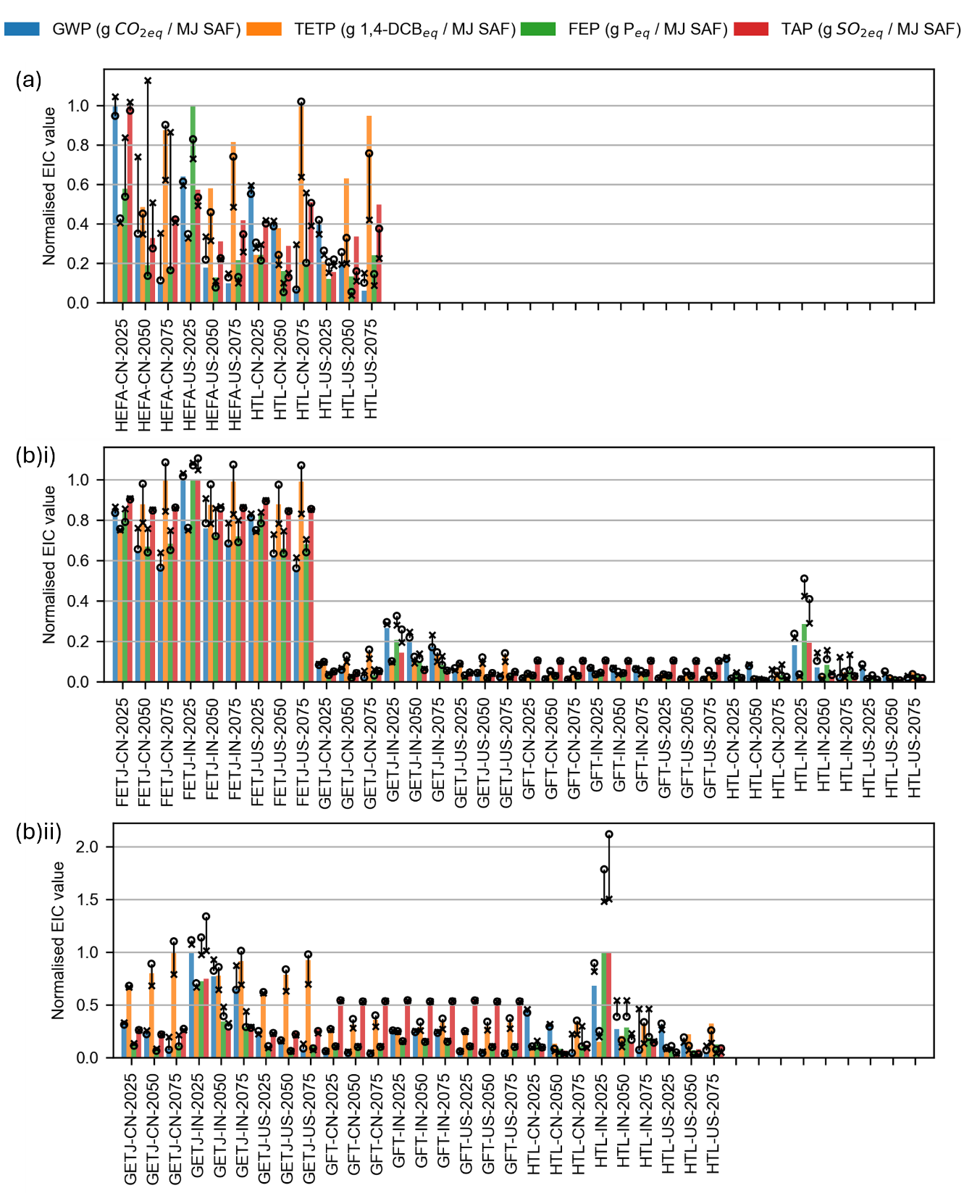
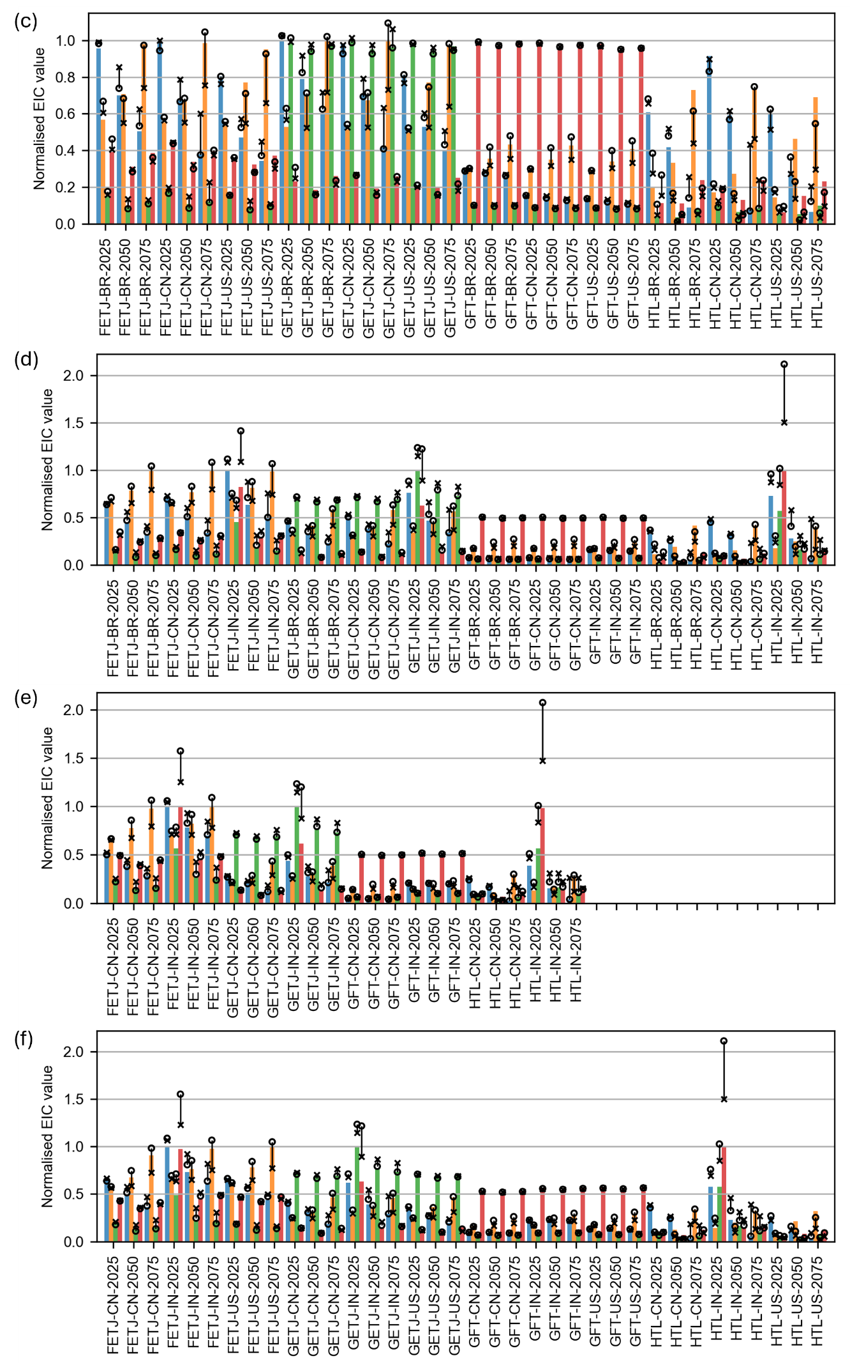
Fig. S2. Normalised environmental impact results for all evaluated SAF pathway-scenarios, grouped by conversion technology. Results for the SSP2-NPi scenario (‘middle-of-the-road’) are shown as coloured bars, while SSP1-NPi (‘sustainable’) and SSP5-NPi (‘fossil-fuelled-development’) scenarios are indicated as error bars with marker shapes of circles and crosses, respectively. Panels correspond to technologies: (a) HEFA, (b) HTL, (c) GFT, (d) GATJ, and (e)i) all FATJ, (e)ii) FATJ excluding MSW. Each bar is labelled with the feedstock, location, and scenario year (FEED-LOC-YEAR). The displayed impact categories are global warming potential (GWP) in blue, terrestrial ecotoxicity potential (TETP) in orange, freshwater eutrophication potential (FEP) in green, and terrestrial acidification potential (TAP) in red.
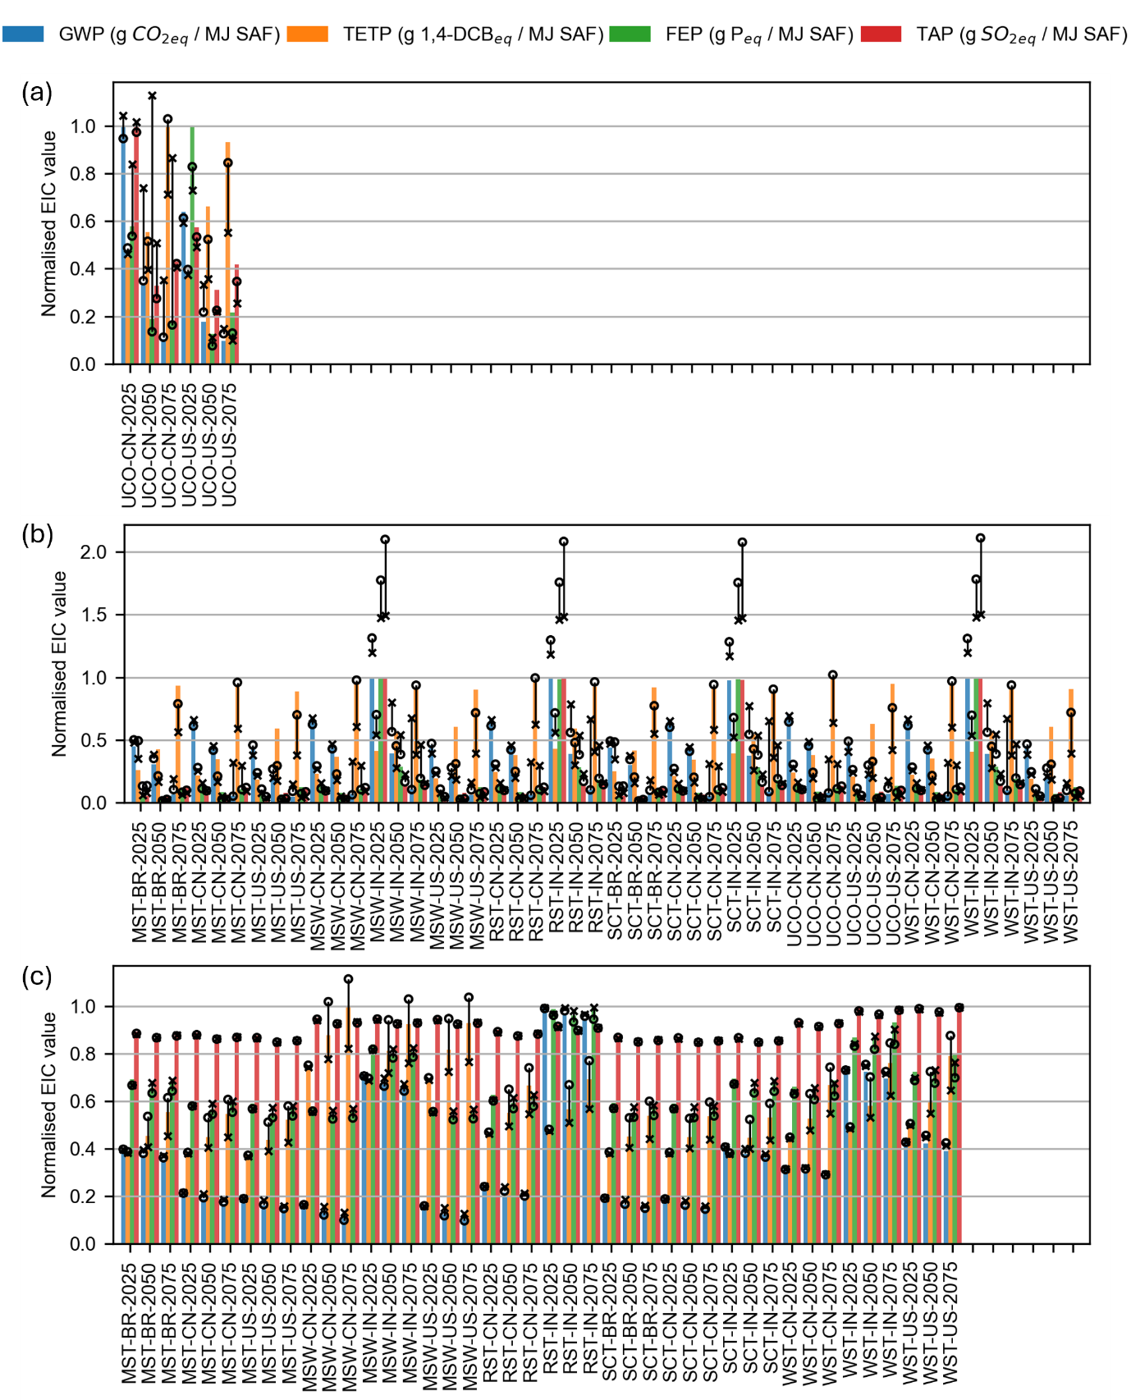
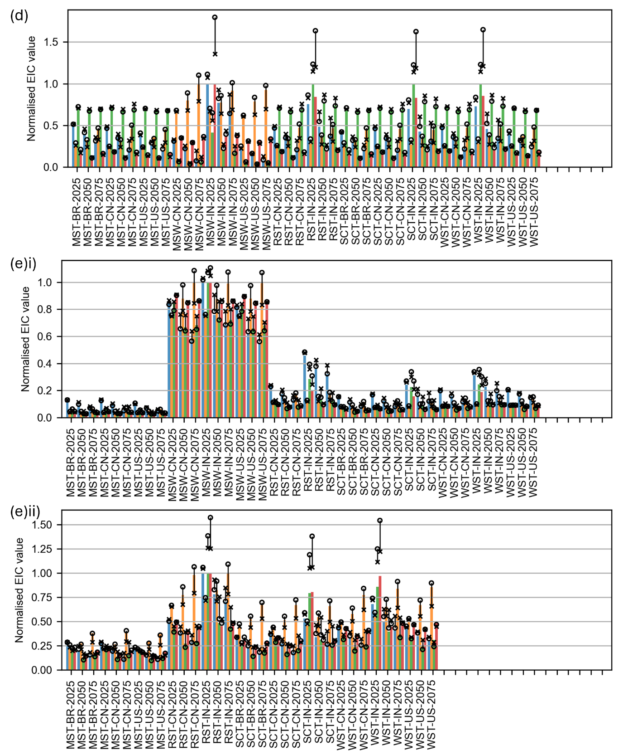

Supplementary Methods

Hydroprocessed Esters and Fatty Acids (HEFA)
The HEFA pathway using UCO as a feedstock is modelled using LCI data from Mannion et al.¹³. The process operates with a defined system efficiency of 0.33 and a heat exchanger efficiency of 0.76.
The conversion begins with the physical refinement of UCO, starting with filtration at 35°C to remove solid residue, followed by water removal at 100°C. The oil is then heated to 420°C and subjected to hydrotreatment through the addition of hydrogen. After this, propane is removed via a propane cleave and subsequently purified for use as a co-product.
Deoxygenation of the hydrotreated product is achieved using a nickel-molybdenum catalyst¹³⁻¹⁵. This occurs across three distinct chemical stages: decarboxylation, decarbonylation, and hydrodeoxygenation. These reactions produce a stream of paraffins with carbon chain lengths C₁₅-C₁₈. Following this, vapour-liquid separation takes place to isolate the produce phases. Excess hydrogen is recovered through steam reforming, water-gas shift, and CO₂ capture, before being recycled back into the system.
To maximise the SAF yield, the paraffins undergo hydrocracking in the presence of addition hydrogen and a catalyst^{14,15}, specifically targeting the jet-range chain lengths (C₉-C₁₅). The final stage involves two-step fractional distillation, first separating the mixture into hydrogen, C₆-C₈, and C₉-C₁₈ fractions, second separating these fractions into jet, diesel, LPG, and naphtha.

Hydrothermal Liquefaction (HTL)
The HTL pathway is modelled with a plant capacity of 100 dry tonnes of feedstock per day, using LCI data primarily from Feng et al.¹⁴. This pathway is characterised by its ability to process wet biomass of varying composition (specified in the literature), with water added to each feedstock to reach specific slurry moisture levels specified in the literature: 80% for UCO¹⁴, 83.1% for MSW¹⁶, 85.7% for MST and WST¹⁷, 90% for SCT¹⁸⁻²², and 69.4% for RST²³.
The slurry is pressurised and heated to subcritical conditions. The baseline reaction occurs at 351°C and 21 MPa for a 15-minute residence time¹⁴, although temperatures are adjusted to 300°C for MST, WST¹⁷, and SCT¹⁸ and 320°C for RST²³ to reflect the literature. The HTL reaction produces four distinct phases: biocrude, aqueous phase, off-gas, and hydrochar, with feedstock-dependent yields and product compositions taken from literature^{16-18,23,24}. Separation is achieved via knock-out drums for gas separation and solid filters for hydrochar recovery. The biocrude and aqueous phases are then isolated using a gravimetric oil-water separator.
The biocrude undergoes hydrotreatment using a CoMo/alumina catalyst²⁵ and supplemental hydrogen. The upgraded oil is fractionated via flash vessels and distillation columns into fuel gas, naphtha, jet, diesel, and heavy oil fractions. Hydrogen is recovered from the fuel gas via PSA and recycled into the hydrotreatment unit to improve system efficiency. Energy inputs for hydrotreating and the subsequent PSA unit were derived from literature^{13,26}. To maximise SAF yield, the heavy oil fraction is hydrocracked using hydrogen and a CoMo catalyst to further produce naphtha, jet, and diesel.
Meanwhile, the hydrochar undergoes acid extraction to recover phosphorus using sulfuric acid, followed by struvite precipitation (supplemented with MgCl₂) alongside the aqueous phase. Phosphorus content is assumed to be directly proportional to the feedstock ash content¹⁶. Residual organics in the aqueous phase are processed via catalytic hydrothermal gasification (CHG) using a 7.8% Ru/C catalyst. However, due to database limitations, a Ni-Al2O3 catalyst is used as a proxy²⁷. The final effluent is processed in a membrane distillation unit to recover ammonium, which is reacted with sulfuric acid to produce ammonium sulphate fertiliser.
The plant uses a system-wide heat exchanger network to minimise external energy requirements. A combined heat and power (CHP) unit converts the fuel gas streams from the PSA, hydrocracking, and CHG units into heat and energy, modelled with an electricity production efficiency of 31.09% and a thermal efficiency of 43.82%²⁸.

Municipal Solid Waste (MSW) Gasification
The gasification of MSW to produce syngas or mixed alcohols is modelled using LCI data from Jones et al.²⁹. The plant is designed with a feed rate of 2000 dry tonnes per day.
The pretreated MSW is gasified at 822°C using steam to fluidise the bed, while olivine particles act as a heat carrier. Post-gasification, cyclones separate the char, ash, and olivine; these solids are sent to a fluidised bed combustor where the char is burned to reheat the olivine to 943°C before it is cycled back to the gasifier. Excess heat generated during this phase is recovered to provide thermal energy for upstream feedstock drying. The resulting raw syngas is sent to a catalytic tar reformer – a bubbling fluidised bed reactor using an iron chelate catalyst³⁰ – to crack tars, methane, and light hydrocarbons into CO and H₂. Ammonia is simultaneously converted into N₂ and H₂. The gas exits the reformer at 751°C and is cooled to 150°C before entering a wet scrubber to remove particulates and residual contaminants.
The compressed syngas passes through carbon beds for mercury removal (treating spent carbon as hazardous waste), followed by liquid-phase oxidation (LO-CAT) process and a ZnO bed for sulphur removal. The gas is then mixed with high-temperature steam and compressed CO₂ (recycled from the amine unit) and sent to the steam reformer. This unit converts remaining light hydrocarbons and adjusts the H₂/CO ratio via the water-gas shift reaction. The amine unit is used to remove excess CO₂ from the stream prior to compression for alcohol synthesis.
For mixed alcohol synthesis, the cleaned syngas is heated to 299°C and fed into a fixed-bed tubular reactor. This uses a modified Fischer-Tropsch catalyst (K/Co/MoS)³¹. Since the reaction is highly exothermic, high-pressure steam is generated in the reactor shell for heat management. The product stream is cooled to separate unconverted syngas (recycled to the steam reformer) from the liquid alcohols. The liquid fraction is dried using a molecular sieve and fractionated into ethanol and higher alcohols (propanol+). To maximise efficiency, any methanol produced is recycled back to the synthesis reactor.
The plant features an integrated steam cycle for internal power generation. Steam generated by cooling streams from the gasifier, steam reformer, and synthesis reactor is sent through a turbine network. Process steam is then extracted from these turbines to provide the necessary fluidisation and heating for the gasification and forming units, while the turbines generate sufficient electricity to support internal operations.

Agricultural Residue Gasification
The conversion of agricultural residues to either syngas or ethanol is evaluated using LCI data from Pati et al.³², based on a model of co-gasification and syngas fermentation of WST and sugarcane bagasse. The facility operates at a biomass flowrate of 30 tonnes per hour, using the same gasifier configuration across all residue types to facilitate direct comparisons.
Gasification is carried out at 750°C, with tar formation neglected in the gasifier stage. Following the reaction, a cyclone is used for ash separation. The raw syngas undergoes a cleanup phase to remove nitrogenous and sulphurous impurities: NH₃ is removed via a water wash, while H₂S is captured in an activated carbon bed. The quantity of activated carbon used is scaled based on the catalyst-to-feed ratios established in Jones et al.²⁹.
For GFT pathways, the clean syngas is cooled to 150°C³³ and directed to the FT synthesis module. For GATJ pathways, the syngas is further cooled to 37°C to meet the requirements for biological fermentation.
In the GATJ pathway, the cooled syngas enters a bioreactor where acetogenic bacteria (Clostridium Ljungdahlii) convert the gas into ethanol via the Wood-Ljungdahl pathway. The fermentation occurs in a water-based medium with a conversion efficiency of 70% for both CO and H₂.
The resulting alcohol-acetate mixture is processed through a flash separator to isolate the liquid and vapour phases. The liquid stream is heated to 90°C and processed through two consecutive distillation columns. Finally, a molecular sieve is used to dehydrate the ethanol to the required purity for ATJ conversion.
To account for the varying energy densities of the four agricultural residues, the process output flows are adjusted using the Cold Gas Efficiency (CGE), defined as the ratio of the total LHV of the syngas to the total LHV of the feedstock – in this case, the LHV values in the original model³². Process yields for each feedstock are calculated as follows:
$$\begin{aligned}Yield=\frac{{LHV}_{feed}×CGE}{{LHV}_{syngas}},\#\left(1\right)\end{aligned}$$
where the LHV_{feed} is adjusted for each feedstock^{20-22,34-39}. The generation of ash is scaled according to the specific ash content of each residue^{20-22,34-38,40}.
It is assumed that the plant uses a closed-loop heat exchanger network so there is no loss of the working fluid. Any net surplus heat is assumed to be converted to electricity with a 25% conversion efficiency⁴¹. While most pathways are net electricity producers, the RST gasification-to-syngas process requires external energy inputs (from the FT process) as the LHV of RST results in insufficient internal heat generation to satisfy the process demands.

Fischer-Tropsch (FT) Synthesis
The conversion of clean syngas into long-chain hydrocarbons via FT synthesis is modelled using LCI data from Ahire et al.³³, with a standard plant capacity of 90 tonnes SAF produced per day.
Following the gasification and primary cleanup stages described previously, the source syngas undergoes further purification using diethanolamine to strip any remaining H₂S and CO₂. To optimise the hydrocarbon synthesis, a water-gas shift reaction is conducted at 150°C and 21 bar using a Cu-ZnO-Al₂O₃ catalyst⁴². This adjustment ensures a specific H₂/CO molar ratio of 2.37, which is ideal for maximising liquid fuel yields.
The synthesis is conducted as a low-temperature FT process to favour the production of kerosene-range paraffins. The adjusted syngas is heated to 200°C and fed into the FT reactor in the presence of a cobalt-based catalyst. The resulting product stream is cooled to 40°C, allowing for the separation of the gaseous and liquid fractions, followed by the removal of the aqueous phase from the liquid hydrocarbons.
To maximise the SAF yield and reduce the concentration of waxes and unsaturated hydrocarbons, the long-chain FT products undergo hydrocracking. This reaction occurs at 277°C and 50 bar with the addition of 1.5% hydrogen and a 0.5Pt/Y(100)35A catalyst. This step selectively breaks down the heavier paraffinic wax into short chain branched hydrocarbons suitable for aviation use.
The refined liquid product is then separated through a series of two distillation columns. The primary column operates at 125°C to separate the flue gases. The secondary column operates at 210°C to fractionate the liquid stream into jet and diesel.
The plant includes an integrated power generation unit to offset the refinery’s energy demand. A gas turbine generator uses the residual fuel gases diverted from the gasification and synthesis stages to produce internal electricity, enhancing the pathway’s overall energy efficiency.

Municipal Solid Waste (MSW) Fermentation
Alcohol production from MSW is modelled using LCI data from Meng et al.⁴³. The plant is designed to process 150,000 tonnes of unprocessed MSW per year. This pathway requires upstream sorting of the biogenic fraction but avoids the pelletisation and drying stages.
The biogenic MSW is first subjected to a mechanical heat treatment in a rotating pressure vessel (autoclave). The waste is treated with high-pressure saturated steam at 160°C for 2 hours, breaking down the organic fraction into a cellulose-rich fibre with high sugar content.
The resulting fibres are milled and diluted with water to a 20% solids concentration in a hydrolysis vessel. Enzymatic saccharification is performed using Novozymes Cellic CTec2 dosed at 5 wt%. The slurry is maintained at 50°C for 48 hours to convert the biogenic fibres into a solution of fermentable sugars, which is subsequently filtered.
The sugar solution is conditioned with nutrients, antifoam, and pH-altering agents before being inoculated with the microorganism Clostridium acetobutylicum ATCC 824. Fermentation occurs at 37°C over 48 hours, yielding acetone, butanol, ethanol, hydrogen, and CO₂. To prevent the butanol from inhibiting microbial growth, a nitrogen gas stripping process is employed to continuously remove the liquid and gaseous products.
The gaseous mixture is processed through a PSA unit to recover and purify the hydrogen, which is pressurised for storage, while nitrogen and CO₂ are vented. The liquid products are recovered and refined through a distillation train. The first column extracts acetone at 99% purity. The second column isolates ethanol, which is further dehydrated via a molecular sieve to a purity of 99.5%. The final column separates butanol and water, achieving a butanol purity of 99.7%.
The plant incorporates a wastewater treatment system to minimise freshwater intake. Stillage from hydrolysis and fermentation is filtered; the solids are sent for combustion, while the liquid is treated via sequential anaerobic and aerobic digestion. Anaerobic digestion produces methane-rich biogas for energy recovery. The aerobic stage includes pH control using caustic soda, followed by a membrane bioreactor. Finally, reverse osmosis is used for salt removal, before the treated water is recycled back into the process.
Energy is recovered from residual lignin, biogas, and dewatered sludge in a grate incinerator. This generates heat and electricity with efficiencies of 21.6% and 18.7% of the input LHV, respectively. Any surplus heat is assumed to be converted to electricity at 25% efficiency⁴¹.

Agricultural Residue Fermentation
The biochemical conversion of pretreated agricultural residues to ethanol follows a similar enzymatic hydrolysis and fermentation process to the MSW pathway, with LCI data primarily derived from Edwards et al.⁴¹. This model assumes that cellulase enzyme production is fully integrated into the plant, using a portion of the pretreated cellulosic feedstock as the growth medium. Water consumption is adjusted based on parameters given by Han et al.⁴⁴.
Because the evaluated residues vary in their chemical and structural composition, the process outputs are adjusted based on feedstock-specific data. Ethanol yields are scaled according to averaged literature values for MST⁴⁵, SCT⁴⁶, RST⁴⁷, and WST⁴¹.
Similarly to the MSW process, this plant uses a CHP unit to combust the recovered lignin to provide process heat and energy. Both the plant’s thermal and electrical energy requirements are satisfied, with gross electricity generated at an efficiency of 26.7% of the input lignin LHV. Any surplus power is exported as a co-product. The average lignin content of each feedstock is used to calculate the energy available for combustion for MST⁴⁸⁻⁵³, SCT⁴⁶, RST⁴⁷, and WST^{37,54}. By using the estimated LHV of lignin derived from the WST baseline⁴¹, the total energy input to the CHP is scaled for all other residues. The amount of residual ash requiring disposal is scaled based on the average ash contents of the raw feedstocks for MST^{35,36,38}, SCT²⁰⁻²², RST^{22,34}, WST^{22,34,37,40}.

Alcohol-to-Jet (ATJ)
The conversion of bioethanol into SAF is modelled using an intensified-integrated process based on the ‘best practice’ scenario established by Romero-Izquierdo et al.⁵⁵. The plant is modelled with a high-capacity throughput of 257,673 kg/h of ethanol, yielding 54,429 kg/hr of SAF. This integrated design is specifically engineered to minimise reliance on external utilities through internal energy recovery.
The process begins with ethanol dehydration at 450°C and 11.4 bar using a SYNDOL catalyst⁵⁶. Saturated steam is added to the reaction to achieve a 99.5% ethylene conversion. Following the reaction, the ethylene stream is expanded through a turbine to reduce the pressure to 3 bar. A distillation column with a partial vapour-liquid condenser is used to recover 99% of the ethylene, which is subsequently fed into the oligomerisation reactor at 120°C and 35 bar to form longer-chain olefins using Ni-LASA and HZSM5 catalysts⁵⁶.
The oligomerised products are directed to a hydrogenation reactor operating at 100°C and 15 bar of hydrogen with a ATHZ5-Cs catalyst⁵⁶, achieving a 99% conversion rate to stable paraffins. The pressure of the hydrocarbon stream is reduced to 1 bar through a turbine before entering the separation zone.
The separation zone is conducted via a three-column distillation train. The first column uses a partial vapour-condenser and 314-A refrigerant as a cooling medium to remove light gases at the top. The second column separated the naphtha fraction. Finally, the third column separates the jet and diesel fractions.
The catalytic requirements are modelled according to Wang et al.⁵⁶, assuming an equal mass distribution across the four catalysts. Due to database limitations, the following compositions and proxies are used: La-P-HZSM-5 is used as a proxy for SYNDOL^{57,58}, Ni-La/ACB is used as a proxy for Ni-LASA⁵⁹, HZSM5 is modelled based on specifications in Mohamed et al.⁶⁰, and ATHZ5-Cs based on Zhang et al.⁶¹.
Electricity is generated by the process turbines, satisfying the requirements of the entire system. Furthermore, while the model in Romero-Izquierdo et al.⁵⁵ uses natural gas for steam production, this work substitutes the heating fuel with a portion of the internally produced gaseous byproducts. The thermal energy required for steam is calculated using an 85% efficiency gas heater⁶², with fuel consumption determined by the LHV of the gaseous product.

References
1 American Society for Testing and Materials (ASTM). Standard Specification for Aviation Turbine Fuel Containing Synthesized Hydrocarbons. Report No. D7566-22, (American Society for Testing and Materials, 2022).
2 American Society for Testing and Materials (ASTM). Standard Practice for Evaluation of New Aviation Turbine Fuels and Fuel Additives. Report No. D4054-22, (American Society for Testing and Materials, 2023).
3 American Society for Testing and Materials (ASTM). Standard Specification for Aviation Turbine Fuels. Report No. D1655-22, (American Society for Testing and Materials, 2023).
4 International Civil Aviation Organization (ICAO). CORSIA Sustainability Criteria for CORSIA Eligible Fuels. (International Civil Aviation Organization, 2025).
5 Department for Transport. The SAF Mandate: an essential guide, <https://www.gov.uk/government/publications/about-the-saf-mandate/the-saf-mandate-an-essential-guide> (2024).
6 Congress Research Service (CRS). Inflation Reduction Act of 2022 (IRA): Provisions Related to Climate Change. Report No. R47262, (Congress Research Service, 2023).
7 European Civil Aviation Conference (ECAC). ECAC Guidance on Sustainable Aviation Fuels (SAF). (European Civil Aviation Conference, 2023).
8 Department for Transport. Sustainable Aviation Fuel (SAF) Mandate, <https://www.gov.uk/government/collections/sustainable-aviation-fuel-saf-mandate> (2025).
9 Ministry of Petroleum and Natural Gas. Government announces mandatory blending of Compressed Bio-Gas in CNG (Transport) & PNG (Domestic) segments of CGD Sector, <https://www.pib.gov.in/PressReleasePage.aspx?PRID=1979705&reg=3&lang=2> (2023).
10 Anselmi, M. & Dupont, R. in Chapter Five Climate Change Mitigation — Aviation Cleaner Energies Ch. Chapter Five Climate Change Mitigation — Aviation Cleaner Energies, 176–179 (EPE, 2024).
11 U.S. Department of Energy. Sustainable Aviation Fuel Grand Challenge, <https://www.energy.gov/eere/bioenergy/sustainable-aviation-fuel-grand-challenge> (2026).
12 International Civil Aviation Organization (ICAO). 2025 Policy and Practice on Green Development in China's Civil Aviation. (International Civil Aviation Organization, 2025).
13 Mannion, L. A. et al. A physics constrained methodology for the life cycle assessment of sustainable aviation fuel production. Biomass and Bioenergy 185 (2024). https://doi.org/https://doi.org/10.1016/j.biombioe.2024.107169
14 Feng, J., Li, Y., Strathmann, T. J. & Guest, J. S. Characterizing the Opportunity Space for Sustainable Hydrothermal Valorization of Wet Organic Wastes. Environmental Science and Technology 58, 2528–2541 (2024). https://doi.org/https://doi.org/10.1021/acs.est.3c07394
15 Eller, Z., Varga, Z. & Hancsók, J. Advanced production process of jet fuel components from technical grade coconut oil with special hydrocracking. Fuel 182, 713–720 (2016). https://doi.org/http://dx.doi.org/10.1016/j.fuel.2016.06.055
16 Kohansal, K. et al. Bio-Crude Production Improvement during Hydrothermal Liquefaction of Biopulp by Simultaneous Application of Alkali Catalysts and Aqueous Phase Recirculation. Energies 14 (2021). https://doi.org/https://doi.org/10.3390/en14154492
17 Das, S. Hydrothermal liquefaction of lignocellulosic biomass using water and hydrogen-donor solvent mixtures to produce energy-dense heavy oil Master of Science thesis, University of Alberta, (2021).
18 Silva, R. S. et al. Hydrothermal Liquefaction of Sugarcane Bagasse and Straw: Effect of Operational Conditions on Product Fractionation and Bio-Oil Composition. Energies 17 (2024). https://doi.org/https://doi.org/10.3390/en17215439
19 Franco, H. C. J. et al. Assessment of sugarcane trash for agronomic and energy purposes in Brazil. Scientia Agricola 70, 305–312 (2013). https://doi.org/10.1590/S0103-90162013000500004
20 Solangi, S. H., Jakhrani, A. Q., Mukwana, K. C., Jatoi, A. R. & Luhur, M. R. Investigation of Quantity, Quality and Energy Content of Indigenous Sugarcane Trash in Naoshehro Feroze District, Sindh. Engineering, Technology and Applied Science Research 8, 3609–3613 (2018). https://doi.org/https://doi.org/10.48084/etasr.2411
21 Basit, A., Akram, M. S., Saleem, M., Awan, J. A. & Jaubert, J.-N. Characterization and kinetic modeling of the pyrolysis of sugar cane trash. International Journal of Energy, Environment and Economics 25, 43–56 (2019).
22 Krishnan, R., Hauchhum, L., Gupta, R. & Pattanayak, S. in 2018 2nd International Conference on Power, Energy and Environment: Towards Smart Technology (ICEPE). 1–5 (IEEE).
23 Tian, Y. et al. Hydrothermal liquefaction of crop straws: Effect of feedstock composition. Fuel 265 (2020). https://doi.org/https://doi.org/10.1016/j.fuel.2019.116946
24 Zhang, B., Keitz, M. v. & Valentas, K. Thermal Effects on Hydrothermal Biomass Liquefaction. Applied Biochemistry and Biotechnology 147, 143–150 (2008). https://doi.org/10.1007/s12010-008-8131-5
25 Hoj, M. et al. Flame spray synthesis of CoMo/Al2O3 hydrotreating catalysts. Applied Catalysis A: General 397, 201–208 (2011). https://doi.org/https://doi.org/10.1016/j.apcata.2011.02.034
26 Thunder Said Energy. Pressure swing adsorption: energy economics?, <https://thundersaidenergy.com/downloads/pressure-swing-adsorption-energy-economics/> (2023).
27 Onwudili, J. A., Lea-Langton, A. R., Ross, A. B. & Williams, P. T. Catalytic hydrothermal gasification of algae for hydrogen production: Composition of reaction products and potential for nutrient recycling. Bioresource Technology 127, 72–80 (2013). https://doi.org/https://doi.org/10.1016/j.biortech.2012.10.020
28 Kang, J. Y., Kang, D. W., Kim, T. S. & Hur, K. B. Comparative economic analysis of gas turbine-based power generation and combined heat and power systems using biogas fuel. Energy 67, 309–318 (2014). https://doi.org/http://dx.doi.org/10.1016/j.energy.2014.01.009
29 Jones, S. B., Zhu, Y. & Valkenburg, C. Municipal Solid Waste (MSW) to Liquid Fuels Synthesis, Volume 2: A Techno-economic Evaluation of the Production of Mixed Alcohols. Report No. PNNL-18482, (Pacific Northwest National Laboratory, 2009).
30 Zhang, L., Oladejo, J., Dawodu, A., Yang, L. & Xiao, Y. Sustainable jet fuel from municipal solid waste–Investigation of carbon negativity and affordability claims. Resources, Conservation & Recycling 210 (2024). https://doi.org/https://doi.org/10.1016/j.resconrec.2024.107819
31 Iranmahboob, J., Hill, D. O. & Toghiani, H. K2CO3/Co-MoS2/clay catalyst for synthesis of alcohol: influence of potassium and cobalt. Applied Catalysis A: General 231, 99–108 (2002). https://doi.org/https://doi.org/10.1016/S0926-860X(01)01011-0
32 Pati, S., De, S. & Chowdhury, R. Exploring the hybrid route of bio-ethanol production via biomass co-gasification and syngas fermentation from wheat straw and sugarcane bagasse: Model development and multi-objective optimization. Journal of Cleaner Production 395 (2023). https://doi.org/https://doi.org/10.1016/j.jclepro.2023.136441
33 Ahire, J. P. et al. Techno-economic and environmental impacts assessments of sustainable aviation fuel production from forest residues. Sustainable Energy & Fuels 8, 4602–4616 (2024). https://doi.org/10.1039/d4se00749b
34 Gummert, M., Hung, N. V., Chivenge, P. & Douthwaite, B. (eds Martin Gummert, Nguyen Van Hung, Pauline Chivenge, & Boru Douthwaite) (Springer Open, 2020).
35 Limo, L. K., Madara, D. S. & Ochola, J. Characterization of Corn Stover and Eucalyptus Sawdust for Pellet Production. European Journal of Energy Research 4 (2024). https://doi.org/10.24018/ejenergy.2024.4.2.135
36 Soka, O. & Oyekola, O. A feasibility assessment of the production of char using the slow pyrolysis process. Heliyon 6 (2020). https://doi.org/https://doi.org/10.1016/j.heliyon.2020.e04346
37 Montero, G. et al. Higher heating value determination of wheat straw from Baja California, Mexico. Energy 109, 612–619 (2016). https://doi.org/http://dx.doi.org/10.1016/j.energy.2016.05.011
38 Rony, A. H. et al. Kinetics, thermodynamics, and physical characterization of corn stover (Zea mays) for solar biomass pyrolysis potential analysis. Bioresource Technology 284, 466–473 (2019). https://doi.org/https://doi.org/10.1016/j.biortech.2019.03.049
39 Yang, Q. et al. Combustion, emission and slagging characteristics for typical agricultural crop straw usage in heating plants. Thermochimica Acta 702 (2021). https://doi.org/https://doi.org/10.1016/j.tca.2021.178979
40 Singh, H., Kumar, P. & Sidhu, B. S. Evaluation and characterization of different biomass residues through proximate and ultimate analysis and heating value. Asian Journal of Engineering and Applied Technology 2, 6–10 (2013). https://doi.org/10.51983/ajeat-2013.2.2.690
41 Edwards, R. et al. Definition of input data to assess GHG default emissions from biofuels in EU legislation. (JCR, 2017).
42 Allam, D., Cheknoun, S. & Hocine, S. Operating Conditions and Composition Effect on the Hydrogenation of Carbon Dioxide Performed over CuO/ZnO/Al2O3 Catalysts. Bulletin of Chemical Reaction Engineering & Catalysis 14, 604–613 (2019). https://doi.org/https://doi.org/10.9767/bcrec.14.3.3451.604-613
43 Meng, F. et al. Process simulation and life cycle assessment of converting autoclaved municipal solid waste into butanol and ethanol as transport fuels. Waste Management 89, 177–189 (2019). https://doi.org/https://doi.org/10.1016/j.wasman.2019.04.003
44 Han, J., Tao, L. & Wang, M. Well-to-wake analysis of ethanol-to-jet and sugar-to-jet pathways. Biotechnology for Biofuels 10 (2017). https://doi.org/10.1186/s13068-017-0698-z
45 International Civil Aviation Organization (ICAO). CORSIA supporting document — CORSIA Eligible Fuels – Life Cycle Assessment Methodology. (International Civil Aviation Organization, 2022).
46 Elnagdy, N. A., Ragab, T. I. M., Fadel, M. A., Abou-Zeid, M. A. & Esawy, M. A. Bioethanol Production from Characterized Pre-treated Sugar Cane Trash and Jatropha Agrowastes. Journal of Biotechnology 386, 28–41 (2024). https://doi.org/https://doi.org/10.1016/j.jbiotec.2024.02.015
47 Takano, M. & Hoshino, K. Bioethanol production from rice straw by simultaneous saccharification and fermentation with statistical optimized cellulase cocktail and fermenting fungus. Bioresources and Bioprocessing 5 (2018). https://doi.org/https://doi.org/10.1186/s40643-018-0203-y
48 Zabed, H. M. et al. Towards the sustainable conversion of corn stover into bioenergy and bioproducts through biochemical route: Technical, economic and strategic perspectives. Journal of Cleaner Production 400 (2023). https://doi.org/https://doi.org/10.1016/j.jclepro.2023.136699
49 Wang, N. et al. Rapid detection of cellulose and hemicellulose contents of corn stover based on near-infrared spectroscopy combined with chemometrics. Applied Optics 60, 4282–4290 (2021). https://doi.org/https://doi.org/10.1364/AO.418226
50 Wang, N., Feng, J., Li, L., Liu, J. & Sun, Y. Rapid Determination of Cellulose and Hemicellulose Contents in Corn Stover Using Near-Infrared Spectroscopy Combined with Wavelength Selection. Molecules 27 (2022). https://doi.org/https://doi.org/10.3390/molecules27113373
51 Cheng, H. et al. Separation, purification and characterization of corn stover hemicelluloses. Cellulose chemistry and technology 51, 215–222 (2017).
52 Mensah, M. B., Jumpah, H., Boadi, N. O. & Awudza, J. A. M. Assessment of quantities and composition of corn stover in Ghana and their conversion into bioethanol. Scientific African 12 (2021). https://doi.org/https://doi.org/10.1016/j.sciaf.2021.e00731
53 Zhang, S. Extrusion and Alkali Extrusion of Corn Stover to Improve Enzyme Saccharification Master of Science thesis, University of Nebraska, (2011).
54 Cai, J. et al. Review of physicochemical properties and analytical characterization of lignocellulosic biomass. Renewable and Sustainable Energy Reviews 76, 309–322 (2017). https://doi.org/http://dx.doi.org/10.1016/j.rser.2017.03.072
55 Romero-Izquierdo, A. G., Gomez-Castro, F. I., Gutierrez-Antonio, C., Hernandez, S. & Errico, M. Intensification of the alcohol-to-jet process to produce renewable aviation fuel. Chemical Engineering and Processing - Process Intensification 160 (2021). https://doi.org/10.1016/j.cep.2020.108270
56 Wang, X. et al. Process design, modeling and life cycle analysis of energy consumption and GHG emission for jet fuel production from bioethanol in China. Journal of Cleaner Production 389 (2023). https://doi.org/https://doi.org/10.1016/j.jclepro.2023.136027
57 Wu, C.-Y. & Wu, H.-S. Ethylene Formation from Ethanol Dehydration Using ZSM‑5 Catalyst. ACS Omega 2, 4287–4296 (2017). https://doi.org/10.1021/acsomega.7b00680
58 Fan, D., Dai, D.-J. & Wu, H.-S. Ethylene Formation by Catalytic Dehydration of Ethanol with Industrial Considerations. Materials 6, 101–115 (2013). https://doi.org/10.3390/ma6010101
59 Zhang, Y. et al. Preparation of Ni-La/Al2O3-CeO2-Bamboo Charcoal Catalyst and its Application in Co-pyrolysis of Straw and Plastic for Hydrogen Production. BioEnergy Research 15, 1501–1514 (2022). https://doi.org/https://doi.org/10.1007/s12155-021-10359-0
60 Mohamed, H. O., Abed, O., Zambrano, N., Castaño, P. & Hita, I. A Zeolite-Based Cascade System to Produce Jet Fuel from Ethylene Oligomerization. Industrial & Engineering Chemistry Research 61 (2022). https://doi.org/https://doi.org/10.1021/acs.iecr.2c02303
61 Zhang, L. et al. Improvement of the Catalytic Efficiency of Butene Oligomerization Using Alkali Metal Hydroxide-Modified Hierarchical ZSM-5 Catalysts. Catalysts 8 (2018). https://doi.org/10.3390/catal8080298
62 Rutten, L. Natural gas steam boiler industry. (TNO, 2019).

