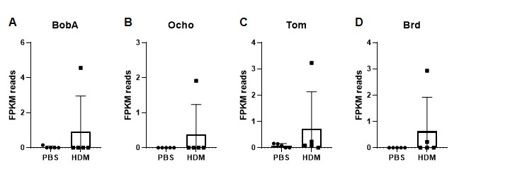
Supplementary Figure 1. Expression level of Notch pathway target genes. (A-D) FPKM reads of Notch pathway target genes in RNAseq analysis. Bar chart represents the mean value and standard deviation.

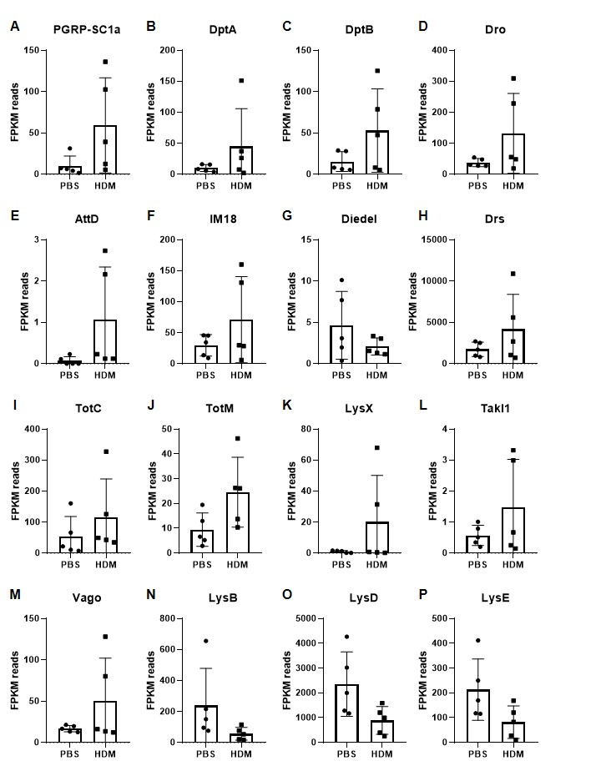

Supplementary Figure 2. Expression level of immune related pathway target genes. (A-P) FPKM reads of immune related pathway target genes in RNAseq analysis. Bar chart represents the mean value and standard deviation.

