Supplementary appendix
This appendix forms part of the original submission and will be peer reviewed.
Supplement to:
Sub-national estimates of incidence of visceral leishmaniasis and optimisation of geographical accessibility to treatment centres in Kenya
Nyamai Mutono^{1,2}, Brian Njuguna¹, Daniel Mwiti³, Paul Kibati⁴, George P. Omondi¹, Wyckliff Omondi³, Joy K. Nthiwa¹, Duncan Ochol⁵, Lenson Kariuki³, Michael Ofire⁴, Joseph Oundo⁶, Loise Ndung’u⁷, Gerald Gakuo⁷, Jafar Oyugi⁷, Francis Lowana⁷, Emmanuel Okunga^{8,9}, Daniel Langat⁹, Josphat Martin Muchangi⁴, Kennedy Senagi⁶, Penina Safari⁶,Maureen Nzilani⁶, James Gathirwa⁶, Daniel Masiga⁶, Damaris Matoke-Muhia¹⁰, SM Thumbi^{1,2,11}

¹ Centre for Epidemiological Modelling and Analysis, University of Nairobi, Nairobi, Kenya
² Paul G Allen School for Global Health, Washington State University, Pullman, USA
³ Kenya Vector borne and Neglected Tropical Disease Unit, Ministry of Health, Nairobi, Kenya
⁴ AMREF Health Kenya, Nairobi, Kenya
⁵ The END Fund, USA 2 Park Avenue, 28th Floor, New York, NY, 10016, USA
⁶ International Centre of Insect Physiology and Ecology, Nairobi, Kenya
⁷ Kenya Field Epidemiology and Laboratory Training Program, Ministry of Health, Kenya
⁸ Zoonotic Disease Unit, Ministry of Health, Nairobi, Kenya
⁹ Department of Disease Surveillance and Response, Ministry of Health, Nairobi, Kenya
¹⁰ Centre for Biotechnology Research for Development, Kenya Medical Research Institute, Nairobi, Kenya
¹¹ Tackling Infections to Benefit Africa (TIBA) Partnership, TIBA Global Health Research Unit, Institute of Immunology and Infection Research, University of Edinburgh, Edinburgh, United Kingdom

Geostatistical modelling of the socioeconomic variables
As described in the main paper, six socioeconomic indicators were obtained from the 2022 Kenya Demographic and Health Survey (KDHS)¹. The KDHS is a nationally representative household survey conducted by the DHS program approximately every 5 years to provide data on key health indicators, particularly in the low-and middle-income countries (LMICs). More information on the 2022 KDHS methodology, sampling procedures and data collection can be obtained from the DHS program website (https://dhsprogram.com).
The indicators included household wealth (lowest wealth quantile), floor and wall material (earth or dung floors, bamboo or dirt walls), and livestock ownership, all defined for de jure household members. Access to insecticide-treated nets (ITNs) was assessed among de facto household members and defined as whether an individual could have slept under an ITN night before the survey, calculated as the minimum of the number of household members and twice the number of ITNs. Household crowding was measured as the number of de jure household members per sleeping room.
Survey weights were applied to household-level data to account for the DHS multi-stage sampling design¹. Household-level estimates were aggregated to the cluster level, where for proportion-based indicators, we calculated the weighted number of individuals with the characteristic of interest, total number of individuals, and the weighted proportion. Household crowding was summarized separately as the weighted mean number of de jure household members per sleeping room (figure S1(a-f)).
Covariates and pre-processing
We assembled a suite of gridded covariates, including the aridity index, built-up volume ($m^{3}$), distance to major roads, elevation, Enhanced Vegetation Index (EVI), population count, Normalized Difference Vegetation Index (NDVI), nighttime lights, precipitation, rural-urban stratification, temperature, and travel time to cities (Table 2). All covariates were processed and standardized to a common 5 × 5 km grid resolution, corresponding to the resolution used to generate the predicted estimates.
To extract covariate values for each DHS cluster while accounting for the intentional displacement of cluster coordinates, we applied the displacement-adjustment approach described by Perez-Haydrich et al². Because pixel-level urban–rural classification data were not available, urban–rural stratification was derived following the method proposed by Dong et al³.
We further applied the algorithm described in the main paper to identify highly correlated predictors (Pearson correlation coefficient $≥0.95$ ). The flagged variables were removed based on their relevance to the response variables. The remaining covariates were then centered and scaled to have a mean zero and unit variance.
Geostatistical modelling
Let $A ∈R^{2}$ denote the geographic extent of Kenya and let $s_{1},s_{2},…,s_{n}∈A$ denote the cluster locations, given by longitude and latitude. For livestock ownership and ITN access, we modelled the number of individuals with the characteristic $Y\left(s_{i}\right)$ out of total individuals $N\left(s_{i}\right)$ at each cluster $i$ such that:
$$Y\left(s_{i} \right)∼\text{Binomial} \left(N\left(s_{i} \right), p\left(s_{i} \right)\right)$$
Wealth quantile, floor materials, and wall materials exhibited excess zeros, therefore, we employed a Zero-Adjusted Binomial model (hurdle Binomial) model, specifically,
$$Y\left(s_{i} \right)∼\text{Binomial} \left(N\left(s_{i} \right), p\left(s_{i} \right), π\right)$$
where, $π$is the probability of observing zero and $p\left(s_{i}\right)$represents the underlying true proportion at location $s_{i}$, modelled on the logit scale as:
$$logit\left(p\left(s_{i}\right)\right)= β_{0}+\sum_{k=1}^{p}{β_{k}X_{k}(s_{i})+ψ\left(s_{i}\right)+ϵ\left(s_{i}\right) }$$
For the household crowding, let $Y\left(s_{i}\right)$ denote the mean number of members per sleeping room at cluster $i$, we assumed:
$$\text{log}\left(Y\left(s_{i}\right)\right)∼\text{Gaussian }\left(μ\left(s_{i}\right),σ^{2}\right)$$
where:
$$μ\left(s_{i}\right)=β_{0}+\sum_{k=1}^{p}{β_{k}X_{k}\left(s_{i}\right)+ψ\left(s_{i}\right)}$$
Here, $β_{0}$is the intercept, $X_{k}\left(s_{i}\right)$ are the pre-processed geo-spatial covariates, and $β_{k}$ are the covariates coefficients. $ψ={\left(ψ\left(s_{1}\right), …, ψ\left(s_{n}\right)\right)}^{T} \sim N(0, Σ_{ψ})$ is a spatially correlated Gaussian random effect that captures the unexplained spatial variation in the characteristic of interest and is assumed to follow a Matérn covariance function. $ϵ\left(s_{i}\right)\sim N(0, σ_{ϵ}^{2})$ is an independently and identically distributed (i.i.d) gaussian random effect that accounts for non-spatial residual variation or between cluster heterogeneity.
Inference
We adopted a Bayesian approach to fit the models using the Integrated Nested Laplace Approximation (INLA) implemented in the R-INLA package^{4–6}. Vague priors were specified for the regression coefficients, $β\sim N(0, 1)$. A Penalized Complexity (PC) prior was applied to the standard deviation of the i.i.d gaussian random effect $σ_{ϵ}$, with the specification that $p\left(σ_{ϵ}>1\right)=0.01$. For the spatial random effect $ψ,$ a joint PC prior was used for its covariance structure specified so that $p\left(r<r_{0}\right)=0.01$ and $p\left(σ_{ψ}>1 \right)=0.01$, with $r_{o}$ chosen to be 5% of the extent of Kenya in the north-south direction.
We evaluated the performance of the six models using a 47-fold Leave-One-County-Out cross-validation. In each fold, all clusters within a single county were held out as a validation set, while the remaining 46 counties were used for training. Model performance was assessed using the Root Mean Squared Error (RMSE), Mean Absolute Error (MAE), Mean Squared Error (MSE), and bias (defined as the mean difference between predicted and observed values) for each county. These metrics were then averaged across all counties to provide an overall assessment of the model performance (Table S3).
Aggregation to Ward level
The predictions were first generated at 5x5km square grid (figure S1(h-l))., which were then aggregated to ward level using population-weighted averages. We generated 1,000 posterior samples at each grid location, and for each $j^{th}$ posterior sample in each ward $i$, the population weighted prediction ${\hat{Y}}_{ki}$ was computed as:
$${\hat{Y}}_{ki}= ∫pop\left(s\right) {\hat{Y}}_{k}\left(s\right)d\left(s\right)≈\sum_{j=1}^{m_{I}}{pop_{prop}\left(s_{j}\right)}×{\hat{Y}}_{k}(s_{j})$$
Where $pop_{prop}\left(s_{j}\right)= \frac{pop\left(s_{j}\right)}{\sum_{j=1}^{m_{i}}{pop(s_{j})}}$ is the proportion of the population at grid cell $s_{j}$, and $m_{I}$is the number of grid cells within ward $i$. We then computed the posterior mean across the 1,000 samples which was then used as the ward-level covariate in the VL model.

Table S1 Covariates used in the Visceral Leishmaniasis Small Area Estimation
Id | Covariate | Timeline | Time extent | Units | Resolution | Source
1 | Clay content, predicted mean at 0-20 cm depth | Static | 2001-2017 | % | 5KM | iSDA [7]
2 | Annual precipitation | Temporal | 2016-2025 | Mm/d | 5KM | CHIRPS [8]
3 | Annual temperature of air at 2m above the surface of land | Temporal | 2016-2025 | Kelvin | 5KM | Google and Copernicus Climate Data Store [9]
4 | Soil Moisture content 0-10 cm depth | Temporal | 2016-2025 |  | 5KM | Global Land Data Assimilation System [10]
5 | Normalized Difference Vegetation Index (NDVI) | Temporal | 2016-2025 |  | 5KM | MODIS [11]
6. | Population | Temporal | 2016-2025 | Number | 100M | WordlPop [¹²]
6 | Proportion of the population living in households with earth or dung floor materials, | Static | 2022 | % | 5KM | 2022 KDHS [1]
7 | Proportion with access to insecticide-treated nets (ITNs) | Static | 2022 | % | 5KM | 2022 KDHS [1]
8 | Proportion in households owning livestock | Static | 2022 | % | 5KM | 2022 KDHS [1]
9 | Proportion in the lowest wealth quintile | Static | 2022 | % | 5KM | 2022 KDHS [1]
10 | Proportion living in households with mud or dirt wall materials | Static | 2022 | % | 5KM | 2022 KDHS [1]
11 | Average number of persons per sleeping room | Static | 2022 | - | 5KM | 2022 KDHS[1]
12 | Travel time to VL treatment centers | Static | - | - | 1KM | -

Table S2 Covariates used in Geostatistical modelling of the 6 socioeconomic covariates
Id | Covariate | Timeline | Time extent | Units | Resolution | Source
1 | Nighttime lights (flares/volcanoes filtered) | Static | 2023 | Annual average radiance (in nW/cm2/sr) | 100M | WorldPop [13]
2 | Elevation | Static | 2007 | Metres | 100M | WorldPop [13]
3 | Precipitation | Temporal | 2016-2025 | Mm/d | 5KM | CHIRPS [8]
4 | Temperature of air at 2m above the surface of land | Temporal | 2016-2025 | Kelvin | 5KM | Google and Copernicus Climate Data Store [9]
5 | Population | Temporal | 2016-2025 | Number | 100M | WorldPop [12]
6 | Distance to major roads | Static | 2023 | Kilometres | 100M | WorldPop [13]
7 | Built-up volume | Static | 2025 | built-up volume (in m3) | 100M | WorldPop [13]
8 | Travel time to cities (200,000 and above ) | Static | 2015 | minutes | 1KM | CGIR [14]
9 | EVI | Temporal | 2016-2025 | - | 5KM | MODIS [11]
10 | NDVI | Temporal | 2016-2025 |  | - | MODIS [11]
11 | Aridity index | Static | 1970-2000 | - | - | CGIAR [15]
13 | Rural-urban stratification | Static | - | - | 5KM | -

Table S3 Leave one county cross validation average model performance metrics
Outcome | RMSE | MAE | MSE | Bias
Proportion of population living in house with earth/dung floor material | 0.2107 | 0.1620 | 0.0470 | -0.0007
Proportion of population with ITN access | 0.2007 | 0.1696 | 0.0470 | -0.0161
Proportion of population in households that own livestock | 0.1827 | 0.1439 | 0.0351 | 0.0030
Number of people per sleeping room | 1.3876 | 1.1505 | 2.4886 | 0.4325
Proportion of population in the lowest wealth quantile | 0.1857 | 0.1374 | 0.0370 | 0.0123
Proportion of population living in house with mud/dirt wall material | 0.2165 | 0.1793 | 0.0529 | 0.0657

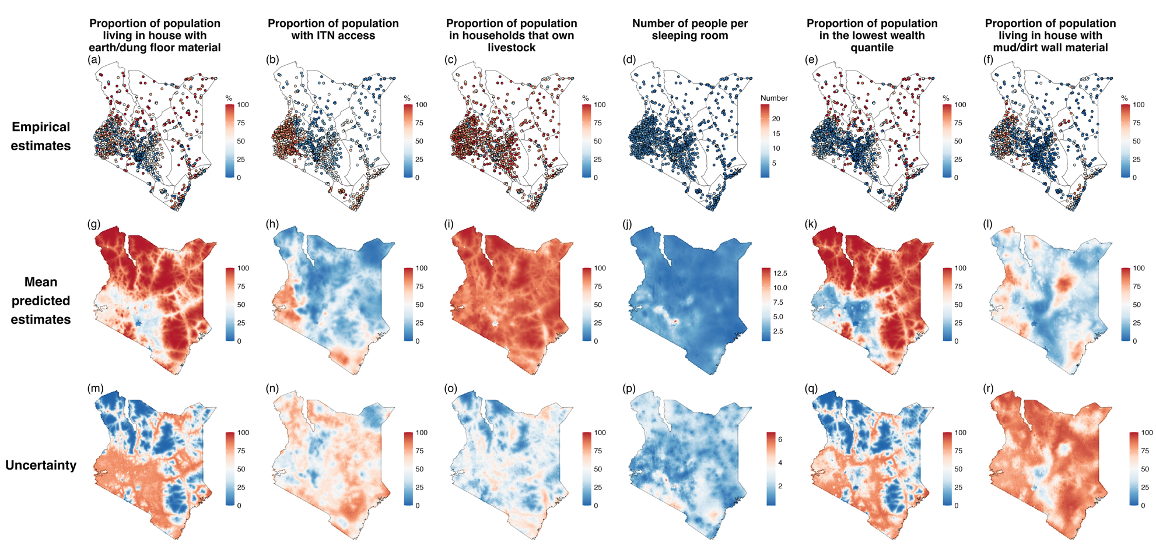
Figure S 1:Cluster-level empirical estimates from the 2022 Kenya DHS are shown in panels a–f. Panels g–l presents the high-resolution (5x5 km) predictions from the Bayesian geostatistical models. The corresponding prediction uncertainty (95% posterior credible interval widths) are displayed in panels m-r.

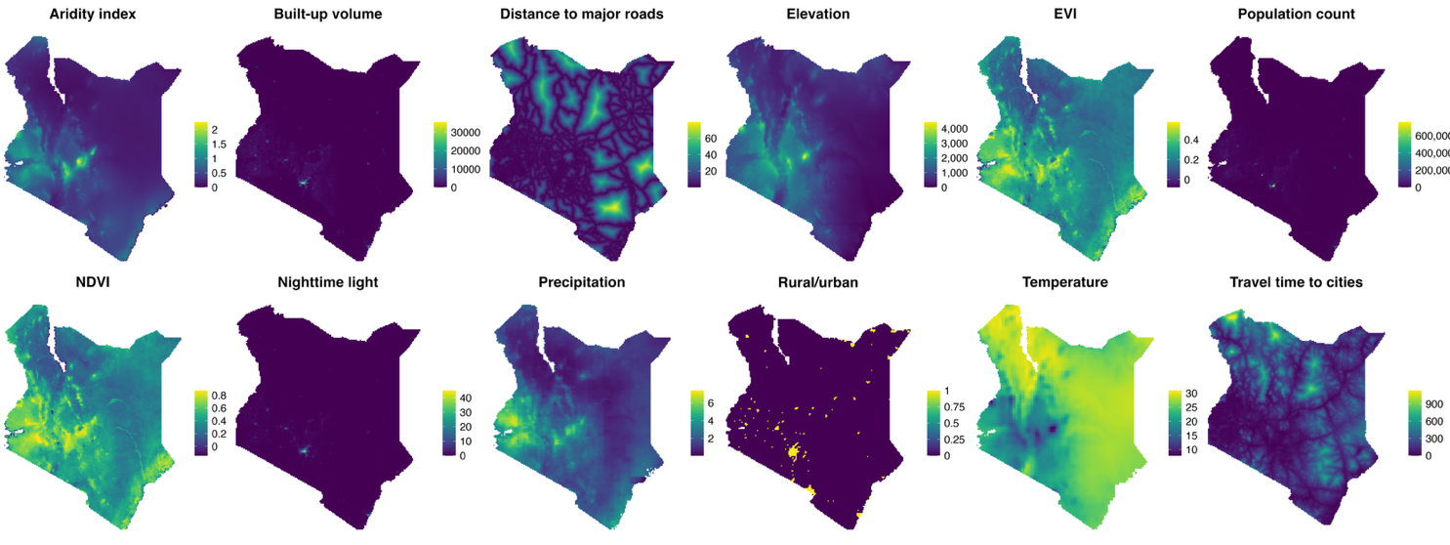
Figure S2: Covariates used in the Bayesian geostatistical modelling of the 6 socioeconomic indicators

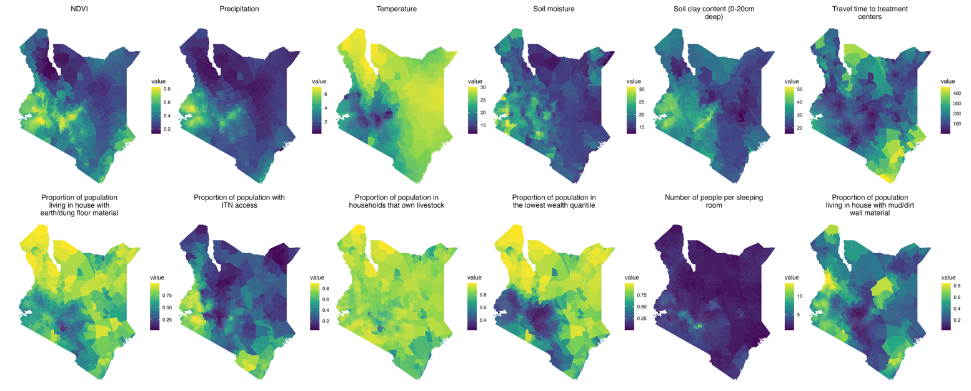
Figure S3: Covariates used in the joint spatial hurdle model of Visceral Leishmaniasis cases at ward level
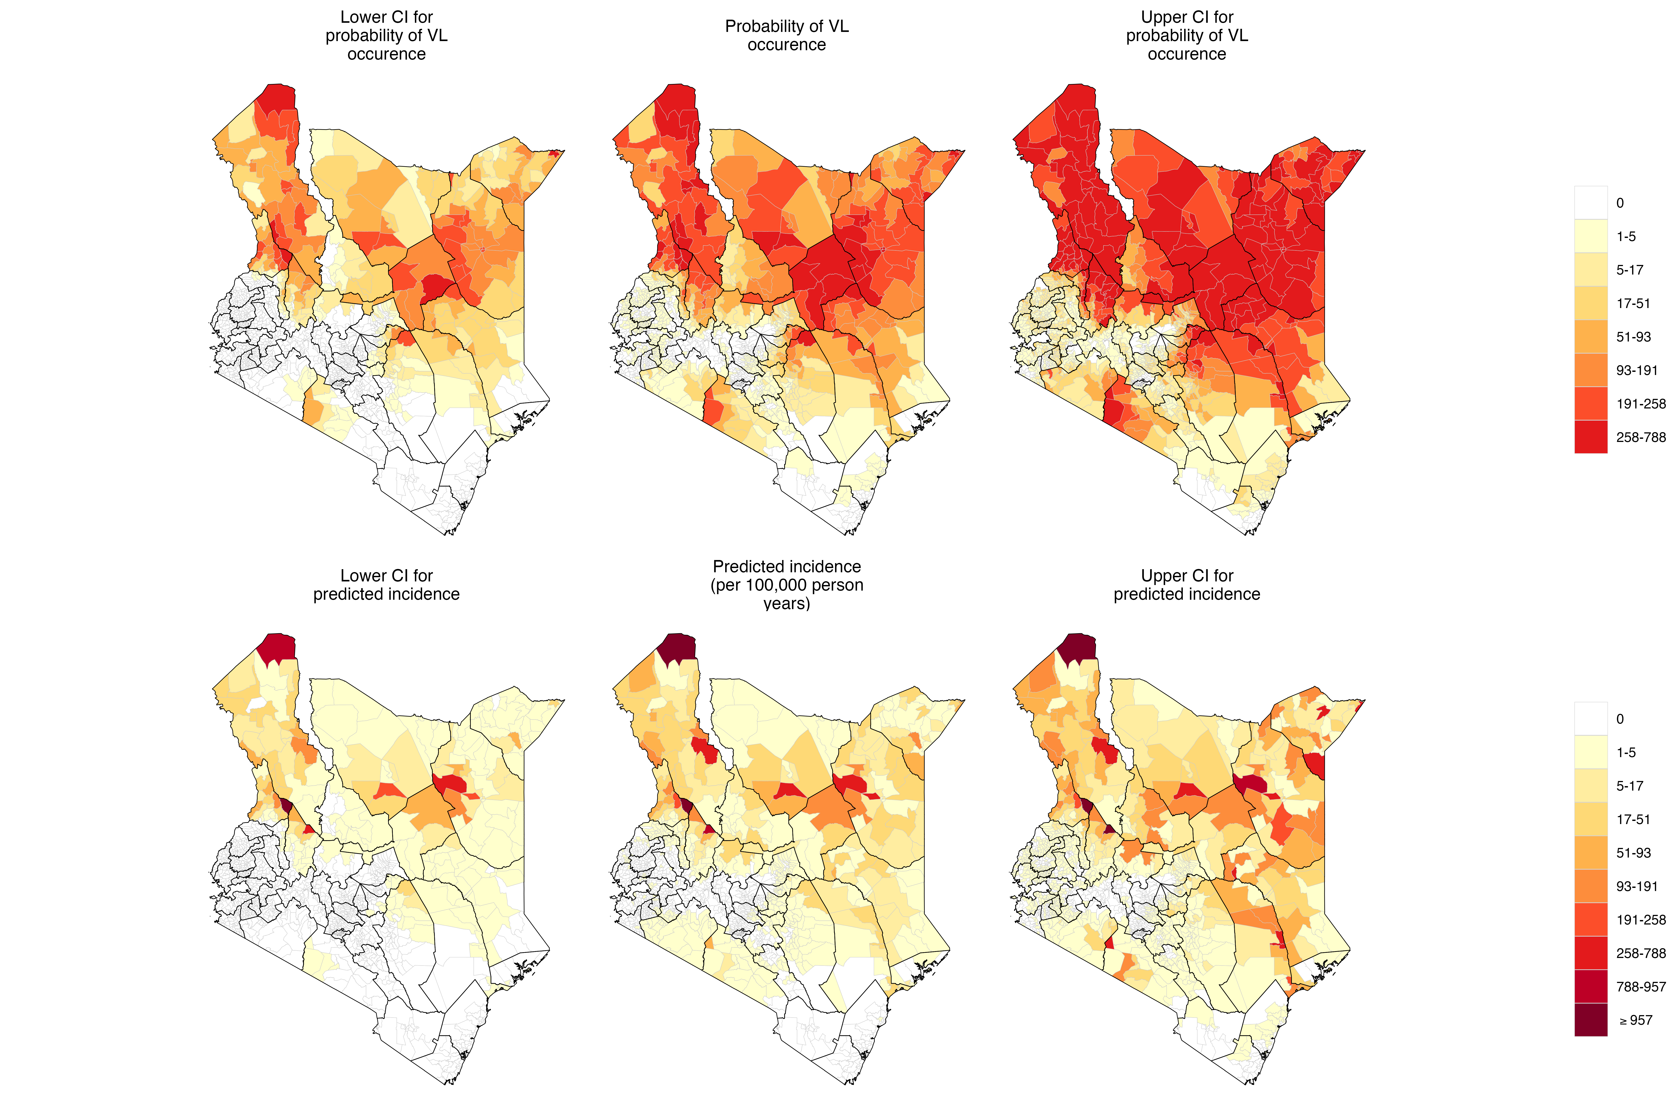
Figure S4: Credible intervals of the predicted incidence of Visceral Leishmaniasis cases at ward level

References
1. Kenya Demographic and Health Survey, 2022. (Kenya National Bureau of Statistics ; ICF, Nairobi, Kenya : Rockville, Maryland, USA, 2022).
2. Perez-Heydrich, C., Warren, J. L., Burgert, C. R. & Emch, M. E. Guidelines on the Use of DHS GPS Data. (2013).
3. Dong, T. Q. & Wakefield, J. Modeling and presentation of vaccination coverage estimates using data from household surveys. Vaccine 39, 2584–2594 (2021).
4. Rue, H., Martino, S. & Chopin, N. Approximate Bayesian inference for latent Gaussian models by using integrated nested Laplace approximations. J. R. Stat. Soc. Ser. B Stat. Methodol. 71, 319–392 (2009).
5. Martins, T. G., Simpson, D., Lindgren, F. & Rue, H. Bayesian computing with INLA: New features. Comput. Stat. Data Anal. 67, 68–83 (2013).
6. Lindgren, F. et al. An explicit link between Gaussian fields and Gaussian Markov random fields: the stochastic partial differential equation approach [with Discussion]. J. R. Stat. Soc. Ser. B Stat. Methodol. 73, 423–498 (2011).
7. Hengl, T. et al. African soil properties and nutrients mapped at 30 m spatial resolution using two-scale ensemble machine learning. Sci. Rep. 11, 6130 (2021).
8. Funk, C. et al. The climate hazards infrared precipitation with stations—a new environmental record for monitoring extremes. Sci. Data 2015 21 2, 1–21 (2015).
9. Copernicus Climate Change Service. ERA5-Land monthly averaged data from 1950 to present. Copernicus Climate Change Service (C3S) Climate Data Store (CDS) https://doi.org/10.24381/CDS.68D2BB30 (2019).
10. Land Data Assimilation System | LDAS. https://ldas.gsfc.nasa.gov/gldas/GLDASpublications.php.
11. Didan, K. MODIS/Terra Vegetation Indices Monthly L3 Global 1km SIN Grid V061. NASA Land Processes Distributed Active Archive Center https://doi.org/10.5067/MODIS/MOD13A3.061 (2021).
12. Bondarenko, M. et al. Kenya - Spatial Distribution of Population 2025. https://doi.org/10.5258/SOTON/WP00839 (2025).
13. Woods, T. et al. WorldPop high resolution, harmonised annual global geospatial covariates. Version 1.0. University of Southampton https://doi.org/10.5258/SOTON/WP00772 (2025).
14. Weiss, D. J. et al. A global map of travel time to cities to assess inequalities in accessibility in 2015. Nature 553, 333–336 (2018).
15. Zomer, R. J., Xu, J. & Trabucco, A. Version 3 of the Global Aridity Index and Potential Evapotranspiration Database. Sci. Data 9, 409 (2022).

