Supplementary Information

This Supporting Information provides additional characterization data (NMR, morphology, TEM/SAED, DSC/TGA) supporting the main manuscript.
Figures
Fig. S1 ¹H NMR spectrum of 4-acetamidobenzoic acid (4-ABA) confirming product formation and showing residual acetic acid (~1%) from recrystallization solvent.
Fig. S2 Comparative morphology of poly(p-benzamide) (PBA) whiskers synthesized from petroleum-derived monomers under identical conditions, observed by polarized optical microscopy (POM)

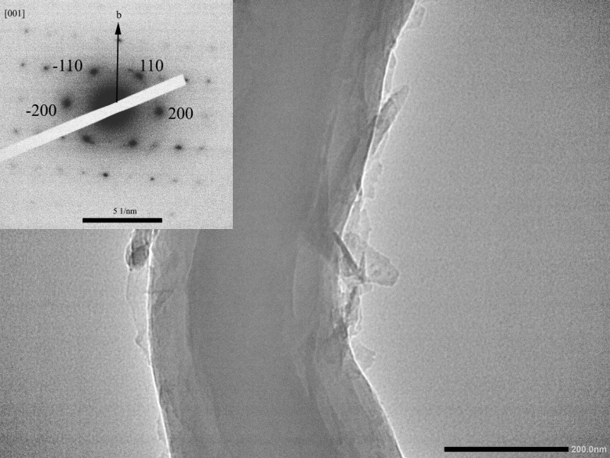
Fig. S3 Crystallographic orientation of bio-derived PBA whiskers revealed by transmission electron microscopy (TEM) and selected-area electron diffraction (SAED). The inset shows a Bright-field TEM image of a PBA whisker and its corresponding electron diffraction pattern oriented along [001] zone axis. Some of the main diffraction spots of the monoclinic lattice have been indexed. The arrow indicates crystal fiber growth along the b-axis.

Fig. S4 Differential scanning calorimetry (DSC) and thermogravimetric analysis (TGA) profiles of PBA whiskers synthesized from petroleum-derived monomers, indicating thermal stability up to 400 °C.

