Supplementary Information
Production and functional evaluation of cyclic carotenoids in the purple bacterium, Rubrivivax gelationsus

Makoto Nabeta, Jiro Harada, Shinichi Takaichi, Keizo Shimada, Kazuhito Inoue, and Kenji V. P. Nagashima
Fig. S1 Nabeta et al.

Figure S1. Growth of wild-type and mutant strains of R. gelatinosus under semi-aerobic conditions. Cell density was monitored by measuring absorbance at 660 nm. Culture conditions were as described in the Methods section. For each time point, five independent measurements were obtained; the highest and lowest values were excluded, and the mean of the remaining three measurements was plotted versus time.

Fig. S2 Nabeta et al.

A B C D E F
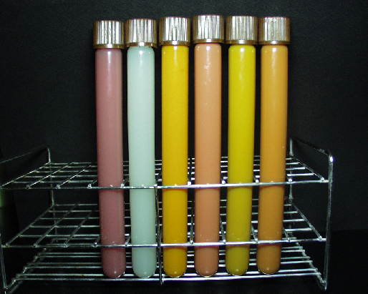
Figure S2. Concentrated cell suspensions of R. gelatinosus wild-type and mutants grown under semi-aerobic conditions. A, wild-type; B, ΔcrtIs (carotenoidless strain); C, DIDC-IY (β-carotene accumulating strain); D, DIDC-IYW (canthaxanthin accumulating strain); E, DIDC-IYZ (zeaxanthin accumulating strain); F, DIDC-IYWZ (astaxanthin accumulating strain). All strains were grown under semi-aerobic dark conditions. Cells were harvested by centrifugation and resuspended in MOPS buffer to one-tenth of the original culture volume to enhance visualization of cellular pigmentation.

Fig. S3 Nabeta et al.

A

B
Figure S3. (A) Schematic representation of the centrifuge tube after fractionation to isolate the membrane fraction. (B) Absorption spectrum of the orange fraction obtained from the DIDC-IY (β-carotene accumulating) mutant strain. Following cell disruption and centrifugation to collect the membrane fraction, a distinct orange-colored layer was observed at the top of the centrifuge tube in the DIDC-IY strain. This orange fraction was not detected in the wild-type strain.

Fig. S4 Nabeta et al.

Figure S4. Absorption spectra of RC-LH1 (black) and LH2 (red) complexes isolated from the DIDC-IYWZ (astaxanthin accumulating) mutant strain.

