GRAPHICAL ABSTRACT AND TEXT

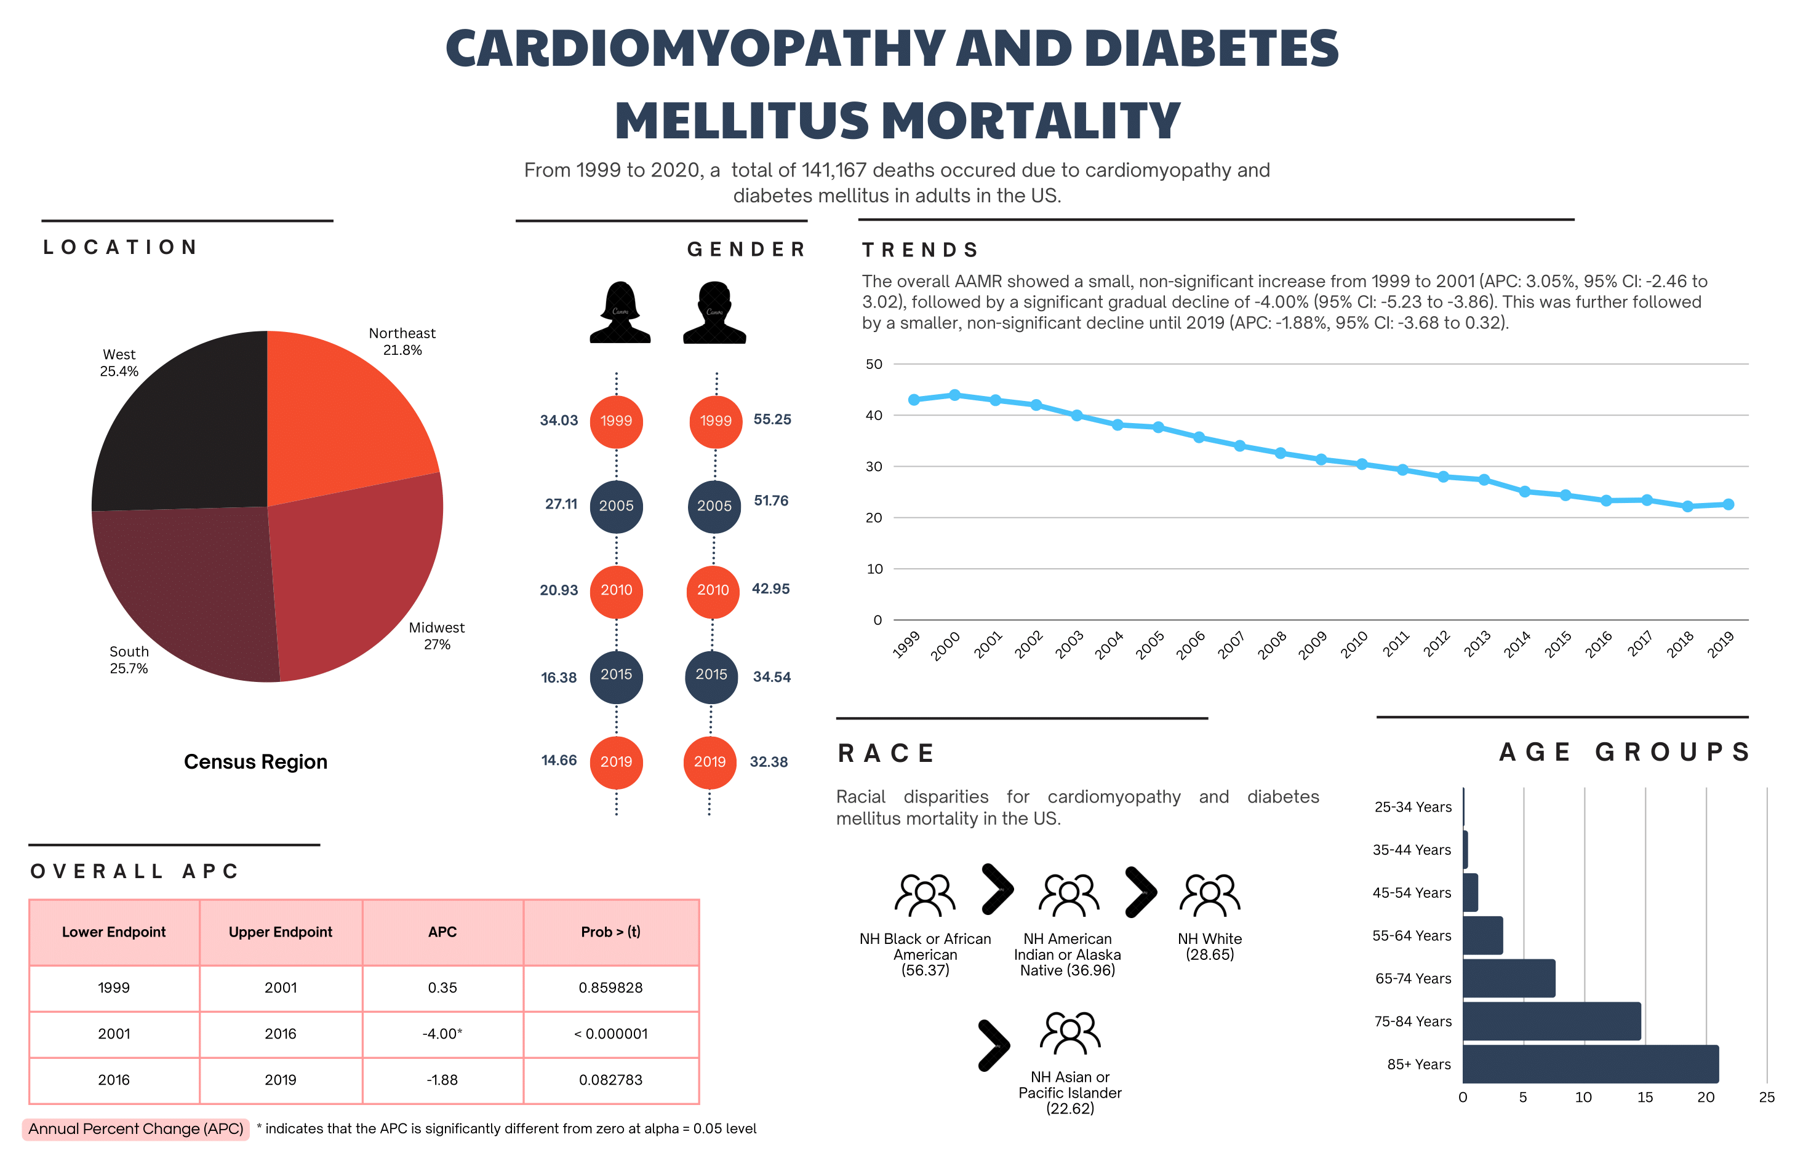
From 1999 to 2020, 141,167 US deaths occurred from cardiomyopathy with diabetes, showing a brief early rise, then a significant decline from 2001 to 2016 and smaller decreases through 2019. Highest mortality occurred in older adults, non-Hispanic Black people, and the Midwest/South.

