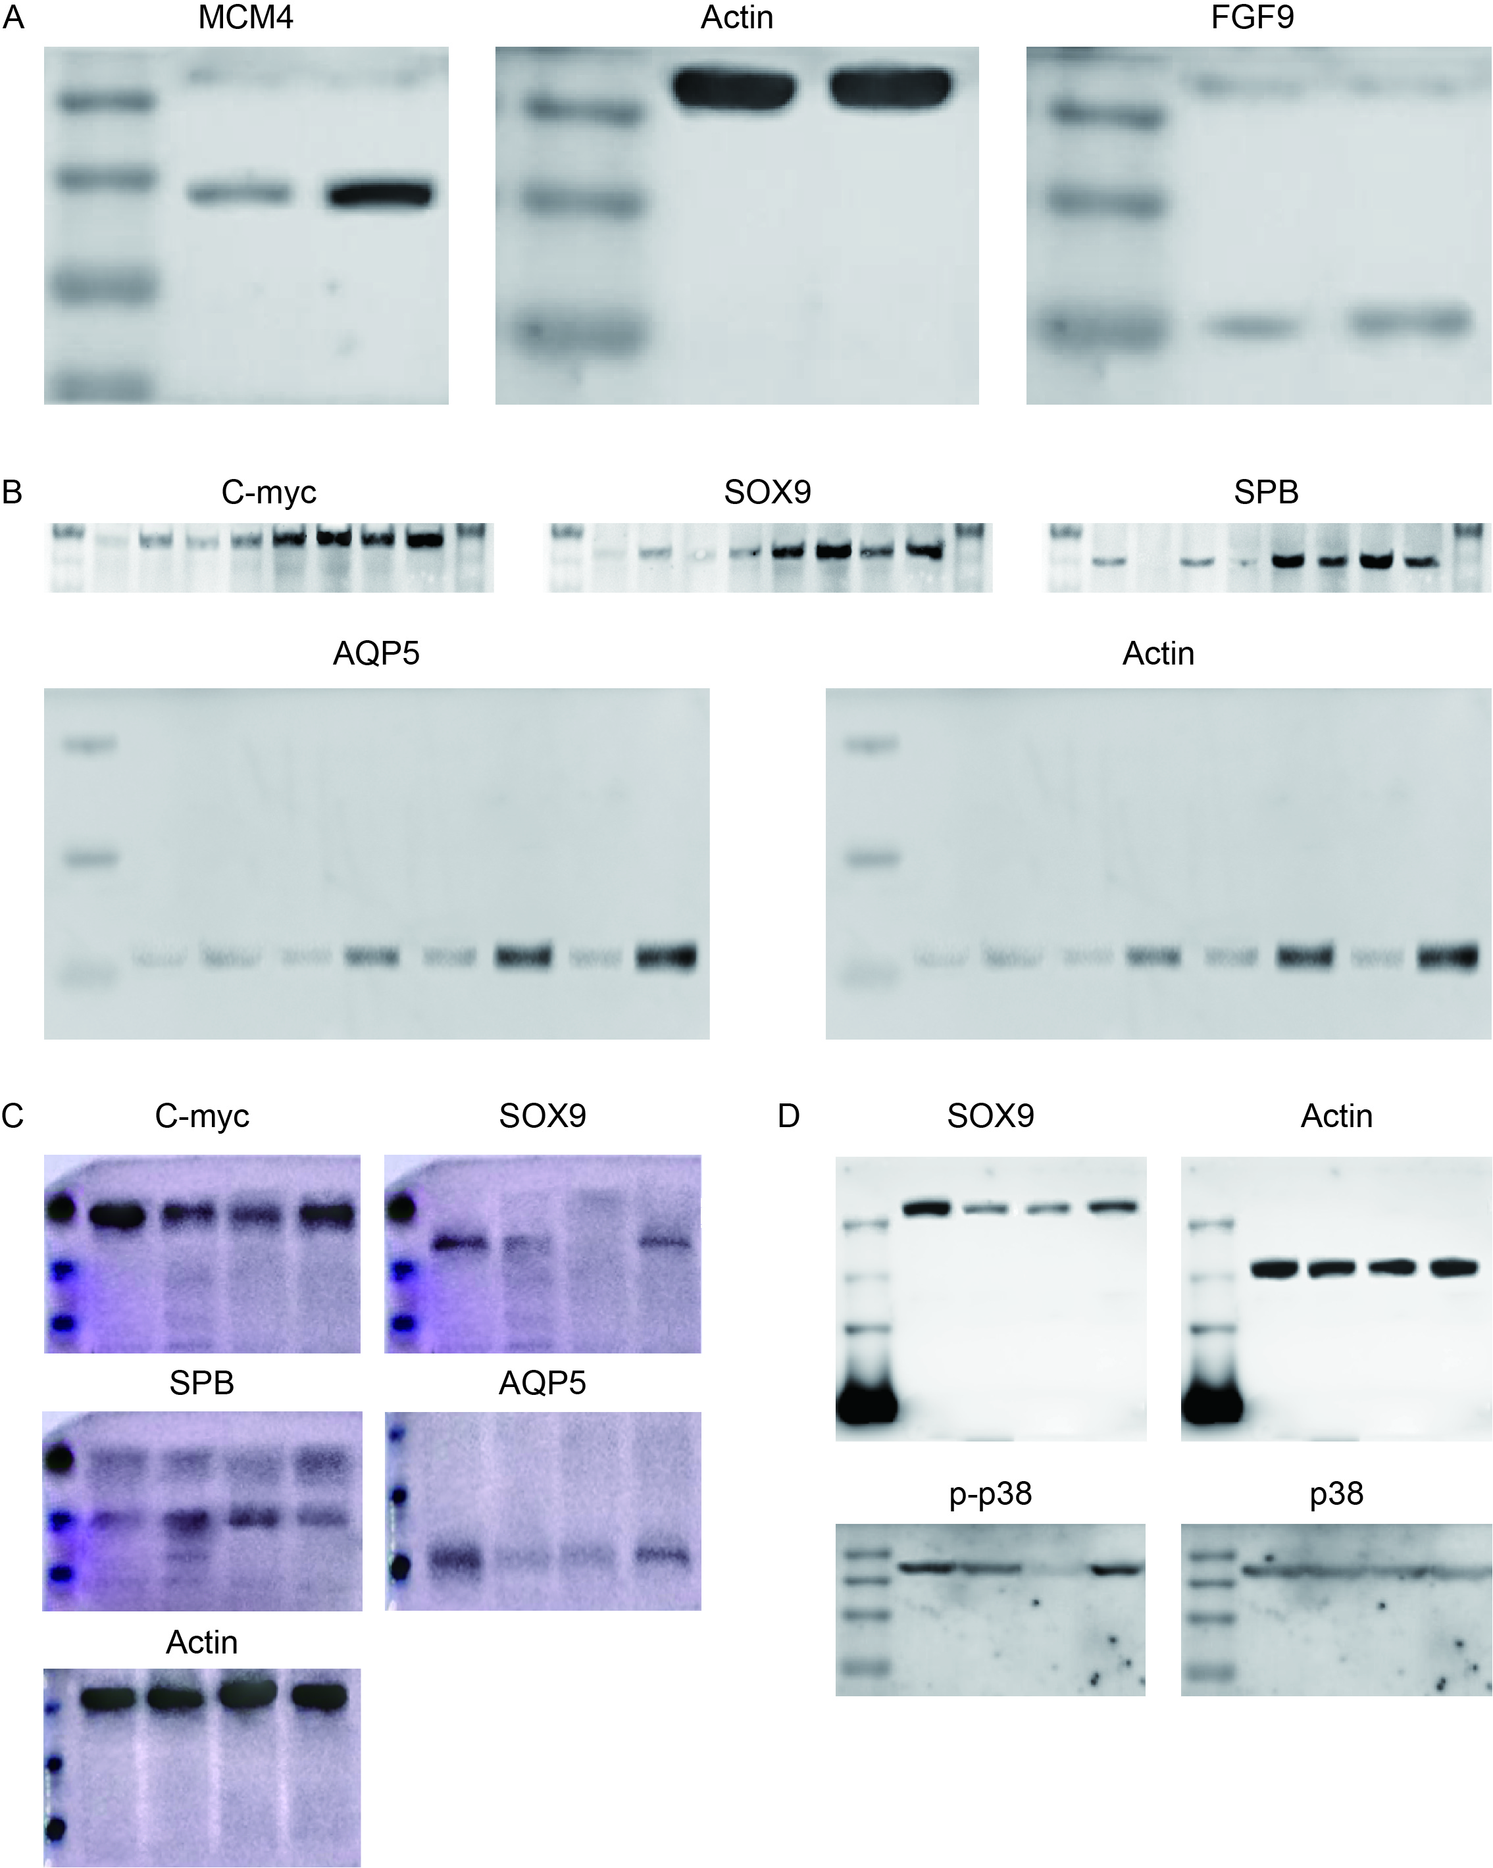Supplementary Figure 1. The full uncropped blots images for: (A) FIgure 2D; (B) Figure 2G; (C) Figure 3F (Left 2) and Figure 4D (Right 2); (D) Figure 4I

