Supplementary Information for:

Liposome Encapsulated Insulin- a viable option for an intranasal insulin delivery system

Saptarshi Roy Choudhury¹, Bhawya Jha¹, Poonima Shyam^{2†}, Anand Thiyagaraj^{3*}
1 Department of Genetic Engineering, SRM Institute of Science and Technology, Kattankulathur, 603203, Tamil Nadu, India.
2 Birac Bionest, Department of Translational Medicine, SRM Institute of Science and Technology, Kattankulathur, 603203, Tamil Nadu, India.
*Department of Genetic Engineering, SRM Institute of Science and Technology, Kattankulathur, 603203, Tamil Nadu, India.
*Corresponding author: E-mail(s): anandt@srmist.edu.in;
†This author contributed equally to this work.

Fluid flow modelling using Python:
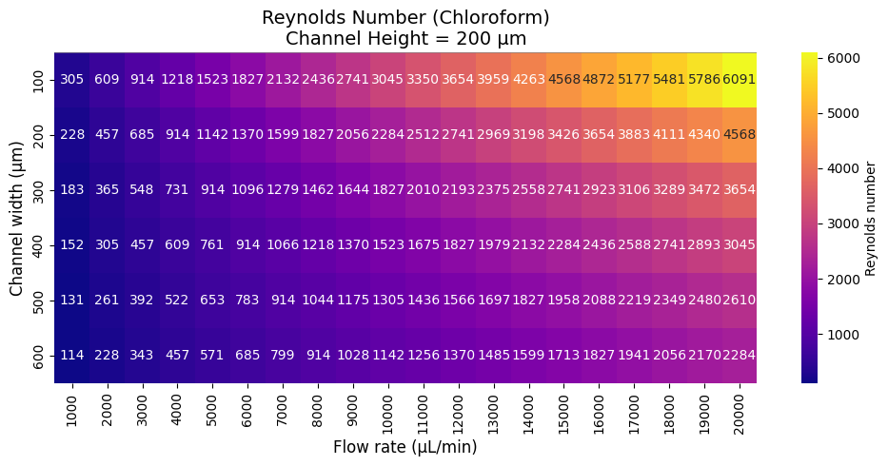
The mathematical model is readily available across the internet for the laminar flow of any liquid. Google Collab was used as a platform to compute the data. Plugging in every variable in the given formula, the cross-sectional area and the fluid velocity were varied in a given range, which was set by experimental verifications. A heat map was generated in order to find the optimum range of the fluid velocity and cross-sectional area.
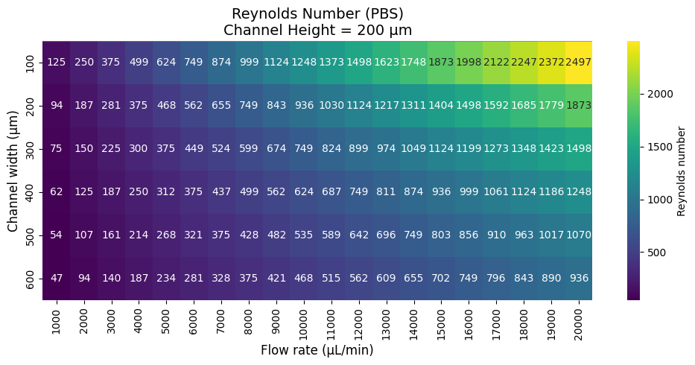
Figures 1.1 and 1.2, depicting heatmaps

The above two heat maps describe the reynold’s number distribution with varying fluid flow rate and cross-sectional area. The two liquid has its subsequent ranges, which define the cross-section of the two ends of the Y-channel. Latter when they coalesce together, the cross-sectional areas of both liquid is added simply creating double the area, causing both liquids to interact witheach other in a laminar fashion.
The code is given in this pdf Python code.pdf.
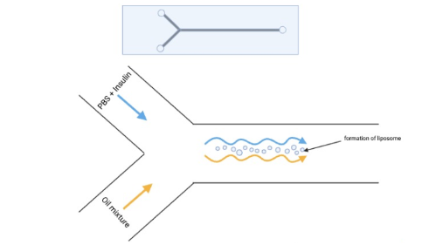
Figure 1.3

Figure 1.3 illustrates the process of liposome creation inside the channel. The interaction between the laminar flowing surfaces of the two liquids causes the salts in PBS to form micro vesicles using the cholesterol and soya lecithin in the chloroform.
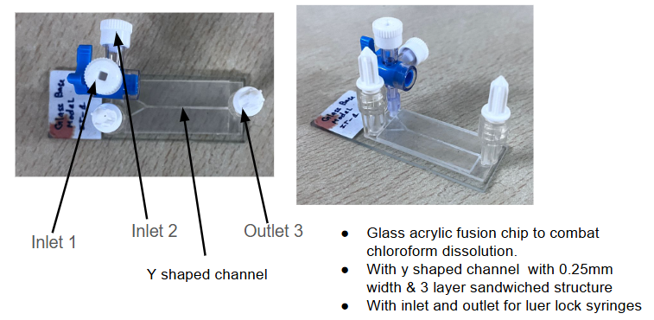
Figure 1.4

Figure 3 shows the actual microfluidic chip created for this purpose (Patent application number 202541035790).
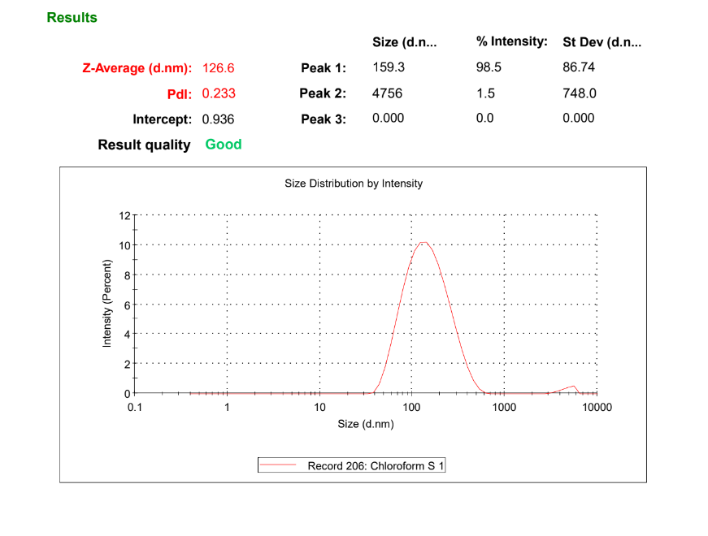
Figure 2. Shows DLS particle analyzer data for Formed liposomes.

CAM Assay results:
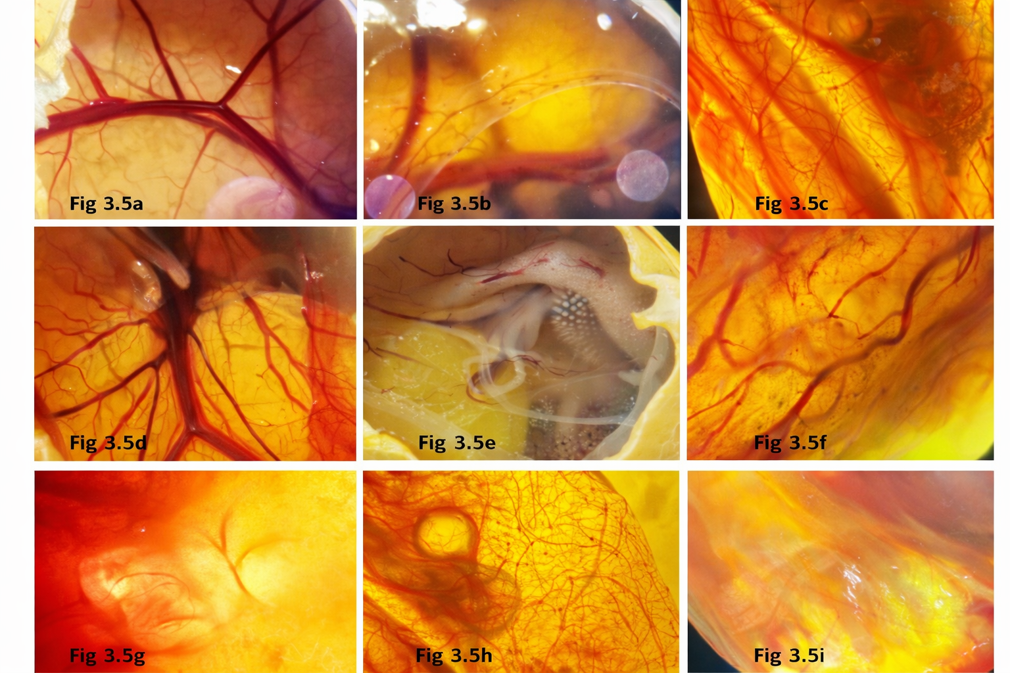
The above collage of figures shows the gradual growth of blood vessels and micro-angiogenesis in the chicken embryo viewed under a tissue microscope. Each image was characterised using Q-path to give a percentage increase in the growth of the blood vessel over time.
Figure 3.5a - Blood vessel formation for eggs at 0th hour, Figure 3.5b Blood vessel formation for control egg at 24th hour, Figure 3.5c Blood vessel formation for egg with raw insulin at 24th hour, Figure 3.5d Blood vessel formation for egg with liposomal insulin at 24th hour, Figure 3.5e Blood vessel formation for egg with glucose at 24th hour, Figure 3.5f Blood vessel formation for control egg at 48th hour, Figure 3.5g Blood vessel formation for egg with raw insulin at 48th hour, Figure 3.5h Blood vessel formation for egg with liposomal insulin at 48th hour, Figure 3.5i Blood vessel formation for egg with glucose at 48th hour.

Administration of drugs into in vivo models:
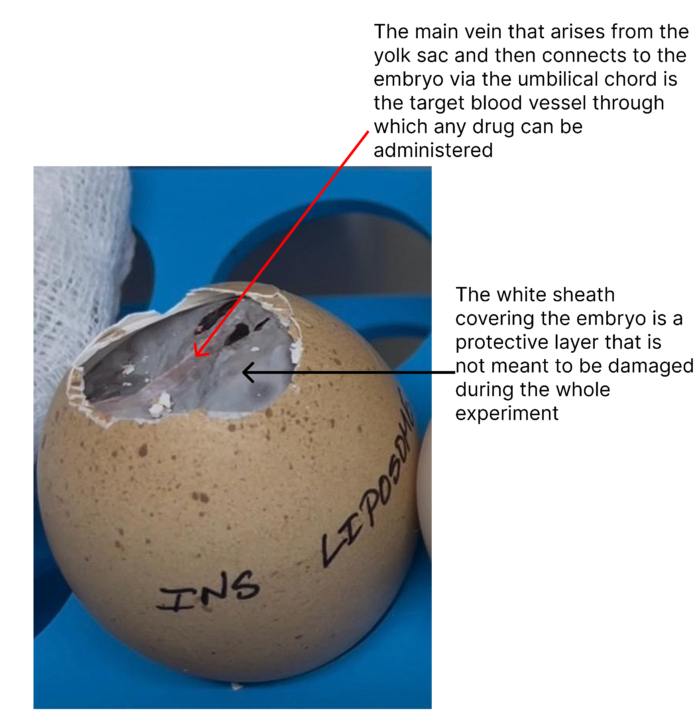
Figure 4

The above figure (Figure 4) describes the midrib vein that provides nutrients from the yolk sac to the embryo, which needs to be targeted for the administration of any drugs. The white protective sheath is a membrane that is attached to the egg shell, so while breaking the shell, great care needs to be taken. If the sheath breaks, it makes the embryo prone to all kinds of environmental factors, and the sheath also contains microvessels, so a rupture can cause the embryo to bleed out.

