Supporting Information
Synthesis of carbon dots via selective microwave heating of reverse micelles in a microwave-transparent solvent
Srikrishna Tummala, and Yen-Peng Ho*
Department of Chemistry, National Dong Hwa University, Hualien 97401, Taiwan

* Corresponding author: ypho@gms.ndhu.edu.tw

Experimental

Optimization of Synthetic Conditions for CDs
Hydrothermal Method
To optimize the precursor composition, varying weight ratios of citric acid (CA) and Tris (700 mg:300 mg, 0 mg:1000 mg, 1000 mg:0 mg, 300 mg:700 mg, and 500 mg:500 mg) were dissolved in 10 mL of deionized water to form clear, homogeneous solutions. Each solution was sealed in a Teflon-lined stainless-steel autoclave and heated at 180 °C for 4 h. The effect of reaction time was evaluated using the optimized precursor composition (700 mg CA:300 mg Tris) by varying the heating duration at 180 °C. Similarly, the effect of reaction temperature was investigated while maintaining the optimized precursor composition and a reaction time of 2 h.
Solvothermal Reverse Micelle Method
To optimize the AOT concentration, 100 µL of an aqueous solution containing 70 mg CA and 30 mg Tris in 1 mL of water was added to 10 mL of n-dodecane containing different concentrations of AOT and sonicated for 30 min to form a homogeneous water-in-oil microemulsion. The emulsion was transferred to Teflon-lined stainless-steel autoclaves and heated at 180 °C for 4 h. Optimization of reaction time was performed using 40 mM AOT, while the reaction temperature was optimized at a reaction time of 2 h using the previously established precursor composition and AOT concentration.
Domestic Microwave Method
For microwave-assisted synthesis, the optimized precursor composition (700 mg CA:300 mg Tris in 5 mL of deionized water) was subjected to microwave irradiation at power levels of 600 W and 1000 W for varying durations to determine the conditions that produced the highest quantum yield.

Figures
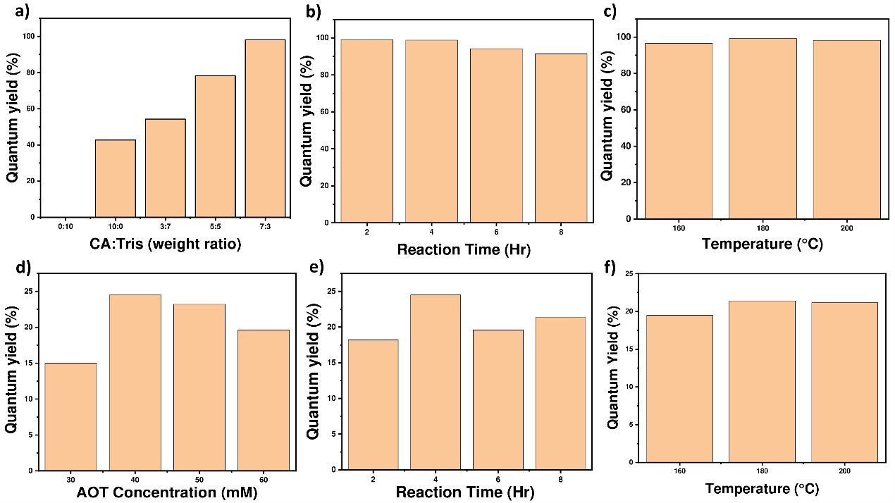
Figure S1. Optimization of synthetic conditions for carbon dots. (a–c) Hydrothermal synthesis: effect of (a) precursor composition, (b) reaction time, and (c) reaction temperature. The optimized conditions were a CA:Tris weight ratio of 7:3, a reaction time of 2 h, and a reaction temperature of 180 °C. (d–f) Solvothermal reverse micelle synthesis: effect of (d) AOT concentration, (e) reaction time, and (f) reaction temperature. The optimized conditions were 40 mM AOT, a 4 h reaction, and 180 °C reaction temperature.
Figure S2. Optimization of the domestic microwave method. (optimized conditions: 1000 W, 3 min)

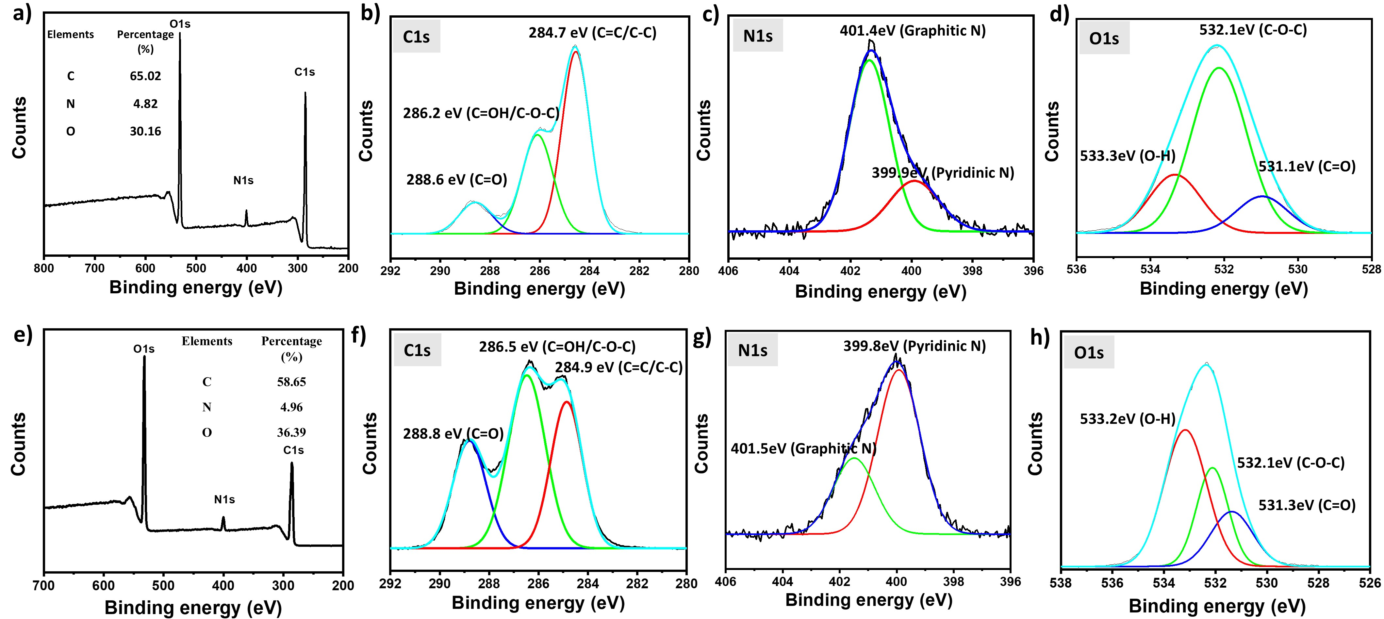
Figure S3. XPS spectra of CDs synthesized by hydrothermal and domestic microwave methods: (a–d) hydrothermal—full scan, C1s, N1s, and O1s; (e–h) domestic microwave—full scan, C1s, N1s, and O1s.

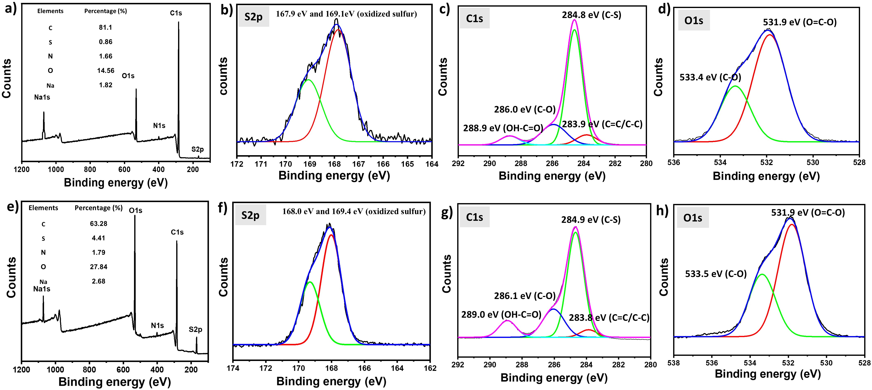
Figure S4. XPS spectra of CDs synthesized by solvothermal and hexanoic acid-based MARM methods: (a–d) solvothermal—full scan, S2p, C1s, and O1s; (e–h) hexanoic acid-based MARM—full scan, S2p, C1s, and O1s.
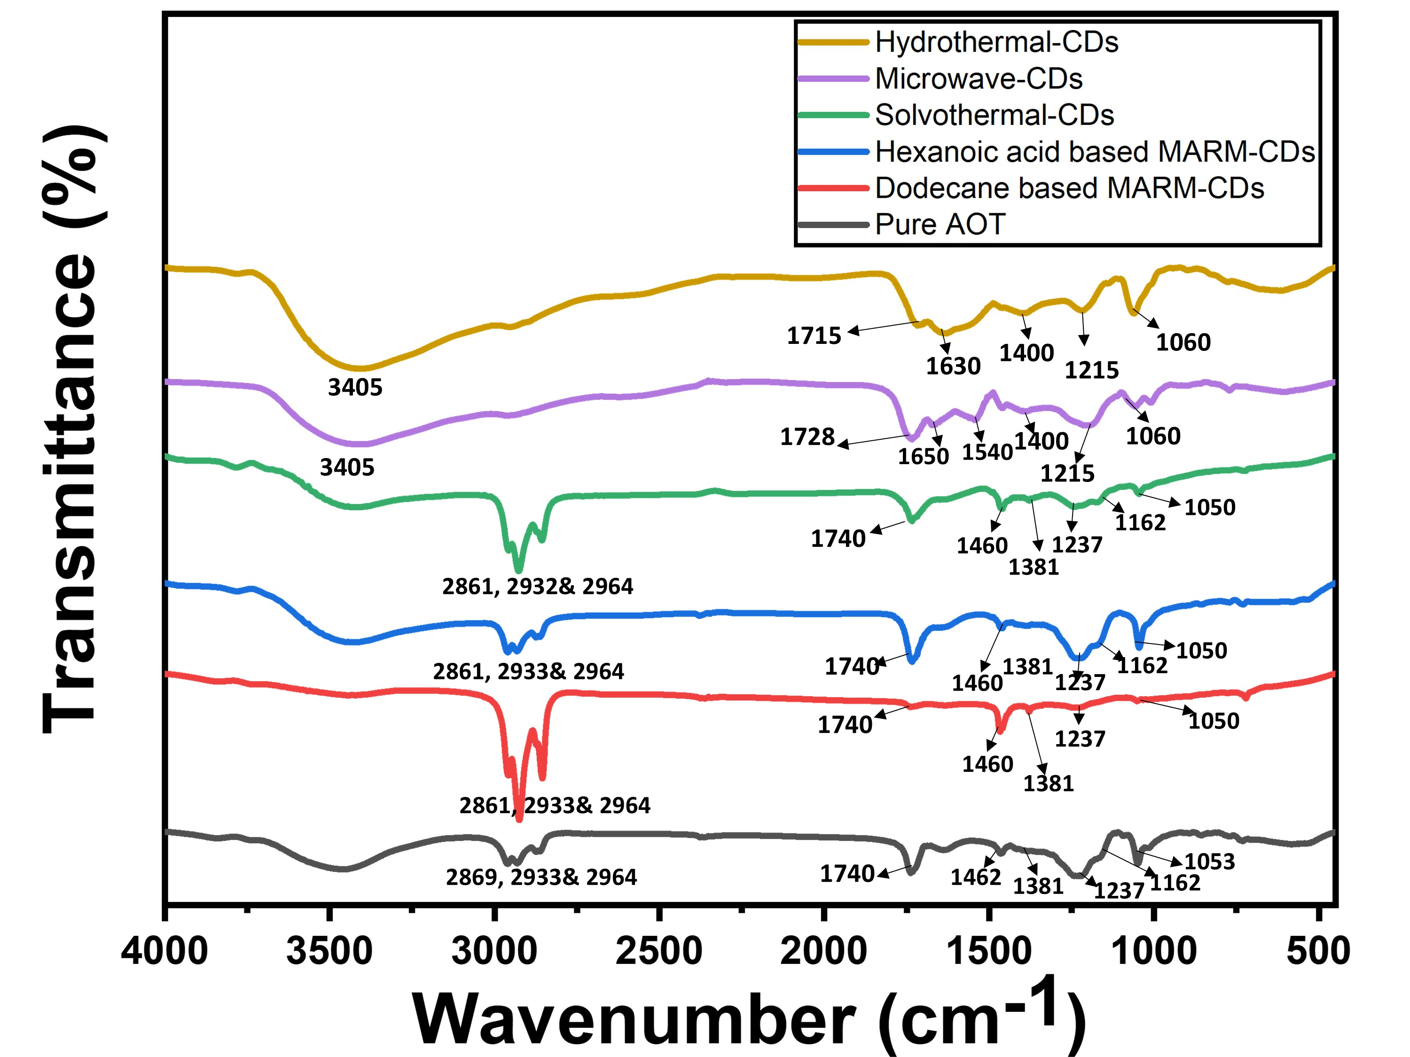
Figure S5. FT-IR spectra of hydrothermal CDs, domestic microwave CDs, solvothermal reverse micelle CDs, hexanoic acid-based MARM-CDs, dodecane-based MARM-CDs, and pure AOT.

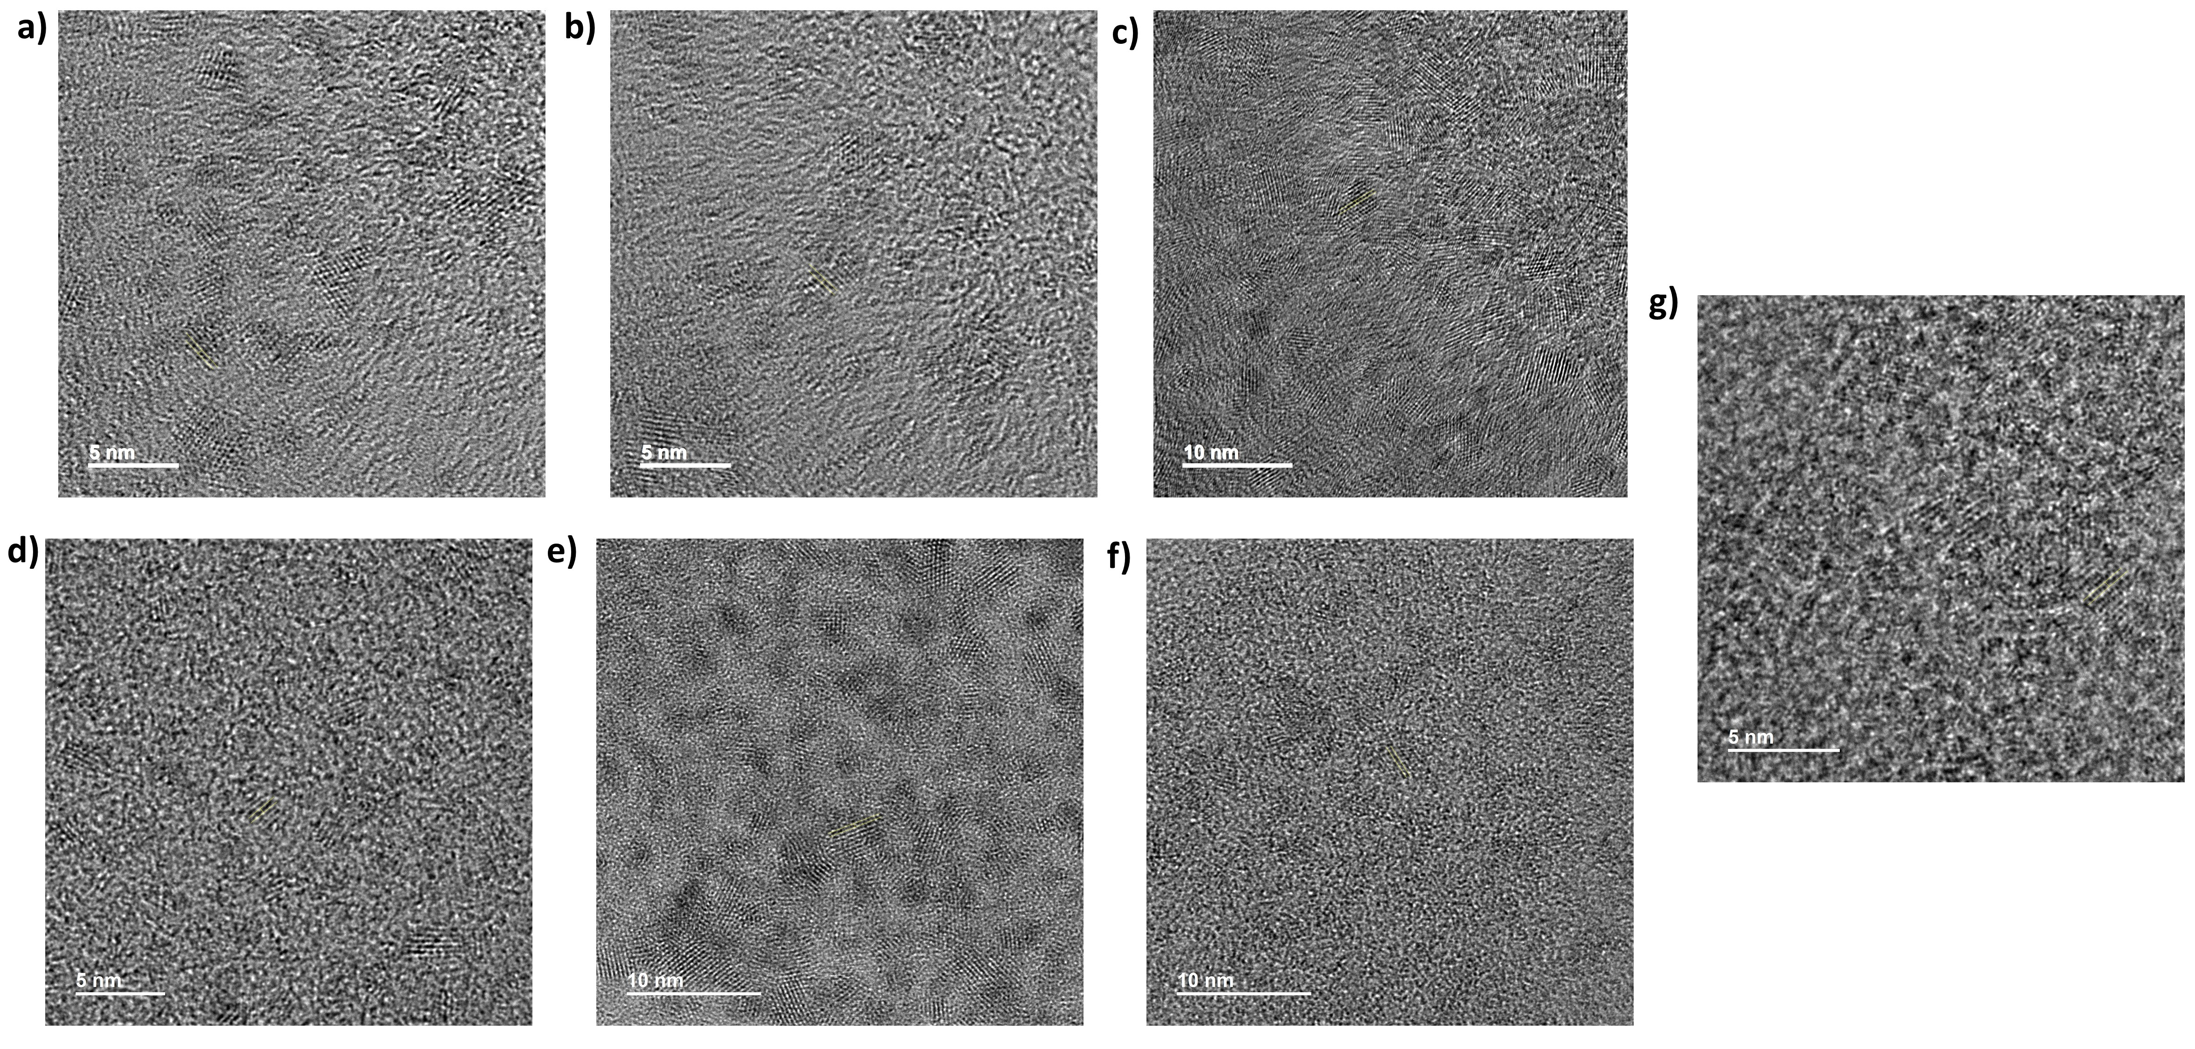
Figure S6. High resolution TEM images showing the d-spacings of CDs prepared using various methods. (a) Dodecane-based MARM at 30 mM AOT (0.31 nm), (b) 40 mM AOT (0.29 nm), (c) 50 mM AOT (0.32 nm), (d) hydrothermal (0.28 nm), (e) solvothermal reverse micelle (0.29 nm), (f) domestic microwave (0.22 nm), and (g) hexanoic acid-based MARM (0.29 nm).

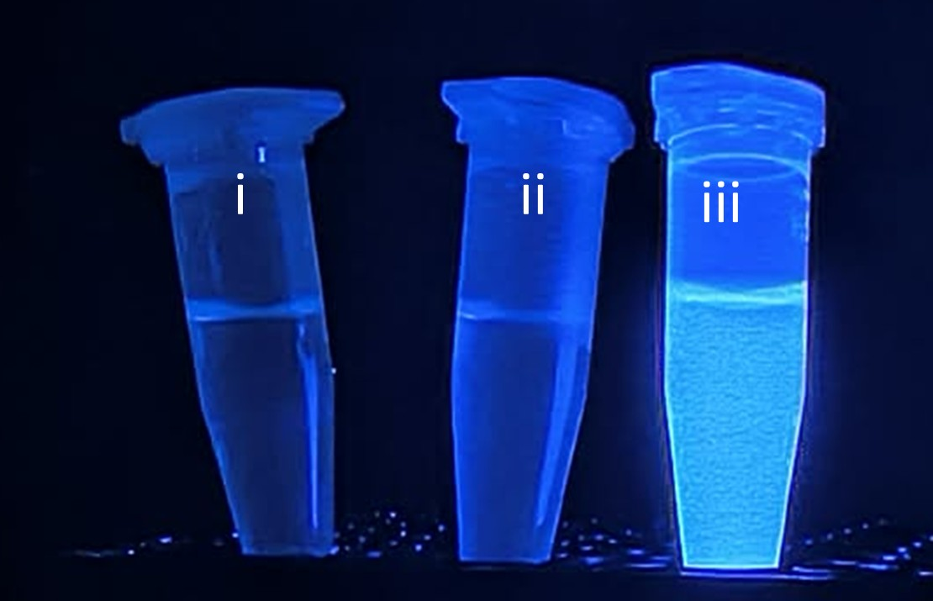

Figure S7. Photographs of solutions under 365 nm UV light. (i) Dodecane, (ii) 40 mM AOT in dodecane, and (iii) MARM-CDs in dodecane. The images illustrate the fluorescence of MARM-CDs compared with the nonfluorescent solvent and surfactant solutions.

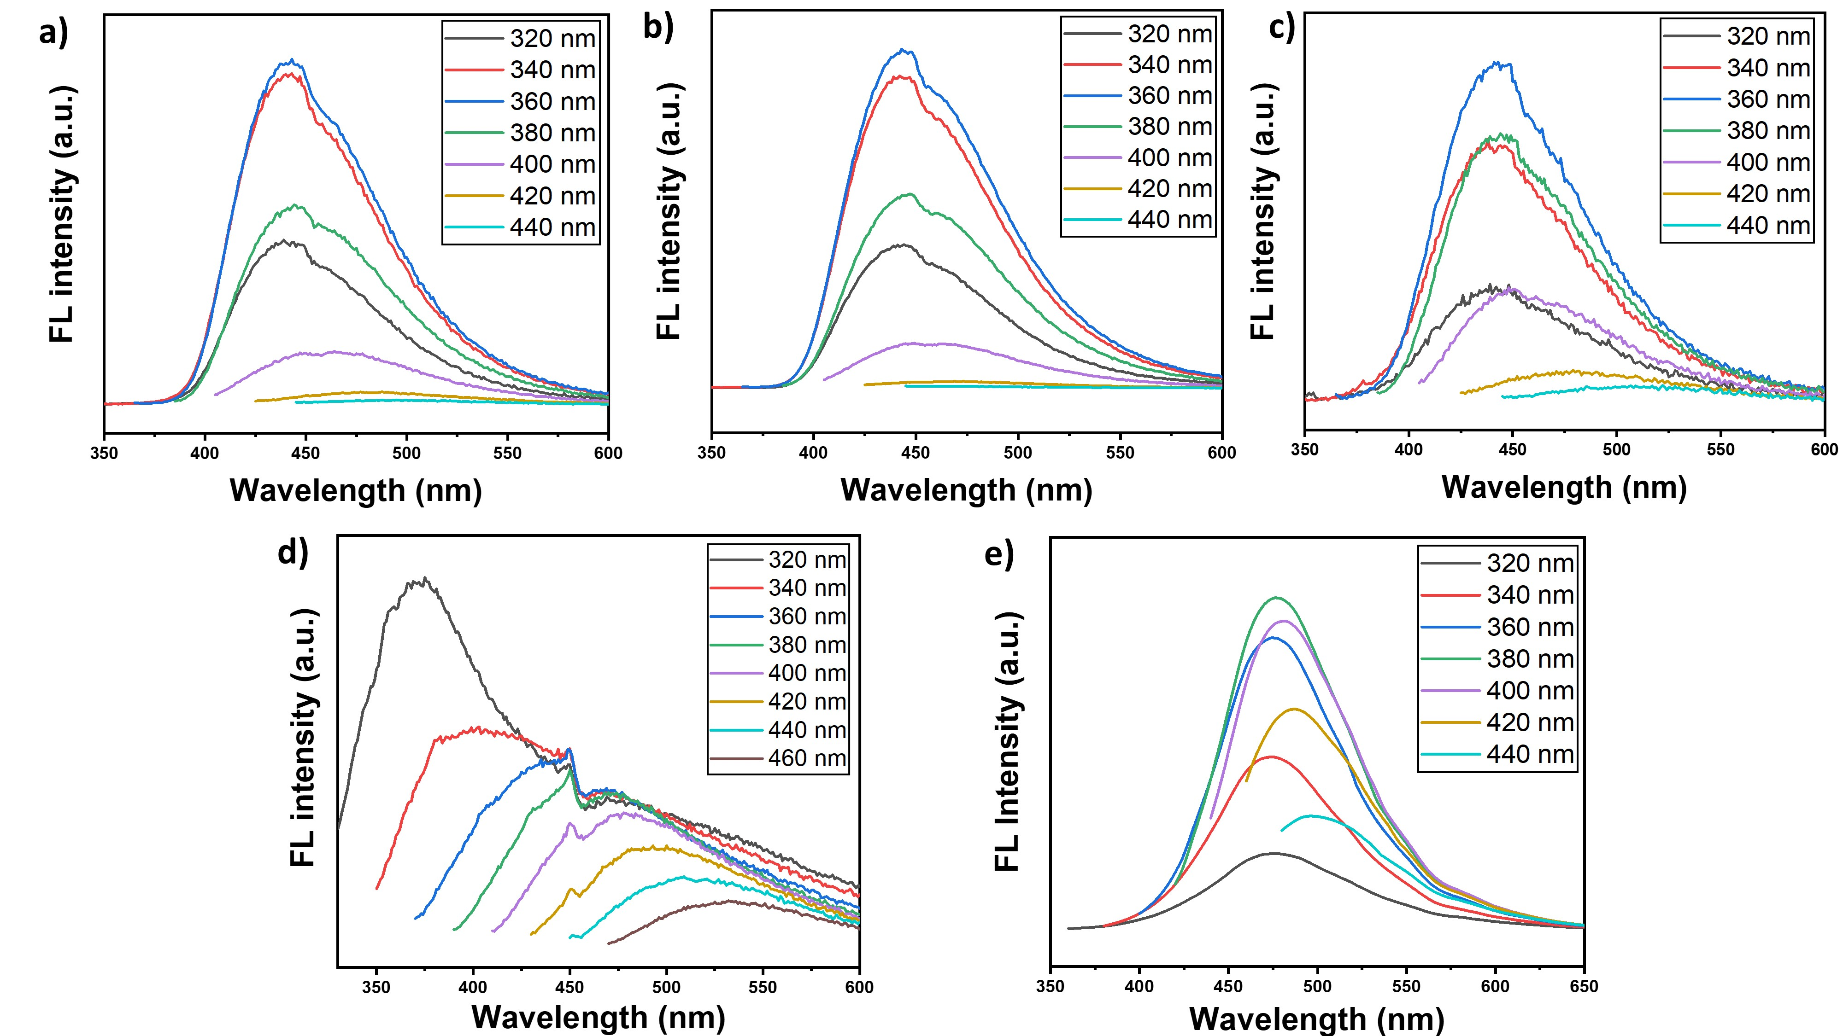
Figure S8. Fluorescence spectra of PEI-derived carbon dots prepared using different methods. CDs were synthesized via (a) dodecane-based MARM, (b) hydrothermal, (c) domestic microwave-assisted, (d) solvothermal reverse micelle, and (e) hexanoic acid-based MARM approaches.

