SUPPLEMENTARY MATERIALS

Behavioral and hormonal responses to urbanization in odorous house ants (Tapinoma sessile)

Insectes Sociaux

Corresponding author: Kevin Neumann; kevinn4@illinios.edu

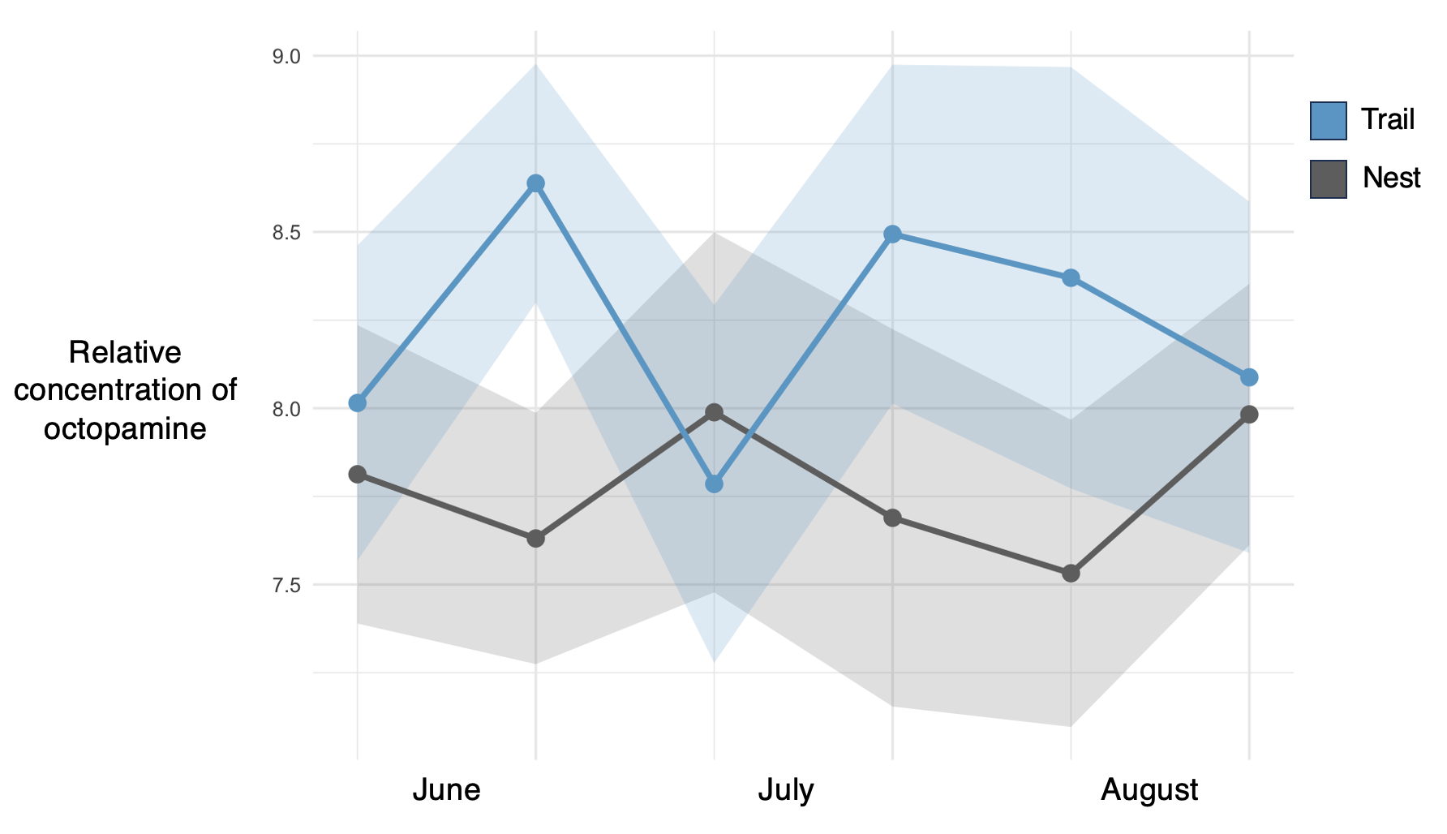
Supplementary Figure S1 Relative concentration of octopamine, by colony type, from pooled samples of 10 workers collected in the field. Points represent mean values and shaded area represented the standard error. Values are log transformed for visualization.

