APPENDIX

Degaga TS, et al, Analysis of the effect of primaquine dose on the efficacy, safety, and tolerability in patients with Plasmodium vivax malaria in Ethiopia: a systematic review and individual patient data meta-analysis

 | Page
Checklist S1. PRISMA-IPD | 2
Table S1. Studies included in analysis | 6
Table S2. Study sites included in analysis | 7
Table S3. Risk of bias assessment in randomised controlled studies | 8
Table S4. Risk of bias assessment in single arm observational studies | 9
Table S5. Any GI disturbance on day 0 inclusive (composite of vomiting, diarrhoea, anorexia), all studies | 10
Table S6. Sensitivity analyses for relationship between total primaquine mg/kg dose and first P. vivax recurrence between days 7 and 180 | 11
Table S7. Sensitivity analyses excluding one study site at a time for relationship between total primaquine mg/kg dose and first P. vivax recurrence between days 7 and 180 | 12
Figure S1. Distribution of total primaquine dose (mg/kg) administered | 13
Figure S2: Boxplot of daily primaquine dose (mg/kg) by age group | 14
Figure S3: Density distribution of day 0 haemoglobin | 15
Figure S4: Cumulative incidence of first Plasmodium vivax recurrence between day 7 and day 180 by treatment arm excluding studies with less than 42 days follow up | 16
Figure S5: Change in Hb on days 2-3 relative day 0 | 17

Checklist S1. PRISMA-IPD Checklist of items to include when reporting a systematic review and meta-analysis of individual participant data (IPD)

PRISMA-IPD  Section/topic | Item No | Checklist item | Reported on page
Title
Title | 1 | Identify the report as a systematic review and meta-analysis of individual participant data. | 1
Abstract
Structured summary | 2 | Provide a structured summary including as applicable: | 2-3
Structured summary | 2 | Background: state research question and main objectives, with information on participants, interventions, comparators and outcomes. | 2-3
Structured summary | 2 | Methods: report eligibility criteria; data sources including dates of last bibliographic search or elicitation, noting that IPD were sought; methods of assessing risk of bias. | 2-3
Structured summary | 2 | Results: provide number and type of studies and participants identified and number (%) obtained; summary effect estimates for main outcomes (benefits and harms) with confidence intervals and measures of statistical heterogeneity. Describe the direction and size of summary effects in terms meaningful to those who would put findings into practice. | 2-3
Structured summary | 2 | Discussion: state main strengths and limitations of the evidence, general interpretation of the results and any important implications. | 2-3
Structured summary | 2 | Other: report primary funding source, registration number and registry name for the systematic review and IPD meta-analysis. | 2-3
Introduction
Rationale | 3 | Describe the rationale for the review in the context of what is already known. | 4
Objectives | 4 | Provide an explicit statement of the questions being addressed with reference, as applicable, to participants, interventions, comparisons, outcomes and study design (PICOS). Include any hypotheses that relate to particular types of participant-level subgroups. | 4
Methods
Protocol and registration | 5 | Indicate if a protocol exists and where it can be accessed. If available, provide registration information including registration number and registry name. Provide publication details, if applicable. | 5
Eligibility criteria | 6 | Specify inclusion and exclusion criteria including those relating to participants, interventions, comparisons, outcomes, study design and characteristics (e.g. years when conducted, required minimum follow-up). Note whether these were applied at the study or individual level i.e. whether eligible participants were included (and ineligible participants excluded) from a study that included a wider population than specified by the review inclusion criteria. The rationale for criteria should be stated. | 5
Identifying studies – information sources | 7 | Describe all methods of identifying published and unpublished studies including, as applicable: which bibliographic databases were searched with dates of coverage; details of any hand searching including of conference proceedings; use of study registers and agency or company databases; contact with the original research team and experts in the field; open adverts and surveys. Give the date of last search or elicitation. | 5
Identifying studies – search | 8 | Present the full electronic search strategy for at least one database, including any limits used, such that it could be repeated. | 5
Study selection processes | 9 | State the process for determining which studies were eligible for inclusion. | 5
Data collection processes | 10 | Describe how IPD were requested, collected and managed, including any processes for querying and confirming data with investigators. If IPD were not sought from any eligible study, the reason for this should be stated (for each such study). | 6  6
Data collection processes | 10 | If applicable, describe how any studies for which IPD were not available were dealt with. This should include whether, how and what aggregate data were sought or extracted from study reports and publications (such as extracting data independently in duplicate) and any processes for obtaining and confirming these data with investigators. | 6  6
Data items | 11 | Describe how the information and variables to be collected were chosen. List and define all study level and participant level data that were sought, including baseline and follow-up information. If applicable, describe methods of standardising or translating variables within the IPD datasets to ensure common scales or measurements across studies. | 6
IPD integrity | A1 | Describe what aspects of IPD were subject to data checking (such as sequence generation, data consistency and completeness, baseline imbalance) and how this was done. | 6
Risk of bias assessment in individual studies. | 12 | Describe methods used to assess risk of bias in the individual studies and whether this was applied separately for each outcome. If applicable, describe how findings of IPD checking were used to inform the assessment. Report if and how risk of bias assessment was used in any data synthesis. | 6
Specification of outcomes and effect measures | 13 | State all treatment comparisons of interests. State all outcomes addressed and define them in detail. State whether they were pre-specified for the review and, if applicable, whether they were primary/main or secondary/additional outcomes. Give the principal measures of effect (such as risk ratio, hazard ratio, difference in means) used for each outcome. | 7
Synthesis methods | 14 | Describe the meta-analysis methods used to synthesise IPD. Specify any statistical methods and models used. Issues should include (but are not restricted to):  - Use of a one-stage or two-stage approach.  - How effect estimates were generated separately within each study and combined across studies (where applicable).  - Specification of one-stage models (where applicable) including how clustering of patients within studies was accounted for.  - Use of fixed or random effects models and any other model assumptions, such as proportional hazards.  - How (summary) survival curves were generated (where applicable).  - Methods for quantifying statistical heterogeneity (such as I² and t²).  - How studies providing IPD and not providing IPD were analysed together (where applicable).  - How missing data within the IPD were dealt with (where applicable). | 7-8
Exploration of variation in effects | A2 | If applicable, describe any methods used to explore variation in effects by study or participant level characteristics (such as estimation of interactions between effect and covariates). State all participant-level characteristics that were analysed as potential effect modifiers, and whether these were pre-specified. | 6
Risk of bias across studies | 15 | Specify any assessment of risk of bias relating to the accumulated body of evidence, including any pertaining to not obtaining IPD for particular studies, outcomes or other variables. | 6
Additional analyses | 16 | Describe methods of any additional analyses, including sensitivity analyses. State which of these were pre-specified. | 7-8
Results
Study selection and IPD obtained | 17 | Give numbers of studies screened, assessed for eligibility, and included in the systematic review with reasons for exclusions at each stage. Indicate the number of studies and participants for which IPD were sought and for which IPD were obtained. For those studies where IPD were not available, give the numbers of studies and participants for which aggregate data were available. Report reasons for non-availability of IPD. Include a flow diagram. | 8,9, Figure 1, appendix pp 6-7
Study characteristics | 18 | For each study, present information on key study and participant characteristics (such as description of interventions, numbers of participants, demographic data, unavailability of outcomes, funding source, and if applicable duration of follow-up). Provide (main) citations for each study. Where applicable, also report similar study characteristics for any studies not providing IPD. | Appendix pp 6-7
IPD integrity | A3 | Report any important issues identified in checking IPD or state that there were none. | 8
Risk of bias within studies | 19 | Present data on risk of bias assessments. If applicable, describe whether data checking led to the up-weighting or down-weighting of these assessments. Consider how any potential bias impacts on the robustness of meta-analysis conclusions. | Appendix pp 8-9
Results of individual studies | 20 | For each comparison and for each main outcome (benefit or harm), for each individual study report the number of eligible participants for which data were obtained and show simple summary data for each intervention group (including, where applicable, the number of events), effect estimates and confidence intervals. These may be tabulated or included on a forest plot. | 8-9, Appendix pp 12-13
Results of syntheses | 21 | Present summary effects for each meta-analysis undertaken, including confidence intervals and measures of statistical heterogeneity. State whether the analysis was pre-specified, and report the numbers of studies and participants and, where applicable, the number of events on which it is based. | 8-9
Results of syntheses | 21 | When exploring variation in effects due to patient or study characteristics, present summary interaction estimates for each characteristic examined, including confidence intervals and measures of statistical heterogeneity. State whether the analysis was pre-specified. State whether any interaction is consistent across trials. | 8-9
Results of syntheses | 21 | Provide a description of the direction and size of effect in terms meaningful to those who would put findings into practice. | 8-9
Risk of bias across studies | 22 | Present results of any assessment of risk of bias relating to the accumulated body of evidence, including any pertaining to the availability and representativeness of available studies, outcomes or other variables. | Appendix pp 8-9
Additional analyses | 23 | Give results of any additional analyses (e.g. sensitivity analyses). If applicable, this should also include any analyses that incorporate aggregate data for studies that do not have IPD. If applicable, summarise the main meta-analysis results following the inclusion or exclusion of studies for which IPD were not available. | -
Discussion
Summary of evidence | 24 | Summarise the main findings, including the strength of evidence for each main outcome. | 8-9
Strengths and limitations | 25 | Discuss any important strengths and limitations of the evidence including the benefits of access to IPD and any limitations arising from IPD that were not available. | 13
Conclusions | 26 | Provide a general interpretation of the findings in the context of other evidence. | 10-12
Implications | A4 | Consider relevance to key groups (such as policy makers, service providers and service users). Consider implications for future research. | 13
Funding
Funding | 27 | Describe sources of funding and other support (such as supply of IPD), and the role in the systematic review of those providing such support. | 14

Table S1. Studies included in analysis
Author-year | Country | Recruitment Period | Age range | Follow up (days) | Included treatment arms* | PQ duration | PQ taken with food | PQ total dose (mg/kg) | PQ supervision | Randomised | Patients available | Days symptom checklist undertaken and available | Efficacy | Tolerability | Haematological
Abreha-2017²¹ | Ethiopia | 2012 – 2014 | 1-67 | 365 | Al, Al_Pq_3.5_14d_D2, Cq, Cq_Pq_3.5_14d_D2 | 14 days | Yes | 3.5 | Partial | Yes | 397 | 0, 1, 2, 3, 7, 14 | Yes | Yes | Yes
Lacerda-2019²⁰ | Multinational | 2013 – 2017 | 15-71 | 180 | Cq, Cq_Pq_3.5_14d_D1 | 14 days | Yes | 3.5 | Partial | Yes | 27 | 0 | Yes | No | No
Taylor-2019¹⁶ | Multinational | 2014 – 2017 | 9m-94 | 365 | Cq, Cq_Pq_7.0_14d_D0, Cq_Pq_7.0_7d_D0, Dp, Dp_Pq_7.0_14d_D0, Dp_Pq_7.0_7d_D0 | 14 days, 7 days, 14 days, 7 days | Yes/Recommended (varied by site) | 7 | Full | Yes | 571 | 0, 1, 2, 3, 4, 5, 6, 7, 8, 9, 10, 11, 12, 13 | Yes | Yes | Yes
Yeshiwondim-2010¹⁸ | Ethiopia | 2003 | 1-65 | 157 | Cq_D0 and Cq_Pq_3.5_14d_D29, Cq_Pq_3.5_14d_D3 | 14 days | Yes | 3.5 | Full | Yes | 281 | 1, 2, 3, 7, 14, 21, 28, | Yes | No | No
Mekonnen-2023¹⁷ | Ethiopia | 2019-2020 | 5-44 | 42 | Cq_Pq_3.5_14d_D0 | 14 days | Yes | 3.5 | Partial | No | 102 | 0, 3, 14, 28, 42 | Yes | No | Yes
Al – artemether-lumefantrine; Cq – chloroquine; Dp – dihydroartemisinin-piperaquine; PQ/Pq – primaquine; *Treatment code describes (schizontocidal drug)_(hypnozoitocidal drug)_(total primaquine dose) _(duration of primaquine treatment eg 14d = 14 days) _ (primaquine start day)
Table S2. Study sites included in analysis

Paper | Study site | Lat | Long | Year Start | Year End | MAP Incidence rate (per 1000 persons) | Transmission intensity* | Relapse periodicity†
Abreha-2017²¹ | Batu | 6.67 | 39.42 | 2013 | 2013 | 85.49 | High |  | Low
Abreha-2017²¹ | Bishoftu | 8.73 | 39.01 | 2013 | 2013 | 85.49 | High |  | Low
Lacerda-2019²⁰ | Jimma | 7.67 | 36.84 | 2013 | 2016 | 40.53 | High |  | Low
Lacerda-2019²⁰ | Gondar | 12.60 | 37.45 | 2013 | 2016 | 6.72 | Moderate |  | Low
Taylor-2019¹⁶ | Arba Minch | 6.01 | 37.54 | 2015 | 2017 | 17.80 | High |  | Low
Taylor-2019¹⁶ | Metehara | 8.90 | 39.92 | 2015 | 2017 | 26.02 | High |  | Low
Yeshiwondim-2010¹⁸ | Debre Zeit | 8.73 | 39.01 | 2003 | 2003 | 37.72 | High |  | Low
Yeshiwondim-2010¹⁸ | Nazareth | 8.54 | 39.27 | 2003 | 2003 | 37.72 | High |  | Low
Mekonnen-2023¹⁷ | Kola Shele | 6.01 | 37.54 | 2019 | 2020 | 9.26 | Moderate |  | Low
Lat – latitude; Long – longitude; MAP – malaria Atlas Project; *Transmission intensity is classified as low (an incidence rate of <1 per 1000 persons), moderate (1 to <10 per 1000 persons), high (≥10 per 1000 persons); †Short relapse periodicity ≤47 days.

Table S3. Risk of bias assessment in randomised controlled studies
Author-year | Bias from randomisation | Bias due to deviation from intervention | Bias from missing outcome |  |  | Bias in measurement of the outcome |  |  | Bias in selection of the reported results | Overall bias | Follow up to 180 days | Comparison of no PQ to PQ
Author-year | Bias from randomisation | Bias due to deviation from intervention | Efficacy | Tolerability | Haematology | Efficacy | Tolerability | Haematology
Abreha-2017²¹
Lacerda-2019²⁰
Taylor-2019¹⁶
Yeshiwondim-2010¹⁸
Green – low risk of bias; Red – high risk of bias; Orange – unclear risk of bias; Grey – not applicable; Assessed according to the Cochrane Risk of Bias 2 tool for randomised controlled trials (Higgins JPT, Savović J, Page MJ, Elbers RG, Sterne JAC. Assessing risk of bias in a randomized trial. In: Higgins JPT, Thomas J, Chandler J, et al., eds. Cochrane Handbook for Systematic Reviews of Interventions version 63 (updated February 2022): Cochrane; 2022); PQ – primaquine.

Table S4. Risk of bias assessment in single arm observational studies
Author-year | Clear criteria for inclusion | Condition measured in reliable way | Valid methods for condition | Consecutive inclusion | Complete inclusion | Demographics reported | Clinical information reported | Outcomes reported | Site description | Analysis appropriate | Follow up to 180 days | Comparison of no PQ to PQ
Mekonnen-2023¹⁷
Green – yes (low risk of bias); Red – no (higher risk of bias); Orange – unclear; Grey – not applicable; Assessed according to the Joanna Briggs Institute Case Series tool (Munn Z, Moola S, Lisy K, Riitano D, Tufanaru C. Methodological guidance for systematic reviews of observational epidemiological studies reporting prevalence and cumulative incidence data. Int J Evid Based Healthc 2015; 13(3): 147-53) for single arm studies; The appropriateness of analysis was considered appropriate for all studies given that the individual patient data were re-analysed as part of these meta-analyses; PQ – primaquine.

Table S5. Any gastrointestinal disturbance on day 0 (composite of vomiting, diarrhoea, anorexia) by study and primaquine daily dose category

Study | No primaquine | Low dose daily primaquine | Intermediate dose daily primaquine | High dose daily primaquine
Abreha-2017 | 62/203 (30.5%) | 65/189 (34.4%) | 1/5 (20.0%) | -
Taylor-2019 | 90/111 (81.1%) | 1/1 (100.0%) | 176/229 (76.9%) | 171/230 (74.4%)
Lacerda-2019 | 6/6 (100.0%) | 5/6 (83.3%) | - | -
Mekonnen-2023 | - | 30/102 (29.4%) | - | -

Table S6. Sensitivity analyses for relationship between total primaquine mg/kg dose and first P. vivax recurrence between days 7 and 180

 | Baseline results | Adjusted hazard ratio (AHR, 95% CI)
Primaquine mg/kg total dose | Recurrence between day 7 and 180 | Patients where actual PQ dose recorded | Patients treated with chloroquine | Analysis without shared frailty
 | n=1,378 | n=990 | n=1,157 | n=1,323
Low dose | 0.20 (0.14–0.28) | 0.54 (0.27-1.09) | 0.22 (0.13-0.35) | 0.20 (0.14-0.28)
High dose | 0.08 (0.05–0.12) | 0.08 (0.06-0.12) | 0.08 (0.05-0.12) | 0.08 (0.06-0.12)

CI – Confidence Interval; PQ – primaquine
Table S7. Sensitivity analyses excluding one study site at a time for relationship between total primaquine mg/kg dose and first P. vivax recurrence between days 7 and 180
Primaquine mg/kg total dose | Range of AHR | Coefficient of Variation (%)
Low dose | 0.17-0.28 | 15.90
High dose | 0.04-0.09 | 20.04

AHR – adjusted hazard ratio; Sensitivity analysis for multivariable Cox regression model adjusted for primaquine mg/kg total dose, age, sex and (log) baseline parasite density with shared frailty for study site.
Figure S1. Distribution of total primaquine dose (mg/kg) administered

Figure S2: Boxplot of daily primaquine dose (mg/kg) by age group
Low - Low daily dose primaquine (<0.375 mg/kg/day); Int - Intermediate daily dose primaquine (>=0.375 & <0.75 mg/kg/day); High - High daily dose primaquine (>=0.75 mg/kg/day)

Figure S3: Density distribution of day 0 haemoglobin

Figure S4: Cumulative incidence of first Plasmodium vivax recurrence between day 7 and day 180 by treatment arm excluding non-randomised studies.

No primaquine: 61.5% (95% CI:57.9-69.3), Low dose primaquine: 16.2% (95% CI: 11.4-22.8), High dose primaquine: 9.3% (95% CI: 6.8-12.9)

Figure S5: Change in haemoglobin between day 0 and days 2-3 in patients with G6PD activity ≥30%
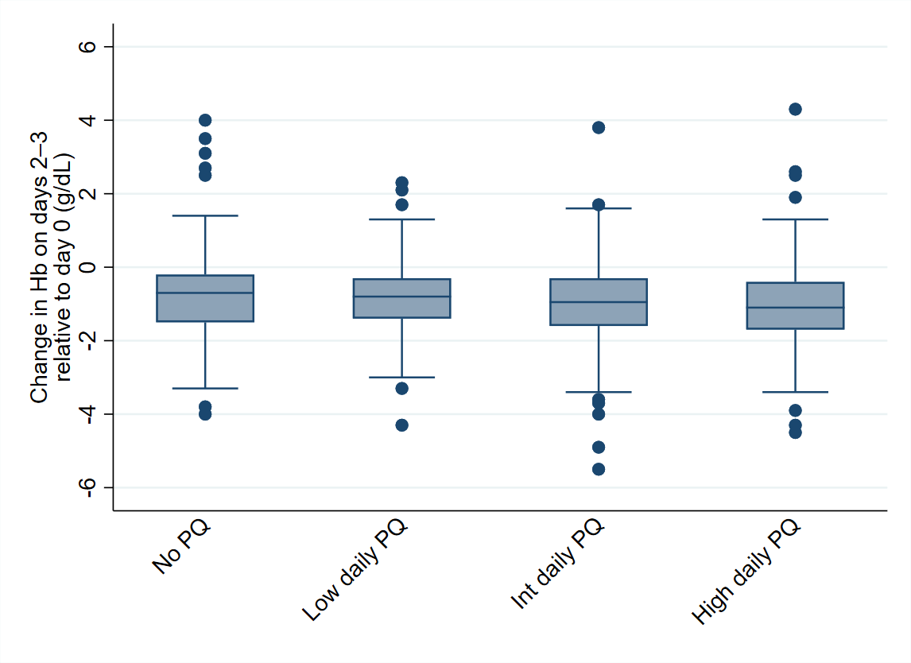
Hb – haemoglobin; PQ - primaquine

