Supplementary Information for

Biobased Plastic: A Plausible Solution to Carbon Neutrality in Plastic Industry

Xiangfei Sun, Eddy Y. Zeng*, Meng-Yi Xie, Xianzhong Song

*Corresponding author. E-mail: eddyzeng@jnu.edu.cn

This PDF file includes:

Materials and Methods
Supplementary Text
Figures S1 to S7
Captions for Data S1 to S3
Captions for Model S1
References

Other Supplementary Materials for this manuscript include the following:

Data S1 to S3 (Excel files)
Model S1 (Python files)

Materials and Methods
Model construction
The fundamental structure of the new LCA model includes two virgin production sectors, three post-use treatment sectors, and one usage phase sector (1). Plastics are first produced from raw materials, and enter the usage phase. After that, plastics are transported into three post treatment sectors according to the allocation matrix. Plastic waste remains in polymer form in the landfill and disposal sector. In incineration sector, plastic waste is burned into carbon dioxide and emits to the atmosphere (2). The recycling sector turns plastic wastes back to plastics and reenters the usage phase. However, 90% of all recycled plastics is only recycled once (3). After that, these recycled plastic waste goes to landfill and disposal sector.
Except usage phase sector, all other sectors generate extra GHG emissions during production process, post treatment process, and transportation process. The GHG emission of production sector and recycling sector are combined with process energy, transportation energy, and process non-energy (4). For incineration sector, the GHG emission mainly comes from plastic combustion (5). The GHG emission of landfill and disposal only includes transportation energy.
For biobased plastic production, an extra carbon flow is created to connect atmosphere and biomass (vegetation) sector, representing carbon dioxide absorb by vegetations (6). During model simulation, only carbon contents which is transformed into plastics is calculated. Other consumption of biomass during production is thought to ultimately decomposed back to carbon dioxide, which offsets the carbon dioxide absorbed from the atmosphere (7).

Additional formula
a. Unit conversion
M_{CO2} = M_{carbon} / 0.273 (1)
where M_{CO2} is the greenhouse gas (GHG) emission in form of Giga ton CO₂ (Gt CO₂).

b. Post treatment sectors
The allocation of plastic wastes is affected by many reasons. In the present study, a low recycling scenario and a high recycling scenario are built based on our best estimations.
$W_{t}^{D}=\sum_{i=1}^{7}{\sum_{j=1}^{8}{W_{i, j}^{t}}*ω_{D}^{t}}$ (2)
$W_{t}^{I}=\sum_{i=1}^{7}{\sum_{j=1}^{8}{W_{i, j}^{t}}*ω_{I}^{t}}$ (3)
$W_{t}^{R}=\sum_{i=1}^{7}{\sum_{j=1}^{8}{W_{i, j}^{t}}*ω_{R}^{t}}$ (4)
$ω_{R}^{t}+ω_{I}^{t}+ω_{D}^{t}=1$ (5)
where $W_{t}^{D}$ represents the number of plastics for landfill and disposal; $W_{t}^{I}$ represents the number of plastics for incineration; $W_{t}^{R}$ represents the number of plastics for recycling; $ω_{D}^{t}$ is the disposal and landfill ratio in tth year; $ω_{I}^{t}$ is the incineration ratio in tth year; $ω_{R}^{t}$ is the recycle ratio in $t$th year. $W_{i, j}^{t}$ is the plastic waste generated in plastic type i with market sector j at year t.

c. Plastics in usage sector
Plastics in usage phase includes virgin plastics and recycled plastics. Moreover, plastics in usage phase are produced in different years. As a result, the number of use phase plastics are calculated as below:
$U_{t}=\sum_{i=1}^{7}{\sum_{j=1}^{8}{\sum_{a=1}^{t}{P_{i,j}^{a}-\left(W_{t}^{I}+W_{t}^{D}-W_{t}^{R}\right)}}}$ (6)
Where U_{t} represents the number of plastics in usage phase at year t.

d. Biobased plastic production and fixed carbon dioxide
According to previous studies, the substitution ratio of bioplastics can reach 90% of total plastic production. Moreover, all plastic types have their biobased version, which means the 1:1 substitution of current plastic types are reasonable. The biobased plastic substitution is present as following forms:
$\left\{\begin{matrix}P_{t}^{bp}=P_{0}^{bp}{(1+ϑ)}^{t-2019}……………(P_{t}^{bp}≤0.9P_{t}) \\ P_{t}^{bp}=0.9P_{t}…………………………(P_{t}^{bp}>0.9P_{t})\end{matrix}\right.$ (7)
where $P_{t}^{bp}$ represents the biobased plastic production at tth year (t > 2019); $P_{0}^{bp}$ is the biobased plastic production by 2019; P_{t} is the virgin plastic production at tth year (t > 2019); ϑ is the substitution rate.

Model boundaries and assumptions
a. The plastic carbon reservoir only accounts carbon in forms of plastics;
b. The natural carbon is considered with in the global carbon cycle until it is converted into plastics；
c. The carbon in biomass (vegetation) is considered to be derived from atmospheric carbon dioxide through photosynthesis (8);
d. For the time being, the model will not specially consider the carbon emissions and losses under different transportation modes and distances;
e. The type, usage and average lifetime of seven plastics under eight usage phases are calculated according to 2015 statistical data acquired from (9).
f. Clean energy (including water, wind, solar, nuclear, and combustion of biomass) is generally considered not to generate additional GHG emissions, and the transmission loss is also ignored.
g. The GHG emission factors of conventional plastic production and post treatment processes are acquired from US EPA, while the emission factors for biobased plastics are calculated by using the estimation of Bölük and Mert, which estimates a 50% reduction during production process (4, 10). However, since the emission factors are combined with process energy, transportation energy, and process non-energy, only process energy is calculated with 50% GHG reduction.

Supplementary Text
Uncertainty analysis
a. Global plastic production
Since 1950, the global plastic production has been growing rapidly and steadily. Due to wide use of plastics, the market demand is strong (11). Therefore, its growth trend is stable in the limited future. However, plastic recycling brings uncertainty to the virgin plastic production (12). To maintain certain number of plastics in usage phase, the increment of recycled plastics, as well as available raw material, will pull down the growth trends of virgin plastics (13). The production trend of high recycling scenario in the present study is just one possible situation for future virgin plastic production. Depending on future technologies for plastic recycling, the global plastic production would certainly vary, which leads to huge differences on the scale of plastic carbon reservoir (9, 11, 14).

b. Plastic recycling
Currently, only PP, HDPE, and PVC could realize recycling systematically (15-17). If no other type of plastics could be recycled in near future. There is an upper boundary for plastic recycling (18). Due to uncertainty on plastic recycling potential and market demands, the estimation of virgin production is just based on the previous records with our best guesses.
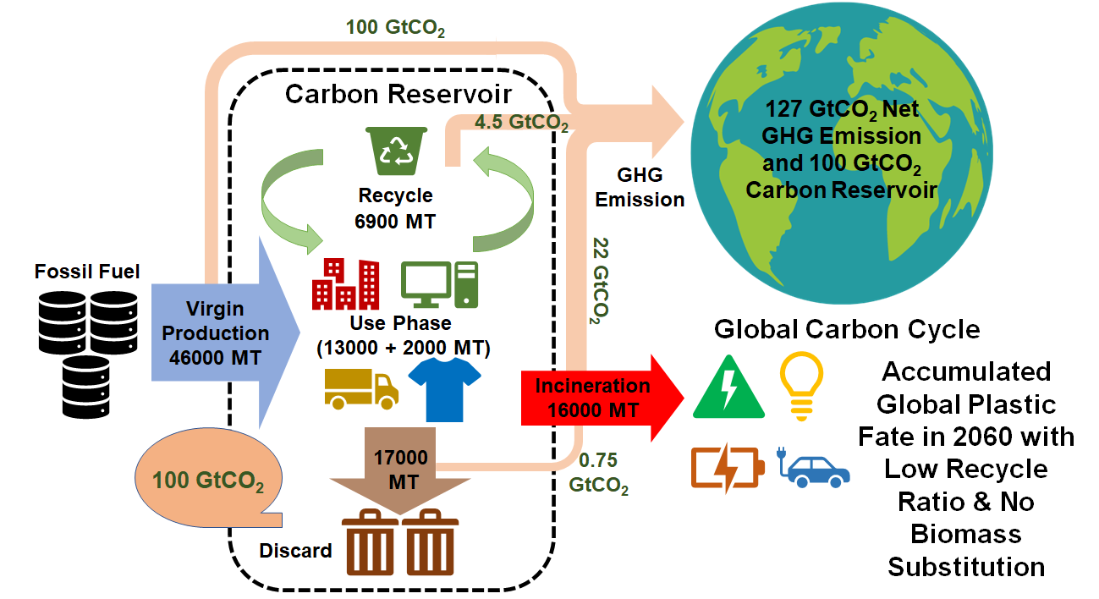
Fig. S1.
Plastic life cycle and net greenhouse gas (GHG) eissions in 2060 (Scenario 1: little biobased plastics substitution with low (22.4%) recycling scenario).
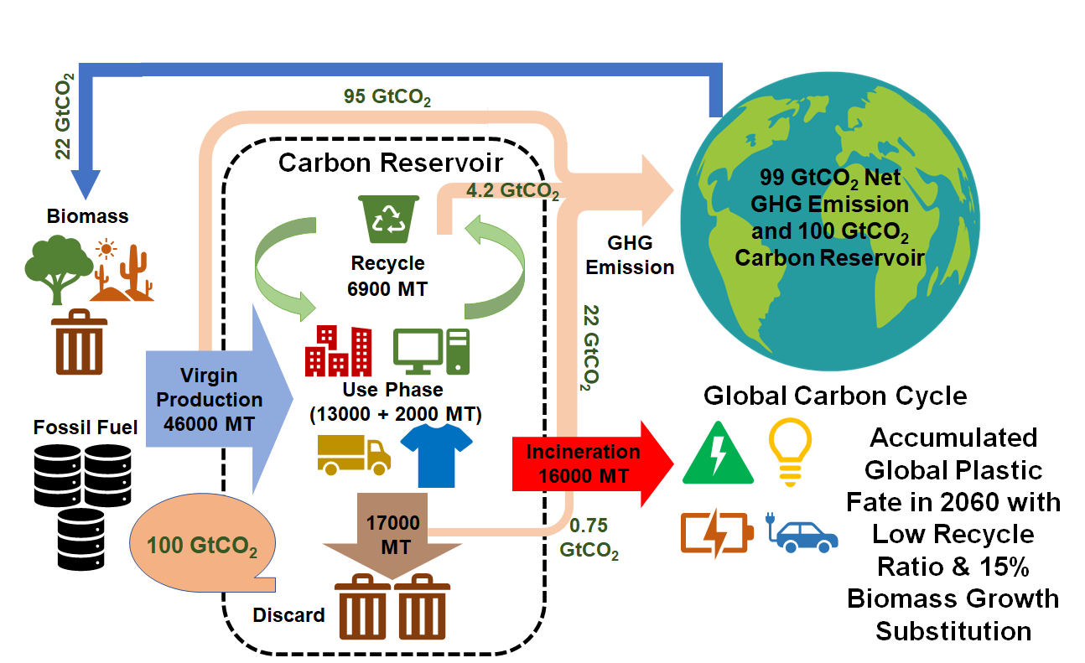
Fig. S2.
Plastic life cycle and net greenhouse gas (GHG) emissions in 2060 (Scenario 2: biobased plastics substitution with low (22.4%) recycling scenario).
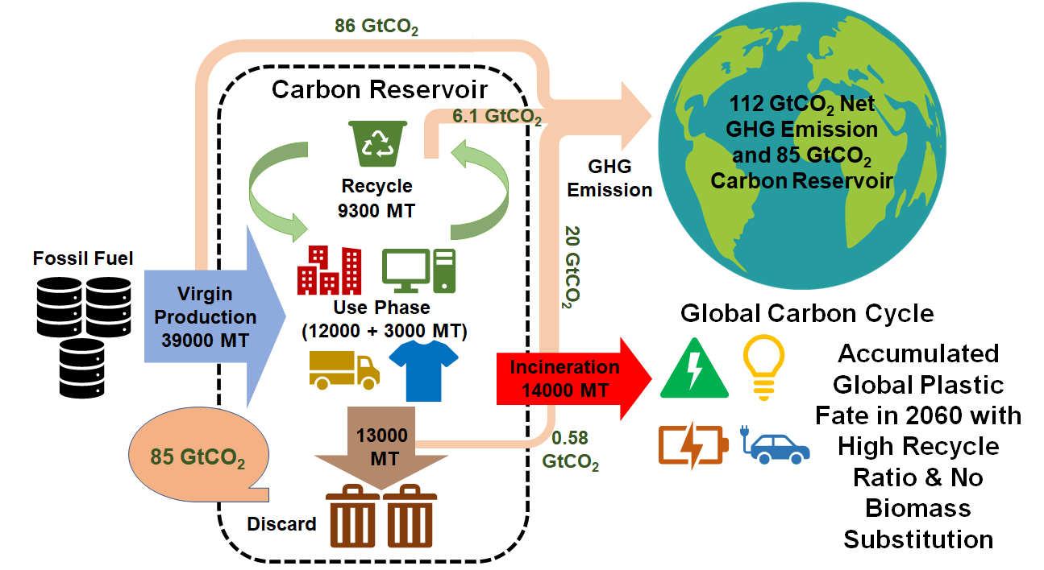
Fig. S3.
Plastic life cycle and net greenhouse gas (GHG) emissions in 2060 (Scenario 3: little biobased plastics substitution with high (49.7%) recycling scenario).
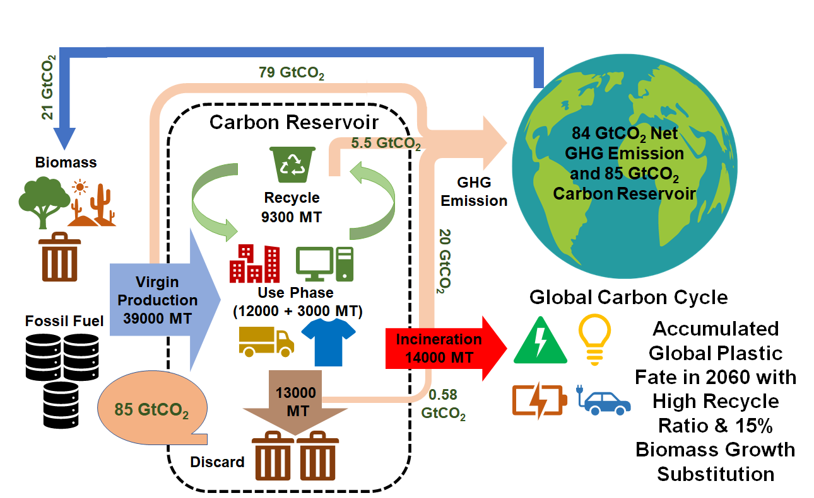
Fig. S4.
Plastic life cycle and net greenhouse gas (GHG) emissions in 2060 (Scenario 4: biobased plastics substitution with high (49.7%) recycling scenario).
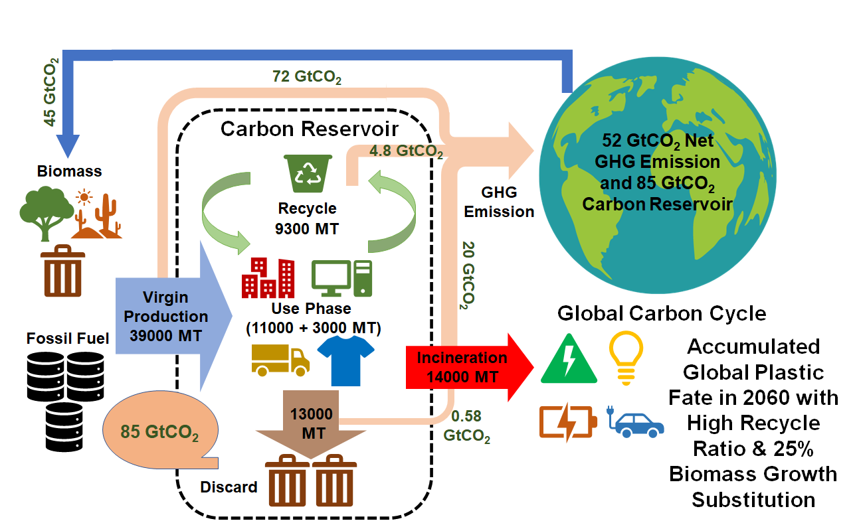
Fig. S5.
Plastic life cycle and net greenhouse gas (GHG) emissions in 2060 (Scenario 5: biobased plastics substitution with high (49.7%) recycling scenario).
Fig. S6.
Annual production of virgin plastics from 1950 to 2019 and projections for 2020–2060 under low (22.4%) and high (49.7%) recycling scenarios.
Fig. S7.
Proportions of natrual carbon and fossil carbon in accumulated plastic production by 2060 under different scenarios.

Data S1. (Excel files)
Calculation Parameters.

Data S2. (Excel files)
Data S2. Global Plastic Production Prediction

Data S3. (Excel files)
Calculation Parameters for Biomass.

Model S1. (Ipynb files)
Plastic_Carbon_Reserve_with_Biomass_Adjusted_Recycle_Waste_Upgrade.

References
1. R. Geyer, in Plastic Waste and Recycling, T. M. Letcher, Ed. (Academic Press, 2020), pp. 13-32.
2. R. H. J. M. Gradus, P. H. L. Nillesen, E. Dijkgraaf, R. J. van Koppen, A Cost-effectiveness Analysis for Incineration or Recycling of Dutch Household Plastic Waste. Ecol. Econ. 135, 22-28 (2017).
3. L. Shen, E. Worrell, M. Patel, Present and future development in plastics from biomass. Biofpr 4, 25-40 (2010).
4. Plastics to EPA's Wast Reduction Model (2015 https://archive.epa.gov/epawaste/conserve/tools/warm/pdfs/Plastics.pdf).
5. S. M. Al-Salem, in Plastics to Energy, S. M. Al-Salem, Ed. (William Andrew Publishing, 2019), pp. 45-64.
6. A. Campeau et al., Current forest carbon fixation fuels stream CO2 emissions. Nat. Commun. 10, 1876 (2019).
7. C. M. T. Johnston, G. Cornelis van Kooten, Back to the past: Burning wood to save the globe. Ecol. Econom. 120, 185-193 (2015).
8. V. Siracusa, I. Blanco, Bio-Polyethylene (Bio-PE), Bio-Polypropylene (Bio-PP) and Bio-Poly(ethylene terephthalate) (Bio-PET): Recent Developments in Bio-Based Polymers Analogous to Petroleum-Derived Ones for Packaging and Engineering Applications. Polymers 12, (2020).
9. R. Geyer, J. R. Jambeck, K. L. Law, Production, use, and fate of all plastics ever made. Sci. Adv. 3, e1700782 (2017).
10. G. Bölük, M. Mert, Fossil & renewable energy consumption, GHGs (greenhouse gases) and economic growth: Evidence from a panel of EU (European Union) countries. Energy 74, 439-446 (2014).
11. D. e. V., M. Düsseldorf., "Plastics – the Facts 2019," (PlasticsEurope, 2019).
12. J. Hopewell, R. Dvorak, E. Kosior, Plastics recycling: challenges and opportunities. Philos. Trans. R. Soc. Lond., B, Biol. Sci. 364, 2115-2126 (2009).
13. S. M. Al-Salem, P. Lettieri, J. Baeyens, Recycling and recovery routes of plastic solid waste (PSW): A review. Waste Manage. 29, 2625-2643 (2009).
14. PlasticsEurope, "Plastics – the Facts 2017," (2018).
15. L. Shen, E. Worrell, in Handbook of Recycling, E. Worrell, M. A. Reuter, Eds. (Elsevier, Boston, 2014), pp. 179-190.
16. C. J. Rhodes, Plastic Pollution and Potential Solutions. Sci. Prog. 101, 207-260 (2018).
17. D. Lazarevic, E. Aoustin, N. Buclet, N. Brandt, Plastic waste management in the context of a European recycling society: Comparing results and uncertainties in a life cycle perspective. Resour. Conserv. Recy. 55, 246-259 (2010).
18. M. K. Eriksen, J. D. Christiansen, A. E. Daugaard, T. F. Astrup, Closing the loop for PET, PE and PP waste from households: Influence of material properties and product design for plastic recycling. Waste Manage. 96, 75-85 (2019).

