A 3D-QSAR-based interaction analysis of Quinazoline derivatives for promising antitumor activity.
Shan He ^{a ‡}, Chen Tang ^{a ‡}, Zhenhua Liu ^{a ‡}, Lingyan Yang ª, Lei Shi
ª, Jiding Liao ^{a,*}and Yunmei Liu ^{a,*}
ª College of Mathematics and Physics, School of Pharmaceutical Science, University of South China，Hengyang City, Hunan Province, 421001, P.R. China
‡ Shan He, Chen Tang and Zhenhua Liu contributed equally to this paper.
⁎Corresponding authors.
E-mail address: lymhsm@126.com
Abstract: Quinazoline compounds have significant scientific implications and can be employed as tyrosine kinase inhibitors to treat cancer. A reasonable three-dimensional quantitative conformational relationship (3D-QSAR) model for quinazoline compounds was constructed using comparative molecular analysis (CoMFA) and comparative molecular similarity index analysis (CoMSIA) methods in order to obtain quinazoline compounds with good anti-tumor activity. The outcomes demonstrate the strong predictability and stability of the CoMFA and CoMSIA models(CoMFA: q²=0.752,r²=0.990,SEE=0.098, F=322.061; CoMSIA: q²=0.748, r²=0.991, SEE=0.095, F=286.959). The anti-tumor activity of the compound is benefited by the presence of large and hydrophilic negatively charged groups at the 6-position substitution site, according to the 3D-QSAR model analysis. The anti-tumor activity of the compound can also be enhanced by the presence of small volume hydrogen bonding receptor groups at the substitution sites of positions 4 and 7. Furthermore, hydrophobicity at position 4 is more beneficial, while hydrophobicity at position 7 is the opposite. The 3D-QSAR research results offer some theoretical groundwork for future structural modifications of quinazoline molecules.
Keywords: Quinazoline; Anti tumor; CoMFA; CoMSIA; 3D-QSAR.

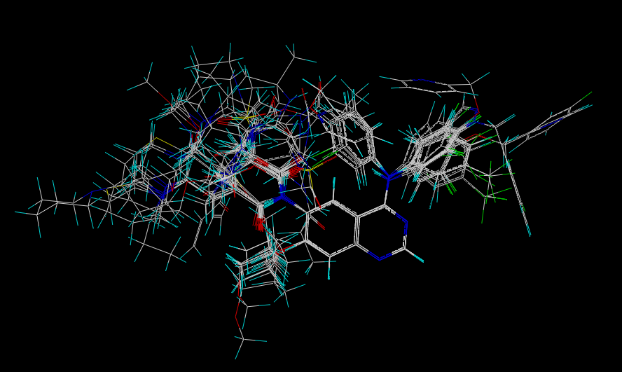
Fig. S1 Alignment of the training set

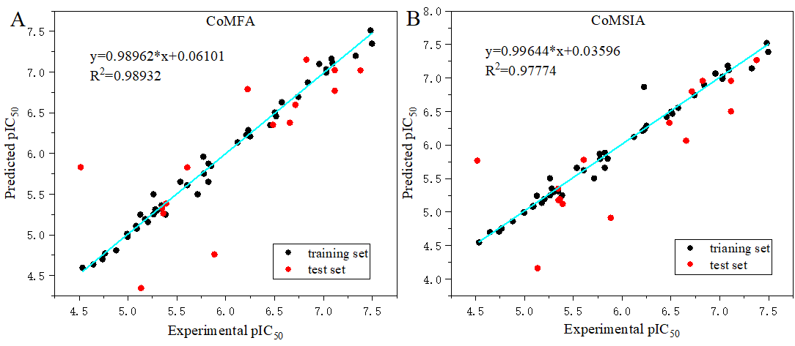
Fig. S2 CoMFA(A), CoMSIA(B) models pIC₅₀ and predicted value correlation ftting diagram

Fig.S3 Isopotential diagrams of steric field (A) and electrostatic field (B) in the CoMSIA model

Fig.S4 Hydrophobic field equipotential diagrams of compounds TKI-47 (A), TKI-45 (B), TKI-52 (C), and TKI-59 (D) in the CoMSIA model

Fig.S5 Isopotential diagrams of hydrogen bond donor fields for compounds TKI-19 (A) and TKI-20 (B) in the CoMSIA model

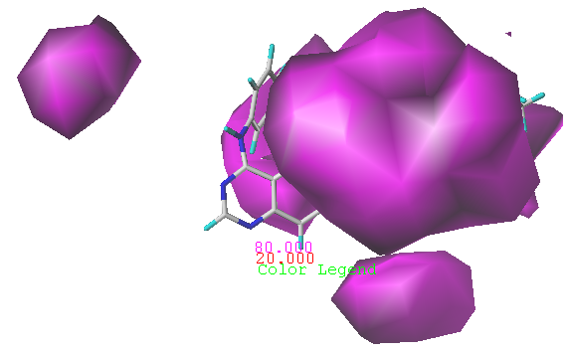
Fig.S6 Isopotential diagram of the hydrogen bond acceptor field based on the CoMSIA model of training set compounds.

Fig.S7 The chemical structure of the target compound

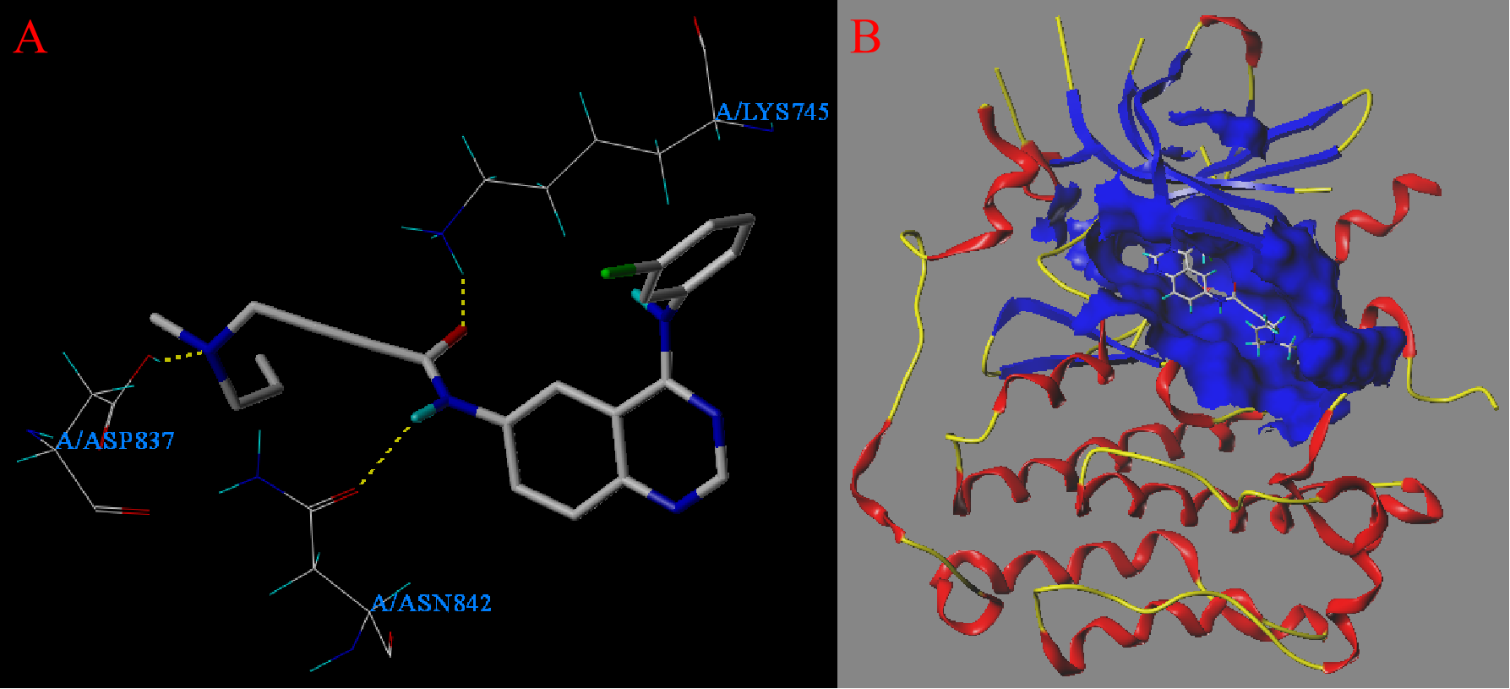
Fig.S8 Active site map (A) and active pocket coverage map (B) of compound 10F docking 3POZ
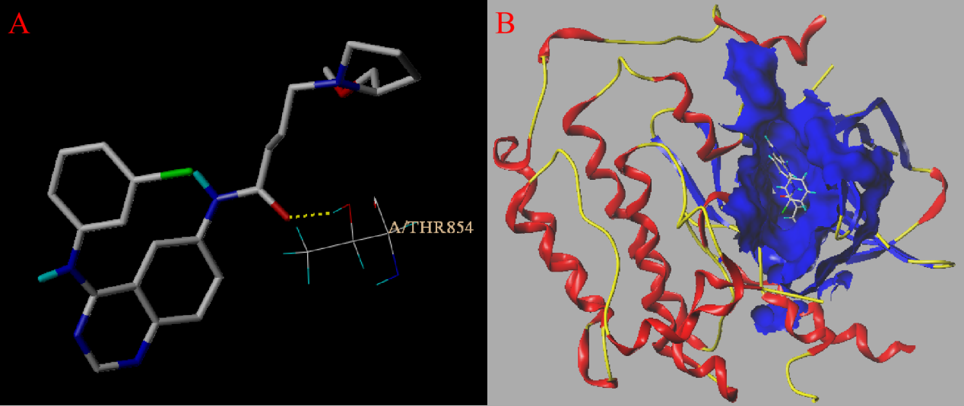
Fig.S9 Active site map (A) and active pocket coverage map (B) of compound 16P docking 3POZ
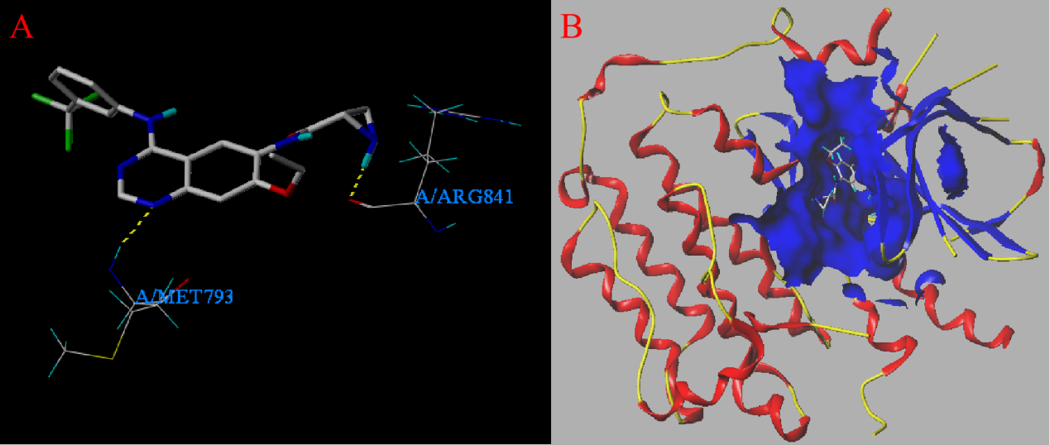
Fig.S10 Active site map (A) and active pocket coverage map (B) of compound TKI-2 docking 3POZ
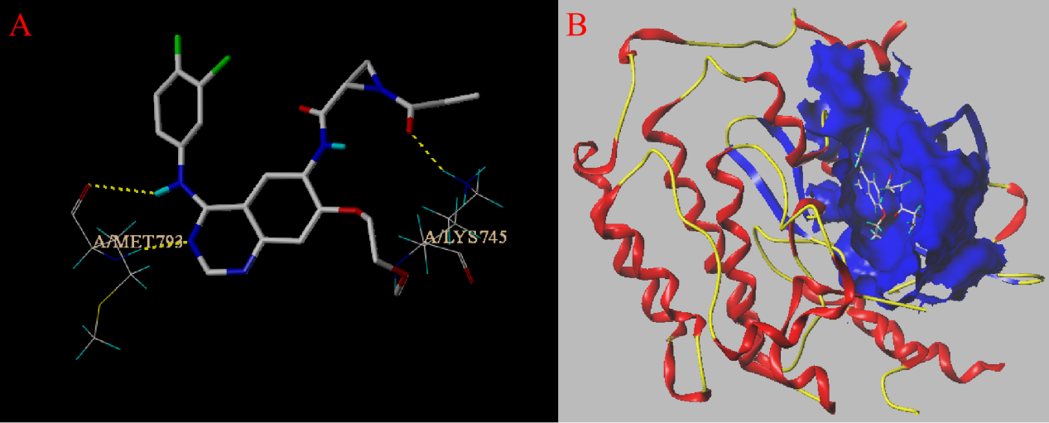
Fig.S11 Active site map (A) and active pocket coverage map (B) of compound TKI-23 docking 3POZ
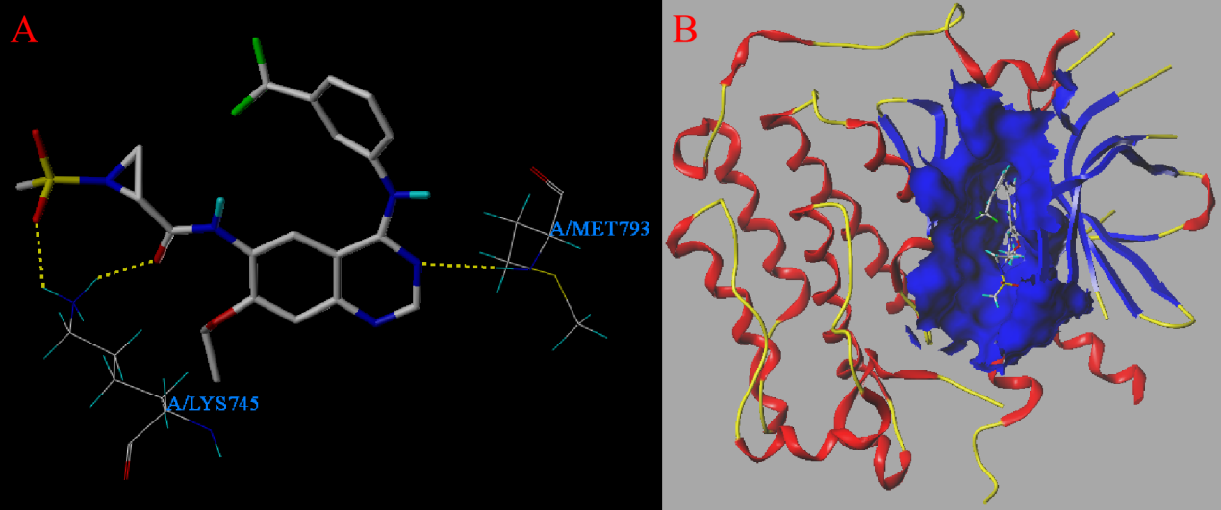
Fig.S12 Active site map (A) and active pocket coverage map (B) of compound TKI-57 docking 3POZ
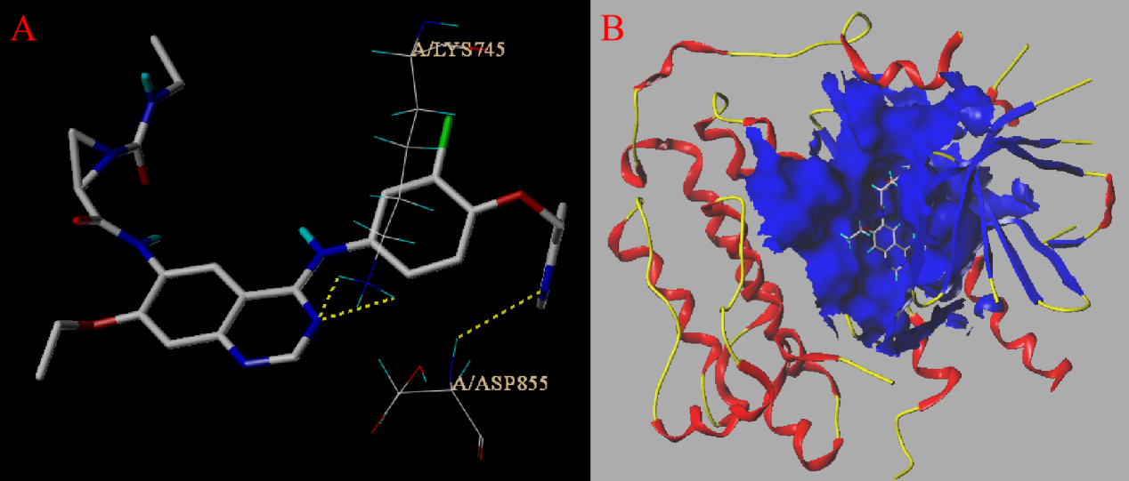
Fig.S13 Active site map (A) and active pocket coverage map (B) of compound TKI-66 docking 3POZ
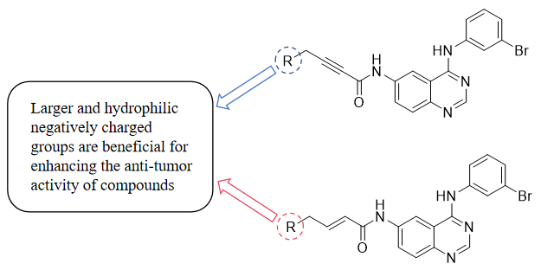
Fig.S14 Analysis of structure-activity relationship of quinazolines compounds
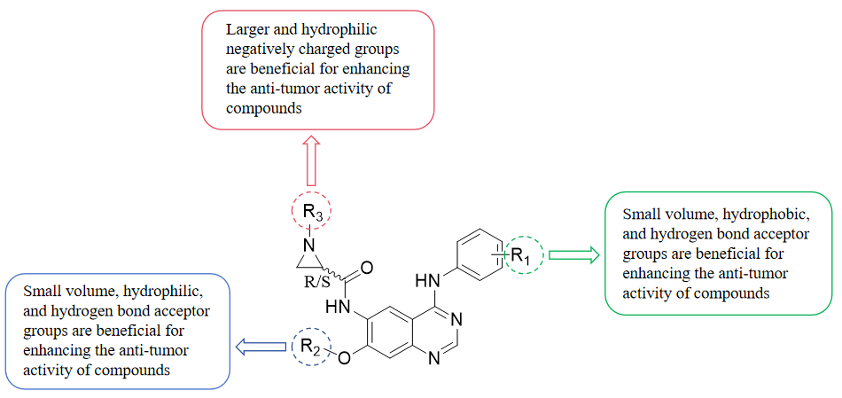
Fig.S15 Structure Activity Relationship Analysis of TKI Series Quinazoline Compounds
Table S1 pIC₅₀ and COMFA model prediction results
NO | name | pIC₅₀ | Pred 1 | Res | NO | name | pIC₅₀ | Pred 1 | Res
01 | 10a | 7.328 | 7.201 | 0.127 | 31 | TKI-8 | 4.740 | 4.699 | 0.041
02 | 10b | 6.955 | 7.099 | -0.144 | 32 | TKI-11 | 5.279 | 5.312 | -0.033
03* | 10c | 7.377 | 7.02 | 0.357 | 33* | TKI-14 | 5.390 | 5.384 | 0.006
04* | 10d | 7.114 | 7.023 | 0.091 | 34 | TKI-19 | 5.775 | 5.752 | 0.023
05 | 10e | 7.027 | 7.033 | -0.006 | 35 | TKI-20 | 5.824 | 5.874 | -0.050
06 | 10f | 7.481 | 7.511 | -0.030 | 36 | TKI-22 | 5.606 | 5.609 | -0.003
07 | 10g | 7.495 | 7.349 | 0.146 | 37 | TKI-23 | 4.997 | 4.974 | 0.023
08* | 10h | 6.824 | 7.152 | -0.328 | 38 | TKI-28 | 5.344 | 5.323 | 0.021
09 | 10i | 7.081 | 7.163 | -0.082 | 39 | TKI-30 | 5.260 | 5.498 | -0.238
10 | 10j | 7.092 | 7.108 | -0.016 | 40 | TKI-33 | 5.535 | 5.65 | -0.115
11* | 10k | 6.223 | 6.789 | -0.566 | 41 | TKI-34 | 5.851 | 5.845 | 0.006
12 | 10l | 6.572 | 6.629 | -0.057 | 42* | TKI-35 | 5.883 | 4.758 | 1.125
13* | 10m | 7.114 | 6.770 | 0.344 | 43 | TKI-36 | 5.821 | 5.65 | 0.171
14 | 10n | 6.514 | 6.456 | 0.058 | 44 | TKI-38 | 5.344 | 5.362 | -0.018
15 | 10o | 6.502 | 6.502 | 0.000 | 45 | TKI-40 | 5.712 | 5.498 | 0.214
16 | 16a | 7.027 | 6.993 | 0.034 | 46* | TKI-44 | 5.606 | 5.828 | -0.222
17* | 16b | 6.712 | 6.597 | 0.115 | 47 | TKI-45 | 5.295 | 5.296 | -0.001
18 | 16c | 6.839 | 6.871 | -0.032 | 48* | TKI-46 | 4.516 | 5.830 | -1.314
19 | 16g | 6.740 | 6.695 | 0.045 | 49 | TKI-47 | 4.534 | 4.594 | -0.060
20 | 16i | 6.230 | 6.285 | -0.055 | 50 | TKI-49 | 5.385 | 5.249 | 0.136
21* | 16j | 6.654 | 6.377 | 0.277 | 51 | TKI-50 | 5.126 | 5.248 | -0.122
22 | 16p | 6.210 | 6.228 | -0.018 | 52 | TKI-52 | 5.082 | 5.109 | -0.027
23 | 16q | 6.249 | 6.209 | 0.040 | 53* | TKI-56 | 5.361 | 5.264 | 0.097
24* | 16r | 6.483 | 6.351 | 0.132 | 54 | TKI-57 | 5.261 | 5.251 | 0.010
25 | 16s | 6.121 | 6.136 | -0.015 | 55 | TKI-59 | 5.203 | 5.157 | 0.046
26 | TKI-1 | 5.770 | 5.959 | -0.189 | 56 | TKI-61 | 5.091 | 5.074 | 0.017
27 | TKI-2 | 4.992 | 5.012 | -0.020 | 57 | TKI-62 | 4.646 | 4.635 | 0.011
Table S1(continued)
NO | name | pIC₅₀ | Pred 1 | Res | NO | name | pIC₅₀ | Pred 1 | Res
28* | TKI-4 | 5.133 | 4.344 | 0.789 | 58 | TKI-64 | 5.176 | 5.192 | -0.016
29 | TKI-5 | 4.879 | 4.808 | 0.071 | 59* | TKI-65 | 5.347 | 5.327 | 0.020
30 | TKI-7 | 6.456 | 6.347 | 0.109 | 60 | TKI-66 | 4.766 | 4.771 | -0.005
*Compounds in the test set;pIC₅₀:experimental value;Pred 1:predicted value;Res=pIC₅₀-Pred 1.

Table S2 pIC₅₀ and COMISA model prediction results
NO | name | pIC₅₀ | Pred 2 | Res | NO | name | pIC₅₀ | Pred 2 | Res
01 | 10a | 7.328 | 7.143 | 0.185 | 31 | TKI-8 | 4.740 | 4.709 | 0.031
02 | 10b | 6.955 | 7.067 | -0.112 | 32 | TKI-11 | 5.279 | 5.35 | -0.071
03* | 10c | 7.377 | 7.268 | 0.109 | 33* | TKI-14 | 5.390 | 5.121 | 0.269
04* | 10d | 7.114 | 6.957 | 0.157 | 34 | TKI-19 | 5.775 | 5.792 | -0.017
05 | 10e | 7.027 | 7.02 | 0.007 | 35 | TKI-20 | 5.824 | 5.884 | -0.060
06 | 10f | 7.481 | 7.521 | -0.040 | 36 | TKI-22 | 5.606 | 5.622 | -0.016
07 | 10g | 7.495 | 7.389 | 0.106 | 37 | TKI-23 | 4.997 | 4.99 | 0.007
08* | 10h | 6.824 | 6.957 | -0.133 | 38 | TKI-28 | 5.344 | 5.348 | -0.004
09 | 10i | 7.081 | 7.183 | -0.102 | 39 | TKI-30 | 5.260 | 5.503 | -0.243
10 | 10j | 7.092 | 7.119 | -0.027 | 40 | TKI-33 | 5.535 | 5.659 | -0.124
11* | 10k | 6.223 | 6.866 | -0.643 | 41 | TKI-34 | 5.851 | 5.796 | 0.055
12 | 10l | 6.572 | 6.554 | 0.018 | 42* | TKI-35 | 5.883 | 4.913 | 0.970
13* | 10m | 7.114 | 6.502 | 0.612 | 43 | TKI-36 | 5.821 | 5.66 | 0.161
14 | 10n | 6.514 | 6.468 | 0.046 | 44 | TKI-38 | 5.344 | 5.31 | 0.034
15 | 10o | 6.502 | 6.497 | 0.005 | 45 | TKI-40 | 5.712 | 5.501 | 0.211
16 | 16a | 7.027 | 6.989 | 0.038 | 46* | TKI-44 | 5.606 | 5.778 | -0.172
17* | 16b | 6.712 | 6.800 | -0.088 | 47 | TKI-45 | 5.295 | 5.296 | -0.001
18 | 16c | 6.839 | 6.896 | -0.057 | 48* | TKI-46 | 4.516 | 5.767 | -1.251
19 | 16g | 6.740 | 6.743 | -0.003 | 49 | TKI-47 | 4.534 | 4.546 | -0.012
20 | 16i | 6.230 | 6.235 | -0.005 | 50 | TKI-49 | 5.385 | 5.248 | 0.137
21* | 16j | 6.654 | 6.064 | 0.590 | 51 | TKI-50 | 5.126 | 5.241 | -0.115
22 | 16p | 6.210 | 6.211 | -0.001 | 52 | TKI-52 | 5.082 | 5.078 | 0.004
23 | 16q | 6.249 | 6.288 | -0.039 | 53* | TKI-56 | 5.361 | 5.193 | 0.168
24* | 16r | 6.483 | 6.331 | 0.152 | 54 | TKI-57 | 5.261 | 5.248 | 0.013
25 | 16s | 6.121 | 6.12 | 0.001 | 55 | TKI-59 | 5.203 | 5.196 | 0.007
26 | TKI-1 | 5.770 | 5.869 | -0.099 | 56 | TKI-61 | 5.091 | 5.09 | 0.001
27 | TKI-2 | 4.992 | 4.995 | -0.003 | 57 | TKI-62 | 4.646 | 4.699 | -0.053
Table S2(continued)
NO | name | pIC₅₀ | Pred 2 | Res | NO | name | pIC₅₀ | Pred 2 | Res
28* | TKI-4 | 5.133 | 4.16 | 0.973 | 58 | TKI-64 | 5.176 | 5.137 | 0.039
29 | TKI-5 | 4.879 | 4.863 | 0.016 | 59* | TKI-65 | 5.347 | 5.176 | 0.171
30 | TKI-7 | 6.456 | 6.42 | 0.036 | 60 | TKI-66 | 4.766 | 4.755 | 0.011
*Compounds in the test set;pIC₅₀:experimental value;Pred 2:predicted value;Res=pIC₅₀-Pred 2.

Table S3 Scoring results for the molecular docking of all the compounds
Name | Total-score | CSCORE | Name | Total-score | CSCORE
10a | 4.66 | 4 | TKI-8 | 7.73 | 5
10b | 5.47 | 5 | TKI-11 | 6.19 | 5
10c | 8.46 | 4 | TKI-14 | 7.54 | 5
10d | 7.68 | 5 | TKI-19 | 4.72 | 5
10e | 6.88 | 5 | TKI-20 | 6.03 | 4
10f | 7.37 | 4 | TKI-22 | 7.42 | 3
10g | 6.85 | 5 | TKI-23 | 8.56 | 5
10h | 8.29 | 4 | TKI-28 | 6.24 | 3
10i | 5.97 | 5 | TKI-30 | 5.08 | 5
10j | 8.13 | 4 | TKI-33 | 5.04 | 4
10k | 7.48 | 4 | TKI-34 | 5.41 | 4
10l | 7.82 | 5 | TKI-35 | 3.56 | 2
10m | 6.27 | 5 | TKI-36 | 4.49 | 5
10n | 8.27 | 5 | TKI-38 | 6.66 | 5
10o | 6.15 | 3 | TKI-40 | 2.80 | 3
16a | 5.63 | 5 | TKI-44 | 5.65 | 5
16b | 6.76 | 5 | TKI-45 | 4.89 | 5
16c | 6.17 | 4 | TKI-46 | 5.98 | 5
16g | 7.77 | 4 | TKI-47 | 6.51 | 3
16i | 5.69 | 5 | TKI-49 | 7.45 | 5
16j | 6.00 | 5 | TKI-50 | 8.75 | 4
16p | 7.39 | 4 | TKI-52 | 6.05 | 5
16q | 6.17 | 4 | TKI-56 | 5.56 | 5
16r | 6.46 | 5 | TKI-57 | 6.20 | 5
16s | 6.85 | 4 | TKI-59 | 4.30 | 5
TKI-1 | 4.56 | 4 | TKI-61 | 6.52 | 4
TKI-2 | 9.10 | 4 | TKI-62 | 5.10 | 3

Table S3(continued)
Name | Total-score | CSCORE | Name | Total-score | CSCORE
TKI-4 | 6.16 | 5 | TKI-64 | 4.55 | 4
TKI-5 | 6.13 | 4 | TKI-65 | 3.27 | 5
TKI-7 | 4.32 | 3 | TKI-66 | 6.95 | 5

Table S4 Physicochemical and drug-likeness properties prediction of compounds using swissAdme
Name | MW  (g/mol) | HBA | HBD | NRB | TBSA  (A²) | LogP | Xlogp | LogS  (ESOL) | Lipinski’s  rule violations | Ghose’s  rule violations | Veber’s rule | Egan’s rule | Muegge’s rule
10a | 424.29 | 4 | 2 | 5 | 70.15 | 3.28 | 3.75 | -4.94 | 0 | 0 | 0 | 0 | 0
10b | 452.35 | 4 | 2 | 7 | 70.15 | 3.86 | 4.48 | -5.41 | 0 | 0 | 0 | 0 | 0
10c | 480.40 | 4 | 2 | 9 | 70.15 | 4.61 | 5.53 | -6.09 | 0 | 2 | 0 | 0 | 1
10d | 452.35 | 4 | 2 | 6 | 70.15 | 3.91 | 4.55 | -5.52 | 0 | 0 | 0 | 0 | 0
10e | 480.40 | 4 | 2 | 7 | 70.15 | 4.47 | 5.35 | -6.11 | 0 | 2 | 0 | 0 | 1
10f | 450.33 | 4 | 2 | 7 | 70.15 | 3.85 | 4.39 | -5.34 | 0 | 0 | 0 | 0 | 0
10g | 464.36 | 4 | 2 | 5 | 70.15 | 3.95 | 4.59 | -5.68 | 0 | 0 | 0 | 0 | 0
10h | 466.33 | 5 | 2 | 5 | 79.38 | 3.09 | 3.37 | -4.92 | 0 | 0 | 0 | 0 | 0
10i | 482.40 | 4 | 2 | 5 | 95.45 | 3.65 | 4.17 | -5.52 | 0 | 2 | 0 | 0 | 0
10j | 494.38 | 5 | 2 | 7 | 79.38 | 3.69 | 4.15 | -5.43 | 0 | 2 | 0 | 0 | 0
10k | 493.40 | 5 | 2 | 6 | 73.39 | 3.39 | 3.92 | -5.34 | 0 | 2 | 0 | 0 | 0
10l | 411.25 | 4 | 2 | 5 | 76.14 | 3.25 | 3.56 | -4.76 | 0 | 0 | 0 | 0 | 0
10m | 455.30 | 5 | 2 | 8 | 85.37 | 3.27 | 3.41 | -4.69 | 0 | 0 | 0 | 0 | 0
10n | 441.28 | 5 | 2 | 7 | 85.37 | 3.19 | 3.51 | -4.75 | 0 | 0 | 0 | 0 | 0
Table S4(continued)
Name | MW  (g/mol) | HBA | HBD | NRB | TBSA  (A²) | LogP | Xlogp | LogS  (ESOL) | Lipinski’s  rule violations | Ghose’s  rule violations | Veber’s rule | Egan’s rule | Muegge’s rule
10o | 397.23 | 4 | 3 | 4 | 87.14 | 2.70 | 3.02 | -4.41 | 0 | 0 | 0 | 0 | 0
16a | 426.31 | 4 | 2 | 7 | 70.15 | 3.41 | 3.58 | -4.72 | 0 | 0 | 0 | 0 | 0
16b | 452.36 | 4 | 2 | 9 | 70.15 | 4.01 | 4.31 | -5.19 | 0 | 0 | 0 | 0 | 0
16c | 482.42 | 4 | 2 | 11 | 70.15 | 4.76 | 5.37 | -5.87 | 0 | 2 | 1 | 0 | 1
16g | 466.37 | 4 | 2 | 7 | 70.15 | 4.07 | 4.42 | -5.45 | 0 | 0 | 0 | 0 | 0
16i | 484.41 | 4 | 2 | 7 | 95.45 | 3.76 | 4.00 | -5.30 | 0 | 2 | 0 | 0 | 0
16j | 496.40 | 5 | 2 | 9 | 79.38 | 3.81 | 3.98 | -5.20 | 0 | 2 | 0 | 0 | 0
16p | 496.40 | 5 | 2 | 9 | 79.38 | 3.84 | 3.98 | -5.20 | 0 | 2 | 0 | 0 | 0
16q | 470.36 | 5 | 2 | 10 | 79.38 | 3.39 | 3.43 | -4.65 | 0 | 0 | 0 | 0 | 0
16r | 456.34 | 5 | 3 | 9 | 90.38 | 2.98 | 2.89 | -4.30 | 0 | 0 | 0 | 0 | 0
16s | 549.51 | 5 | 2 | 8 | 73.39 | 4.42 | 5.01 | -6.20 | 1 | 2 | 0 | 0 | 1
TKI-1 | 387.80 | 6 | 3 | 6 | 98.08 | 2.87 | 2.70 | -3.99 | 0 | 0 | 0 | 0 | 0
TKI-2 | 417.38 | 8 | 3 | 8 | 98.08 | 3.36 | 3.22 | -4.32 | 0 | 0 | 0 | 0 | 0
TKI-4 | 490.94 | 7 | 3 | 10 | 120.20 | 3.41 | 3.40 | -4.83 | 0 | 2 | 0 | 0 | 0
Table S4(continued)
Name | MW  (g/mol) | HBA | HBD | NRB | TBSA  (A²) | LogP | Xlogp | LogS  (ESOL) | Lipinski’s  rule violations | Ghose’s  rule violations | Veber’s rule | Egan’s rule | Muegge’s rule
TKI-5 | 507.94 | 7 | 3 | 10 | 107.31 | 4.41 | 4.53 | -5.64 | 1 | 2 | 0 | 0 | 0
TKI-7 | 387.80 | 6 | 3 | 6 | 98.08 | 2.87 | 2.70 | -3.99 | 0 | 0 | 0 | 0 | 0
TKI-8 | 490.94 | 7 | 3 | 10 | 120.20 | 3.41 | 3.40 | -4.83 | 0 | 2 | 0 | 0 | 0
TKI-11 | 417.38 | 8 | 3 | 8 | 98.08 | 3.36 | 3.22 | -4.32 | 0 | 0 | 0 | 0 | 0
TKI-14 | 507.94 | 7 | 3 | 10 | 107.31 | 4.41 | 4.53 | -5.64 | 1 | 2 | 0 | 0 | 0
TKI-19 | 429.83 | 6 | 2 | 7 | 96.22 | 2.78 | 2.63 | -4.09 | 0 | 0 | 0 | 0 | 0
TKI-20 | 441.84 | 6 | 2 | 8 | 96.22 | 3.08 | 3.22 | -4.46 | 0 | 0 | 0 | 0 | 0
TKI-22 | 499.92 | 7 | 2 | 9 | 105.45 | 3.23 | 3.15 | -4.67 | 0 | 2 | 0 | 0 | 0
TKI-23 | 487.91 | 7 | 2 | 11 | 105.45 | 3.21 | 2.95 | -4.35 | 0 | 1 | 1 | 0 | 0
TKI-28 | 471.43 | 8 | 2 | 10 | 96.22 | 3.58 | 3.74 | -4.81 | 0 | 0 | 0 | 0 | 0
TKI-30 | 544.99 | 7 | 2 | 11 | 118.34 | 3.64 | 3.92 | -5.31 | 1 | 2 | 1 | 0 | 0
TKI-33 | 443.86 | 6 | 2 | 8 | 96.22 | 3.10 | 3.10 | -4.40 | 0 | 0 | 0 | 0 | 0
TKI-34 | 429.83 | 6 | 2 | 7 | 96.22 | 2.78 | 2.63 | -4.09 | 0 | 0 | 0 | 0 | 0
TKI-35 | 441.84 | 6 | 2 | 8 | 96.22 | 3.14 | 3.22 | -4.46 | 0 | 0 | 0 | 0 | 0
TKI-36 | 443.86 | 6 | 2 | 8 | 96.22 | 3.10 | 3.10 | -4.40 | 0 | 0 | 0 | 0 | 0
Table S4(continued)
Name | MW  (g/mol) | HBA | HBD | NRB | TBSA  (A²) | LogP | Xlogp | LogS  (ESOL) | Lipinski’s  rule violations | Ghose’s  rule violations | Veber’s rule | Egan’s rule | Muegge’s rule
TKI-38 | 471.43 | 8 | 2 | 10 | 96.22 | 3.58 | 3.74 | -4.81 | 0 | 0 | 0 | 0 | 0
TKI-40 | 544.99 | 7 | 2 | 12 | 118.34 | 3.63 | 3.92 | -5.31 | 1 | 2 | 1 | 0 | 0
TKI-44 | 499.92 | 7 | 2 | 9 | 105.45 | 3.28 | 3.15 | -4.67 | 0 | 2 | 0 | 0 | 0
TKI-45 | 487.91 | 7 | 2 | 11 | 105.45 | 3.21 | 2.95 | -4.35 | 0 | 1 | 1 | 0 | 0
TKI-46 | 407.42 | 6 | 2 | 8 | 105.45 | 1.98 | 1.87 | -3.41 | 0 | 0 | 0 | 0 | 0
TKI-47 | 407.42 | 6 | 2 | 8 | 105.45 | 2.00 | 1.87 | -3.41 | 0 | 0 | 0 | 0 | 0
TKI-49 | 539.56 | 7 | 2 | 10 | 114.04 | 3.55 | 3.61 | -5.26 | 1 | 2 | 0 | 0 | 0
TKI-50 | 539.56 | 7 | 2 | 10 | 114.04 | 3.59 | 3.61 | -5.26 | 1 | 2 | 0 | 0 | 0
TKI-52 | 465.89 | 8 | 2 | 7 | 121.67 | 2.41 | 2.42 | -4.17 | 0 | 0 | 0 | 0 | 0
TKI-56 | 495.47 | 10 | 2 | 9 | 121.67 | 2.86 | 2.94 | -4.52 | 0 | 1 | 0 | 0 | 0
TKI-57 | 495.47 | 10 | 2 | 9 | 121.67 | 2.86 | 2.94 | -4.52 | 0 | 1 | 0 | 0 | 0
TKI-59 | 465.89 | 8 | 2 | 7 | 121.67 | 2.36 | 2.42 | -4.17 | 0 | 0 | 0 | 0 | 0
TKI-61 | 458.87 | 6 | 3 | 9 | 108.25 | 2.93 | 2.82 | -4.24 | 0 | 0 | 0 | 0 | 0
TKI-62 | 506.92 | 6 | 3 | 9 | 108.25 | 3.61 | 4.01 | -5.37 | 1 | 2 | 0 | 0 | 0
TKI-64 | 486.93 | 6 | 3 | 9 | 107.25 | 3.42 | 3.44 | -4.78 | 0 | 2 | 0 | 0 | 0
Table S4(continued)
Name | MW  (g/mol) | HBA | HBD | NRB | TBSA  (A²) | LogP | Xlogp | LogS  (ESOL) | Lipinski’s  rule violations | Ghose’s  rule violations | Veber’s rule | Egan’s rule | Muegge’s rule
TKI-65 | 458.87 | 6 | 3 | 9 | 108.25 | 2.93 | 2.82 | -4.24 | 0 | 0 | 0 | 0 | 0
TKI-66 | 562.02 | 7 | 3 | 13 | 130.37 | 3.40 | 3.52 | -5.09 | 2 | 2 | 1 | 0 | 0
LogP: The consensus value of iLogP, XLogP3, WLogP, MLogP and LogP (SILICOS-IT)
LogS scale: Insoluble < − 10 < Poorly soluble < − 6 < Moderately soluble < − 4 < Soluble < − 2 < Very soluble < 0 < Highly soluble
Muegge’s rule: 200 ≤ MW ≤ 600, − 2 ≤ XLogP ≤ 5, TPSA ≤ 150; # of rings ≤ 7, # of carbons > 4, # of heteroatoms > 1, NRB ≤ 15, HBA ≤ 10 and HBA ≤ 5
Ghose’s rule: 160 ≤ MW ≤ 480, − 0.4 ≤ WLogP ≤ 5.6, 40 ≤ Molar Refractivity (MR) ≤ 130 and 20 ≤ Atoms ≤ 70
Veber’s rule: NRB ≤ 10 and TPSA ≤ 140
Egan’s rule: WLogP ≤ 5.88 and TPSA ≤ 131.6

Table S5The pharmacokinetics and toxicity of 10 series compounds were predicted using PKCSM
Name |  | 10a | 10b | 10c | 10d | 10e | 10f | 10g | 10h | 10i | 10j | 10k | 10l | 10m | 10n | 10o
Absorption | CaCo-2 Permeability(Log unit) | -4.6 | -4.76 | -4.73 | -4.79 | -4.86 | -4.79 | -4.81 | -4.62 | -4.99 | -4.84 | -4.94 | -4.52 | -4.6 | -4.59 | -4.75
Absorption | HIA | 0.936 | 0.934 | 0.918 | 0.921 | 0.881 | 0.913 | 0.969 | 0.947 | 0.949 | 0.942 | 0.882 | 0.96 | 0.921 | 0.935 | 0.975
Distribution | BBB Penetration | 0.837 | 0.301 | 0.76 | 0.9 | 0.938 | 0.99 | 0.984 | 0.98 | 0.967 | 0.796 | 0.957 | 0.901 | 0.781 | 0.869 | 0.799
Distribution | PPB(%) | 91.65 | 96.58 | 94.62 | 93.56 | 91.71 | 91.31 | 99.08 | 98.58 | 94.99 | 95.98 | 99.06 | 98.3 | 94.47 | 93.87 | 94.59
Metaboliam | CYP1A2 inhibitor | 0.984 | 0.997 | 0.997 | 0.996 | 0.995 | 0.997 | 0.975 | 0.969 | 0.991 | 0.934 | 0.918 | 0.998 | 0.992 | 0.991 | 0.999
Metaboliam | CYP1A2 substrate | 0.294 | 0.264 | 0.241 | 0.254 | 0.21 | 0.247 | 0.244 | 0.234 | 0.263 | 0.272 | 0.382 | 0.259 | 0.254 | 0.224 | 0.158
Metaboliam | CYP2C19 inhibitor | 0.682 | 0.895 | 0.928 | 0.854 | 0.774 | 0.795 | 0.889 | 0.689 | 0.868 | 0.786 | 0.297 | 0.87 | 0.776 | 0.812 | 0.895
Metaboliam | CYP2C19 substrate | 0.602 | 0.579 | 0.58 | 0.596 | 0.585 | 0.611 | 0.538 | 0.538 | 0.612 | 0.558 | 0.614 | 0.547 | 0.497 | 0.507 | 0.52
Metaboliam | CYP2C9 inhibitor | 0.036 | 0.296 | 0.098 | 0.398 | 0.114 | 0.351 | 0.036 | 0.232 | 0.374 | 0.39 | 0.085 | 0.577 | 0.675 | 0.435 | 0.42
Metaboliam | CYP2C9 substrate | 0.292 | 0.225 | 0.116 | 0.252 | 0.182 | 0.32 | 0.013 | 0.001 | 0.384 | 0.128 | 0.078 | 0.711 | 0.286 | 0.505 | 0.569
Metaboliam | CYP2D6 inhibitor | 0.229 | 0.035 | 0.756 | 0.558 | 0.365 | 0.968 | 0.791 | 0.072 | 0.539 | 0.468 | 0.009 | 0.074 | 0.041 | 0.065 | 0.116
Metaboliam | CYP2D6 substrate | 0.365 | 0.352 | 0.365 | 0.392 | 0.406 | 0.356 | 0.376 | 0.388 | 0.345 | 0.379 | 0.355 | 0.352 | 0.379 | 0.358 | 0.345
Metaboliam | CYP3A4 inhibitor | 0.582 | 0.623 | 0.704 | 0.542 | 0.543 | 0.867 | 0.697 | 0.836 | 0.809 | 0.879 | 0.788 | 0.899 | 0.898 | 0.916 | 0.848
Metaboliam | CYP3A4 substrate | 0.725 | 0.761 | 0.844 | 0.816 | 0.904 | 0.778 | 0.566 | 0.566 | 0.725 | 0.882 | 0.988 | 0.539 | 0.781 | 0.631 | 0.337
Table S5(continued)
Name |  | 10a | 10b | 10c | 10d | 10e | 10f | 10g | 10h | 10i | 10j | 10k | 10l | 10m | 10n | 10o
Excretion | Clearance(ml/min/kg) | 7.03 | 5.93 | 5.91 | 7.62 | 8.14 | 7.21 | 5.77 | 5.72 | 7.52 | 7.54 | 6.35 | 6.49 | 7.03 | 6.83 | 5.41
Excretion | Half-life(h) | <3 | <3 | <3 | <3 | < 3 | < 3 | < 3 | < 3 | < 3 | < 3 | < 3 | < 3 | < 3 | < 3 | < 3
Toxicity | AMES Toxicity | 0.009 | 0.105 | 0.025 | 0.046 | 0.102 | 0.003 | 0.003 | 0.015 | 0.011 | 0.008 | 0.025 | 0.203 | 0.186 | 0.305 | 0.038
Toxicity | Carcinogenicity | 0.251 | 0.191 | 0.143 | 0.154 | 0.101 | 0.197 | 0.119 | 0.316 | 0.277 | 0.099 | 0.084 | 0.236 | 0.192 | 0.218 | 0.34
Toxicity | hERG Blockers | 0.964 | 0.973 | 0.978 | 0.966 | 0.982 | 0.916 | 0.928 | 0.654 | 0.574 | 0.974 | 0.895 | 0.634 | 0.732 | 0.632 | 0.295

Table S6 The pharmacokinetics and toxicity of 16 series compounds were predicted using PkCSM
Name |  | 16a | 16b | 16c | 16g | 16i | 16j | 16p | 16q | 16r | 16s
Absorption | CaCo-2 Permeability(Log unit) | -4.62 | -4.81 | -4.78 | -4.87 | -5.08 | -4.91 | -4.86 | -4.93 | -5.21 | -5.46
Absorption | HIA | 0.929 | 0.935 | 0.935 | 0.977 | 0.959 | 0.954 | 0.952 | 0.9 | 0.893 | 0.942
Distribution | BBB Penetration | 0.995 | 0.881 | 0.987 | 0.999 | 0.999 | 0.993 | 0.99 | 0.968 | 0.81 | 0.999
Distribution | PPB(%) | 82.93 | 90.66 | 89.27 | 95.04 | 90.66 | 92.56 | 92.47 | 81.8 | 83.01 | 96.12
Metaboliam | CYP1A2 inhibitor | 0.932 | 0.935 | 0.982 | 0.909 | 0.959 | 0.694 | 0.692 | 0.929 | 0.97 | 0.144
Metaboliam | CYP1A2 substrate | 0.274 | 0.256 | 0.217 | 0.219 | 0.239 | 0.251 | 0.256 | 0.287 | 0.174 | 0.176
Metaboliam | CYP2C19 inhibitor | 0.763 | 0.856 | 0.972 | 0.957 | 0.99 | 0.981 | 0.959 | 0.97 | 0.869 | 0.822
Metaboliam | CYP2C19 substrate | 0.516 | 0.512 | 0.526 | 0.487 | 0.555 | 0.505 | 0.507 | 0.495 | 0.468 | 0.459
Metaboliam | CYP2C9 inhibitor | 0.182 | 0.277 | 0.265 | 0.134 | 0.751 | 0.719 | 0.678 | 0.131 | 0.728 | 0.019
Metaboliam | CYP2C9 substrate | 0.239 | 0.151 | 0.051 | 0.005 | 0.2 | 0.066 | 0.066 | 0.354 | 0.243 | 0
Metaboliam | CYP2D6 inhibitor | 0.911 | 0.054 | 0.848 | 0.932 | 0.783 | 0.805 | 0.652 | 0.9 | 0.292 | 0.991
Metaboliam | CYP2D6 substrate | 0.373 | 0.367 | 0.384 | 0.41 | 0.378 | 0.39 | 0.39 | 0.383 | 0.355 | 0.381
Metaboliam | CYP3A4 inhibitor | 0.457 | 0.453 | 0.552 | 0.465 | 0.626 | 0.756 | 0.748 | 0.664 | 0.615 | 0.178
Metaboliam | CYP3A4 substrate | 0.773 | 0.789 | 0.85 | 0.535 | 0.65 | 0.877 | 0.877 | 0.908 | 0.768 | 0.727
Table S6(continued)
Name |  | 16a | 16b | 16c | 16g | 16i | 16j | 16p | 16q | 16r | 16s
Excretion | Clearance(ml/min/kg) | 7.83 | 5.99 | 5.94 | 5.82 | 7.76 | 7.76 | 7.72 | 8.41 | 8.19 | 5.32
Excretion | Half-life(h) | < 3 | < 3 | < 3 | < 3 | < 3 | < 3 | < 3 | < 3 | < 3 | < 3
Toxicity | AMES Toxicity | 0.001 | 0.029 | 0.006 | 0 | 0 | 0 | 0.004 | 0.002 | 0 | 0
Toxicity | Carcinogenicity | 0.226 | 0.161 | 0.127 | 0.127 | 0.289 | 0.098 | 0.098 | 0.181 | 0.194 | 0.035
Toxicity | hERG Blockers | 0.911 | 0.927 | 0.965 | 0.932 | 0.465 | 0.972 | 0.936 | 0.779 | 0.707 | 0.906

Table S7The pharmacokinetics and toxicity of TKI series compounds (TKI-1 to TKI-22) were predicted using PkCSM
Name |  | TKI-1 | TKI-2 | TKI-4 | TKI-5 | TKI-7 | TKI-8 | TKI-11 | TKI-14 | TKI-19 | TKI-20 | TKI-22
Absorption | CaCo-2 Permeability(Log unit) | -4.98 | -5.31 | -5.62 | -5.6 | -4.98 | -5.62 | -5.31 | -5.6 | -4.77 | -4.9 | -5.52
Absorption | HIA | 0.888 | 0.911 | 0.688 | 0.786 | 0.888 | 0.688 | 0.911 | 0.786 | 0.915 | 0.988 | 0.983
Distribution | BBB Penetration | 0.112 | 0.326 | 0.001 | 0.003 | 0.112 | 0.001 | 0.326 | 0.003 | 0.006 | 0.053 | 0.004
Distribution | PPB(%) | 88.58 | 94.6 | 98.58 | 97.05 | 88.58 | 98.58 | 94.6 | 97.05 | 93.67 | 89.02 | 96.83
Metaboliam | CYP1A2 inhibitor | 0.992 | 0.983 | 0.922 | 0.932 | 0.992 | 0.922 | 0.983 | 0.932 | 0.987 | 0.962 | 0.912
Metaboliam | CYP1A2 substrate | 0.226 | 0.343 | 0.104 | 0.113 | 0.226 | 0.104 | 0.343 | 0.113 | 0.204 | 0.17 | 0.152
Metaboliam | CYP2C19 inhibitor | 0.476 | 0.602 | 0.49 | 0.26 | 0.476 | 0.49 | 0.602 | 0.26 | 0.911 | 0.81 | 0.392
Metaboliam | CYP2C19 substrate | 0.426 | 0.372 | 0.36 | 0.341 | 0.426 | 0.36 | 0.372 | 0.341 | 0.377 | 0.497 | 0.449
Metaboliam | CYP2C9 inhibitor | 0 | 0 | 0 | 0.002 | 0 | 0 | 0 | 0.002 | 0 | 0 | 0
Metaboliam | CYP2C9 substrate | 0.961 | 0.93 | 0.546 | 0.926 | 0.961 | 0.546 | 0.93 | 0.926 | 0.939 | 0.455 | 0.067
Metaboliam | CYP2D6 inhibitor | 0.046 | 0.009 | 0.001 | 0.006 | 0.046 | 0.001 | 0.009 | 0.006 | 0.001 | 0.247 | 0.029
Metaboliam | CYP2D6 substrate | 0.065 | 0.069 | 0.09 | 0.083 | 0.065 | 0.09 | 0.069 | 0.083 | 0.054 | 0.056 | 0.051
Metaboliam | CYP3A4 inhibitor | 0.544 | 0.549 | 0.74 | 0.862 | 0.544 | 0.74 | 0.549 | 0.862 | 0.494 | 0.573 | 0.618
Metaboliam | CYP3A4 substrate | 0.952 | 0.921 | 0.977 | 0.986 | 0.952 | 0.977 | 0.921 | 0.986 | 0.96 | 0.996 | 0.999
Table S7(continued)
Name |  | TKI-1 | TKI-2 | TKI-4 | TKI-5 | TKI-7 | TKI-8 | TKI-11 | TKI-14 | TKI-19 | TKI-20 | TKI-22
Excretion | Clearance(ml/min/kg) | 6.69 | 8.65 | 6.91 | 6.47 | 6.69 | 6.91 | 8.65 | 6.47 | 6.13 | 7.29 | 7.3
Excretion | Half-life(h) | < 3 | < 3 | < 3 | < 3 | < 3 | < 3 | < 3 | < 3 | < 3 | < 3 | < 3
Toxicity | AMES Toxicity | 1 | 1 | 0.999 | 0.998 | 1 | 0.999 | 1 | 0.998 | 1 | 1 | 1
Toxicity | Carcinogenicity | 0.668 | 0.753 | 0.653 | 0.488 | 0.668 | 0.653 | 0.753 | 0.488 | 0.703 | 0.802 | 0.806
Toxicity | hERG Blockers | 0.004 | 0.002 | 0.005 | 0.004 | 0.004 | 0.005 | 0.002 | 0.004 | 0 | 0 | 0.017

Table S8The pharmacokinetics and toxicity of TKI series compounds (TKI-23 to TKI-46) were predicted using PkCSM
Name |  | TKI-23 | TKI-28 | TKI-30 | TKI-33 | TKI-34 | TKI-35 | TKI-36 | TKI-38 | TKI-40 | TKI-44 | TKI-45 | TKI-46
Absorption | CaCo-2 Permeability(Log unit) | -5.38 | -5.23 | -5.58 | -4.93 | -4.77 | -4.9 | -4.94 | -5.23 | -5.58 | -5.52 | -5.38 | -4.77
Absorption | HIA | 0.978 | 0.99 | 0.955 | 0.987 | 0.915 | 0.988 | 0.987 | 0.99 | 0.957 | 0.983 | 0.978 | 0.862
Distribution | BBB Penetration | 0.007 | 0.173 | 0 | 0.016 | 0.006 | 0.053 | 0.007 | 0.173 | 0.001 | 0.004 | 0.007 | 0
Distribution | PPB(%) | 86.18 | 94.49 | 99.16 | 100.25 | 93.67 | 89.02 | 91.38 | 94.49 | 99.07 | 96.83 | 86.18 | 95.86
Metaboliam | CYP1A2 inhibitor | 0.894 | 0.921 | 0.697 | 0.987 | 0.987 | 0.962 | 0.986 | 0.921 | 0.666 | 0.912 | 0.894 | 0.957
Metaboliam | CYP1A2 substrate | 0.182 | 0.305 | 0.075 | 0.197 | 0.204 | 0.17 | 0.197 | 0.305 | 0.073 | 0.152 | 0.182 | 0.259
Metaboliam | CYP2C19 inhibitor | 0.654 | 0.543 | 0.09 | 0.365 | 0.911 | 0.81 | 0.707 | 0.543 | 0.35 | 0.392 | 0.654 | 0.591
Metaboliam | CYP2C19 substrate | 0.473 | 0.491 | 0.422 | 0.49 | 0.377 | 0.497 | 0.491 | 0.491 | 0.421 | 0.449 | 0.473 | 0.399
Metaboliam | CYP2C9 inhibitor | 0 | 0 | 0.001 | 0 | 0 | 0 | 0 | 0 | 0.001 | 0 | 0 | 0
Metaboliam | CYP2C9 substrate | 0.147 | 0.124 | 0.034 | 0.431 | 0.939 | 0.455 | 0.421 | 0.124 | 0.033 | 0.067 | 0.147 | 0.709
Metaboliam | CYP2D6 inhibitor | 0.06 | 0.009 | 0.099 | 0.055 | 0.001 | 0.247 | 0.046 | 0.009 | 0.118 | 0.029 | 0.06 | 0.012
Metaboliam | CYP2D6 substrate | 0.057 | 0.066 | 0.076 | 0.057 | 0.054 | 0.056 | 0.057 | 0.066 | 0.076 | 0.051 | 0.057 | 0.07
Metaboliam | CYP3A4 inhibitor | 0.537 | 0.467 | 0.712 | 0.567 | 0.494 | 0.573 | 0.556 | 0.467 | 0.684 | 0.618 | 0.537 | 0.393
Metaboliam | CYP3A4 substrate | 0.999 | 0.986 | 0.998 | 0.998 | 0.96 | 0.996 | 0.998 | 0.986 | 0.998 | 0.999 | 0.999 | 0.991
Table S8(continued)
Name |  | TKI-23 | TKI-28 | TKI-30 | TKI-33 | TKI-34 | TKI-35 | TKI-36 | TKI-38 | TKI-40 | TKI-44 | TKI-45 | TKI-46
Excretion | Clearance(ml/min/kg) | 7.57 | 8.66 | 6.87 | 7.19 | 6.13 | 7.29 | 7.23 | 8.66 | 6.89 | 7.3 | 7.57 | 5.38
Excretion | Half-life(h) | < 3 | < 3 | < 3 | < 3 | < 3 | < 3 | < 3 | < 3 | < 3 | < 3 | < 3 | < 3
Toxicity | AMES Toxicity | 1 | 1 | 1 | 1 | 1 | 1 | 1 | 1 | 0.998 | 1 | 1 | 1
Toxicity | Carcinogenicity | 0.827 | 0.844 | 0.749 | 0.799 | 0.703 | 0.802 | 0.802 | 0.844 | 0.752 | 0.806 | 0.827 | 0.647
Toxicity | hERG Blockers | 0.001 | 0 | 0.004 | 0.003 | 0 | 0 | 0.001 | 0 | 0.03 | 0.017 | 0.001 | 0.008

Table S9The pharmacokinetics and toxicity of TKI series compounds (TKI-47 to TKI-66) were predicted using PkCSM
Name |  | TKI-47 | TKI-49 | TKI-50 | TKI-52 | TKI-56 | TKI-57 | TKI-59 | TKI-61 | TKI-62 | TKI-64 | TKI-65 | TKI-66
Absorption | CaCo-2 Permeability(Log unit) | -4.77 | -5.65 | -5.65 | -4.97 | -5.57 | -5.57 | -4.97 | -5.53 | -5.2 | -5.1 | -5.52 | -5.66
Absorption | HIA | 0.852 | 0.876 | 0.881 | 0.967 | 0.97 | 0.971 | 0.965 | 0.975 | 0.705 | 0.703 | 0.972 | 0.902
Distribution | BBB Penetration | 0 | 0 | 0 | 0.029 | 0.056 | 0.121 | 0.013 | 0.13 | 0.126 | 0.012 | 0.061 | 0
Distribution | PPB(%) | 83.88 | 99.33 | 100.95 | 94.97 | 90.29 | 96.23 | 85.99 | 102.06 | 108.18 | 109.15 | 93.54 | 96.64
Metaboliam | CYP1A2 inhibitor | 0.951 | 0.878 | 0.89 | 0.991 | 0.971 | 0.986 | 0.981 | 0.935 | 0.997 | 0.971 | 0.921 | 0.491
Metaboliam | CYP1A2 substrate | 0.262 | 0.09 | 0.089 | 0.172 | 0.297 | 0.297 | 0.173 | 0.099 | 0.064 | 0.083 | 0.101 | 0.041
Metaboliam | CYP2C19 inhibitor | 0.603 | 0.586 | 0.527 | 0.512 | 0.904 | 0.825 | 0.645 | 0.909 | 0.513 | 0.972 | 0.919 | 0.441
Metaboliam | CYP2C19 substrate | 0.401 | 0.316 | 0.314 | 0.354 | 0.352 | 0.35 | 0.355 | 0.503 | 0.323 | 0.391 | 0.505 | 0.438
Metaboliam | CYP2C9 inhibitor | 0 | 0.003 | 0.004 | 0.001 | 0.001 | 0.001 | 0.001 | 0 | 0.002 | 0 | 0 | 0
Metaboliam | CYP2C9 substrate | 0.701 | 0.341 | 0.35 | 0.977 | 0.92 | 0.921 | 0.977 | 0.479 | 0.958 | 0.927 | 0.466 | 0.037
Metaboliam | CYP2D6 inhibitor | 0.007 | 0 | 0 | 0 | 0 | 0 | 0 | 0.007 | 0.077 | 0 | 0.004 | 0.001
Metaboliam | CYP2D6 substrate | 0.07 | 0.069 | 0.069 | 0.053 | 0.059 | 0.059 | 0.053 | 0.044 | 0.052 | 0.053 | 0.044 | 0.058
Metaboliam | CYP3A4 inhibitor | 0.405 | 0.849 | 0.843 | 0.723 | 0.667 | 0.667 | 0.725 | 0.544 | 0.733 | 0.796 | 0.568 | 0.731
Metaboliam | CYP3A4 substrate | 0.991 | 0.909 | 0.909 | 0.994 | 0.977 | 0.977 | 0.994 | 0.997 | 0.944 | 0.981 | 0.997 | 0.999
Table S9(continued)
Name |  | TKI-47 | TKI-49 | TKI-50 | TKI-52 | TKI-56 | TKI-57 | TKI-59 | TKI-61 | TKI-62 | TKI-64 | TKI-65 | TKI-66
Excretion | Clearance(ml/min/kg) | 5.4 | 5.86 | 5.87 | 4.46 | 8.73 | 8.73 | 4.5 | 7.41 | 6.2 | 7.05 | 7.43 | 6.98
Excretion | Half-life(h) | < 3 | < 3 | < 3 | < 3 | < 3 | < 3 | < 3 | < 3 | < 3 | < 3 | < 3 | < 3
Toxicity | AMES Toxicity | 1 | 0.998 | 0.999 | 1 | 1 | 1 | 1 | 1 | 1 | 1 | 1 | 0.999
Toxicity | Carcinogenicity | 0.646 | 0.653 | 0.654 | 0.61 | 0.692 | 0.689 | 0.614 | 0.765 | 0.387 | 0.503 | 0.765 | 0.698
Toxicity | hERG Blockers | 0 | 0.001 | 0.014 | 0 | 0 | 0 | 0 | 0.033 | 0.009 | 0.009 | 0 | 0

