Supplemental Material

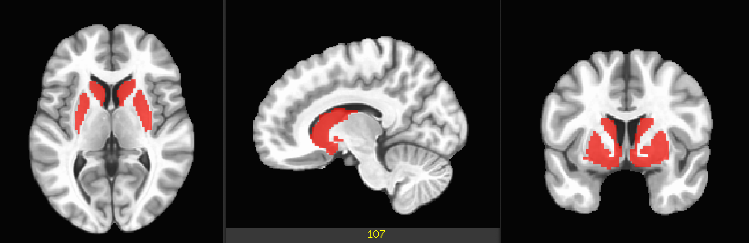
Figure S1. Mask used for the analyses.

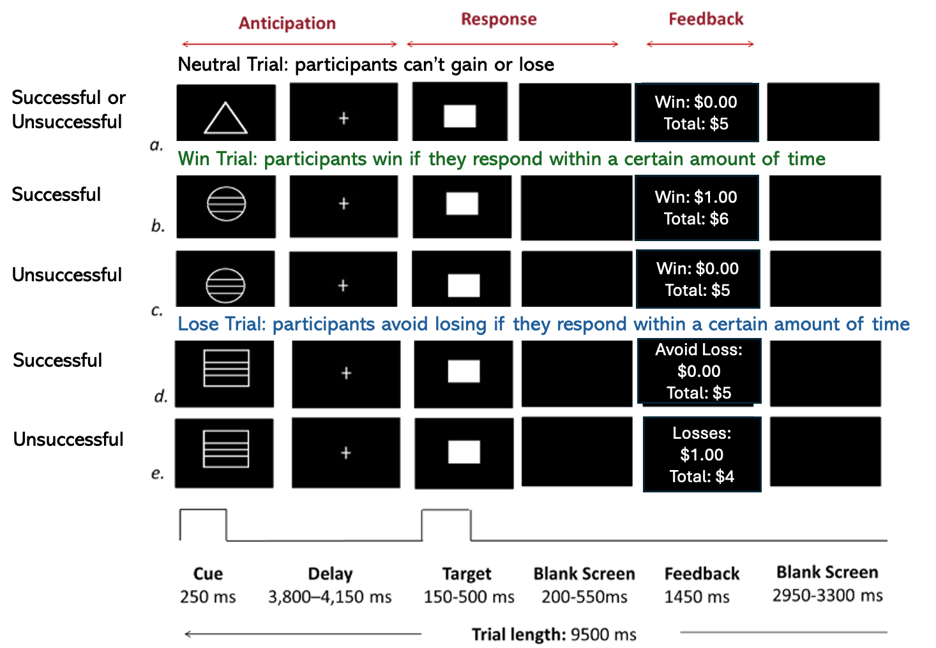
Figure S2. Monetary Incentive Delay (MID) Task.

Table S1. Comparison of comorbidities between the two groups
Comorbidities |  |  | BA  N = 18¹ | non-BA  N = 46¹ |  | p-value²
Attention deficit hyperactivity disorder (ADHD) |  |  | 2 (11%) |  | 6 (13%) |  | >0.9
Body dysmorphic disorder (BDD) |  |  | 2 (11%) |  | 1 (2.2%) |  | 0.2
Eating disorder |  |  | 0 (0%) |  | 1 (2.2%) |  | >0.9
Generalized anxiety disorder (GAD) |  |  | 14 (78%) |  | 30 (65%) |  | 0.3
Obsessive compulsive disorder (OCD) |  |  | 2 (11%) |  | 1 (2.2%) |  | 0.2
Oppositional defiant disorder (ODD) |  |  | 1 (5.6%) |  | 3 (6.5%) |  | >0.9
Panic disorder |  |  | 1 (5.6%) |  | 0 (0%) |  | 0.3
Separation Anxiety |  |  | 3 (17%) |  | 9 (20%) |  | >0.9
Social Anxiety |  |  | 13 (72%) |  | 20 (43%) |  | 0.039
Specific Anxiety |  |  | 2 (11%) |  | 6 (13%) |  | >0.9
¹ n (%)
² Fisher’s exact test; Pearson’s Chi-squared test

Table S2. Comparison of reaction time between the two groups

 | Reaction Time (RT)
Predictors | Estimates |  | CI | p
(Intercept) | 0.389 |  | 0.348 – 0.431 | <0.001
Group[BA] | -0.06 |  | -0.136 – 0.0140 | 0.115
sinceFirstScan | 0.00002 |  | -0.0003 – 0.0003 | 0.892
sinceFirstScan × BA | 0.0001 |  | -0.0004 – 0.0007 | 0.603
N (Participants/Sessions) |  | 64/153
Observations |  | 12611
Model: RT ~ Group * sinceFirstScan + (1 | participant/session)

1. Data Preprocessing
1.1. Preprocessing of B0 inhomogeneity mappings
A total of 2 fieldmaps were collected for each session. A B0- nonuniformity map (or fieldmap) was estimated based on two (or more) echo-planar imaging (EPI) references with topup (1; FSL 6.0.5.1:57b01774).
1.2. Anatomical data preprocessing
A T1-weighted (T1w) images was collected for each session. All of them were corrected for intensity non-uniformity (INU) with N4BiasFieldCorrection (2), distributed with ANTs 2.3.3 (3, RRID:SCR_004757). The T1w-reference was then skull-stripped with a Nipype implementation of the antsBrainExtraction.sh workflow (from ANTs), using OASIS30ANTs as target template. Brain tissue segmentation of cerebrospinal fluid (CSF), white-matter (WM) and gray-matter (GM) was performed on the brain-extracted T1w using fast (FSL 6.0.5.1:57b01774, RRID:SCR_002823, 4). A T1w-reference map for each subject was computed after registration of all of the T1w images (after INU-correction) using mri_robust_template (FreeSurfer 6.0.1, 5). Brain surfaces were reconstructed using recon-all (FreeSurfer 6.0.1, RRID:SCR_001847, 6), and the brain mask estimated previously was refined with a custom variation of the method to reconcile ANTs-derived and FreeSurfer-derived segmentations of the cortical gray-matter of Mindboggle (RRID:SCR_002438, 7). Volume-based spatial normalization to MNI152NLin2009cAsym was performed through nonlinear registration with antsRegistration (ANTs 2.3.3), using brain-extracted versions of both T1w reference and the T1w template. The following templates were selected for spatial normalization: ICBM 152 Nonlinear Asymmetrical template version 2009c [8, RRID:SCR_008796; TemplateFlow ID: MNI152NLin2009cAsym], FSL’s MNI ICBM 152 non-linear 6th Generation Asymmetric Average Brain Stereotaxic Registration Model [9, RRID:SCR_002823; TemplateFlow ID: MNI152NLin6Asym].
1.3. Functional data preprocessing
For each of the BOLD runs found per subject (across all tasks and sessions), the following preprocessing was performed. First, a reference volume and its skull-stripped version were generated from the shortest echo of the BOLD run using a custom methodology of fMRIPrep. Head-motion parameters with respect to the BOLD reference (transformation matrices, and six corresponding rotation and translation parameters) are estimated before any spatiotemporal filtering using mcflirt (FSL 6.0.5.1:57b01774, 10). The estimated fieldmap was then aligned with rigid-registration to the target EPI (echo-planar imaging) reference run. The field coefficients were mapped on to the reference EPI using the transform. BOLD runs were slice-time corrected to 1.21s (0.5 of slice acquisition range 0s-2.42s) using 3dTshift from AFNI (11, RRID:SCR_005927). A T2★ map was estimated from the preprocessed EPI echoes, by voxel- wise fitting the maximal number of echoes with reliable signal in that voxel to a monoexponential signal decay model with nonlinear regression. The T2★/S0 estimates from a log-linear regression fit were used for initial values. The calculated T2★ map was then used to optimally combine preprocessed BOLD across echoes following the method described in (12). The optimally combined time series was carried forward as the preprocessed BOLD. The BOLD reference was then co-registered to the T1w reference using bbregister (FreeSurfer) which implements boundary-based registration (13). Co-registration was configured with six degrees of freedom. First, a reference volume and its skull-stripped version were generated using a custom methodology of fMRIPrep. Several confounding time-series were calculated based on the preprocessed BOLD: framewise displacement (FD), DVARS and three region-wise global signals. FD was computed using two formulations following Power (absolute sum of relative motions (14)) and Jenkinson (relative root mean square displacement between affines (10)). FD and DVARS are calculated for each functional run, both using their implementations in Nipype (following the definitions by (14)). Frames that exceeded a threshold of 0.5 mm FD as well as following frames were annotated as motion outliers and censored in all analyses. Additionally, frames in which more than 10% of voxels were temporal outliers were censored in all analyses. The BOLD time-series were resampled into standard space, generating a preprocessed BOLD run in MNI152NLin2009cAsym space. First, a reference volume and its skull-stripped version were generated using a custom methodology of fMRIPrep. All resamplings can be performed with a single interpolation step by composing all the pertinent transformations (i.e. head-motion transform matrices, susceptibility distortion correction when available, and co-registrations to anatomical and output spaces). Gridded (volumetric) resamplings were performed using antsApplyTransforms (ANTs), configured with Lanczos interpolation to minimize the smoothing effects of other kernels (15).
Many internal operations of fMRIPrep use Nilearn 0.8.1 (16, RRID:SCR_001362), mostly within the functional processing workflow. For more details of the pipeline, see the section corresponding to workflows in fMRIPrep’s documentation.
1.4. Copyright Waiver
The above boilerplate text was automatically generated by fMRIPrep with the express intention that users should copy and paste this text into their manuscripts unchanged. It is released under the CC0 license.
Supplemental References
1. Andersson JLR, Skare S, Ashburner J (2003): How to correct susceptibility distortions in spin- echo echo-planar images: application to diffusion tensor imaging. NeuroImage 20: 870– 888.
2. Tustison NJ, Avants BB, Cook PA, Yuanjie Zheng, Egan A, Yushkevich PA, Gee JC (2010): N4ITK: Improved N3 Bias Correction. IEEE Trans Med Imaging 29: 1310–1320.
3. Avants B, Epstein C, Grossman M, Gee J (2008): Symmetric diffeomorphic image registration with cross-correlation: Evaluating automated labeling of elderly and neurodegenerative brain. Med Image Anal 12: 26–41.
4. Zhang Y, Brady M, Smith S (2001): Segmentation of brain MR images through a hidden Markov random field model and the expectation-maximization algorithm. IEEE Trans Med Imaging 20: 45–57.
5. Reuter M, Rosas HD, Fischl B (2010): Highly accurate inverse consistent registration: A robust approach. NeuroImage 53: 1181–1196.
6. Dale AM, Fischl B, Sereno MI (1999): Cortical Surface-Based Analysis. NeuroImage 9: 179– 194.
7. Klein A, Ghosh SS, Bao FS, Giard J, Häme Y, Stavsky E, et al. (2017): Mindboggling morphometry of human brains ((D. Schneidman, editor)). PLOS Comput Biol 13: e1005350.
8. Fonov V, Evans A, McKinstry R, Almli C, Collins D (2009): Unbiased nonlinear average age- appropriate brain templates from birth to adulthood. NeuroImage 47: S102.
9. Evans AC, Janke AL, Collins DL, Baillet S (2012): Brain templates and atlases. NeuroImage 62: 911–922.
10. Jenkinson M, Bannister P, Brady M, Smith S (2002): Improved Optimization for the Robust and Accurate Linear Registration and Motion Correction of Brain Images. NeuroImage 17: 825–841.
11. Cox RW, Hyde JS (1997): Software tools for analysis and visualization of fMRI data. NMR Biomed 10: 171–178.
12. Posse S, Wiese S, Gembris D, Mathiak K, Kessler C, Grosse-Ruyken M-L, et al. (1999): Enhancement of BOLD-contrast sensitivity by single-shot multi-echo functional MR imaging. Magn Reson Med 42: 87–97.
13. Greve DN, Fischl B (2009): Accurate and robust brain image alignment using boundary- based registration. NeuroImage 48: 63–72.
14. Power JD, Mitra A, Laumann TO, Snyder AZ, Schlaggar BL, Petersen SE (2014): Methods to detect, characterize, and remove motion artifact in resting state fMRI. NeuroImage 84: 320–341.
15. Lanczos C (1964): Evaluation of Noisy Data. J Soc Ind Appl Math Ser B Numer Anal 1: 76– 85.
16. Abraham A, Pedregosa F, Eickenberg M, Gervais P, Mueller A, Kossaifi J, et al. (2014): Machine learning for neuroimaging with scikit-learn. Front Neuroinformatics 8. https://doi.org/10.3389/fninf.2014.00014

