Supplementary Table 1 Baseline Characteristics of MCI Patients According to Oral Frailty Status
Characteristics | Total  (456) | Training Set(319) | Validation Set  (137) | x²/Z value | P value
Sex |  |  |  | 1.100 | 0.294
male | 250(54.8) | 180(56.4) | 70(51.1)
female | 206(45.2) | 139(43.6) | 67(48.9)
Age group |  |  |  | 1.861 | 0.394
60~69 year | 275(60.3) | 186(58.3) | 89(65.0)
70~79 year | 156(34.2) | 114(35.7) | 42(30.7)
≥80 year | 25(5.5) | 19(6.0) | 6(4.3)
BMI,kg/m² |  |  |  | 3.348 | 0.188
18.5~23.9 | 137(30.0) | 97(30.4) | 40(29.2)
24.0~27.9 | 182(40.0) | 134(42.0) | 48(35.0)
≥28 | 137(30.0) | 88(27.6) | 49(35.8)
Marriage |  |  |  | 3.610 | 0.164
Married | 422(92.5) | 292(91.5) | 130(94.9)
Divorced | 14(3.1) | 13(4.1) | 1(0.7)
Widowed | 20(4.4) | 14(4.4) | 6(4.4)
Education Level |  |  |  | 4.762 | 0.313
Elementary school or lower | 123(27.0) | 84(26.3) | 39(28.5)
Junior high school | 205(45.0) | 149(46.7) | 56(40.9)
High school | 86(18.9) | 60(18.8) | 26(19.0)
Associate's degree | 27(5.9) | 19(6.0) | 8(5.8)
Bachelor's degree or higher | 15(3.2) | 7(2.2) | 8(5.8)
Income |  |  |  | 0.712 | 0.870
＜1000 RMB | 65(14.3) | 45(14.1) | 20(14.6)
1000~2999 RMB | 199(43.6) | 143(44.8) | 56(40.9)
3000~4999 RMB | 141(30.9) | 97(30.4) | 44(32.1)
＞5000 RMB | 51(11.2) | 34(10.7) | 17(12.4)
Medical insurance |  |  |  | 2.795 | 0.593
Residents' Medical | 304(66.7) | 212(66.5) | 92(67.2)
New Rural Cooperative | 116(25.4) | 78(24.5) | 38(27.7)
Subsistence Allowance | 15(3.3) | 12(3.8) | 3(2.2)
Commercial Insurance | 7(1.5) | 5(1.6) | 2(1.5)
Self-pay | 14(3.1) | 12(3.8) | 2(1.5)
Residential Setting |  |  |  | 0.444 | 0.505
Towns | 279(61.2) | 192(60.2) | 87(63.5)
Rural | 177(38.8) | 127(39.8) | 50(36.5)
Living Arrangement |  |  |  | 0.223 | 0.974
With spouse and children | 47(10.3) | 33(10.3) | 14(10.2)
With spouse | 317(69.5) | 220(69.0) | 97(70.8)
With children | 51(11.2) | 37(11.6) | 14(10.2)
Live alone | 41(9.0) | 29(9.1) | 12(8.8)
Smoking |  |  |  | 0.741 | 0.690
Yes | 156(34.2) | 107(33.5) | 49(35.8)
No | 274(60.1) | 192(60.2) | 82(59.9)
Quit smoking | 26(5.7) | 20(6.3) | 6(4.4)
Drinking |  |  |  | 0.837 | 0.658
Yes | 137(30.0) | 95(29.8) | 42(30.7)
No | 292(64.0) | 203(63.6) | 89(65.0)
Quit drinking | 27(5.9) | 21(6.6) | 6(4.4)
Comorbidity |  |  |  | 0.650 | 0.723
0 type | 87(19.1) | 61(19.1) | 26(19.0)
1~3 type | 332(72.8) | 230(72.1) | 102(74.5)
＞3 type | 37(8.1) | 28(8.8) | 9(6.6)
Sarcopenia |  |  |  | 0.487 | 0.485
Yes | 113(24.8) | 82(25.7) | 31(22.60)
No | 343(75.2) | 237(74.3) | 106(77.4)
Malnutrition |  |  |  | 0.044 | 0.831
Yes | 263(57.7) | 185(58.0) | 78(56.9)
No | 193(42.3) | 134(42.0) | 59(43.1)
Chewing Difficulties |  |  |  | 0.518 | 0.472
Yes | 248(54.4) | 177(55.5) | 71(51.8)
No | 208(45.6) | 142(44.5) | 66(48.2)
Denture |  |  |  | 0.284 | 0.868
None | 181(39.7) | 126(39.5) | 55(40.1)
1~5 dentures | 236(51.8) | 167(52.4) | 69(50.4)
＞5 dentures | 39(8.6) | 26(8.1) | 13(9.5)
Oral Frailty |  |  |  | 0.003 | 0.954
Yes | 337(73.9) | 236(74.0) | 101(73.7)
No | 119(26.1) | 83(26.0) | 36(26.3)
Depression,median(IQR) | 9.00(7.00,10.00) | 9.00(7.00,10.00) | 9.00(7.00,10.00) | -1.438 | 0.150

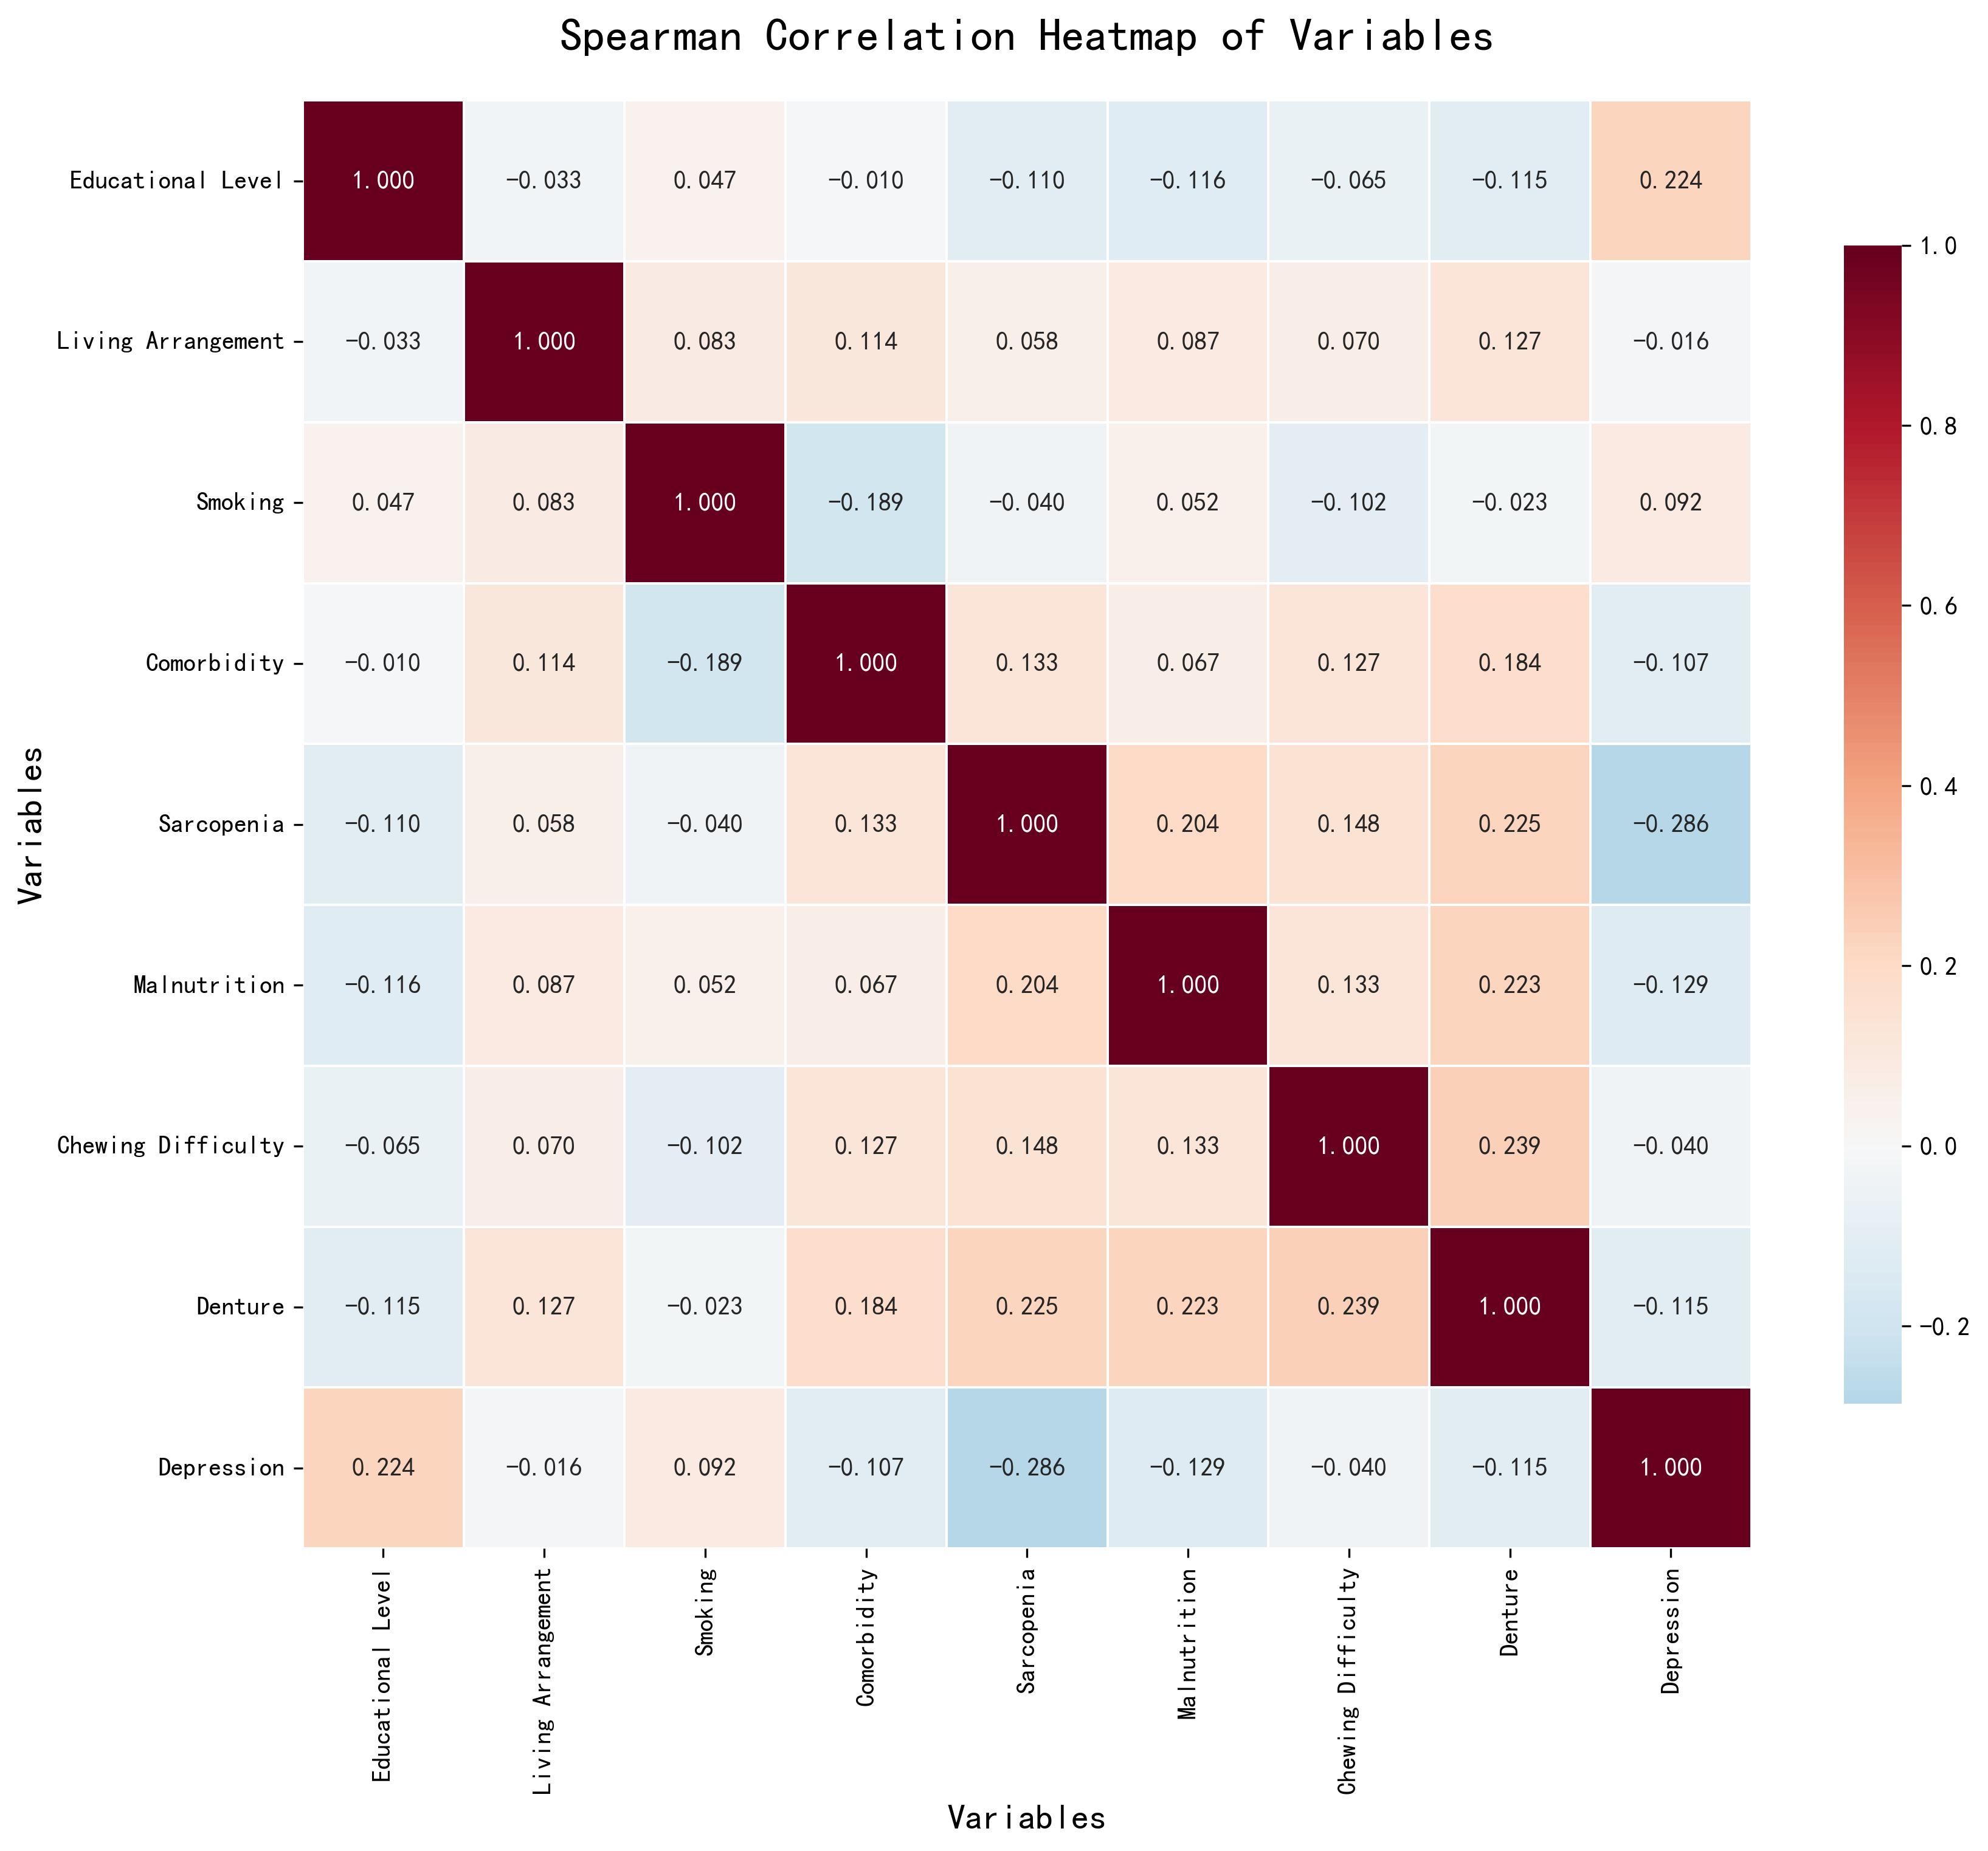
Supplementary Figure 1. Correlation analysis heatmap
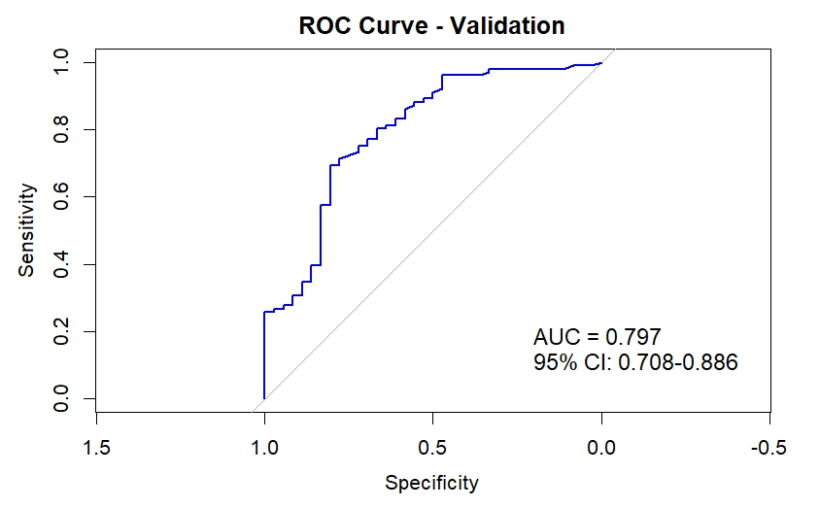
Supplementary Figure 2. ROC curve for the sensitivity analysis

