Supplementary Figure 1. Restricted Cubic Spline Analysis of ΔLEN
A
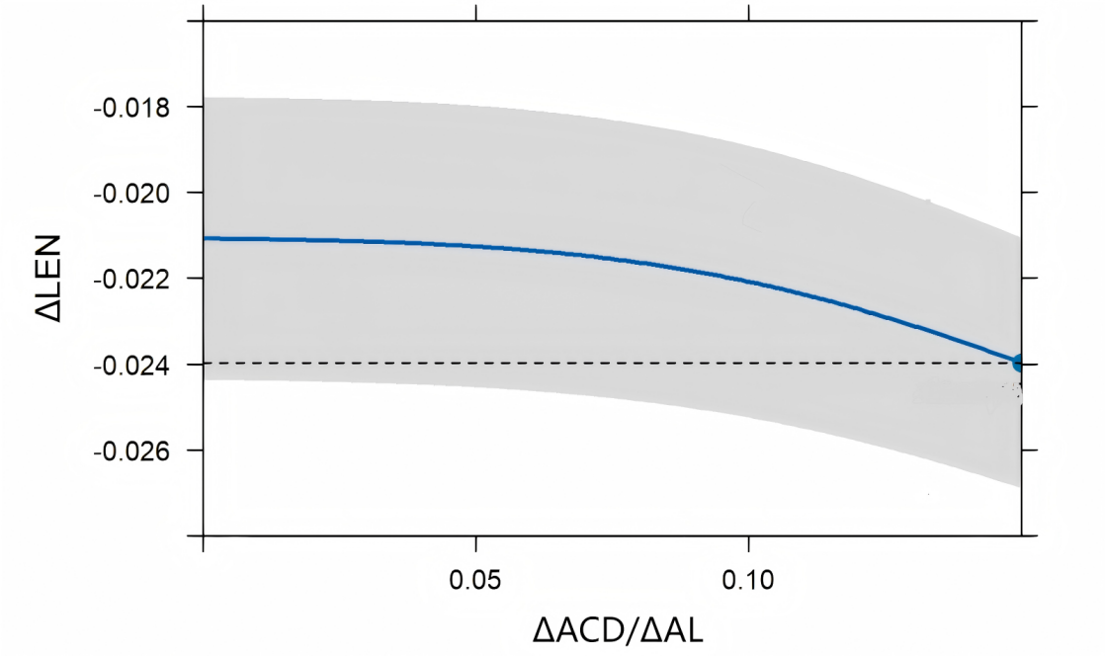
B
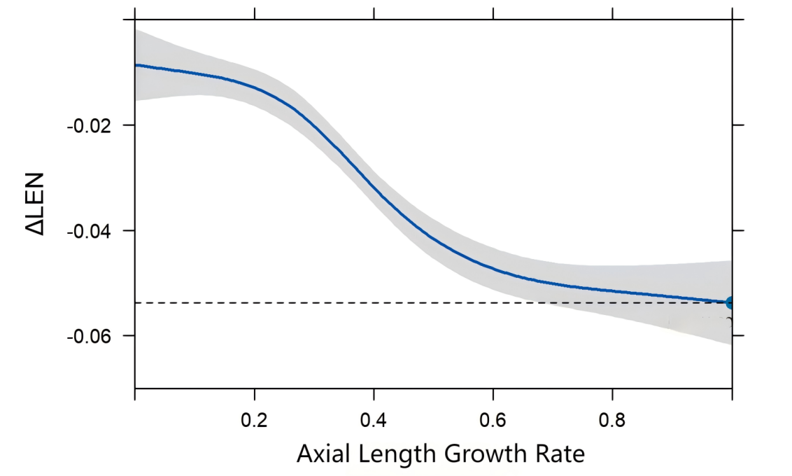
Supplementary Figure 1. Restricted cubic spline (RCS) analysis of non-linear relationships between ΔLEN (mm) and related variables within the Model 2 framework. (A) Relationship between ΔACD/ΔAL and ΔLEN (mm). (B) Relationship between axial growth rate (mm/year) and ΔLEN (mm). All variance inflation factors (VIF) were below 5, indicating no significant multicollinearity in the model. The overall associations were assessed using F-tests, and both ΔACD/ΔAL and axial growth rate demonstrated significant overall associations with ΔLEN (P < 0.001 for both).

