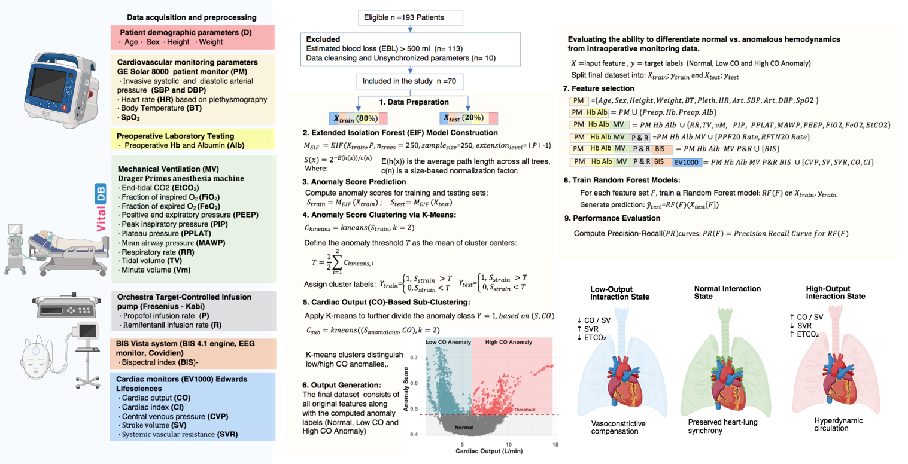

Supplement Figure 1. Unsupervised analytical framework for the identification of intraoperative cardiopulmonary interaction states
Standard intraoperative monitoring, ventilatory, laboratory, anesthetic depth, and hemodynamic data were time-synchronized and analyzed using the Extended Isolation Forest (EIF) algorithm. Anomaly scores generated by EIF quantified deviations from the prevailing multivariate physiological structure. These scores facilitated the distinction between normal cardiopulmonary interaction states and anomalous interaction phenotypes. Anomalous observations were subsequently stratified by concurrent cardiac output into low-output and high-output cardiopulmonary interaction states.

