Interview Schedule
Note: The interview schedule includes components adapted from established and validated instruments and classification frameworks, including the Fagerström Test for Nicotine Dependence (FTND/FTND-ST), the CAGE questionnaire, the Patient Health Questionnaire-9 (PHQ-9), the Generalized Anxiety Disorder-7 (GAD-7), and the Standard of Living Index (SLI). Original sources and validation references are cited in the main manuscript.

I) Case Record Form
- Demographic details
- Name:
- Gender:
- Date of Birth:
- Age:
- Village of residence:
- Total number of family members:
- Type of family:
- Occupation:
- Education (years of completion):
- Religion
- Marital status: Single/married/widowed/separate/divorced
- Socioeconomic status
- Total monthly family income:
- Per Capita monthly income:
- Standard of Living Index: -
- Type of House:
  - Kuccha (mud/thatched)
  - Semi-pucca
  - Pucca (cemented)
- Source of Lighting:
  - Kerosene
  - Electricity
  - Solar
- Fuel Used for Cooking:
  - Firewood/coal
  - Kerosene
  - LPG/biogas/electricity
- Source of Drinking Water:
  - Unprotected source (well, pond, river)
  - Protected well/handpump
  - Piped water supply
- Toilet Facility:
  - Open defecation
  - Pit latrine
  - Flush toilet (attached/detached)
- Ownership of Land:
  - Yes / No (and size in some versions)
- Ownership of House:
  - Yes / No
- Ownership of Livestock:
  - Cow/Buffalo
  - Goat/Sheep
  - Poultry
- Agricultural Equipment Ownership:
  - Tractor / Thresher / Pump set
- Means of Transport Owned:
- Bicycle
- Two-wheeler
- Four-wheeler
- Bullock cart
- Household Assets Owned:
- Radio
- Television (Black & White / Colour)
- Mobile Phone / Landline
- Refrigerator
- Washing Machine
- Computer
- Internet Connectivity
- Furniture:
- Cot/bed
- Table/chair
- Sofa set
- Kitchen Appliances:
- Mixer/grinder
- Microwave oven
- Water Purifier:
- RO / Filter / UV Purifier
- Electric Fan / Cooler / Air Conditioner:
- Clock or Watch:
- Sewing Machine:
- Medical History
- Diabetes YES/ NO Age of Diagnosis:
- Hypertension YES/ NO Age of Diagnosis:
- Clinical Assessment
- Height:
- Weight:
- BMI:
- Waist circumference
- Hip circumference
- Waist Hip Ratio
- Duration of moderate intensity physical activity per week: >150 minutes, <150 minutes
- Frequency of fried/oily/ junk foods? Never/ Rarely/ Sometimes/ Often
- Frequency of sweets and sugary items? Never/ Rarely/ Sometimes/ Often
- Family and Medication History
- Family History of Diabetes/ Hypertension: YES/ NO
- Current Medication for Diabetes/ Hypertension:
- Past History of Mental Illness: YES/NO Diagnosis:
- Past Medication History for Mental Illness:
- Family History of Mental Illness: YES/ NO
- Other medications patient may be on:
- Laboratory investigations
- Blood tests in the last 3 months:
- FBS: Serum Creatinine:
- PPBS: Serum Urea:
- HBa1C:
- RBS at time of interview:
- BP reading at time of interview:
- Complications of Diabetes and Hypertension and Health Seeking Behaviour
- History of Macro (CVD, CVA, PVD, Diabetic foot) or Micro vascular Complications (Nephropathy, Retinopathy, Neuropathy) in the patient: YES/ NO
- How often does the patient visit the health care centre/ doctor for their DM/HTN? Once a month/ once in 2 months/ once in 3 months/ once in 6 months/ once a year
- How much of their total monthly income do they spend directly on health care?
- Substance use History
- History of Tobacco usage: YES/ NO type of tobacco use: No. of pack years:
- Dependence- smoke Tobacco (FTND)/ smokeless Tobacco (FTND-ST)
FTND-
- How soon after you wake up do you smoke your first cigarette?
  - Within 5 minutes – 3 points
  - 6–30 minutes – 2 points
  - 31–60 minutes – 1 point
  - After 60 minutes – 0 points
- Do you find it difficult to refrain from smoking in places where it is forbidden (e.g., church, library, cinema)?
  - Yes – 1 point
  - No – 0 points
- Which cigarette would you hate most to give up?
  - The first one in the morning – 1 point
  - Any other – 0 points
- How many cigarettes per day do you smoke?
  - 10 or less – 0 points
  - 11–20 – 1 point
  - 21–30 – 2 points
  - 31 or more – 3 points
- Do you smoke more frequently during the first hours after waking than during the rest of the day?
  - Yes – 1 point
  - No – 0 points
- Do you smoke even if you are so ill that you are in bed most of the day?
  - Yes – 1 point
  - No – 0 points
FTND-ST
- How soon after you wake up do you place your first dip of tobacco?
  - Within 5 minutes – 3 points
  - 6–30 minutes – 2 points
  - 31–60 minutes – 1 point
  - After 60 minutes – 0 points
- How often do you intentionally swallow tobacco juice?
  - Always – 2 points
  - Sometimes – 1 point
  - Never – 0 points
- Which dip would you hate most to give up?
  - The first one in the morning – 1 point
  - Any other – 0 points
- How many cans/pouches do you use per week?
  - More than 3 – 2 points
  - 2–3 – 1 point
  - Less than 2 – 0 points
- Do you dip more frequently during the first hours after waking than during the rest of the day?
  - Yes – 1 point
  - No – 0 points
- Do you sleep with the dip in your mouth?
  - Yes – 1 point
  - No – 0 points

- History of alcohol consumption: YES/ NO Units of alcohol/ week:
- Dependence-CAGE Questionnaire
- Have you ever felt that you needed to cut down on your drinking?
- Have people annoyed you by criticizing your drinking?
- Have you ever felt Guilty about drinking?
- Have you ever felt you needed a drink first thing in the morning to feel calm or to get rid of a hangover?

II) Screening for DepressionPHQ9
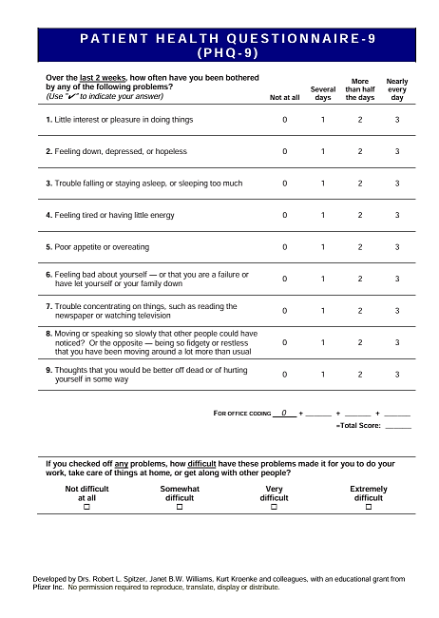

III) Screening for Anxiety GAD7
