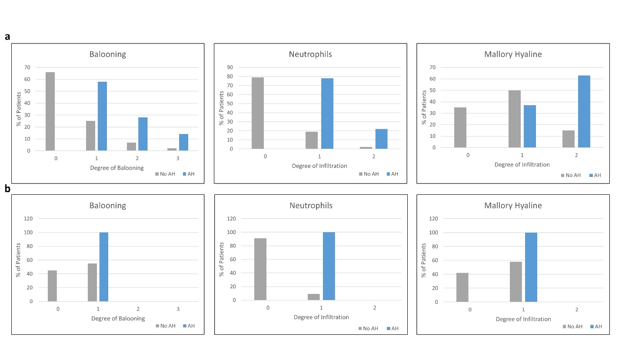
Supplementary Fig. 1 Percentage of subjects with hepatocyte ballooning, Mallory Hyaline, and neutrophilic infiltration stratified for presence or absence of alcohol-associated hepatitis (AH) in the training and testing cohorts.

