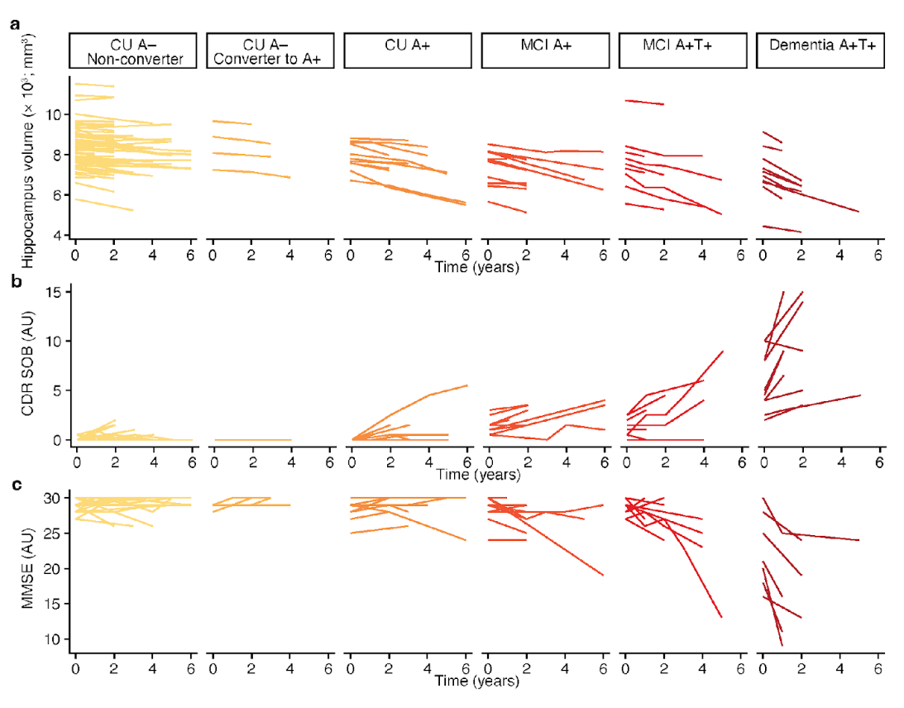
Extended Data Fig. 1 | Longitudinal disease trajectories in TRIAD. (a-c) Longitudinal hippocampus volume (a), CDR SOB (b), and MMSE (c) in six clinically and biomarker-defined stages spanning the Alzheimer’s disease (AD) continuum in TRIAD: cognitively unimpaired (CU) Aβ-negative (A−) non-converters (n = 69), CU A− converters to Aβ-positivity (A+; n = 4), CU A+ (n = 11), A+ with mild cognitive impairment (MCI; n = 12), A+ tau-positive (T+) with MCI (n = 10), and A+T+ dementia (n = 10).

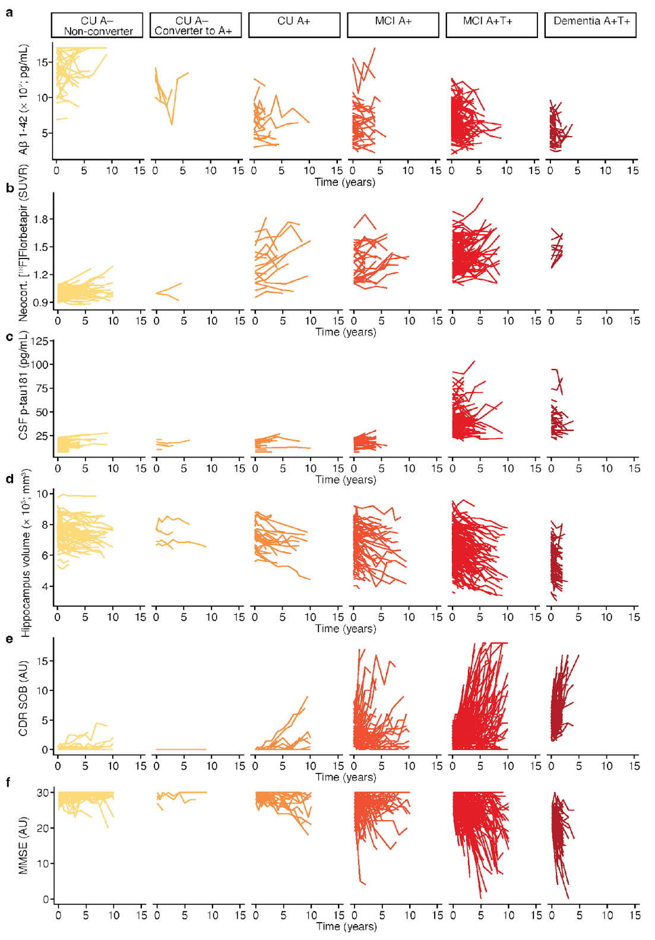
Extended Data Fig. 2 | Longitudinal disease trajectories in ADNI. (a-f) Longitudinal cerebrospinal fluid (CSF) amyloid-β1-42 (a), neocortical [18F]Florbetapir SUVR (b), CSF phosphorylated tau 181 (c; p-tau181), hippocampus volume (d), CDR SOB (e), and MMSE (f) in six clinically and biomarker-defined stages spanning the Alzheimer’s disease (AD) continuum in ADNI: cognitively unimpaired (CU) Aβ-negative (A−) non-converters (n = 79), CU A− converters to Aβ-positivity (A+; n = 5), CU A+ (n = 27), A+ with mild cognitive impairment (MCI; n = 89), A+ tau-positive (T+) with MCI (n = 217), and A+T+ dementia (n = 109).

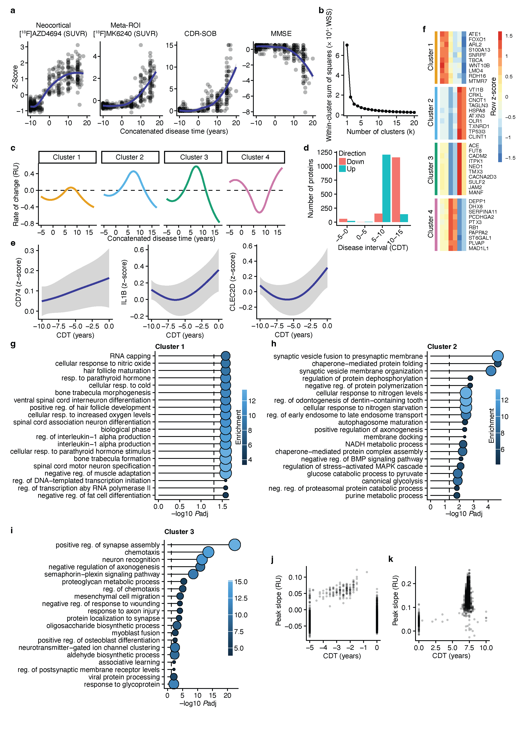Extended Data Fig. 3 | Distinct temporal CSF protein patterns of biological pathways in Alzheimer’s disease. (a) Longitudinal neocortical amyloid-β accumulation measured by [¹⁸F]AZD4694 positron emission tomography (PET), meta-ROI tau-accumulation measured by [¹⁸F]MK6240 PET, CDR SOB and MMSE in the concatenated disease time (CDT) in TRIAD. (b) Elbow plot of the 1367 proteins that significantly changed over the concatenated disease time. This was used to generate the 4 temporally distinct protein clusters 1 (n = 14 proteins), 2 (n = 621 proteins), 3 (n = 583 proteins), 4 (n = 149 proteins). (c) Rate of change of the 4 protein clusters in the CDT. (d) Number of proteins that increase or decrease in the indicated time periods of the CDT. (e) Trajectories of the class II major histocompatibility protein CD74, interleukin-1β (IL1B), and C-type lectin domain family 2 member D (CLEC2D) in the pre-amyloid CDT. (f) Top 10 proteins determined by the magnitude of change in the 4 protein clusters. The row z-score is shown in the heatmap. (g-i) Gene ontology (GO) biological process analyses of the clusters 1 (g), 2 (h) and 3 (i). No significant GO terms were detected for cluster 4. The dashed line indicates FDR-adjusted P-value < 0.05. (j-k) Peak slope of Aβ transition score defining proteins (j) and tau transition score defining proteins (k) in the CDT. The highest peak slopes are observed in the transition period between the time anchors (-5, 0, 5, 10 years) for the Aβ and tau transition scores.

TRIAD
Diagnosis | CN | MCI | ADD
N (%) | 237 (69.7) | 49 (14.4) | 54 (15.9)
Female, N (%) | 157 (66.2) | 23 (46.9) | 23 (42.6)
APOE ɛ4 carriers, N (%) | 44 (18.6) | 29 (59.2) | 30 (55.6)
Age, years, mean (SD) | 61.2 (17.2) | 71.4 (5.8) | 66.4 (8.1)
Education, years, mean (SD) | 15.5 (3.2) | 15.3 (3.6) | 15.3 (3.3)
[¹⁸F]MK6240, SUVR, mean (SD) | 1.1 (0.2) | 2 (1.2) | 3.3 (1.4)
[¹⁸F]AZD4694, SUVR, mean (SD) | 1.2 (0.3) | 2.3 (0.4) | 2.3 (0.5)
Hippocampal volume, mm³, mean (SD) | 8339.5 (937.1) | 7280 (1000.7) | 7126.2 (1165.9)

Extended Data Table 1 | Demographics of TRIAD. Abbreviations: ADD = Alzheimer’s disease dementia, CN = Cognitively unimpaired, MCI = Mild cognitive impairment, SD = Standard deviation, SUVR = Standard uptake value ratio

ADNI
Diagnosis | CN | MCI | ADD
N (%) | 142 (27) | 254 (48.3) | 130 (24.7)
Female, N (%) | 65 (45.8) | 108 (42.5) | 56 (43.1)
APOE ɛ4 carriers, N, (%) | 40 (28.2) | 175 (68.9) | 100 (76.9)
Age, years, mean (SD) | 74.4 (5.7) | 73.1 (7) | 74.6 (8.4)
Education, years, mean (SD) | 16.3 (2.7) | 15.8 (2.9) | 15.4 (2.9)
CSF p-tau181, pg/mL, mean (SD) | 20.3 (9.1) | 34 (16.5) | 37.1 (15.4)
CSF Aβ1-42, pg/mL, mean (SD) | 1153 (427.9) | 708.6 (253.2) | 580.2 (191.5)
[¹⁸F]AV1451, SUVR, mean (SD) | 1.1 (0.2) | 1.4 (0.2) | 1.5 (0.2)
Hippocampal volume, mm³, mean (SD) | 7421.2 (799.6) | 6580.5 (1057.4) | 5816.6 (952.6)

Extended Data Table 2 | Demographics of ADNI. Abbreviations: ADD = Alzheimer’s disease dementia, CN = Cognitively unimpaired, CSF = Cerebrospinal fluid, MCI = Mild cognitive impairment, SD = Standard deviation, SUVR = Standard uptake value ratio

 | TRIAD  cross-sectional, N | ADNI  cross-sectional, N | TRIAD  longitudinal, N | TRIAD, follow-up, years, mean (SD)
CU A– non-converter | 189 | 79 | 69 | 3 (1.5)
CU A– converter | 4 | 5 | 4 | 3 (0.8)
CU A+T– | 22 | 27 | 11 | 3.9 (1.5)
MCI A+T– | 24 | 89 | 12 | 3.2 (2.0)
MCI A+T+ | 32 | 217 | 10 | 2.9 (1.9)
ADD A+T+ | 45 | 109 | 10 | 2 (2.3)

Extended Data Table 3 | Number of individuals per disease stage. Abbreviations: A– = Aβ-negative, A+ = Aβ-positive, ADD = Alzheimer’s disease dementia, CU = cognitively unimpaired, MCI = Mild cognitive impairment, T– = tau-negative, T+ = tau-positive.

