Supplementary Figures
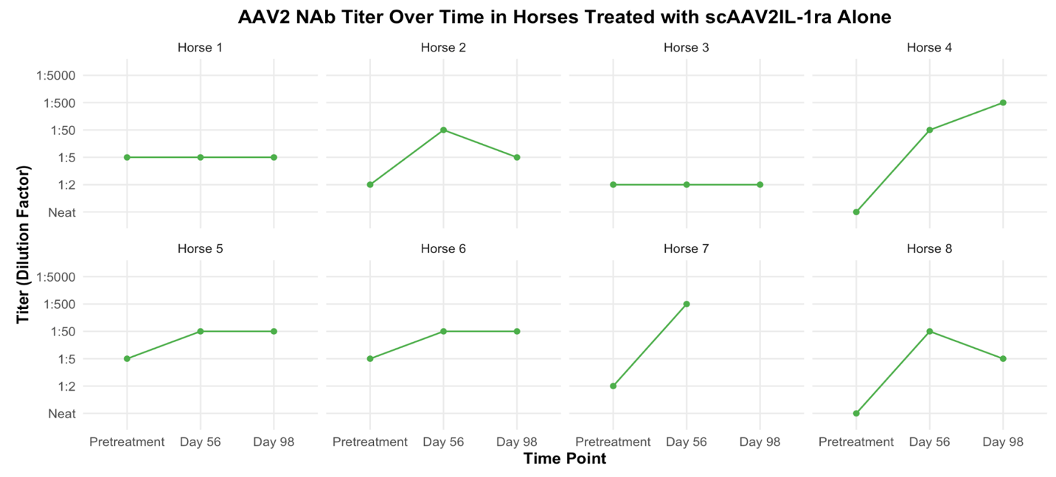
Supplementary Figure 1: Titers of serum neutralizing antibodies to AAV2 in each horse treated with scAAV2IL-1ra alone over the study period. Serum for Horse 7 was not available at Day 98, leading to the time point’s exclusion from analysis.

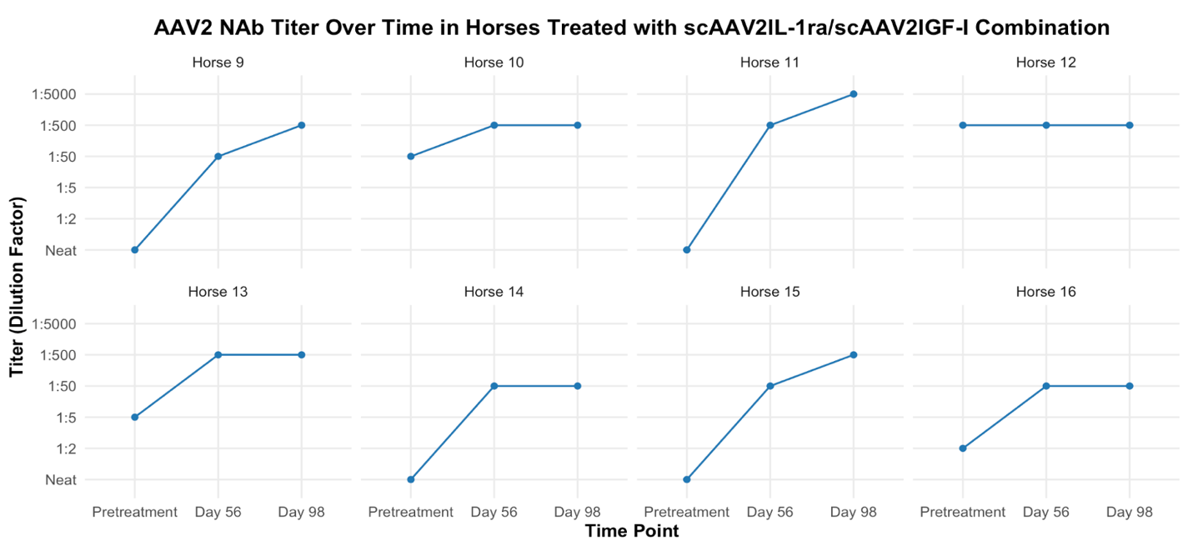Supplementary Figure 2: Titers of serum neutralizing antibodies to AAV2 in each horse treated with the scAAV2IL-1ra/scAAV2IGF-I combination therapeutic over the study period.

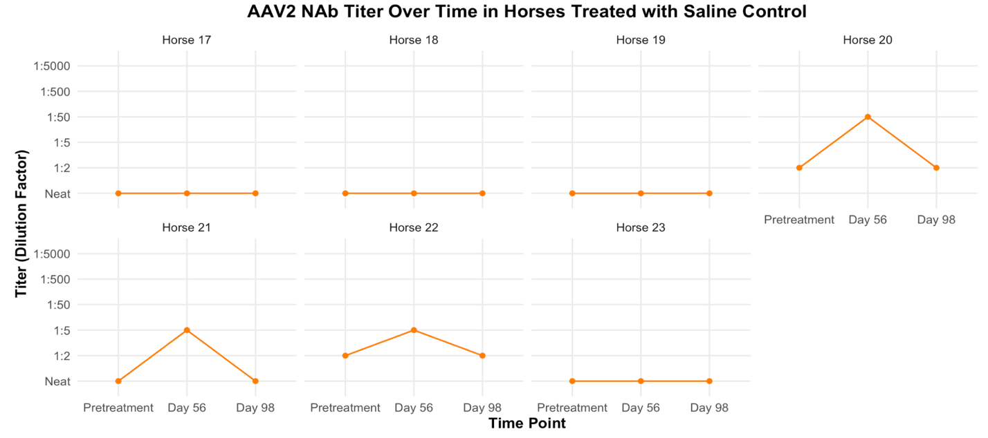Supplementary Figure 3: Titers of serum neutralizing antibodies to AAV2 in each horse treated with the saline control over the study period.

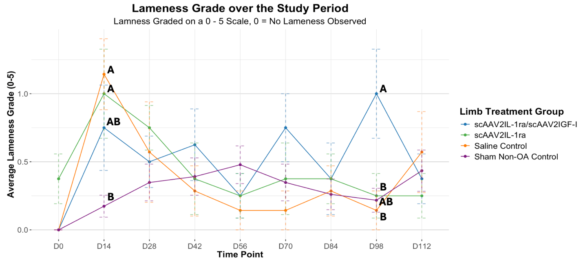
Supplementary Figure 4: Average lameness exam grades over study period. Data displayed as mean +/- standard error, p-values are listed in Appendix A.

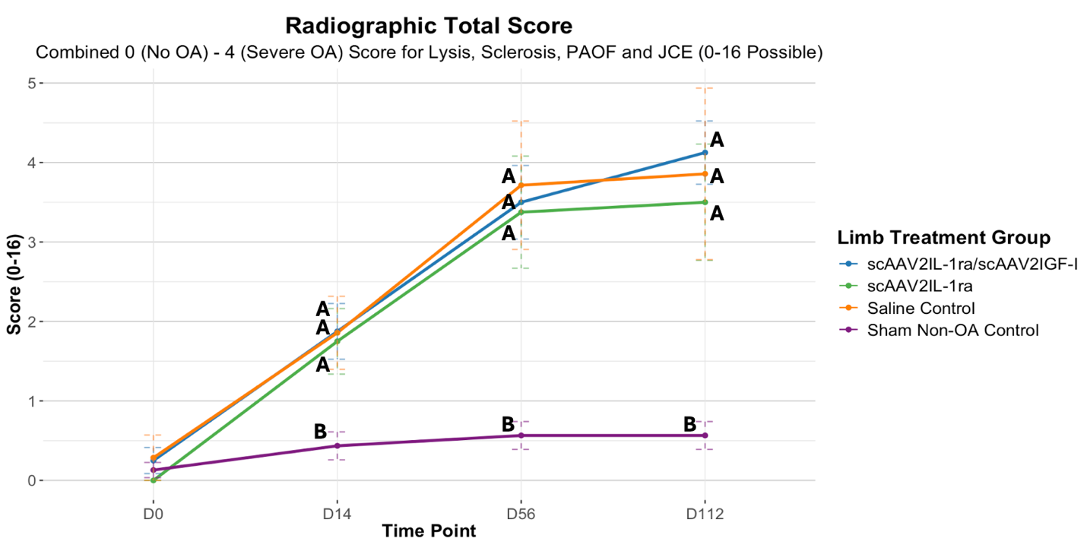
Supplementary Figure 5: Radiographic OA total scores over the study period. Total scores were calculated as the sum of the 0 (no OA) – 4 (severe OA) scores for lysis, sclerosis, peri-articular osteophyte formation, and joint capsule enthesopathy. Data displayed as mean +/- standard error, p-values are listed in Appendix A.

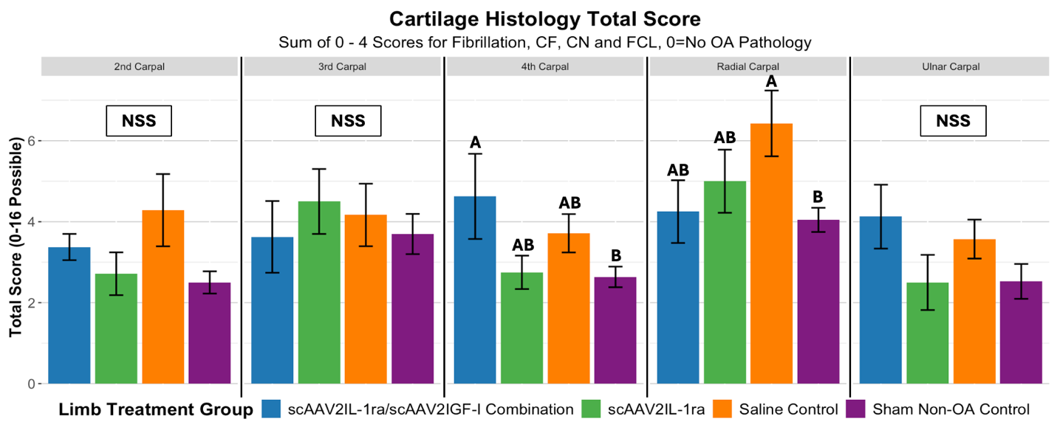
Supplementary Figure 6: Cartilage histology total scores for each individual carpal bone sampled. Total scores calculated by summing the 0 (no OA) – 4 (severe OA) score for fibrillation, chondrone formation, chondrocyte necrosis, and focal cell loss for a total 0-16 score.

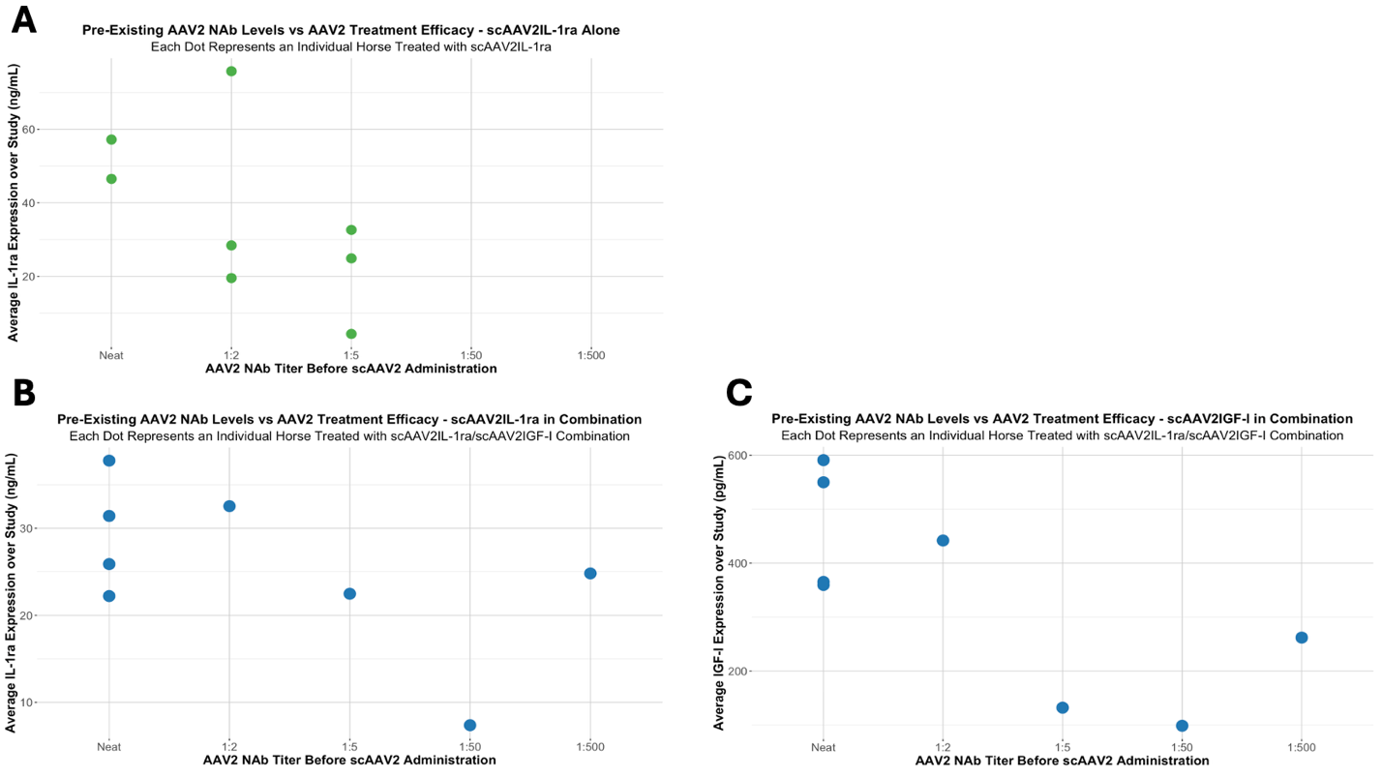
Supplementary Figure 7: Pre-existing AAV2 serum neutralizing antibody titers per horse vs therapeutic protein expression over the study. (A) AAV2 serum NAb titers from horses in the scAAV2IL-1ra treated group pre-treatment administration (Day 14) plotted against average synovial fluid IL-1ra level in the treated joint over the expected expression period (Day 28 through Day 112). A higher titer dilution indicates that the horse had a greater number of pre-existing NAbs to AAV2. Horses with higher titer dilutions (more pre-existing AAV2 NAbs) typically had lower average IL-1ra expression after treatment with the scAAV2IL-1ra vector. Analysis using a Spearman correlation revealed moderate negative correlation (rho= -0.592, higher titers before treatment administration correlated with lower average IL-1ra expression). (B) AAV2 serum NAb titers from horses in the scAAV2IL-1ra/scAAV2IGF-I treated group pre-treatment administration plotted against average synovial fluid IL-1ra level in the treated joint over the expected expression period. Average IL-1ra expression was typically lower in horses that had a higher titer (between 1:5 and 1:500) as compared to those with a neat titer. Analysis using a Spearman correlation revealed a moderate negative correlation (rho= -0.444, higher titers before treatment administration correlated with lower average IL-1ra expression). (C) AAV2 serum NAb titers from horses in the scAAV2IL-1ra/scAAV2IGF-I treated group pre-treatment administration plotted against average synovial fluid IGF-I level in the treated joint over the expected expression period. A large decrease in average IGF-I expression was observed in horses with higher titers as compared to those with neat or 1:2 titers. Analysis using a Spearman correlation revealed a strong negative correlation (rho= -0.736, higher titers before treatment administration correlated strongly with lower average IGF-I expression).

