Supplementary Methods

(Description of survey items not included in main analyses)
Spiritual and Religious Significance
Respondents were asked how spiritually or religiously significant their most memorable psychedelic experience was and if they would use psychedelics again to enhance their spiritual growth or connection to God or higher power.
Suicidality
Respondents were asked if they were contemplating suicide before their most memorable psychedelic experience, after 1 month, and at the time of survey. Respondents could indicate “yes” or ”no.”
Bad Habits
Respondents were asked if they had a dependency or relationship with a list of 7 habits before their most memorable psychedelic experience. The habits included sex addiction, excessive drinking, risky behavior, infidelity, excessive gambling,illegal drug use, pornography addiction.
If a respondent endorsed one of the options, they were presented with a four item scale (below) to rate how the dynamic changed after their most memorable psychedelic experience.
Four Item Scale
- Absent from my life
- Decreased in intensity
- No change
- Increased in Intensity
Numinous Encounters and Family Trauma
Respondents were asked if they encountered an angel, demon, religious figure, guide, deceased family member, unknown deceased person, evil or dark presence, spirit, monster, devil, helper, deceased friend, Jesus, or other entity during their most memorable psychedelic experience and if they were able to move past the encounter and find clarity or reprieve.
Additionally, participants were asked if their experience revealed intergenerational trauma or familial wounds and if the psychedelic experience and their participation in VETS programming ended cycles of intergenerational trauma or familial wounds. Respondents could indicate “yes” or ”no.”
VETS Programing
Respondents were asked if they were interested in a faith based group offering at VETS with the option of suggesting ideas in an open text field.

Supplementary Results:
Sensitivity analyses excluding potential duplicates
Sensitivity analyses for our primary outcomes were conducted excluding one item from each response pair (n=6 potential duplicate pairs). Outcomes from these analyses remained consistent with these potential duplicates removed: 1) McNemar’s test indicated a significant change in proportions for endorsement of “active belief” before and after one’s most memorable psychedelic experience ( $χ^{2}$(1) =75.013, p < .001; within ibogaine subsample: ( $χ^{2}$(1) =48.020, p < .001). 2) McNemar’s test (using binomial test on discordant pairs) indicated a significantly lower proportion of participants who endorsed “no belief” after compared to before the most memorable psychedelic experience (p < .001; within ibogaine subsample: p < .001). 3) McNemar’s test (using binomial test on discordant pairs) indicated that there was not a significant change in the proportion of participants endorsing affiliation with an organized religious group from before to after their most memorable psychedelic experience (p = .664, within ibogaine subsample: p = 1). 4) McNemar’s test (using binomial test on discordant pairs) indicated that there was not a significant change in the proportion of participants endorsing affiliation with Christianity from before to after their most memorable psychedelic experience (p = .189, within ibogaine subsample: p = .388).
Perceived closeness to a Higher Power
Analysis of perceived closeness to a higher power was not included in our main outcomes due to redundancy with analysis of level of belief in higher power. A one-sample binomial test was performed to determine if the proportion of participants endorsing that their most memorable psychedelic experience did and did not bring them closer to God or a higher power differed from the hypothesized proportion of 0.50. An exact binomial test indicated that the proportion of participants endorsing “Yes” (n = 134, observed proportion = .887) was significantly larger than the proportion who endorsed “No” (n = 17, observed proportion = .113; p < .001.
An overwhelming majority of participants (88.7%) reported that their most memorable psychedelic experience brought them closer to God or a higher power, a proportion significantly greater than chance. This result reinforces the interpretation that psychedelic experiences are frequently perceived as spiritually salient or transcendent, regardless of prior belief system. (Griffiths et al., 2006). Importantly, this perceived closeness was not restricted to participants with pre-existing religious belief.

Exploratory outcomes: change in emotions, beliefs, and behaviors after psychedelic experience
The overall pattern of outcomes for emotions, beliefs, and behaviors was consistent with increased positive experiences and decreased negative experiences following one’s most memorable psychedelic experience (Figure S2). Some of the items with the highest average selection involved increased positive emotions; specifically, the averages for responses on feelings of peace, love, and joy were among the highest and exceeded 1.5. The other response that exceeded 1.5 was “connection to self”.
Regarding items specific to faith, on average, participant responses indicated increased engagement with their faith following their most memorable psychedelic experience. The items that seemed to stand out, with the highest average scores were “connection to faith”, “ability to uncover the spirit in daily experiences”, and “appreciation for other faiths”. Additionally, it may be notable that some of the items associated with traditional services in organized religion (donations to one’s church/faith program, engagement with spiritual leaders) were among those with the lowest average.
Supplementary Discussion

Exploratory findings - psychedelic experience showed general associations with positive changes
Exploratory analyses revealed broad increases in positive psychosocial outcomes following psychedelic experiences. The overall positive outcomes reported following one’s most memorable psychedelic experience aligns with those reported by an early cross-over of psilocybin versus placebo by Griffiths et al. (2006) as well as a survey study by Raison (2022); both of these studies reported elevations in ratings of positive attitudes, mood, social effects, and behavior associated with psychedelics, albeit, both were conducted in populations of the general public (i.e., sample not restricted to veterans or persons seeking psychedelic treatment for clinical treatment reasons). The observed shifts in mood, beliefs, and behavior may represent potential mechanisms through which psychedelic experiences influence spiritual meaning-making (Hartogsohn, 2018); alternatively, these outcomes may reflect general increases in well-being supported by an increased connection with one’s spirituality and the support and sense of meaning rendered by that. Future mediation studies would be necessary to clarify the direction of causation and influence.
The three items with the highest average endorsement in the current analysis were enhanced feelings of peace, joy, love, and a sense of connection to self. Simultaneously, participants reported reductions in negatively-valenced experiences of fear of death, shame, guilt, and feelings of condemnation. The survey study completed by Raison (2022) published the percentage of participants who endorsed improvements on specific questionnaire items, enabling some direct comparison of related questions. Similar to our outcomes, Raison (2022) also queried feelings of peace (“feelings of inner peace”), joy, and love, and found 92.9%, 89.9%, and 90.5% of the sample reported improvements in these items. Presence of these outcomes across two differing populations suggest these increases in positive emotion may be a fairly robust and nonspecific effect of voluntary psychedelic use.
Faith-specific exploratory outcomes further indicated increases in sense of connection to faith, ability to uncover the spirit in daily experiences, and appreciation for other faiths. On the other hand, items associated with institutional participation (donations to spiritual organizations, engagement with spiritual leaders), while still exhibiting an increase, were among the least strongly endorsed. This reinforces the notion that psychedelic experiences may be predisposed to support individualized, internally-oriented spiritual engagement (Buchborn et al., 2023).

Supplementary Figures
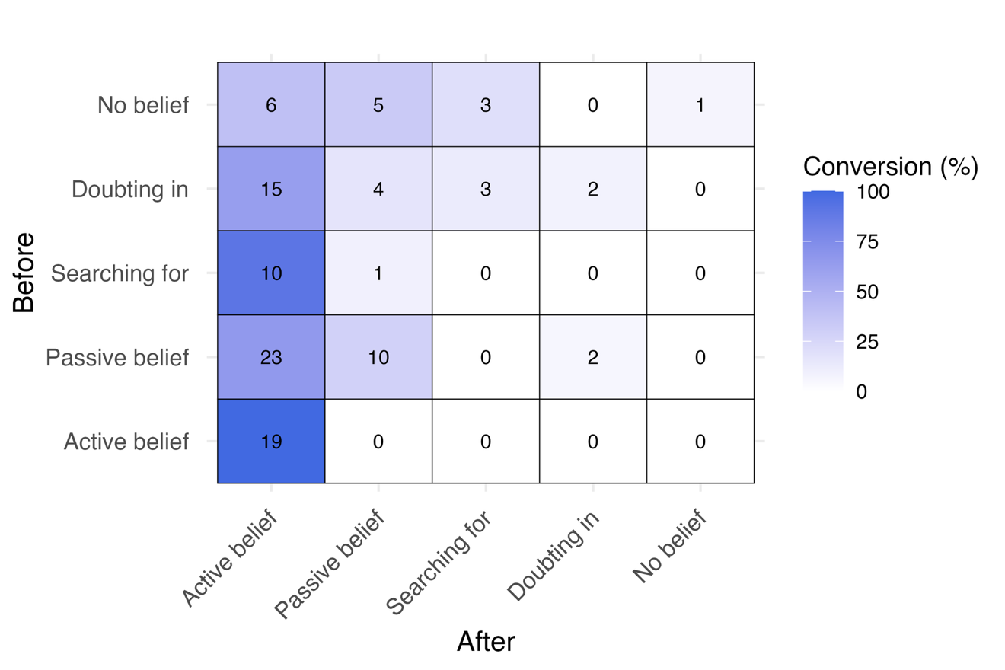
Figure S1. Level of belief in God or a higher power reported before and after one’s most memorable psychedelic experience within the subgroup of n = 104 participants who endorsed use of ibogaine (or ibogaine + 5-MeO-DMT). Numbers in figure reflect the number of participants endorsing each set of Before/After responses within (e.g., in the top left corner, 6 participants selected “no belief” at the before time point and “active belief” at the after time point). The tile colors indicate the percentage of participants from each row (i.e., each ‘before’ response selection) who selected each response at the after time point.

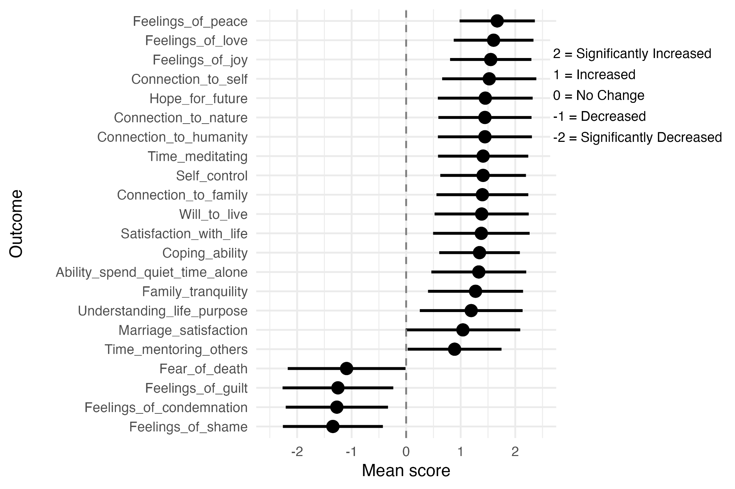

Figure S2. Mean and SD for response selections of N = 151 participants across 22 items querying change in emotions, beliefs, and behaviors from before to after their most memorable psychedelic experience.

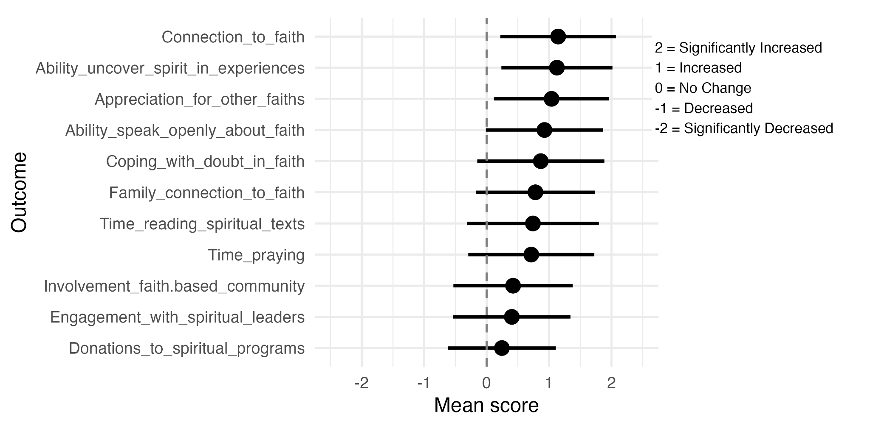
Figure S3. Mean and SD for response selections of N = 151 participants across 11 items querying change in faith-related emotions and behaviors from before to after their most memorable psychedelic experience.

References
Buchborn, T., Kettner, H. S., Kärtner, L., & Meinhardt, M. W. (2023). The ego in psychedelic
drug action–ego defenses, ego boundaries, and the therapeutic role of regression.
Frontiers in Neuroscience, 17, 1232459. https://doi.org/10.3389/fnins.2023.1232459
Griffiths, R. R., Richards, W. A., McCann, U., & Jesse, R. (2006). Psilocybin can occasion
mystical-type experiences having substantial and sustained personal meaning and
spiritual significance. Psychopharmacology, 187(3), 268–283.
https://doi.org/10.1007/s00213-006-0457-5
Hartogsohn, I. (2018). The meaning-enhancing properties of psychedelics and their mediator role
in psychedelic therapy, spirituality, and creativity. Frontiers in neuroscience, 12, 129.
https://doi.org/10.3389/fnins.2018.00129
Raison, C. L., Jain, R., Penn, A. D., Cole, S. P., & Jain, S. (2022). Effects of Naturalistic
Psychedelic Use on Depression, Anxiety, and Well-Being: Associations With Patterns of
Use, Reported Harms, and Transformative Mental States. Frontiers in Psychiatry, 13,
831092. https://doi.org/10.3389/fpsyt.2022.831092

