Supplementary Information
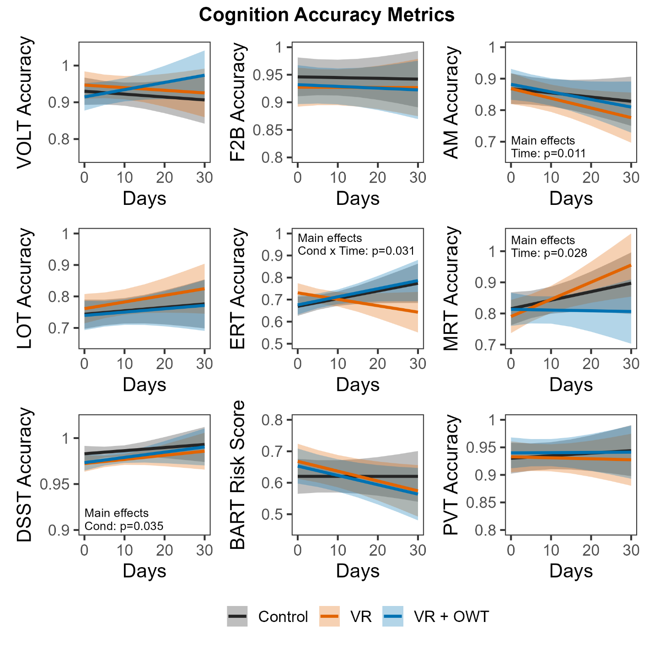
Supplementary Figure 1: Linear and robust linear mixed models for accuracy metrics on nine tasks in the Cognition battery. Models are presented as mean ± 95% confidence interval. Fixed factors included Time [numeric: days since T1], Condition [categorical: Control, VR, OVR], and their interaction. Subjects were included as random factors. VOLT: Visual Object Learning Test; F2B: Fractal 2-Back; AM: Abstract Matching; LOT: Line Orientation Test; ERT: Emotion Recognition Task; MRT: Matrix Reasoning Test; DSST: Digit Symbol Substitution Task; BART: Balloon Analog Risk Test; PVT: Psychomotor Vigilance Test.

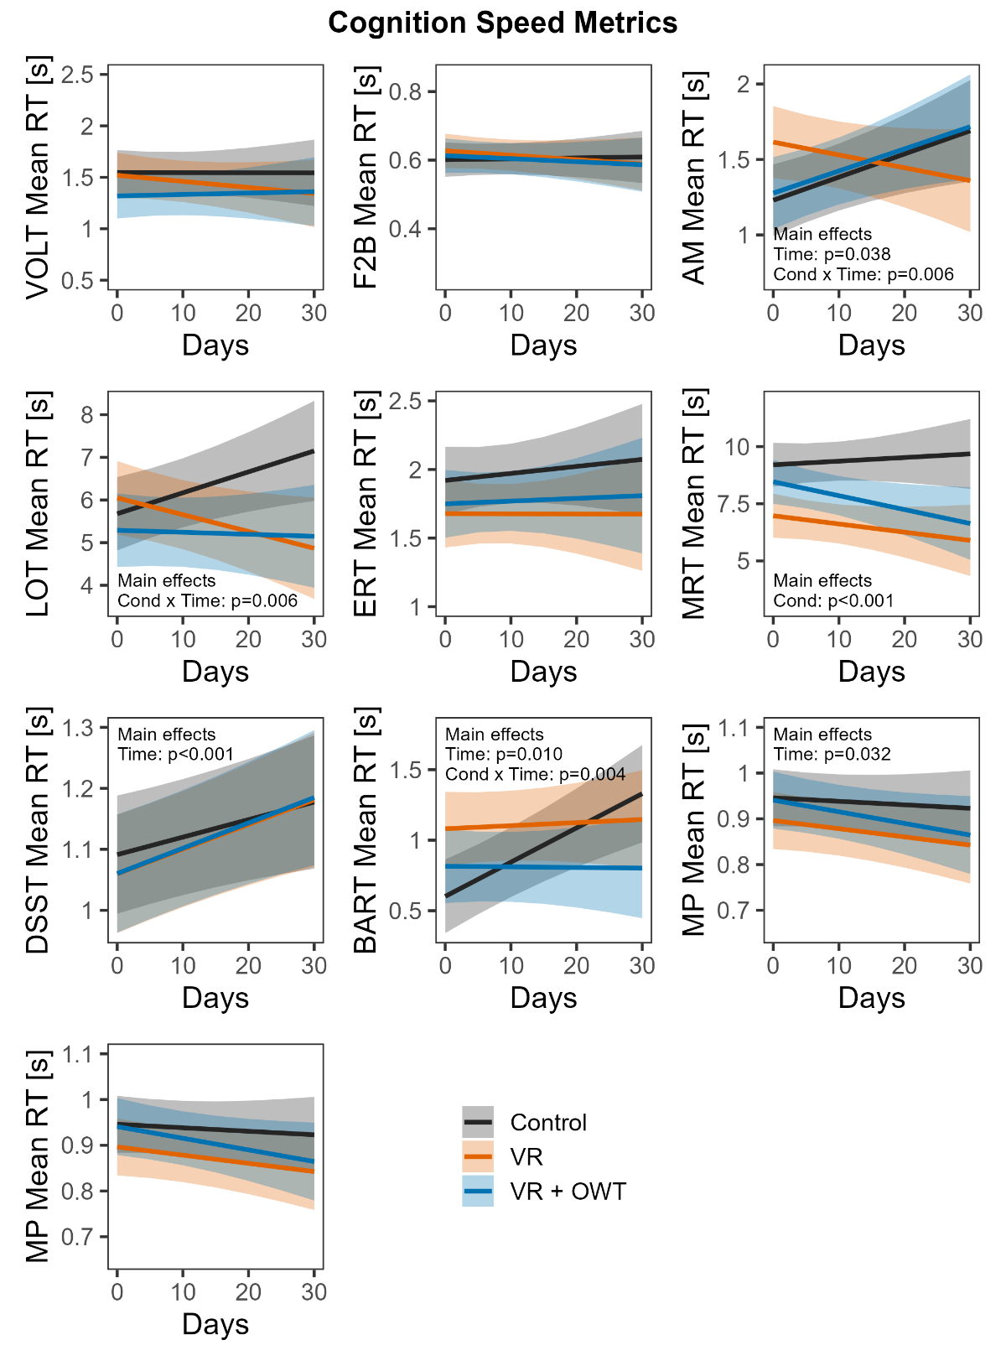
Supplementary Figure 2: Linear and robust linear mixed models for speed metrics on the ten tasks in the Cognition battery. Models are presented as predicted mean ± 95% confidence interval. Fixed factors included Time [numeric: days since T1], Condition [categorical: Control, VR, OVR], and their interaction. Subjects were included as random factors. VOLT: Visual Object Learning Test; F2B: Fractal 2-Back; AM: Abstract Matching; LOT: Line Orientation Test; ERT: Emotion Recognition Task; MRT: Matrix Reasoning Test; DSST: Digit Symbol Substitution Task; BART: Balloon Analog Risk Test; PVT: Psychomotor Vigilance Test; MP: Motor Praxis.
Supplementary Table 1: Descriptions of the 10 tasks in the Cognition battery in the order of administration.
Task | Description
Motor Praxis (MP) | Subjects clicked on squares (n=20) that appeared randomly on the screen. The size of each subsequent square decreased.
Visual Object Learning (VOLT) | Subjects were asked to memorize 10 sequentially displayed 3-D figures. Next, they were asked to identify the objects they had memorized from a group of 20 similar objects (sequentially presented), half of them from the learning set and half of them new.
Fractal 2-Back (F2B) | Subjects were presented with a series of sequential figures (fractals, n=62) and asked to respond when the current stimulus matched the stimulus displayed two figures ago.
Abstract Matching (AM) | Subjects were presented with two pairs of objects, differing in perceptual dimensions (e.g., color and shape). Subjects were presented a target object (n=30) they had to classify as belonging more to one of the two pairs based on a set of implicit, abstract rules.
Line Orientation (LOT) | Subjects were presented with two lines (n=12 pairs), one stationary and one movable by clicking an arrow. Subjects were asked to rotate the movable line until the perceived it to be parallel with the stationary line.
Emotion Recognition (ERT) | Subjects were asked to label photographs of professional actors with different facial expressions as “happy”, “sad”, “angry”, “fearful”, or “no emotion”. There were 40 total stimuli, 8 of each emotion category.
Matrix Reasoning (MRT) | Subjects were shown a series of patterns overlaid on a grid with one grid element missing. Subjects then selected the element that fit the pattern from a set of alternative options. There were 12 stimuli total.
Digit Symbol Substitution (DSST) | Subjects were shown 1 of 9 symbols, each corresponding to a specific digit displayed in a legend, at a time and asked to select the correct number as quickly as possible. The test duration was fixed at 90 seconds.
Balloon Analog Risk (BART) | Subjects could inflate an animated balloon or stop inflating and collect a reward proportional to the size of the balloon. If a balloon popped, no reward was granted for that stimulus. The average tendency for a set of balloons (n=30/set) systematically differed between test administrations.
Psychomotor Vigilance (PVT) | Subjects were asked to monitor a box on the screen and press the spacebar as quickly as possible once a millisecond counter appeared in the box. This was a 3-minute PVT with 2 to 5 second interstimulus intervals.

