Supplementary Tables
Table S1: Bathroom assessment with 86 LUX
Item | Tape EU class I (±0.1 cm) measurement | iPad Pro | Professional Laser LiDAR | iPhone LiDAR Height 163.2 | iPhone LiDAR Height 182
Shower room Width (cm) | 74.5 | 76 | 74 | 68 | 100
Shower room Height (cm) | 190 | 194 |  | 200 | 190
Shower room entrance Width (cm) | 74 | 76 | 73.2 | 84 | 58
Shower room entrance Height (cm) | 190 | 192 | 192 | 200 | 190
sink Width (cm) | 49.5 | 47 | 47.7 | 43
sink Height (cm) | 91 | 91 | 92.8 | 86 | 89
Toilet door Width (cm) | 66 | 62 | 71 | 52 | 62
Toilet door Height (cm) | 188 | 190 | 187 | 180
toilet room inside Width (cm) | 73 | 60 | 70.1 | 68 | 66
toilet seat Width (cm) | 37 | 33 | 31.3 | 32 | 36.7
toilet seat Height (cm) | 42 | 44 | 43.1 | 40 | 44
distance of toilet to the wall Width (cm) | 66 | 65 | 68 | 71 | 53

Table S2: Corridor assessment with 54 LUX
Item | Tape EU class I (±0.1 cm) measurement | iPad Pro | Professional Laser LiDAR | iPhone LiDAR Height 163.2 | iPhone LiDAR Height 182
Entrance Width (cm) | 77 | 66 | 71.7 | 65 | 72
Stairs rail Width (cm) | 76 | 79 |  | 80 | 68
Stairs rail Height (cm) | 82 | 78 |  | 66 | 72
step Width (cm) | 73 | 74 |  | 70 | 72
step Height (cm) | 17 | 17 |  | 17 | 15

Table S3: Kitchen assessment 353 LUX
Item | Tape EU class I (±0.1 cm) measurement | iPad Pro | Professional Laser LiDAR | iPhone LiDAR Height 163.2 | iPhone LiDAR Height 182
Kitchen Bath Door Width | 66 | 69 | 65.9 | 68 | 68
Kitchen Bath Door Height | 200 | 195 | 195.3 | 190 | 200
Kitchen Out Door Width | 69 | 65 | 72.2 | 60 | 67
Kitchen Out Door Height | 198 | 200 | 198.3 | 200 | 200
Kitchen Corridor Door Width | 73 | 69 | 69.5 | 70 | 71
Kitchen Corridor Door Height | 196 | 194 | 194.6 | 200 | 200
Kitchen Sink Width | 108 | 106 | 105 | 110 | 100
Kitchen Sink Height | 90 | 90 | 89.7 | 87 | 86
Kitchen Table width | 110 | 110 |  | 96 | 100
Kitchen Table Height | 74 | 75 |  | 74 | 74
Kitchen Table Length | 67.5 | 65 |  | 68 | 64
Kitchen Step Width | 73 | 69 | 68.5 | 85 | 71
Kitchen Step Height | 16 | 12 | 14.4 | 14.16 | 13
Kitchen Chair Height | 36 | NA | 36.6 | 32 | 31.5
Kitchen Chair Width | 40 | NA | 44.3 | 42 | 41

Table S4: Laundry room (conservatory/outside room) assessment, with 1051 LUX
Item | Tape EU class I (±0.1 cm) measurement | iPad Pro | Professional Laser LiDAR | iPhone LiDAR Height 163.2 | iPhone LiDAR Height 182
Step Width (cm) | 13 | 13 |  | 15 | 14
Step Height (cm) | 12 | 10 |  | 11 | 12
Distance to washing Machine Width (cm) | 79 | 82 | 87 | 73 | 71
Outside doorway Width (cm) | 69 | 65 | 71 | 63 | 67
Outside doorway Height (cm) | 194 | 192 | 198.6 | 180 | 190

Supplementary Figures

Figure S1: Laundry room leica blk360 (left), iPad Pro 11 (right). Lines are an example of the measurements.

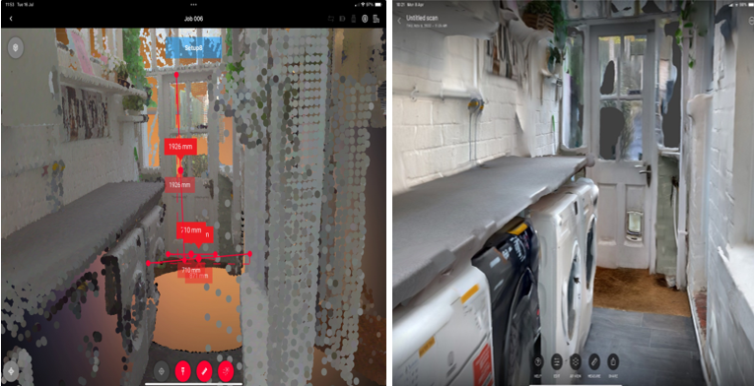

Figure S2: Kitchen leica blk360 (left), iPad Pro 11 (right)
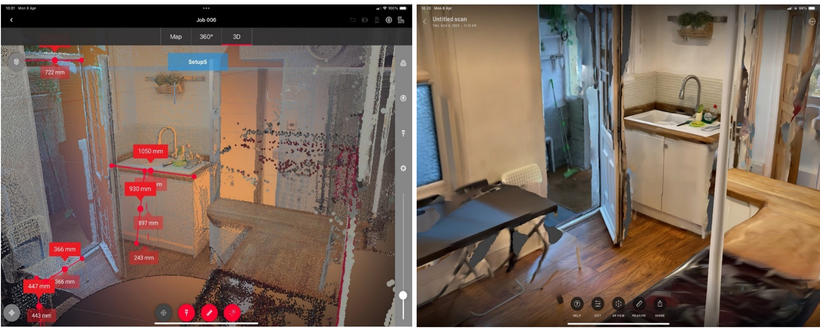

Figure S3: Bedroom leica blk360 (left), iPad Pro 11 (right)
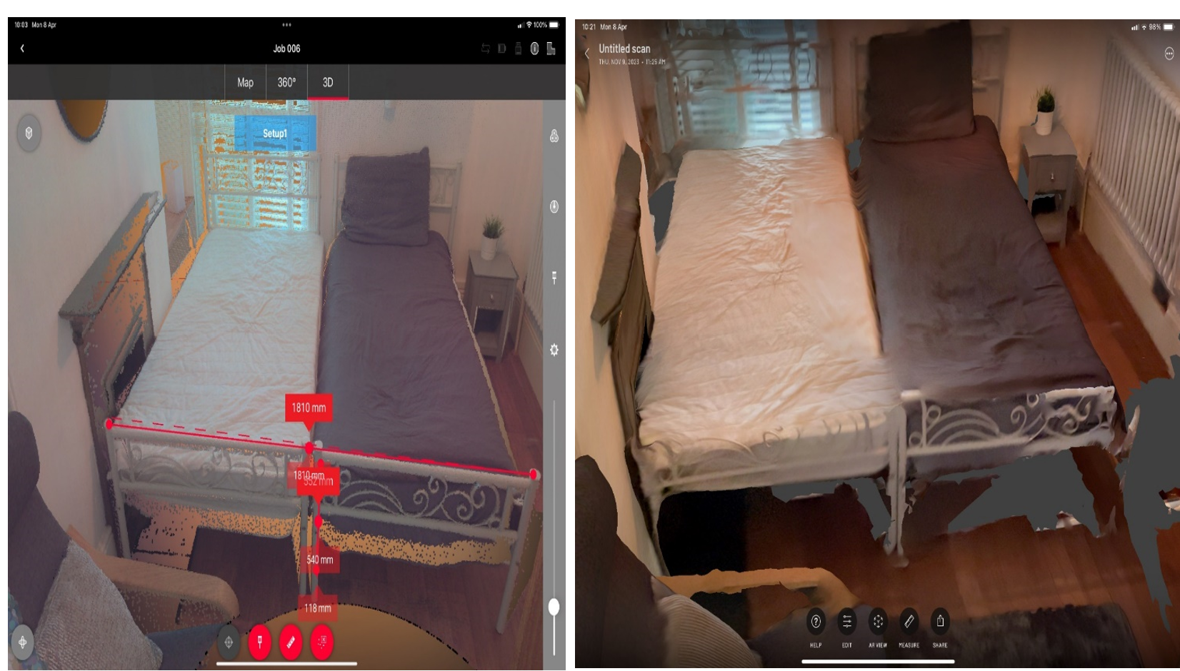

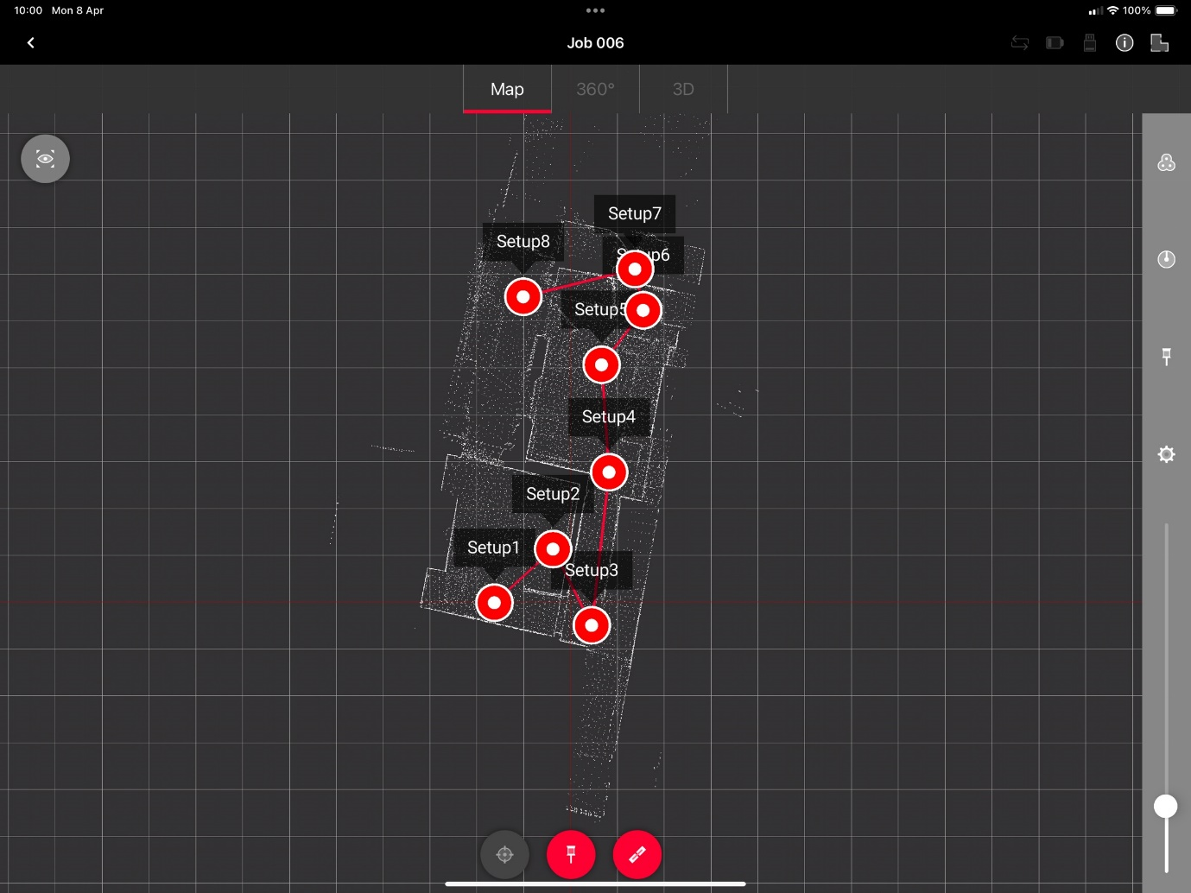
Figure S4: House ground floor plan mapped by Laser LiDAR leica blk360

