Supplementary figures
Partitioning tree for microbiome diversity
Hill numbers for alpha diversity or SES-PD for phylogenetic diversity ~ species + genus + family + order + habitat + crude_protein_percent + vertebrate_protein_sources + plant_protein_sources + insect_protein_sources + crude_lipid_percent + vertebrate_fat + plant_fat + insect_fat + total_carbohydrate_percent + sample + preservation + extraction_kit + amplified_region + sequencing + strand + duration_experiment_days + life_stage + trimming
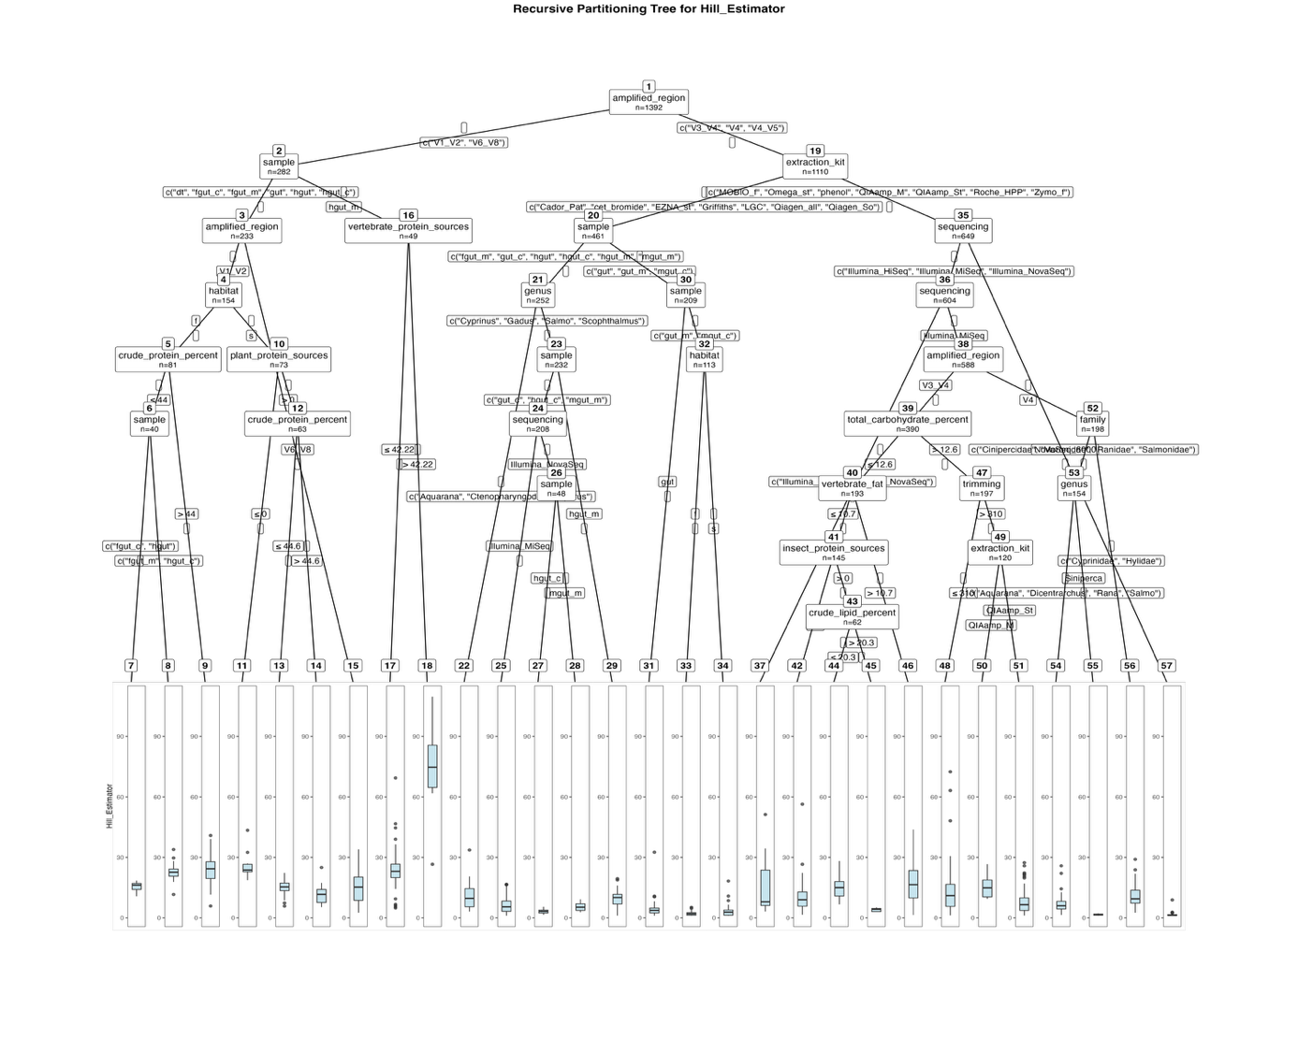
Fitted party – alpha diversity – Hill estimators (Fig. 2):

[1] root
| [2] amplified_region in V1_V2, V6_V8
| | [3] sample in dt, fgut_c, fgut_m, gut, hgut, hgut_c
| | | [4] amplified_region in V1_V2
| | | | [5] habitat in f
| | | | | [6] crude_protein_percent <= 44
| | | | | | [7] sample in fgut_c, hgut: 15.220 (n = 15, err = 84.9)
| | | | | | [8] sample in fgut_m, hgut_c: 22.723 (n = 25, err = 424.2)
| | | | | [9] crude_protein_percent > 44: 23.952 (n = 41, err = 2112.0)
| | | | [10] habitat in s
| | | | | [11] plant_protein_sources <= 0: 26.043 (n = 10, err = 460.3)
| | | | | [12] plant_protein_sources > 0
| | | | | | [13] crude_protein_percent <= 44.6: 14.856 (n = 48, err = 572.1)
| | | | | | [14] crude_protein_percent > 44.6: 11.822 (n = 15, err = 400.7)
| | | [15] amplified_region in V6_V8: 14.881 (n = 79, err = 4730.6)
| | [16] sample in hgut_m
| | | [17] vertebrate_protein_sources <= 42.22: 23.967 (n = 39, err = 5607.4)
| | | [18] vertebrate_protein_sources > 42.22: 73.715 (n = 10, err = 4269.1)
| [19] amplified_region in V3_V4, V4, V4_V5
| | [20] extraction_kit in Cador_Pat, cet_bromide, EZNA_st, Griffiths, LGC, Qiagen_all, Qiagen_So
| | | [21] sample in fgut_m, gut_c, hgut, hgut_c, hgut_m, mgut_m
| | | | [22] genus in Aquarana, Ctenopharyngodon, Sparus: 11.413 (n = 20, err = 1103.8)
| | | | [23] genus in Cyprinus, Gadus, Salmo, Scophthalmus
| | | | | [24] sample in gut_c, hgut_c, mgut_m
| | | | | | [25] sequencing in Illumina_MiSeq: 6.192 (n = 160, err = 2147.5)
| | | | | | [26] sequencing in Illumina_NovaSeq
| | | | | | | [27] sample in hgut_c: 3.312 (n = 24, err = 26.3)
| | | | | | | [28] sample in mgut_m: 5.620 (n = 24, err = 101.4)
| | | | | [29] sample in hgut_m: 9.383 (n = 24, err = 517.1)
| | | [30] sample in gut, gut_m, mgut_c
| | | | [31] sample in gut: 4.183 (n = 96, err = 1156.2)
| | | | [32] sample in gut_m, mgut_c
| | | | | [33] habitat in f: 2.036 (n = 78, err = 61.1)
| | | | | [34] habitat in s: 3.515 (n = 35, err = 386.8)
| | [35] extraction_kit in MOBIO_f, Omega_st, phenol, QIAamp_M, QIAamp_St, Roche_HPP, Zymo_f
| | | [36] sequencing in Illumina_HiSeq, Illumina_MiSeq, Illumina_NovaSeq
| | | | [37] sequencing in Illumina_HiSeq, Illumina_NovaSeq: 15.132 (n = 16, err = 2947.4)
| | | | [38] sequencing in Illumina_MiSeq
| | | | | [39] amplified_region in V3_V4
| | | | | | [40] total_carbohydrate_percent <= 12.6
| | | | | | | [41] vertebrate_fat <= 10.7
| | | | | | | | [42] insect_protein_sources <= 0: 10.187 (n = 83, err = 4429.1)
| | | | | | | | [43] insect_protein_sources > 0
| | | | | | | | | [44] crude_lipid_percent <= 20.3: 14.864 (n = 54, err = 1420.3)
| | | | | | | | | [45] crude_lipid_percent > 20.3: 4.011 (n = 8, err = 5.8)
| | | | | | | [46] vertebrate_fat > 10.7: 16.755 (n = 48, err = 4713.6)
| | | | | | [47] total_carbohydrate_percent > 12.6
| | | | | | | [48] trimming <= 310: 13.024 (n = 77, err = 10563.6)
| | | | | | | [49] trimming > 310
| | | | | | | | [50] extraction_kit in QIAamp_M: 15.597 (n = 7, err = 243.1)
| | | | | | | | [51] extraction_kit in QIAamp_St: 7.727 (n = 113, err = 3501.0)
| | | | | [52] amplified_region in V4
| | | | | | [53] family in Cinipercidae, Moronidae, Ranidae, Salmonidae
| | | | | | | [54] genus in Aquarana, Dicentrarchus, Rana, Salmo: 6.429 (n = 149, err = 1630.3)
| | | | | | | [55] genus in Siniperca: 1.565 (n = 5, err = 0.9)
| | | | | | [56] family in Cyprinidae, Hylidae: 10.697 (n = 44, err = 1260.9)
| | | [57] sequencing in NovaSeq_6000: 1.569 (n = 45, err = 62.1)

Number of inner nodes: 28
Number of terminal nodes: 29
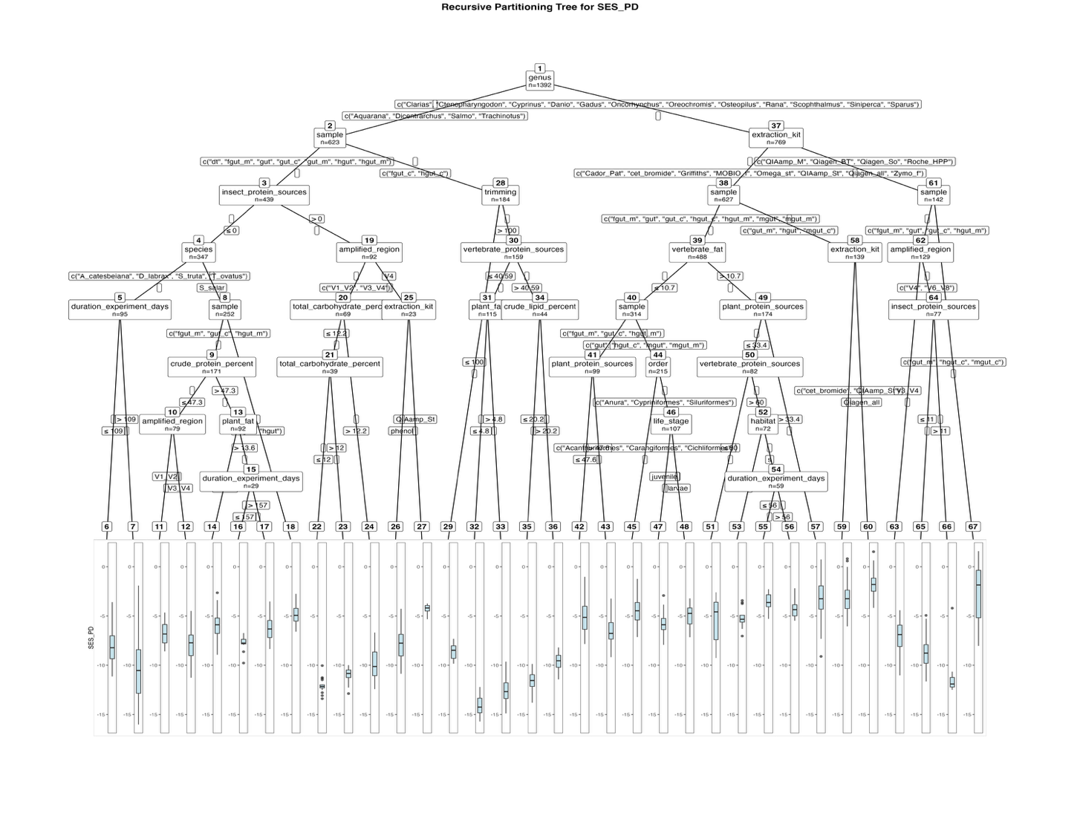
Fig. S1. Fitted party – Phylogenetic diversity - Faith’s Phylogenetic Diversity with Standardized Effect Size (SES-PD):

[1] root
| [2] genus in Aquarana, Dicentrarchus, Salmo, Trachinotus
| | [3] sample in dt, fgut_m, gut, gut_c, gut_m, hgut, hgut_m
| | | [4] insect_protein_sources <= 0
| | | | [5] species in A_catesbeiana, D_labrax, S_truta, T_ovatus
| | | | | [6] duration_experiment_days <= 109: -8.156 (n = 82, err = 205.2)
| | | | | [7] duration_experiment_days > 109: -10.332 (n = 13, err = 169.3)
| | | | [8] species in S_salar
| | | | | [9] sample in fgut_m, gut_c, hgut_m
| | | | | | [10] crude_protein_percent <= 47.3
| | | | | | | [11] amplified_region in V1_V2: -6.826 (n = 34, err = 46.5)
| | | | | | | [12] amplified_region in V3_V4: -7.947 (n = 45, err = 118.4)
| | | | | | [13] crude_protein_percent > 47.3
| | | | | | | [14] plant_fat <= 13.6: -5.909 (n = 63, err = 90.5)
| | | | | | | [15] plant_fat > 13.6
| | | | | | | | [16] duration_experiment_days <= 157: -7.738 (n = 15, err = 7.6)
| | | | | | | | [17] duration_experiment_days > 157: -6.198 (n = 14, err = 28.0)
| | | | | [18] sample in gut, hgut: -4.827 (n = 81, err = 61.2)
| | | [19] insect_protein_sources > 0
| | | | [20] amplified_region in V1_V2, V3_V4
| | | | | [21] total_carbohydrate_percent <= 12.2
| | | | | | [22] total_carbohydrate_percent <= 12: -12.097 (n = 24, err = 9.5)
| | | | | | [23] total_carbohydrate_percent > 12: -11.010 (n = 15, err = 9.7)
| | | | | [24] total_carbohydrate_percent > 12.2: -9.957 (n = 30, err = 61.7)
| | | | [25] amplified_region in V4
| | | | | [26] extraction_kit in phenol: -7.943 (n = 17, err = 46.1)
| | | | | [27] extraction_kit in QIAamp_St: -4.315 (n = 6, err = 1.7)
| | [28] sample in fgut_c, hgut_c
| | | [29] trimming <= 100: -8.579 (n = 25, err = 14.3)
| | | [30] trimming > 100
| | | | [31] vertebrate_protein_sources <= 40.59
| | | | | [32] plant_fat <= 4.8: -14.101 (n = 31, err = 28.0)
| | | | | [33] plant_fat > 4.8: -12.631 (n = 84, err = 94.5)
| | | | [34] vertebrate_protein_sources > 40.59
| | | | | [35] crude_lipid_percent <= 20.2: -11.615 (n = 23, err = 21.4)
| | | | | [36] crude_lipid_percent > 20.2: -9.642 (n = 21, err = 13.2)
| [37] genus in Clarias, Ctenopharyngodon, Cyprinus, Danio, Gadus, Oncorhynchus, Oreochromis, Osteopilus, Rana, Scophthalmus, Siniperca, Sparus
| | [38] extraction_kit in Cador_Pat, cet_bromide, Griffiths, MOBIO_f, Omega_st, QIAamp_St, Qiagen_all, Zymo_f
| | | [39] sample in fgut_m, gut, gut_c, hgut_c, hgut_m, mgut, mgut_m
| | | | [40] vertebrate_fat <= 10.7
| | | | | [41] sample in fgut_m, gut_c, hgut_m
| | | | | | [42] plant_protein_sources <= 47.6: -5.026 (n = 23, err = 73.5)
| | | | | | [43] plant_protein_sources > 47.6: -6.538 (n = 76, err = 104.5)
| | | | | [44] sample in gut, hgut_c, mgut, mgut_m
| | | | | | [45] order in Acanthuriformes, Carangiformes, Cichliformes: -4.399 (n = 108, err = 150.3)
| | | | | | [46] order in Anura, Cypriniformes, Siluriformes
| | | | | | | [47] life_stage in juvenile: -5.815 (n = 61, err = 55.9)
| | | | | | | [48] life_stage in larvae: -4.956 (n = 46, err = 52.4)
| | | | [49] vertebrate_fat > 10.7
| | | | | [50] plant_protein_sources <= 33.4
| | | | | | [51] vertebrate_protein_sources <= 60: -5.359 (n = 10, err = 49.3)
| | | | | | [52] vertebrate_protein_sources > 60
| | | | | | | [53] habitat in f: -5.149 (n = 13, err = 13.3)
| | | | | | | [54] habitat in s
| | | | | | | | [55] duration_experiment_days <= 56: -3.630 (n = 28, err = 20.7)
| | | | | | | | [56] duration_experiment_days > 56: -4.302 (n = 31, err = 20.1)
| | | | | [57] plant_protein_sources > 33.4: -3.282 (n = 92, err = 295.0)
| | | [58] sample in gut_m, hgut, mgut_c
| | | | [59] extraction_kit in cet_bromide, QIAamp_St: -3.114 (n = 73, err = 188.3)
| | | | [60] extraction_kit in Qiagen_all: -1.823 (n = 66, err = 71.5)
| | [61] extraction_kit in QIAamp_M, Qiagen_BT, Qiagen_So, Roche_HPP
| | | [62] sample in fgut_m, gut, gut_c, hgut_m
| | | | [63] amplified_region in V3_V4: -7.053 (n = 52, err = 124.6)
| | | | [64] amplified_region in V4, V6_V8
| | | | | [65] insect_protein_sources <= 11: -8.767 (n = 69, err = 147.9)
| | | | | [66] insect_protein_sources > 11: -10.901 (n = 8, err = 53.7)
| | | [67] sample in gut_m, hgut_c, mgut_c: -2.836 (n = 13, err = 108.7)

Number of inner nodes: 33
Number of terminal nodes: 34
Partitioning trees (based on the whole dataset) for genera and families whose number of reads correlated with diet descriptor variables
Model formulas:
Genus or Family ~ species + family + order + habitat + crude_protein_percent + vertebrate_protein_sources + plant_protein_sources + insect_protein_sources + crude_lipid_percent + vertebrate_fat + plant_fat + insect_fat + total_carbohydrate_percent + sample + preservation + extraction_kit + amplified_region + sequencing + strand + duration_experiment_days + life_stage + trimming

Results for the complete dataset – Genera:

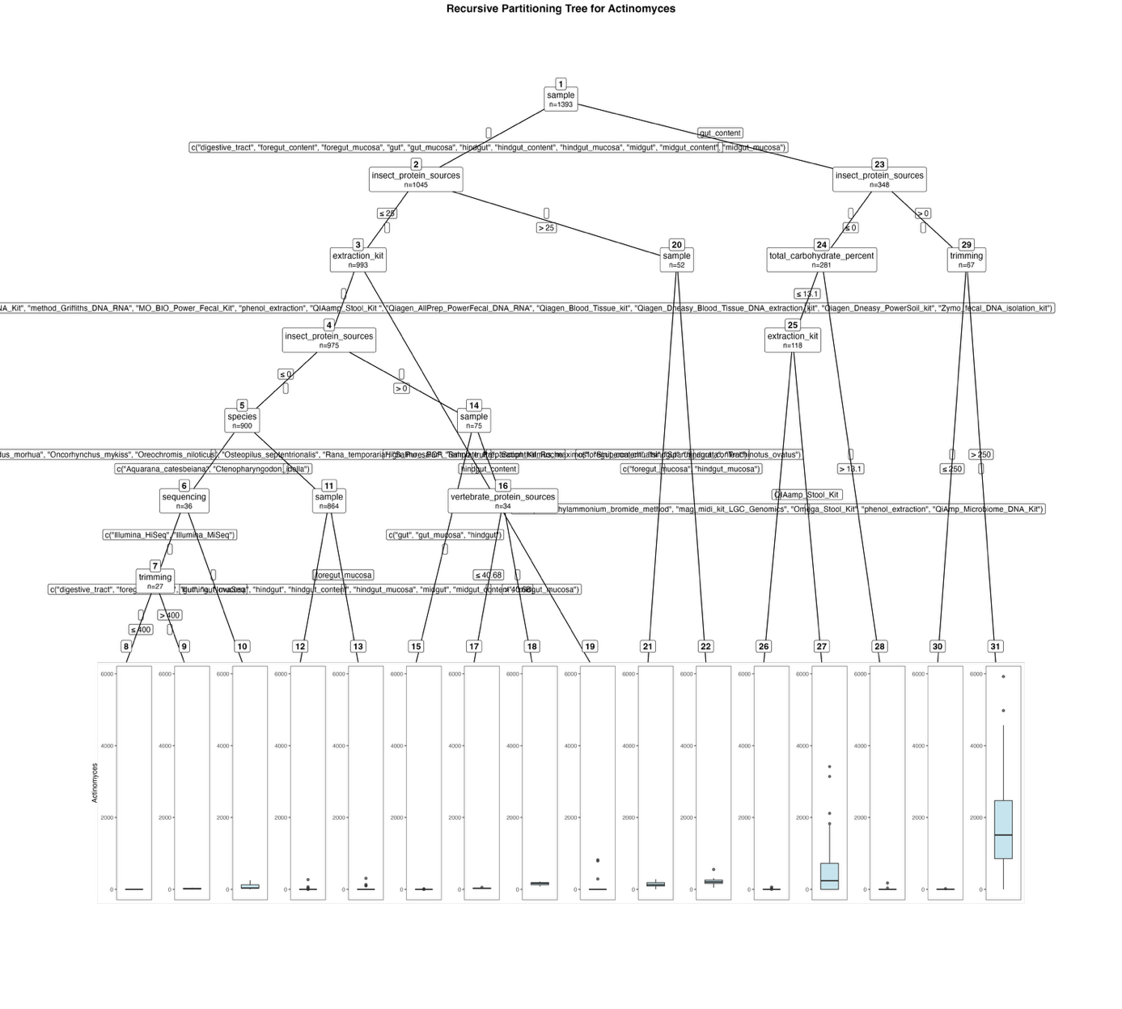
Fig. S2. Fitted party - Actinomyces:

[1] root
| [2] sample in digestive_tract, foregut_content, foregut_mucosa, gut, gut_mucosa, hindgut, hindgut_content, hindgut_mucosa, midgut, midgut_content, midgut_mucosa
| | [3] insect_protein_sources <= 25
| | | [4] extraction_kit in Cador_Pathogen_96_QIAcube_HT_Kit, cetyltrimethylammonium_bromide_method, EZNA_Stool_DNA_Kit, method_Griffiths_DNA_RNA, MO_BIO_Power_Fecal_Kit, phenol_extraction, QIAamp_Stool_Kit , Qiagen_AllPrep_PowerFecal_DNA_RNA, Qiagen_Blood_Tissue_kit, Qiagen_Dneasy_Blood_Tissue_DNA_extraction_kit, Qiagen_Dneasy_PowerSoil_kit, Zymo_fecal_DNA_isolation_kit
| | | | [5] insect_protein_sources <= 0
| | | | | [6] species in Aquarana_catesbeiana, Ctenopharyngodon_idella
| | | | | | [7] sequencing in Illumina_HiSeq, Illumina_MiSeq
| | | | | | | [8] trimming <= 400: 0.000 (n = 9, err = 0.0)
| | | | | | | [9] trimming > 400: 20.167 (n = 18, err = 3374.5)
| | | | | | [10] sequencing in Illumina_NovaSeq: 79.444 (n = 9, err = 52026.2)
| | | | | [11] species in Clarias_gariepinus, Danio_rerio, Dicentrarchus_labrax, Gadus_morhua, Oncorhynchus_mykiss, Oreochromis_niloticus, Osteopilus_septentrionalis, Rana_temporaria, Salmo_salar, Salmo_trutta, Scophthalmus_maximus, Siniperca_chuatsi, Sparus_aurata, Trachinotus_ovatus
| | | | | | [12] sample in digestive_tract, foregut_content, gut, gut_mucosa, hindgut, hindgut_content, hindgut_mucosa, midgut, midgut_content, midgut_mucosa: 0.541 (n = 814, err = 80260.2)
| | | | | | [13] sample in foregut_mucosa: 12.840 (n = 50, err = 124248.7)
| | | | [14] insect_protein_sources > 0
| | | | | [15] sample in gut, gut_mucosa, hindgut: 0.610 (n = 41, err = 213.8)
| | | | | [16] sample in hindgut_content
| | | | | | [17] vertebrate_protein_sources <= 40.68: 29.091 (n = 22, err = 2173.8)
| | | | | | [18] vertebrate_protein_sources > 40.68: 157.167 (n = 12, err = 20699.7)
| | | [19] extraction_kit in High_Pure_PCR_Template_Preparation_Kit_Roche: 105.722 (n = 18, err = 1184215.6)
| | [20] insect_protein_sources > 25
| | | [21] sample in foregut_content, hindgut, hindgut_content: 138.286 (n = 28, err = 127093.7)
| | | [22] sample in foregut_mucosa, hindgut_mucosa: 222.167 (n = 24, err = 219011.3)
| [23] sample in gut_content
| | [24] insect_protein_sources <= 0
| | | [25] total_carbohydrate_percent <= 13.1
| | | | [26] extraction_kit in cetyltrimethylammonium_bromide_method, mag_midi_kit_LGC_Genomics, Omega_Stool_Kit, phenol_extraction, QiAmp_Microbiome_DNA_Kit: 1.394 (n = 66, err = 4437.8)
| | | | [27] extraction_kit in QIAamp_Stool_Kit : 546.077 (n = 52, err = 31241897.7)
| | | [28] total_carbohydrate_percent > 13.1: 1.313 (n = 163, err = 32699.0)
| | [29] insect_protein_sources > 0
| | | [30] trimming <= 250: 4.375 (n = 8, err = 225.9)
| | | [31] trimming > 250: 1731.949 (n = 59, err = 104293668.8)

Number of inner nodes: 15
Number of terminal nodes: 16

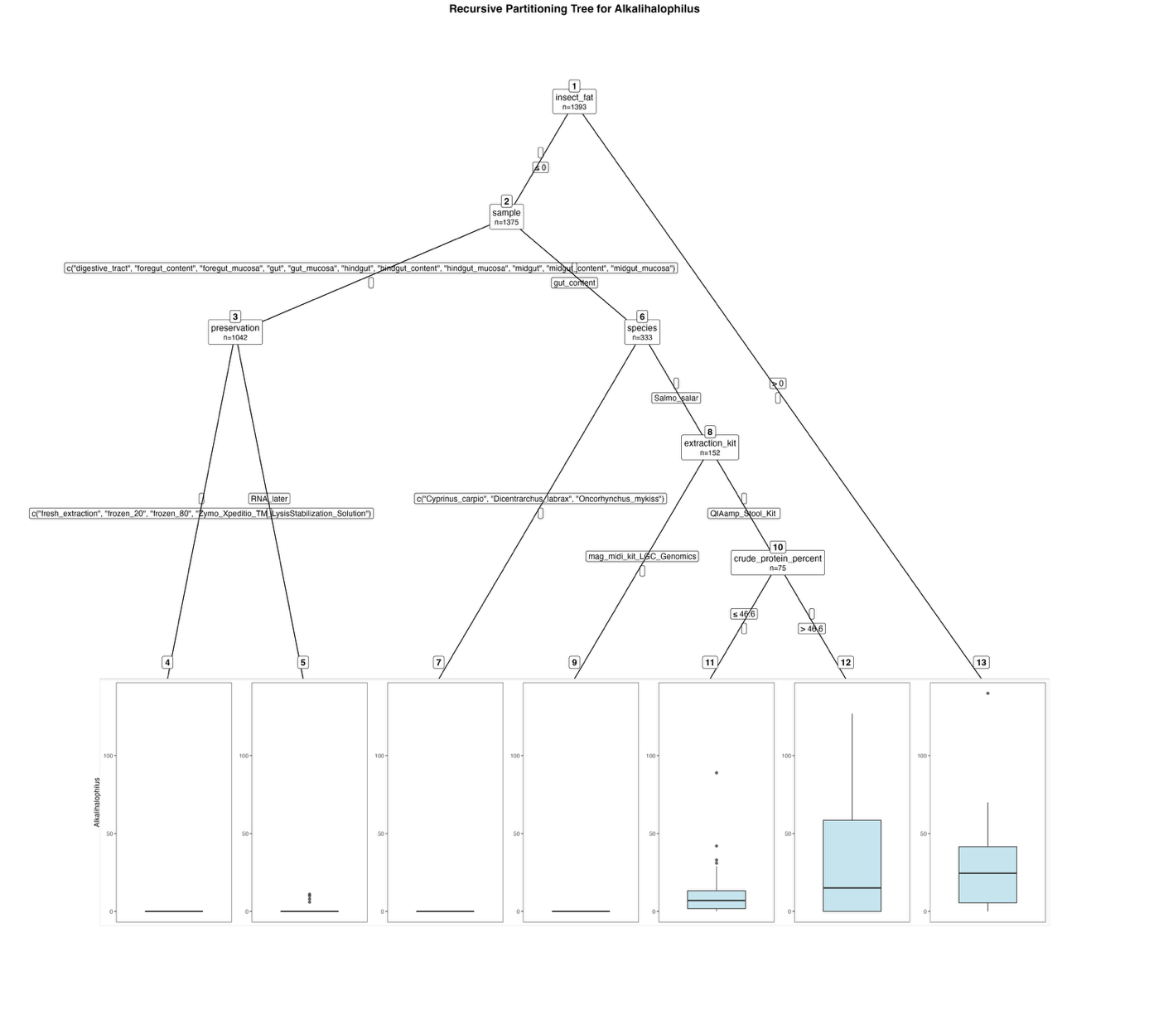
Fig. S3. Fitted party - Alkalihalophilus:

[1] root
| [2] insect_fat <= 0
| | [3] sample in digestive_tract, foregut_content, foregut_mucosa, gut, gut_mucosa, hindgut, hindgut_content, hindgut_mucosa, midgut, midgut_content, midgut_mucosa
| | | [4] preservation in fresh_extraction, frozen_20, frozen_80, Zymo_Xpeditio_TM_LysisStabilization_Solution: 0.000 (n = 1008, err = 0.0)
| | | [5] preservation in RNA_later: 1.029 (n = 34, err = 285.0)
| | [6] sample in gut_content
| | | [7] species in Cyprinus_carpio, Dicentrarchus_labrax, Oncorhynchus_mykiss: 0.000 (n = 181, err = 0.0)
| | | [8] species in Salmo_salar
| | | | [9] extraction_kit in mag_midi_kit_LGC_Genomics: 0.000 (n = 77, err = 0.0)
| | | | [10] extraction_kit in QIAamp_Stool_Kit
| | | | | [11] crude_protein_percent <= 46.6: 10.200 (n = 60, err = 11541.6)
| | | | | [12] crude_protein_percent > 46.6: 36.000 (n = 15, err = 27754.0)
| [13] insect_fat > 0: 31.444 (n = 18, err = 19808.4)

Number of inner nodes: 6
Number of terminal nodes: 7

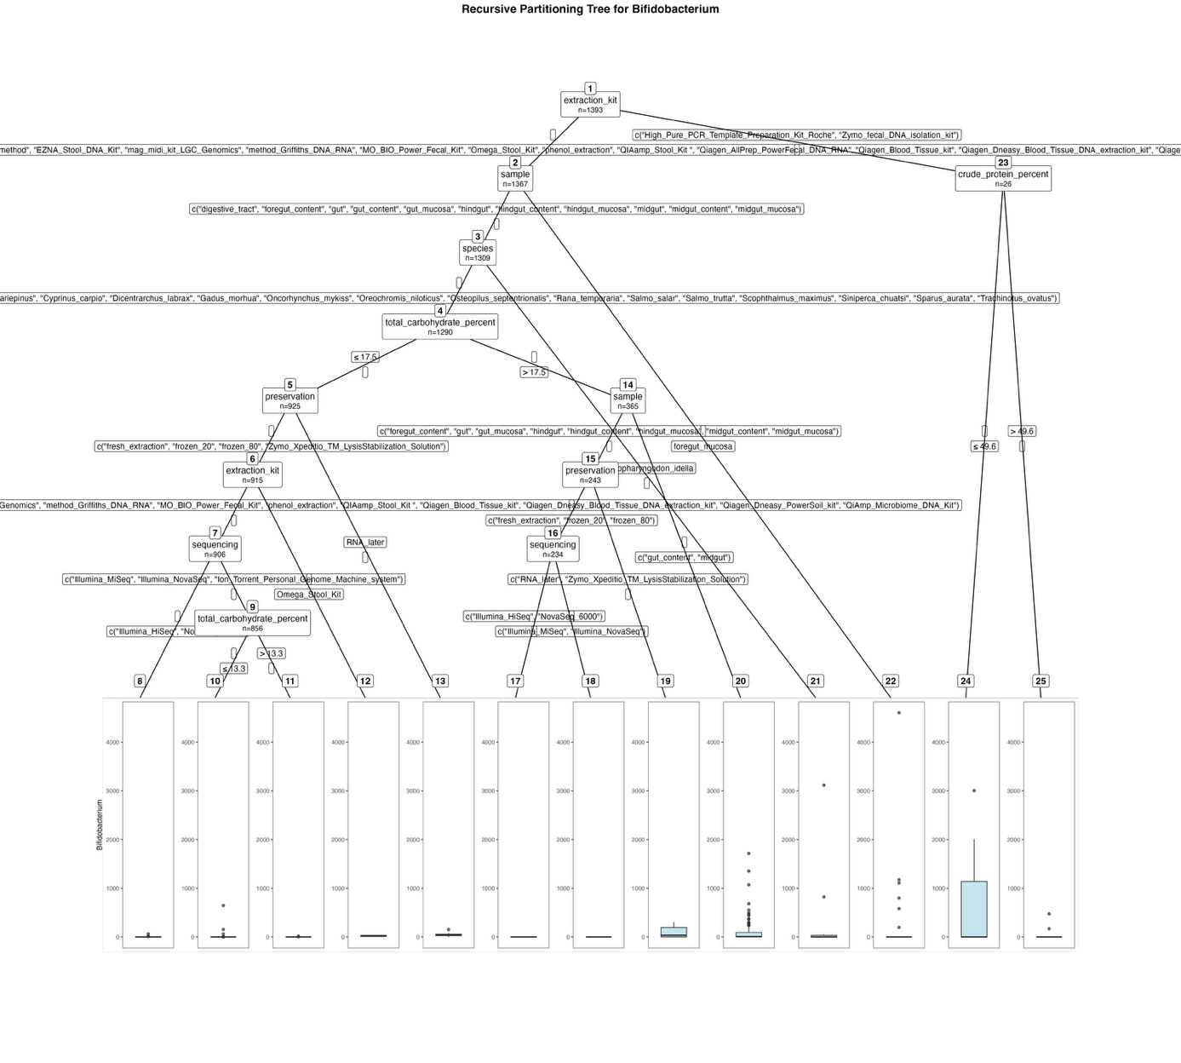
Fig. S4. Fitted party - Bifidobacterium:

[1] root
| [2] extraction_kit in Cador_Pathogen_96_QIAcube_HT_Kit, cetyltrimethylammonium_bromide_method, EZNA_Stool_DNA_Kit, mag_midi_kit_LGC_Genomics, method_Griffiths_DNA_RNA, MO_BIO_Power_Fecal_Kit, Omega_Stool_Kit, phenol_extraction, QIAamp_Stool_Kit , Qiagen_AllPrep_PowerFecal_DNA_RNA, Qiagen_Blood_Tissue_kit, Qiagen_Dneasy_Blood_Tissue_DNA_extraction_kit, Qiagen_Dneasy_PowerSoil_kit, QiAmp_Microbiome_DNA_Kit
| | [3] sample in digestive_tract, foregut_content, gut, gut_content, gut_mucosa, hindgut, hindgut_content, hindgut_mucosa, midgut, midgut_content, midgut_mucosa
| | | [4] species in Aquarana_catesbeiana, Clarias_gariepinus, Cyprinus_carpio, Dicentrarchus_labrax, Gadus_morhua, Oncorhynchus_mykiss, Oreochromis_niloticus, Osteopilus_septentrionalis, Rana_temporaria, Salmo_salar, Salmo_trutta, Scophthalmus_maximus, Siniperca_chuatsi, Sparus_aurata, Trachinotus_ovatus
| | | | [5] total_carbohydrate_percent <= 17.5
| | | | | [6] preservation in fresh_extraction, frozen_20, frozen_80, Zymo_Xpeditio_TM_LysisStabilization_Solution
| | | | | | [7] extraction_kit in Cador_Pathogen_96_QIAcube_HT_Kit, cetyltrimethylammonium_bromide_method, EZNA_Stool_DNA_Kit, mag_midi_kit_LGC_Genomics, method_Griffiths_DNA_RNA, MO_BIO_Power_Fecal_Kit, phenol_extraction, QIAamp_Stool_Kit , Qiagen_Blood_Tissue_kit, Qiagen_Dneasy_Blood_Tissue_DNA_extraction_kit, Qiagen_Dneasy_PowerSoil_kit, QiAmp_Microbiome_DNA_Kit
| | | | | | | [8] sequencing in Illumina_HiSeq, NovaSeq_6000: 2.740 (n = 50, err = 4463.6)
| | | | | | | [9] sequencing in Illumina_MiSeq, Illumina_NovaSeq, Ion_Torrent_Personal_Genome_Machine_system
| | | | | | | | [10] total_carbohydrate_percent <= 13.3: 1.052 (n = 829, err = 442836.8)
| | | | | | | | [11] total_carbohydrate_percent > 13.3: 0.704 (n = 27, err = 279.6)
| | | | | | [12] extraction_kit in Omega_Stool_Kit: 22.111 (n = 9, err = 1660.9)
| | | | | [13] preservation in RNA_later: 48.800 (n = 10, err = 16651.6)
| | | | [14] total_carbohydrate_percent > 17.5
| | | | | [15] sample in foregut_content, gut, gut_mucosa, hindgut, hindgut_content, hindgut_mucosa, midgut_content, midgut_mucosa
| | | | | | [16] preservation in fresh_extraction, frozen_20, frozen_80
| | | | | | | [17] sequencing in Illumina_HiSeq, NovaSeq_6000: 2.308 (n = 13, err = 138.8)
| | | | | | | [18] sequencing in Illumina_MiSeq, Illumina_NovaSeq: 0.000 (n = 221, err = 0.0)
| | | | | | [19] preservation in RNA_later, Zymo_Xpeditio_TM_LysisStabilization_Solution: 97.667 (n = 9, err = 119304.0)
| | | | | [20] sample in gut_content, midgut: 103.352 (n = 122, err = 7188929.8)
| | | [21] species in Ctenopharyngodon_idella: 218.211 (n = 19, err = 9494499.2)
| | [22] sample in foregut_mucosa: 145.862 (n = 58, err = 23555618.9)
| [23] extraction_kit in High_Pure_PCR_Template_Preparation_Kit_Roche, Zymo_fecal_DNA_isolation_kit
| | [24] crude_protein_percent <= 49.6: 634.706 (n = 17, err = 13760343.5)
| | [25] crude_protein_percent > 49.6: 71.556 (n = 9, err = 207494.2)

Number of inner nodes: 12
Number of terminal nodes: 13

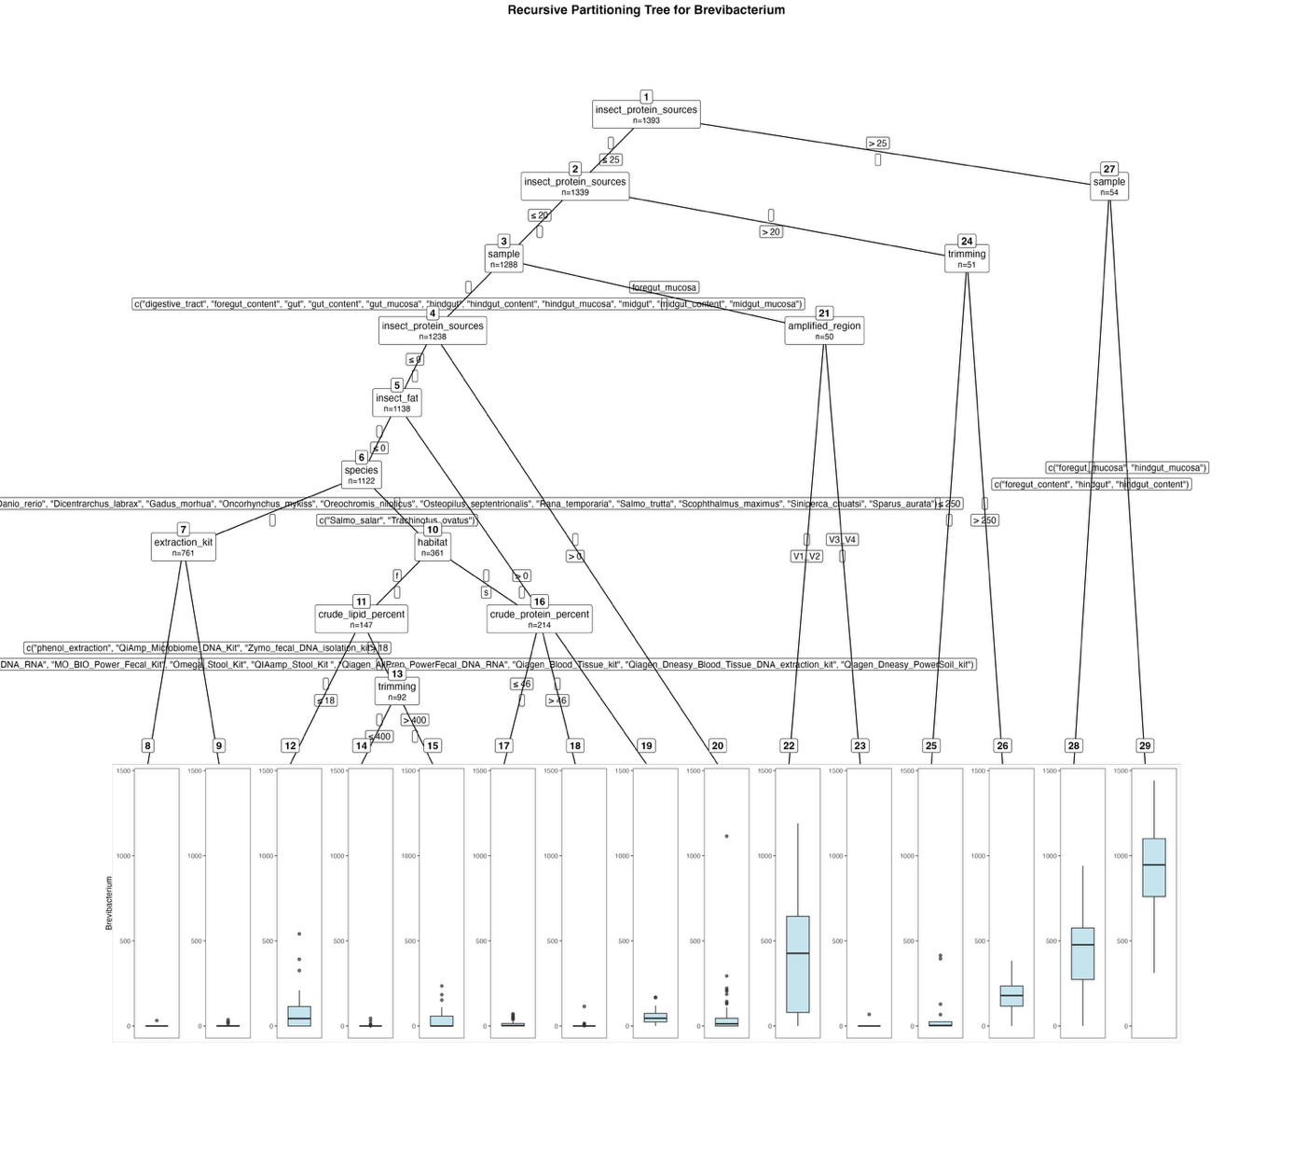
Fig. S5. Fitted party - Brevibacterium:

[1] root
| [2] insect_protein_sources <= 25
| | [3] insect_protein_sources <= 20
| | | [4] sample in digestive_tract, foregut_content, gut, gut_content, gut_mucosa, hindgut, hindgut_content, hindgut_mucosa, midgut, midgut_content, midgut_mucosa
| | | | [5] insect_protein_sources <= 0
| | | | | [6] insect_fat <= 0
| | | | | | [7] species in Aquarana_catesbeiana, Clarias_gariepinus, Ctenopharyngodon_idella, Cyprinus_carpio, Danio_rerio, Dicentrarchus_labrax, Gadus_morhua, Oncorhynchus_mykiss, Oreochromis_niloticus, Osteopilus_septentrionalis, Rana_temporaria, Salmo_trutta, Scophthalmus_maximus, Siniperca_chuatsi, Sparus_aurata
| | | | | | | [8] extraction_kit in Cador_Pathogen_96_QIAcube_HT_Kit, cetyltrimethylammonium_bromide_method, High_Pure_PCR_Template_Preparation_Kit_Roche, method_Griffiths_DNA_RNA, MO_BIO_Power_Fecal_Kit, Omega_Stool_Kit, QIAamp_Stool_Kit , Qiagen_AllPrep_PowerFecal_DNA_RNA, Qiagen_Blood_Tissue_kit, Qiagen_Dneasy_Blood_Tissue_DNA_extraction_kit, Qiagen_Dneasy_PowerSoil_kit: 0.044 (n = 730, err = 1022.6)
| | | | | | | [9] extraction_kit in phenol_extraction, QiAmp_Microbiome_DNA_Kit, Zymo_fecal_DNA_isolation_kit: 3.806 (n = 31, err = 2262.8)
| | | | | | [10] species in Salmo_salar, Trachinotus_ovatus
| | | | | | | [11] habitat in f
| | | | | | | | [12] crude_lipid_percent <= 18: 78.545 (n = 55, err = 572231.6)
| | | | | | | | [13] crude_lipid_percent > 18
| | | | | | | | | [14] trimming <= 400: 1.597 (n = 77, err = 2970.5)
| | | | | | | | | [15] trimming > 400: 45.800 (n = 15, err = 93066.4)
| | | | | | | [16] habitat in s
| | | | | | | | [17] crude_protein_percent <= 46: 9.388 (n = 98, err = 21893.3)
| | | | | | | | [18] crude_protein_percent > 46: 1.362 (n = 116, err = 13454.8)
| | | | | [19] insect_fat > 0: 57.750 (n = 16, err = 42503.0)
| | | | [20] insect_protein_sources > 0: 43.940 (n = 100, err = 1454717.6)
| | | [21] sample in foregut_mucosa
| | | | [22] amplified_region in V1_V2: 417.750 (n = 12, err = 1465452.2)
| | | | [23] amplified_region in V3_V4: 1.789 (n = 38, err = 4502.3)
| | [24] insect_protein_sources > 20
| | | [25] trimming <= 250: 54.850 (n = 20, err = 289796.6)
| | | [26] trimming > 250: 180.742 (n = 31, err = 290795.9)
| [27] insect_protein_sources > 25
| | [28] sample in foregut_content, hindgut, hindgut_content: 440.567 (n = 30, err = 1664945.4)
| | [29] sample in foregut_mucosa, hindgut_mucosa: 920.333 (n = 24, err = 1955249.3)

Number of inner nodes: 14
Number of terminal nodes: 15

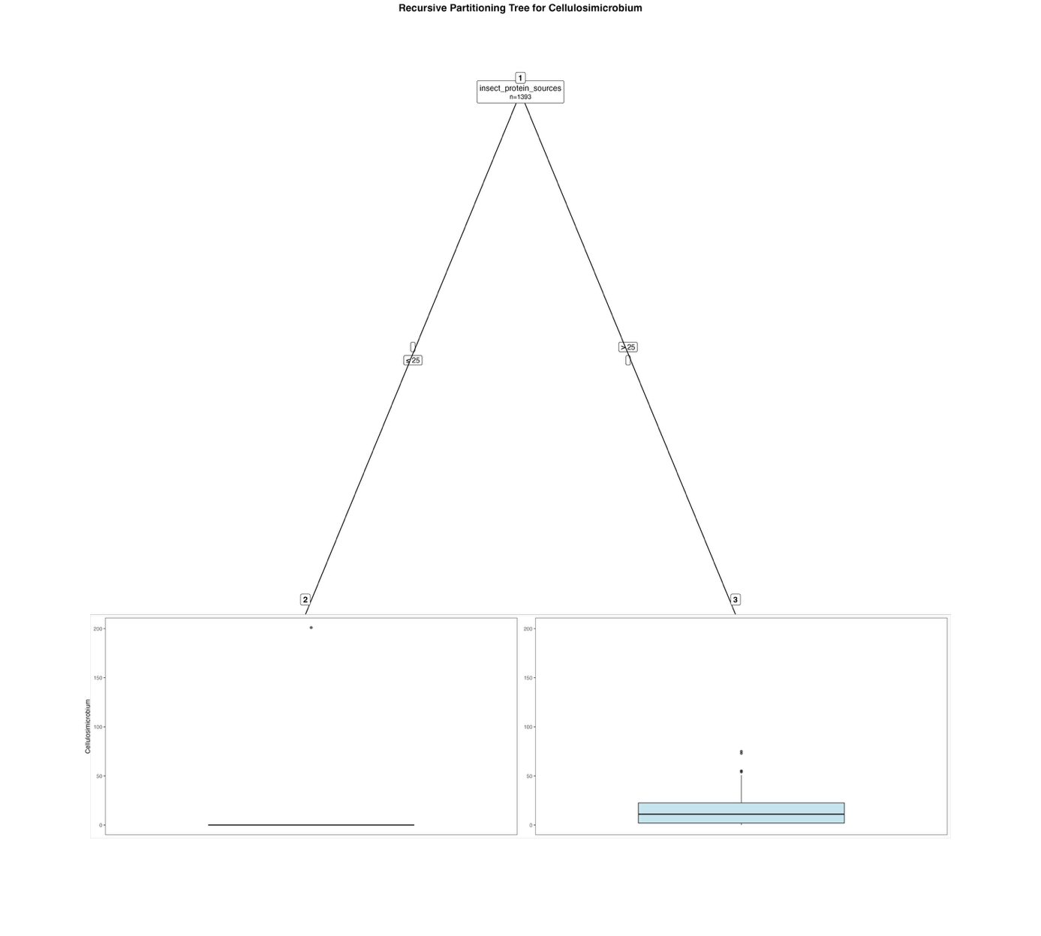
Fig. S6. Fitted party - Cellulosimicrobium:

[1] root
| [2] insect_protein_sources <= 25: 0.150 (n = 1338, err = 40370.8)
| [3] insect_protein_sources > 25: 17.055 (n = 55, err = 19412.8)

Number of inner nodes: 1
Number of terminal nodes: 2

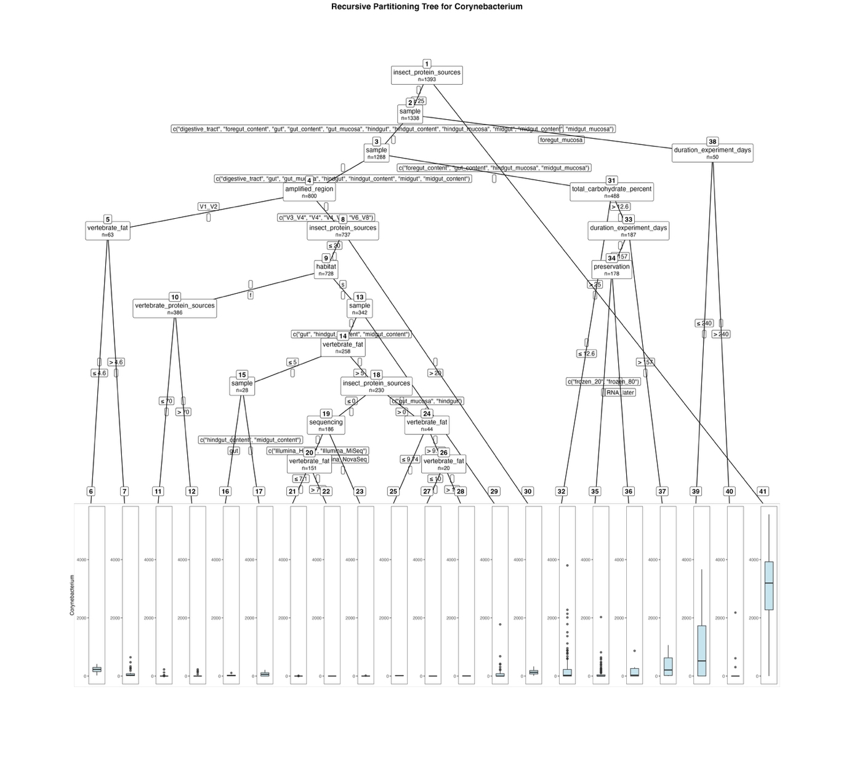
Fig. S7. Fitted party - Corynebacterium:

[1] root
| [2] insect_protein_sources <= 25
| | [3] sample in digestive_tract, foregut_content, gut, gut_content, gut_mucosa, hindgut, hindgut_content, hindgut_mucosa, midgut, midgut_content, midgut_mucosa
| | | [4] sample in digestive_tract, gut, gut_mucosa, hindgut, hindgut_content, midgut, midgut_content
| | | | [5] amplified_region in V1_V2
| | | | | [6] vertebrate_fat <= 4.6: 219.857 (n = 14, err = 159871.7)
| | | | | [7] vertebrate_fat > 4.6: 75.735 (n = 49, err = 791125.6)
| | | | [8] amplified_region in V3_V4, V4, V4_V5, V6_V8
| | | | | [9] insect_protein_sources <= 20
| | | | | | [10] habitat in f
| | | | | | | [11] vertebrate_protein_sources <= 70: 1.485 (n = 355, err = 69000.7)
| | | | | | | [12] vertebrate_protein_sources > 70: 24.548 (n = 31, err = 112707.7)
| | | | | | [13] habitat in s
| | | | | | | [14] sample in gut, hindgut_content, midgut_content
| | | | | | | | [15] vertebrate_fat <= 5
| | | | | | | | | [16] sample in gut: 23.562 (n = 16, err = 11289.9)
| | | | | | | | | [17] sample in hindgut_content, midgut_content: 67.083 (n = 12, err = 53914.9)
| | | | | | | | [18] vertebrate_fat > 5
| | | | | | | | | [19] insect_protein_sources <= 0
| | | | | | | | | | [20] sequencing in Illumina_HiSeq, Illumina_MiSeq
| | | | | | | | | | | [21] vertebrate_fat <= 7.1: 0.750 (n = 60, err = 179.2)
| | | | | | | | | | | [22] vertebrate_fat > 7.1: 0.000 (n = 91, err = 0.0)
| | | | | | | | | | [23] sequencing in Illumina_NovaSeq: 2.457 (n = 35, err = 498.7)
| | | | | | | | | [24] insect_protein_sources > 0
| | | | | | | | | | [25] vertebrate_fat <= 9.74: 13.750 (n = 24, err = 722.5)
| | | | | | | | | | [26] vertebrate_fat > 9.74
| | | | | | | | | | | [27] vertebrate_fat <= 10: 0.000 (n = 10, err = 0.0)
| | | | | | | | | | | [28] vertebrate_fat > 10: 3.300 (n = 10, err = 28.1)
| | | | | | | [29] sample in gut_mucosa, hindgut: 78.083 (n = 84, err = 3933212.4)
| | | | | [30] insect_protein_sources > 20: 147.111 (n = 9, err = 91916.9)
| | | [31] sample in foregut_content, gut_content, hindgut_mucosa, midgut_mucosa
| | | | [32] total_carbohydrate_percent <= 12.6: 176.239 (n = 301, err = 42577528.8)
| | | | [33] total_carbohydrate_percent > 12.6
| | | | | [34] duration_experiment_days <= 157
| | | | | | [35] preservation in frozen_20, frozen_80: 72.765 (n = 170, err = 6819888.6)
| | | | | | [36] preservation in RNA_later: 184.750 (n = 8, err = 636671.5)
| | | | | [37] duration_experiment_days > 157: 366.000 (n = 9, err = 1247808.0)
| | [38] sample in foregut_mucosa
| | | [39] duration_experiment_days <= 240: 906.767 (n = 30, err = 29911353.4)
| | | [40] duration_experiment_days > 240: 154.900 (n = 20, err = 4740699.8)
| [41] insect_protein_sources > 25: 3051.255 (n = 55, err = 99355512.4)

Number of inner nodes: 20
Number of terminal nodes: 21

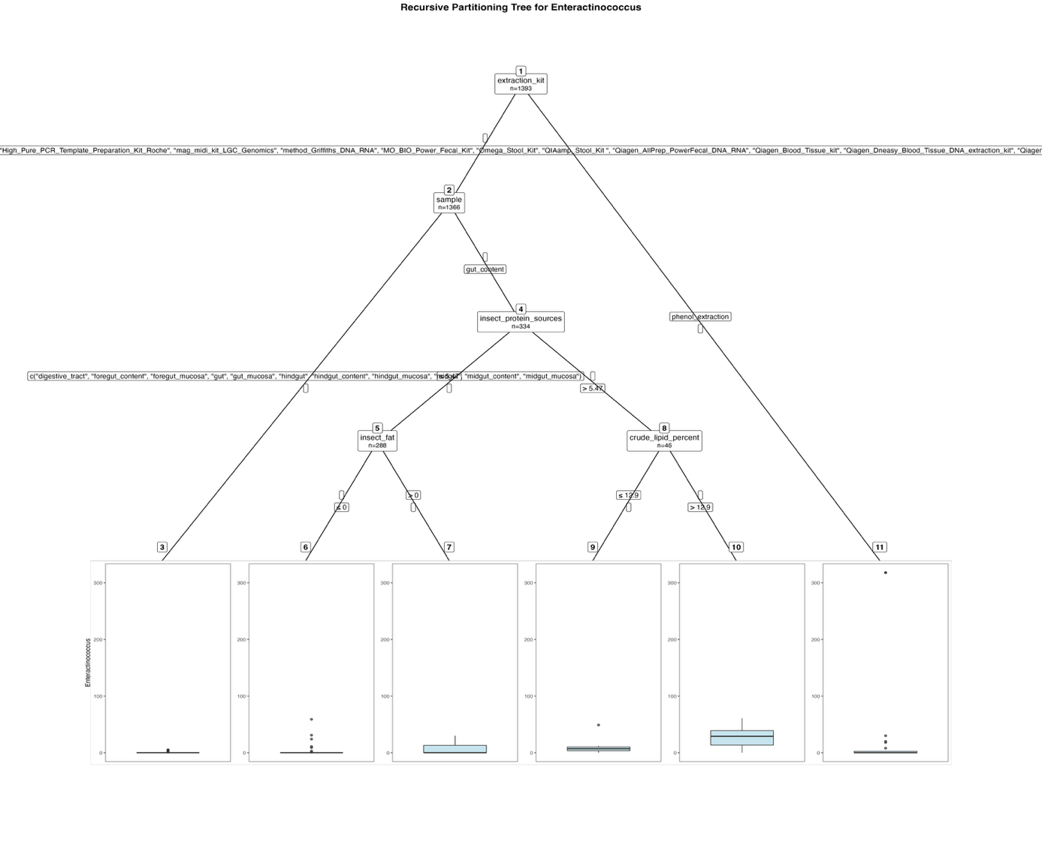
Fig. S8. Fitted party - Enteractinococcus:

[1] root
| [2] extraction_kit in Cador_Pathogen_96_QIAcube_HT_Kit, cetyltrimethylammonium_bromide_method, EZNA_Stool_DNA_Kit, High_Pure_PCR_Template_Preparation_Kit_Roche, mag_midi_kit_LGC_Genomics, method_Griffiths_DNA_RNA, MO_BIO_Power_Fecal_Kit, Omega_Stool_Kit, QIAamp_Stool_Kit , Qiagen_AllPrep_PowerFecal_DNA_RNA, Qiagen_Blood_Tissue_kit, Qiagen_Dneasy_Blood_Tissue_DNA_extraction_kit, Qiagen_Dneasy_PowerSoil_kit, QiAmp_Microbiome_DNA_Kit, Zymo_fecal_DNA_isolation_kit
| | [3] sample in digestive_tract, foregut_content, foregut_mucosa, gut, gut_mucosa, hindgut, hindgut_content, hindgut_mucosa, midgut, midgut_content, midgut_mucosa: 0.031 (n = 1032, err = 129.0)
| | [4] sample in gut_content
| | | [5] insect_protein_sources <= 5.47
| | | | [6] insect_fat <= 0: 0.505 (n = 273, err = 5160.2)
| | | | [7] insect_fat > 0: 8.400 (n = 15, err = 1755.6)
| | | [8] insect_protein_sources > 5.47
| | | | [9] crude_lipid_percent <= 12.9: 8.933 (n = 15, err = 1968.9)
| | | | [10] crude_lipid_percent > 12.9: 27.032 (n = 31, err = 8697.0)
| [11] extraction_kit in phenol_extraction: 26.556 (n = 27, err = 184908.7)

Number of inner nodes: 5
Number of terminal nodes: 6
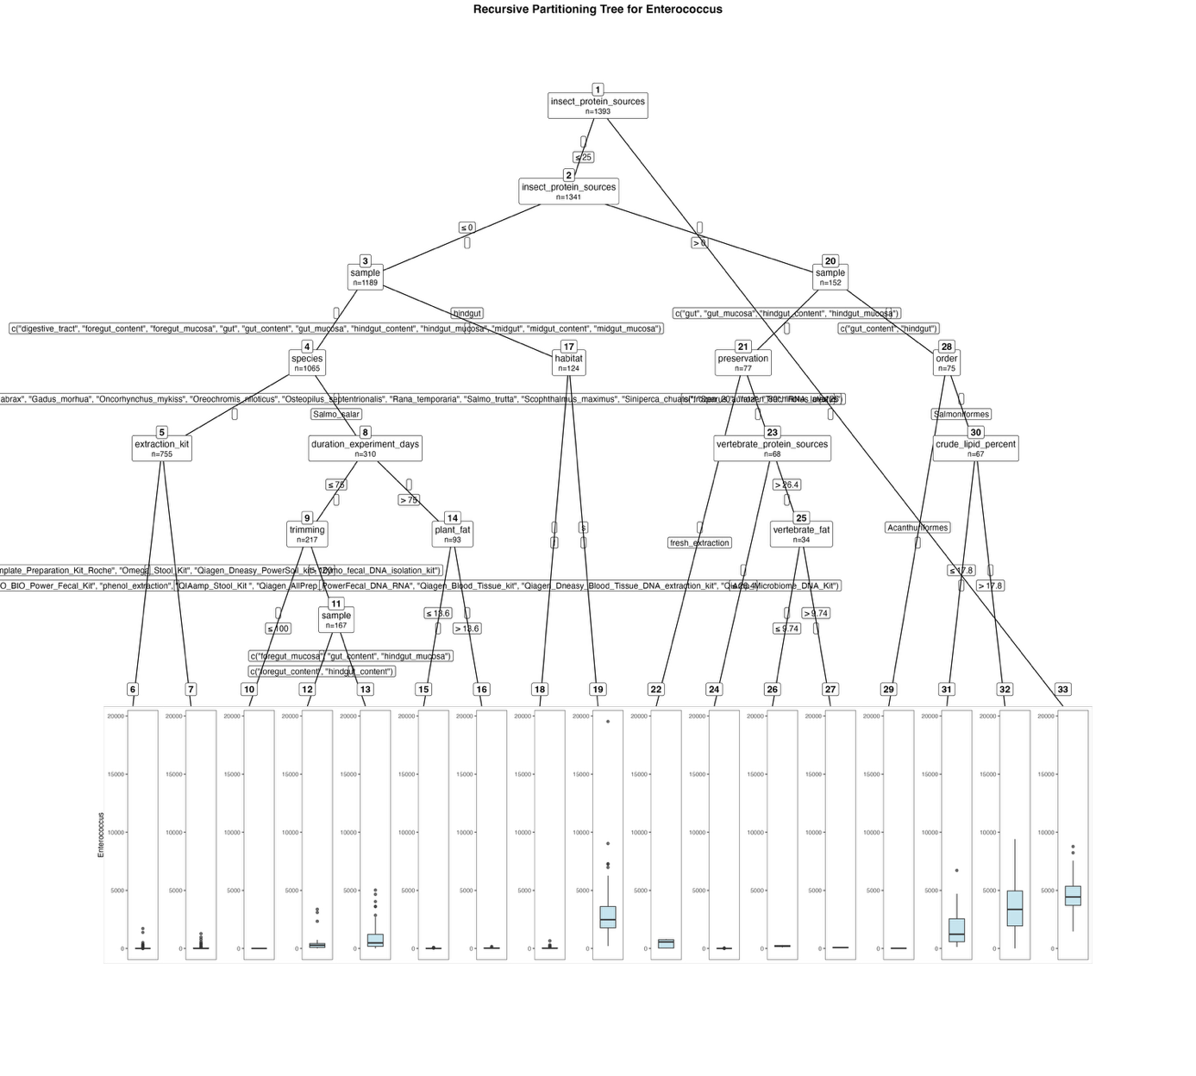
Fig. S9. Fitted party - Enterococcus:

[1] root
| [2] insect_protein_sources <= 25
| | [3] insect_protein_sources <= 0
| | | [4] sample in digestive_tract, foregut_content, foregut_mucosa, gut, gut_content, gut_mucosa, hindgut_content, hindgut_mucosa, midgut, midgut_content, midgut_mucosa
| | | | [5] species in Clarias_gariepinus, Ctenopharyngodon_idella, Cyprinus_carpio, Danio_rerio, Dicentrarchus_labrax, Gadus_morhua, Oncorhynchus_mykiss, Oreochromis_niloticus, Osteopilus_septentrionalis, Rana_temporaria, Salmo_trutta, Scophthalmus_maximus, Siniperca_chuatsi, Sparus_aurata, Trachinotus_ovatus
| | | | | [6] extraction_kit in Cador_Pathogen_96_QIAcube_HT_Kit, cetyltrimethylammonium_bromide_method, EZNA_Stool_DNA_Kit, method_Griffiths_DNA_RNA, MO_BIO_Power_Fecal_Kit, phenol_extraction, QIAamp_Stool_Kit , Qiagen_AllPrep_PowerFecal_DNA_RNA, Qiagen_Blood_Tissue_kit, Qiagen_Dneasy_Blood_Tissue_DNA_extraction_kit, QiAmp_Microbiome_DNA_Kit: 13.088 (n = 682, err = 5872956.7)
| | | | | [7] extraction_kit in High_Pure_PCR_Template_Preparation_Kit_Roche, Omega_Stool_Kit, Qiagen_Dneasy_PowerSoil_kit, Zymo_fecal_DNA_isolation_kit: 89.000 (n = 73, err = 3714012.0)
| | | | [8] species in Salmo_salar
| | | | | [9] duration_experiment_days <= 75
| | | | | | [10] trimming <= 100: 0.000 (n = 50, err = 0.0)
| | | | | | [11] trimming > 100
| | | | | | | [12] sample in foregut_content, hindgut_content: 354.939 (n = 98, err = 24989631.6)
| | | | | | | [13] sample in foregut_mucosa, gut_content, hindgut_mucosa: 912.928 (n = 69, err = 90323540.6)
| | | | | [14] duration_experiment_days > 75
| | | | | | [15] plant_fat <= 13.6: 11.031 (n = 64, err = 22177.9)
| | | | | | [16] plant_fat > 13.6: 36.862 (n = 29, err = 50271.4)
| | | [17] sample in hindgut
| | | | [18] habitat in f: 48.302 (n = 63, err = 571747.3)
| | | | [19] habitat in s: 3115.574 (n = 61, err = 488699144.9)
| | [20] insect_protein_sources > 0
| | | [21] sample in gut, gut_mucosa, hindgut_content, hindgut_mucosa
| | | | [22] preservation in fresh_extraction: 426.000 (n = 9, err = 947290.0)
| | | | [23] preservation in frozen_20, frozen_80, RNA_later
| | | | | [24] vertebrate_protein_sources <= 26.4: 2.059 (n = 34, err = 1313.9)
| | | | | [25] vertebrate_protein_sources > 26.4
| | | | | | [26] vertebrate_fat <= 9.74: 197.542 (n = 24, err = 85738.0)
| | | | | | [27] vertebrate_fat > 9.74: 76.900 (n = 10, err = 2448.9)
| | | [28] sample in gut_content, hindgut
| | | | [29] order in Acanthuriformes: 13.875 (n = 8, err = 1152.9)
| | | | [30] order in Salmoniformes
| | | | | [31] crude_lipid_percent <= 17.8: 1711.800 (n = 30, err = 71176838.8)
| | | | | [32] crude_lipid_percent > 17.8: 3526.514 (n = 37, err = 158287379.2)
| [33] insect_protein_sources > 25: 4641.096 (n = 52, err = 128495494.5)

Number of inner nodes: 16
Number of terminal nodes: 17

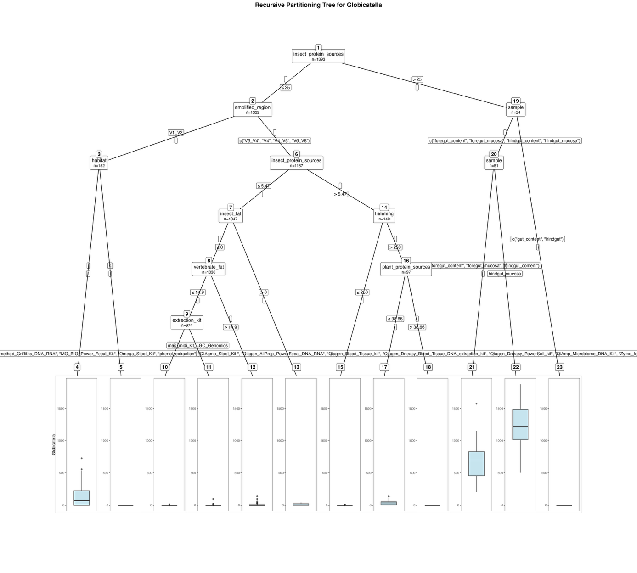
Fig. S10. Fitted party - Globicatella:

[1] root
| [2] insect_protein_sources <= 25
| | [3] amplified_region in V1_V2
| | | [4] habitat in f: 142.093 (n = 54, err = 1637430.5)
| | | [5] habitat in s: 0.000 (n = 98, err = 0.0)
| | [6] amplified_region in V3_V4, V4, V4_V5, V6_V8
| | | [7] insect_protein_sources <= 5.47
| | | | [8] insect_fat <= 0
| | | | | [9] vertebrate_fat <= 14.9
| | | | | | [10] extraction_kit in Cador_Pathogen_96_QIAcube_HT_Kit, cetyltrimethylammonium_bromide_method, EZNA_Stool_DNA_Kit, High_Pure_PCR_Template_Preparation_Kit_Roche, method_Griffiths_DNA_RNA, MO_BIO_Power_Fecal_Kit, Omega_Stool_Kit, phenol_extraction, QIAamp_Stool_Kit , Qiagen_AllPrep_PowerFecal_DNA_RNA, Qiagen_Blood_Tissue_kit, Qiagen_Dneasy_Blood_Tissue_DNA_extraction_kit, Qiagen_Dneasy_PowerSoil_kit, QiAmp_Microbiome_DNA_Kit, Zymo_fecal_DNA_isolation_kit: 0.013 (n = 889, err = 103.8)
| | | | | | [11] extraction_kit in mag_midi_kit_LGC_Genomics: 2.341 (n = 85, err = 9919.1)
| | | | | [12] vertebrate_fat > 14.9: 9.625 (n = 56, err = 32217.1)
| | | | [13] insect_fat > 0: 9.765 (n = 17, err = 2669.1)
| | | [14] insect_protein_sources > 5.47
| | | | [15] trimming <= 250: 0.326 (n = 43, err = 69.4)
| | | | [16] trimming > 250
| | | | | [17] plant_protein_sources <= 38.66: 34.146 (n = 82, err = 81330.2)
| | | | | [18] plant_protein_sources > 38.66: 0.000 (n = 15, err = 0.0)
| [19] insect_protein_sources > 25
| | [20] sample in foregut_content, foregut_mucosa, hindgut_content, hindgut_mucosa
| | | [21] sample in foregut_content, foregut_mucosa, hindgut_content: 683.795 (n = 39, err = 2794044.4)
| | | [22] sample in hindgut_mucosa: 1209.417 (n = 12, err = 1547874.9)
| | [23] sample in gut_content, hindgut: 0.000 (n = 3, err = 0.0)

Number of inner nodes: 11
Number of terminal nodes: 12

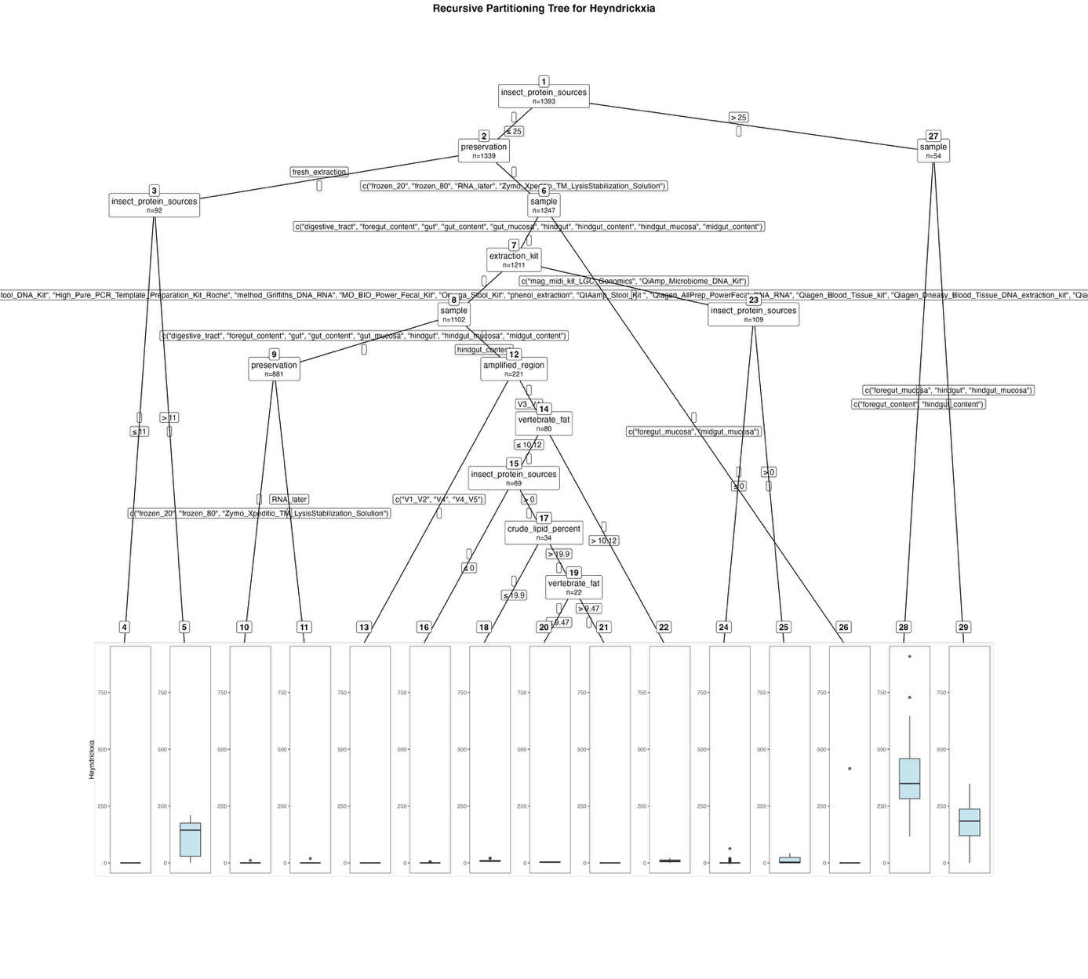
Fig. S11. Fitted party - Heyndrickxia:

[1] root
| [2] insect_protein_sources <= 25
| | [3] preservation in fresh_extraction
| | | [4] insect_protein_sources <= 11: 0.000 (n = 84, err = 0.0)
| | | [5] insect_protein_sources > 11: 114.750 (n = 8, err = 50961.5)
| | [6] preservation in frozen_20, frozen_80, RNA_later, Zymo_Xpeditio_TM_LysisStabilization_Solution
| | | [7] sample in digestive_tract, foregut_content, gut, gut_content, gut_mucosa, hindgut, hindgut_content, hindgut_mucosa, midgut_content
| | | | [8] extraction_kit in Cador_Pathogen_96_QIAcube_HT_Kit, cetyltrimethylammonium_bromide_method, EZNA_Stool_DNA_Kit, High_Pure_PCR_Template_Preparation_Kit_Roche, method_Griffiths_DNA_RNA, MO_BIO_Power_Fecal_Kit, Omega_Stool_Kit, phenol_extraction, QIAamp_Stool_Kit , Qiagen_AllPrep_PowerFecal_DNA_RNA, Qiagen_Blood_Tissue_kit, Qiagen_Dneasy_Blood_Tissue_DNA_extraction_kit, Qiagen_Dneasy_PowerSoil_kit, Zymo_fecal_DNA_isolation_kit
| | | | | [9] sample in digestive_tract, foregut_content, gut, gut_content, gut_mucosa, hindgut, hindgut_mucosa, midgut_content
| | | | | | [10] preservation in frozen_20, frozen_80, Zymo_Xpeditio_TM_LysisStabilization_Solution: 0.013 (n = 847, err = 120.9)
| | | | | | [11] preservation in RNA_later: 0.559 (n = 34, err = 350.4)
| | | | | [12] sample in hindgut_content
| | | | | | [13] amplified_region in V1_V2, V4, V4_V5: 0.000 (n = 141, err = 0.0)
| | | | | | [14] amplified_region in V3_V4
| | | | | | | [15] vertebrate_fat <= 10.12
| | | | | | | | [16] insect_protein_sources <= 0: 0.286 (n = 35, err = 47.1)
| | | | | | | | [17] insect_protein_sources > 0
| | | | | | | | | [18] crude_lipid_percent <= 19.9: 9.833 (n = 12, err = 345.7)
| | | | | | | | | [19] crude_lipid_percent > 19.9
| | | | | | | | | | [20] vertebrate_fat <= 9.47: 3.500 (n = 12, err = 61.0)
| | | | | | | | | | [21] vertebrate_fat > 9.47: 0.000 (n = 10, err = 0.0)
| | | | | | | [22] vertebrate_fat > 10.12: 8.909 (n = 11, err = 396.9)
| | | | [23] extraction_kit in mag_midi_kit_LGC_Genomics, QiAmp_Microbiome_DNA_Kit
| | | | | [24] insect_protein_sources <= 0: 1.701 (n = 97, err = 5100.3)
| | | | | [25] insect_protein_sources > 0: 11.333 (n = 12, err = 2550.7)
| | | [26] sample in foregut_mucosa, midgut_mucosa: 11.528 (n = 36, err = 167441.0)
| [27] insect_protein_sources > 25
| | [28] sample in foregut_content, hindgut_content: 394.185 (n = 27, err = 777820.1)
| | [29] sample in foregut_mucosa, hindgut, hindgut_mucosa: 174.111 (n = 27, err = 264198.7)

Number of inner nodes: 14
Number of terminal nodes: 15

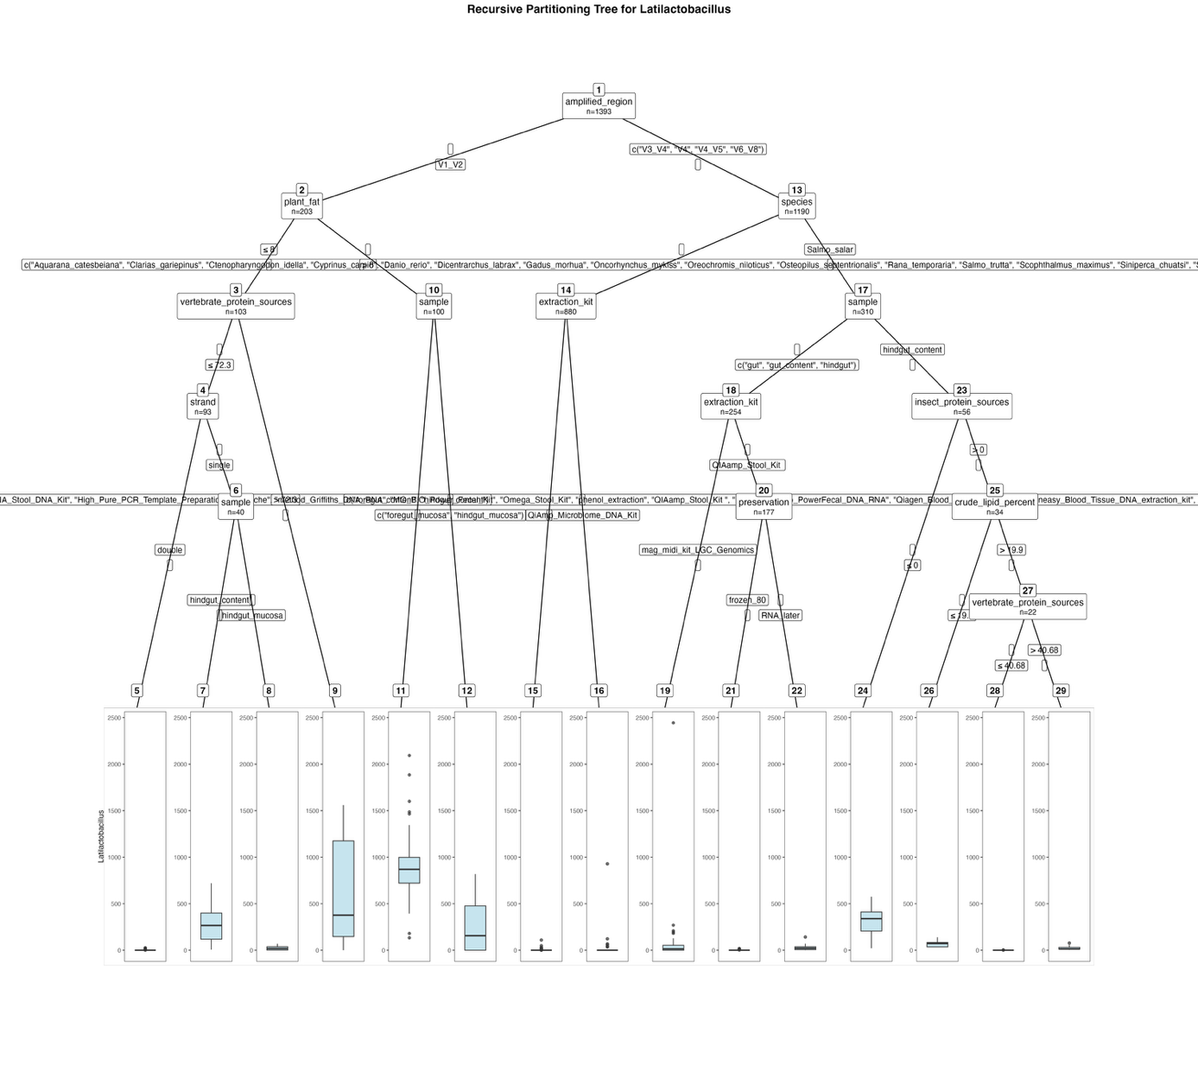
Fig. S12. Fitted party - Latilactobacillus:

[1] root
| [2] amplified_region in V1_V2
| | [3] plant_fat <= 8
| | | [4] vertebrate_protein_sources <= 72.3
| | | | [5] strand in double: 2.170 (n = 53, err = 1537.5)
| | | | [6] strand in single
| | | | | [7] sample in hindgut_content: 296.600 (n = 20, err = 856474.8)
| | | | | [8] sample in hindgut_mucosa: 22.350 (n = 20, err = 9514.5)
| | | [9] vertebrate_protein_sources > 72.3: 611.300 (n = 10, err = 3350258.1)
| | [10] plant_fat > 8
| | | [11] sample in foregut_content, hindgut_content: 897.184 (n = 76, err = 7154979.4)
| | | [12] sample in foregut_mucosa, hindgut_mucosa: 257.833 (n = 24, err = 1704351.3)
| [13] amplified_region in V3_V4, V4, V4_V5, V6_V8
| | [14] species in Aquarana_catesbeiana, Clarias_gariepinus, Ctenopharyngodon_idella, Cyprinus_carpio, Danio_rerio, Dicentrarchus_labrax, Gadus_morhua, Oncorhynchus_mykiss, Oreochromis_niloticus, Osteopilus_septentrionalis, Rana_temporaria, Salmo_trutta, Scophthalmus_maximus, Siniperca_chuatsi, Sparus_aurata, Trachinotus_ovatus
| | | [15] extraction_kit in Cador_Pathogen_96_QIAcube_HT_Kit, cetyltrimethylammonium_bromide_method, EZNA_Stool_DNA_Kit, High_Pure_PCR_Template_Preparation_Kit_Roche, method_Griffiths_DNA_RNA, MO_BIO_Power_Fecal_Kit, Omega_Stool_Kit, phenol_extraction, QIAamp_Stool_Kit , Qiagen_AllPrep_PowerFecal_DNA_RNA, Qiagen_Blood_Tissue_kit, Qiagen_Dneasy_Blood_Tissue_DNA_extraction_kit, Qiagen_Dneasy_PowerSoil_kit, Zymo_fecal_DNA_isolation_kit: 0.420 (n = 849, err = 17216.9)
| | | [16] extraction_kit in QiAmp_Microbiome_DNA_Kit: 40.290 (n = 31, err = 836364.4)
| | [17] species in Salmo_salar
| | | [18] sample in gut, gut_content, hindgut
| | | | [19] extraction_kit in mag_midi_kit_LGC_Genomics: 67.701 (n = 77, err = 5936318.1)
| | | | [20] extraction_kit in QIAamp_Stool_Kit
| | | | | [21] preservation in frozen_80: 0.317 (n = 161, err = 642.8)
| | | | | [22] preservation in RNA_later: 30.062 (n = 16, err = 20510.9)
| | | [23] sample in hindgut_content
| | | | [24] insect_protein_sources <= 0: 328.091 (n = 22, err = 442267.8)
| | | | [25] insect_protein_sources > 0
| | | | | [26] crude_lipid_percent <= 19.9: 68.000 (n = 12, err = 11696.0)
| | | | | [27] crude_lipid_percent > 19.9
| | | | | | [28] vertebrate_protein_sources <= 40.68: 0.400 (n = 10, err = 6.4)
| | | | | | [29] vertebrate_protein_sources > 40.68: 24.000 (n = 12, err = 5424.0)

Number of inner nodes: 14
Number of terminal nodes: 15

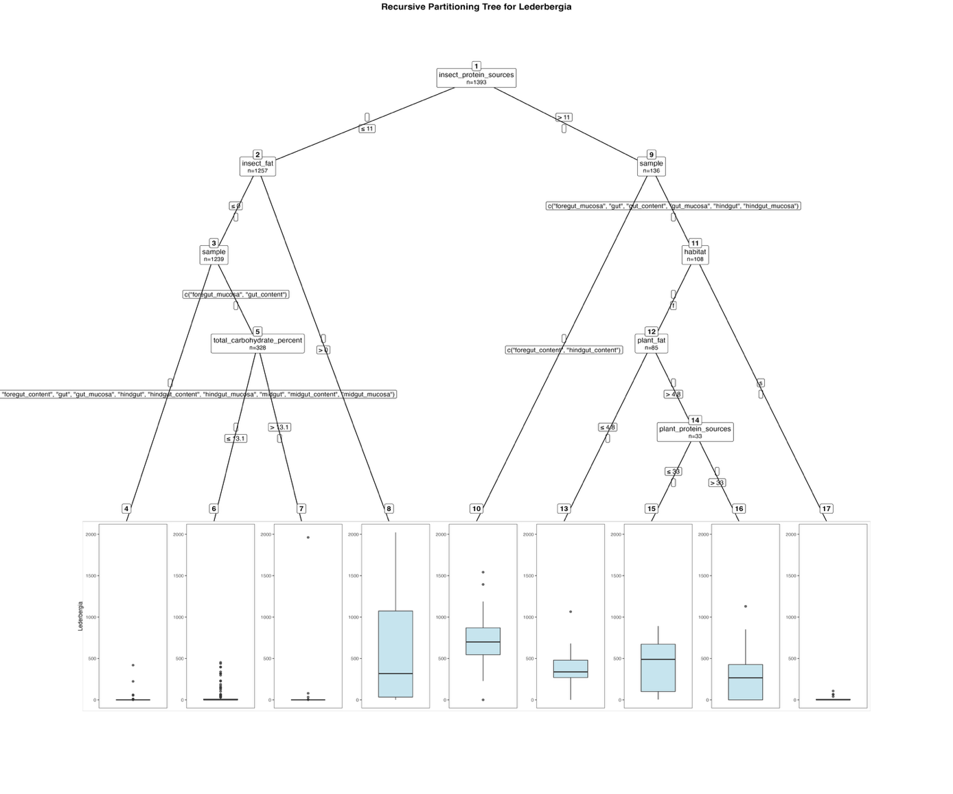
Fig. S13. Fitted party - Lederbergia:

[1] root
| [2] insect_protein_sources <= 11
| | [3] insect_fat <= 0
| | | [4] sample in digestive_tract, foregut_content, gut, gut_mucosa, hindgut, hindgut_content, hindgut_mucosa, midgut, midgut_content, midgut_mucosa: 0.861 (n = 911, err = 231443.3)
| | | [5] sample in foregut_mucosa, gut_content
| | | | [6] total_carbohydrate_percent <= 13.1: 40.204 (n = 147, err = 1431507.9)
| | | | [7] total_carbohydrate_percent > 13.1: 11.525 (n = 181, err = 3832769.1)
| | [8] insect_fat > 0: 586.833 (n = 18, err = 6810672.5)
| [9] insect_protein_sources > 11
| | [10] sample in foregut_content, hindgut_content: 730.893 (n = 28, err = 3132026.7)
| | [11] sample in foregut_mucosa, gut, gut_content, gut_mucosa, hindgut, hindgut_mucosa
| | | [12] habitat in f
| | | | [13] plant_fat <= 4.8: 362.596 (n = 52, err = 1895434.5)
| | | | [14] plant_fat > 4.8
| | | | | [15] plant_protein_sources <= 33: 425.750 (n = 8, err = 750947.5)
| | | | | [16] plant_protein_sources > 33: 296.000 (n = 25, err = 2066014.0)
| | | [17] habitat in s: 13.478 (n = 23, err = 17857.7)

Number of inner nodes: 8
Number of terminal nodes: 9
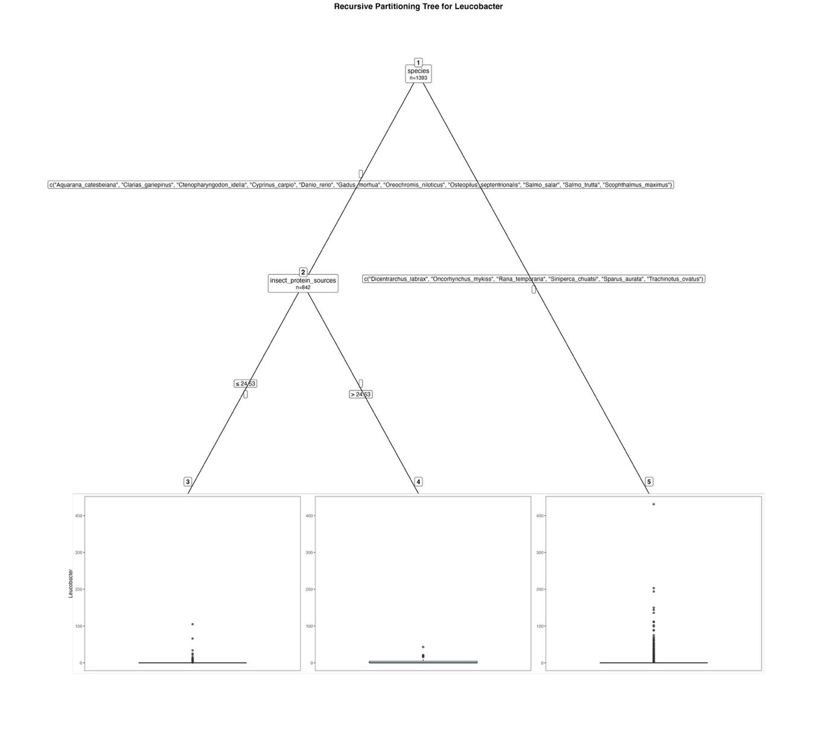
Fig. S14. Fitted party - Leucobacter:

[1] root
| [2] species in Aquarana_catesbeiana, Clarias_gariepinus, Ctenopharyngodon_idella, Cyprinus_carpio, Danio_rerio, Gadus_morhua, Oreochromis_niloticus, Osteopilus_septentrionalis, Salmo_salar, Salmo_trutta, Scophthalmus_maximus
| | [3] insect_protein_sources <= 24.53: 0.480 (n = 786, err = 18586.2)
| | [4] insect_protein_sources > 24.53: 4.018 (n = 56, err = 3547.0)
| [5] species in Dicentrarchus_labrax, Oncorhynchus_mykiss, Rana_temporaria, Siniperca_chuatsi, Sparus_aurata, Trachinotus_ovatus: 6.873 (n = 551, err = 438811.1)

Number of inner nodes: 2
Number of terminal nodes: 3

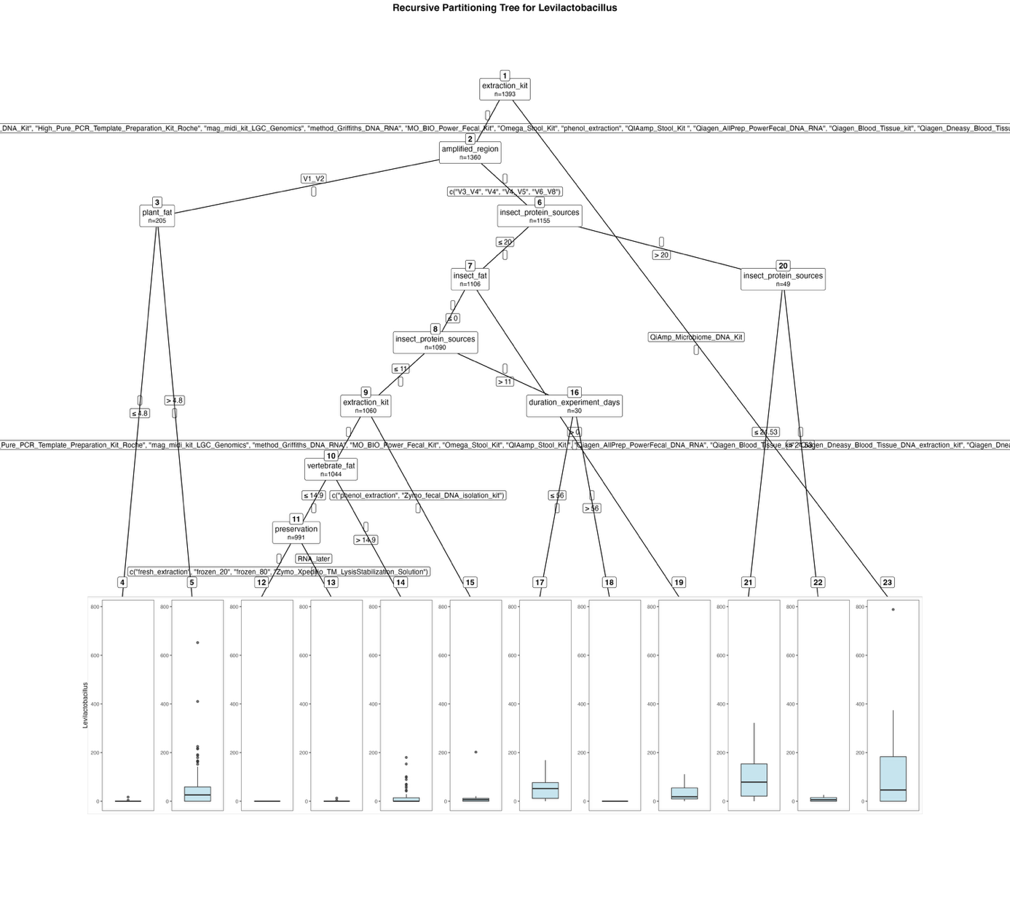
Fig. S15. Fitted party - Levilactobacillus:

[1] root
| [2] extraction_kit in Cador_Pathogen_96_QIAcube_HT_Kit, cetyltrimethylammonium_bromide_method, EZNA_Stool_DNA_Kit, High_Pure_PCR_Template_Preparation_Kit_Roche, mag_midi_kit_LGC_Genomics, method_Griffiths_DNA_RNA, MO_BIO_Power_Fecal_Kit, Omega_Stool_Kit, phenol_extraction, QIAamp_Stool_Kit , Qiagen_AllPrep_PowerFecal_DNA_RNA, Qiagen_Blood_Tissue_kit, Qiagen_Dneasy_Blood_Tissue_DNA_extraction_kit, Qiagen_Dneasy_PowerSoil_kit, Zymo_fecal_DNA_isolation_kit
| | [3] amplified_region in V1_V2
| | | [4] plant_fat <= 4.8: 0.404 (n = 52, err = 296.5)
| | | [5] plant_fat > 4.8: 49.020 (n = 153, err = 908002.9)
| | [6] amplified_region in V3_V4, V4, V4_V5, V6_V8
| | | [7] insect_protein_sources <= 20
| | | | [8] insect_fat <= 0
| | | | | [9] insect_protein_sources <= 11
| | | | | | [10] extraction_kit in Cador_Pathogen_96_QIAcube_HT_Kit, cetyltrimethylammonium_bromide_method, EZNA_Stool_DNA_Kit, High_Pure_PCR_Template_Preparation_Kit_Roche, mag_midi_kit_LGC_Genomics, method_Griffiths_DNA_RNA, MO_BIO_Power_Fecal_Kit, Omega_Stool_Kit, QIAamp_Stool_Kit , Qiagen_AllPrep_PowerFecal_DNA_RNA, Qiagen_Blood_Tissue_kit, Qiagen_Dneasy_Blood_Tissue_DNA_extraction_kit, Qiagen_Dneasy_PowerSoil_kit
| | | | | | | [11] vertebrate_fat <= 14.9
| | | | | | | | [12] preservation in fresh_extraction, frozen_20, frozen_80, Zymo_Xpeditio_TM_LysisStabilization_Solution: 0.000 (n = 957, err = 0.0)
| | | | | | | | [13] preservation in RNA_later: 0.471 (n = 34, err = 170.5)
| | | | | | | [14] vertebrate_fat > 14.9: 19.415 (n = 53, err = 84942.9)
| | | | | | [15] extraction_kit in phenol_extraction, Zymo_fecal_DNA_isolation_kit: 18.375 (n = 16, err = 36591.8)
| | | | | [16] insect_protein_sources > 11
| | | | | | [17] duration_experiment_days <= 56: 56.333 (n = 15, err = 38609.3)
| | | | | | [18] duration_experiment_days > 56: 0.000 (n = 15, err = 0.0)
| | | | [19] insect_fat > 0: 31.625 (n = 16, err = 16169.8)
| | | [20] insect_protein_sources > 20
| | | | [21] insect_protein_sources <= 24.53: 92.250 (n = 32, err = 199280.0)
| | | | [22] insect_protein_sources > 24.53: 8.471 (n = 17, err = 1118.2)
| [23] extraction_kit in QiAmp_Microbiome_DNA_Kit: 121.424 (n = 33, err = 904830.1)

Number of inner nodes: 11
Number of terminal nodes: 12

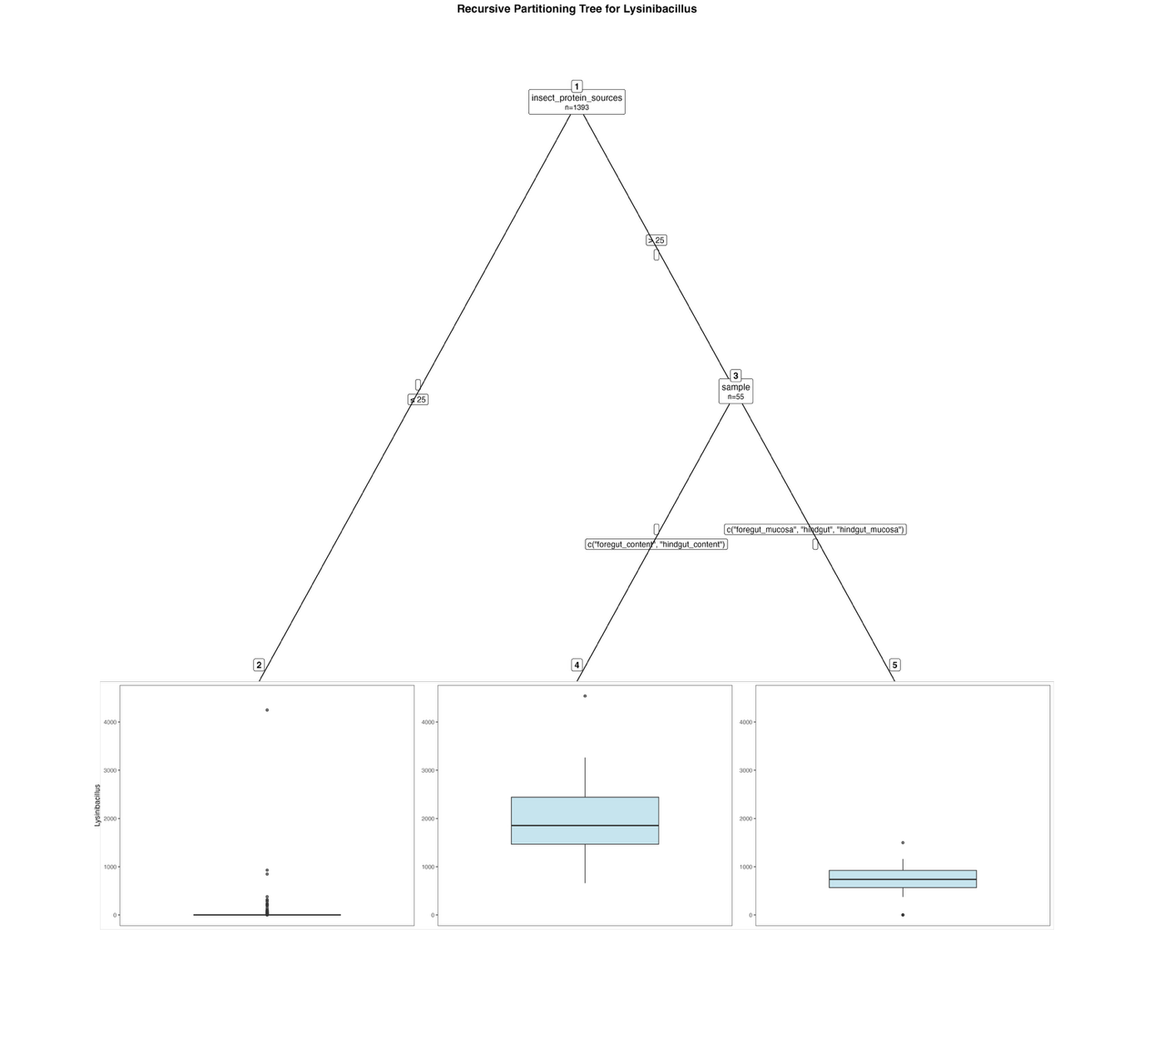
Fig. S16. Fitted party - Lysinibacillus:

[1] root
| [2] insect_protein_sources <= 25: 9.537 (n = 1338, err = 20332534.7)
| [3] insect_protein_sources > 25
| | [4] sample in foregut_content, hindgut_content: 1976.407 (n = 27, err = 19085288.5)
| | [5] sample in foregut_mucosa, hindgut, hindgut_mucosa: 689.357 (n = 28, err = 3615984.4)

Number of inner nodes: 2
Number of terminal nodes: 3

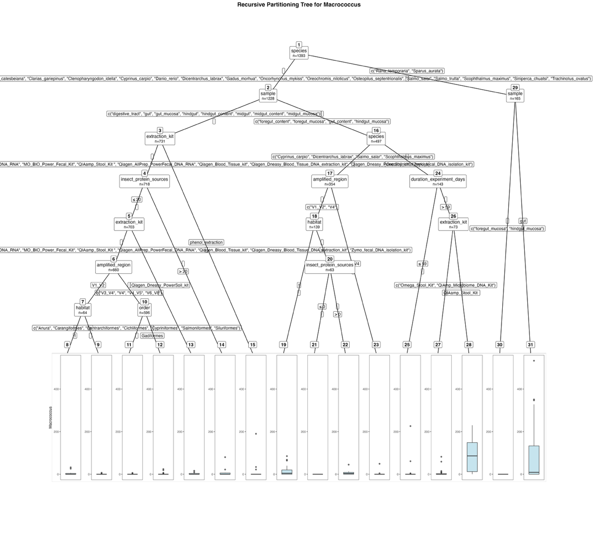
Fig. S17. Fitted party - Macrococcus:

[1] root
| [2] species in Aquarana_catesbeiana, Clarias_gariepinus, Ctenopharyngodon_idella, Cyprinus_carpio, Danio_rerio, Dicentrarchus_labrax, Gadus_morhua, Oncorhynchus_mykiss, Oreochromis_niloticus, Osteopilus_septentrionalis, Salmo_salar, Salmo_trutta, Scophthalmus_maximus, Siniperca_chuatsi, Trachinotus_ovatus
| | [3] sample in digestive_tract, gut, gut_mucosa, hindgut, hindgut_content, midgut, midgut_content, midgut_mucosa
| | | [4] extraction_kit in cetyltrimethylammonium_bromide_method, EZNA_Stool_DNA_Kit, method_Griffiths_DNA_RNA, MO_BIO_Power_Fecal_Kit, QIAamp_Stool_Kit , Qiagen_AllPrep_PowerFecal_DNA_RNA, Qiagen_Blood_Tissue_kit, Qiagen_Dneasy_Blood_Tissue_DNA_extraction_kit, Qiagen_Dneasy_PowerSoil_kit, Zymo_fecal_DNA_isolation_kit
| | | | [5] insect_protein_sources <= 20
| | | | | [6] extraction_kit in cetyltrimethylammonium_bromide_method, EZNA_Stool_DNA_Kit, method_Griffiths_DNA_RNA, MO_BIO_Power_Fecal_Kit, QIAamp_Stool_Kit , Qiagen_AllPrep_PowerFecal_DNA_RNA, Qiagen_Blood_Tissue_kit, Qiagen_Dneasy_Blood_Tissue_DNA_extraction_kit, Zymo_fecal_DNA_isolation_kit
| | | | | | [7] amplified_region in V1_V2
| | | | | | | [8] habitat in f: 4.733 (n = 15, err = 1428.9)
| | | | | | | [9] habitat in s: 0.245 (n = 49, err = 59.1)
| | | | | | [10] amplified_region in V3_V4, V4, V4_V5, V6_V8
| | | | | | | [11] order in Anura, Carangiformes, Centrarchiformes, Cichliformes, Cypriniformes, Salmoniformes, Siluriformes: 0.020 (n = 537, err = 48.8)
| | | | | | | [12] order in Gadiformes: 1.000 (n = 59, err = 952.0)
| | | | | [13] extraction_kit in Qiagen_Dneasy_PowerSoil_kit: 2.116 (n = 43, err = 562.4)
| | | | [14] insect_protein_sources > 20: 8.133 (n = 15, err = 6005.7)
| | | [15] extraction_kit in phenol_extraction: 18.923 (n = 13, err = 33084.9)
| | [16] sample in foregut_content, foregut_mucosa, gut_content, hindgut_mucosa
| | | [17] species in Cyprinus_carpio, Dicentrarchus_labrax, Salmo_salar, Scophthalmus_maximus
| | | | [18] amplified_region in V1_V2, V4
| | | | | [19] habitat in f: 12.026 (n = 76, err = 21405.9)
| | | | | [20] habitat in s
| | | | | | [21] insect_protein_sources <= 0: 0.000 (n = 55, err = 0.0)
| | | | | | [22] insect_protein_sources > 0: 9.000 (n = 8, err = 1644.0)
| | | | [23] amplified_region in V3_V4: 0.247 (n = 215, err = 2403.9)
| | | [24] species in Oncorhynchus_mykiss
| | | | [25] duration_experiment_days <= 59: 4.186 (n = 70, err = 53590.6)
| | | | [26] duration_experiment_days > 59
| | | | | [27] extraction_kit in Omega_Stool_Kit, QiAmp_Microbiome_DNA_Kit: 4.565 (n = 46, err = 9849.3)
| | | | | [28] extraction_kit in QIAamp_Stool_Kit : 88.148 (n = 27, err = 172853.4)
| [29] species in Rana_temporaria, Sparus_aurata
| | [30] sample in foregut_mucosa, hindgut_mucosa: 0.000 (n = 56, err = 0.0)
| | [31] sample in gut: 76.431 (n = 109, err = 1211030.7)

Number of inner nodes: 15
Number of terminal nodes: 16

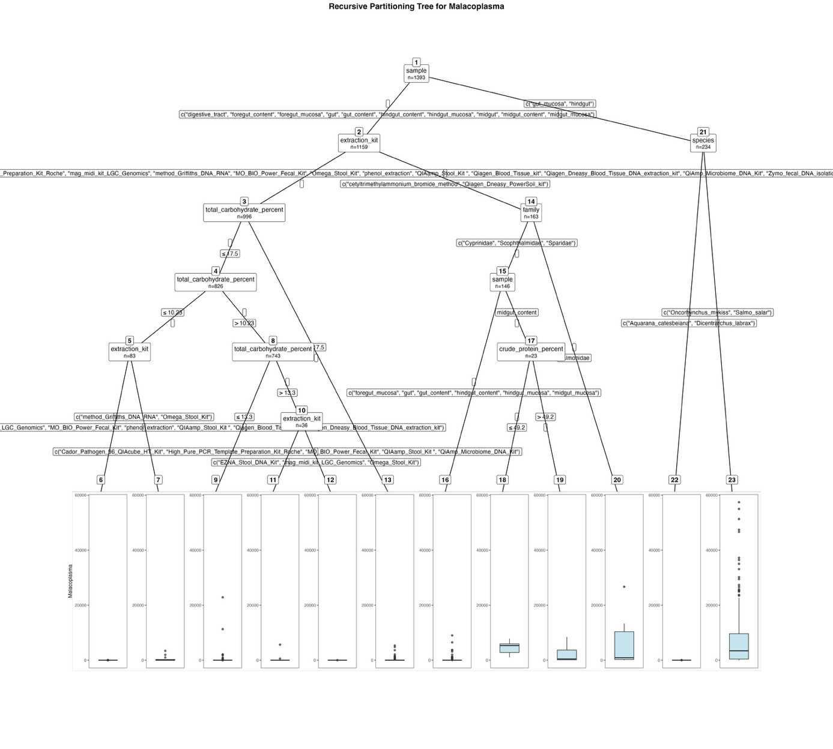
Fig. S18. Fitted party - Malacoplasma:

[1] root
| [2] sample in digestive_tract, foregut_content, foregut_mucosa, gut, gut_content, hindgut_content, hindgut_mucosa, midgut, midgut_content, midgut_mucosa
| | [3] extraction_kit in Cador_Pathogen_96_QIAcube_HT_Kit, EZNA_Stool_DNA_Kit, High_Pure_PCR_Template_Preparation_Kit_Roche, mag_midi_kit_LGC_Genomics, method_Griffiths_DNA_RNA, MO_BIO_Power_Fecal_Kit, Omega_Stool_Kit, phenol_extraction, QIAamp_Stool_Kit , Qiagen_Blood_Tissue_kit, Qiagen_Dneasy_Blood_Tissue_DNA_extraction_kit, QiAmp_Microbiome_DNA_Kit, Zymo_fecal_DNA_isolation_kit
| | | [4] total_carbohydrate_percent <= 17.5
| | | | [5] total_carbohydrate_percent <= 10.23
| | | | | [6] extraction_kit in Cador_Pathogen_96_QIAcube_HT_Kit, EZNA_Stool_DNA_Kit, mag_midi_kit_LGC_Genomics, MO_BIO_Power_Fecal_Kit, phenol_extraction, QIAamp_Stool_Kit , Qiagen_Blood_Tissue_kit, Qiagen_Dneasy_Blood_Tissue_DNA_extraction_kit: 1.620 (n = 71, err = 2150.7)
| | | | | [7] extraction_kit in method_Griffiths_DNA_RNA, Omega_Stool_Kit: 529.250 (n = 12, err = 12878296.2)
| | | | [8] total_carbohydrate_percent > 10.23
| | | | | [9] total_carbohydrate_percent <= 13.3: 62.931 (n = 707, err = 660731537.6)
| | | | | [10] total_carbohydrate_percent > 13.3
| | | | | | [11] extraction_kit in Cador_Pathogen_96_QIAcube_HT_Kit, High_Pure_PCR_Template_Preparation_Kit_Roche, MO_BIO_Power_Fecal_Kit, QIAamp_Stool_Kit , QiAmp_Microbiome_DNA_Kit: 214.069 (n = 29, err = 30793141.9)
| | | | | | [12] extraction_kit in EZNA_Stool_DNA_Kit, mag_midi_kit_LGC_Genomics, Omega_Stool_Kit: 0.714 (n = 7, err = 21.4)
| | | [13] total_carbohydrate_percent > 17.5: 207.353 (n = 170, err = 76587814.8)
| | [14] extraction_kit in cetyltrimethylammonium_bromide_method, Qiagen_Dneasy_PowerSoil_kit
| | | [15] family in Cyprinidae, Scophthalmidae, Sparidae
| | | | [16] sample in foregut_mucosa, gut, gut_content, hindgut_content, hindgut_mucosa, midgut_mucosa: 307.984 (n = 123, err = 160914188.0)
| | | | [17] sample in midgut_content
| | | | | [18] crude_protein_percent <= 49.2: 4524.727 (n = 11, err = 47682602.2)
| | | | | [19] crude_protein_percent > 49.2: 2186.500 (n = 12, err = 97509967.0)
| | | [20] family in Salmonidae: 5431.588 (n = 17, err = 871141302.1)
| [21] sample in gut_mucosa, hindgut
| | [22] species in Aquarana_catesbeiana, Dicentrarchus_labrax: 1.605 (n = 43, err = 2414.3)
| | [23] species in Oncorhynchus_mykiss, Salmo_salar: 7610.670 (n = 191, err = 23109243778.2)

Number of inner nodes: 11
Number of terminal nodes: 12

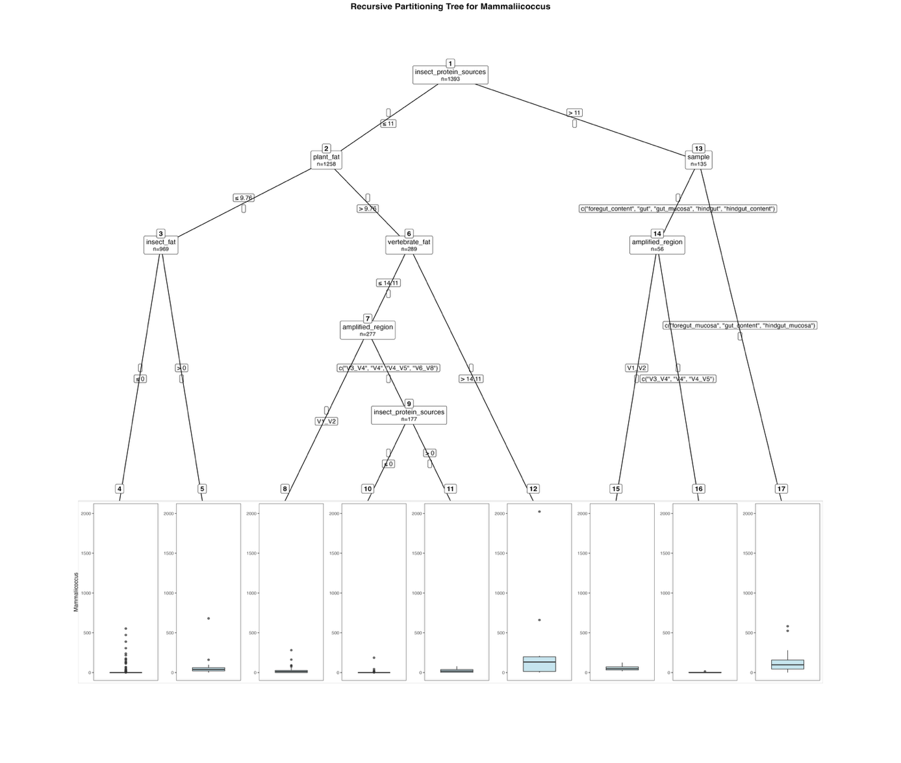
Fig. S19. Fitted party - Mammaliicoccus:

[1] root
| [2] insect_protein_sources <= 11
| | [3] plant_fat <= 9.76
| | | [4] insect_fat <= 0: 4.231 (n = 954, err = 1028883.3)
| | | [5] insect_fat > 0: 86.600 (n = 15, err = 401537.6)
| | [6] plant_fat > 9.76
| | | [7] vertebrate_fat <= 14.11
| | | | [8] amplified_region in V1_V2: 19.450 (n = 100, err = 124262.8)
| | | | [9] amplified_region in V3_V4, V4, V4_V5, V6_V8
| | | | | [10] insect_protein_sources <= 0: 1.962 (n = 157, err = 36943.8)
| | | | | [11] insect_protein_sources > 0: 21.800 (n = 20, err = 10053.2)
| | | [12] vertebrate_fat > 14.11: 301.667 (n = 12, err = 3589836.7)
| [13] insect_protein_sources > 11
| | [14] sample in foregut_content, gut, gut_mucosa, hindgut, hindgut_content
| | | [15] amplified_region in V1_V2: 55.704 (n = 27, err = 22297.6)
| | | [16] amplified_region in V3_V4, V4, V4_V5: 2.172 (n = 29, err = 430.1)
| | [17] sample in foregut_mucosa, gut_content, hindgut_mucosa: 113.570 (n = 79, err = 842331.4)

Number of inner nodes: 8
Number of terminal nodes: 9
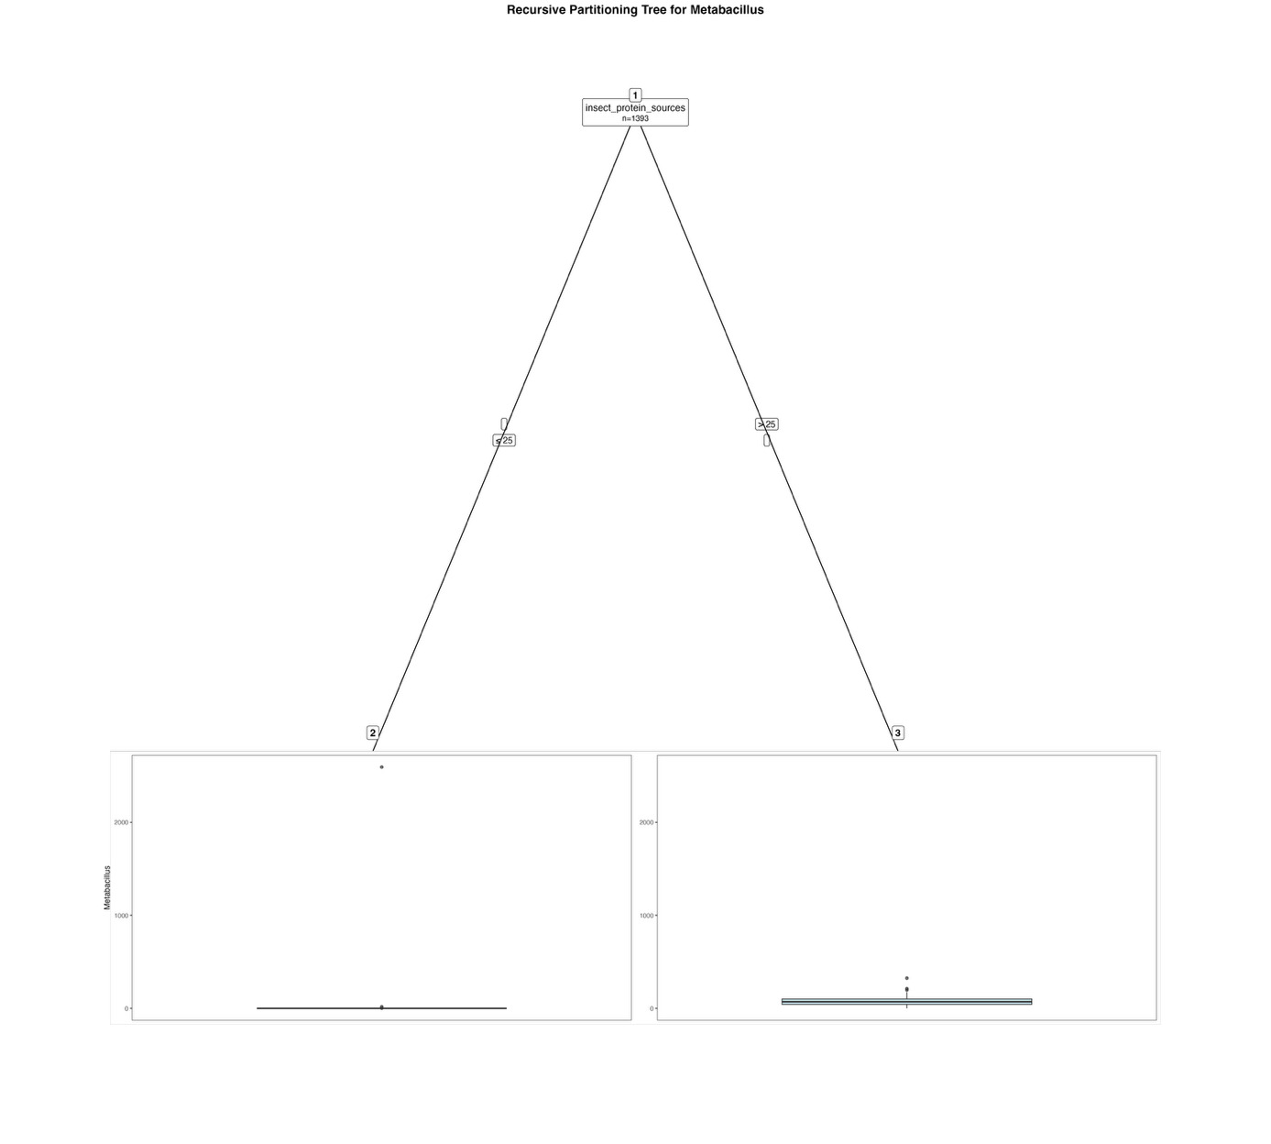
Fig. S20. Fitted party - Metabacillus:

[1] root
| [2] insect_protein_sources <= 25: 1.954 (n = 1337, err = 6718839.1)
| [3] insect_protein_sources > 25: 78.518 (n = 56, err = 200396.0)

Number of inner nodes: 1
Number of terminal nodes: 2

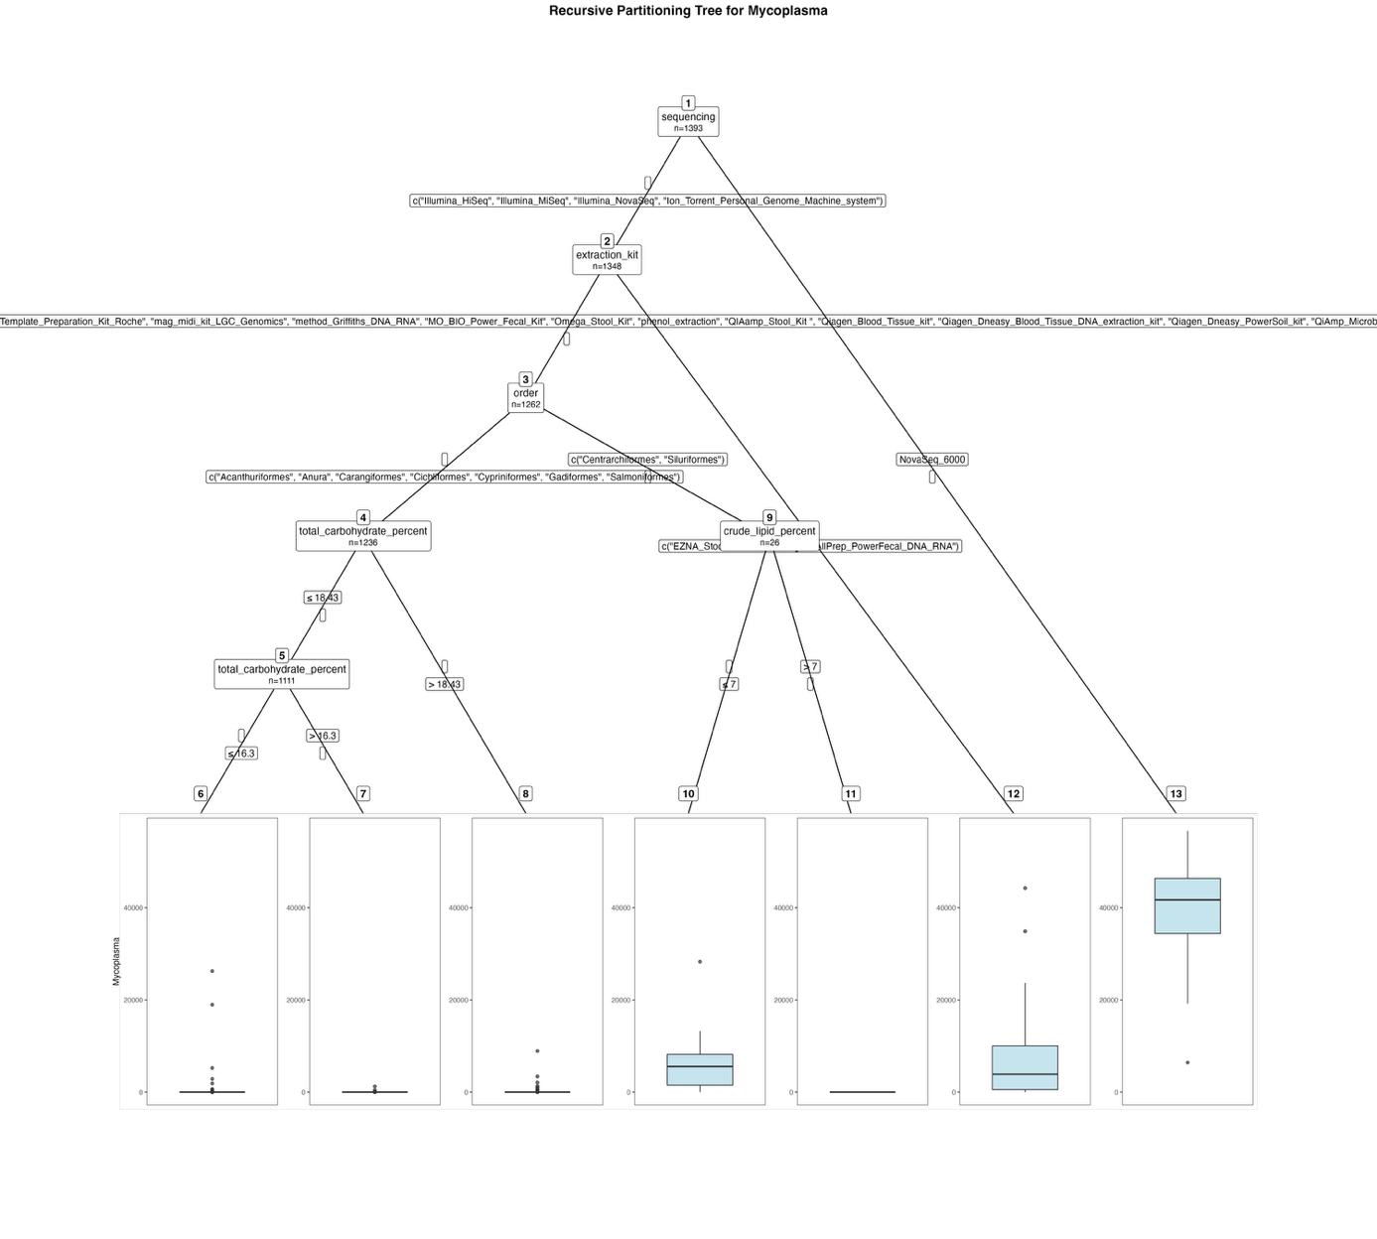
Fig. S21. Fitted party - Mycoplasma:

[1] root
| [2] sequencing in Illumina_HiSeq, Illumina_MiSeq, Illumina_NovaSeq, Ion_Torrent_Personal_Genome_Machine_system
| | [3] extraction_kit in Cador_Pathogen_96_QIAcube_HT_Kit, cetyltrimethylammonium_bromide_method, High_Pure_PCR_Template_Preparation_Kit_Roche, mag_midi_kit_LGC_Genomics, method_Griffiths_DNA_RNA, MO_BIO_Power_Fecal_Kit, Omega_Stool_Kit, phenol_extraction, QIAamp_Stool_Kit , Qiagen_Blood_Tissue_kit, Qiagen_Dneasy_Blood_Tissue_DNA_extraction_kit, Qiagen_Dneasy_PowerSoil_kit, QiAmp_Microbiome_DNA_Kit, Zymo_fecal_DNA_isolation_kit
| | | [4] order in Acanthuriformes, Anura, Carangiformes, Cichliformes, Cypriniformes, Gadiformes, Salmoniformes
| | | | [5] total_carbohydrate_percent <= 18.43
| | | | | [6] total_carbohydrate_percent <= 16.3: 57.761 (n = 1018, err = 1085403393.0)
| | | | | [7] total_carbohydrate_percent > 16.3: 21.000 (n = 93, err = 1676754.0)
| | | | [8] total_carbohydrate_percent > 18.43: 161.232 (n = 125, err = 96904616.3)
| | | [9] order in Centrarchiformes, Siluriformes
| | | | [10] crude_lipid_percent <= 7: 7752.778 (n = 9, err = 620623331.6)
| | | | [11] crude_lipid_percent > 7: 0.000 (n = 17, err = 0.0)
| | [12] extraction_kit in EZNA_Stool_DNA_Kit, Qiagen_AllPrep_PowerFecal_DNA_RNA: 6612.860 (n = 86, err = 5199937402.3)
| [13] sequencing in NovaSeq_6000: 39904.822 (n = 45, err = 4644462830.6)

Number of inner nodes: 6
Number of terminal nodes: 7

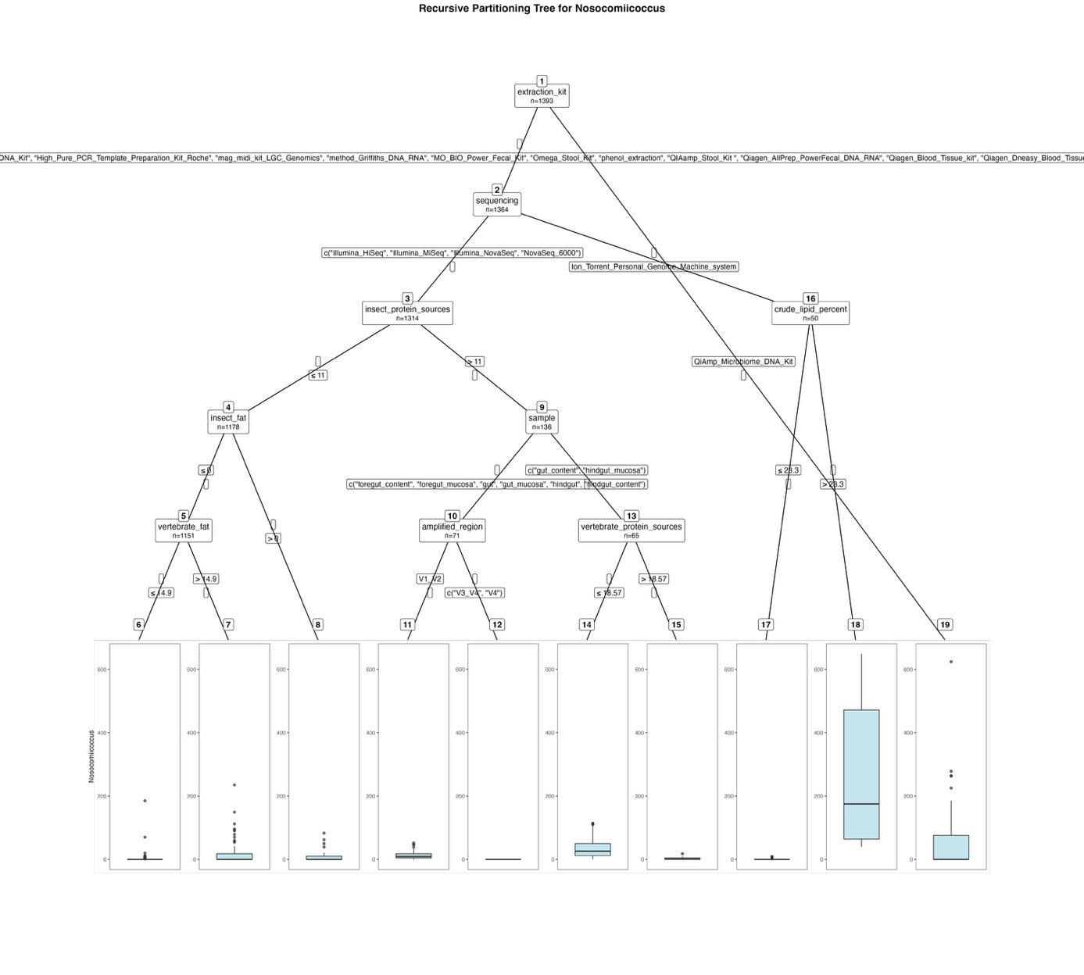
Fig. S22. Fitted party - Nosocomiicoccus:

[1] root
| [2] extraction_kit in Cador_Pathogen_96_QIAcube_HT_Kit, cetyltrimethylammonium_bromide_method, EZNA_Stool_DNA_Kit, High_Pure_PCR_Template_Preparation_Kit_Roche, mag_midi_kit_LGC_Genomics, method_Griffiths_DNA_RNA, MO_BIO_Power_Fecal_Kit, Omega_Stool_Kit, phenol_extraction, QIAamp_Stool_Kit , Qiagen_AllPrep_PowerFecal_DNA_RNA, Qiagen_Blood_Tissue_kit, Qiagen_Dneasy_Blood_Tissue_DNA_extraction_kit, Qiagen_Dneasy_PowerSoil_kit, Zymo_fecal_DNA_isolation_kit
| | [3] sequencing in Illumina_HiSeq, Illumina_MiSeq, Illumina_NovaSeq, NovaSeq_6000
| | | [4] insect_protein_sources <= 11
| | | | [5] insect_fat <= 0
| | | | | [6] vertebrate_fat <= 14.9: 0.395 (n = 1094, err = 40325.4)
| | | | | [7] vertebrate_fat > 14.9: 22.421 (n = 57, err = 113577.9)
| | | | [8] insect_fat > 0: 10.741 (n = 27, err = 12551.2)
| | | [9] insect_protein_sources > 11
| | | | [10] sample in foregut_content, foregut_mucosa, gut, gut_mucosa, hindgut, hindgut_content
| | | | | [11] amplified_region in V1_V2: 13.350 (n = 40, err = 7231.1)
| | | | | [12] amplified_region in V3_V4, V4: 0.000 (n = 31, err = 0.0)
| | | | [13] sample in gut_content, hindgut_mucosa
| | | | | [14] vertebrate_protein_sources <= 18.57: 34.860 (n = 57, err = 55286.9)
| | | | | [15] vertebrate_protein_sources > 18.57: 4.000 (n = 8, err = 290.0)
| | [16] sequencing in Ion_Torrent_Personal_Genome_Machine_system
| | | [17] crude_lipid_percent <= 23.3: 0.925 (n = 40, err = 204.8)
| | | [18] crude_lipid_percent > 23.3: 262.200 (n = 10, err = 511193.6)
| [19] extraction_kit in QiAmp_Microbiome_DNA_Kit: 79.897 (n = 29, err = 551586.7)

Number of inner nodes: 9
Number of terminal nodes: 10

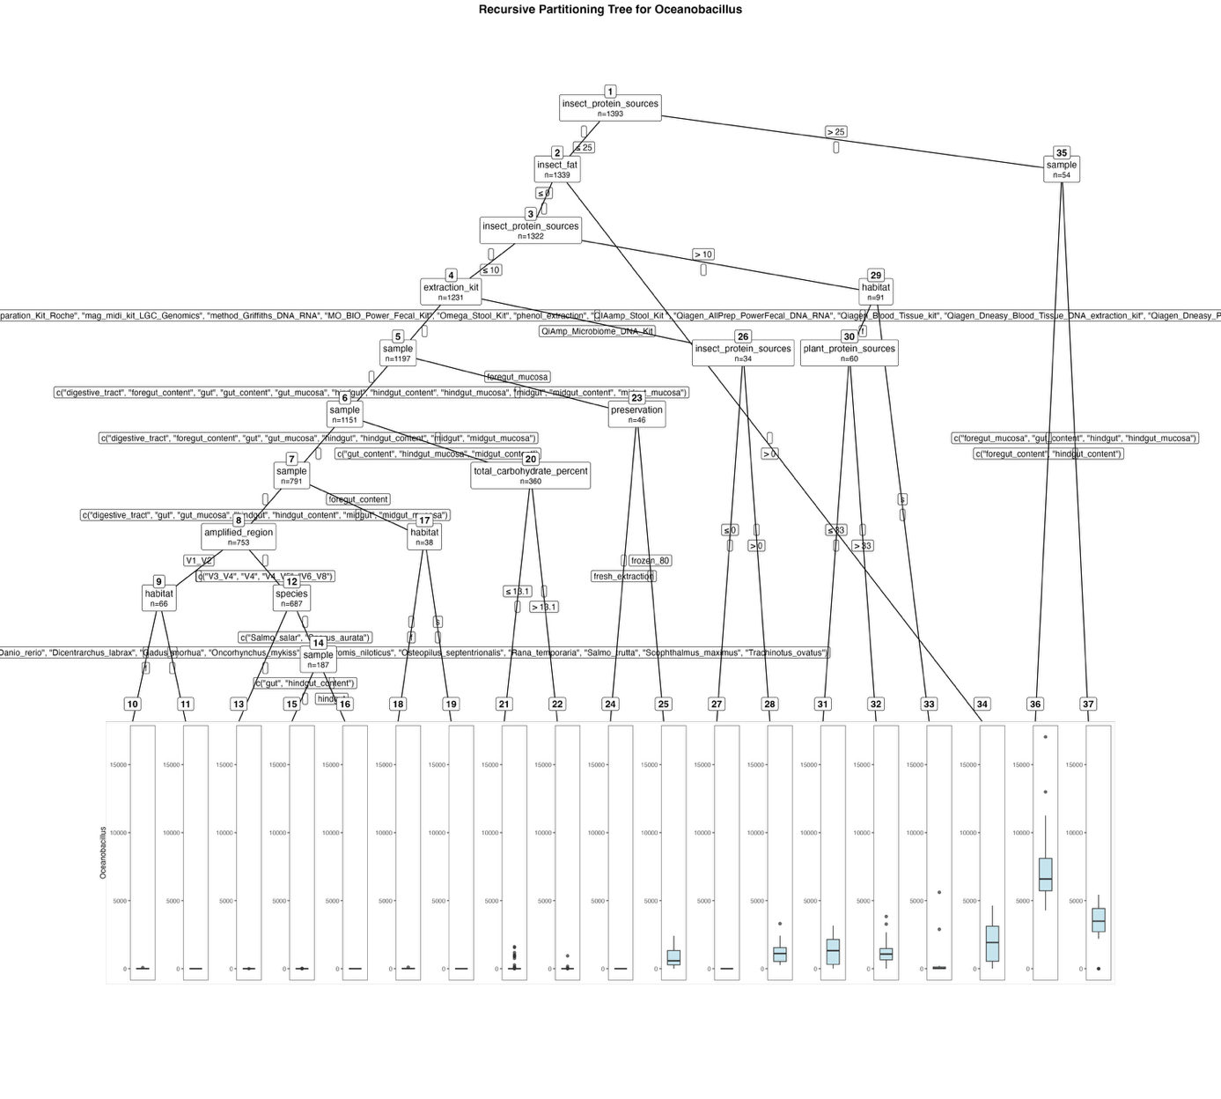
Fig. S23. Fitted party - Oceanobacillus:

[1] root
| [2] insect_protein_sources <= 25
| | [3] insect_fat <= 0
| | | [4] insect_protein_sources <= 10
| | | | [5] extraction_kit in Cador_Pathogen_96_QIAcube_HT_Kit, cetyltrimethylammonium_bromide_method, EZNA_Stool_DNA_Kit, High_Pure_PCR_Template_Preparation_Kit_Roche, mag_midi_kit_LGC_Genomics, method_Griffiths_DNA_RNA, MO_BIO_Power_Fecal_Kit, Omega_Stool_Kit, phenol_extraction, QIAamp_Stool_Kit , Qiagen_AllPrep_PowerFecal_DNA_RNA, Qiagen_Blood_Tissue_kit, Qiagen_Dneasy_Blood_Tissue_DNA_extraction_kit, Qiagen_Dneasy_PowerSoil_kit, Zymo_fecal_DNA_isolation_kit
| | | | | [6] sample in digestive_tract, foregut_content, gut, gut_content, gut_mucosa, hindgut, hindgut_content, hindgut_mucosa, midgut, midgut_content, midgut_mucosa
| | | | | | [7] sample in digestive_tract, foregut_content, gut, gut_mucosa, hindgut, hindgut_content, midgut, midgut_mucosa
| | | | | | | [8] sample in digestive_tract, gut, gut_mucosa, hindgut, hindgut_content, midgut, midgut_mucosa
| | | | | | | | [9] amplified_region in V1_V2
| | | | | | | | | [10] habitat in f: 11.588 (n = 17, err = 6066.1)
| | | | | | | | | [11] habitat in s: 0.000 (n = 49, err = 0.0)
| | | | | | | | [12] amplified_region in V3_V4, V4, V4_V5, V6_V8
| | | | | | | | | [13] species in Aquarana_catesbeiana, Clarias_gariepinus, Ctenopharyngodon_idella, Danio_rerio, Dicentrarchus_labrax, Gadus_morhua, Oncorhynchus_mykiss, Oreochromis_niloticus, Osteopilus_septentrionalis, Rana_temporaria, Salmo_trutta, Scophthalmus_maximus, Trachinotus_ovatus: 0.006 (n = 500, err = 9.0)
| | | | | | | | | [14] species in Salmo_salar, Sparus_aurata
| | | | | | | | | | [15] sample in gut, hindgut_content: 1.488 (n = 123, err = 1328.7)
| | | | | | | | | | [16] sample in hindgut: 0.000 (n = 64, err = 0.0)
| | | | | | | [17] sample in foregut_content
| | | | | | | | [18] habitat in f: 21.786 (n = 14, err = 10154.4)
| | | | | | | | [19] habitat in s: 0.000 (n = 24, err = 0.0)
| | | | | | [20] sample in gut_content, hindgut_mucosa, midgut_content
| | | | | | | [21] total_carbohydrate_percent <= 13.1: 77.206 (n = 155, err = 11582901.4)
| | | | | | | [22] total_carbohydrate_percent > 13.1: 6.468 (n = 205, err = 911335.0)
| | | | | [23] sample in foregut_mucosa
| | | | | | [24] preservation in fresh_extraction: 0.000 (n = 35, err = 0.0)
| | | | | | [25] preservation in frozen_80: 888.455 (n = 11, err = 6898612.7)
| | | | [26] extraction_kit in QiAmp_Microbiome_DNA_Kit
| | | | | [27] insect_protein_sources <= 0: 0.000 (n = 22, err = 0.0)
| | | | | [28] insect_protein_sources > 0: 1242.333 (n = 12, err = 9208606.7)
| | | [29] insect_protein_sources > 10
| | | | [30] habitat in f
| | | | | [31] plant_protein_sources <= 33: 1306.667 (n = 9, err = 11459638.0)
| | | | | [32] plant_protein_sources > 33: 1128.431 (n = 51, err = 35996578.5)
| | | | [33] habitat in s: 325.677 (n = 31, err = 36826424.8)
| | [34] insect_fat > 0: 1875.000 (n = 17, err = 35912040.0)
| [35] insect_protein_sources > 25
| | [36] sample in foregut_content, hindgut_content: 7553.556 (n = 27, err = 216789770.7)
| | [37] sample in foregut_mucosa, gut_content, hindgut, hindgut_mucosa: 3350.667 (n = 27, err = 56734250.0)

Number of inner nodes: 18
Number of terminal nodes: 19

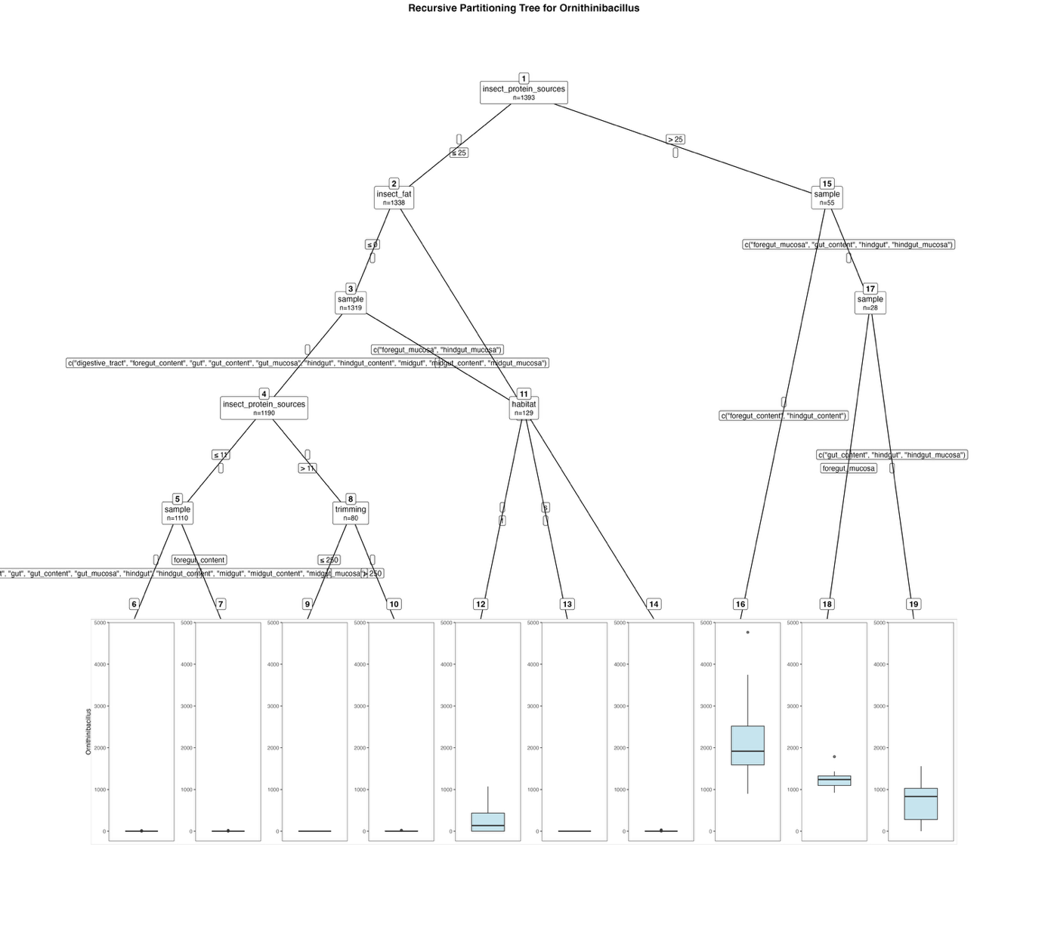
Fig. S24. Fitted party - Ornithinibacillus:

[1] root
| [2] insect_protein_sources <= 25
| | [3] insect_fat <= 0
| | | [4] sample in digestive_tract, foregut_content, gut, gut_content, gut_mucosa, hindgut, hindgut_content, midgut, midgut_content, midgut_mucosa
| | | | [5] insect_protein_sources <= 11
| | | | | [6] sample in digestive_tract, gut, gut_content, gut_mucosa, hindgut, hindgut_content, midgut, midgut_content, midgut_mucosa: 0.031 (n = 1072, err = 286.0)
| | | | | [7] sample in foregut_content: 1.053 (n = 38, err = 583.9)
| | | | [8] insect_protein_sources > 11
| | | | | [9] trimming <= 250: 0.000 (n = 29, err = 0.0)
| | | | | [10] trimming > 250: 3.059 (n = 51, err = 1250.8)
| | | [11] sample in foregut_mucosa, hindgut_mucosa
| | | | [12] habitat in f: 254.875 (n = 24, err = 2301814.6)
| | | | [13] habitat in s: 0.000 (n = 105, err = 0.0)
| | [14] insect_fat > 0: 3.474 (n = 19, err = 1260.7)
| [15] insect_protein_sources > 25
| | [16] sample in foregut_content, hindgut_content: 2165.000 (n = 27, err = 20805932.0)
| | [17] sample in foregut_mucosa, gut_content, hindgut, hindgut_mucosa
| | | [18] sample in foregut_mucosa: 1234.417 (n = 12, err = 629922.9)
| | | [19] sample in gut_content, hindgut, hindgut_mucosa: 706.875 (n = 16, err = 3554607.8)

Number of inner nodes: 9
Number of terminal nodes: 10

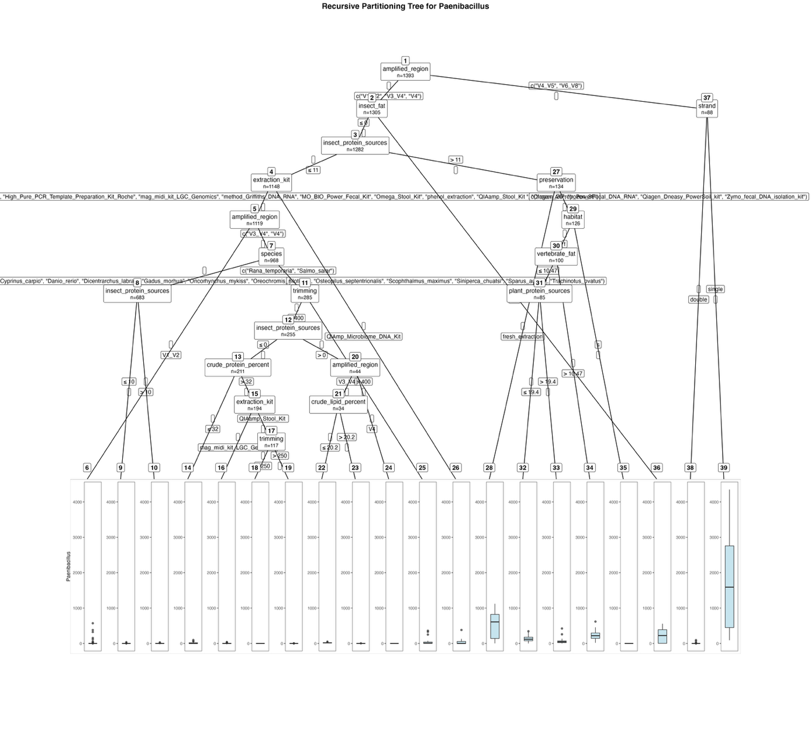
Fig. S25. Fitted party - Paenibacillus:

[1] root
| [2] amplified_region in V1_V2, V3_V4, V4
| | [3] insect_fat <= 0
| | | [4] insect_protein_sources <= 11
| | | | [5] extraction_kit in Cador_Pathogen_96_QIAcube_HT_Kit, cetyltrimethylammonium_bromide_method, EZNA_Stool_DNA_Kit, High_Pure_PCR_Template_Preparation_Kit_Roche, mag_midi_kit_LGC_Genomics, method_Griffiths_DNA_RNA, MO_BIO_Power_Fecal_Kit, Omega_Stool_Kit, phenol_extraction, QIAamp_Stool_Kit , Qiagen_AllPrep_PowerFecal_DNA_RNA, Qiagen_Dneasy_PowerSoil_kit, Zymo_fecal_DNA_isolation_kit
| | | | | [6] amplified_region in V1_V2: 11.675 (n = 151, err = 597277.1)
| | | | | [7] amplified_region in V3_V4, V4
| | | | | | [8] species in Aquarana_catesbeiana, Clarias_gariepinus, Ctenopharyngodon_idella, Cyprinus_carpio, Danio_rerio, Dicentrarchus_labrax, Gadus_morhua, Oncorhynchus_mykiss, Oreochromis_niloticus, Osteopilus_septentrionalis, Scophthalmus_maximus, Siniperca_chuatsi, Sparus_aurata, Trachinotus_ovatus
| | | | | | | [9] insect_protein_sources <= 10: 0.123 (n = 673, err = 1660.8)
| | | | | | | [10] insect_protein_sources > 10: 4.400 (n = 10, err = 784.4)
| | | | | | [11] species in Rana_temporaria, Salmo_salar
| | | | | | | [12] trimming <= 400
| | | | | | | | [13] insect_protein_sources <= 0
| | | | | | | | | [14] crude_protein_percent <= 32: 16.176 (n = 17, err = 13368.5)
| | | | | | | | | [15] crude_protein_percent > 32
| | | | | | | | | | [16] extraction_kit in mag_midi_kit_LGC_Genomics: 3.636 (n = 77, err = 4159.8)
| | | | | | | | | | [17] extraction_kit in QIAamp_Stool_Kit
| | | | | | | | | | | [18] trimming <= 250: 0.000 (n = 95, err = 0.0)
| | | | | | | | | | | [19] trimming > 250: 0.364 (n = 22, err = 13.1)
| | | | | | | | [20] insect_protein_sources > 0
| | | | | | | | | [21] amplified_region in V3_V4
| | | | | | | | | | [22] crude_lipid_percent <= 20.2: 19.417 (n = 24, err = 2117.8)
| | | | | | | | | | [23] crude_lipid_percent > 20.2: 0.800 (n = 10, err = 17.6)
| | | | | | | | | [24] amplified_region in V4: 0.000 (n = 10, err = 0.0)
| | | | | | | [25] trimming > 400: 47.267 (n = 30, err = 254857.9)
| | | | [26] extraction_kit in QiAmp_Microbiome_DNA_Kit: 41.103 (n = 29, err = 159398.7)
| | | [27] insect_protein_sources > 11
| | | | [28] preservation in fresh_extraction: 533.625 (n = 8, err = 1202785.9)
| | | | [29] preservation in frozen_20, frozen_80
| | | | | [30] habitat in f
| | | | | | [31] vertebrate_fat <= 10.47
| | | | | | | [32] plant_protein_sources <= 19.4: 133.042 (n = 48, err = 272117.9)
| | | | | | | [33] plant_protein_sources > 19.4: 60.649 (n = 37, err = 222134.4)
| | | | | | [34] vertebrate_fat > 10.47: 243.133 (n = 15, err = 328507.7)
| | | | | [35] habitat in s: 0.000 (n = 26, err = 0.0)
| | [36] insect_fat > 0: 213.913 (n = 23, err = 874861.8)
| [37] amplified_region in V4_V5, V6_V8
| | [38] strand in double: 2.974 (n = 78, err = 13537.9)
| | [39] strand in single: 1770.100 (n = 10, err = 19772498.9)

Number of inner nodes: 19
Number of terminal nodes: 20

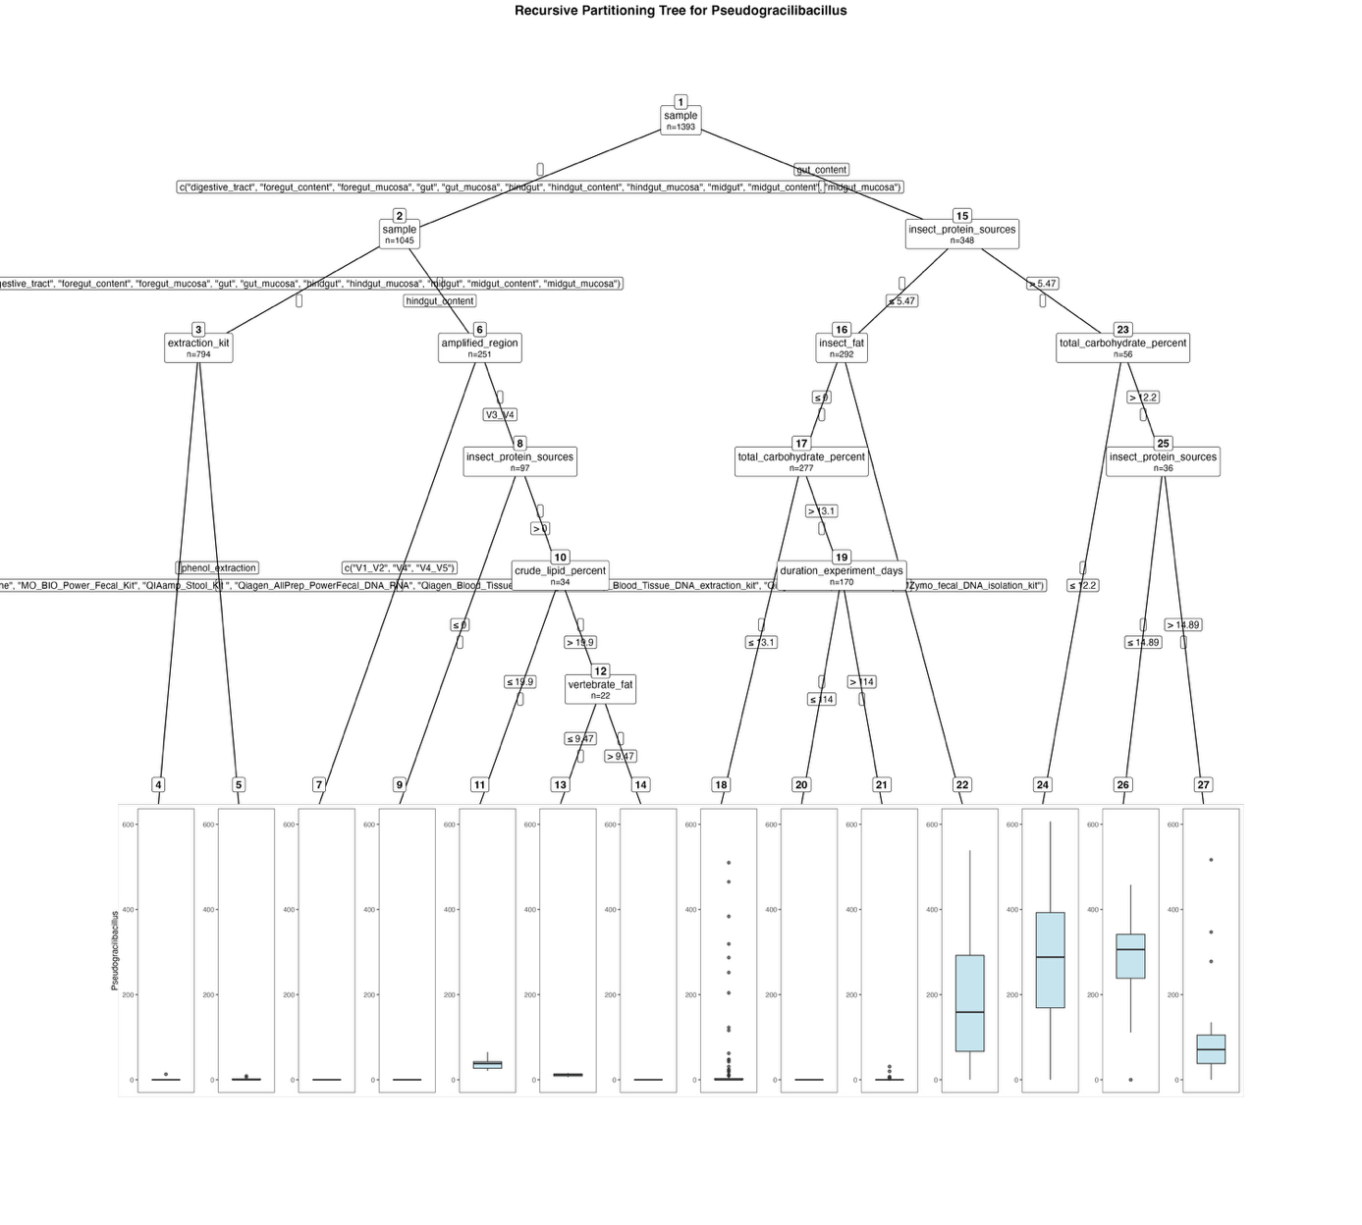
Fig. S26. Fitted party - Pseudogracilibacillus:

[1] root
| [2] sample in digestive_tract, foregut_content, foregut_mucosa, gut, gut_mucosa, hindgut, hindgut_content, hindgut_mucosa, midgut, midgut_content, midgut_mucosa
| | [3] sample in digestive_tract, foregut_content, foregut_mucosa, gut, gut_mucosa, hindgut, hindgut_mucosa, midgut, midgut_content, midgut_mucosa
| | | [4] extraction_kit in Cador_Pathogen_96_QIAcube_HT_Kit, cetyltrimethylammonium_bromide_method, EZNA_Stool_DNA_Kit, High_Pure_PCR_Template_Preparation_Kit_Roche, MO_BIO_Power_Fecal_Kit, QIAamp_Stool_Kit , Qiagen_AllPrep_PowerFecal_DNA_RNA, Qiagen_Blood_Tissue_kit, Qiagen_Dneasy_Blood_Tissue_DNA_extraction_kit, Qiagen_Dneasy_PowerSoil_kit, Zymo_fecal_DNA_isolation_kit: 0.017 (n = 779, err = 168.8)
| | | [5] extraction_kit in phenol_extraction: 1.467 (n = 15, err = 101.7)
| | [6] sample in hindgut_content
| | | [7] amplified_region in V1_V2, V4, V4_V5: 0.000 (n = 154, err = 0.0)
| | | [8] amplified_region in V3_V4
| | | | [9] insect_protein_sources <= 0: 0.000 (n = 63, err = 0.0)
| | | | [10] insect_protein_sources > 0
| | | | | [11] crude_lipid_percent <= 19.9: 38.000 (n = 12, err = 2036.0)
| | | | | [12] crude_lipid_percent > 19.9
| | | | | | [13] vertebrate_fat <= 9.47: 11.500 (n = 12, err = 109.0)
| | | | | | [14] vertebrate_fat > 9.47: 0.000 (n = 10, err = 0.0)
| [15] sample in gut_content
| | [16] insect_protein_sources <= 5.47
| | | [17] insect_fat <= 0
| | | | [18] total_carbohydrate_percent <= 13.1: 28.458 (n = 107, err = 868390.6)
| | | | [19] total_carbohydrate_percent > 13.1
| | | | | [20] duration_experiment_days <= 114: 0.000 (n = 130, err = 0.0)
| | | | | [21] duration_experiment_days > 114: 1.825 (n = 40, err = 1339.8)
| | | [22] insect_fat > 0: 209.533 (n = 15, err = 450695.7)
| | [23] insect_protein_sources > 5.47
| | | [24] total_carbohydrate_percent <= 12.2: 282.700 (n = 20, err = 707528.2)
| | | [25] total_carbohydrate_percent > 12.2
| | | | [26] insect_protein_sources <= 14.89: 280.800 (n = 15, err = 204570.4)
| | | | [27] insect_protein_sources > 14.89: 106.333 (n = 21, err = 323642.7)

Number of inner nodes: 13
Number of terminal nodes: 14

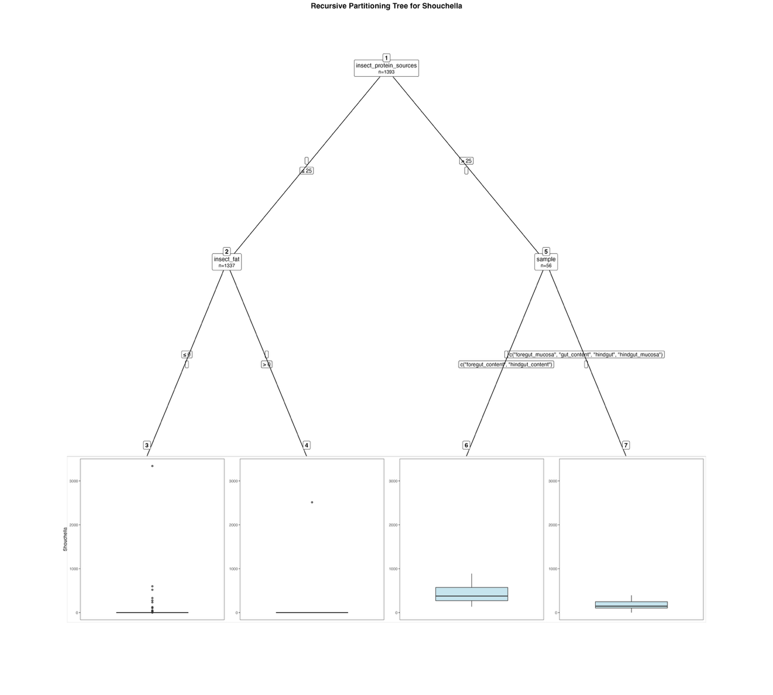
Fig. S27. Fitted party - Shouchella:

[1] root
| [2] insect_protein_sources <= 25
| | [3] insect_fat <= 0: 4.551 (n = 1316, err = 12048975.6)
| | [4] insect_fat > 0: 119.667 (n = 21, err = 6014446.7)
| [5] insect_protein_sources > 25
| | [6] sample in foregut_content, hindgut_content: 424.556 (n = 27, err = 1036310.7)
| | [7] sample in foregut_mucosa, gut_content, hindgut, hindgut_mucosa: 162.138 (n = 29, err = 337013.4)

Number of inner nodes: 3
Number of terminal nodes: 4

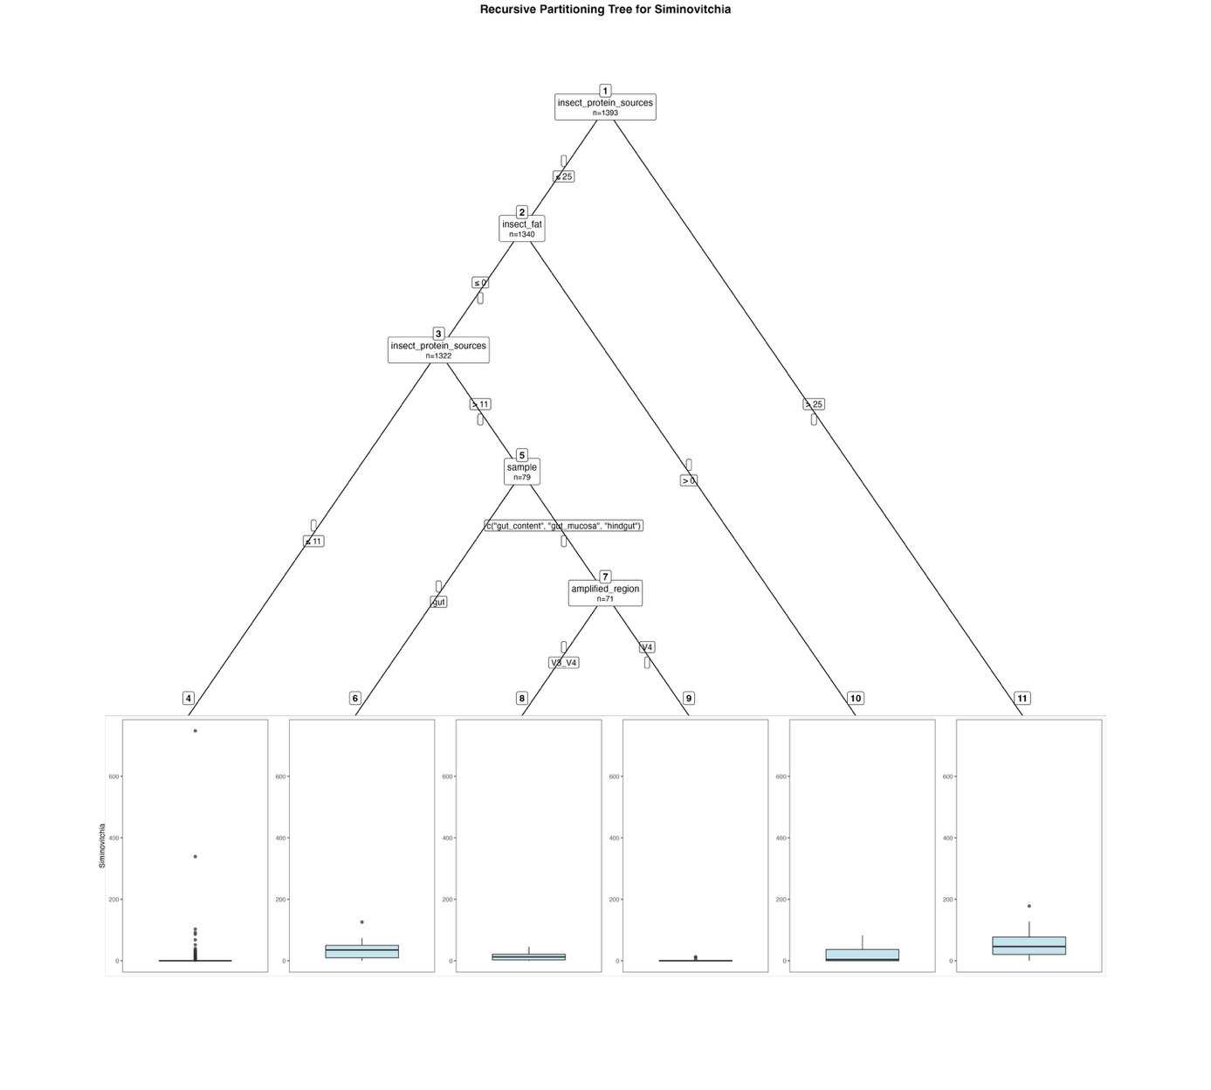
Fig. S28. Fitted party - Siminovitchia:

[1] root
| [2] insect_protein_sources <= 25
| | [3] insect_fat <= 0
| | | [4] insect_protein_sources <= 11: 1.607 (n = 1243, err = 716138.6)
| | | [5] insect_protein_sources > 11
| | | | [6] sample in gut: 41.250 (n = 8, err = 12189.5)
| | | | [7] sample in gut_content, gut_mucosa, hindgut
| | | | | [8] amplified_region in V3_V4: 14.096 (n = 52, err = 7442.5)
| | | | | [9] amplified_region in V4: 1.684 (n = 19, err = 260.1)
| | [10] insect_fat > 0: 20.167 (n = 18, err = 12058.5)
| [11] insect_protein_sources > 25: 50.302 (n = 53, err = 90569.2)

Number of inner nodes: 5
Number of terminal nodes: 6

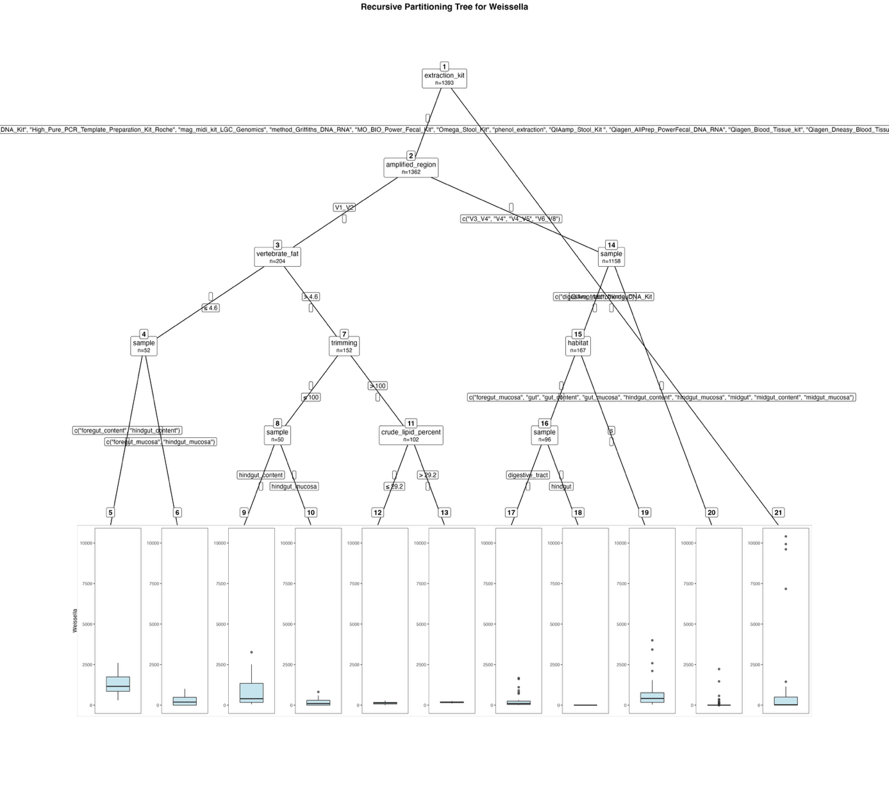
Fig. S29. Fitted party - Weissella:

[1] root
| [2] extraction_kit in Cador_Pathogen_96_QIAcube_HT_Kit, cetyltrimethylammonium_bromide_method, EZNA_Stool_DNA_Kit, High_Pure_PCR_Template_Preparation_Kit_Roche, mag_midi_kit_LGC_Genomics, method_Griffiths_DNA_RNA, MO_BIO_Power_Fecal_Kit, Omega_Stool_Kit, phenol_extraction, QIAamp_Stool_Kit , Qiagen_AllPrep_PowerFecal_DNA_RNA, Qiagen_Blood_Tissue_kit, Qiagen_Dneasy_Blood_Tissue_DNA_extraction_kit, Qiagen_Dneasy_PowerSoil_kit, Zymo_fecal_DNA_isolation_kit
| | [3] amplified_region in V1_V2
| | | [4] vertebrate_fat <= 4.6
| | | | [5] sample in foregut_content, hindgut_content: 1313.821 (n = 28, err = 10621226.1)
| | | | [6] sample in foregut_mucosa, hindgut_mucosa: 285.375 (n = 24, err = 2252489.6)
| | | [7] vertebrate_fat > 4.6
| | | | [8] trimming <= 100
| | | | | [9] sample in hindgut_content: 857.640 (n = 25, err = 19860245.8)
| | | | | [10] sample in hindgut_mucosa: 173.640 (n = 25, err = 1188007.8)
| | | | [11] trimming > 100
| | | | | [12] crude_lipid_percent <= 29.2: 123.808 (n = 78, err = 304766.1)
| | | | | [13] crude_lipid_percent > 29.2: 174.958 (n = 24, err = 44027.0)
| | [14] amplified_region in V3_V4, V4, V4_V5, V6_V8
| | | [15] sample in digestive_tract, hindgut
| | | | [16] habitat in f
| | | | | [17] sample in digestive_tract: 269.081 (n = 37, err = 6432970.8)
| | | | | [18] sample in hindgut: 0.000 (n = 59, err = 0.0)
| | | | [19] habitat in s: 626.873 (n = 71, err = 36449277.9)
| | | [20] sample in foregut_mucosa, gut, gut_content, gut_mucosa, hindgut_content, hindgut_mucosa, midgut, midgut_content, midgut_mucosa: 10.490 (n = 991, err = 7989711.7)
| [21] extraction_kit in QiAmp_Microbiome_DNA_Kit: 1382.129 (n = 31, err = 296573977.5)

Number of inner nodes: 10
Number of terminal nodes: 11

Results for the filtered dataset – Genera:

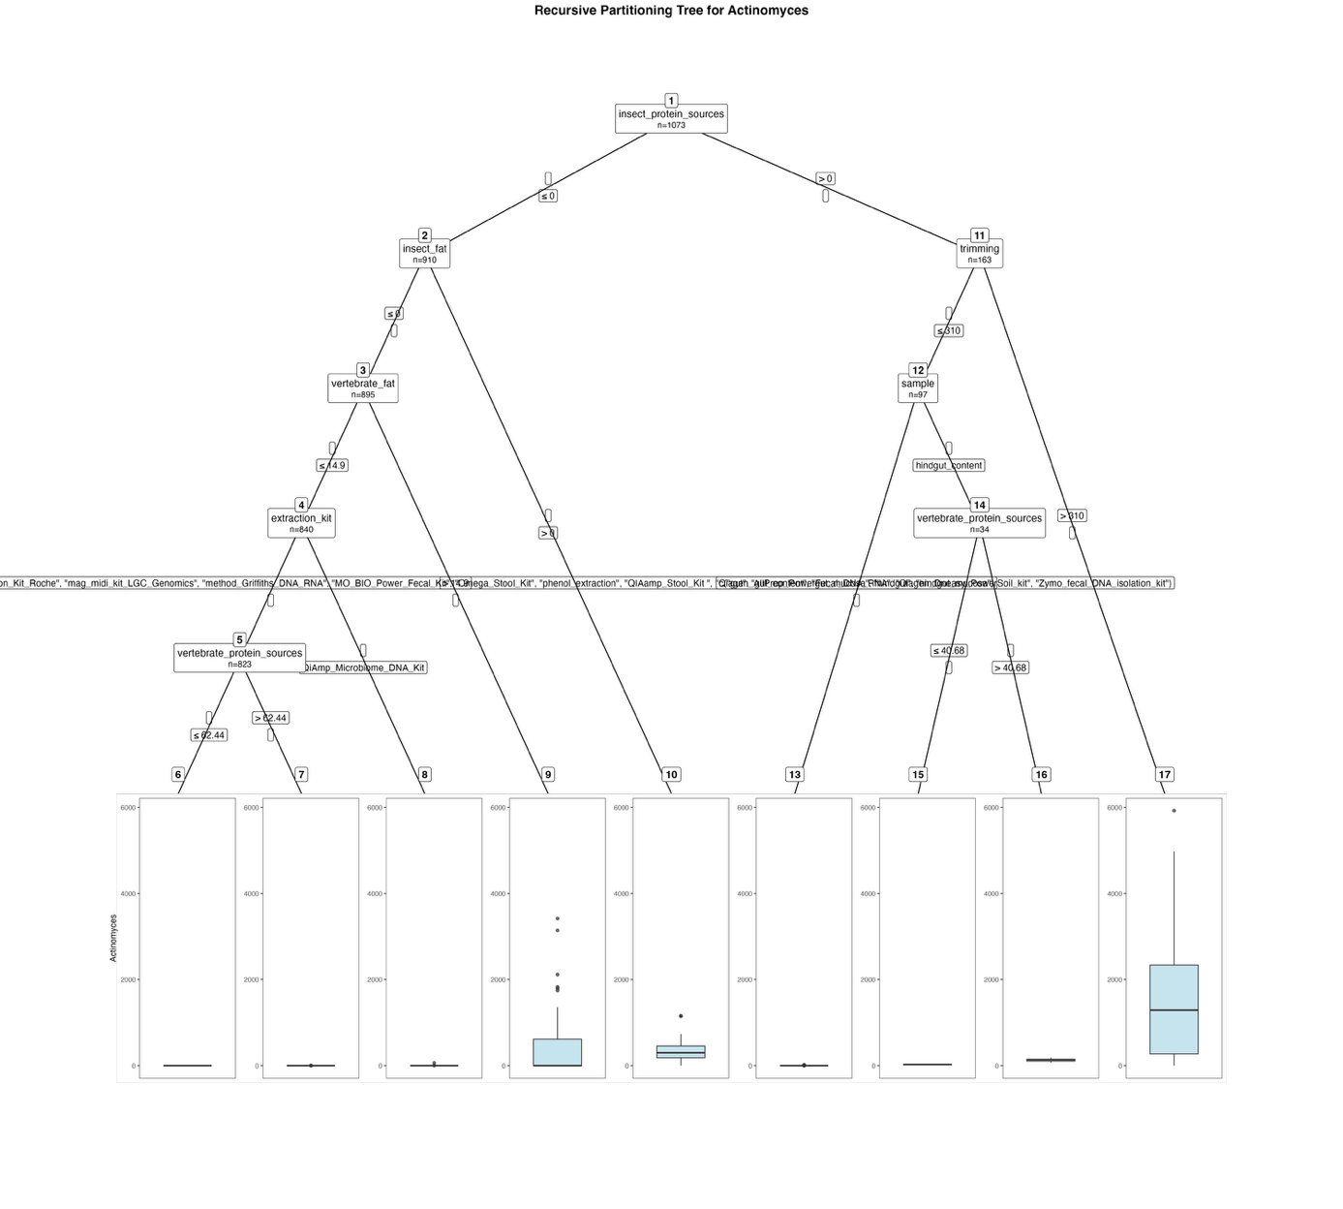
Fig. S30. Fitted party - Actinomyces:

[1] root
| [2] insect_protein_sources <= 0
| | [3] insect_fat <= 0
| | | [4] vertebrate_fat <= 14.9
| | | | [5] extraction_kit in Cador_Pathogen_96_QIAcube_HT_Kit, cetyltrimethylammonium_bromide_method, EZNA_Stool_DNA_Kit, High_Pure_PCR_Template_Preparation_Kit_Roche, mag_midi_kit_LGC_Genomics, method_Griffiths_DNA_RNA, MO_BIO_Power_Fecal_Kit, Omega_Stool_Kit, phenol_extraction, QIAamp_Stool_Kit , Qiagen_AllPrep_PowerFecal_DNA_RNA, Qiagen_Dneasy_PowerSoil_kit, Zymo_fecal_DNA_isolation_kit
| | | | | [6] vertebrate_protein_sources <= 62.44: 0.000 (n = 758, err = 0.0)
| | | | | [7] vertebrate_protein_sources > 62.44: 0.092 (n = 65, err = 11.4)
| | | | [8] extraction_kit in QiAmp_Microbiome_DNA_Kit: 3.706 (n = 17, err = 3491.5)
| | | [9] vertebrate_fat > 14.9: 406.600 (n = 55, err = 33507105.2)
| | [10] insect_fat > 0: 402.200 (n = 15, err = 1721924.4)
| [11] insect_protein_sources > 0
| | [12] trimming <= 310
| | | [13] sample in gut, gut_content, gut_mucosa, hindgut, hindgut_mucosa: 0.857 (n = 63, err = 541.7)
| | | [14] sample in hindgut_content
| | | | [15] vertebrate_protein_sources <= 40.68: 24.727 (n = 22, err = 1198.4)
| | | | [16] vertebrate_protein_sources > 40.68: 129.000 (n = 12, err = 14488.0)
| | [17] trimming > 310: 1547.576 (n = 66, err = 123087540.1)

Number of inner nodes: 8
Number of terminal nodes: 9

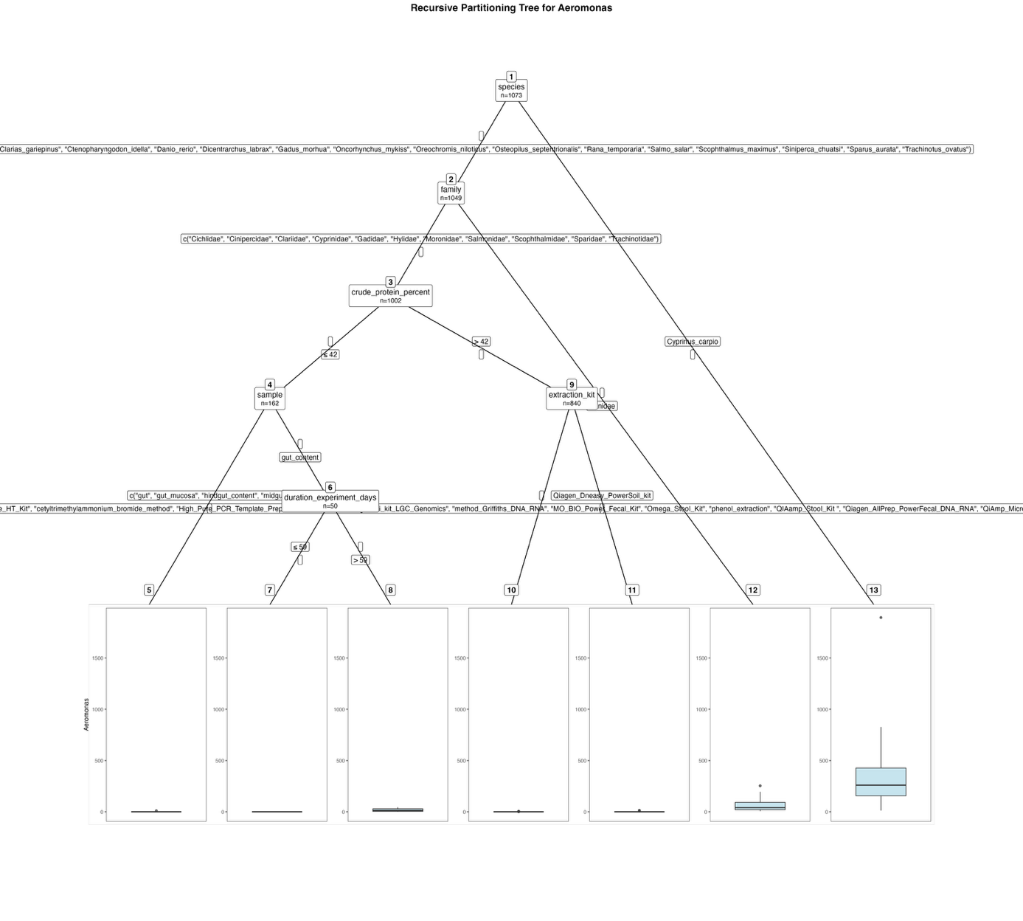
Fig. S31. Fitted party - Aeromonas:

[1] root
| [2] species in Clarias_gariepinus, Ctenopharyngodon_idella, Danio_rerio, Dicentrarchus_labrax, Gadus_morhua, Oncorhynchus_mykiss, Oreochromis_niloticus, Osteopilus_septentrionalis, Rana_temporaria, Salmo_salar, Scophthalmus_maximus, Siniperca_chuatsi, Sparus_aurata, Trachinotus_ovatus
| | [3] family in Cichlidae, Cinipercidae, Clariidae, Cyprinidae, Gadidae, Hylidae, Moronidae, Salmonidae, Scophthalmidae, Sparidae, Trachinotidae
| | | [4] crude_protein_percent <= 42
| | | | [5] sample in gut, gut_mucosa, hindgut_content, midgut: 0.089 (n = 112, err = 99.1)
| | | | [6] sample in gut_content
| | | | | [7] duration_experiment_days <= 59: 0.000 (n = 31, err = 0.0)
| | | | | [8] duration_experiment_days > 59: 15.684 (n = 19, err = 3162.1)
| | | [9] crude_protein_percent > 42
| | | | [10] extraction_kit in Cador_Pathogen_96_QIAcube_HT_Kit, cetyltrimethylammonium_bromide_method, High_Pure_PCR_Template_Preparation_Kit_Roche, mag_midi_kit_LGC_Genomics, method_Griffiths_DNA_RNA, MO_BIO_Power_Fecal_Kit, Omega_Stool_Kit, phenol_extraction, QIAamp_Stool_Kit , Qiagen_AllPrep_PowerFecal_DNA_RNA, QiAmp_Microbiome_DNA_Kit, Zymo_fecal_DNA_isolation_kit: 0.011 (n = 803, err = 34.9)
| | | | [11] extraction_kit in Qiagen_Dneasy_PowerSoil_kit: 0.568 (n = 37, err = 233.1)
| | [12] family in Ranidae: 58.319 (n = 47, err = 125534.2)
| [13] species in Cyprinus_carpio: 371.708 (n = 24, err = 3446553.0)

Number of inner nodes: 6
Number of terminal nodes: 7

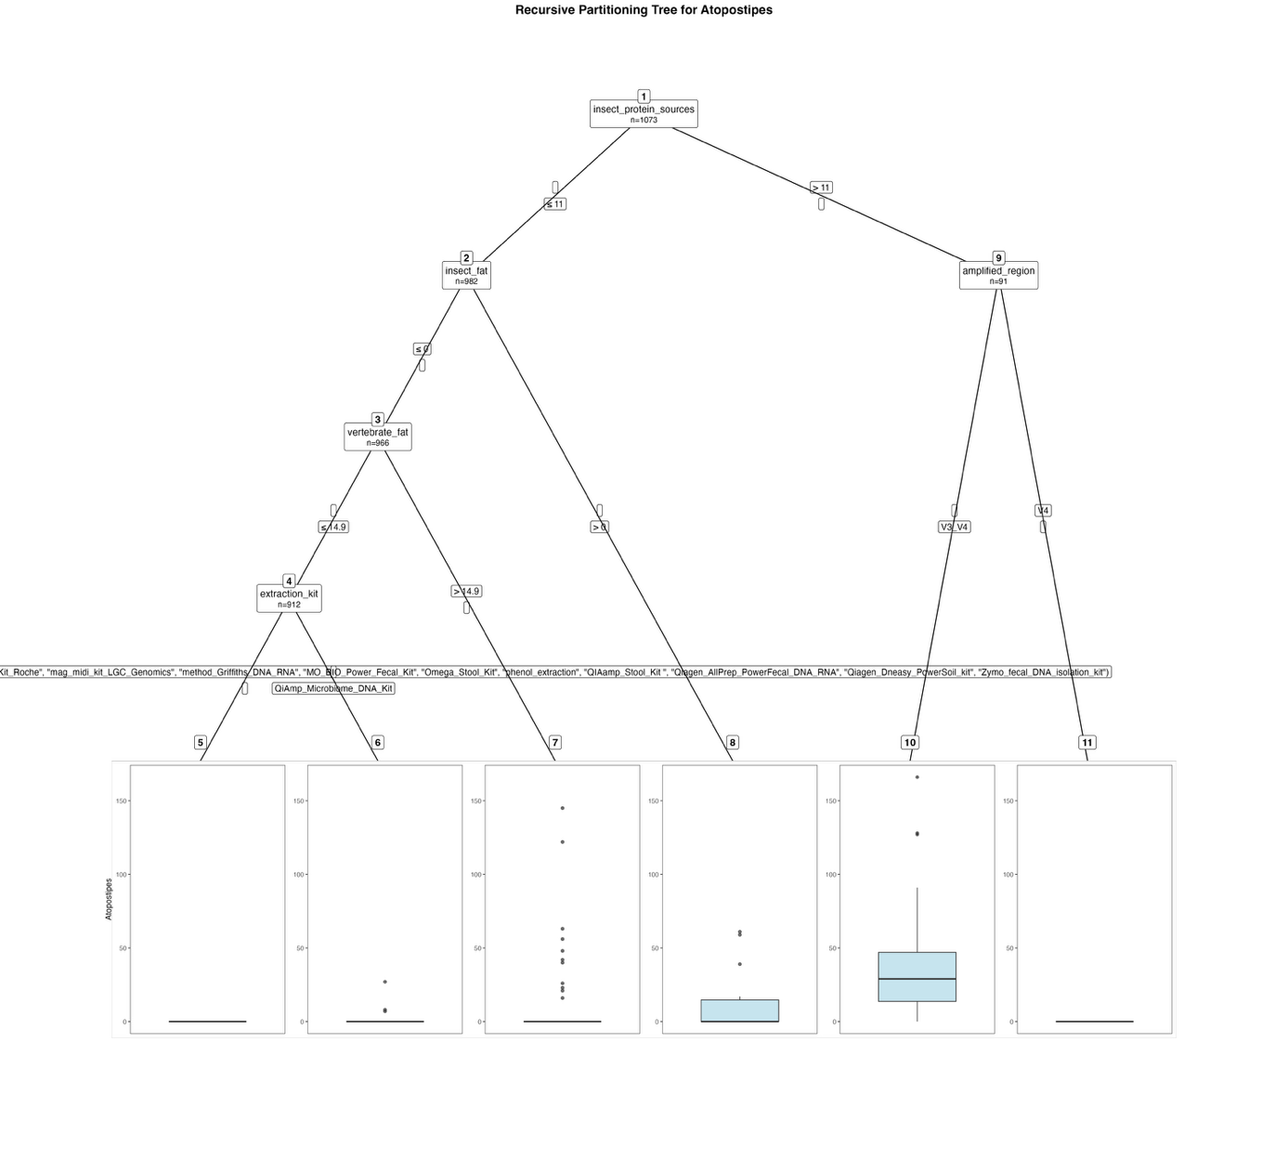
Fig. S32. Fitted party - Atopostipes:

[1] root
| [2] insect_protein_sources <= 11
| | [3] insect_fat <= 0
| | | [4] vertebrate_fat <= 14.9
| | | | [5] extraction_kit in Cador_Pathogen_96_QIAcube_HT_Kit, cetyltrimethylammonium_bromide_method, EZNA_Stool_DNA_Kit, High_Pure_PCR_Template_Preparation_Kit_Roche, mag_midi_kit_LGC_Genomics, method_Griffiths_DNA_RNA, MO_BIO_Power_Fecal_Kit, Omega_Stool_Kit, phenol_extraction, QIAamp_Stool_Kit , Qiagen_AllPrep_PowerFecal_DNA_RNA, Qiagen_Dneasy_PowerSoil_kit, Zymo_fecal_DNA_isolation_kit: 0.000 (n = 883, err = 0.0)
| | | | [6] extraction_kit in QiAmp_Microbiome_DNA_Kit: 1.448 (n = 29, err = 781.2)
| | | [7] vertebrate_fat > 14.9: 11.148 (n = 54, err = 43872.8)
| | [8] insect_fat > 0: 12.938 (n = 16, err = 6686.9)
| [9] insect_protein_sources > 11
| | [10] amplified_region in V3_V4: 38.577 (n = 52, err = 67926.7)
| | [11] amplified_region in V4: 0.000 (n = 39, err = 0.0)

Number of inner nodes: 5
Number of terminal nodes: 6

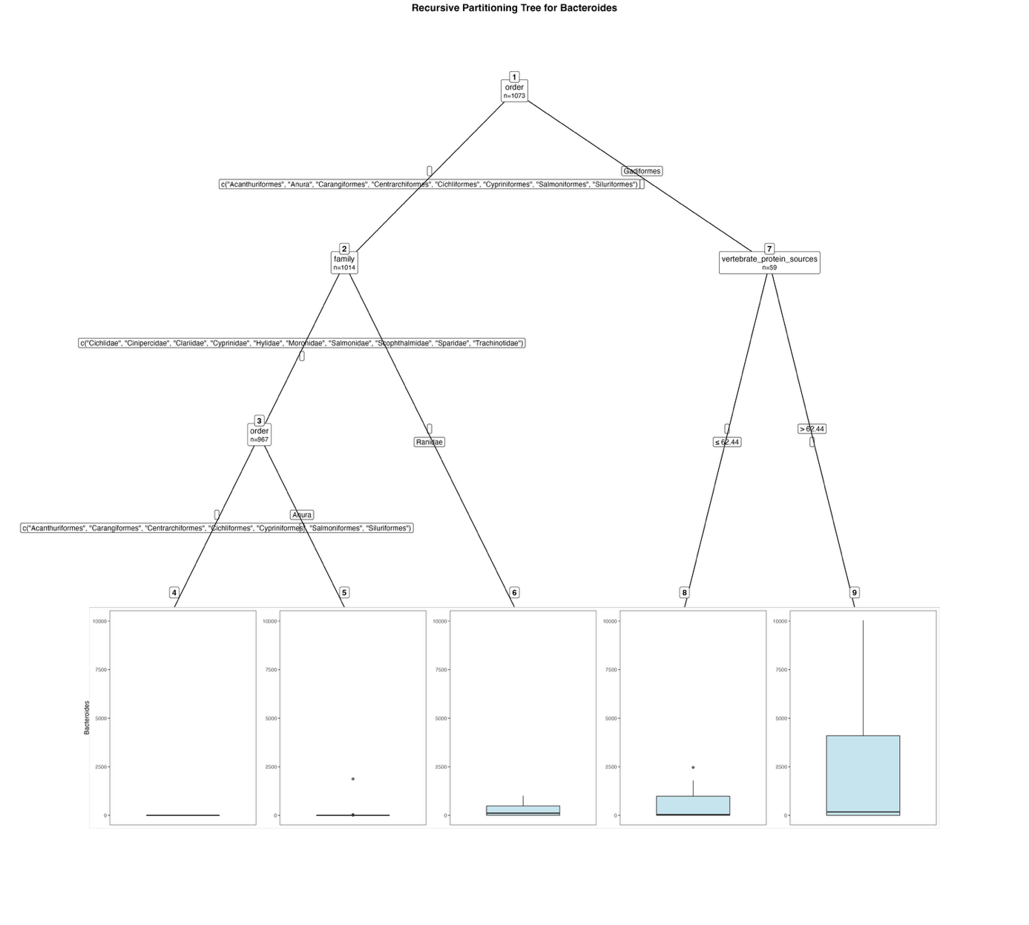
Fig. S33. Fitted party - Bacteroides:

[1] root
| [2] order in Acanthuriformes, Anura, Carangiformes, Centrarchiformes, Cichliformes, Cypriniformes, Salmoniformes, Siluriformes
| | [3] family in Cichlidae, Cinipercidae, Clariidae, Cyprinidae, Hylidae, Moronidae, Salmonidae, Scophthalmidae, Sparidae, Trachinotidae
| | | [4] order in Acanthuriformes, Carangiformes, Centrarchiformes, Cichliformes, Cypriniformes, Salmoniformes, Siluriformes: 0.000 (n = 931, err = 0.0)
| | | [5] order in Anura: 53.722 (n = 36, err = 3405841.2)
| | [6] family in Ranidae: 243.043 (n = 47, err = 3786613.9)
| [7] order in Gadiformes
| | [8] vertebrate_protein_sources <= 62.44: 455.286 (n = 28, err = 12806891.7)
| | [9] vertebrate_protein_sources > 62.44: 2124.355 (n = 31, err = 263333871.1)

Number of inner nodes: 4
Number of terminal nodes: 5

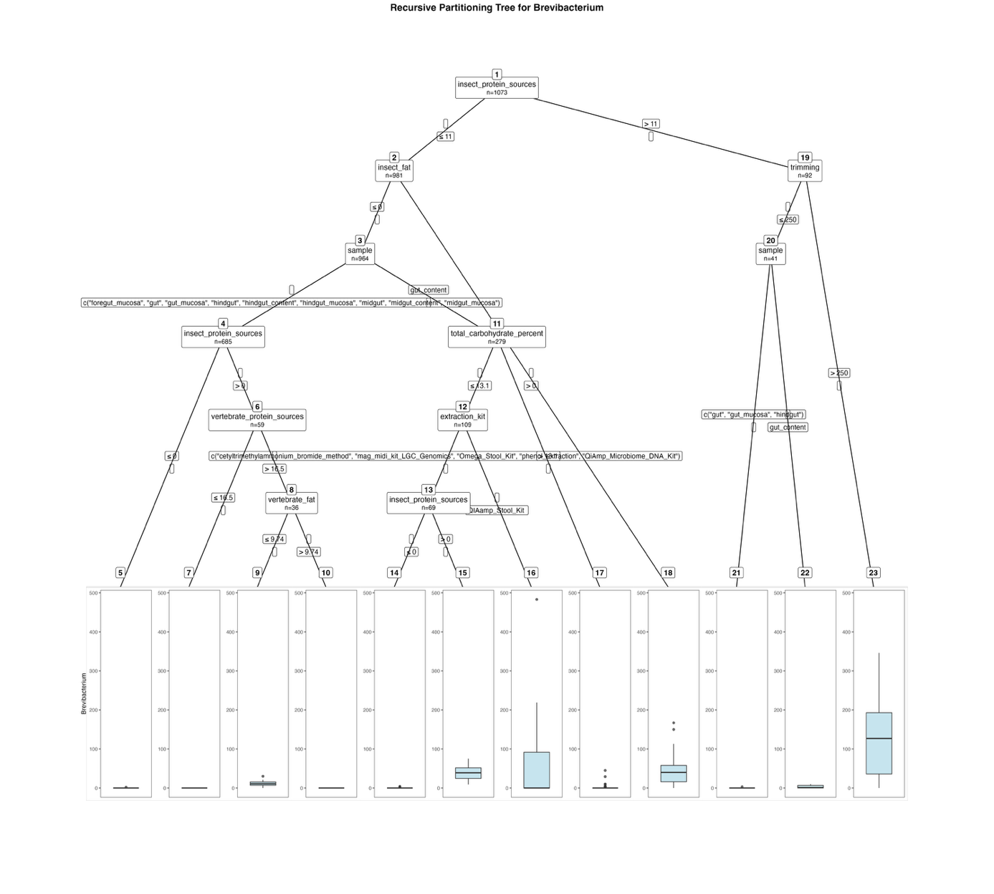
Fig. S34. Fitted party - Brevibacterium:

[1] root
| [2] insect_protein_sources <= 11
| | [3] insect_fat <= 0
| | | [4] sample in foregut_mucosa, gut, gut_mucosa, hindgut, hindgut_content, hindgut_mucosa, midgut, midgut_content, midgut_mucosa
| | | | [5] insect_protein_sources <= 0: 0.003 (n = 626, err = 4.0)
| | | | [6] insect_protein_sources > 0
| | | | | [7] vertebrate_protein_sources <= 16.5: 0.000 (n = 23, err = 0.0)
| | | | | [8] vertebrate_protein_sources > 16.5
| | | | | | [9] vertebrate_fat <= 9.74: 11.222 (n = 27, err = 1478.7)
| | | | | | [10] vertebrate_fat > 9.74: 0.000 (n = 9, err = 0.0)
| | | [11] sample in gut_content
| | | | [12] total_carbohydrate_percent <= 13.1
| | | | | [13] extraction_kit in cetyltrimethylammonium_bromide_method, mag_midi_kit_LGC_Genomics, Omega_Stool_Kit, phenol_extraction, QiAmp_Microbiome_DNA_Kit
| | | | | | [14] insect_protein_sources <= 0: 0.158 (n = 57, err = 27.6)
| | | | | | [15] insect_protein_sources > 0: 38.750 (n = 12, err = 4592.2)
| | | | | [16] extraction_kit in QIAamp_Stool_Kit : 57.450 (n = 40, err = 348971.9)
| | | | [17] total_carbohydrate_percent > 13.1: 0.671 (n = 170, err = 3061.6)
| | [18] insect_fat > 0: 49.588 (n = 17, err = 41026.1)
| [19] insect_protein_sources > 11
| | [20] trimming <= 250
| | | [21] sample in gut, gut_mucosa, hindgut: 0.091 (n = 33, err = 8.7)
| | | [22] sample in gut_content: 3.250 (n = 8, err = 119.5)
| | [23] trimming > 250: 130.529 (n = 51, err = 460572.7)

Number of inner nodes: 11
Number of terminal nodes: 12

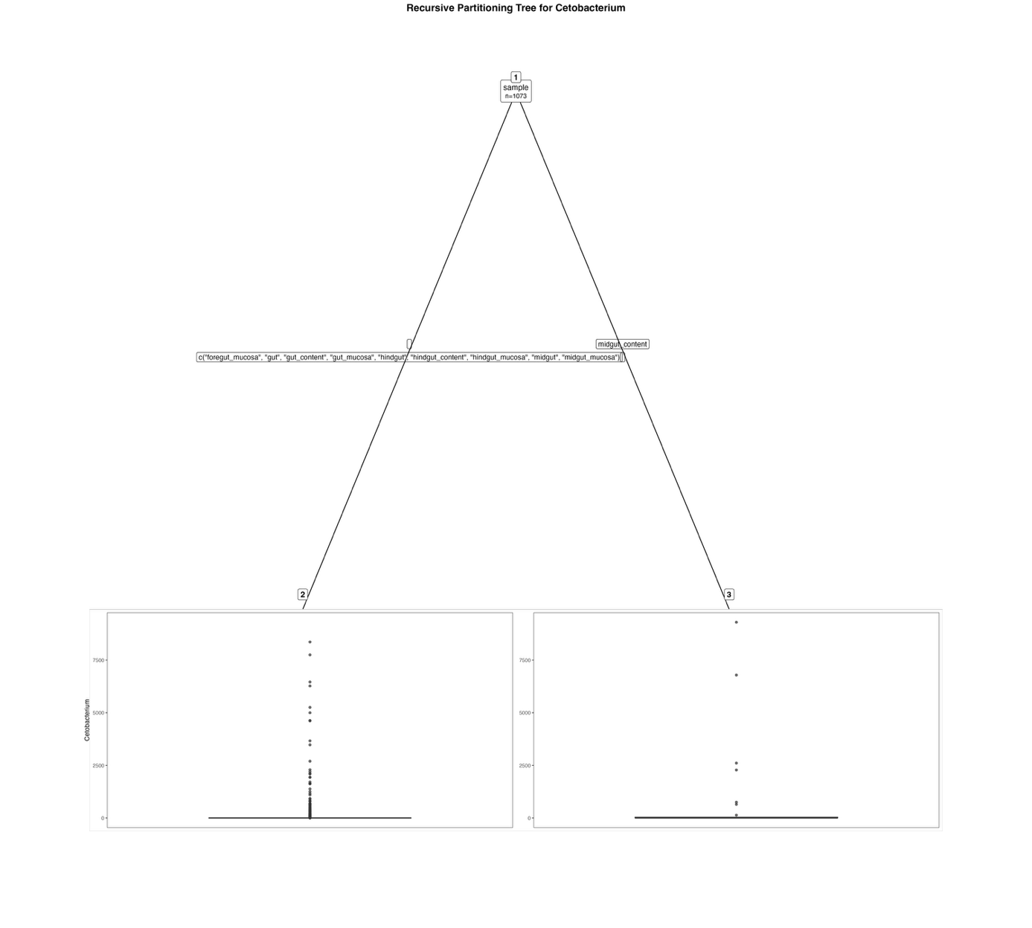
Fig. S35. Fitted party - Cetobacterium:

[1] root
| [2] sample in foregut_mucosa, gut, gut_content, gut_mucosa, hindgut, hindgut_content, hindgut_mucosa, midgut, midgut_mucosa: 109.134 (n = 1041, err = 383415789.2)
| [3] sample in midgut_content: 707.750 (n = 32, err = 129466960.0)

Number of inner nodes: 1
Number of terminal nodes: 2

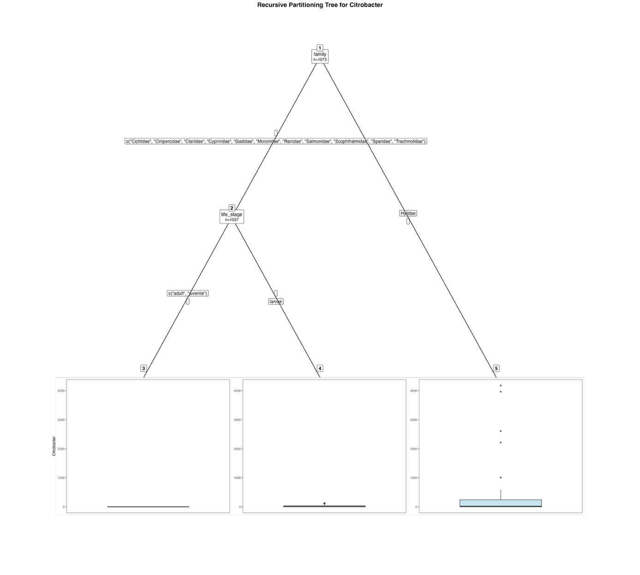
Fig. S36. Fitted party - Citrobacter:

[1] root
| [2] family in Cichlidae, Cinipercidae, Clariidae, Cyprinidae, Gadidae, Moronidae, Ranidae, Salmonidae, Scophthalmidae, Sparidae, Trachinotidae
| | [3] life_stage in adult, juvenile: 0.000 (n = 990, err = 0.0)
| | [4] life_stage in larvae: 26.447 (n = 47, err = 56401.6)
| [5] family in Hylidae: 461.611 (n = 36, err = 39220510.6)

Number of inner nodes: 2
Number of terminal nodes: 3

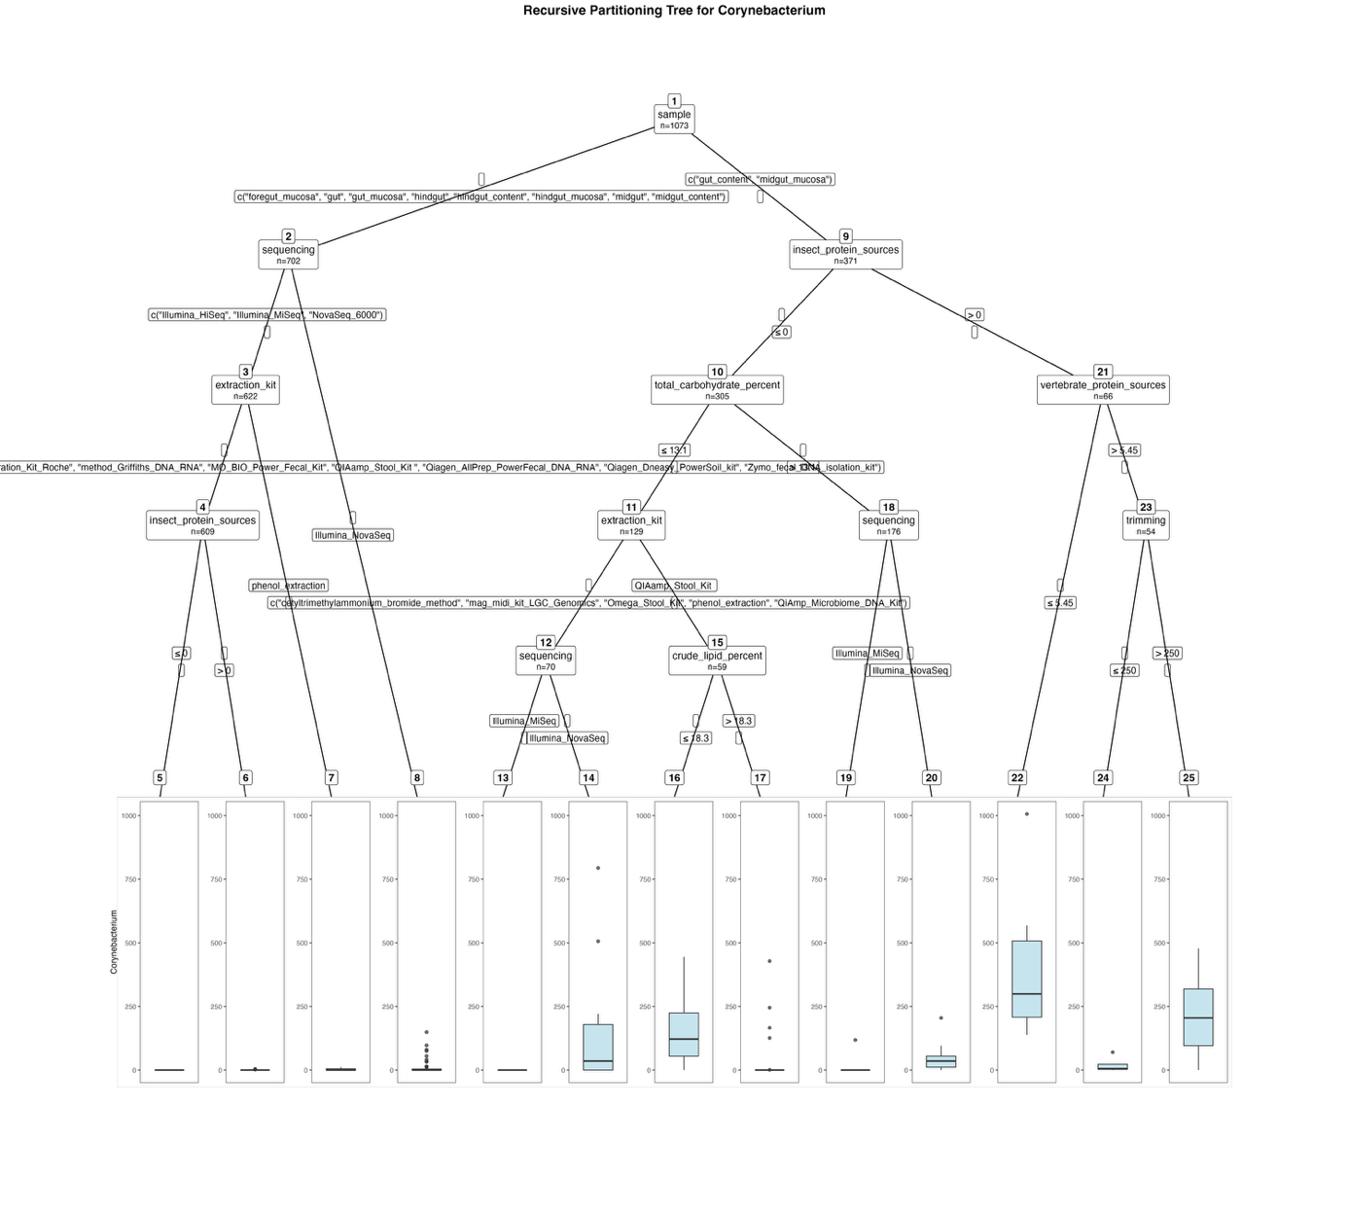
Fig. S37. Fitted party - Corynebacterium:

[1] root
| [2] sample in foregut_mucosa, gut, gut_mucosa, hindgut, hindgut_content, hindgut_mucosa, midgut, midgut_content
| | [3] sequencing in Illumina_HiSeq, Illumina_MiSeq, NovaSeq_6000
| | | [4] extraction_kit in Cador_Pathogen_96_QIAcube_HT_Kit, EZNA_Stool_DNA_Kit, High_Pure_PCR_Template_Preparation_Kit_Roche, method_Griffiths_DNA_RNA, MO_BIO_Power_Fecal_Kit, QIAamp_Stool_Kit , Qiagen_AllPrep_PowerFecal_DNA_RNA, Qiagen_Dneasy_PowerSoil_kit, Zymo_fecal_DNA_isolation_kit
| | | | [5] insect_protein_sources <= 0: 0.000 (n = 520, err = 0.0)
| | | | [6] insect_protein_sources > 0: 0.169 (n = 89, err = 44.5)
| | | [7] extraction_kit in phenol_extraction: 2.846 (n = 13, err = 205.7)
| | [8] sequencing in Illumina_NovaSeq: 8.537 (n = 80, err = 45679.9)
| [9] sample in gut_content, midgut_mucosa
| | [10] insect_protein_sources <= 0
| | | [11] total_carbohydrate_percent <= 13.1
| | | | [12] extraction_kit in cetyltrimethylammonium_bromide_method, mag_midi_kit_LGC_Genomics, Omega_Stool_Kit, phenol_extraction, QiAmp_Microbiome_DNA_Kit
| | | | | [13] sequencing in Illumina_MiSeq: 0.000 (n = 58, err = 0.0)
| | | | | [14] sequencing in Illumina_NovaSeq: 152.250 (n = 12, err = 692722.2)
| | | | [15] extraction_kit in QIAamp_Stool_Kit
| | | | | [16] crude_lipid_percent <= 18.3: 147.906 (n = 32, err = 450114.7)
| | | | | [17] crude_lipid_percent > 18.3: 35.778 (n = 27, err = 252080.7)
| | | [18] total_carbohydrate_percent > 13.1
| | | | [19] sequencing in Illumina_MiSeq: 0.720 (n = 164, err = 13839.1)
| | | | [20] sequencing in Illumina_NovaSeq: 48.167 (n = 12, err = 37153.7)
| | [21] insect_protein_sources > 0
| | | [22] vertebrate_protein_sources <= 5.45: 388.083 (n = 12, err = 675012.9)
| | | [23] vertebrate_protein_sources > 5.45
| | | | [24] trimming <= 250: 16.750 (n = 8, err = 3883.5)
| | | | [25] trimming > 250: 212.152 (n = 46, err = 883633.9)

Number of inner nodes: 12
Number of terminal nodes: 13

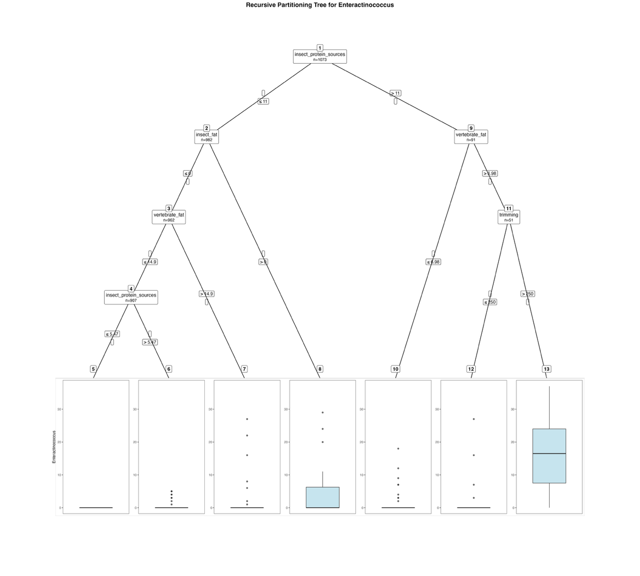
Fig. S38. Fitted party - Enteractinococcus:

[1] root
| [2] insect_protein_sources <= 11
| | [3] insect_fat <= 0
| | | [4] vertebrate_fat <= 14.9
| | | | [5] insect_protein_sources <= 5.47: 0.000 (n = 854, err = 0.0)
| | | | [6] insect_protein_sources > 5.47: 0.604 (n = 53, err = 110.7)
| | | [7] vertebrate_fat > 14.9: 1.491 (n = 55, err = 1451.7)
| | [8] insect_fat > 0: 4.850 (n = 20, err = 1552.6)
| [9] insect_protein_sources > 11
| | [10] vertebrate_fat <= 6.98: 1.625 (n = 40, err = 579.4)
| | [11] vertebrate_fat > 6.98
| | | [12] trimming <= 250: 2.524 (n = 21, err = 909.2)
| | | [13] trimming > 250: 15.867 (n = 30, err = 2625.5)

Number of inner nodes: 6
Number of terminal nodes: 7

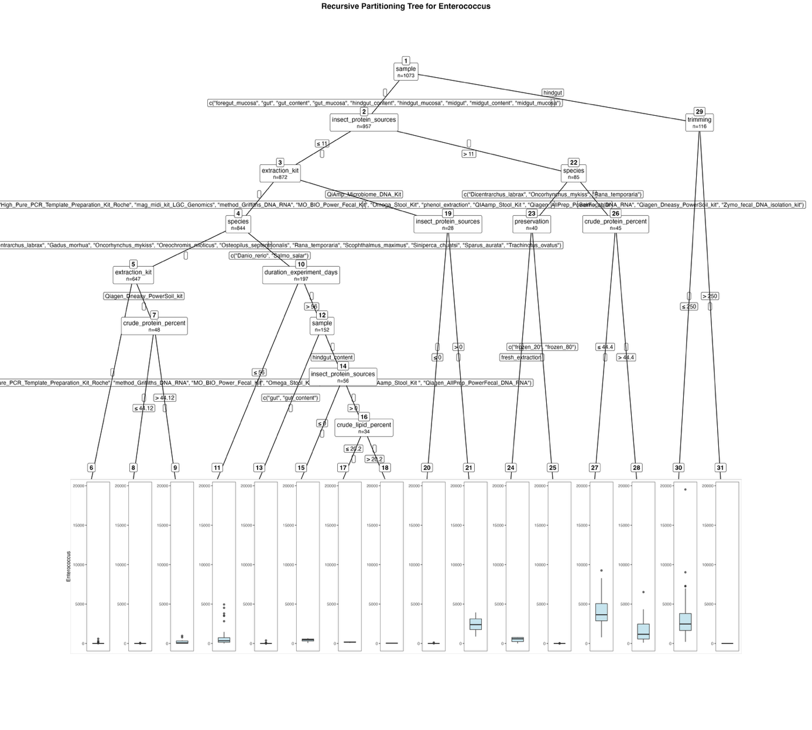
Fig. S39. Fitted party - Enterococcus:

[1] root
| [2] sample in foregut_mucosa, gut, gut_content, gut_mucosa, hindgut_content, hindgut_mucosa, midgut, midgut_content, midgut_mucosa
| | [3] insect_protein_sources <= 11
| | | [4] extraction_kit in Cador_Pathogen_96_QIAcube_HT_Kit, cetyltrimethylammonium_bromide_method, EZNA_Stool_DNA_Kit, High_Pure_PCR_Template_Preparation_Kit_Roche, mag_midi_kit_LGC_Genomics, method_Griffiths_DNA_RNA, MO_BIO_Power_Fecal_Kit, Omega_Stool_Kit, phenol_extraction, QIAamp_Stool_Kit , Qiagen_AllPrep_PowerFecal_DNA_RNA, Qiagen_Dneasy_PowerSoil_kit, Zymo_fecal_DNA_isolation_kit
| | | | [5] species in Clarias_gariepinus, Ctenopharyngodon_idella, Cyprinus_carpio, Dicentrarchus_labrax, Gadus_morhua, Oncorhynchus_mykiss, Oreochromis_niloticus, Osteopilus_septentrionalis, Rana_temporaria, Scophthalmus_maximus, Siniperca_chuatsi, Sparus_aurata, Trachinotus_ovatus
| | | | | [6] extraction_kit in Cador_Pathogen_96_QIAcube_HT_Kit, cetyltrimethylammonium_bromide_method, EZNA_Stool_DNA_Kit, High_Pure_PCR_Template_Preparation_Kit_Roche, method_Griffiths_DNA_RNA, MO_BIO_Power_Fecal_Kit, Omega_Stool_Kit, phenol_extraction, QIAamp_Stool_Kit , Qiagen_AllPrep_PowerFecal_DNA_RNA: 2.803 (n = 599, err = 554430.8)
| | | | | [7] extraction_kit in Qiagen_Dneasy_PowerSoil_kit
| | | | | | [8] crude_protein_percent <= 44.12: 4.297 (n = 37, err = 7067.7)
| | | | | | [9] crude_protein_percent > 44.12: 241.455 (n = 11, err = 1142684.7)
| | | | [10] species in Danio_rerio, Salmo_salar
| | | | | [11] duration_experiment_days <= 56: 850.311 (n = 45, err = 70379515.6)
| | | | | [12] duration_experiment_days > 56
| | | | | | [13] sample in gut, gut_content: 7.146 (n = 96, err = 160766.0)
| | | | | | [14] sample in hindgut_content
| | | | | | | [15] insect_protein_sources <= 0: 436.864 (n = 22, err = 570586.6)
| | | | | | | [16] insect_protein_sources > 0
| | | | | | | | [17] crude_lipid_percent <= 20.2: 163.625 (n = 24, err = 53561.6)
| | | | | | | | [18] crude_lipid_percent > 20.2: 32.000 (n = 10, err = 666.0)
| | | [19] extraction_kit in QiAmp_Microbiome_DNA_Kit
| | | | [20] insect_protein_sources <= 0: 7.062 (n = 16, err = 11098.9)
| | | | [21] insect_protein_sources > 0: 2363.333 (n = 12, err = 9569046.7)
| | [22] insect_protein_sources > 11
| | | [23] species in Dicentrarchus_labrax, Oncorhynchus_mykiss, Rana_temporaria
| | | | [24] preservation in fresh_extraction: 477.250 (n = 8, err = 734593.5)
| | | | [25] preservation in frozen_20, frozen_80: 1.844 (n = 32, err = 908.2)
| | | [26] species in Salmo_salar
| | | | [27] crude_protein_percent <= 44.4: 4174.267 (n = 15, err = 79229220.9)
| | | | [28] crude_protein_percent > 44.4: 1627.900 (n = 30, err = 65265176.7)
| [29] sample in hindgut
| | [30] trimming <= 250: 3064.873 (n = 71, err = 512658869.9)
| | [31] trimming > 250: 0.000 (n = 45, err = 0.0)

Number of inner nodes: 15
Number of terminal nodes: 16

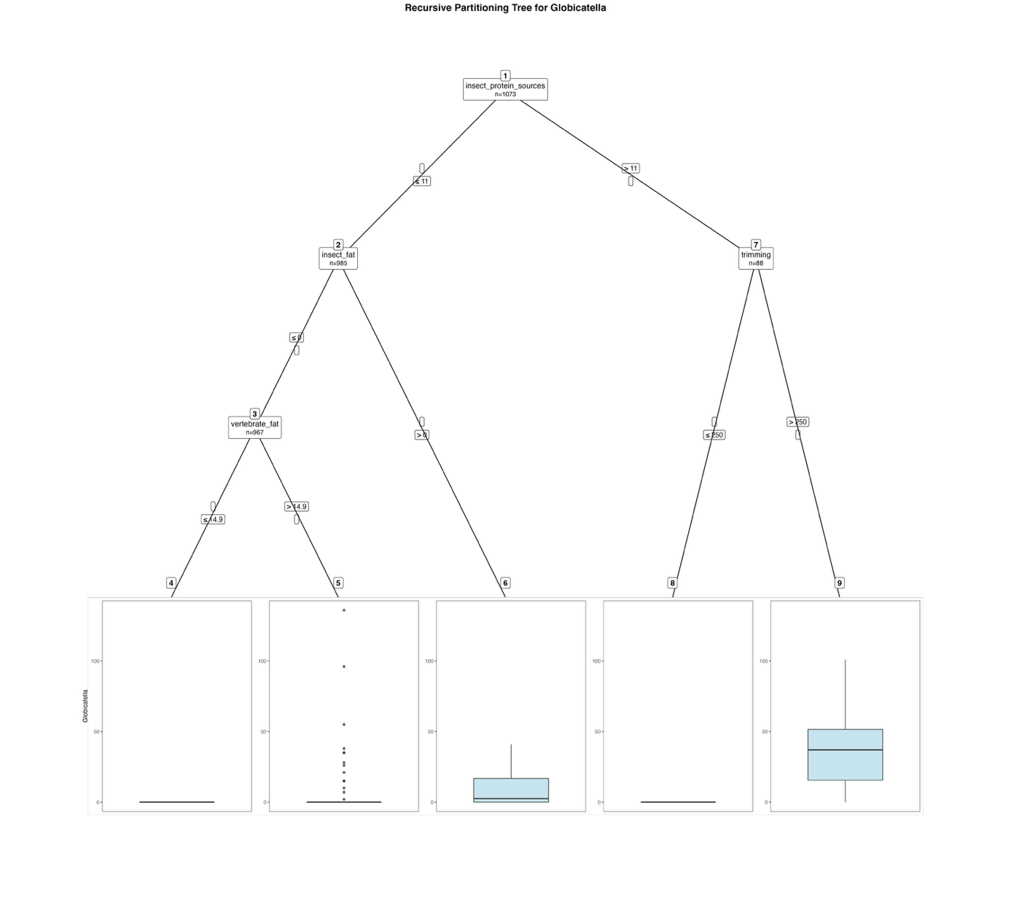
Fig. S40. Fitted party - Globicatella:

[1] root
| [2] insect_protein_sources <= 11
| | [3] insect_fat <= 0
| | | [4] vertebrate_fat <= 14.9: 0.000 (n = 906, err = 0.0)
| | | [5] vertebrate_fat > 14.9: 8.754 (n = 61, err = 32685.3)
| | [6] insect_fat > 0: 9.056 (n = 18, err = 2696.9)
| [7] insect_protein_sources > 11
| | [8] trimming <= 250: 0.000 (n = 37, err = 0.0)
| | [9] trimming > 250: 35.882 (n = 51, err = 38789.3)

Number of inner nodes: 4
Number of terminal nodes: 5

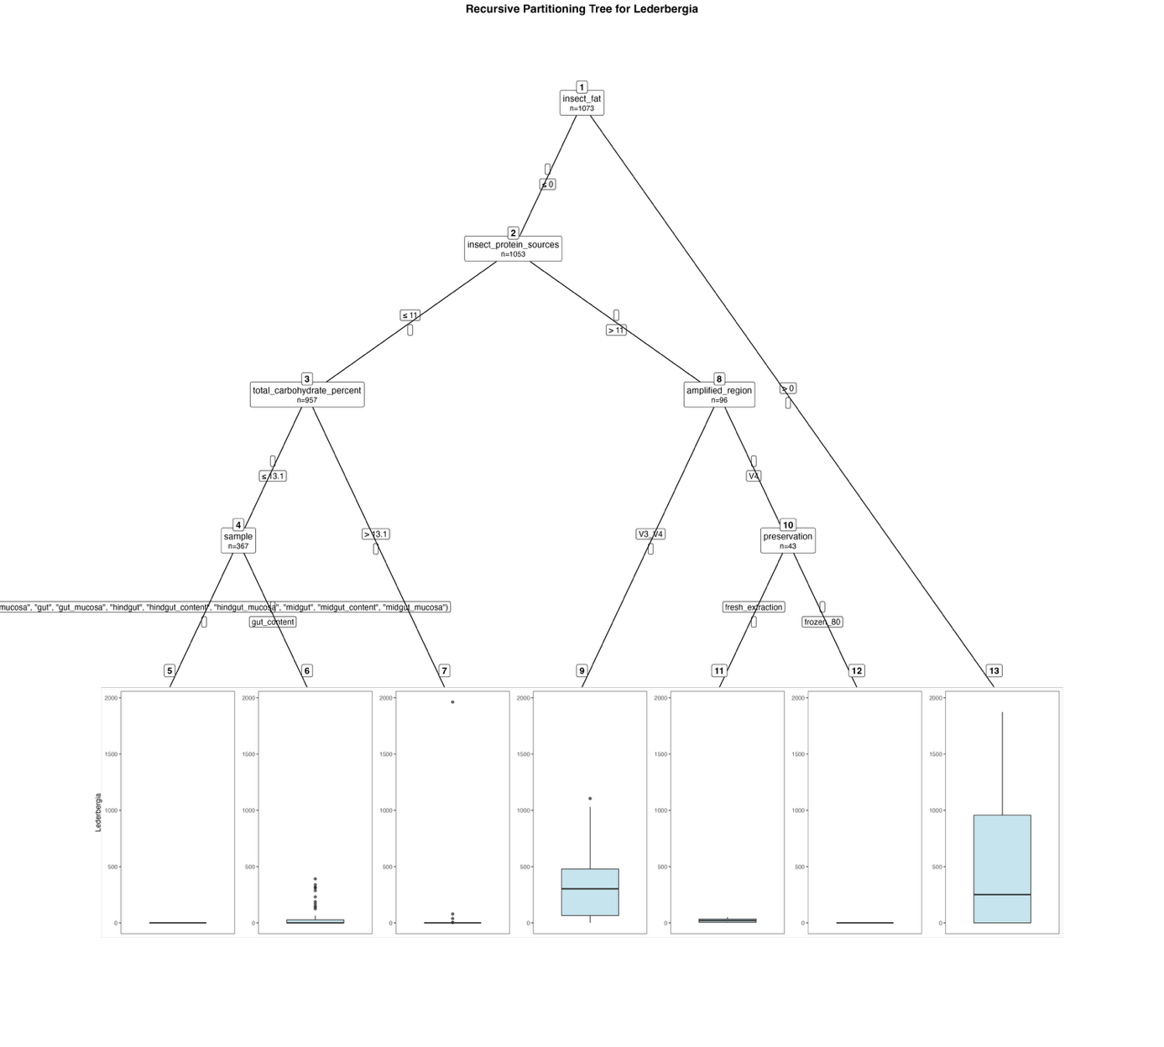
Fig. S41. Fitted party - Lederbergia:

[1] root
| [2] insect_fat <= 0
| | [3] insect_protein_sources <= 11
| | | [4] total_carbohydrate_percent <= 13.1
| | | | [5] sample in foregut_mucosa, gut, gut_mucosa, hindgut, hindgut_content, hindgut_mucosa, midgut, midgut_content, midgut_mucosa: 0.000 (n = 265, err = 0.0)
| | | | [6] sample in gut_content: 36.029 (n = 102, err = 721968.9)
| | | [7] total_carbohydrate_percent > 13.1: 3.536 (n = 590, err = 3849778.8)
| | [8] insect_protein_sources > 11
| | | [9] amplified_region in V3_V4: 318.396 (n = 53, err = 3446378.7)
| | | [10] amplified_region in V4
| | | | [11] preservation in fresh_extraction: 21.125 (n = 8, err = 2308.9)
| | | | [12] preservation in frozen_80: 0.000 (n = 35, err = 0.0)
| [13] insect_fat > 0: 507.250 (n = 20, err = 6780457.8)

Number of inner nodes: 6
Number of terminal nodes: 7

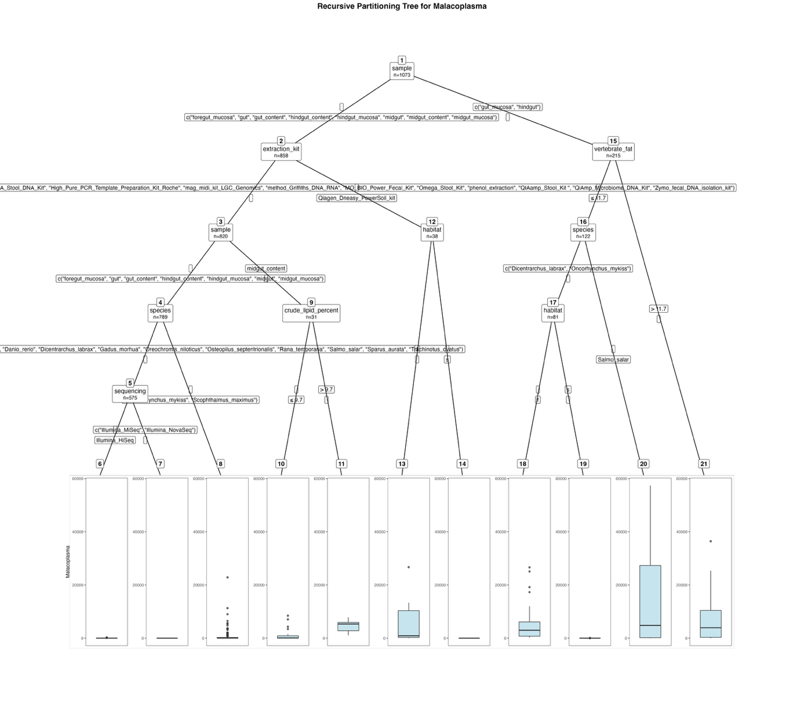
Fig. S42. Fitted party - Malacoplasma:

[1] root
| [2] sample in foregut_mucosa, gut, gut_content, hindgut_content, hindgut_mucosa, midgut, midgut_content, midgut_mucosa
| | [3] extraction_kit in Cador_Pathogen_96_QIAcube_HT_Kit, cetyltrimethylammonium_bromide_method, EZNA_Stool_DNA_Kit, High_Pure_PCR_Template_Preparation_Kit_Roche, mag_midi_kit_LGC_Genomics, method_Griffiths_DNA_RNA, MO_BIO_Power_Fecal_Kit, Omega_Stool_Kit, phenol_extraction, QIAamp_Stool_Kit , QiAmp_Microbiome_DNA_Kit, Zymo_fecal_DNA_isolation_kit
| | | [4] sample in foregut_mucosa, gut, gut_content, hindgut_content, hindgut_mucosa, midgut, midgut_mucosa
| | | | [5] species in Clarias_gariepinus, Ctenopharyngodon_idella, Cyprinus_carpio, Danio_rerio, Dicentrarchus_labrax, Gadus_morhua, Oreochromis_niloticus, Osteopilus_septentrionalis, Rana_temporaria, Salmo_salar, Sparus_aurata, Trachinotus_ovatus
| | | | | [6] sequencing in Illumina_HiSeq: 41.556 (n = 18, err = 82328.4)
| | | | | [7] sequencing in Illumina_MiSeq, Illumina_NovaSeq: 0.000 (n = 557, err = 0.0)
| | | | [8] species in Oncorhynchus_mykiss, Scophthalmus_maximus: 602.607 (n = 214, err = 890329481.0)
| | | [9] sample in midgut_content
| | | | [10] crude_lipid_percent <= 9.7: 1311.900 (n = 20, err = 120457721.8)
| | | | [11] crude_lipid_percent > 9.7: 4524.727 (n = 11, err = 47682602.2)
| | [12] extraction_kit in Qiagen_Dneasy_PowerSoil_kit
| | | [13] habitat in f: 5431.588 (n = 17, err = 871141302.1)
| | | [14] habitat in s: 0.000 (n = 21, err = 0.0)
| [15] sample in gut_mucosa, hindgut
| | [16] vertebrate_fat <= 11.7
| | | [17] species in Dicentrarchus_labrax, Oncorhynchus_mykiss
| | | | [18] habitat in f: 4599.070 (n = 57, err = 1827066825.7)
| | | | [19] habitat in s: 2.875 (n = 24, err = 2326.6)
| | | [20] species in Salmo_salar: 14096.244 (n = 41, err = 13412308867.6)
| | [21] vertebrate_fat > 11.7: 6597.258 (n = 93, err = 5532812503.8)

Number of inner nodes: 10
Number of terminal nodes: 11

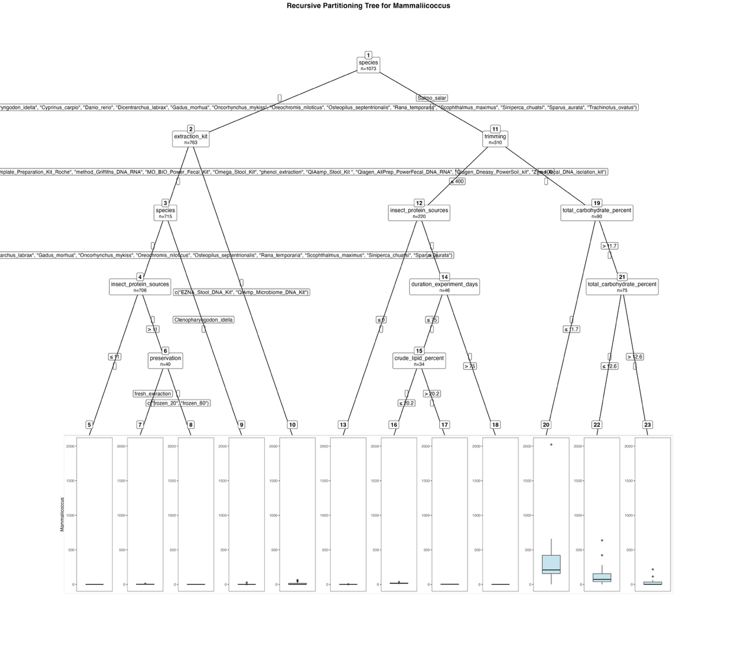
Fig. S43. Fitted party - Mammaliicoccus:

[1] root
| [2] species in Clarias_gariepinus, Ctenopharyngodon_idella, Cyprinus_carpio, Danio_rerio, Dicentrarchus_labrax, Gadus_morhua, Oncorhynchus_mykiss, Oreochromis_niloticus, Osteopilus_septentrionalis, Rana_temporaria, Scophthalmus_maximus, Siniperca_chuatsi, Sparus_aurata, Trachinotus_ovatus
| | [3] extraction_kit in Cador_Pathogen_96_QIAcube_HT_Kit, cetyltrimethylammonium_bromide_method, High_Pure_PCR_Template_Preparation_Kit_Roche, method_Griffiths_DNA_RNA, MO_BIO_Power_Fecal_Kit, Omega_Stool_Kit, phenol_extraction, QIAamp_Stool_Kit , Qiagen_AllPrep_PowerFecal_DNA_RNA, Qiagen_Dneasy_PowerSoil_kit, Zymo_fecal_DNA_isolation_kit
| | | [4] species in Clarias_gariepinus, Cyprinus_carpio, Danio_rerio, Dicentrarchus_labrax, Gadus_morhua, Oncorhynchus_mykiss, Oreochromis_niloticus, Osteopilus_septentrionalis, Rana_temporaria, Scophthalmus_maximus, Siniperca_chuatsi, Sparus_aurata
| | | | [5] insect_protein_sources <= 11: 0.000 (n = 666, err = 0.0)
| | | | [6] insect_protein_sources > 11
| | | | | [7] preservation in fresh_extraction: 2.500 (n = 8, err = 84.0)
| | | | | [8] preservation in frozen_20, frozen_80: 0.000 (n = 32, err = 0.0)
| | | [9] species in Ctenopharyngodon_idella: 3.556 (n = 9, err = 736.2)
| | [10] extraction_kit in EZNA_Stool_DNA_Kit, QiAmp_Microbiome_DNA_Kit: 10.292 (n = 48, err = 11729.9)
| [11] species in Salmo_salar
| | [12] trimming <= 400
| | | [13] insect_protein_sources <= 0: 0.011 (n = 174, err = 4.0)
| | | [14] insect_protein_sources > 0
| | | | [15] duration_experiment_days <= 75
| | | | | [16] crude_lipid_percent <= 20.2: 16.000 (n = 24, err = 1072.0)
| | | | | [17] crude_lipid_percent > 20.2: 2.300 (n = 10, err = 34.1)
| | | | [18] duration_experiment_days > 75: 0.000 (n = 12, err = 0.0)
| | [19] trimming > 400
| | | [20] total_carbohydrate_percent <= 11.7: 384.067 (n = 15, err = 3324248.9)
| | | [21] total_carbohydrate_percent > 11.7
| | | | [22] total_carbohydrate_percent <= 12.6: 108.250 (n = 60, err = 701243.2)
| | | | [23] total_carbohydrate_percent > 12.6: 31.667 (n = 15, err = 52149.3)

Number of inner nodes: 11
Number of terminal nodes: 12

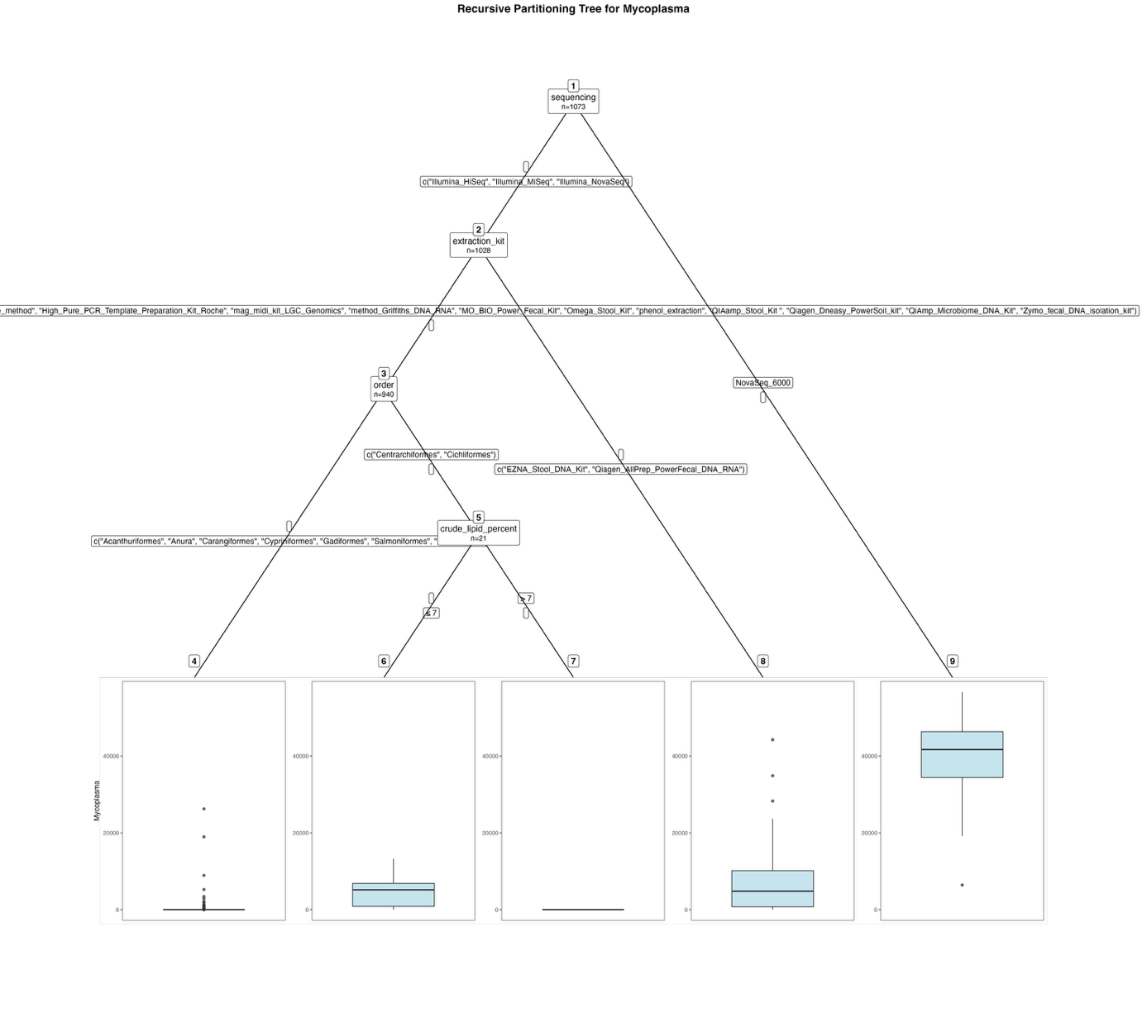
Fig. S44. Fitted party - Mycoplasma:

[1] root
| [2] sequencing in Illumina_HiSeq, Illumina_MiSeq, Illumina_NovaSeq
| | [3] extraction_kit in Cador_Pathogen_96_QIAcube_HT_Kit, cetyltrimethylammonium_bromide_method, High_Pure_PCR_Template_Preparation_Kit_Roche, mag_midi_kit_LGC_Genomics, method_Griffiths_DNA_RNA, MO_BIO_Power_Fecal_Kit, Omega_Stool_Kit, phenol_extraction, QIAamp_Stool_Kit , Qiagen_Dneasy_PowerSoil_kit, QiAmp_Microbiome_DNA_Kit, Zymo_fecal_DNA_isolation_kit
| | | [4] order in Acanthuriformes, Anura, Carangiformes, Cypriniformes, Gadiformes, Salmoniformes, Siluriformes: 88.039 (n = 919, err = 1183548594.6)
| | | [5] order in Centrarchiformes, Cichliformes
| | | | [6] crude_lipid_percent <= 7: 4833.143 (n = 7, err = 138587774.9)
| | | | [7] crude_lipid_percent > 7: 0.000 (n = 14, err = 0.0)
| | [8] extraction_kit in EZNA_Stool_DNA_Kit, Qiagen_AllPrep_PowerFecal_DNA_RNA: 6871.011 (n = 88, err = 5665631413.0)
| [9] sequencing in NovaSeq_6000: 39904.822 (n = 45, err = 4644462830.6)

Number of inner nodes: 4
Number of terminal nodes: 5

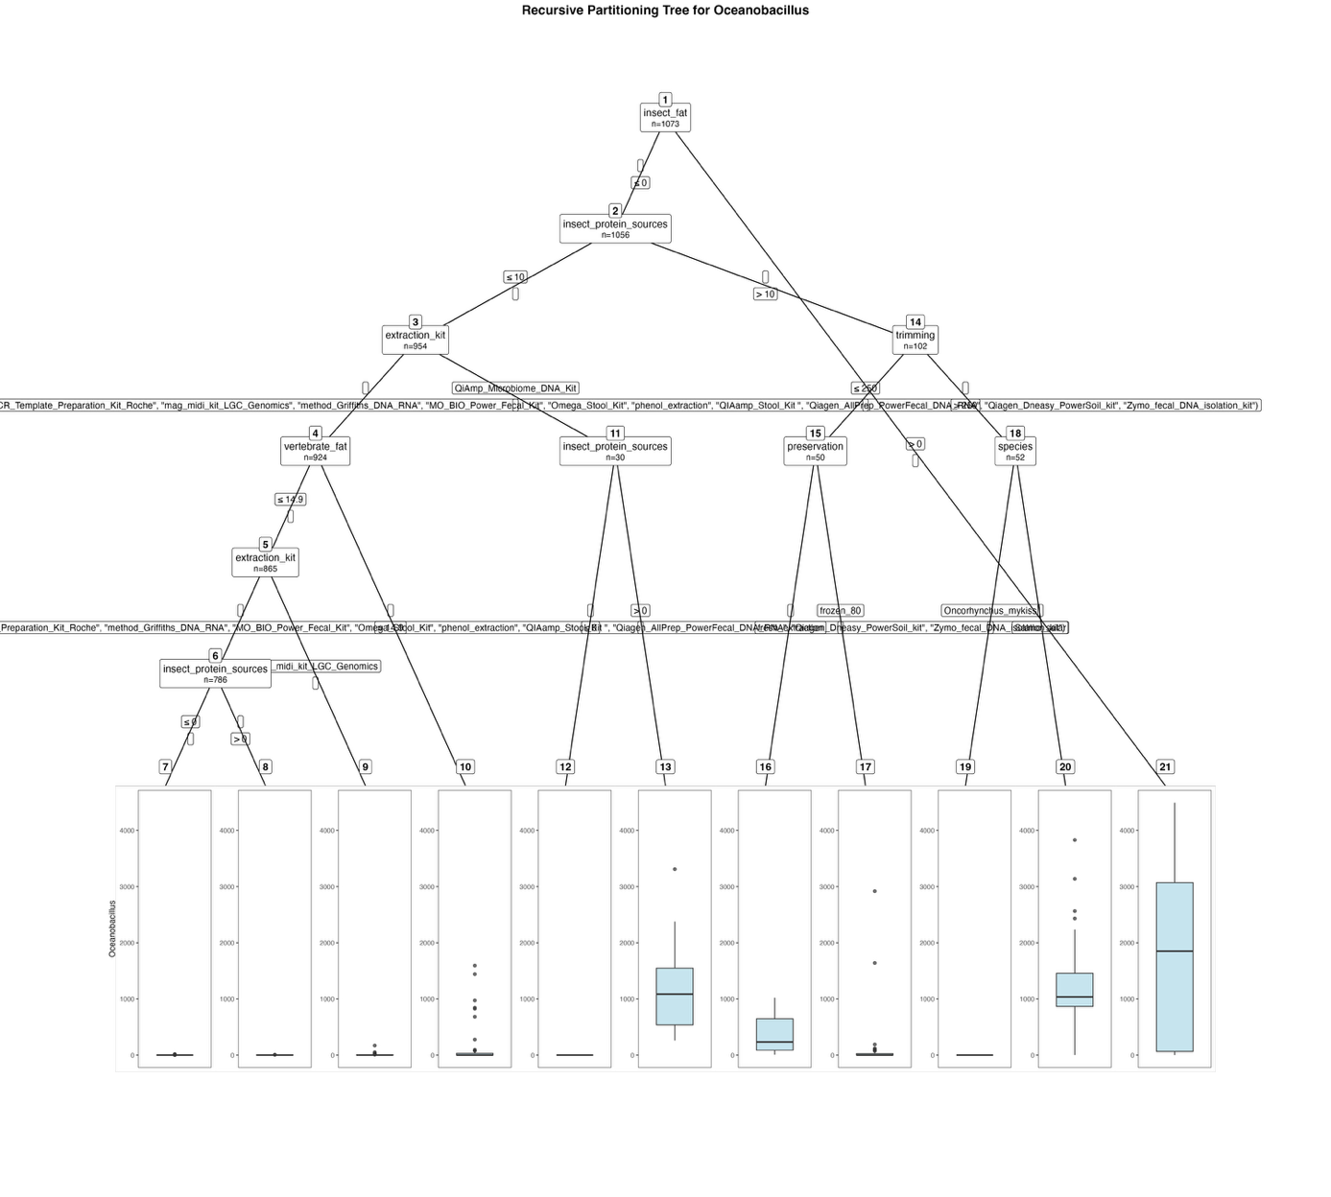
Fig. S45. Fitted party - Oceanobacillus:

[1] root
| [2] insect_fat <= 0
| | [3] insect_protein_sources <= 10
| | | [4] extraction_kit in Cador_Pathogen_96_QIAcube_HT_Kit, cetyltrimethylammonium_bromide_method, EZNA_Stool_DNA_Kit, High_Pure_PCR_Template_Preparation_Kit_Roche, mag_midi_kit_LGC_Genomics, method_Griffiths_DNA_RNA, MO_BIO_Power_Fecal_Kit, Omega_Stool_Kit, phenol_extraction, QIAamp_Stool_Kit , Qiagen_AllPrep_PowerFecal_DNA_RNA, Qiagen_Dneasy_PowerSoil_kit, Zymo_fecal_DNA_isolation_kit
| | | | [5] vertebrate_fat <= 14.9
| | | | | [6] extraction_kit in Cador_Pathogen_96_QIAcube_HT_Kit, cetyltrimethylammonium_bromide_method, EZNA_Stool_DNA_Kit, High_Pure_PCR_Template_Preparation_Kit_Roche, method_Griffiths_DNA_RNA, MO_BIO_Power_Fecal_Kit, Omega_Stool_Kit, phenol_extraction, QIAamp_Stool_Kit , Qiagen_AllPrep_PowerFecal_DNA_RNA, Qiagen_Dneasy_PowerSoil_kit, Zymo_fecal_DNA_isolation_kit
| | | | | | [7] insect_protein_sources <= 0: 0.175 (n = 741, err = 1129.2)
| | | | | | [8] insect_protein_sources > 0: 0.956 (n = 45, err = 129.9)
| | | | | [9] extraction_kit in mag_midi_kit_LGC_Genomics: 6.177 (n = 79, err = 33517.5)
| | | | [10] vertebrate_fat > 14.9: 122.254 (n = 59, err = 6646877.2)
| | | [11] extraction_kit in QiAmp_Microbiome_DNA_Kit
| | | | [12] insect_protein_sources <= 0: 0.000 (n = 18, err = 0.0)
| | | | [13] insect_protein_sources > 0: 1227.250 (n = 12, err = 9190704.2)
| | [14] insect_protein_sources > 10
| | | [15] trimming <= 250
| | | | [16] preservation in fresh_extraction: 373.000 (n = 10, err = 1146536.0)
| | | | [17] preservation in frozen_80: 134.050 (n = 40, err = 10570743.9)
| | | [18] trimming > 250
| | | | [19] species in Oncorhynchus_mykiss: 0.000 (n = 7, err = 0.0)
| | | | [20] species in Salmo_salar: 1218.267 (n = 45, err = 26609098.8)
| [21] insect_fat > 0: 1725.059 (n = 17, err = 37588812.9)

Number of inner nodes: 10
Number of terminal nodes: 11

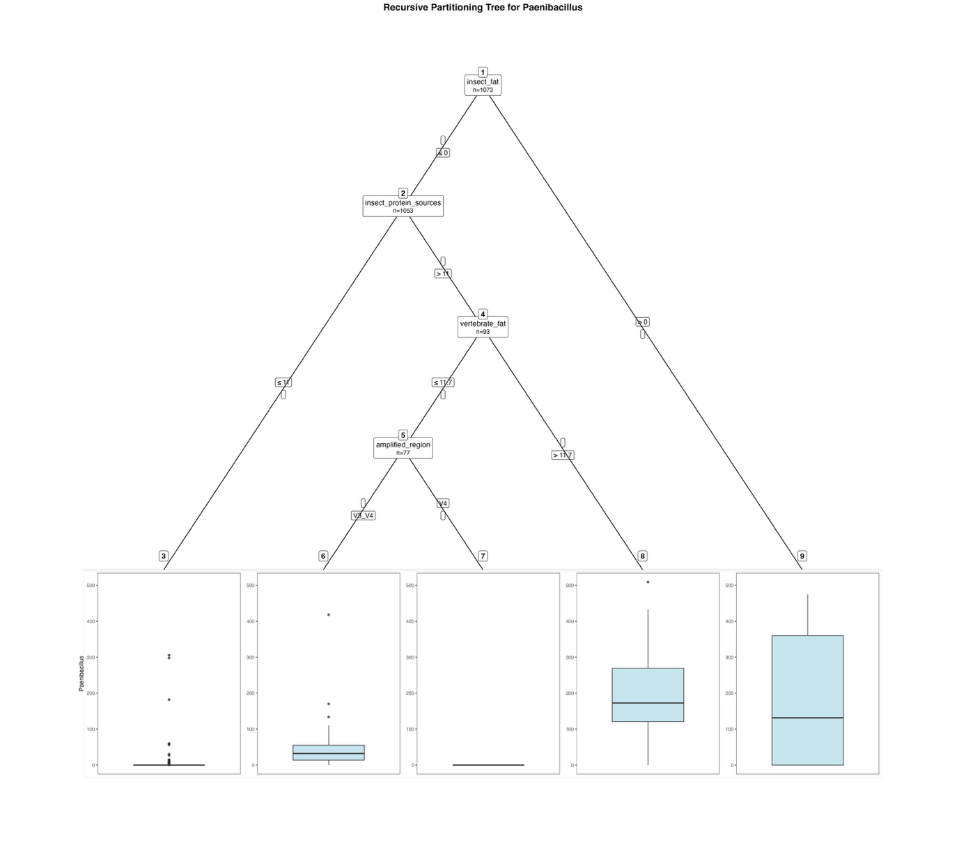
Fig. S46. Fitted party – Paenibacillus:

[1] root
| [2] insect_fat <= 0
| | [3] insect_protein_sources <= 11: 1.191 (n = 960, err = 227176.1)
| | [4] insect_protein_sources > 11
| | | [5] vertebrate_fat <= 11.7
| | | | [6] amplified_region in V3_V4: 50.405 (n = 37, err = 192676.9)
| | | | [7] amplified_region in V4: 0.000 (n = 40, err = 0.0)
| | | [8] vertebrate_fat > 11.7: 201.812 (n = 16, err = 305768.4)
| [9] insect_fat > 0: 186.100 (n = 20, err = 714529.8)

Number of inner nodes: 4
Number of terminal nodes: 5

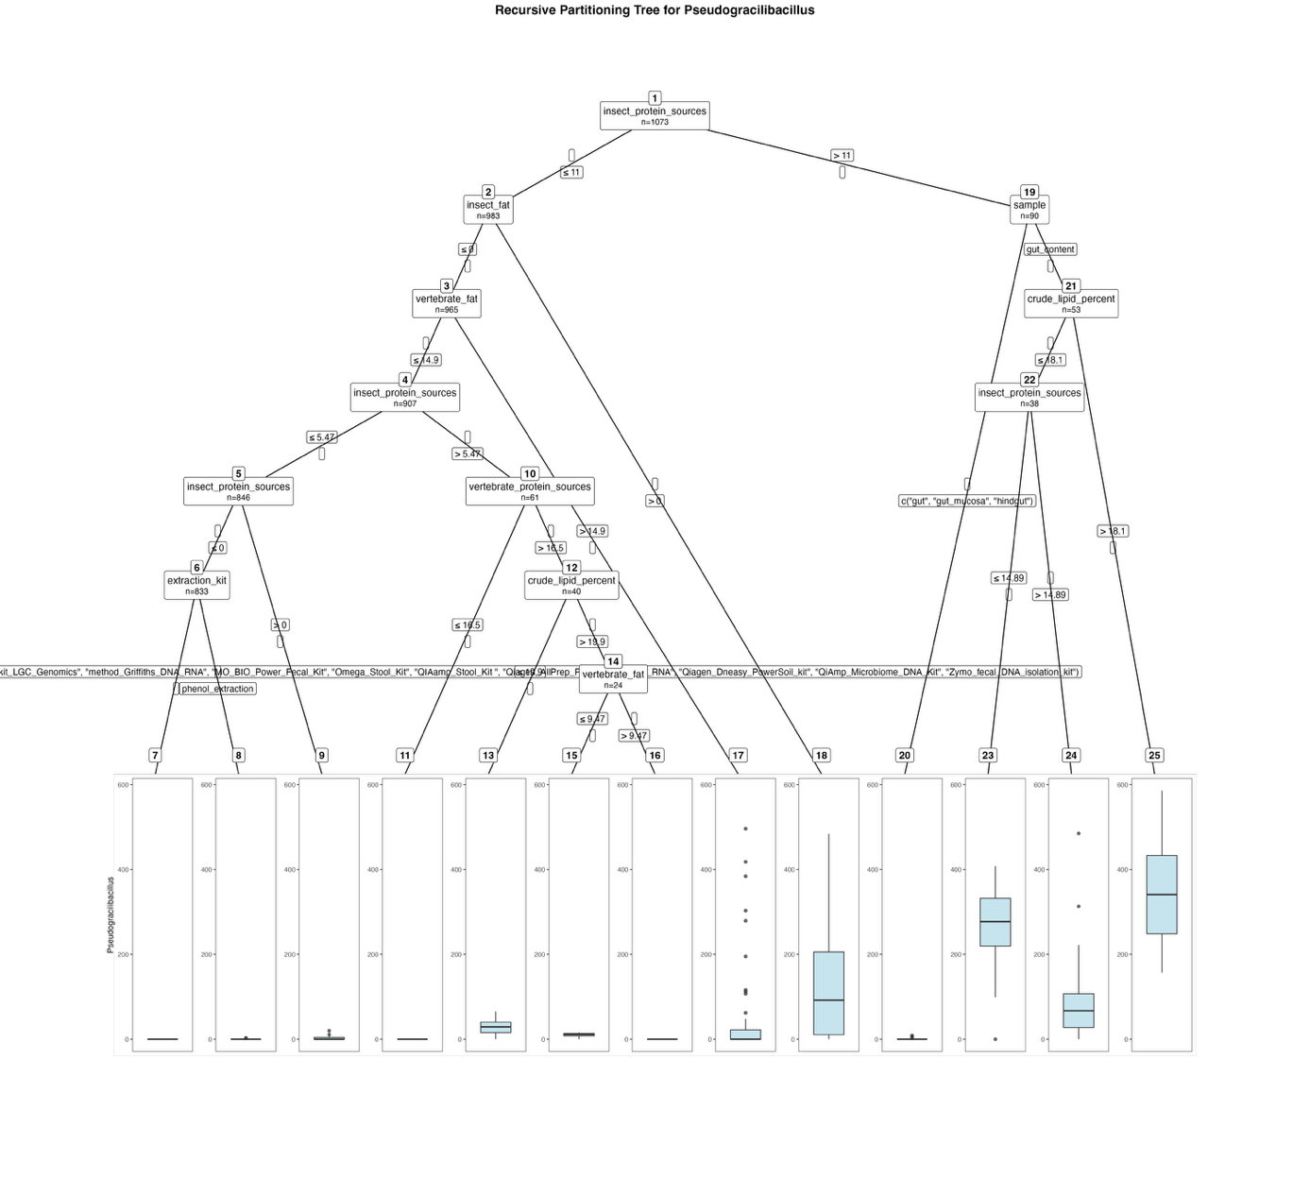
Fig. S47. Fitted party - Pseudogracilibacillus:

[1] root
| [2] insect_protein_sources <= 11
| | [3] insect_fat <= 0
| | | [4] vertebrate_fat <= 14.9
| | | | [5] insect_protein_sources <= 5.47
| | | | | [6] insect_protein_sources <= 0
| | | | | | [7] extraction_kit in Cador_Pathogen_96_QIAcube_HT_Kit, cetyltrimethylammonium_bromide_method, EZNA_Stool_DNA_Kit, High_Pure_PCR_Template_Preparation_Kit_Roche, mag_midi_kit_LGC_Genomics, method_Griffiths_DNA_RNA, MO_BIO_Power_Fecal_Kit, Omega_Stool_Kit, QIAamp_Stool_Kit , Qiagen_AllPrep_PowerFecal_DNA_RNA, Qiagen_Dneasy_PowerSoil_kit, QiAmp_Microbiome_DNA_Kit, Zymo_fecal_DNA_isolation_kit: 0.000 (n = 821, err = 0.0)
| | | | | | [8] extraction_kit in phenol_extraction: 0.417 (n = 12, err = 10.9)
| | | | | [9] insect_protein_sources > 0: 3.692 (n = 13, err = 468.8)
| | | | [10] insect_protein_sources > 5.47
| | | | | [11] vertebrate_protein_sources <= 16.5: 0.000 (n = 21, err = 0.0)
| | | | | [12] vertebrate_protein_sources > 16.5
| | | | | | [13] crude_lipid_percent <= 19.9: 28.500 (n = 16, err = 6368.0)
| | | | | | [14] crude_lipid_percent > 19.9
| | | | | | | [15] vertebrate_fat <= 9.47: 9.857 (n = 14, err = 335.7)
| | | | | | | [16] vertebrate_fat > 9.47: 0.000 (n = 10, err = 0.0)
| | | [17] vertebrate_fat > 14.9: 46.414 (n = 58, err = 699012.1)
| | [18] insect_fat > 0: 138.722 (n = 18, err = 342803.6)
| [19] insect_protein_sources > 11
| | [20] sample in gut, gut_mucosa, hindgut: 0.459 (n = 37, err = 113.2)
| | [21] sample in gut_content
| | | [22] crude_lipid_percent <= 18.1
| | | | [23] insect_protein_sources <= 14.89: 256.133 (n = 15, err = 162767.7)
| | | | [24] insect_protein_sources > 14.89: 97.304 (n = 23, err = 284410.9)
| | | [25] crude_lipid_percent > 18.1: 352.667 (n = 15, err = 278145.3)

Number of inner nodes: 12
Number of terminal nodes: 13

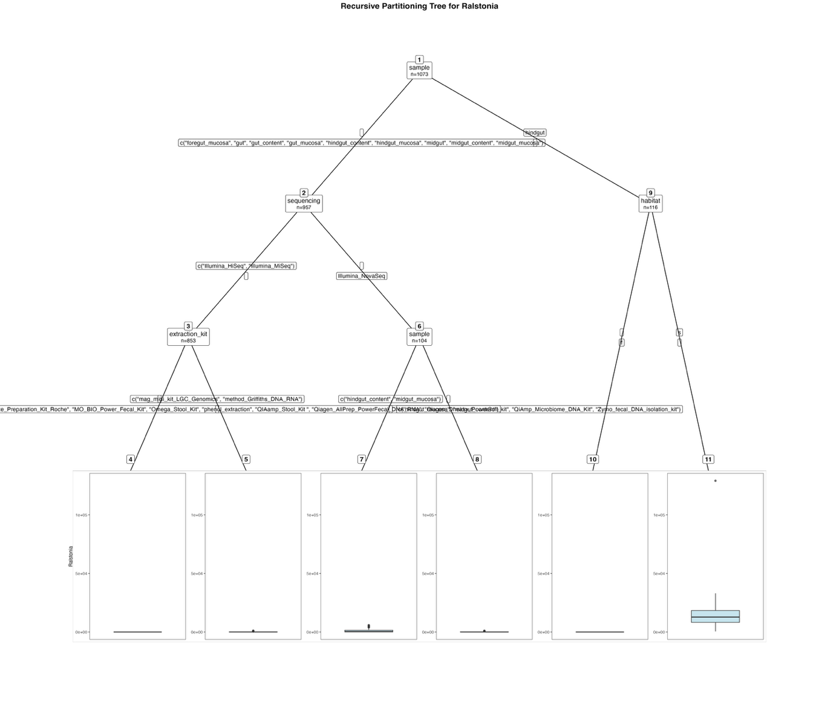
Fig. S48. Fitted party - Ralstonia:

[1] root
| [2] sample in foregut_mucosa, gut, gut_content, gut_mucosa, hindgut_content, hindgut_mucosa, midgut, midgut_content, midgut_mucosa
| | [3] sequencing in Illumina_HiSeq, Illumina_MiSeq
| | | [4] extraction_kit in Cador_Pathogen_96_QIAcube_HT_Kit, cetyltrimethylammonium_bromide_method, EZNA_Stool_DNA_Kit, High_Pure_PCR_Template_Preparation_Kit_Roche, MO_BIO_Power_Fecal_Kit, Omega_Stool_Kit, phenol_extraction, QIAamp_Stool_Kit , Qiagen_AllPrep_PowerFecal_DNA_RNA, Qiagen_Dneasy_PowerSoil_kit, QiAmp_Microbiome_DNA_Kit, Zymo_fecal_DNA_isolation_kit: 0.000 (n = 708, err = 0.0)
| | | [5] extraction_kit in mag_midi_kit_LGC_Genomics, method_Griffiths_DNA_RNA: 89.228 (n = 145, err = 3566823.5)
| | [6] sequencing in Illumina_NovaSeq
| | | [7] sample in hindgut_content, midgut_mucosa: 1133.158 (n = 57, err = 136033575.6)
| | | [8] sample in hindgut_mucosa, midgut_content: 164.936 (n = 47, err = 3062778.8)
| [9] sample in hindgut
| | [10] habitat in f: 0.000 (n = 45, err = 0.0)
| | [11] habitat in s: 15035.352 (n = 71, err = 17037806896.2)

Number of inner nodes: 5
Number of terminal nodes: 6
Results for the complete dataset – Families:

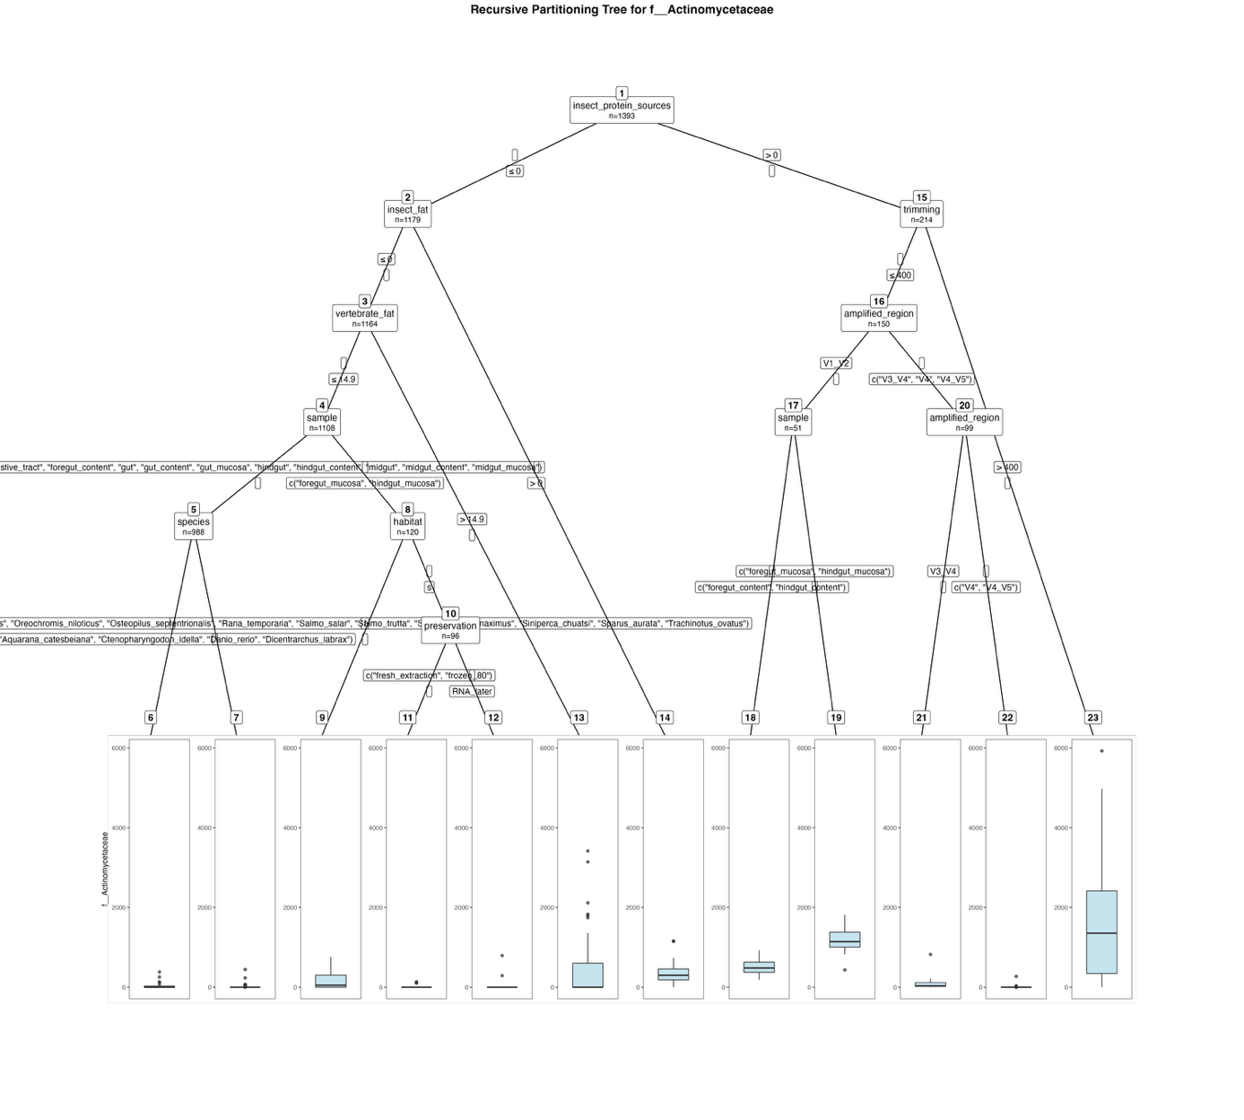
Fig. S49. Fitted party - Actinomycetaceae:

[1] root
| [2] insect_protein_sources <= 0
| | [3] insect_fat <= 0
| | | [4] vertebrate_fat <= 14.9
| | | | [5] sample in digestive_tract, foregut_content, gut, gut_content, gut_mucosa, hindgut, hindgut_content, midgut, midgut_content, midgut_mucosa
| | | | | [6] species in Aquarana_catesbeiana, Ctenopharyngodon_idella, Danio_rerio, Dicentrarchus_labrax: 25.468 (n = 62, err = 232881.4)
| | | | | [7] species in Clarias_gariepinus, Cyprinus_carpio, Gadus_morhua, Oncorhynchus_mykiss, Oreochromis_niloticus, Osteopilus_septentrionalis, Rana_temporaria, Salmo_salar, Salmo_trutta, Scophthalmus_maximus, Siniperca_chuatsi, Sparus_aurata, Trachinotus_ovatus: 1.231 (n = 926, err = 274008.5)
| | | | [8] sample in foregut_mucosa, hindgut_mucosa
| | | | | [9] habitat in f: 174.083 (n = 24, err = 1195473.8)
| | | | | [10] habitat in s
| | | | | | [11] preservation in fresh_extraction, frozen_80: 4.011 (n = 87, err = 39755.0)
| | | | | | [12] preservation in RNA_later: 120.222 (n = 9, err = 581283.6)
| | | [13] vertebrate_fat > 14.9: 400.250 (n = 56, err = 33629704.5)
| | [14] insect_fat > 0: 402.200 (n = 15, err = 1721924.4)
| [15] insect_protein_sources > 0
| | [16] trimming <= 400
| | | [17] amplified_region in V1_V2
| | | | [18] sample in foregut_content, hindgut_content: 501.111 (n = 27, err = 1051188.7)
| | | | [19] sample in foregut_mucosa, hindgut_mucosa: 1184.833 (n = 24, err = 2299319.3)
| | | [20] amplified_region in V3_V4, V4, V4_V5
| | | | [21] amplified_region in V3_V4: 82.302 (n = 43, err = 763853.1)
| | | | [22] amplified_region in V4, V4_V5: 6.500 (n = 56, err = 72772.0)
| | [23] trimming > 400: 1599.594 (n = 64, err = 118723569.4)

Number of inner nodes: 11
Number of terminal nodes: 12

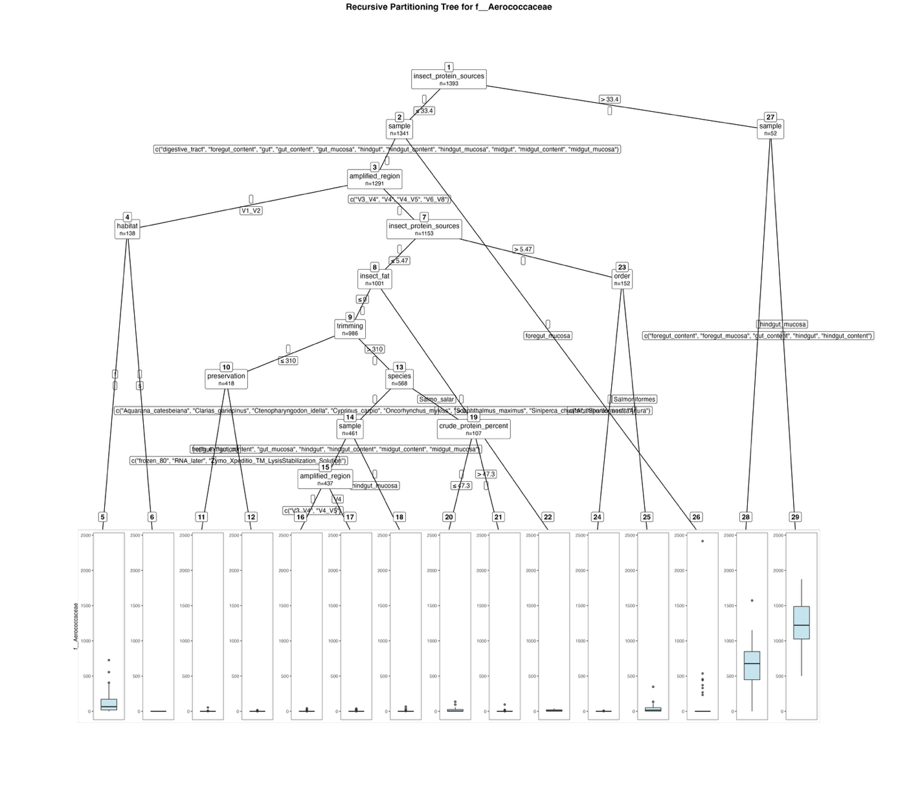
Fig. S50. Fitted party - Aerococcaceae:

[1] root
| [2] insect_protein_sources <= 33.4
| | [3] sample in digestive_tract, foregut_content, gut, gut_content, gut_mucosa, hindgut, hindgut_content, hindgut_mucosa, midgut, midgut_content, midgut_mucosa
| | | [4] amplified_region in V1_V2
| | | | [5] habitat in f: 126.275 (n = 40, err = 1029890.0)
| | | | [6] habitat in s: 0.000 (n = 98, err = 0.0)
| | | [7] amplified_region in V3_V4, V4, V4_V5, V6_V8
| | | | [8] insect_protein_sources <= 5.47
| | | | | [9] insect_fat <= 0
| | | | | | [10] trimming <= 310
| | | | | | | [11] preservation in fresh_extraction: 2.615 (n = 26, err = 2812.2)
| | | | | | | [12] preservation in frozen_80, RNA_later, Zymo_Xpeditio_TM_LysisStabilization_Solution: 0.122 (n = 392, err = 440.1)
| | | | | | [13] trimming > 310
| | | | | | | [14] species in Aquarana_catesbeiana, Clarias_gariepinus, Ctenopharyngodon_idella, Cyprinus_carpio, Oncorhynchus_mykiss, Scophthalmus_maximus, Siniperca_chuatsi, Sparus_aurata
| | | | | | | | [15] sample in gut, gut_content, gut_mucosa, hindgut, hindgut_content, midgut_content, midgut_mucosa
| | | | | | | | | [16] amplified_region in V3_V4, V4_V5: 0.395 (n = 370, err = 3432.4)
| | | | | | | | | [17] amplified_region in V4: 3.000 (n = 67, err = 4362.0)
| | | | | | | | [18] sample in hindgut_mucosa: 5.875 (n = 24, err = 5592.6)
| | | | | | | [19] species in Salmo_salar
| | | | | | | | [20] crude_protein_percent <= 47.3: 18.100 (n = 30, err = 28032.7)
| | | | | | | | [21] crude_protein_percent > 47.3: 2.584 (n = 77, err = 9870.7)
| | | | | [22] insect_fat > 0: 11.800 (n = 15, err = 2322.4)
| | | | [23] insect_protein_sources > 5.47
| | | | | [24] order in Acanthuriformes, Anura: 0.311 (n = 45, err = 69.6)
| | | | | [25] order in Salmoniformes: 32.000 (n = 107, err = 209304.0)
| | [26] sample in foregut_mucosa: 101.060 (n = 50, err = 6386402.8)
| [27] insect_protein_sources > 33.4
| | [28] sample in foregut_content, foregut_mucosa, gut_content, hindgut, hindgut_content: 670.725 (n = 40, err = 3307660.0)
| | [29] sample in hindgut_mucosa: 1213.917 (n = 12, err = 1551518.9)

Number of inner nodes: 14
Number of terminal nodes: 15

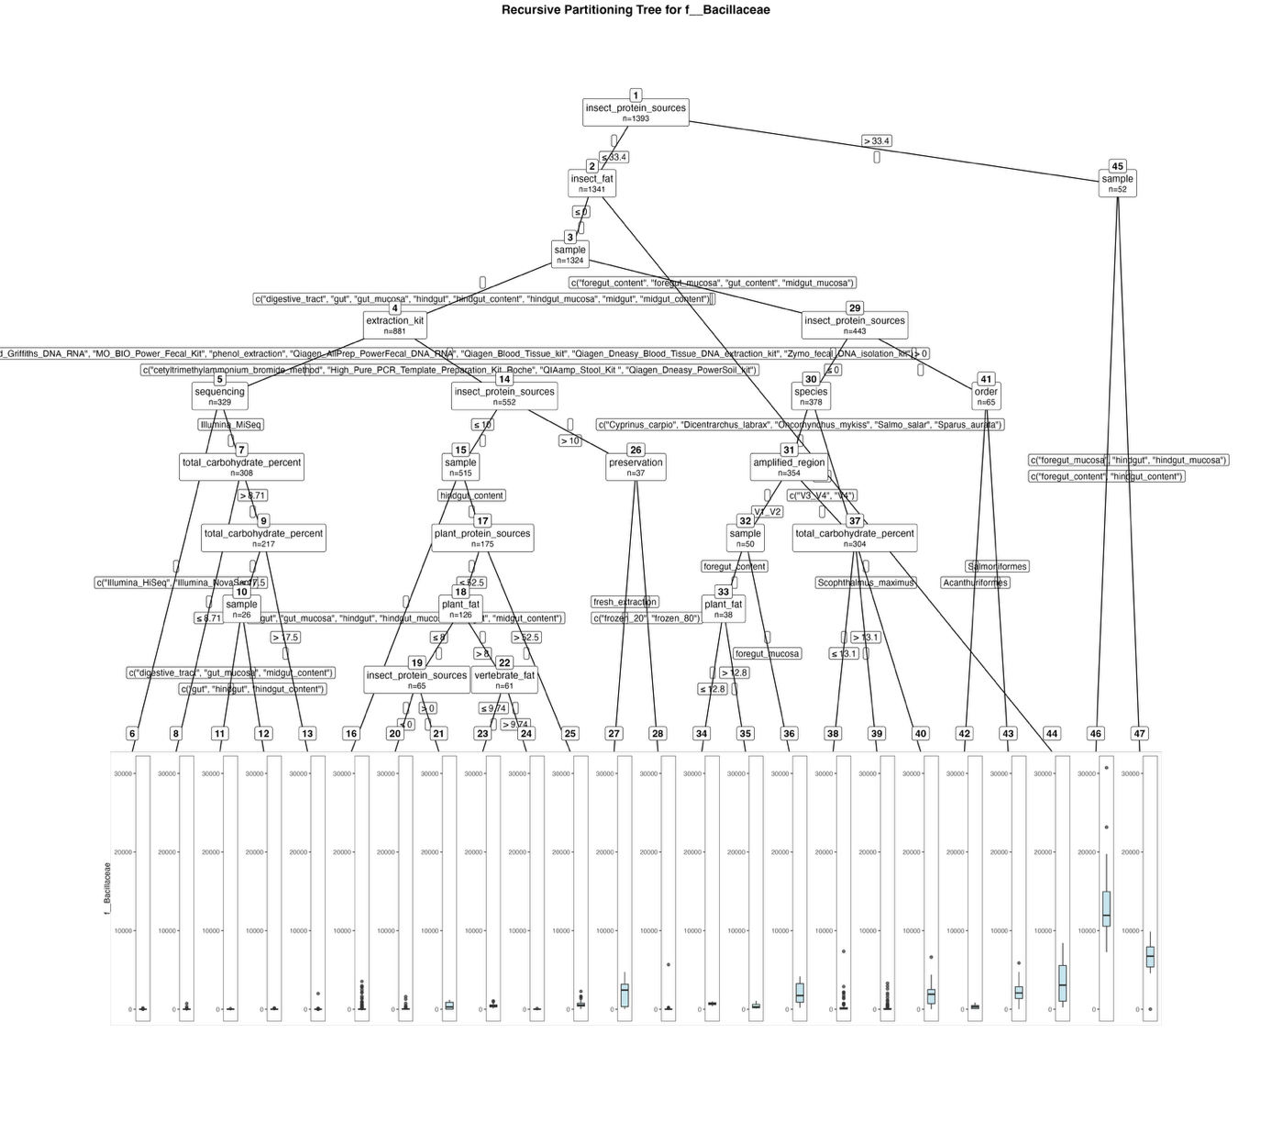
Fig. S51. Fitted party - Bacillaceae:

[1] root
| [2] insect_protein_sources <= 33.4
| | [3] insect_fat <= 0
| | | [4] sample in digestive_tract, gut, gut_mucosa, hindgut, hindgut_content, hindgut_mucosa, midgut, midgut_content
| | | | [5] extraction_kit in Cador_Pathogen_96_QIAcube_HT_Kit, EZNA_Stool_DNA_Kit, method_Griffiths_DNA_RNA, MO_BIO_Power_Fecal_Kit, phenol_extraction, Qiagen_AllPrep_PowerFecal_DNA_RNA, Qiagen_Blood_Tissue_kit, Qiagen_Dneasy_Blood_Tissue_DNA_extraction_kit, Zymo_fecal_DNA_isolation_kit
| | | | | [6] sequencing in Illumina_HiSeq, Illumina_NovaSeq: 10.286 (n = 21, err = 22648.3)
| | | | | [7] sequencing in Illumina_MiSeq
| | | | | | [8] total_carbohydrate_percent <= 8.71: 28.319 (n = 91, err = 703629.8)
| | | | | | [9] total_carbohydrate_percent > 8.71
| | | | | | | [10] total_carbohydrate_percent <= 17.5
| | | | | | | | [11] sample in digestive_tract, gut_mucosa, midgut_content: 16.182 (n = 11, err = 4059.6)
| | | | | | | | [12] sample in gut, hindgut, hindgut_content: 25.667 (n = 15, err = 29025.3)
| | | | | | | [13] total_carbohydrate_percent > 17.5: 14.974 (n = 191, err = 3980922.9)
| | | | [14] extraction_kit in cetyltrimethylammonium_bromide_method, High_Pure_PCR_Template_Preparation_Kit_Roche, QIAamp_Stool_Kit , Qiagen_Dneasy_PowerSoil_kit
| | | | | [15] insect_protein_sources <= 10
| | | | | | [16] sample in gut, gut_mucosa, hindgut, hindgut_mucosa, midgut, midgut_content: 110.344 (n = 340, err = 60589000.7)
| | | | | | [17] sample in hindgut_content
| | | | | | | [18] plant_protein_sources <= 52.5
| | | | | | | | [19] plant_fat <= 8
| | | | | | | | | [20] insect_protein_sources <= 0: 121.607 (n = 56, err = 4531861.4)
| | | | | | | | | [21] insect_protein_sources > 0: 434.333 (n = 9, err = 2129724.0)
| | | | | | | | [22] plant_fat > 8
| | | | | | | | | [23] vertebrate_fat <= 9.74: 459.103 (n = 39, err = 2018695.6)
| | | | | | | | | [24] vertebrate_fat > 9.74: 14.045 (n = 22, err = 9169.0)
| | | | | | | [25] plant_protein_sources > 52.5: 639.265 (n = 49, err = 9473423.6)
| | | | | [26] insect_protein_sources > 10
| | | | | | [27] preservation in fresh_extraction: 1964.182 (n = 11, err = 30596973.6)
| | | | | | [28] preservation in frozen_20, frozen_80: 249.269 (n = 26, err = 30694009.1)
| | | [29] sample in foregut_content, foregut_mucosa, gut_content, midgut_mucosa
| | | | [30] insect_protein_sources <= 0
| | | | | [31] species in Cyprinus_carpio, Dicentrarchus_labrax, Oncorhynchus_mykiss, Salmo_salar, Sparus_aurata
| | | | | | [32] amplified_region in V1_V2
| | | | | | | [33] sample in foregut_content
| | | | | | | | [34] plant_fat <= 12.8: 705.100 (n = 20, err = 642409.8)
| | | | | | | | [35] plant_fat > 12.8: 422.889 (n = 18, err = 1725007.8)
| | | | | | | [36] sample in foregut_mucosa: 1986.417 (n = 12, err = 19992580.9)
| | | | | | [37] amplified_region in V3_V4, V4
| | | | | | | [38] total_carbohydrate_percent <= 13.1: 338.474 (n = 97, err = 76158462.2)
| | | | | | | [39] total_carbohydrate_percent > 13.1: 152.894 (n = 207, err = 39725209.7)
| | | | | [40] species in Scophthalmus_maximus: 1906.500 (n = 24, err = 54811930.0)
| | | | [41] insect_protein_sources > 0
| | | | | [42] order in Acanthuriformes: 320.125 (n = 8, err = 573564.9)
| | | | | [43] order in Salmoniformes: 2145.368 (n = 57, err = 82470939.3)
| | [44] insect_fat > 0: 3606.000 (n = 17, err = 124094082.0)
| [45] insect_protein_sources > 33.4
| | [46] sample in foregut_content, hindgut_content: 13642.370 (n = 27, err = 737351732.3)
| | [47] sample in foregut_mucosa, hindgut, hindgut_mucosa: 6551.520 (n = 25, err = 96289536.2)

Number of inner nodes: 23
Number of terminal nodes: 24

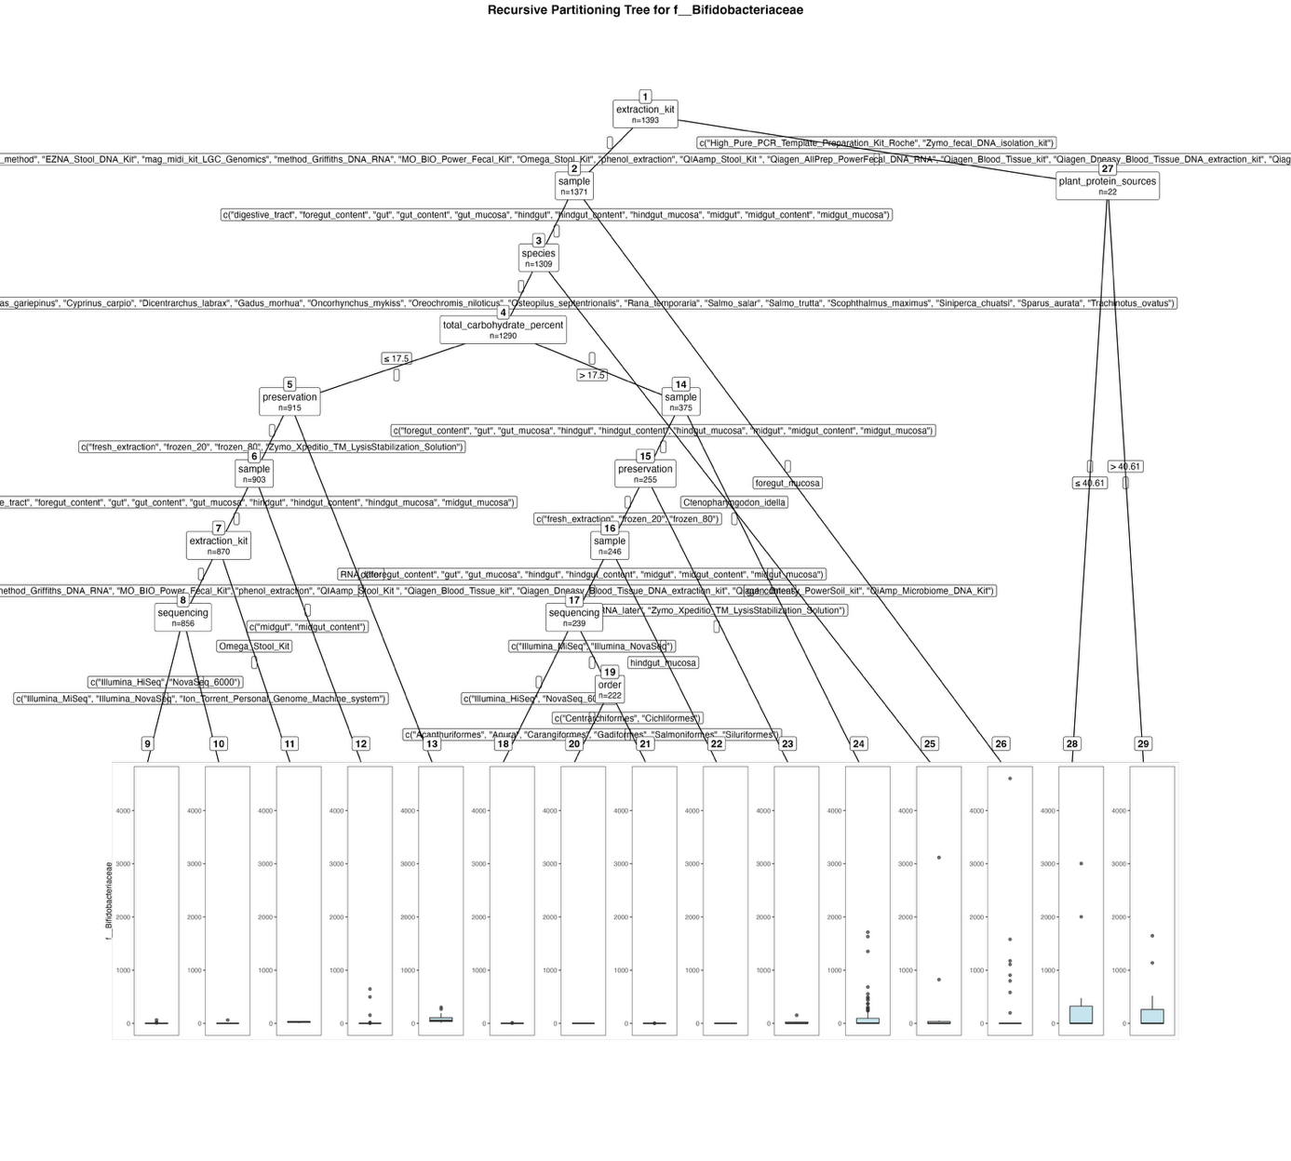
Fig. S52. Fitted party - Bifidobacteriaceae:

[1] root
| [2] extraction_kit in Cador_Pathogen_96_QIAcube_HT_Kit, cetyltrimethylammonium_bromide_method, EZNA_Stool_DNA_Kit, mag_midi_kit_LGC_Genomics, method_Griffiths_DNA_RNA, MO_BIO_Power_Fecal_Kit, Omega_Stool_Kit, phenol_extraction, QIAamp_Stool_Kit , Qiagen_AllPrep_PowerFecal_DNA_RNA, Qiagen_Blood_Tissue_kit, Qiagen_Dneasy_Blood_Tissue_DNA_extraction_kit, Qiagen_Dneasy_PowerSoil_kit, QiAmp_Microbiome_DNA_Kit
| | [3] sample in digestive_tract, foregut_content, gut, gut_content, gut_mucosa, hindgut, hindgut_content, hindgut_mucosa, midgut, midgut_content, midgut_mucosa
| | | [4] species in Aquarana_catesbeiana, Clarias_gariepinus, Cyprinus_carpio, Dicentrarchus_labrax, Gadus_morhua, Oncorhynchus_mykiss, Oreochromis_niloticus, Osteopilus_septentrionalis, Rana_temporaria, Salmo_salar, Salmo_trutta, Scophthalmus_maximus, Siniperca_chuatsi, Sparus_aurata, Trachinotus_ovatus
| | | | [5] total_carbohydrate_percent <= 17.5
| | | | | [6] preservation in fresh_extraction, frozen_20, frozen_80, Zymo_Xpeditio_TM_LysisStabilization_Solution
| | | | | | [7] sample in digestive_tract, foregut_content, gut, gut_content, gut_mucosa, hindgut, hindgut_content, hindgut_mucosa, midgut_mucosa
| | | | | | | [8] extraction_kit in Cador_Pathogen_96_QIAcube_HT_Kit, cetyltrimethylammonium_bromide_method, EZNA_Stool_DNA_Kit, mag_midi_kit_LGC_Genomics, method_Griffiths_DNA_RNA, MO_BIO_Power_Fecal_Kit, phenol_extraction, QIAamp_Stool_Kit , Qiagen_Blood_Tissue_kit, Qiagen_Dneasy_Blood_Tissue_DNA_extraction_kit, Qiagen_Dneasy_PowerSoil_kit, QiAmp_Microbiome_DNA_Kit
| | | | | | | | [9] sequencing in Illumina_HiSeq, NovaSeq_6000: 3.239 (n = 46, err = 4458.4)
| | | | | | | | [10] sequencing in Illumina_MiSeq, Illumina_NovaSeq, Ion_Torrent_Personal_Genome_Machine_system: 0.078 (n = 810, err = 3964.1)
| | | | | | | [11] extraction_kit in Omega_Stool_Kit: 25.714 (n = 14, err = 2294.9)
| | | | | | [12] sample in midgut, midgut_content: 40.000 (n = 33, err = 633286.0)
| | | | | [13] preservation in RNA_later: 96.250 (n = 12, err = 109240.2)
| | | | [14] total_carbohydrate_percent > 17.5
| | | | | [15] sample in foregut_content, gut, gut_mucosa, hindgut, hindgut_content, hindgut_mucosa, midgut, midgut_content, midgut_mucosa
| | | | | | [16] preservation in fresh_extraction, frozen_20, frozen_80
| | | | | | | [17] sample in foregut_content, gut, gut_mucosa, hindgut, hindgut_content, midgut, midgut_content, midgut_mucosa
| | | | | | | | [18] sequencing in Illumina_HiSeq, NovaSeq_6000: 1.059 (n = 17, err = 86.9)
| | | | | | | | [19] sequencing in Illumina_MiSeq, Illumina_NovaSeq
| | | | | | | | | [20] order in Acanthuriformes, Anura, Carangiformes, Gadiformes, Salmoniformes, Siluriformes: 0.000 (n = 214, err = 0.0)
| | | | | | | | | [21] order in Centrarchiformes, Cichliformes: 0.500 (n = 8, err = 6.0)
| | | | | | | [22] sample in hindgut_mucosa: 0.000 (n = 7, err = 0.0)
| | | | | | [23] preservation in RNA_later, Zymo_Xpeditio_TM_LysisStabilization_Solution: 23.556 (n = 9, err = 20216.2)
| | | | | [24] sample in gut_content: 108.667 (n = 120, err = 8593898.7)
| | | [25] species in Ctenopharyngodon_idella: 218.211 (n = 19, err = 9494499.2)
| | [26] sample in foregut_mucosa: 176.500 (n = 62, err = 26168629.5)
| [27] extraction_kit in High_Pure_PCR_Template_Preparation_Kit_Roche, Zymo_fecal_DNA_isolation_kit
| | [28] plant_protein_sources <= 40.61: 513.636 (n = 11, err = 10381548.5)
| | [29] plant_protein_sources > 40.61: 300.091 (n = 11, err = 3277744.9)

Number of inner nodes: 14
Number of terminal nodes: 15

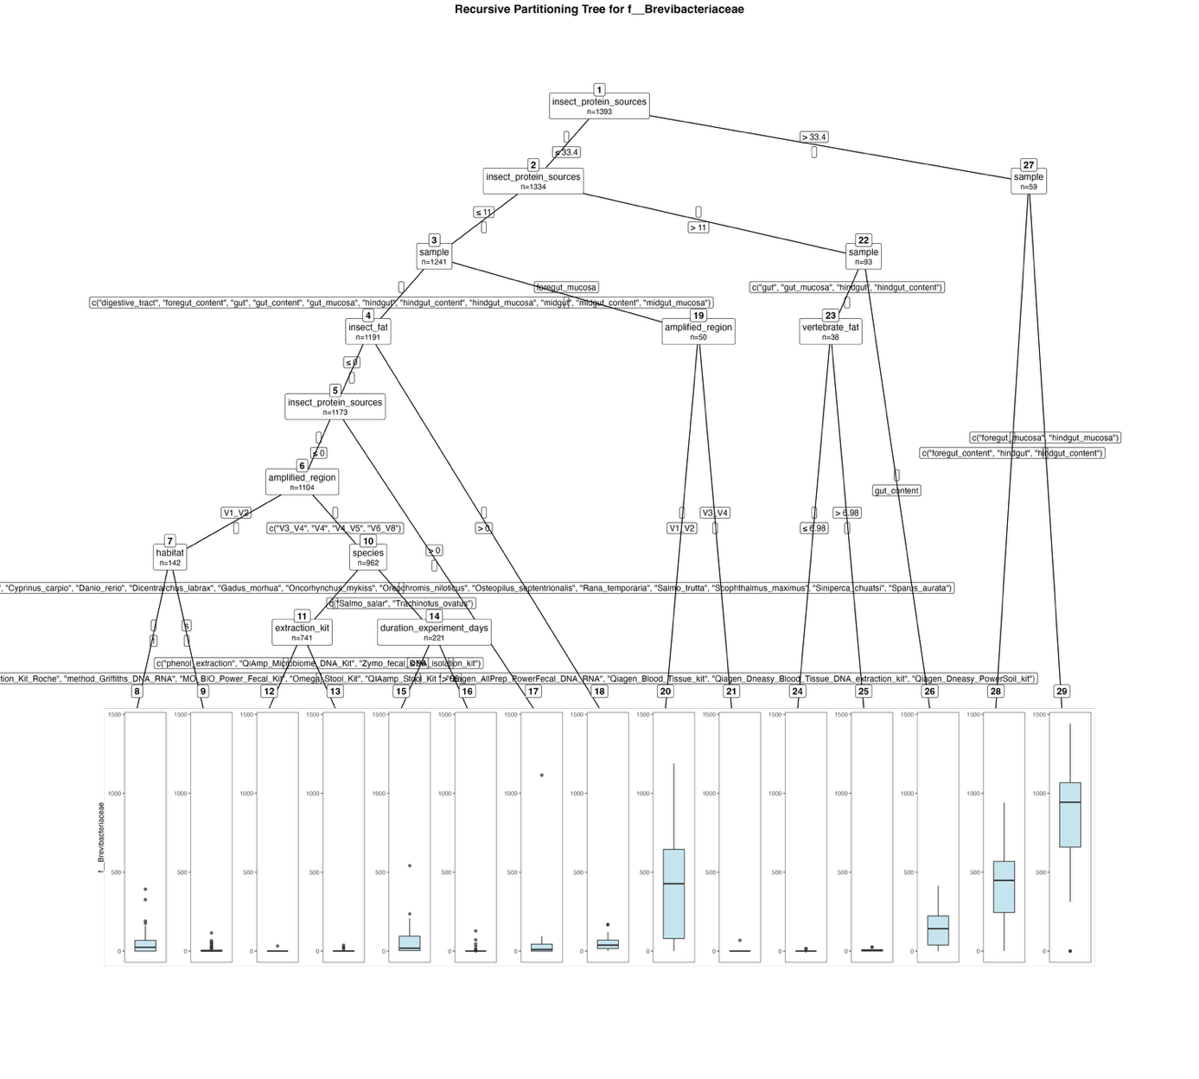
Fig. S53. Fitted party - Brevibacteriaceae:

[1] root
| [2] insect_protein_sources <= 33.4
| | [3] insect_protein_sources <= 11
| | | [4] sample in digestive_tract, foregut_content, gut, gut_content, gut_mucosa, hindgut, hindgut_content, hindgut_mucosa, midgut, midgut_content, midgut_mucosa
| | | | [5] insect_fat <= 0
| | | | | [6] insect_protein_sources <= 0
| | | | | | [7] amplified_region in V1_V2
| | | | | | | [8] habitat in f: 54.409 (n = 44, err = 310940.6)
| | | | | | | [9] habitat in s: 7.316 (n = 98, err = 28315.2)
| | | | | | [10] amplified_region in V3_V4, V4, V4_V5, V6_V8
| | | | | | | [11] species in Aquarana_catesbeiana, Clarias_gariepinus, Ctenopharyngodon_idella, Cyprinus_carpio, Danio_rerio, Dicentrarchus_labrax, Gadus_morhua, Oncorhynchus_mykiss, Oreochromis_niloticus, Osteopilus_septentrionalis, Rana_temporaria, Salmo_trutta, Scophthalmus_maximus, Siniperca_chuatsi, Sparus_aurata
| | | | | | | | [12] extraction_kit in Cador_Pathogen_96_QIAcube_HT_Kit, cetyltrimethylammonium_bromide_method, High_Pure_PCR_Template_Preparation_Kit_Roche, method_Griffiths_DNA_RNA, MO_BIO_Power_Fecal_Kit, Omega_Stool_Kit, QIAamp_Stool_Kit , Qiagen_AllPrep_PowerFecal_DNA_RNA, Qiagen_Blood_Tissue_kit, Qiagen_Dneasy_Blood_Tissue_DNA_extraction_kit, Qiagen_Dneasy_PowerSoil_kit: 0.045 (n = 711, err = 1022.6)
| | | | | | | | [13] extraction_kit in phenol_extraction, QiAmp_Microbiome_DNA_Kit, Zymo_fecal_DNA_isolation_kit: 3.933 (n = 30, err = 2247.9)
| | | | | | | [14] species in Salmo_salar, Trachinotus_ovatus
| | | | | | | | [15] duration_experiment_days <= 56: 59.979 (n = 48, err = 427505.0)
| | | | | | | | [16] duration_experiment_days > 56: 1.908 (n = 173, err = 24002.5)
| | | | | [17] insect_protein_sources > 0: 37.174 (n = 69, err = 1221379.9)
| | | | [18] insect_fat > 0: 52.222 (n = 18, err = 47031.1)
| | | [19] sample in foregut_mucosa
| | | | [20] amplified_region in V1_V2: 417.750 (n = 12, err = 1465452.2)
| | | | [21] amplified_region in V3_V4: 1.789 (n = 38, err = 4502.3)
| | [22] insect_protein_sources > 11
| | | [23] sample in gut, gut_mucosa, hindgut, hindgut_content
| | | | [24] vertebrate_fat <= 6.98: 1.179 (n = 28, err = 446.1)
| | | | [25] vertebrate_fat > 6.98: 7.400 (n = 10, err = 884.4)
| | | [26] sample in gut_content: 150.800 (n = 55, err = 715482.8)
| [27] insect_protein_sources > 33.4
| | [28] sample in foregut_content, hindgut, hindgut_content: 413.031 (n = 32, err = 2028881.0)
| | [29] sample in foregut_mucosa, hindgut_mucosa: 818.074 (n = 27, err = 4213951.9)

Number of inner nodes: 14
Number of terminal nodes: 15

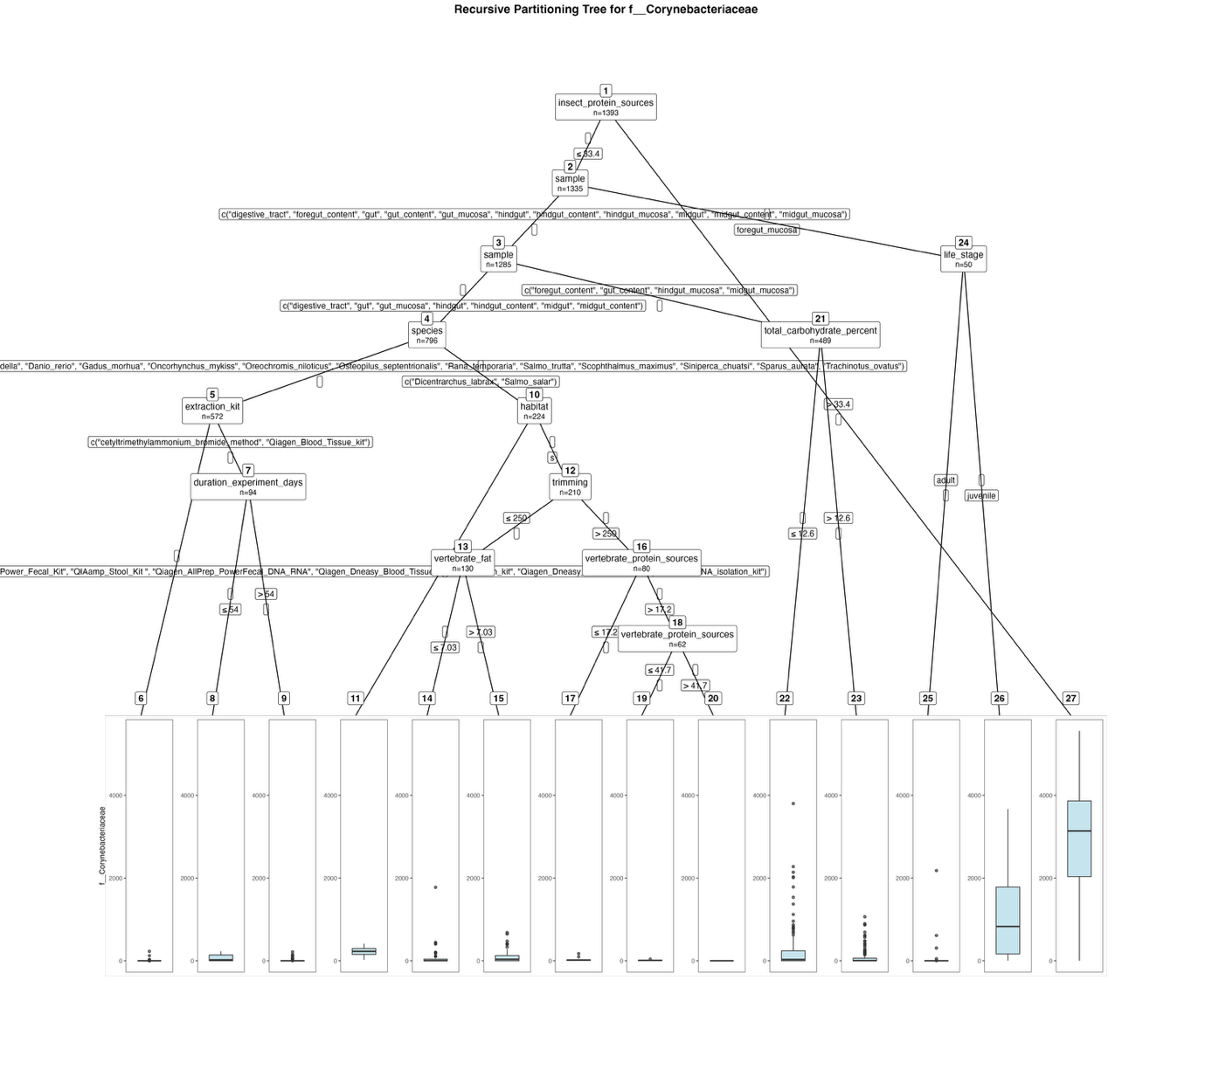
Fig. S54. Fitted party - Corynebacteriaceae:

[1] root
| [2] insect_protein_sources <= 33.4
| | [3] sample in digestive_tract, foregut_content, gut, gut_content, gut_mucosa, hindgut, hindgut_content, hindgut_mucosa, midgut, midgut_content, midgut_mucosa
| | | [4] sample in digestive_tract, gut, gut_mucosa, hindgut, hindgut_content, midgut, midgut_content
| | | | [5] species in Aquarana_catesbeiana, Clarias_gariepinus, Ctenopharyngodon_idella, Danio_rerio, Gadus_morhua, Oncorhynchus_mykiss, Oreochromis_niloticus, Osteopilus_septentrionalis, Rana_temporaria, Salmo_trutta, Scophthalmus_maximus, Siniperca_chuatsi, Sparus_aurata, Trachinotus_ovatus
| | | | | [6] extraction_kit in Cador_Pathogen_96_QIAcube_HT_Kit, EZNA_Stool_DNA_Kit, method_Griffiths_DNA_RNA, MO_BIO_Power_Fecal_Kit, QIAamp_Stool_Kit , Qiagen_AllPrep_PowerFecal_DNA_RNA, Qiagen_Dneasy_Blood_Tissue_DNA_extraction_kit, Qiagen_Dneasy_PowerSoil_kit, Zymo_fecal_DNA_isolation_kit: 1.149 (n = 478, err = 68836.5)
| | | | | [7] extraction_kit in cetyltrimethylammonium_bromide_method, Qiagen_Blood_Tissue_kit
| | | | | | [8] duration_experiment_days <= 54: 71.273 (n = 11, err = 76040.2)
| | | | | | [9] duration_experiment_days > 54: 10.735 (n = 83, err = 99062.2)
| | | | [10] species in Dicentrarchus_labrax, Salmo_salar
| | | | | [11] habitat in f: 219.857 (n = 14, err = 159871.7)
| | | | | [12] habitat in s
| | | | | | [13] trimming <= 250
| | | | | | | [14] vertebrate_fat <= 7.03: 85.000 (n = 53, err = 3499688.0)
| | | | | | | [15] vertebrate_fat > 7.03: 97.039 (n = 77, err = 1626510.9)
| | | | | | [16] trimming > 250
| | | | | | | [17] vertebrate_protein_sources <= 17.2: 28.167 (n = 18, err = 30128.5)
| | | | | | | [18] vertebrate_protein_sources > 17.2
| | | | | | | | [19] vertebrate_protein_sources <= 41.7: 11.075 (n = 40, err = 2726.8)
| | | | | | | | [20] vertebrate_protein_sources > 41.7: 0.000 (n = 22, err = 0.0)
| | | [21] sample in foregut_content, gut_content, hindgut_mucosa, midgut_mucosa
| | | | [22] total_carbohydrate_percent <= 12.6: 189.912 (n = 297, err = 45735055.7)
| | | | [23] total_carbohydrate_percent > 12.6: 76.693 (n = 192, err = 5799802.9)
| | [24] sample in foregut_mucosa
| | | [25] life_stage in adult: 157.300 (n = 20, err = 4727924.2)
| | | [26] life_stage in juvenile: 1078.533 (n = 30, err = 31271051.5)
| [27] insect_protein_sources > 33.4: 2898.724 (n = 58, err = 124098229.6)

Number of inner nodes: 13
Number of terminal nodes: 14

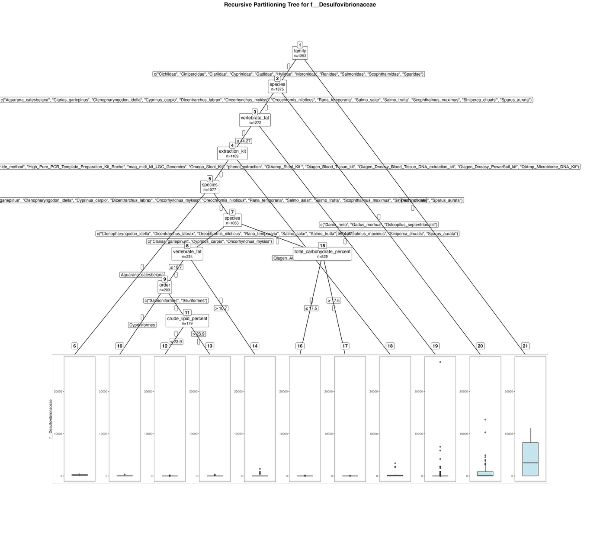
Fig. S55. Fitted party - Desulfovibrionaceae:

[1] root
| [2] family in Cichlidae, Cinipercidae, Clariidae, Cyprinidae, Gadidae, Hylidae, Moronidae, Ranidae, Salmonidae, Scophthalmidae, Sparidae
| | [3] species in Aquarana_catesbeiana, Clarias_gariepinus, Ctenopharyngodon_idella, Cyprinus_carpio, Dicentrarchus_labrax, Oncorhynchus_mykiss, Oreochromis_niloticus, Rana_temporaria, Salmo_salar, Salmo_trutta, Scophthalmus_maximus, Siniperca_chuatsi, Sparus_aurata
| | | [4] vertebrate_fat <= 14.27
| | | | [5] extraction_kit in Cador_Pathogen_96_QIAcube_HT_Kit, cetyltrimethylammonium_bromide_method, High_Pure_PCR_Template_Preparation_Kit_Roche, mag_midi_kit_LGC_Genomics, Omega_Stool_Kit, phenol_extraction, QIAamp_Stool_Kit , Qiagen_Blood_Tissue_kit, Qiagen_Dneasy_Blood_Tissue_DNA_extraction_kit, Qiagen_Dneasy_PowerSoil_kit, QiAmp_Microbiome_DNA_Kit
| | | | | [6] species in Aquarana_catesbeiana: 236.714 (n = 14, err = 419664.9)
| | | | | [7] species in Clarias_gariepinus, Ctenopharyngodon_idella, Cyprinus_carpio, Dicentrarchus_labrax, Oncorhynchus_mykiss, Oreochromis_niloticus, Rana_temporaria, Salmo_salar, Salmo_trutta, Scophthalmus_maximus, Siniperca_chuatsi, Sparus_aurata
| | | | | | [8] species in Clarias_gariepinus, Cyprinus_carpio, Oncorhynchus_mykiss
| | | | | | | [9] vertebrate_fat <= 10.7
| | | | | | | | [10] order in Cypriniformes: 48.250 (n = 24, err = 136452.5)
| | | | | | | | [11] order in Salmoniformes, Siluriformes
| | | | | | | | | [12] crude_lipid_percent <= 23.9: 2.417 (n = 163, err = 48013.6)
| | | | | | | | | [13] crude_lipid_percent > 23.9: 48.625 (n = 16, err = 146205.8)
| | | | | | | [14] vertebrate_fat > 10.7: 160.484 (n = 31, err = 4283293.7)
| | | | | | [15] species in Ctenopharyngodon_idella, Dicentrarchus_labrax, Oreochromis_niloticus, Rana_temporaria, Salmo_salar, Salmo_trutta, Scophthalmus_maximus, Siniperca_chuatsi, Sparus_aurata
| | | | | | | [16] total_carbohydrate_percent <= 17.5: 0.312 (n = 799, err = 26097.4)
| | | | | | | [17] total_carbohydrate_percent > 17.5: 2.833 (n = 30, err = 4572.2)
| | | | [18] extraction_kit in Qiagen_AllPrep_PowerFecal_DNA_RNA: 300.562 (n = 32, err = 16019185.9)
| | | [19] vertebrate_fat > 14.27: 374.221 (n = 163, err = 825290990.0)
| | [20] species in Danio_rerio, Gadus_morhua, Osteopilus_septentrionalis: 875.709 (n = 103, err = 365410203.3)
| [21] family in Trachinotidae: 3943.722 (n = 18, err = 259069041.6)

Number of inner nodes: 10
Number of terminal nodes: 11

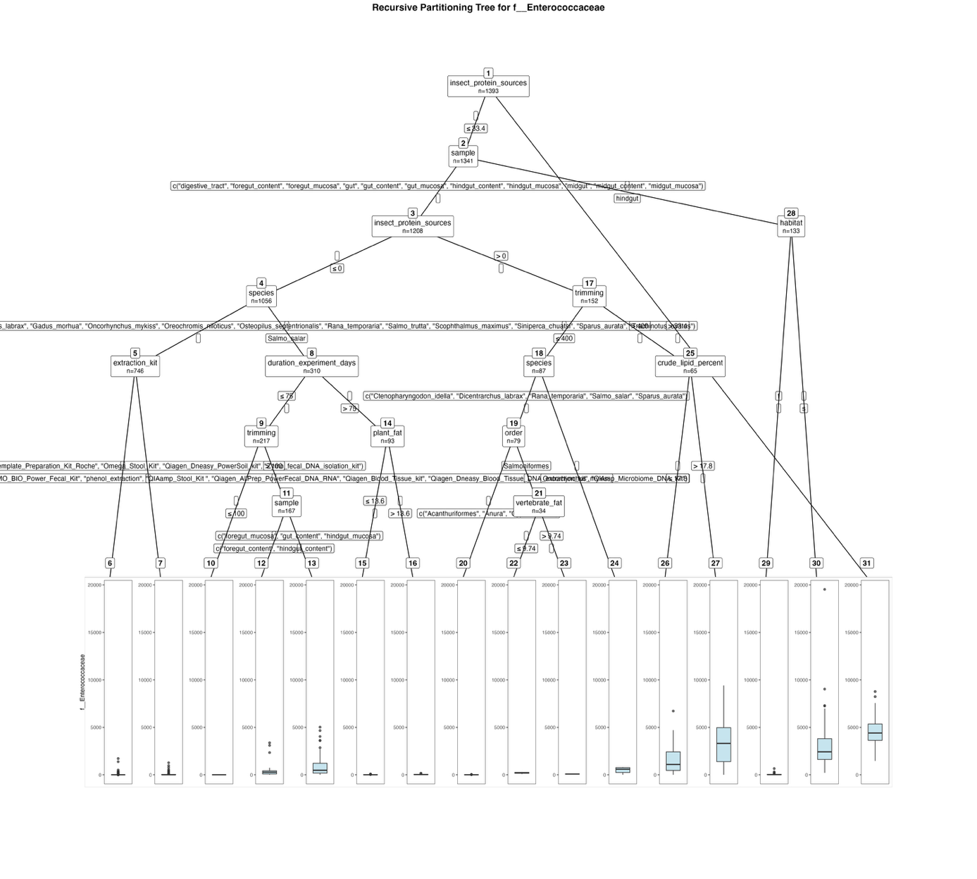
Fig. S56. Fitted party - Enterococcaceae:

[1] root
| [2] insect_protein_sources <= 33.4
| | [3] sample in digestive_tract, foregut_content, foregut_mucosa, gut, gut_content, gut_mucosa, hindgut_content, hindgut_mucosa, midgut, midgut_content, midgut_mucosa
| | | [4] insect_protein_sources <= 0
| | | | [5] species in Clarias_gariepinus, Ctenopharyngodon_idella, Cyprinus_carpio, Danio_rerio, Dicentrarchus_labrax, Gadus_morhua, Oncorhynchus_mykiss, Oreochromis_niloticus, Osteopilus_septentrionalis, Rana_temporaria, Salmo_trutta, Scophthalmus_maximus, Siniperca_chuatsi, Sparus_aurata, Trachinotus_ovatus
| | | | | [6] extraction_kit in Cador_Pathogen_96_QIAcube_HT_Kit, cetyltrimethylammonium_bromide_method, EZNA_Stool_DNA_Kit, method_Griffiths_DNA_RNA, MO_BIO_Power_Fecal_Kit, phenol_extraction, QIAamp_Stool_Kit , Qiagen_AllPrep_PowerFecal_DNA_RNA, Qiagen_Blood_Tissue_kit, Qiagen_Dneasy_Blood_Tissue_DNA_extraction_kit, QiAmp_Microbiome_DNA_Kit: 13.262 (n = 673, err = 5871420.0)
| | | | | [7] extraction_kit in High_Pure_PCR_Template_Preparation_Kit_Roche, Omega_Stool_Kit, Qiagen_Dneasy_PowerSoil_kit, Zymo_fecal_DNA_isolation_kit: 89.000 (n = 73, err = 3714012.0)
| | | | [8] species in Salmo_salar
| | | | | [9] duration_experiment_days <= 75
| | | | | | [10] trimming <= 100: 0.000 (n = 50, err = 0.0)
| | | | | | [11] trimming > 100
| | | | | | | [12] sample in foregut_content, hindgut_content: 354.939 (n = 98, err = 24989631.6)
| | | | | | | [13] sample in foregut_mucosa, gut_content, hindgut_mucosa: 912.928 (n = 69, err = 90323540.6)
| | | | | [14] duration_experiment_days > 75
| | | | | | [15] plant_fat <= 13.6: 11.031 (n = 64, err = 22177.9)
| | | | | | [16] plant_fat > 13.6: 36.862 (n = 29, err = 50271.4)
| | | [17] insect_protein_sources > 0
| | | | [18] trimming <= 400
| | | | | [19] species in Ctenopharyngodon_idella, Dicentrarchus_labrax, Rana_temporaria, Salmo_salar, Sparus_aurata
| | | | | | [20] order in Acanthuriformes, Anura, Cypriniformes: 4.022 (n = 45, err = 3423.0)
| | | | | | [21] order in Salmoniformes
| | | | | | | [22] vertebrate_fat <= 9.74: 197.542 (n = 24, err = 85738.0)
| | | | | | | [23] vertebrate_fat > 9.74: 76.900 (n = 10, err = 2448.9)
| | | | | [24] species in Oncorhynchus_mykiss: 479.250 (n = 8, err = 743129.5)
| | | | [25] trimming > 400
| | | | | [26] crude_lipid_percent <= 17.8: 1604.812 (n = 32, err = 76671074.9)
| | | | | [27] crude_lipid_percent > 17.8: 3270.121 (n = 33, err = 191638937.5)
| | [28] sample in hindgut
| | | [29] habitat in f: 48.302 (n = 63, err = 571747.3)
| | | [30] habitat in s: 3058.100 (n = 70, err = 512430862.3)
| [31] insect_protein_sources > 33.4: 4613.231 (n = 52, err = 129549391.2)

Number of inner nodes: 15
Number of terminal nodes: 16

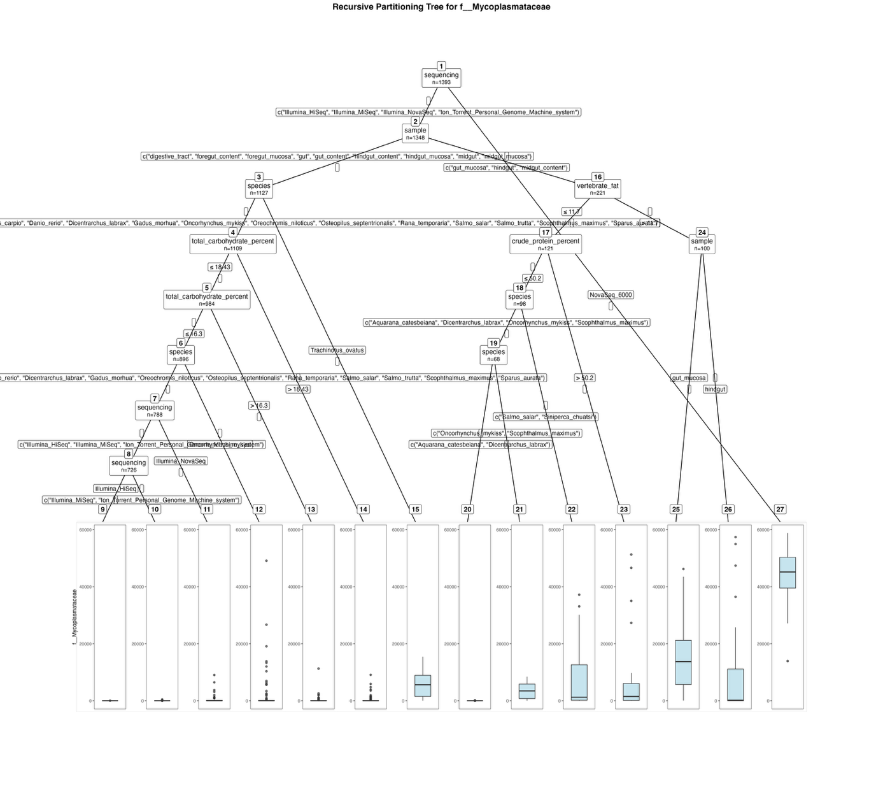
Fig. S57. Fitted party - Mycoplasmataceae:

[1] root
| [2] sequencing in Illumina_HiSeq, Illumina_MiSeq, Illumina_NovaSeq, Ion_Torrent_Personal_Genome_Machine_system
| | [3] sample in digestive_tract, foregut_content, foregut_mucosa, gut, gut_content, hindgut_content, hindgut_mucosa, midgut, midgut_mucosa
| | | [4] species in Clarias_gariepinus, Ctenopharyngodon_idella, Cyprinus_carpio, Danio_rerio, Dicentrarchus_labrax, Gadus_morhua, Oncorhynchus_mykiss, Oreochromis_niloticus, Osteopilus_septentrionalis, Rana_temporaria, Salmo_salar, Salmo_trutta, Scophthalmus_maximus, Sparus_aurata
| | | | [5] total_carbohydrate_percent <= 18.43
| | | | | [6] total_carbohydrate_percent <= 16.3
| | | | | | [7] species in Clarias_gariepinus, Ctenopharyngodon_idella, Cyprinus_carpio, Danio_rerio, Dicentrarchus_labrax, Gadus_morhua, Oreochromis_niloticus, Osteopilus_septentrionalis, Rana_temporaria, Salmo_salar, Salmo_trutta, Scophthalmus_maximus, Sparus_aurata
| | | | | | | [8] sequencing in Illumina_HiSeq, Illumina_MiSeq, Ion_Torrent_Personal_Genome_Machine_system
| | | | | | | | [9] sequencing in Illumina_HiSeq: 1.100 (n = 10, err = 108.9)
| | | | | | | | [10] sequencing in Illumina_MiSeq, Ion_Torrent_Personal_Genome_Machine_system: 0.890 (n = 716, err = 219484.3)
| | | | | | | [11] sequencing in Illumina_NovaSeq: 545.661 (n = 62, err = 141154923.9)
| | | | | | [12] species in Oncorhynchus_mykiss: 1782.120 (n = 108, err = 3988119807.4)
| | | | | [13] total_carbohydrate_percent > 16.3: 304.114 (n = 88, err = 140049846.9)
| | | | [14] total_carbohydrate_percent > 18.43: 389.296 (n = 125, err = 173474732.0)
| | | [15] species in Trachinotus_ovatus: 5958.389 (n = 18, err = 382061130.3)
| | [16] sample in gut_mucosa, hindgut, midgut_content
| | | [17] vertebrate_fat <= 11.7
| | | | [18] crude_protein_percent <= 50.2
| | | | | [19] species in Aquarana_catesbeiana, Dicentrarchus_labrax, Oncorhynchus_mykiss, Scophthalmus_maximus
| | | | | | [20] species in Aquarana_catesbeiana, Dicentrarchus_labrax: 8.273 (n = 33, err = 20190.5)
| | | | | | [21] species in Oncorhynchus_mykiss, Scophthalmus_maximus: 3574.457 (n = 35, err = 245882418.7)
| | | | | [22] species in Salmo_salar, Siniperca_chuatsi: 8466.700 (n = 30, err = 4131489572.3)
| | | | [23] crude_protein_percent > 50.2: 8812.478 (n = 23, err = 5241072673.7)
| | | [24] vertebrate_fat > 11.7
| | | | [25] sample in gut_mucosa: 15118.587 (n = 63, err = 7534122387.3)
| | | | [26] sample in hindgut: 8497.919 (n = 37, err = 9351733986.8)
| [27] sequencing in NovaSeq_6000: 44661.489 (n = 45, err = 3475175851.2)

Number of inner nodes: 13
Number of terminal nodes: 14

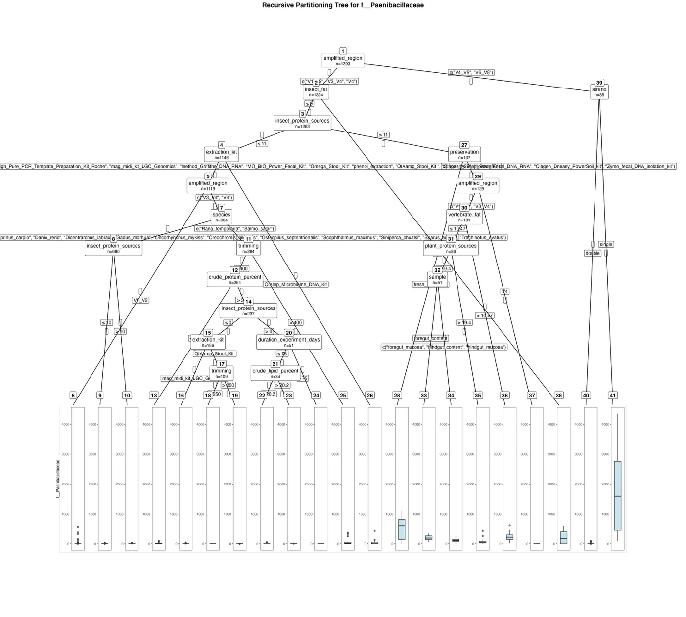
Fig. S58. Fitted party - Paenibacillaceae:

[1] root
| [2] amplified_region in V1_V2, V3_V4, V4
| | [3] insect_fat <= 0
| | | [4] insect_protein_sources <= 11
| | | | [5] extraction_kit in Cador_Pathogen_96_QIAcube_HT_Kit, cetyltrimethylammonium_bromide_method, EZNA_Stool_DNA_Kit, High_Pure_PCR_Template_Preparation_Kit_Roche, mag_midi_kit_LGC_Genomics, method_Griffiths_DNA_RNA, MO_BIO_Power_Fecal_Kit, Omega_Stool_Kit, phenol_extraction, QIAamp_Stool_Kit , Qiagen_AllPrep_PowerFecal_DNA_RNA, Qiagen_Dneasy_PowerSoil_kit, Zymo_fecal_DNA_isolation_kit
| | | | | [6] amplified_region in V1_V2: 11.426 (n = 155, err = 597689.9)
| | | | | [7] amplified_region in V3_V4, V4
| | | | | | [8] species in Aquarana_catesbeiana, Clarias_gariepinus, Ctenopharyngodon_idella, Cyprinus_carpio, Danio_rerio, Dicentrarchus_labrax, Gadus_morhua, Oncorhynchus_mykiss, Oreochromis_niloticus, Osteopilus_septentrionalis, Scophthalmus_maximus, Siniperca_chuatsi, Sparus_aurata, Trachinotus_ovatus
| | | | | | | [9] insect_protein_sources <= 10: 0.124 (n = 670, err = 1660.7)
| | | | | | | [10] insect_protein_sources > 10: 4.400 (n = 10, err = 784.4)
| | | | | | [11] species in Rana_temporaria, Salmo_salar
| | | | | | | [12] trimming <= 400
| | | | | | | | [13] crude_protein_percent <= 32: 16.176 (n = 17, err = 13368.5)
| | | | | | | | [14] crude_protein_percent > 32
| | | | | | | | | [15] insect_protein_sources <= 0
| | | | | | | | | | [16] extraction_kit in mag_midi_kit_LGC_Genomics: 3.636 (n = 77, err = 4159.8)
| | | | | | | | | | [17] extraction_kit in QIAamp_Stool_Kit
| | | | | | | | | | | [18] trimming <= 250: 0.000 (n = 87, err = 0.0)
| | | | | | | | | | | [19] trimming > 250: 0.364 (n = 22, err = 13.1)
| | | | | | | | | [20] insect_protein_sources > 0
| | | | | | | | | | [21] duration_experiment_days <= 75
| | | | | | | | | | | [22] crude_lipid_percent <= 20.2: 19.417 (n = 24, err = 2117.8)
| | | | | | | | | | | [23] crude_lipid_percent > 20.2: 0.800 (n = 10, err = 17.6)
| | | | | | | | | | [24] duration_experiment_days > 75: 0.000 (n = 17, err = 0.0)
| | | | | | | [25] trimming > 400: 47.867 (n = 30, err = 261945.5)
| | | | [26] extraction_kit in QiAmp_Microbiome_DNA_Kit: 41.926 (n = 27, err = 192991.9)
| | | [27] insect_protein_sources > 11
| | | | [28] preservation in fresh_extraction: 533.625 (n = 8, err = 1202785.9)
| | | | [29] preservation in frozen_20, frozen_80
| | | | | [30] amplified_region in V1_V2, V3_V4
| | | | | | [31] vertebrate_fat <= 10.47
| | | | | | | [32] plant_protein_sources <= 19.4
| | | | | | | | [33] sample in foregut_content: 193.000 (n = 14, err = 109558.0)
| | | | | | | | [34] sample in foregut_mucosa, hindgut_content, hindgut_mucosa: 115.378 (n = 37, err = 123460.7)
| | | | | | | [35] plant_protein_sources > 19.4: 66.600 (n = 35, err = 217362.4)
| | | | | | [36] vertebrate_fat > 10.47: 248.067 (n = 15, err = 333012.9)
| | | | | [37] amplified_region in V4: 0.000 (n = 28, err = 0.0)
| | [38] insect_fat > 0: 216.571 (n = 21, err = 893355.1)
| [39] amplified_region in V4_V5, V6_V8
| | [40] strand in double: 2.937 (n = 79, err = 13546.7)
| | [41] strand in single: 1770.100 (n = 10, err = 19772498.9)

Number of inner nodes: 20
Number of terminal nodes: 21

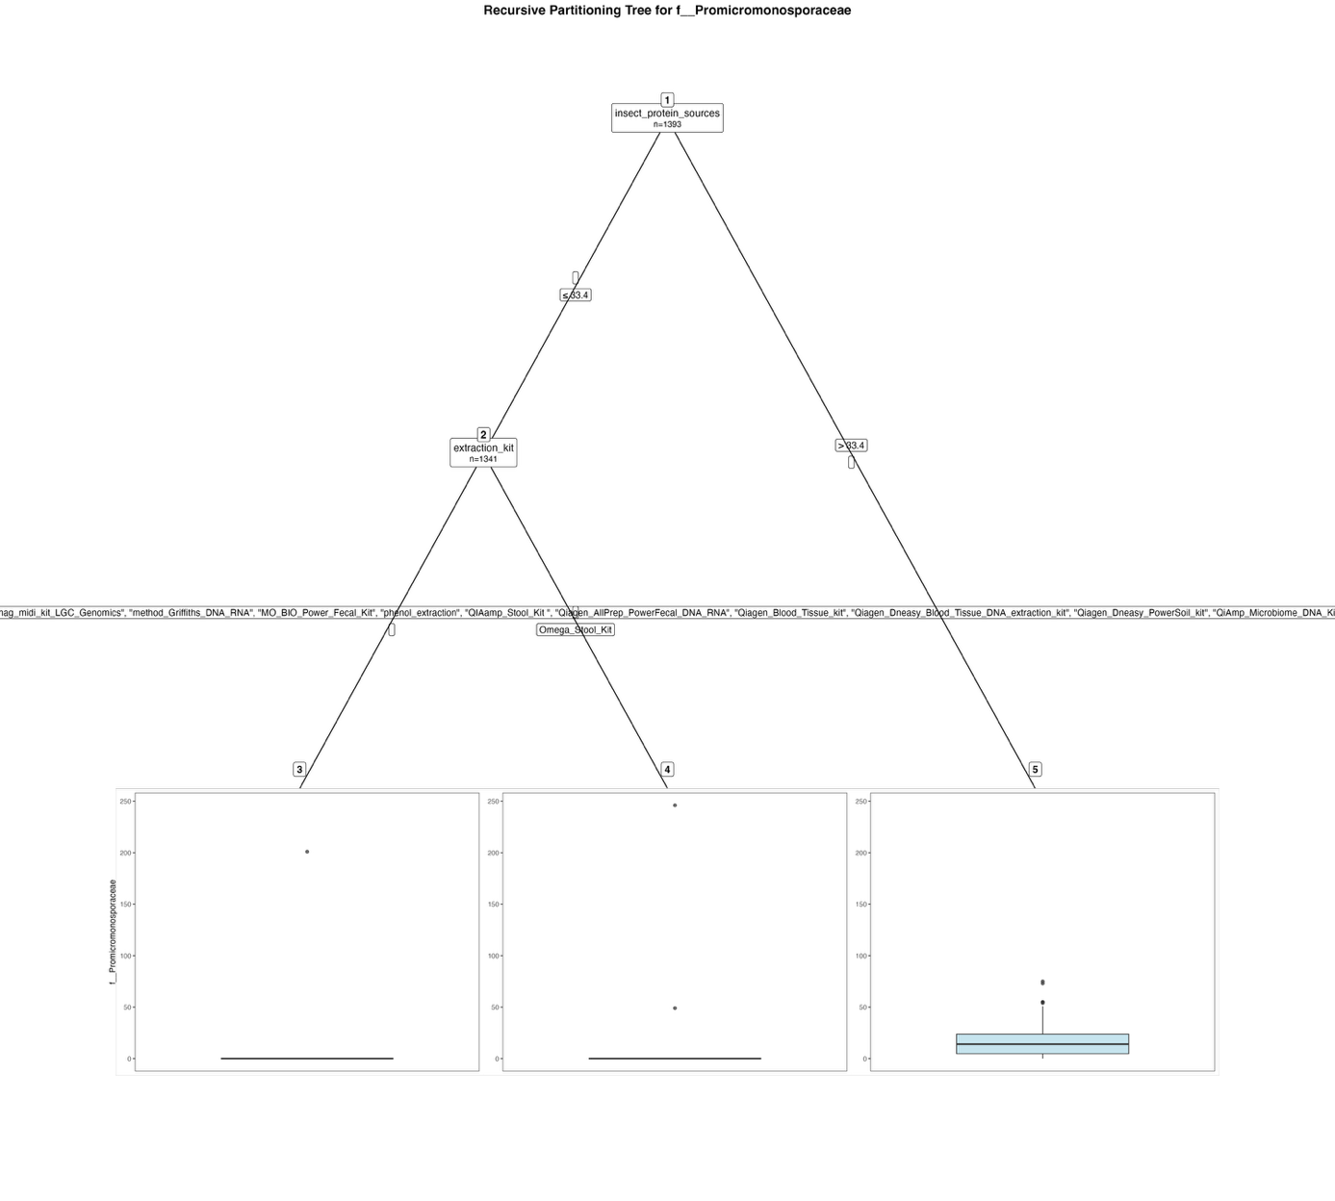
Fig. S59. Fitted party - Promicromonosporaceae:

[1] root
| [2] insect_protein_sources <= 33.4
| | [3] extraction_kit in Cador_Pathogen_96_QIAcube_HT_Kit, cetyltrimethylammonium_bromide_method, EZNA_Stool_DNA_Kit, High_Pure_PCR_Template_Preparation_Kit_Roche, mag_midi_kit_LGC_Genomics, method_Griffiths_DNA_RNA, MO_BIO_Power_Fecal_Kit, phenol_extraction, QIAamp_Stool_Kit , Qiagen_AllPrep_PowerFecal_DNA_RNA, Qiagen_Blood_Tissue_kit, Qiagen_Dneasy_Blood_Tissue_DNA_extraction_kit, Qiagen_Dneasy_PowerSoil_kit, QiAmp_Microbiome_DNA_Kit, Zymo_fecal_DNA_isolation_kit: 0.152 (n = 1322, err = 40370.4)
| | [4] extraction_kit in Omega_Stool_Kit: 15.526 (n = 19, err = 58336.7)
| [5] insect_protein_sources > 33.4: 18.038 (n = 52, err = 18489.9)

Number of inner nodes: 2
Number of terminal nodes: 3

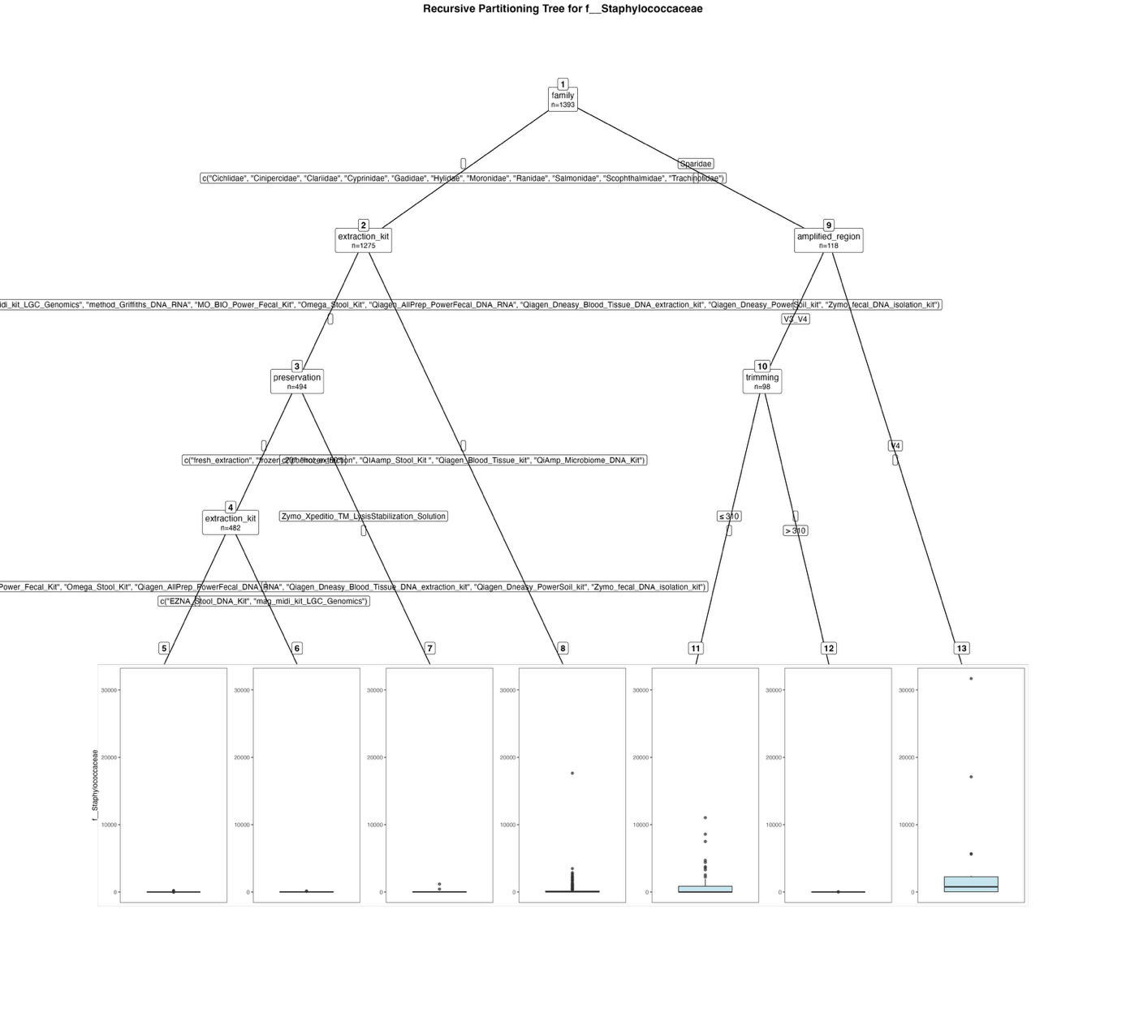
Fig. S60. Fitted party - Staphylococcaceae:

[1] root
| [2] family in Cichlidae, Cinipercidae, Clariidae, Cyprinidae, Gadidae, Hylidae, Moronidae, Ranidae, Salmonidae, Scophthalmidae, Trachinotidae
| | [3] extraction_kit in cetyltrimethylammonium_bromide_method, EZNA_Stool_DNA_Kit, mag_midi_kit_LGC_Genomics, method_Griffiths_DNA_RNA, MO_BIO_Power_Fecal_Kit, Omega_Stool_Kit, Qiagen_AllPrep_PowerFecal_DNA_RNA, Qiagen_Dneasy_Blood_Tissue_DNA_extraction_kit, Qiagen_Dneasy_PowerSoil_kit, Zymo_fecal_DNA_isolation_kit
| | | [4] preservation in fresh_extraction, frozen_20, frozen_80
| | | | [5] extraction_kit in cetyltrimethylammonium_bromide_method, method_Griffiths_DNA_RNA, MO_BIO_Power_Fecal_Kit, Omega_Stool_Kit, Qiagen_AllPrep_PowerFecal_DNA_RNA, Qiagen_Dneasy_Blood_Tissue_DNA_extraction_kit, Qiagen_Dneasy_PowerSoil_kit, Zymo_fecal_DNA_isolation_kit: 2.953 (n = 381, err = 115931.1)
| | | | [6] extraction_kit in EZNA_Stool_DNA_Kit, mag_midi_kit_LGC_Genomics: 21.762 (n = 101, err = 62270.3)
| | | [7] preservation in Zymo_Xpeditio_TM_LysisStabilization_Solution: 151.500 (n = 12, err = 1325261.0)
| | [8] extraction_kit in phenol_extraction, QIAamp_Stool_Kit , Qiagen_Blood_Tissue_kit, QiAmp_Microbiome_DNA_Kit: 174.711 (n = 781, err = 405636402.6)
| [9] family in Sparidae
| | [10] amplified_region in V3_V4
| | | [11] trimming <= 310: 1094.339 (n = 56, err = 287921620.6)
| | | [12] trimming > 310: 5.405 (n = 42, err = 2078.1)
| | [13] amplified_region in V4: 3567.650 (n = 20, err = 1123989232.6)

Number of inner nodes: 6
Number of terminal nodes: 7

Results for the filtered dataset – Families:

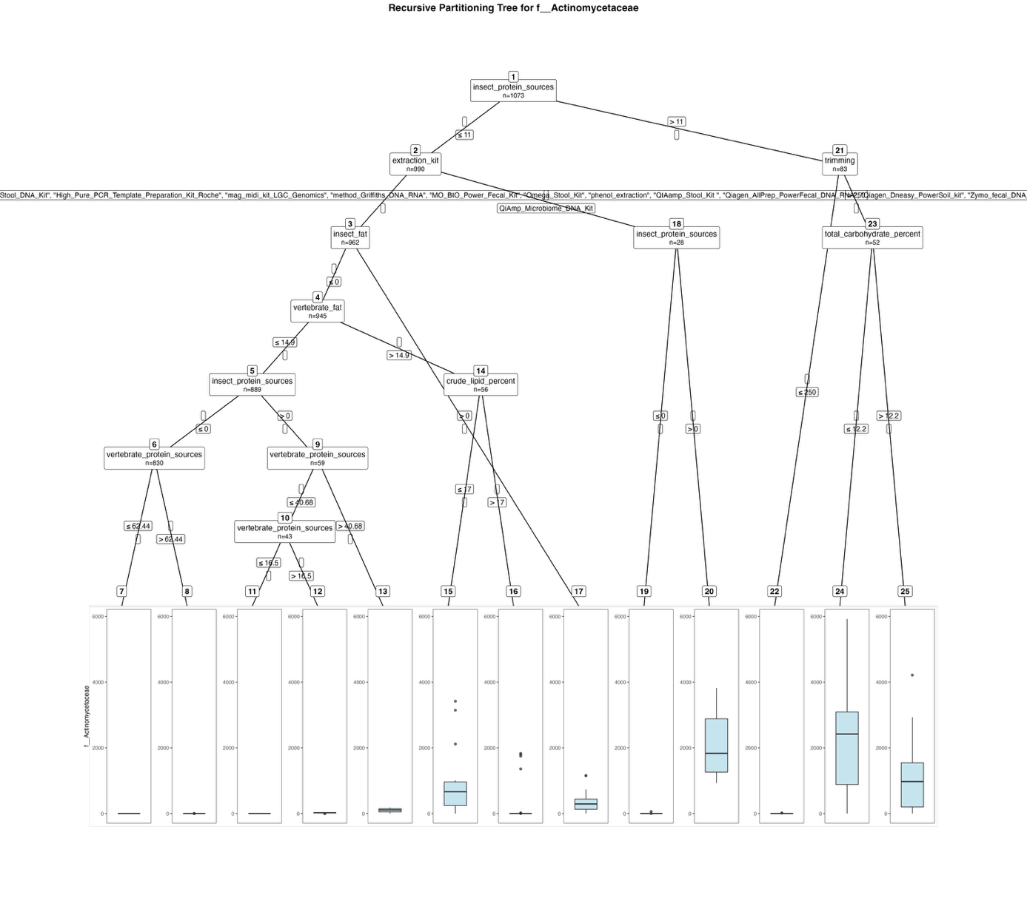
Fig. S61. Fitted party - Actinomycetaceae:

[1] root
| [2] insect_protein_sources <= 11
| | [3] extraction_kit in Cador_Pathogen_96_QIAcube_HT_Kit, cetyltrimethylammonium_bromide_method, EZNA_Stool_DNA_Kit, High_Pure_PCR_Template_Preparation_Kit_Roche, mag_midi_kit_LGC_Genomics, method_Griffiths_DNA_RNA, MO_BIO_Power_Fecal_Kit, Omega_Stool_Kit, phenol_extraction, QIAamp_Stool_Kit , Qiagen_AllPrep_PowerFecal_DNA_RNA, Qiagen_Dneasy_PowerSoil_kit, Zymo_fecal_DNA_isolation_kit
| | | [4] insect_fat <= 0
| | | | [5] vertebrate_fat <= 14.9
| | | | | [6] insect_protein_sources <= 0
| | | | | | [7] vertebrate_protein_sources <= 62.44: 0.000 (n = 761, err = 0.0)
| | | | | | [8] vertebrate_protein_sources > 62.44: 0.087 (n = 69, err = 11.5)
| | | | | [9] insect_protein_sources > 0
| | | | | | [10] vertebrate_protein_sources <= 40.68
| | | | | | | [11] vertebrate_protein_sources <= 16.5: 0.000 (n = 19, err = 0.0)
| | | | | | | [12] vertebrate_protein_sources > 16.5: 22.667 (n = 24, err = 2319.3)
| | | | | | [13] vertebrate_protein_sources > 40.68: 96.750 (n = 16, err = 64411.0)
| | | | [14] vertebrate_fat > 14.9
| | | | | [15] crude_lipid_percent <= 17: 918.294 (n = 17, err = 16811863.5)
| | | | | [16] crude_lipid_percent > 17: 173.128 (n = 39, err = 10283586.4)
| | | [17] insect_fat > 0: 354.882 (n = 17, err = 2007391.8)
| | [18] extraction_kit in QiAmp_Microbiome_DNA_Kit
| | | [19] insect_protein_sources <= 0: 3.938 (n = 16, err = 3476.9)
| | | [20] insect_protein_sources > 0: 2159.500 (n = 12, err = 13025503.0)
| [21] insect_protein_sources > 11
| | [22] trimming <= 250: 1.742 (n = 31, err = 493.9)
| | [23] trimming > 250
| | | [24] total_carbohydrate_percent <= 12.2: 2297.833 (n = 18, err = 50720416.5)
| | | [25] total_carbohydrate_percent > 12.2: 1025.441 (n = 34, err = 30657034.4)

Number of inner nodes: 12
Number of terminal nodes: 13

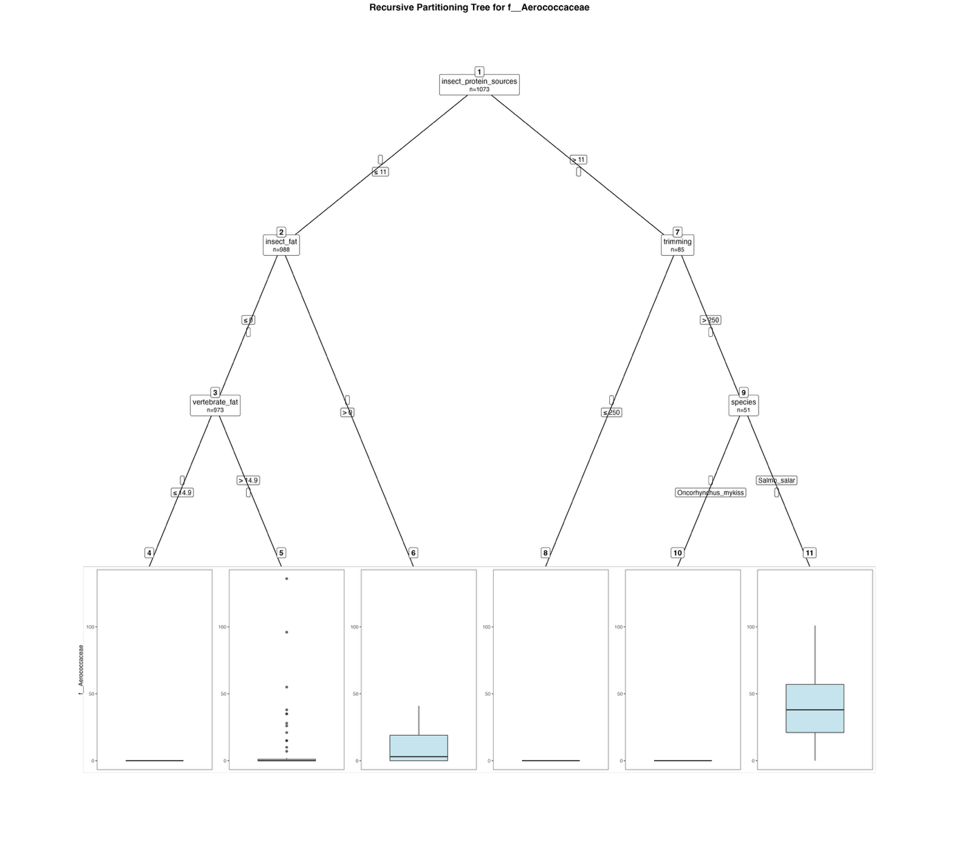
Fig. S62. Fitted party - Aerococcaceae:

[1] root
| [2] insect_protein_sources <= 11
| | [3] insect_fat <= 0
| | | [4] vertebrate_fat <= 14.9: 0.000 (n = 914, err = 0.0)
| | | [5] vertebrate_fat > 14.9: 9.051 (n = 59, err = 32526.8)
| | [6] insect_fat > 0: 10.867 (n = 15, err = 2401.7)
| [7] insect_protein_sources > 11
| | [8] trimming <= 250: 0.000 (n = 34, err = 0.0)
| | [9] trimming > 250
| | | [10] species in Oncorhynchus_mykiss: 0.000 (n = 6, err = 0.0)
| | | [11] species in Salmo_salar: 40.667 (n = 45, err = 30034.0)

Number of inner nodes: 5
Number of terminal nodes: 6

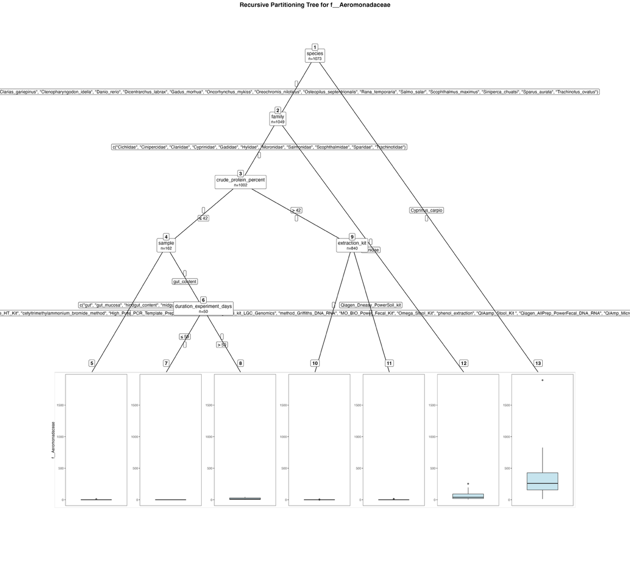
Fig. S63. Fitted party - Aeromonadaceae:

[1] root
| [2] species in Clarias_gariepinus, Ctenopharyngodon_idella, Danio_rerio, Dicentrarchus_labrax, Gadus_morhua, Oncorhynchus_mykiss, Oreochromis_niloticus, Osteopilus_septentrionalis, Rana_temporaria, Salmo_salar, Scophthalmus_maximus, Siniperca_chuatsi, Sparus_aurata, Trachinotus_ovatus
| | [3] family in Cichlidae, Cinipercidae, Clariidae, Cyprinidae, Gadidae, Hylidae, Moronidae, Salmonidae, Scophthalmidae, Sparidae, Trachinotidae
| | | [4] crude_protein_percent <= 42
| | | | [5] sample in gut, gut_mucosa, hindgut_content, midgut: 0.089 (n = 112, err = 99.1)
| | | | [6] sample in gut_content
| | | | | [7] duration_experiment_days <= 59: 0.000 (n = 31, err = 0.0)
| | | | | [8] duration_experiment_days > 59: 15.684 (n = 19, err = 3162.1)
| | | [9] crude_protein_percent > 42
| | | | [10] extraction_kit in Cador_Pathogen_96_QIAcube_HT_Kit, cetyltrimethylammonium_bromide_method, High_Pure_PCR_Template_Preparation_Kit_Roche, mag_midi_kit_LGC_Genomics, method_Griffiths_DNA_RNA, MO_BIO_Power_Fecal_Kit, Omega_Stool_Kit, phenol_extraction, QIAamp_Stool_Kit , Qiagen_AllPrep_PowerFecal_DNA_RNA, QiAmp_Microbiome_DNA_Kit, Zymo_fecal_DNA_isolation_kit: 0.011 (n = 805, err = 34.9)
| | | | [11] extraction_kit in Qiagen_Dneasy_PowerSoil_kit: 0.600 (n = 35, err = 232.4)
| | [12] family in Ranidae: 58.319 (n = 47, err = 125534.2)
| [13] species in Cyprinus_carpio: 371.708 (n = 24, err = 3446553.0)

Number of inner nodes: 6
Number of terminal nodes: 7

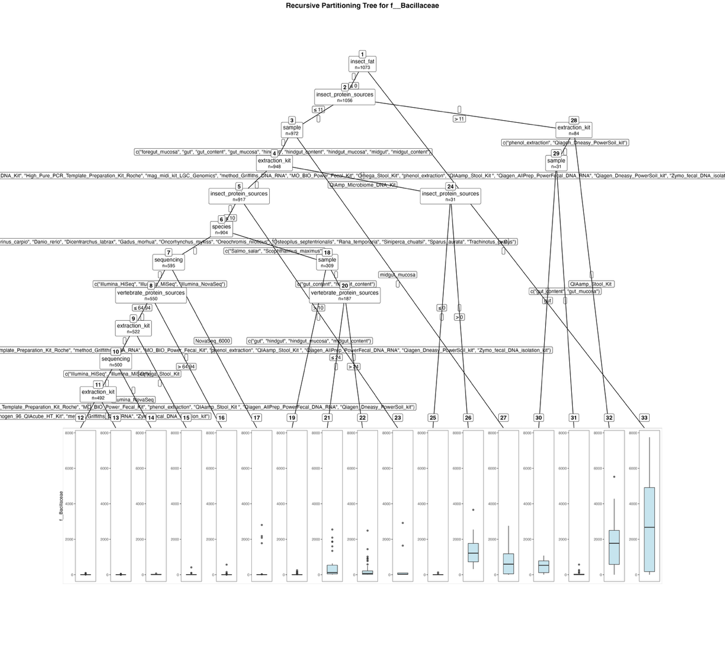
Fig. S64. Fitted party - Bacillaceae:

[1] root
| [2] insect_fat <= 0
| | [3] insect_protein_sources <= 11
| | | [4] sample in foregut_mucosa, gut, gut_content, gut_mucosa, hindgut, hindgut_content, hindgut_mucosa, midgut, midgut_content
| | | | [5] extraction_kit in Cador_Pathogen_96_QIAcube_HT_Kit, cetyltrimethylammonium_bromide_method, EZNA_Stool_DNA_Kit, High_Pure_PCR_Template_Preparation_Kit_Roche, mag_midi_kit_LGC_Genomics, method_Griffiths_DNA_RNA, MO_BIO_Power_Fecal_Kit, Omega_Stool_Kit, phenol_extraction, QIAamp_Stool_Kit , Qiagen_AllPrep_PowerFecal_DNA_RNA, Qiagen_Dneasy_PowerSoil_kit, Zymo_fecal_DNA_isolation_kit
| | | | | [6] insect_protein_sources <= 10
| | | | | | [7] species in Clarias_gariepinus, Ctenopharyngodon_idella, Cyprinus_carpio, Danio_rerio, Dicentrarchus_labrax, Gadus_morhua, Oncorhynchus_mykiss, Oreochromis_niloticus, Osteopilus_septentrionalis, Rana_temporaria, Siniperca_chuatsi, Sparus_aurata, Trachinotus_ovatus
| | | | | | | [8] sequencing in Illumina_HiSeq, Illumina_MiSeq, Illumina_NovaSeq
| | | | | | | | [9] vertebrate_protein_sources <= 64.94
| | | | | | | | | [10] extraction_kit in Cador_Pathogen_96_QIAcube_HT_Kit, cetyltrimethylammonium_bromide_method, EZNA_Stool_DNA_Kit, High_Pure_PCR_Template_Preparation_Kit_Roche, method_Griffiths_DNA_RNA, MO_BIO_Power_Fecal_Kit, phenol_extraction, QIAamp_Stool_Kit , Qiagen_AllPrep_PowerFecal_DNA_RNA, Qiagen_Dneasy_PowerSoil_kit, Zymo_fecal_DNA_isolation_kit
| | | | | | | | | | [11] sequencing in Illumina_HiSeq, Illumina_MiSeq
| | | | | | | | | | | [12] extraction_kit in Cador_Pathogen_96_QIAcube_HT_Kit, method_Griffiths_DNA_RNA, Zymo_fecal_DNA_isolation_kit: 4.854 (n = 96, err = 17192.0)
| | | | | | | | | | | [13] extraction_kit in cetyltrimethylammonium_bromide_method, EZNA_Stool_DNA_Kit, High_Pure_PCR_Template_Preparation_Kit_Roche, MO_BIO_Power_Fecal_Kit, phenol_extraction, QIAamp_Stool_Kit , Qiagen_AllPrep_PowerFecal_DNA_RNA, Qiagen_Dneasy_PowerSoil_kit: 0.626 (n = 396, err = 5222.7)
| | | | | | | | | | [14] sequencing in Illumina_NovaSeq: 17.875 (n = 8, err = 3392.9)
| | | | | | | | | [15] extraction_kit in Omega_Stool_Kit: 30.227 (n = 22, err = 166377.9)
| | | | | | | | [16] vertebrate_protein_sources > 64.94: 32.357 (n = 28, err = 324412.4)
| | | | | | | [17] sequencing in NovaSeq_6000: 199.911 (n = 45, err = 18294973.6)
| | | | | | [18] species in Salmo_salar, Scophthalmus_maximus
| | | | | | | [19] sample in gut, hindgut, hindgut_mucosa, midgut_content: 12.869 (n = 122, err = 153317.9)
| | | | | | | [20] sample in gut_content, hindgut_content
| | | | | | | | [21] vertebrate_protein_sources <= 24: 460.556 (n = 36, err = 16539786.9)
| | | | | | | | [22] vertebrate_protein_sources > 24: 167.000 (n = 151, err = 12670524.0)
| | | | | [23] insect_protein_sources > 10: 385.154 (n = 13, err = 9311955.7)
| | | | [24] extraction_kit in QiAmp_Microbiome_DNA_Kit
| | | | | [25] insect_protein_sources <= 0: 10.526 (n = 19, err = 18234.7)
| | | | | [26] insect_protein_sources > 0: 1399.583 (n = 12, err = 10311726.9)
| | | [27] sample in midgut_mucosa: 788.000 (n = 24, err = 15943594.0)
| | [28] insect_protein_sources > 11
| | | [29] extraction_kit in phenol_extraction, Qiagen_Dneasy_PowerSoil_kit
| | | | [30] sample in gut: 496.125 (n = 8, err = 1099472.9)
| | | | [31] sample in gut_content, gut_mucosa: 59.696 (n = 23, err = 377684.9)
| | | [32] extraction_kit in QIAamp_Stool_Kit : 1716.038 (n = 53, err = 81422143.9)
| [33] insect_fat > 0: 2790.235 (n = 17, err = 107016263.1)

Number of inner nodes: 16
Number of terminal nodes: 17

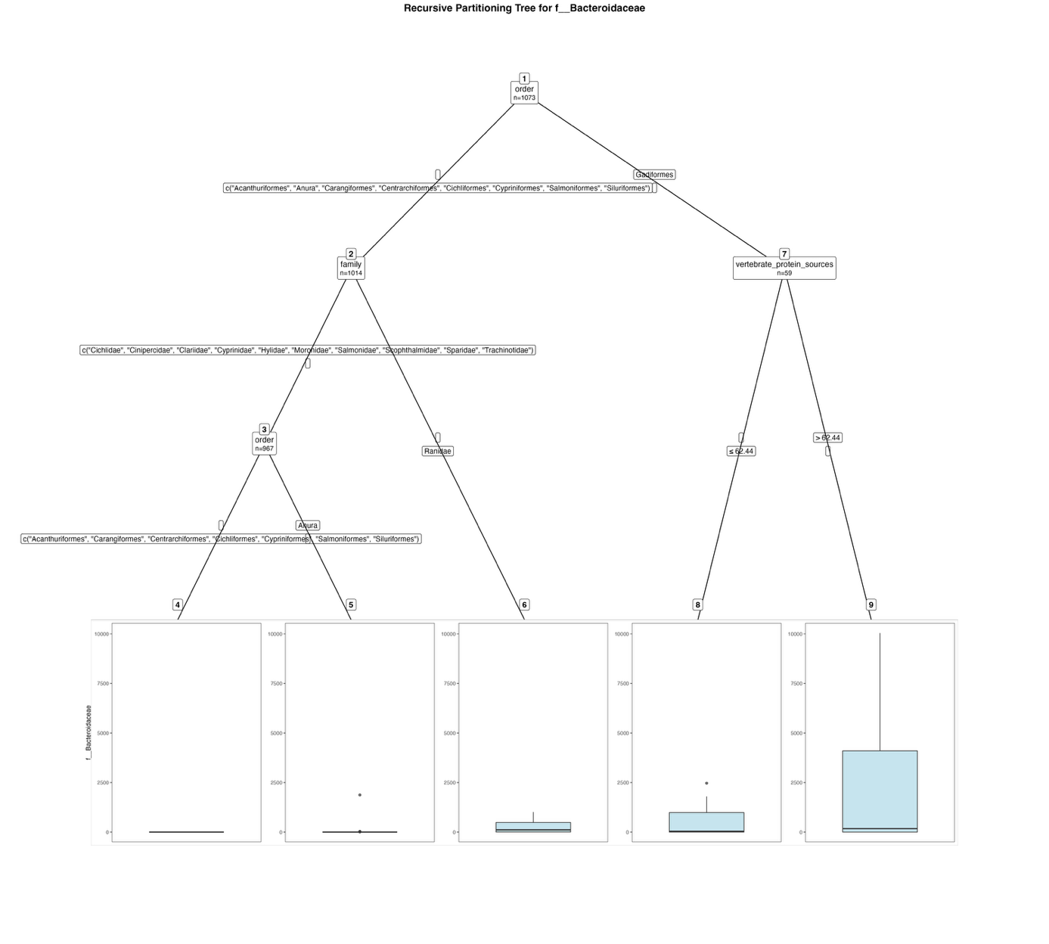
Fig. S65. Fitted party - Bacteroidaceae:

[1] root
| [2] order in Acanthuriformes, Anura, Carangiformes, Centrarchiformes, Cichliformes, Cypriniformes, Salmoniformes, Siluriformes
| | [3] family in Cichlidae, Cinipercidae, Clariidae, Cyprinidae, Hylidae, Moronidae, Salmonidae, Scophthalmidae, Sparidae, Trachinotidae
| | | [4] order in Acanthuriformes, Carangiformes, Centrarchiformes, Cichliformes, Cypriniformes, Salmoniformes, Siluriformes: 0.000 (n = 931, err = 0.0)
| | | [5] order in Anura: 53.722 (n = 36, err = 3405841.2)
| | [6] family in Ranidae: 243.043 (n = 47, err = 3786613.9)
| [7] order in Gadiformes
| | [8] vertebrate_protein_sources <= 62.44: 455.286 (n = 28, err = 12806891.7)
| | [9] vertebrate_protein_sources > 62.44: 2124.355 (n = 31, err = 263333871.1)

Number of inner nodes: 4
Number of terminal nodes: 5

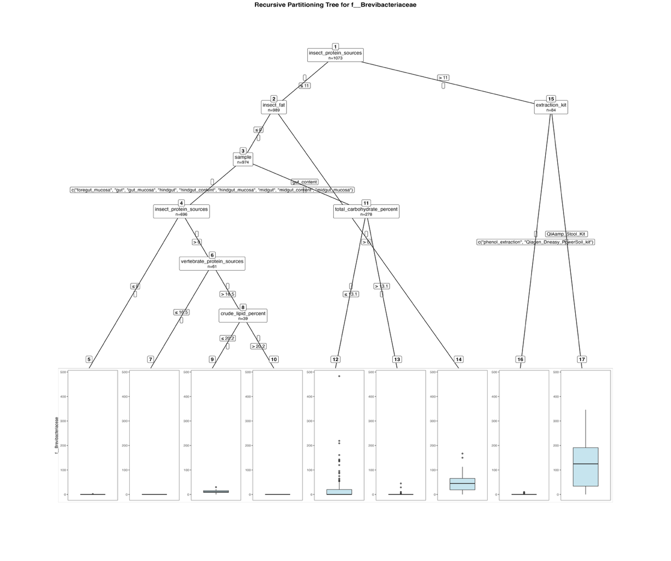
Fig. S66. Fitted party - Brevibacteriaceae:

[1] root
| [2] insect_protein_sources <= 11
| | [3] insect_fat <= 0
| | | [4] sample in foregut_mucosa, gut, gut_mucosa, hindgut, hindgut_content, hindgut_mucosa, midgut, midgut_content, midgut_mucosa
| | | | [5] insect_protein_sources <= 0: 0.003 (n = 635, err = 4.0)
| | | | [6] insect_protein_sources > 0
| | | | | [7] vertebrate_protein_sources <= 16.5: 0.000 (n = 22, err = 0.0)
| | | | | [8] vertebrate_protein_sources > 16.5
| | | | | | [9] crude_lipid_percent <= 20.2: 11.885 (n = 26, err = 1242.7)
| | | | | | [10] crude_lipid_percent > 20.2: 0.000 (n = 13, err = 0.0)
| | | [11] sample in gut_content
| | | | [12] total_carbohydrate_percent <= 13.1: 26.381 (n = 105, err = 430552.8)
| | | | [13] total_carbohydrate_percent > 13.1: 0.671 (n = 173, err = 3064.2)
| | [14] insect_fat > 0: 55.800 (n = 15, err = 36088.4)
| [15] insect_protein_sources > 11
| | [16] extraction_kit in phenol_extraction, Qiagen_Dneasy_PowerSoil_kit: 0.935 (n = 31, err = 185.9)
| | [17] extraction_kit in QIAamp_Stool_Kit : 125.604 (n = 53, err = 493362.7)

Number of inner nodes: 8
Number of terminal nodes: 9
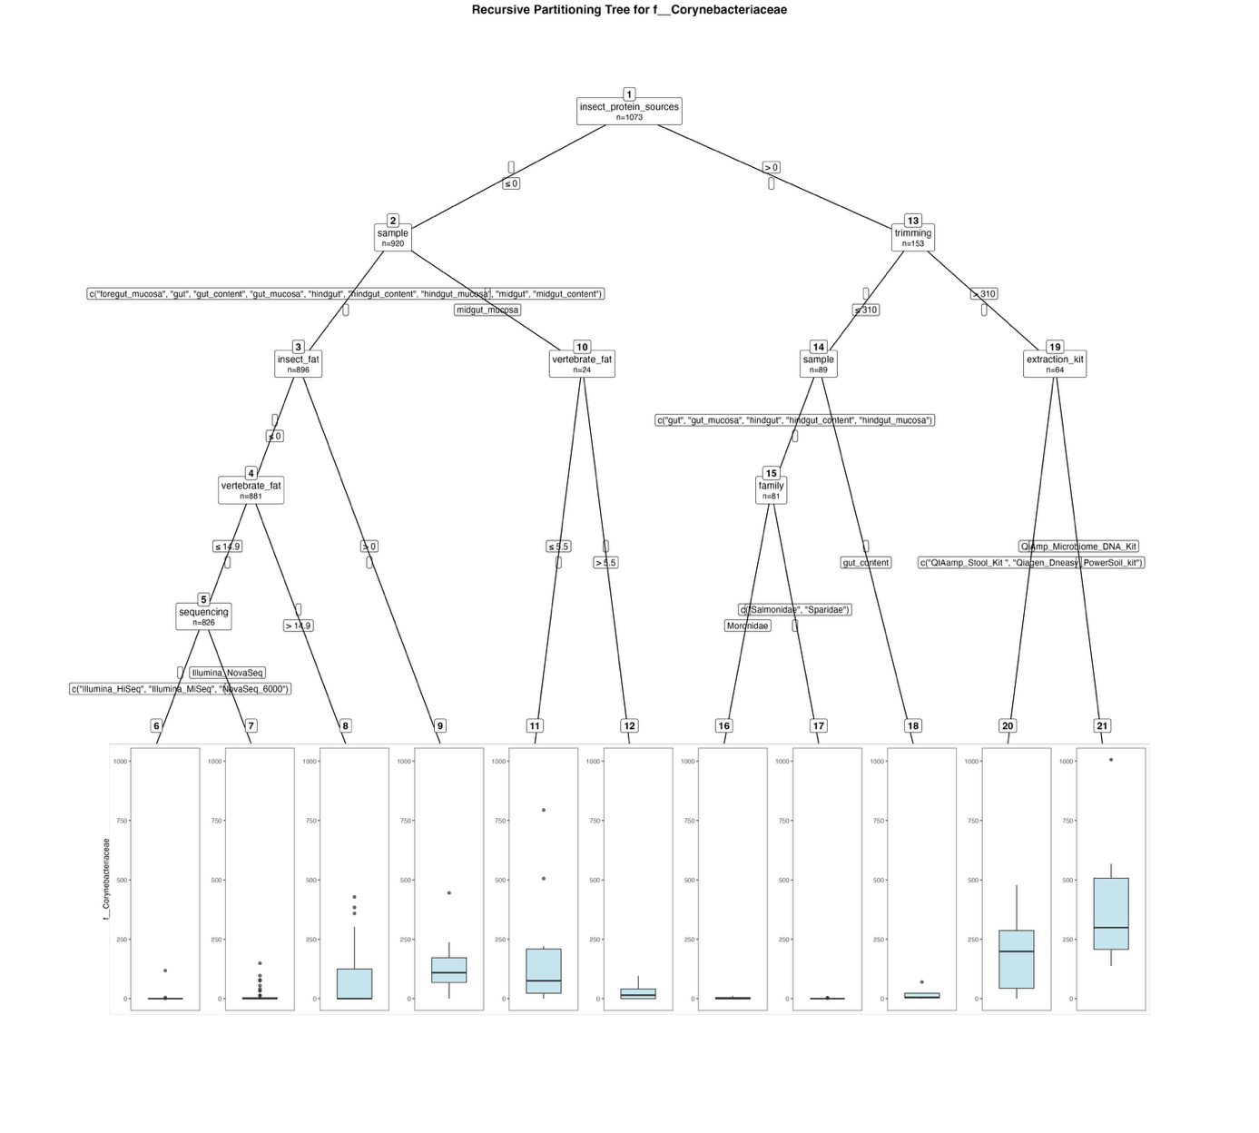
Fig. S67. Fitted party - Corynebacteriaceae:

[1] root
| [2] insect_protein_sources <= 0
| | [3] sample in foregut_mucosa, gut, gut_content, gut_mucosa, hindgut, hindgut_content, hindgut_mucosa, midgut, midgut_content
| | | [4] insect_fat <= 0
| | | | [5] vertebrate_fat <= 14.9
| | | | | [6] sequencing in Illumina_HiSeq, Illumina_MiSeq, NovaSeq_6000: 0.166 (n = 746, err = 13929.4)
| | | | | [7] sequencing in Illumina_NovaSeq: 8.537 (n = 80, err = 45679.9)
| | | | [8] vertebrate_fat > 14.9: 68.491 (n = 55, err = 753163.7)
| | | [9] insect_fat > 0: 128.800 (n = 15, err = 176786.4)
| | [10] sample in midgut_mucosa
| | | [11] vertebrate_fat <= 5.5: 176.583 (n = 12, err = 644920.9)
| | | [12] vertebrate_fat > 5.5: 23.833 (n = 12, err = 9959.7)
| [13] insect_protein_sources > 0
| | [14] trimming <= 310
| | | [15] sample in gut, gut_mucosa, hindgut, hindgut_content, hindgut_mucosa
| | | | [16] family in Moronidae: 3.444 (n = 9, err = 178.2)
| | | | [17] family in Salmonidae, Sparidae: 0.208 (n = 72, err = 43.9)
| | | [18] sample in gut_content: 16.750 (n = 8, err = 3883.5)
| | [19] trimming > 310
| | | [20] extraction_kit in QIAamp_Stool_Kit , Qiagen_Dneasy_PowerSoil_kit: 187.673 (n = 52, err = 1122525.4)
| | | [21] extraction_kit in QiAmp_Microbiome_DNA_Kit: 388.083 (n = 12, err = 675012.9)

Number of inner nodes: 10
Number of terminal nodes: 11

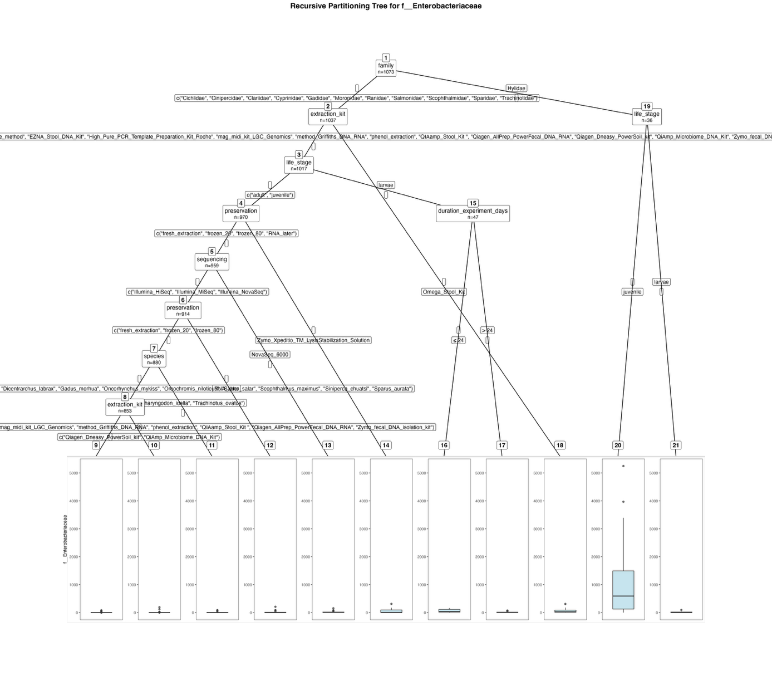
Fig. S68. Fitted party - Enterobacteriaceae:

[1] root
| [2] family in Cichlidae, Cinipercidae, Clariidae, Cyprinidae, Gadidae, Moronidae, Ranidae, Salmonidae, Scophthalmidae, Sparidae, Trachinotidae
| | [3] extraction_kit in Cador_Pathogen_96_QIAcube_HT_Kit, cetyltrimethylammonium_bromide_method, EZNA_Stool_DNA_Kit, High_Pure_PCR_Template_Preparation_Kit_Roche, mag_midi_kit_LGC_Genomics, method_Griffiths_DNA_RNA, phenol_extraction, QIAamp_Stool_Kit , Qiagen_AllPrep_PowerFecal_DNA_RNA, Qiagen_Dneasy_PowerSoil_kit, QiAmp_Microbiome_DNA_Kit, Zymo_fecal_DNA_isolation_kit
| | | [4] life_stage in adult, juvenile
| | | | [5] preservation in fresh_extraction, frozen_20, frozen_80, RNA_later
| | | | | [6] sequencing in Illumina_HiSeq, Illumina_MiSeq, Illumina_NovaSeq
| | | | | | [7] preservation in fresh_extraction, frozen_20, frozen_80
| | | | | | | [8] species in Clarias_gariepinus, Cyprinus_carpio, Danio_rerio, Dicentrarchus_labrax, Gadus_morhua, Oncorhynchus_mykiss, Oreochromis_niloticus, Salmo_salar, Scophthalmus_maximus, Siniperca_chuatsi, Sparus_aurata
| | | | | | | | [9] extraction_kit in Cador_Pathogen_96_QIAcube_HT_Kit, cetyltrimethylammonium_bromide_method, mag_midi_kit_LGC_Genomics, method_Griffiths_DNA_RNA, phenol_extraction, QIAamp_Stool_Kit , Qiagen_AllPrep_PowerFecal_DNA_RNA, Zymo_fecal_DNA_isolation_kit: 0.530 (n = 774, err = 18700.8)
| | | | | | | | [10] extraction_kit in Qiagen_Dneasy_PowerSoil_kit, QiAmp_Microbiome_DNA_Kit: 5.772 (n = 79, err = 52251.9)
| | | | | | | [11] species in Ctenopharyngodon_idella, Trachinotus_ovatus: 10.778 (n = 27, err = 15476.7)
| | | | | | [12] preservation in RNA_later: 16.265 (n = 34, err = 53292.6)
| | | | | [13] sequencing in NovaSeq_6000: 18.511 (n = 45, err = 29979.2)
| | | | [14] preservation in Zymo_Xpeditio_TM_LysisStabilization_Solution: 62.818 (n = 11, err = 111621.6)
| | | [15] life_stage in larvae
| | | | [16] duration_experiment_days <= 24: 62.957 (n = 23, err = 63353.0)
| | | | [17] duration_experiment_days > 24: 15.042 (n = 24, err = 8835.0)
| | [18] extraction_kit in Omega_Stool_Kit: 63.950 (n = 20, err = 115003.0)
| [19] family in Hylidae
| | [20] life_stage in juvenile: 1164.120 (n = 25, err = 48878580.6)
| | [21] life_stage in larvae: 17.909 (n = 11, err = 8446.9)

Number of inner nodes: 10
Number of terminal nodes: 11

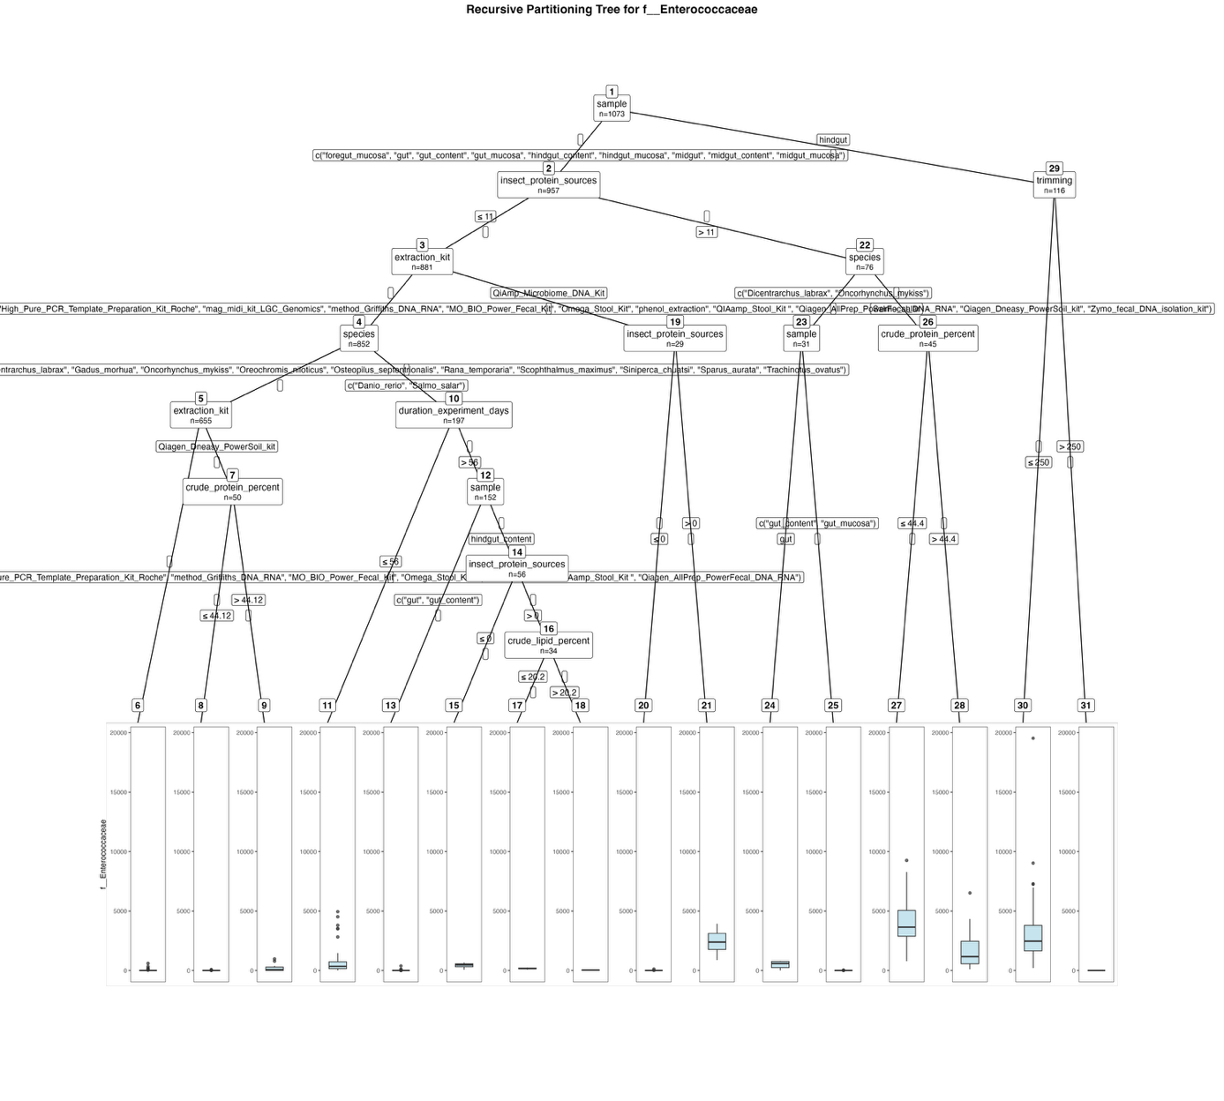
Fig. S69. Fitted party - Enterococcaceae:

[1] root
| [2] sample in foregut_mucosa, gut, gut_content, gut_mucosa, hindgut_content, hindgut_mucosa, midgut, midgut_content, midgut_mucosa
| | [3] insect_protein_sources <= 11
| | | [4] extraction_kit in Cador_Pathogen_96_QIAcube_HT_Kit, cetyltrimethylammonium_bromide_method, EZNA_Stool_DNA_Kit, High_Pure_PCR_Template_Preparation_Kit_Roche, mag_midi_kit_LGC_Genomics, method_Griffiths_DNA_RNA, MO_BIO_Power_Fecal_Kit, Omega_Stool_Kit, phenol_extraction, QIAamp_Stool_Kit , Qiagen_AllPrep_PowerFecal_DNA_RNA, Qiagen_Dneasy_PowerSoil_kit, Zymo_fecal_DNA_isolation_kit
| | | | [5] species in Clarias_gariepinus, Ctenopharyngodon_idella, Cyprinus_carpio, Dicentrarchus_labrax, Gadus_morhua, Oncorhynchus_mykiss, Oreochromis_niloticus, Osteopilus_septentrionalis, Rana_temporaria, Scophthalmus_maximus, Siniperca_chuatsi, Sparus_aurata, Trachinotus_ovatus
| | | | | [6] extraction_kit in Cador_Pathogen_96_QIAcube_HT_Kit, cetyltrimethylammonium_bromide_method, EZNA_Stool_DNA_Kit, High_Pure_PCR_Template_Preparation_Kit_Roche, method_Griffiths_DNA_RNA, MO_BIO_Power_Fecal_Kit, Omega_Stool_Kit, phenol_extraction, QIAamp_Stool_Kit , Qiagen_AllPrep_PowerFecal_DNA_RNA: 2.775 (n = 605, err = 554477.4)
| | | | | [7] extraction_kit in Qiagen_Dneasy_PowerSoil_kit
| | | | | | [8] crude_protein_percent <= 44.12: 4.184 (n = 38, err = 7085.7)
| | | | | | [9] crude_protein_percent > 44.12: 221.333 (n = 12, err = 1196126.7)
| | | | [10] species in Danio_rerio, Salmo_salar
| | | | | [11] duration_experiment_days <= 56: 850.311 (n = 45, err = 70379515.6)
| | | | | [12] duration_experiment_days > 56
| | | | | | [13] sample in gut, gut_content: 7.146 (n = 96, err = 160766.0)
| | | | | | [14] sample in hindgut_content
| | | | | | | [15] insect_protein_sources <= 0: 436.864 (n = 22, err = 570586.6)
| | | | | | | [16] insect_protein_sources > 0
| | | | | | | | [17] crude_lipid_percent <= 20.2: 163.625 (n = 24, err = 53561.6)
| | | | | | | | [18] crude_lipid_percent > 20.2: 32.000 (n = 10, err = 666.0)
| | | [19] extraction_kit in QiAmp_Microbiome_DNA_Kit
| | | | [20] insect_protein_sources <= 0: 6.647 (n = 17, err = 11145.9)
| | | | [21] insect_protein_sources > 0: 2363.333 (n = 12, err = 9569046.7)
| | [22] insect_protein_sources > 11
| | | [23] species in Dicentrarchus_labrax, Oncorhynchus_mykiss
| | | | [24] sample in gut: 477.250 (n = 8, err = 734593.5)
| | | | [25] sample in gut_content, gut_mucosa: 2.565 (n = 23, err = 865.7)
| | | [26] species in Salmo_salar
| | | | [27] crude_protein_percent <= 44.4: 4174.267 (n = 15, err = 79229220.9)
| | | | [28] crude_protein_percent > 44.4: 1627.900 (n = 30, err = 65265176.7)
| [29] sample in hindgut
| | [30] trimming <= 250: 3064.873 (n = 71, err = 512658869.9)
| | [31] trimming > 250: 0.000 (n = 45, err = 0.0)

Number of inner nodes: 15
Number of terminal nodes: 16

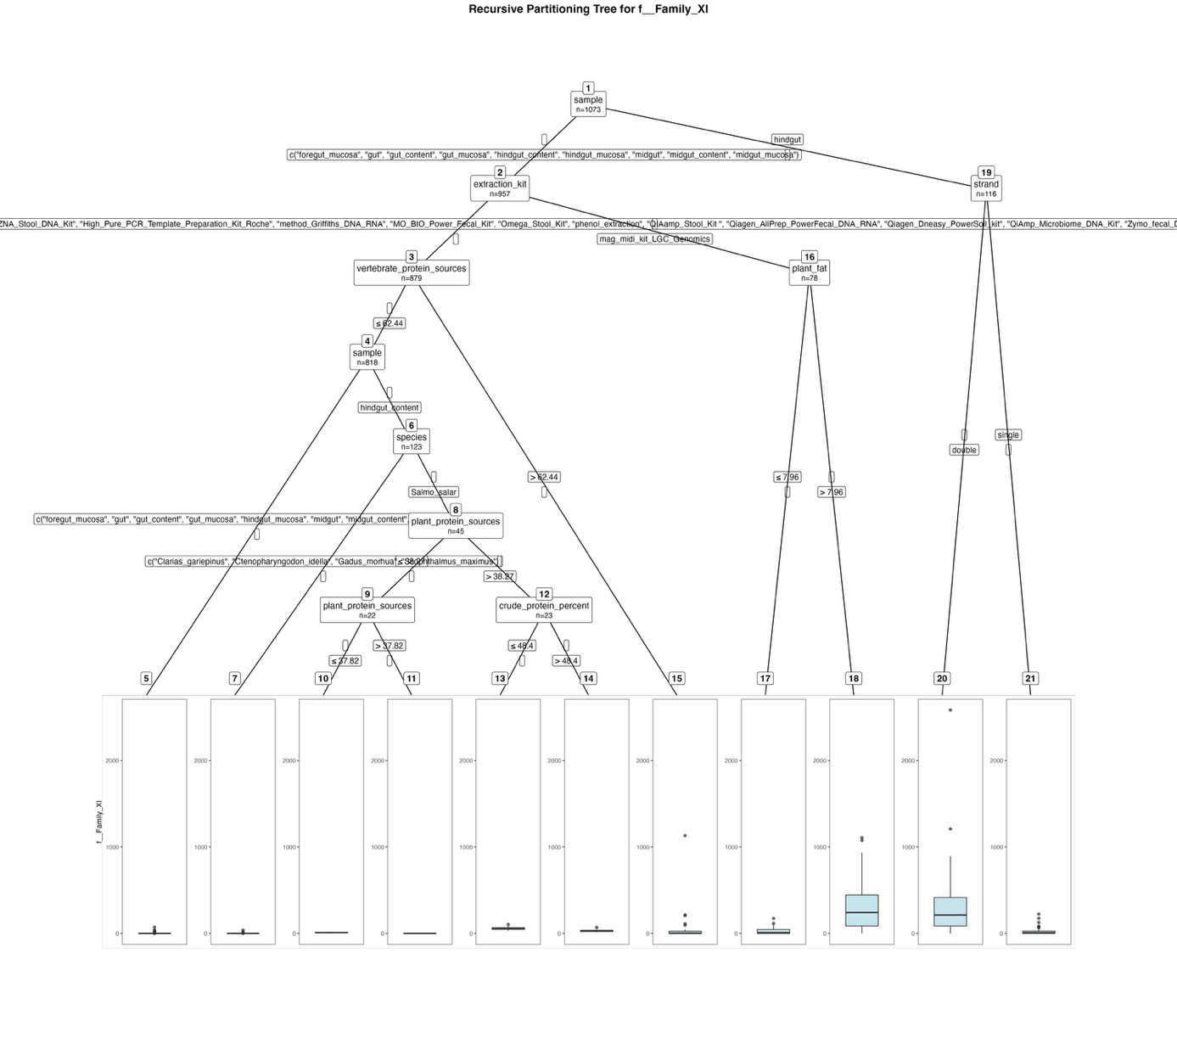
Fig. S70. Fitted party – Family XI:

[1] root
| [2] sample in foregut_mucosa, gut, gut_content, gut_mucosa, hindgut_content, hindgut_mucosa, midgut, midgut_content, midgut_mucosa
| | [3] extraction_kit in Cador_Pathogen_96_QIAcube_HT_Kit, cetyltrimethylammonium_bromide_method, EZNA_Stool_DNA_Kit, High_Pure_PCR_Template_Preparation_Kit_Roche, method_Griffiths_DNA_RNA, MO_BIO_Power_Fecal_Kit, Omega_Stool_Kit, phenol_extraction, QIAamp_Stool_Kit , Qiagen_AllPrep_PowerFecal_DNA_RNA, Qiagen_Dneasy_PowerSoil_kit, QiAmp_Microbiome_DNA_Kit, Zymo_fecal_DNA_isolation_kit
| | | [4] vertebrate_protein_sources <= 62.44
| | | | [5] sample in foregut_mucosa, gut, gut_content, gut_mucosa, hindgut_mucosa, midgut, midgut_content, midgut_mucosa: 0.399 (n = 695, err = 9726.6)
| | | | [6] sample in hindgut_content
| | | | | [7] species in Clarias_gariepinus, Ctenopharyngodon_idella, Gadus_morhua, Scophthalmus_maximus: 1.103 (n = 78, err = 1915.2)
| | | | | [8] species in Salmo_salar
| | | | | | [9] plant_protein_sources <= 38.27
| | | | | | | [10] plant_protein_sources <= 37.82: 9.583 (n = 12, err = 268.9)
| | | | | | | [11] plant_protein_sources > 37.82: 0.600 (n = 10, err = 8.4)
| | | | | | [12] plant_protein_sources > 38.27
| | | | | | | [13] crude_protein_percent <= 48.4: 60.364 (n = 11, err = 5056.5)
| | | | | | | [14] crude_protein_percent > 48.4: 31.083 (n = 12, err = 2558.9)
| | | [15] vertebrate_protein_sources > 62.44: 37.311 (n = 61, err = 1320917.1)
| | [16] extraction_kit in mag_midi_kit_LGC_Genomics
| | | [17] plant_fat <= 7.96: 29.051 (n = 39, err = 59029.9)
| | | [18] plant_fat > 7.96: 314.385 (n = 39, err = 3283879.2)
| [19] sample in hindgut
| | [20] strand in double: 308.944 (n = 71, err = 9746127.8)
| | [21] strand in single: 25.756 (n = 45, err = 96524.3)

Number of inner nodes: 10
Number of terminal nodes: 11

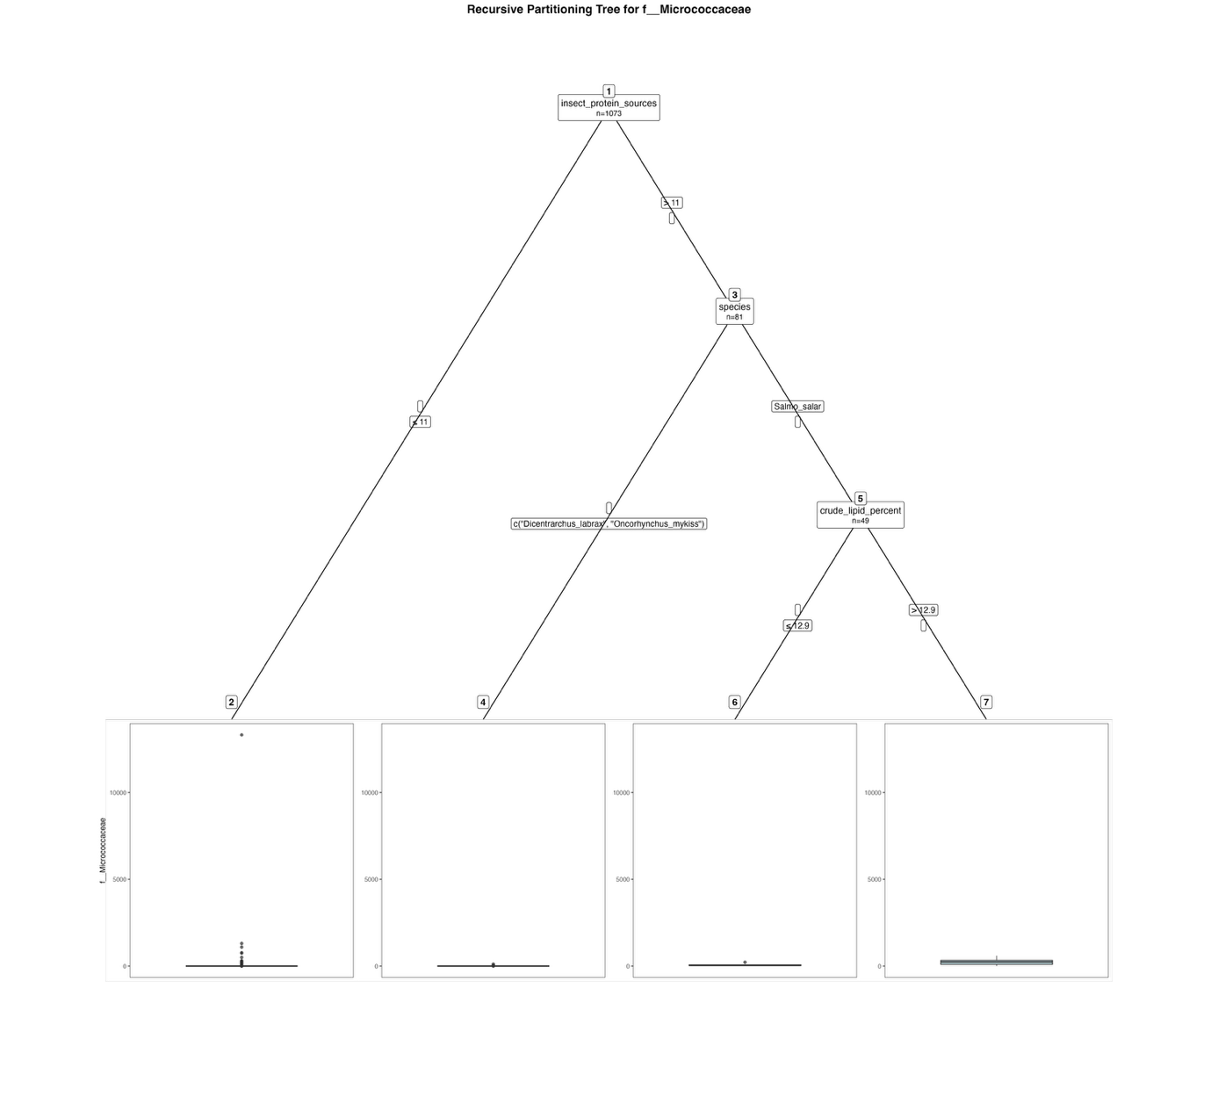
Fig. S71. Fitted party - Micrococcaceae:

[1] root
| [2] insect_protein_sources <= 11: 22.368 (n = 992, err = 181900560.7)
| [3] insect_protein_sources > 11
| | [4] species in Dicentrarchus_labrax, Oncorhynchus_mykiss: 6.125 (n = 32, err = 12179.5)
| | [5] species in Salmo_salar
| | | [6] crude_lipid_percent <= 12.9: 57.067 (n = 15, err = 40104.9)
| | | [7] crude_lipid_percent > 12.9: 228.882 (n = 34, err = 895581.5)

Number of inner nodes: 3
Number of terminal nodes: 4

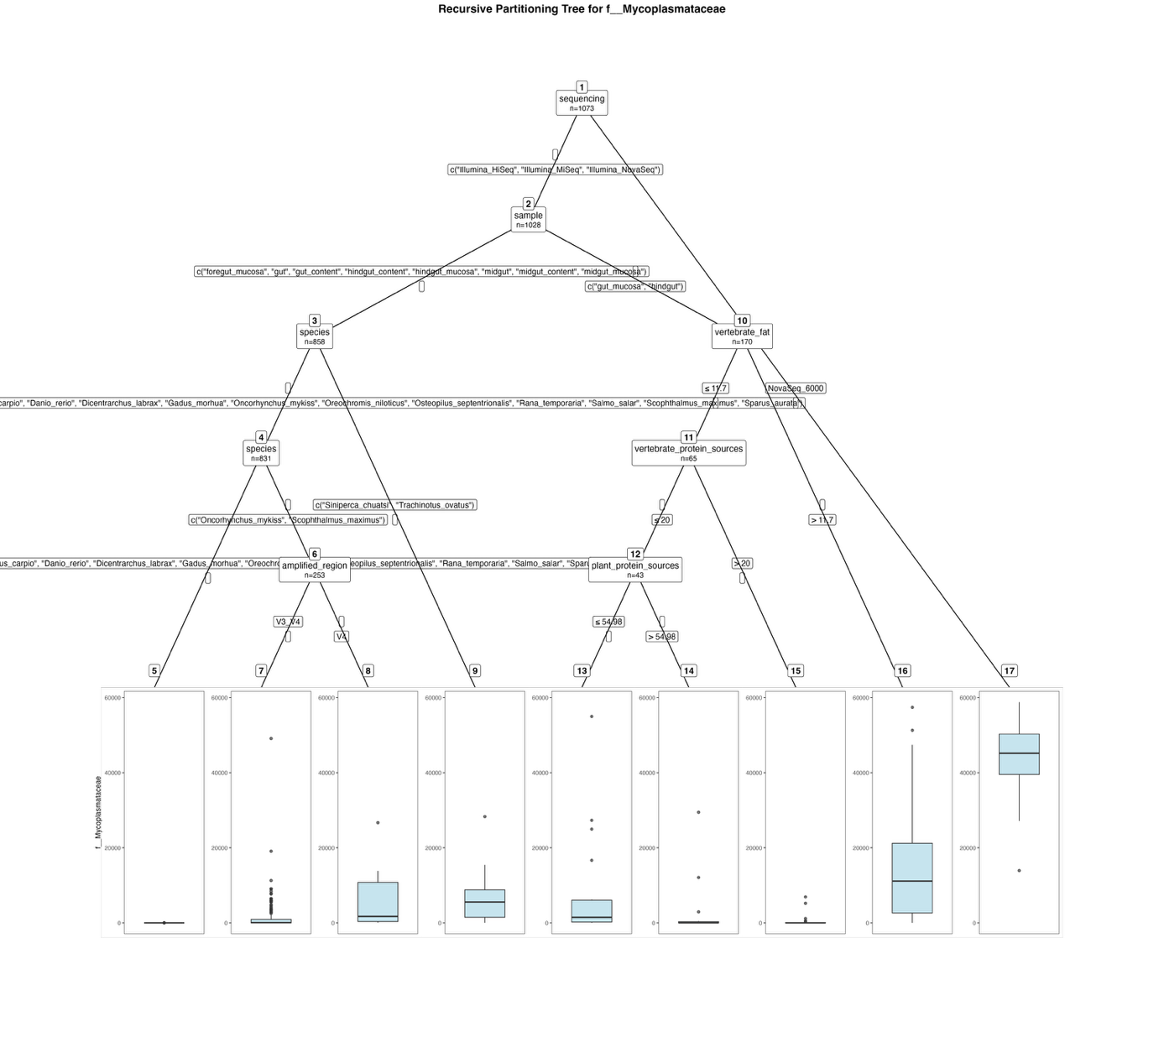
Fig. S72. Fitted party - Mycoplasmataceae:

[1] root
| [2] sequencing in Illumina_HiSeq, Illumina_MiSeq, Illumina_NovaSeq
| | [3] sample in foregut_mucosa, gut, gut_content, hindgut_content, hindgut_mucosa, midgut, midgut_content, midgut_mucosa
| | | [4] species in Clarias_gariepinus, Ctenopharyngodon_idella, Cyprinus_carpio, Danio_rerio, Dicentrarchus_labrax, Gadus_morhua, Oncorhynchus_mykiss, Oreochromis_niloticus, Osteopilus_septentrionalis, Rana_temporaria, Salmo_salar, Scophthalmus_maximus, Sparus_aurata
| | | | [5] species in Clarias_gariepinus, Ctenopharyngodon_idella, Cyprinus_carpio, Danio_rerio, Dicentrarchus_labrax, Gadus_morhua, Oreochromis_niloticus, Osteopilus_septentrionalis, Rana_temporaria, Salmo_salar, Sparus_aurata: 0.073 (n = 578, err = 308.9)
| | | | [6] species in Oncorhynchus_mykiss, Scophthalmus_maximus
| | | | | [7] amplified_region in V3_V4: 1197.895 (n = 237, err = 3509363480.4)
| | | | | [8] amplified_region in V4: 5888.938 (n = 16, err = 866463306.9)
| | | [9] species in Siniperca_chuatsi, Trachinotus_ovatus: 6553.556 (n = 27, err = 1022870106.7)
| | [10] sample in gut_mucosa, hindgut
| | | [11] vertebrate_fat <= 11.7
| | | | [12] vertebrate_protein_sources <= 20
| | | | | [13] plant_protein_sources <= 54.98: 6663.654 (n = 26, err = 3767807477.9)
| | | | | [14] plant_protein_sources > 54.98: 2687.941 (n = 17, err = 900432806.9)
| | | | [15] vertebrate_protein_sources > 20: 643.455 (n = 22, err = 67535841.5)
| | | [16] vertebrate_fat > 11.7: 13989.343 (n = 105, err = 19787612103.7)
| [17] sequencing in NovaSeq_6000: 44661.489 (n = 45, err = 3475175851.2)

Number of inner nodes: 8
Number of terminal nodes: 9

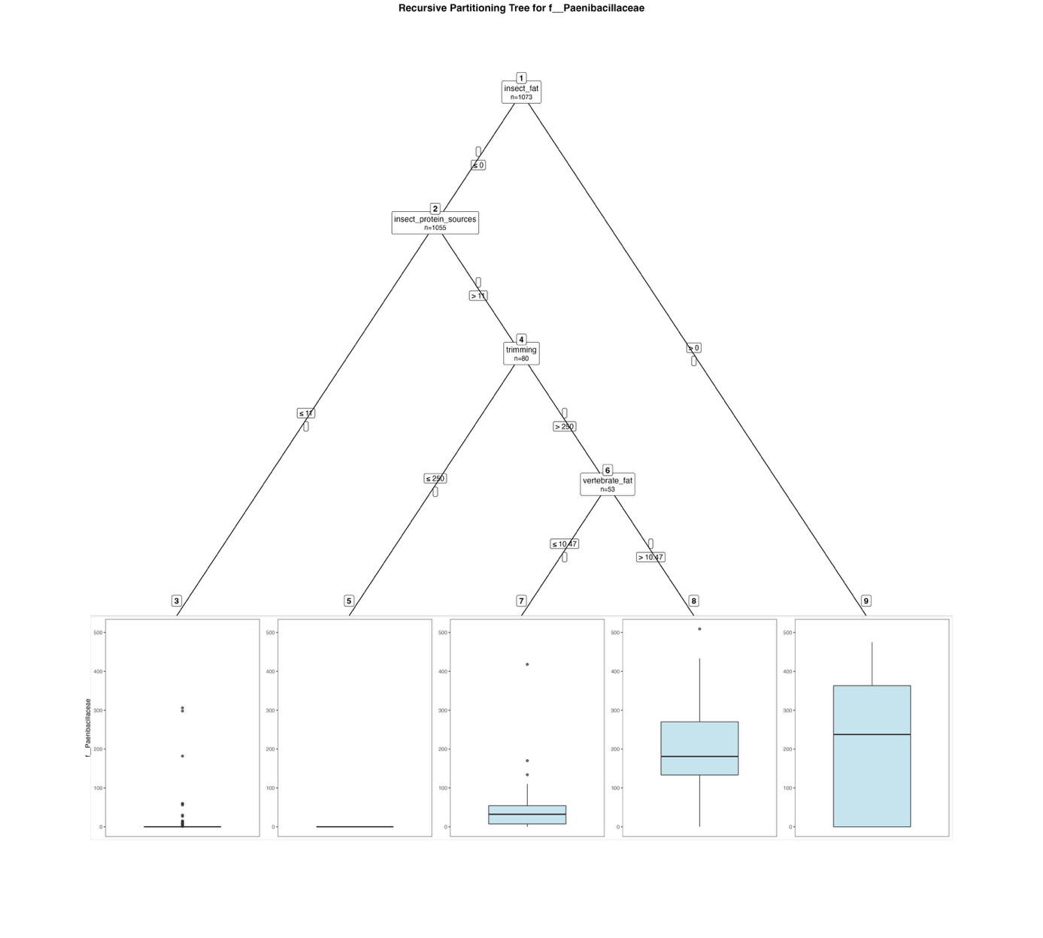
Fig. S73. Fitted party - Paenibacillaceae:

[1] root
| [2] insect_fat <= 0
| | [3] insect_protein_sources <= 11: 1.172 (n = 975, err = 227197.1)
| | [4] insect_protein_sources > 11
| | | [5] trimming <= 250: 0.000 (n = 27, err = 0.0)
| | | [6] trimming > 250
| | | | [7] vertebrate_fat <= 10.47: 49.079 (n = 38, err = 195150.8)
| | | | [8] vertebrate_fat > 10.47: 215.267 (n = 15, err = 262324.9)
| [9] insect_fat > 0: 206.778 (n = 18, err = 637567.1)

Number of inner nodes: 4
Number of terminal nodes: 5

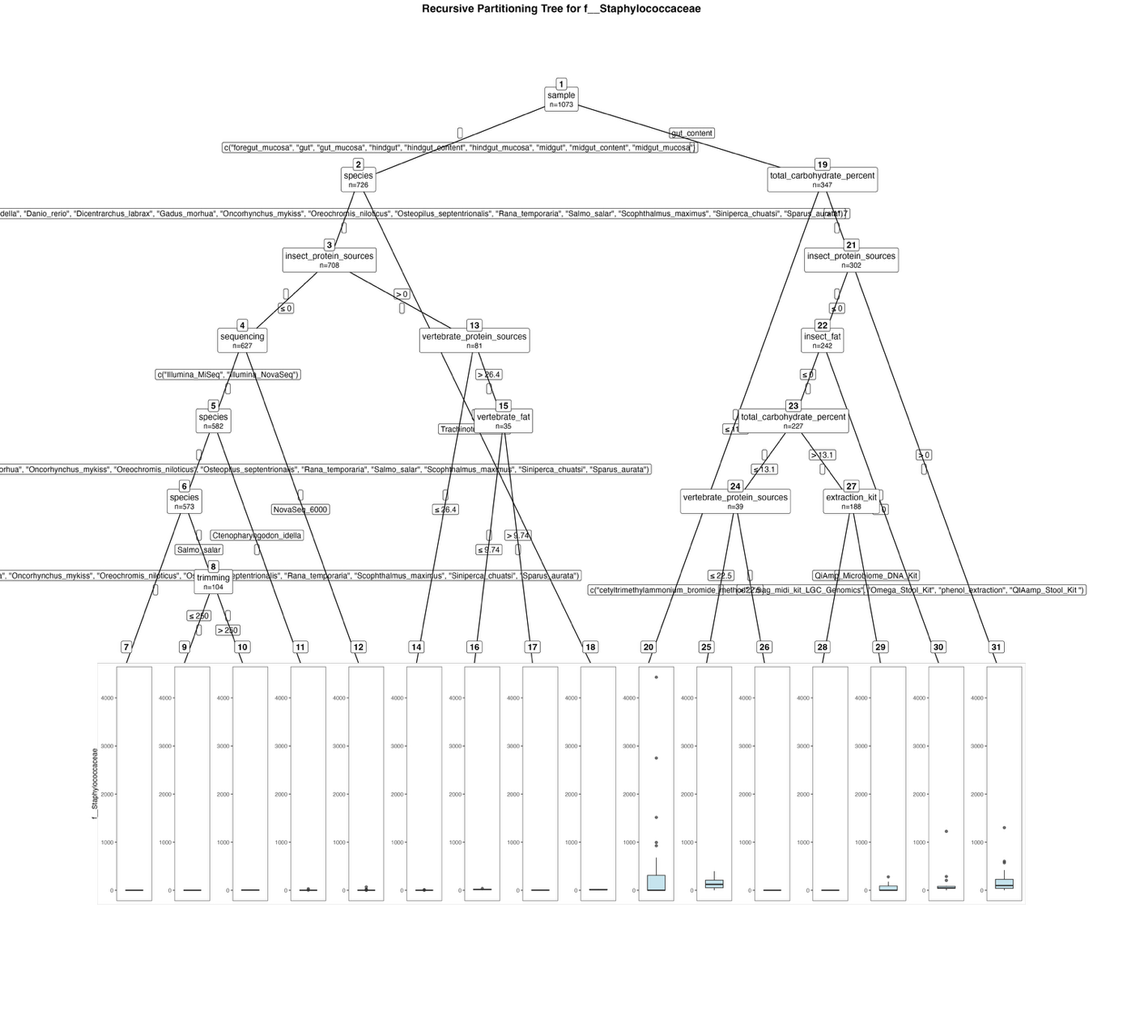
Fig. S74. Fitted party - Staphylococcaceae:

[1] root
| [2] sample in foregut_mucosa, gut, gut_mucosa, hindgut, hindgut_content, hindgut_mucosa, midgut, midgut_content, midgut_mucosa
| | [3] species in Clarias_gariepinus, Ctenopharyngodon_idella, Danio_rerio, Dicentrarchus_labrax, Gadus_morhua, Oncorhynchus_mykiss, Oreochromis_niloticus, Osteopilus_septentrionalis, Rana_temporaria, Salmo_salar, Scophthalmus_maximus, Siniperca_chuatsi, Sparus_aurata
| | | [4] insect_protein_sources <= 0
| | | | [5] sequencing in Illumina_MiSeq, Illumina_NovaSeq
| | | | | [6] species in Clarias_gariepinus, Danio_rerio, Dicentrarchus_labrax, Gadus_morhua, Oncorhynchus_mykiss, Oreochromis_niloticus, Osteopilus_septentrionalis, Rana_temporaria, Salmo_salar, Scophthalmus_maximus, Siniperca_chuatsi, Sparus_aurata
| | | | | | [7] species in Clarias_gariepinus, Danio_rerio, Dicentrarchus_labrax, Gadus_morhua, Oncorhynchus_mykiss, Oreochromis_niloticus, Osteopilus_septentrionalis, Rana_temporaria, Scophthalmus_maximus, Siniperca_chuatsi, Sparus_aurata: 0.000 (n = 469, err = 0.0)
| | | | | | [8] species in Salmo_salar
| | | | | | | [9] trimming <= 250: 0.000 (n = 82, err = 0.0)
| | | | | | | [10] trimming > 250: 3.136 (n = 22, err = 152.6)
| | | | | [11] species in Ctenopharyngodon_idella: 3.556 (n = 9, err = 736.2)
| | | | [12] sequencing in NovaSeq_6000: 2.622 (n = 45, err = 5184.6)
| | | [13] insect_protein_sources > 0
| | | | [14] vertebrate_protein_sources <= 26.4: 0.435 (n = 46, err = 125.3)
| | | | [15] vertebrate_protein_sources > 26.4
| | | | | [16] vertebrate_fat <= 9.74: 16.120 (n = 25, err = 1296.6)
| | | | | [17] vertebrate_fat > 9.74: 2.300 (n = 10, err = 34.1)
| | [18] species in Trachinotus_ovatus: 12.889 (n = 18, err = 819.8)
| [19] sample in gut_content
| | [20] total_carbohydrate_percent <= 11.7: 346.844 (n = 45, err = 27985423.9)
| | [21] total_carbohydrate_percent > 11.7
| | | [22] insect_protein_sources <= 0
| | | | [23] insect_fat <= 0
| | | | | [24] total_carbohydrate_percent <= 13.1
| | | | | | [25] vertebrate_protein_sources <= 22.5: 135.938 (n = 16, err = 175294.9)
| | | | | | [26] vertebrate_protein_sources > 22.5: 0.000 (n = 23, err = 0.0)
| | | | | [27] total_carbohydrate_percent > 13.1
| | | | | | [28] extraction_kit in cetyltrimethylammonium_bromide_method, mag_midi_kit_LGC_Genomics, Omega_Stool_Kit, phenol_extraction, QIAamp_Stool_Kit : 0.000 (n = 181, err = 0.0)
| | | | | | [29] extraction_kit in QiAmp_Microbiome_DNA_Kit: 65.286 (n = 7, err = 79489.4)
| | | | [30] insect_fat > 0: 150.133 (n = 15, err = 1316583.7)
| | | [31] insect_protein_sources > 0: 165.367 (n = 60, err = 2494671.9)

Number of inner nodes: 15
Number of terminal nodes: 16

