Supplementary material 1: Study Questionnaire

1. Sex: (1) Male (2) Female
¡
¡
2. Age of child or ward: ………………
3. Where do you reside? (1) Rural (2) Urban (3) Not indicated
¡
¡
¡
4. Child in School? (1) Yes (2) No
¡
¡
5. Level of Education: (1) Islamic (2) Nursery (3) Primary (4) Secondary
¡
¡
¡
¡
6. Health status of your child: (1) Healthy (2) Sick
¡
¡
7. If yes, duration in the hospital: (1) ≤ 1 week (2) 2 weeks (3) 3 weeks (4) 4 weeks
¡
¡
¡
¡
(5) 5 weeks
¡
8. Number of persons in your household (household density): (1) 1-4 (2) 5 – 8 (3) ≥9
¡
¡
¡
(5) Not indicated
¡
9. Occupation of father: (1) Unemployed (2) Trader (3) Civil Servant (4) Military
¡
¡
¡
¡
¡
10. Occupation of Mother: (1) Unemployed (2)Trader (3) Civil Servant (4) Military
¡
¡
¡
(5) Housewife
¡
11. Education of father: (1) Non-formal (2) Primary (3) Secondary (4) Tertiary
¡
¡
¡
¡
(5) Not indicated
12. Education of mother: (1) Non-formal (2) Primary (3) Secondary (4) Tertiary
¡
¡
¡
¡
(5) Not indicated
¡
13. Household income per month: (1) Less than 50 USD (2) Between 50 to 75 USD
¡
¡
(3) Between 76 to 150 USD (4) More than 150 USD (5) Not indicated
¡
¡
¡
14. Does parent or guardian has knowledge of antimicrobial resistance? (1) Yes (2) No
¡
¡
15. Has the child used unprescribed antibiotics in the past three months? (1) Yes (2) No
¡
¡
(3) Not indicated
16. Do you have pets and livestock at home? (1) Yes (2) No (3) Not indicated
¡
¡
¡
17. If yes, type of animal……….

Supplementary Table S1: Sociodemographic variables of study participants
Variables | Healthy children (n, %) | Septicemic children (n, %)
Sex  Male  Female | 33 (46.5)  38 (53.5) | 23 (57.5)  17 (42.5)
Age (years)  1  2  3  4 | 34 (47.9)  26 (36.6)  10 (14.1)  1 (1.4) | 29 (72.5)  8 (20)  3 (7.5)  0
Place of residence  Rural  Urban  Not indicated | 23 (32.4)  45 (63.4)  3 (4.2) | 16 (40)  24 (60)  0
Level of education of the child  Non formal  Nursery  Primary | 9 (12.7)  28 (39.4)  34 (47.9) | 21 (52.5)  2 (5)  17 (42.5)
Household density (number of persons)  (1-4)  (5-8)  >9  Not indicated | 19 (26.8)  21 (29.6)  19 (26.8)  12 (16.9) | 13 (32.5)  9 (22.5)  18 (45)  0
Level of education of the father  Non-formal  Primary  Secondary  Tertiary  Not indicated | 23 (32.4)  3 (4.2)  3 (4.2)  40 (56.3)  2 (2.8) | 2 (5)  12 (30)  5 (12.5)  21 (52.5)  0
Level of education of the mother  Non-formal  Primary  Secondary  Tertiary  Not indicated | 22 (30.9)  7 (9.9)  16 (22.5)  23 (32.4)  3 (4.2) | 3 (7.5)  4 (10)  17 (42.5)  16 (40)  0
Household income per month  <50 USD  51 – 75 USD  76 – 150 USD  >150 USD  Not indicated | 26 (36.6)  20 (28.2)  12 (16.9)  9 (12.7)  4 (5.6) | 14 (32.5)  9 (22.5)  5 (12.5)  3 (7.5)  9 (22.5)

(a)
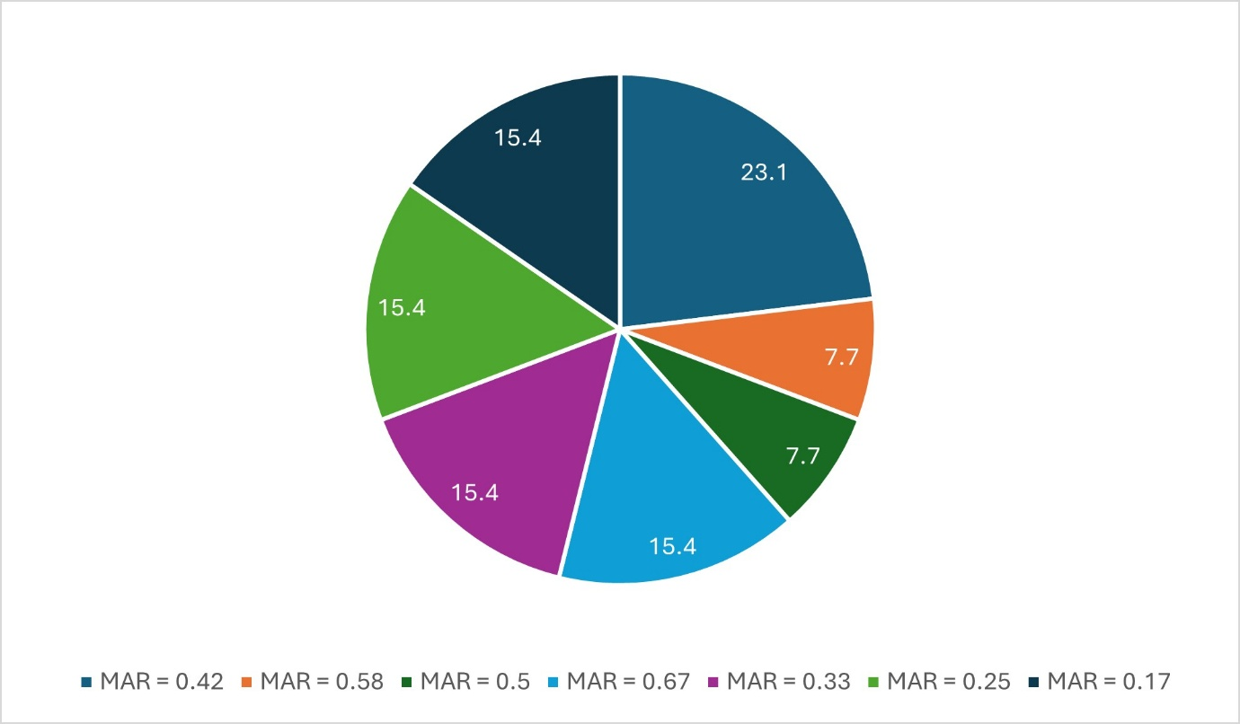

(b)
MAR: Multiple antimicrobial resistance index
Supplementary Figure S1 (a & b). Levels and frequency of multiple antimicrobial resistance (MAR) indices of MRSA isolates from (a) healthy and (b) septicemic children

Supplementary Table S2: Antimicrobial resistance profile and multiple antimicrobial resistance indices of the MRSA isolates from healthy children
AMR phenotype | MDR | MAR index
PEN-LZD-C-MUP-TET-DA-FOX-SXT | Yes | 0.58
PEN-LZD-C-E-VAN-TEC-MUP-TET-FOX-SXT | Yes | 0.75
PEN-E-VAN-TEC-MUP-TET-FOX-SXT | Yes | 0.58
PEN-LZD-C-E-VAN-TEC-MUP-TET-FOX | Yes | 0.58
PEN-VAN-TEC-MUP-TET-FOX | Yes | 0.42
PEN-MUP-CIP-FOX | Yes | 0.33
PEN-MUP-TET-FOX | Yes | 0.33
PEN-E-TET-CN-FOX-SXT | Yes | 0.5
PEN-MUP-TET-CN-FOX-SXT | Yes | 0.5
PEN-LZD-C-MUP-CIP-TET-DA-FOX | Yes | 0.58
PEN-E-VAN-TEC-MUP-CN-FOX | Yes | 0.5
PEN-LZD-C-E-MUP-TET-DA-FOX-SXT | Yes | 0.67
E-MUP-TET-FOX-SXT | Yes | 0.42
LZD-C-E-MUP-TET-FOX | Yes | 0.42
PEN-LZD-C-E-VAN-TEC-MUP-TET-DA-FOX | Yes | 0.67
PEN-LZD-C-E-MUP-TET-CN-FOX-SXT | Yes | 0.75
PEN-LZD-C-VAN-TEC-E-MUP-TET-CN-FOX | Yes | 0.75
PEN-LZD-C-E-MUP-CIP-TET-CN-FOX-SXT | Yes | 0.75
Abbreviation: PEN: penicillin, C: chloramphenicol, CIP: ciprofloxacin, E: erythromycin, DA: clindamycin, MUP: mupirocin, LZD: linezolid, SXT: Sulfamethoxazole and trimethoprim, CN: gentamicin, TEC: Teicoplanin, TET: tetracycline, VAN: Vancomycin

Supplementary Table S3: Antimicrobial resistance profile and multiple antimicrobial resistance indices of the MRSA isolates from septicemic children
AMR Phenotype | MDR | MAR index
PEN-E-TET-FOX-SXT | Yes | 0.42
PEN-C-E-MUP-DA-FOX-SXT | Yes | 0.58
PEN-C-E-MUP-CIP-TET-FOX-SXT | Yes | 0.67
PEN-MUP-TET-FOX | Yes | 0.33
PEN-CIP-FOX | No | 0.25
PEN-MUP-TET-FOX-SXT | Yes | 0.42
PEN-FOX | No | 0.17
PEN-E-MUP-CIP-TET_DA-FOX-SXT | Yes | 0.67
PEN-MUP-CIP-TET-FOX | Yes | 0.42
PEN-E-MUP-TET-FOX-SXT | Yes | 0.5
PEN-TET-FOX | No | 0.25
PEN-MUP-TET-FOX | Yes | 0.33
PEN-FOX | No | 0.17
Abbreviation: PEN: penicillin, C: chloramphenicol, CIP: ciprofloxacin, E: erythromycin, DA: clindamycin, MUP: mupirocin, LZD: linezolid, SXT: Sulfamethoxazole and trimethoprim, CN: gentamicin, TET: tetracycline, VAN: Vancomycin

