Table S1. Sampling replicates given sections and associated trees.
 | Mugavu  (n replicates) | Avocado  (n replicates) | Bark-cloth fig  (n replicates) | Jackfruit  (n replicates) | TOTAL
Kitagera | 6 | 4 | 4 | 4 | 18
Kitemba | 5 | 4 | 4 | 4 | 17
Kyamutuma | 4 | 4 | 5 | 4 | 17
Luwunga | 4 | 3 | 4 | 4 | 15
Nonve | 5 | 4 | 4 | 5 | 18
TOTAL | 24 | 19 | 21 | 21 | 85

Table S2. Top five models of shrub CWD incidence.
 |  |  | Fixed effect terms
p | Log-likelihood | AICc | At*D | Cv | Cv:D | Cv:At | Cv:D:At
4 | -142.2 | 316.7 | fixed | +
3 | -149.0 | 319.1 | fixed
5 | -141.2 | 326.3 | fixed | + | +
5 | -134.6 | 338.5 | fixed | + |  | +
6 | -119.8 | 367.7 | fixed | + | + | +
Models ranked from most parsimonious (lowest AICc) to less parsimonious (highest AICc), with their log-likelihood, number of parameters (p), corrected AIC (AICc). The terms included in each model are notified by the (+) sign. Cv = Coffee variety; D = Distance from associated tree; At = Associated tree. Models also include random effects based on the following structure: (1|Section of Kaweri/replicate of the associated tree). Model selected (bold) for the analysis with the lowest AIC and good residuals.

Table S3. Top five models of leaf BES incidence.
 |  |  |  |  | Fixed effect terms |  |  |  |  | Zi term | Disp term
p | Log-likelihood | AICc |  | At*D |  | Cv | Cv:D | Cv:AT | Cv:D:At
5 | -330.7 | 700.2 |  | locked |  |  |  |  |  | ~Cv | ~log(Tot)
6 | -328.6 | 702.5 |  | locked |  | + |  |  |  | ~Cv | ~log(Tot)
7 | -325.1 | 710.2 |  | locked |  | + | + |  |  | ~Cv | ~log(Tot)
7 | -315.8 | 713.2 |  | locked |  | + |  | + |  | ~Cv | ~log(Tot)
8 | -313.5 | 719.4 |  | locked |  | + | + | + |  | ~Cv | ~log(Tot)
Models ranked from most parsimonious (lowest AICc) to less parsimonious (highest AICc), with their log-likelihood, number of parameters (p), corrected AIC (AICc). The terms included in each model are notified by the (+) sign. Cv = Coffee variety; = Distance from associated tree; At = Associated tree; log(Tot) = Total number of leaves per branch log transform. Models also include random effects based on the following structure: (1|Section of Kaweri/replicate of the associated tree/coffee shrub). Model selected (bold) for the analysis with the lowest AIC and good residuals.

Table S4. Top five models of leaf CWD incidence.
 |  |  | Fixed effect terms |  |  |  |  | Zi term | Disp term
p | Log-likelihood | AICc | At*D | Cv | Cv:D | Cv:AT | Cv:D:At
3 | -266.3 | 559.1 | locked |  |  |  |  | ~1 | ~1
5 | -258.7 | 564.6 | locked | + | + |  |  | ~1 | ~1
4 | -264.7 | 566.1 | locked | + |  |  |  | ~1 | ~1
6 | -246.9 | 573.1 | locked | + | + | + |  | ~1 | ~1
5 | Convergence issue |  | locked | + |  | + |  | ~1 | ~1
Models ranked from most parsimonious (lowest AICc) to less parsimonious (highest AICc), with their log-likelihood, number of parameters (p), corrected AIC (AICc). The terms included in each model are notified by the (+) sign. Cv = Coffee variety; D = Distance from associated tree; At = Associated tree. Models also include random effects based on the following structure: (1|Section of Kaweri/replicate of the associated tree/coffee shrub). Model selected (bold) for the analysis with the lowest AIC and good residuals.

Table S5. Top five models of leaf CLR incidence level.
 |  |  | Fixed effect terms |  |  |  |  | Zi term | Disp term
p | Log-likelihood | AICc | AT*D | Cv | Cv:D | Cv:AT | Cv:D:At
6 | -88.4 | 226.1 | locked | + |  |  |  | ~Cv | ~log(Tot)
7 | -84.4 | 228.7 | locked | + | + |  |  | ~Cv | ~log(Tot)
7 | -80.9 | 243.3 | locked | + |  | + |  | ~Cv | ~log(Tot)
8 | -78.1 | 248.7 | locked | + | + | + |  | ~Cv | ~log(Tot)
5 | -110.2 | 259.3 | locked |  |  |  |  | ~Cv | ~log(Tot)
Models ranked from most parsimonious (lowest AICc) to less parsimonious (highest AICc), with their log-likelihood, number of parameters (p), corrected AIC (AICc). The terms included in each model are notified by the (+) sign. Cv = Coffee variety; D = Distance from associated tree; At = Associated tree; log(Tot) = Total number of leaves per branch log transform. Models also include random effects based on the following structure: (1|Section of Kaweri/replicate of the associated tree/coffee shrub). Model selected (bold) for the analysis with the lowest AIC and good residuals.

Table S6. Fruit load model selection.
 |  |  | Fixed effect terms
p | Log-likelihood | AICc | At*D | Cv | disease | Cv:D | Cv:At | disease:Cv
12 | -88.4 | 226.1 | locked | + | CLR+BES+CWD | + | + | CLR+BES+CWD
11 | -84.4 | 228.7 | locked | + | CLR+BES+CWD | + | + | BES+CWD
10 | -80.9 | 243.3 | locked | + | BES+CWD | + | + | BES+CWD
11 | -78.1 | 248.7 | locked | + | CLR+BES+CWD | + | + | CLR+CWD
11 | -110.2 | 259.3 | locked | + | CLR+BES+CWD |  | + | CLR+BES+CWD
Models ranked from most parsimonious (lowest AICc) to less parsimonious (highest AICc), with their log-likelihood, number of parameters (p), corrected AIC (AICc). The terms included in each model are notified by the (+) sign. Cv = Coffee variety; D = Distance from associated tree; At = Associated tree; CLR = incidence of CLR; BES = incidence of BES; CWD = incidence of CWD (all at the leaf level). Models also include random effects based on the following structure: (1|Section of Kaweri/replicate of the associated tree). Model selected (bold) for the analysis with the lowest AIC and good residuals.

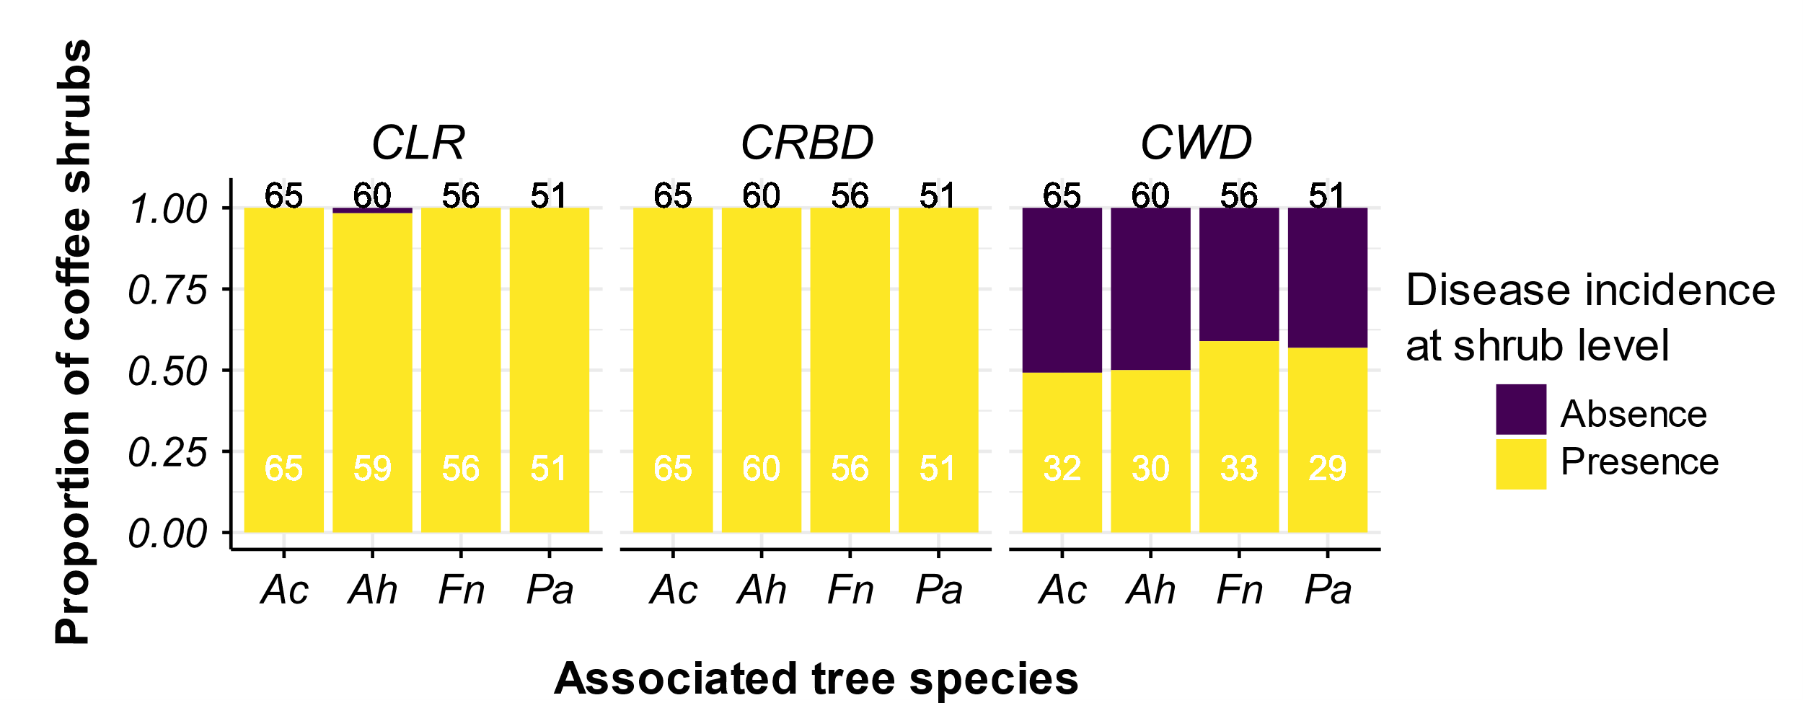
Fig. S1. Proportion of coffee shrubs with symptoms (presence = 1) or not (absence = 0) according to the proximity with an associated tree. CLR, coffee leaf rust each; BES, brown-eye spot; CWD, coffee wilt disease. The total number of coffee shrubs per category is indicated in black at the top of each bar chart, and in white for the number of coffee shrubs scored for disease. Ficus natalensis (Fn), Albizia coriaria (Ac), Persea americana (Pa), and Artocarpus heterophyllus (Ah).

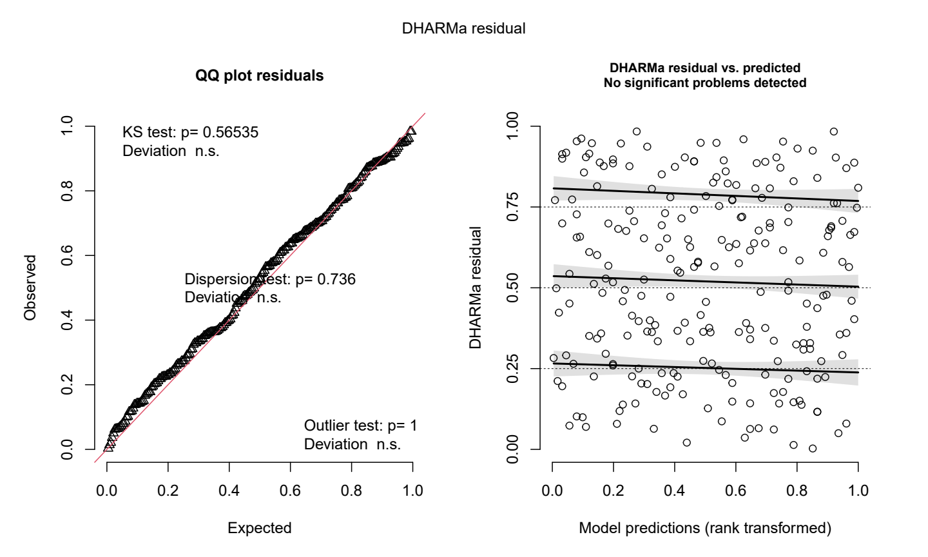
Fig. S2. Residuals of the selected model for shrub CWD incidence.

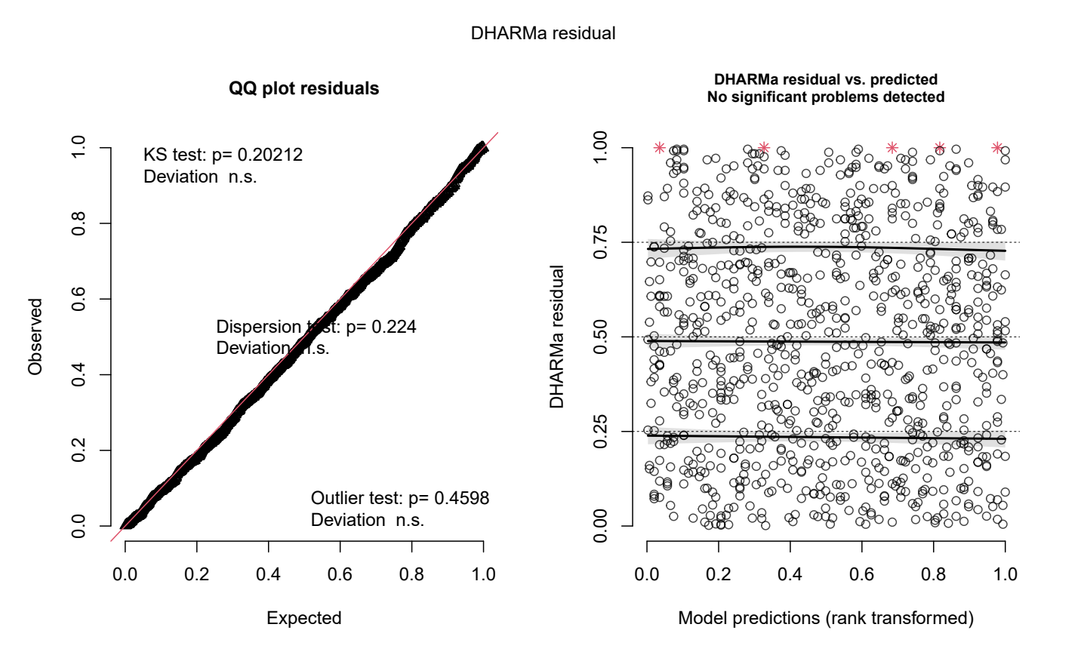
Fig. S3. Residuals of the selected model for leaf BES incidence.

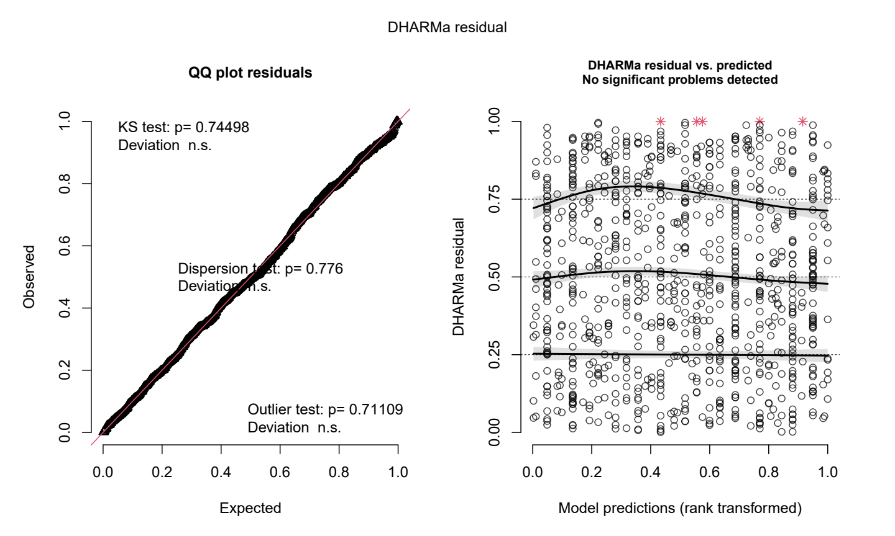
Fig. S4. Residuals of the selected model for leaf CWD incidence.

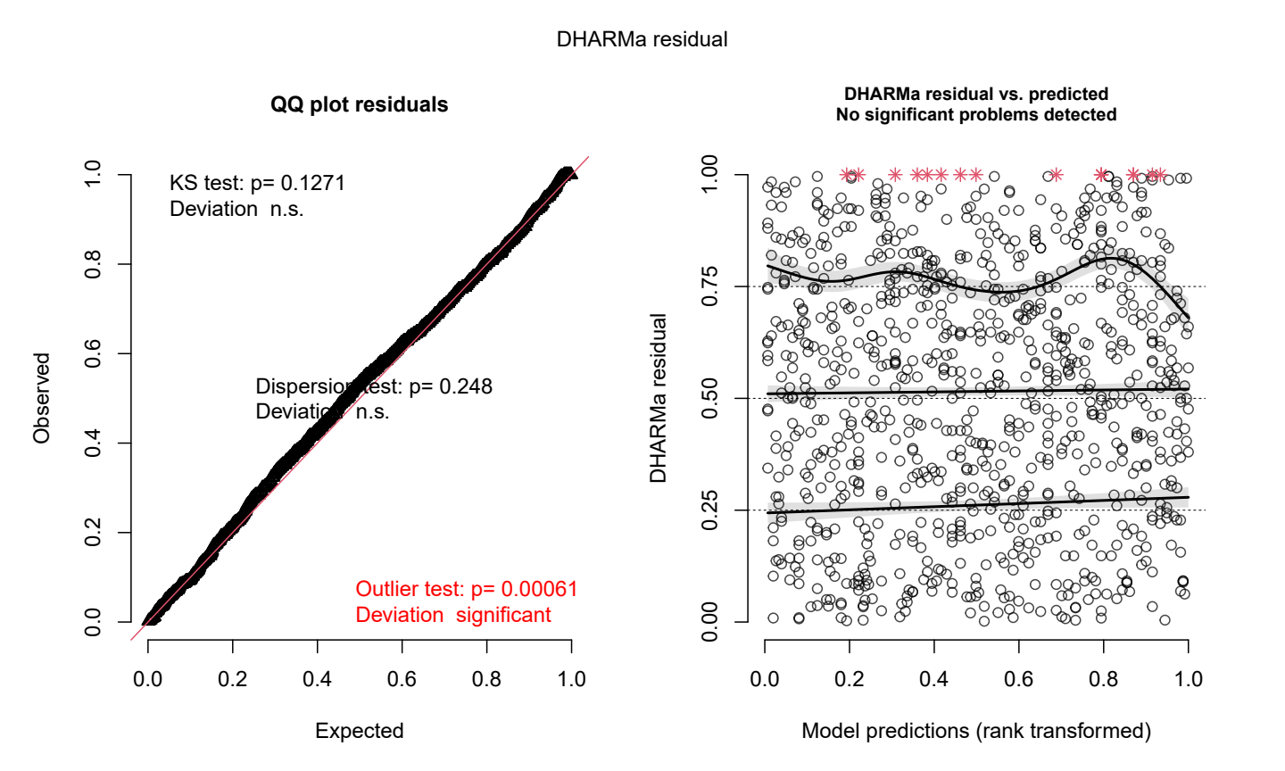
Fig. S5. Residuals of the selected model for leaf CLR incidence.

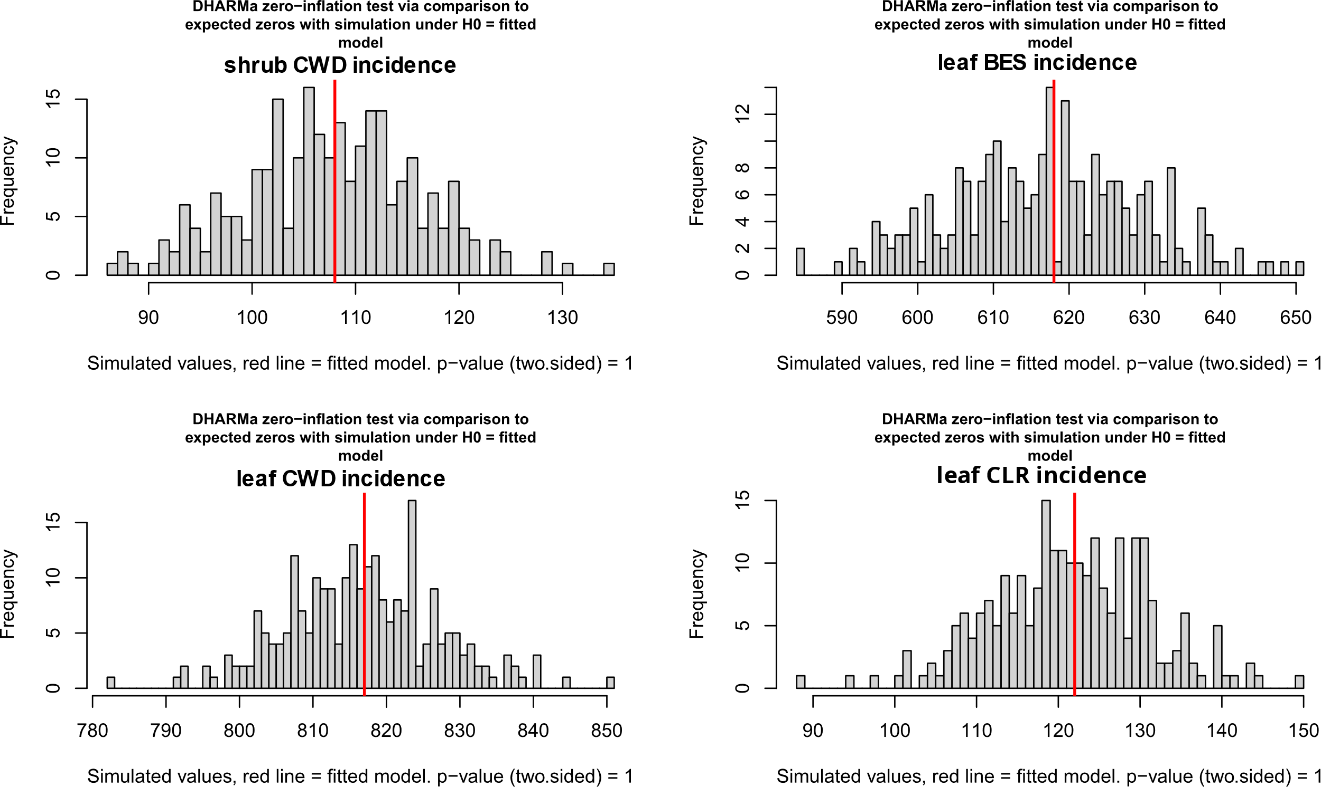

Fig. S6. Zero inflation tests of selected model for (A) shrub CWD incidence, (B) leaf BES incidence, (C) leaf CWD incidence and (D) leaf CLR incidence.

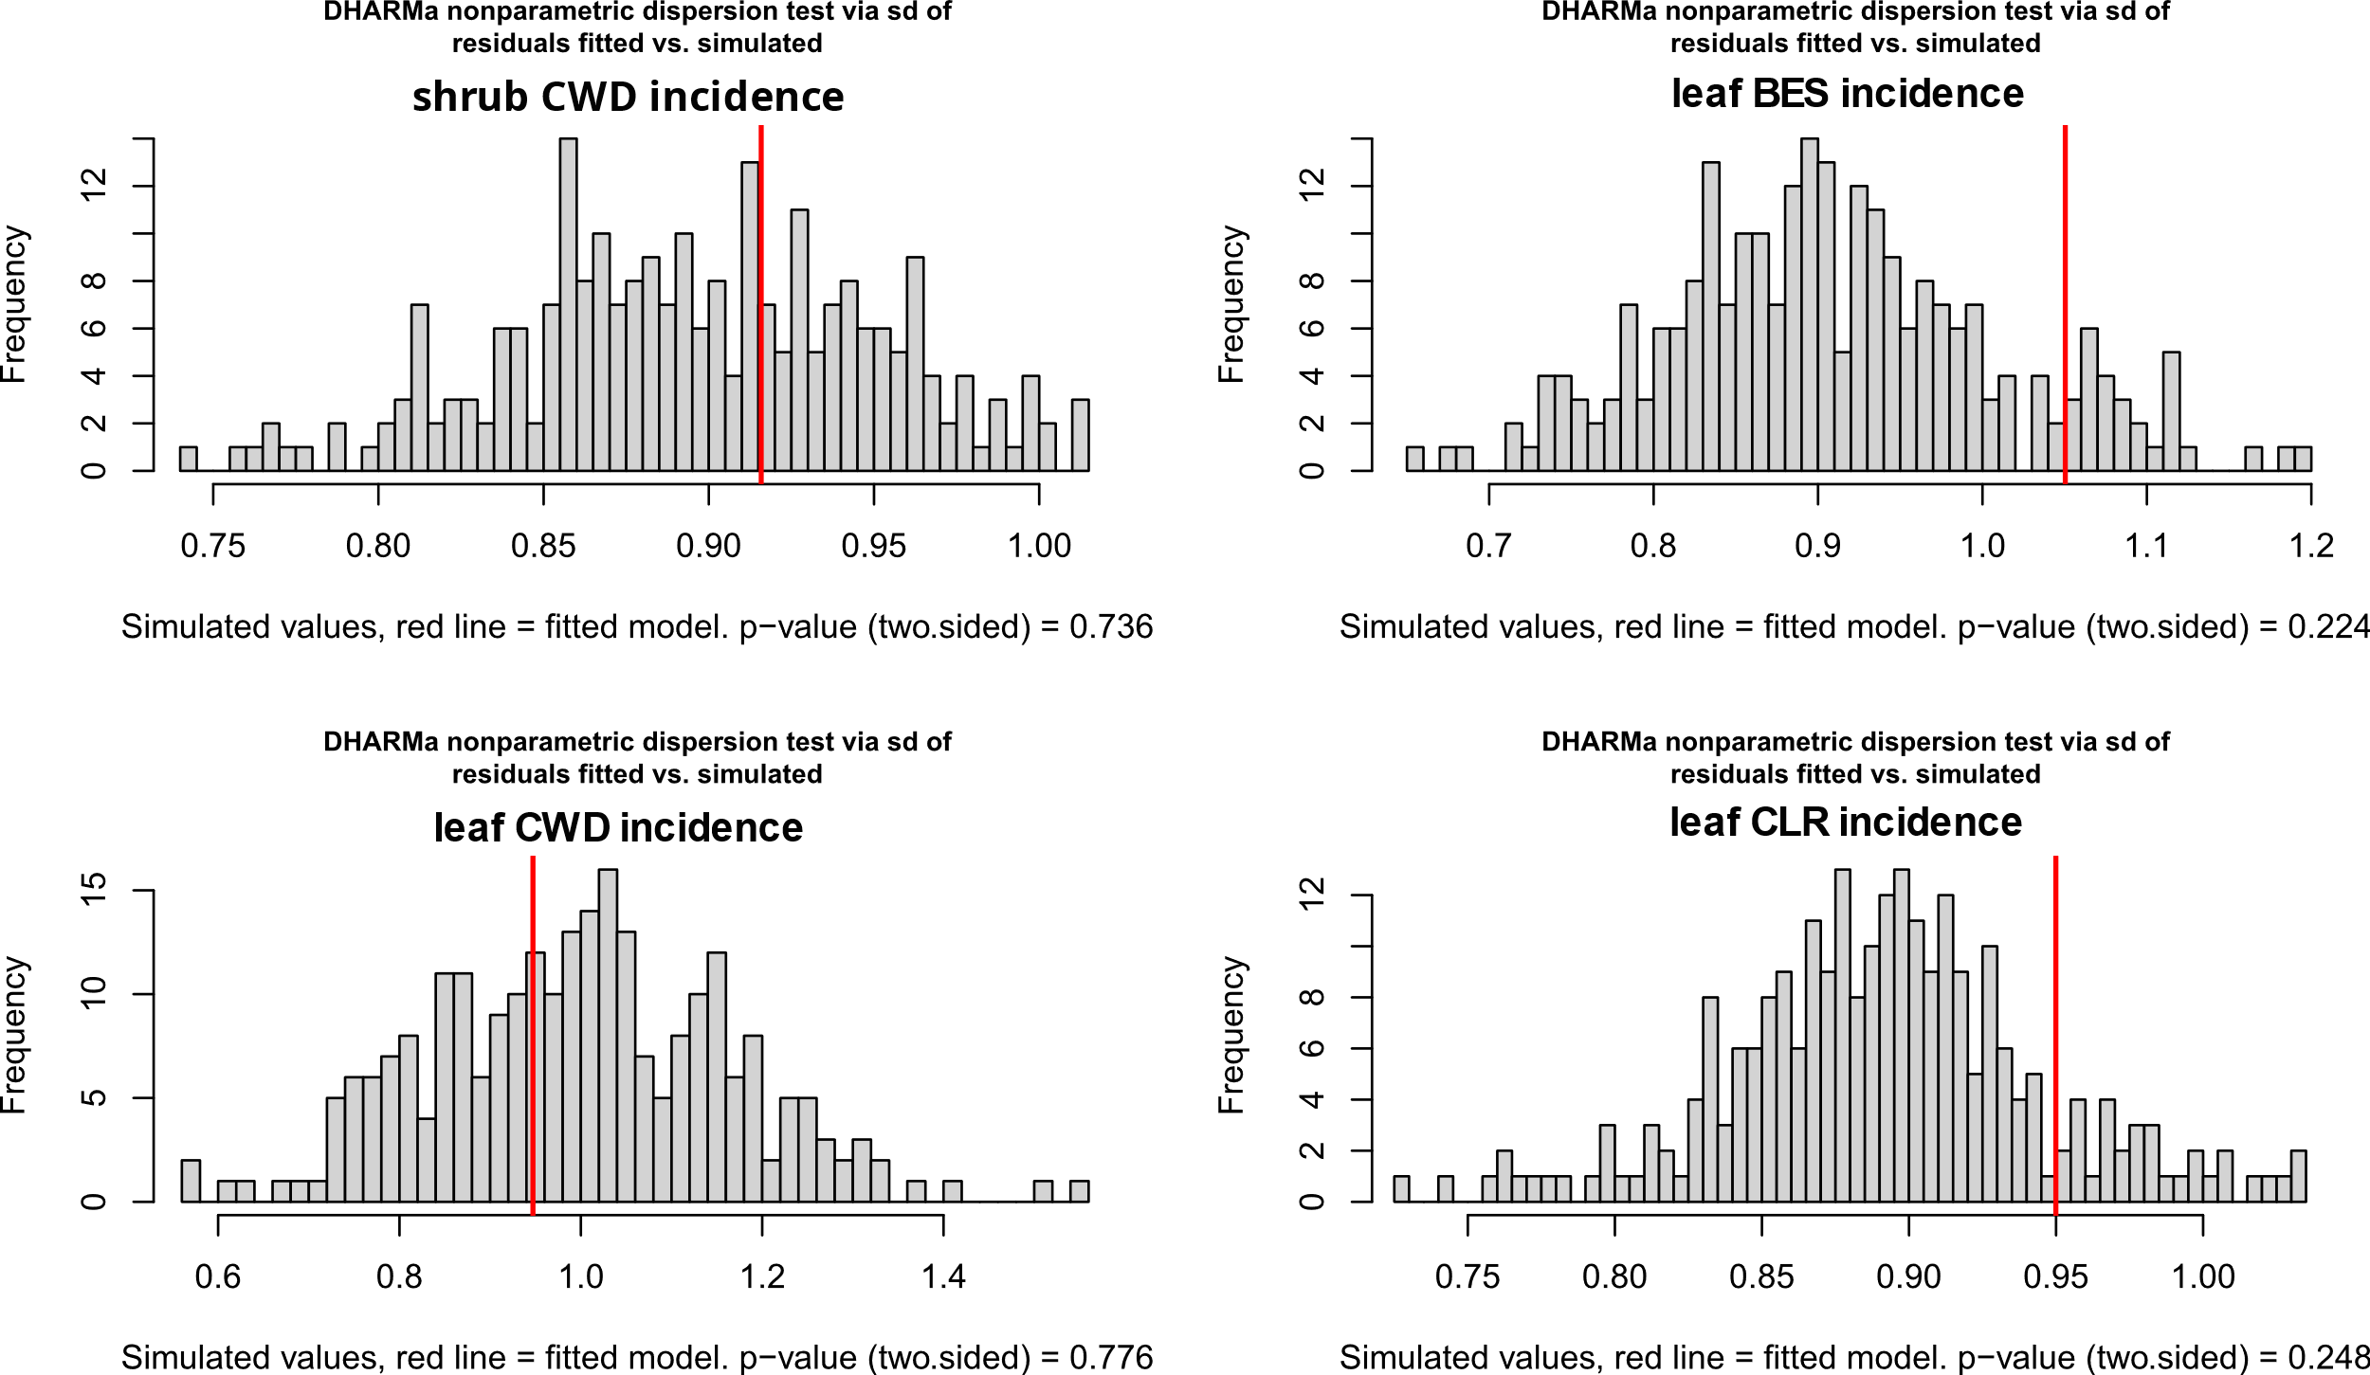

Fig. S7. Dispersion tests of selected model for (A) shrub CWD incidence, (B) leaf BES incidence, (C) leaf CWD incidence and (D) leaf CLR incidence.

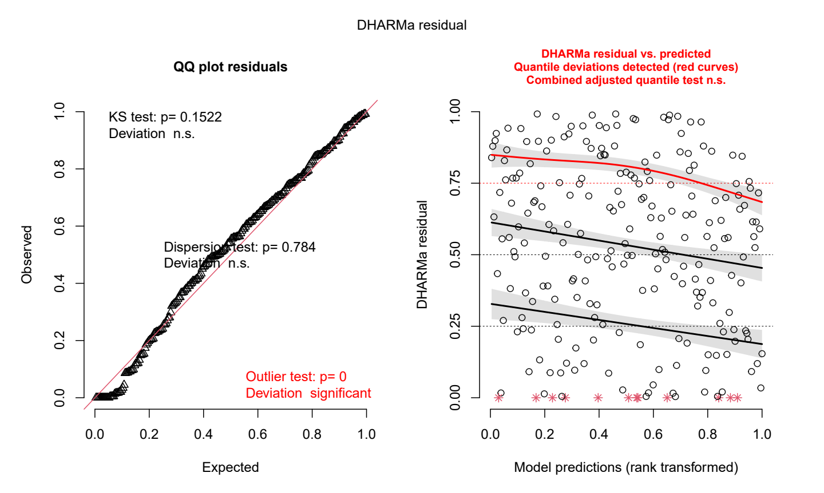
Fig. S8. Representation of residuals from the selected model for fruit load. The upper quantile deviation revealed a problem of homoscedasticity, but the model was kept because displaying the best models based on AICc compared to other models also showing a problem of homoscedasticity.

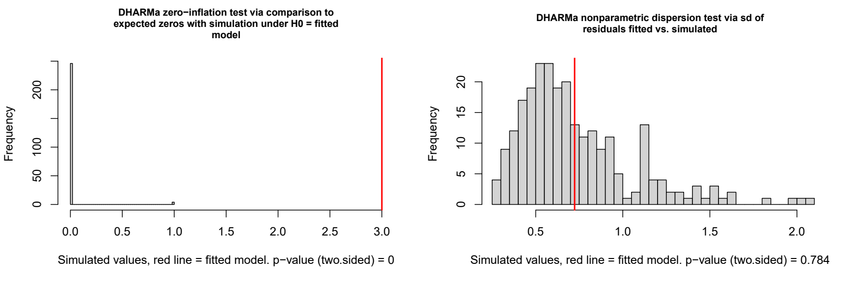
Fig. S9. (A) Zero inflation tests and (B) dispersion test of selected model for fruit load.

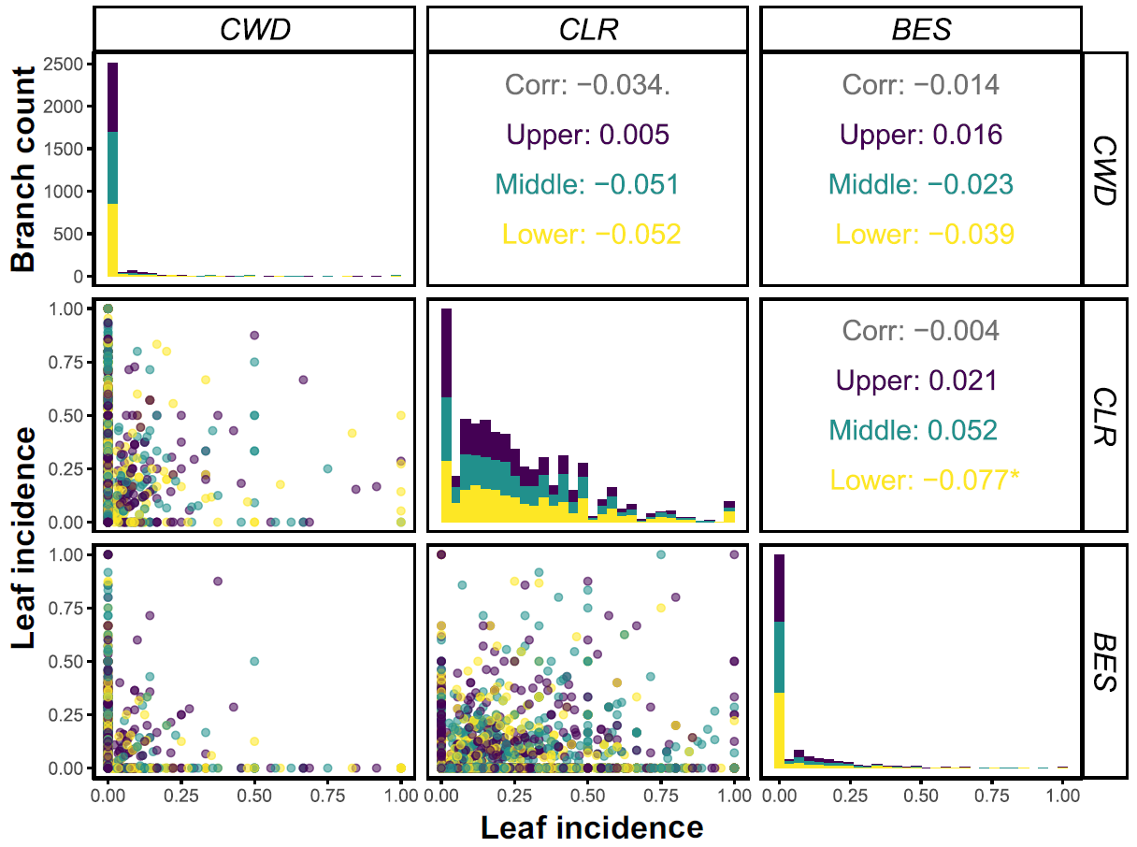 Fig. S10. Interaction between leaf incidence of coffee diseases (CWD, CLR and BES) and coffee shrub portions in the Kaweri Coffee Plantation.

