Table S1:LASSO regression selected 25 radiomics features relevant for classification.
18 | N_original_gldm_DependenceEntropy | Dependence Entropy of GLDM in N phase
19 | V_original_glszm_SizeZoneNonUniformityNormalized | Size-Zone Non-Uniformity Normalized GLSZM in N phase
20 | A_original_glcm_Idn | Inverse Difference Normalized GLCM in A phase
21 | V_original_glrlm_RunLengthNonUniformityNormalized | Run Length Non-Uniformity Normalized GLRLM in V phase
22 | V_original_glrlm_LongRunEmphasis | Long Run Emphasis of GLRLM in V phase
23 | V_original_glcm_Imc1 | Informational Measure of Correlation (IMC) 1 of GLCM in V phase
24 | V_original_firstorder_Range | The Range of Intensity values in V phase
25 | A_original_firstorder_Range | The Range of Intensity values in A phase
- GLDM |  | Gray-Level Dependence Matrix
- GLRLM |  | Gray Level Run Length Matrix
- GLCM |  | Gray Level Co-occurrence Matrix
- NGTDM |  | Neighbourhood Gray-Tone Difference Matrix
- GLSZM |  | Gray-Level Size Zone Matrix
- NGTDM |  | Neighbourhood Gray-Tone Difference Matrix

Figure S1: Diagnostic performance of the proposed diagnostic model(Small renal cell carcinoma )
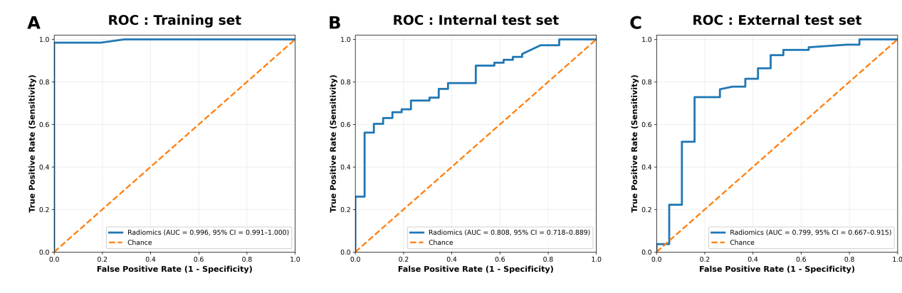
Receiver operating characteristic (ROC) curve of the radiomics-based Random Forest classifier in the training set restricted to small renal masses (≤4 cm), demonstrating excellent discrimination between fat-poor angiomyolipoma (fp-AML) and renal cell carcinoma (RCC).(B) ROC curve in the internal test set for small renal masses (≤4 cm), showing stable diagnostic performance in the independent holdout cohort.(C) ROC curve in the external test set for small renal masses (≤4 cm), indicating generalizability across centers in the small-tumor subgroup.
AUC values are reported with 95% confidence intervals estimated by 1,000 bootstrap resampling iterations.
Abbreviations: ROC, receiver operating characteristic; AUC, area under the ROC curve; CI, confidence interval; fp-AML, fat-poor angiomyolipoma; RCC, renal cell carcinoma.

