Supplementary Material 1
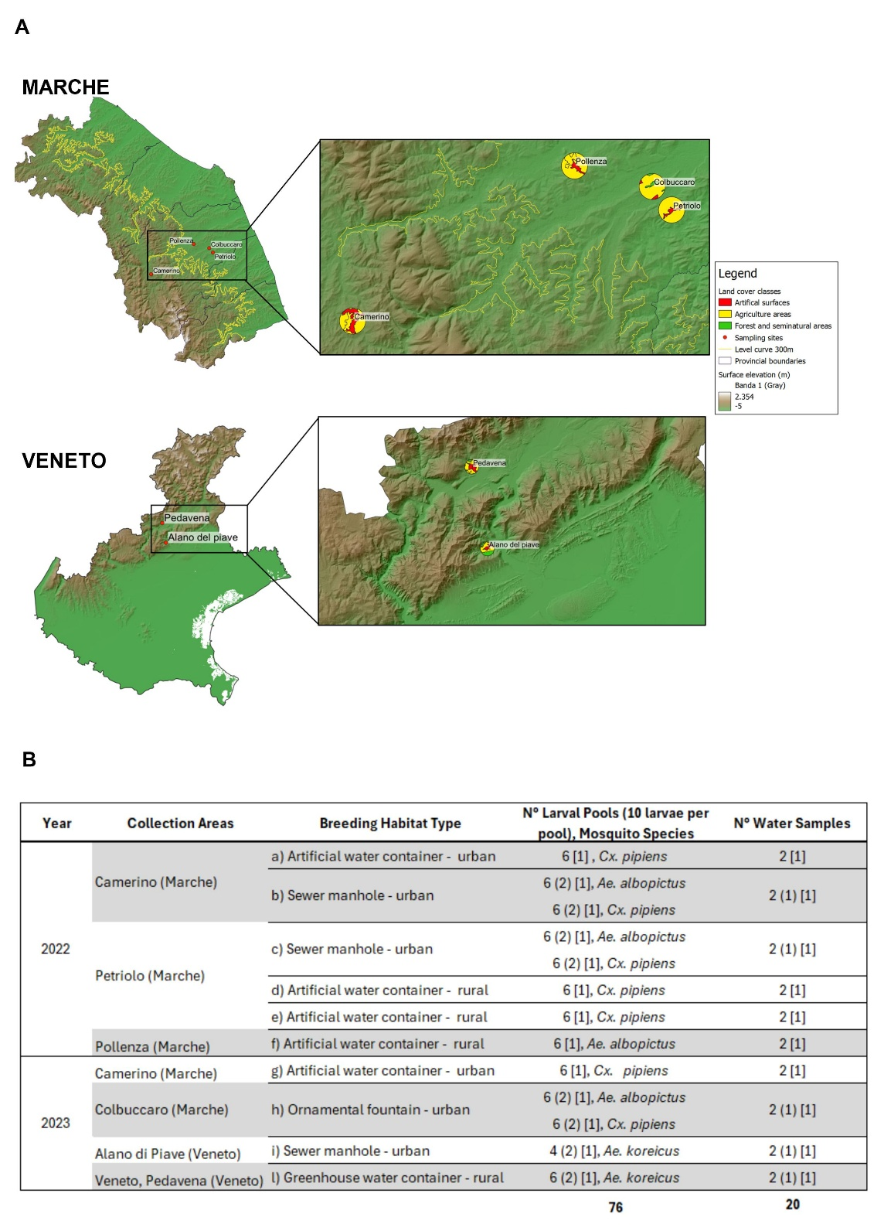

Fig. S1: Mosquito larval pools and water samples across years, collection areas, breeding habitat types. (A) Collection areas: Camerino (43.135764N, 13.068309E), Colbuccaro (43.2442313N, 13.441837E), Petriolo (43.221521N, 13.4663061E), and Pollenza (43.2677749N, 13.3477918E) in the Marche region (central Italy); Pedavena (46.039624N, 11.880433E) and Alano di Piave (45.9078199N, 11.9080775E) in the Veneto region (northern Italy). Land cover classes are reported in the legend; (B) Collection of samples comprises 76 pools of larvae (10 individuals each) (36 Culex pipiens, 24 Aedes albopictus, 10 Aedes koreicus, and 6 Culex spp.), along with 20 breeding water samples (50 mL per site). Pools analysed by NGS or cultural method are indicated with round and square brackets, respectively. Letters (a - l,) refer to different breeding habitat types in rural and urban settings.

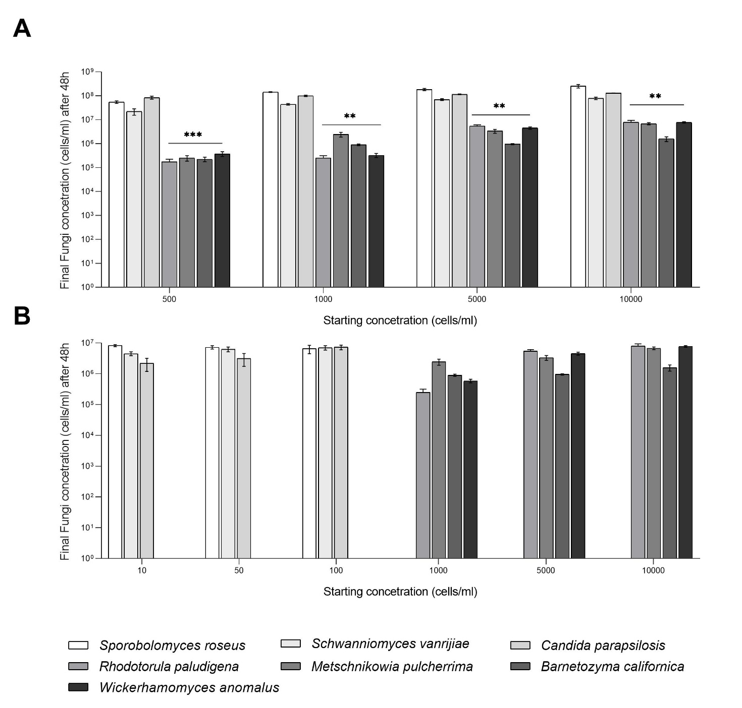

Fig. S2: Evaluation of yeast growth rates in the HaCaT cell culture medium. (A) Growth performance of the different yeast isolates after 48 h of incubation. Yeasts inoculated at identical starting concentrations (500, 1,000, 5,000, and 10,000 cells/mL) exhibited strain-dependent differences in final cell densities. (B) To obtain comparable final concentrations across strains, lower initial inocula (10, 50, and 100 cells/mL) were tested for the selected isolates Sp. roseus, Sc. vanrijiae, and C. parapsilosis. Yeast cells were counted after 48 h using a Neubauer chamber with Trypan blue staining. Experiments were performed in triplicate, and data are presented as mean ± SEM. Statistical significance was determined by two-way ANOVA followed by Tukey’s multiple comparisons test (GraphPad Prism).

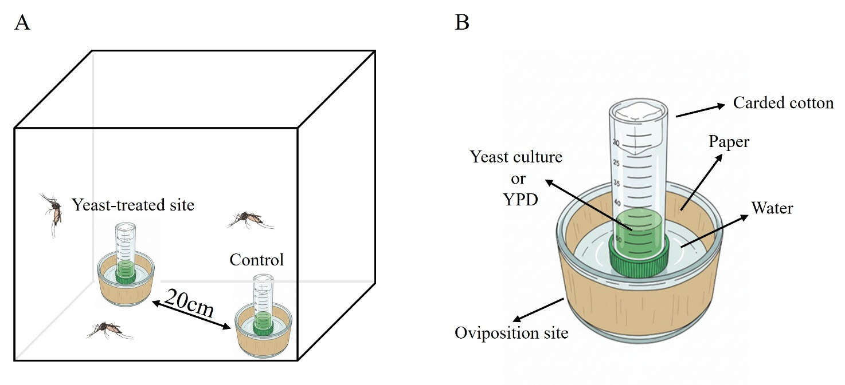

Fig. S3: Experimental setup for dual-choice oviposition bioassays. (A) Representation of the oviposition site containing water and oviposition paper for egg deposition. A cut Falcon tube containing yeast culture (or sterile medium for control treatments) was positioned at the centre of the container and covered with carded cotton to prevent direct contact with mosquitoes while allowing diffusion of volatile organic compounds (VOCs). (B) Schematic diagram of the BagDormⓇ cage setup showing two oviposition sites (yeast-treated and control) placed at opposite corners (approximately 20 cm apart) within a cage containing three gravid female mosquitoes.

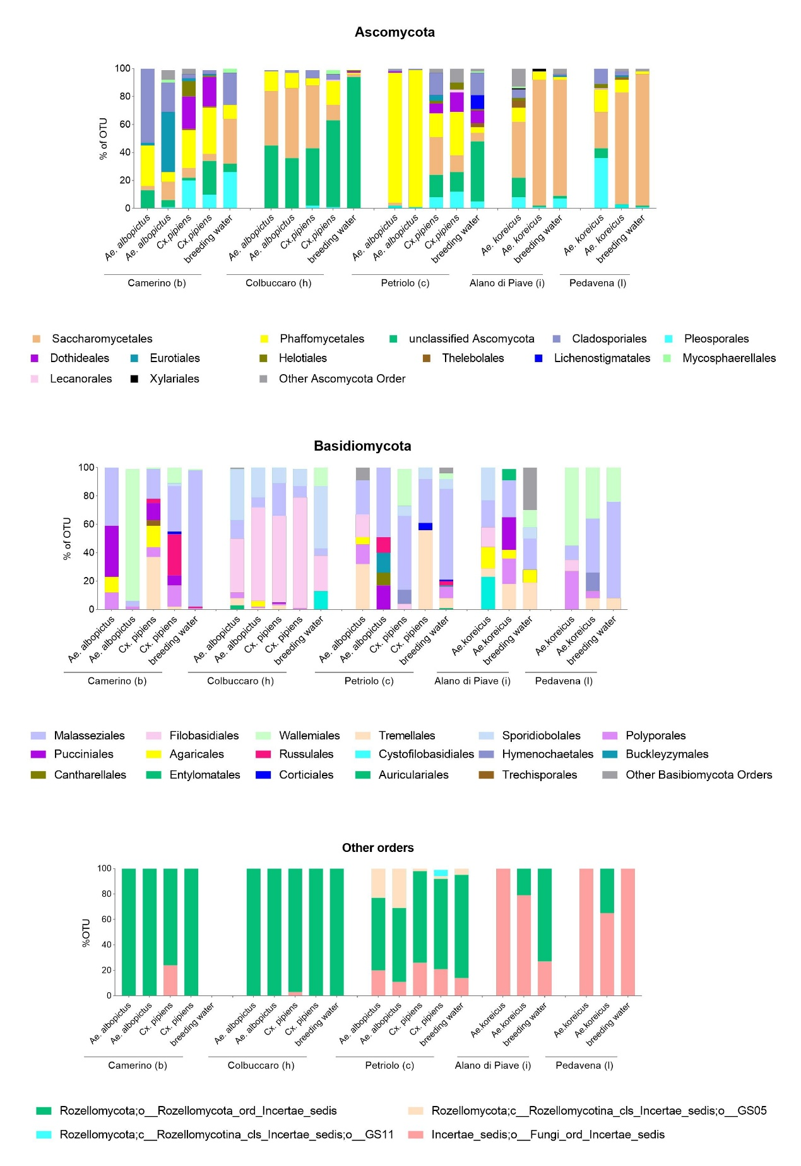

Fig. S4: Composition and distribution of fungal communities at order level associated with mosquito species and breeding waters across sampling areas analysed by ITS metabarcoding. Stacked bar plots showing the relative abundances of fungal orders in different phyla (cut-off: ≥2% in ≥1 sample). The X-axis indicates larval samples and collection site, and the Y-axis indicates the relative abundance of fungal taxa calculated as a percentage of operational taxonomic units (OTUs). The letters (b, c, h, i, l) indicate different breeding habitat types as defined in Table S1.

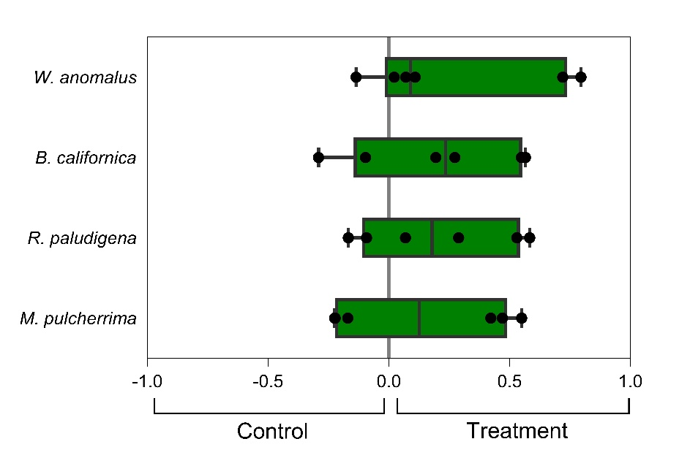

Fig. S5: Oviposition preference assay expressed as Oviposition Activity Index (OAI).
OAI values range from -1 to +1, where positive values indicate preference for the treatment, negative values indicate preference for the control, and 0 indicates no preference. Each point represents one cage. The boxplots show the interquartile range (IQR), with the median indicated by a horizontal line and whiskers representing minimum and maximum values. No significant differences in OAI were observed among yeast treatments (one-way ANOVA, p = 0.8789).

