Supplemental materials

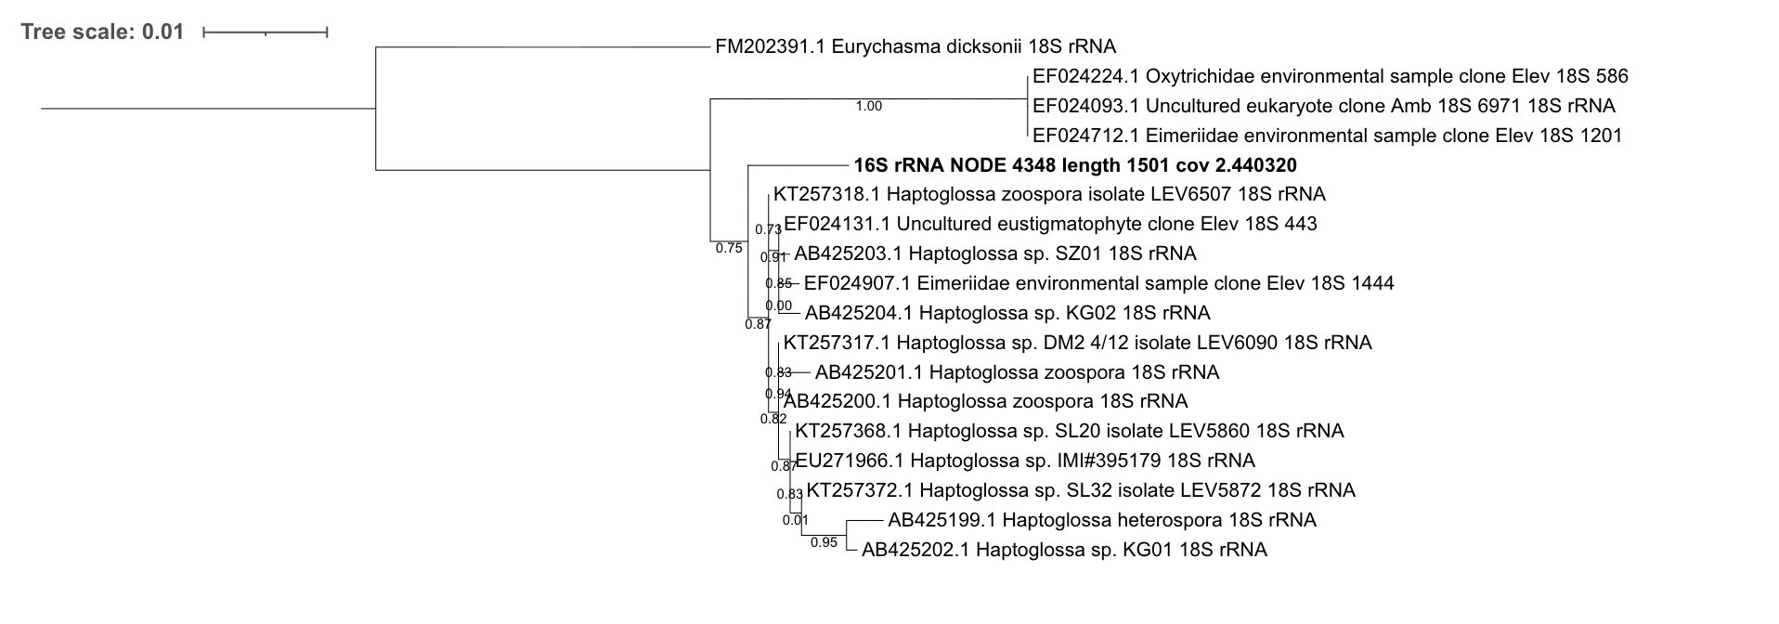
Figure S1. Phylogenetic tree based on the aligned 18S rRNA gene sequences demonstrating the phylogenetic position of the potentially novel Haptoglossa sp. oomycete isolated from Cucumibius annulatus. Sequence alignment: MAFFT v.7.526, ML tree inference: FastTree v.2.1.11, model GTR+CAT, SH-aLRT test for clade support.

