Supplementary material
Table S1 Dates of dust events and corresponding PM₁₀ concentrations observed at Andong (136) and Daegu (143) using dust-monitoring instruments, operated by Korea Meteorological Administration (KMA). PM₁₀ concentration were obtained from Open MET Data Portal from KMA (https://data.kma.go.kr/resources/html/en/aowdp.html) and dust dates were obtained KMA weather service (https://www.weather.go.kr/neng/index.do). The symbol ‘Y’ indicates dust storm event date from KMA.

Station name  (station number) | Date  (yyyy-mm-dd) | PM₁₀  (μg/m³)
Andong  (136) | 2025-03-22 | 41
Andong  (136) | 2025-03-23 | 84
Andong  (136) | 2025-03-24 (Y) | 82
Andong  (136) | 2025-03-25 (Y) | 147
Daegu  (143) | 2025-03-22 | 39
Daegu  (143) | 2025-03-23 | 43
Daegu  (143) | 2025-03-24 (Y) | 66
Daegu  (143) | 2025-03-25 (Y) | 101
Daegu  (143) | 2025-03-26 | 56

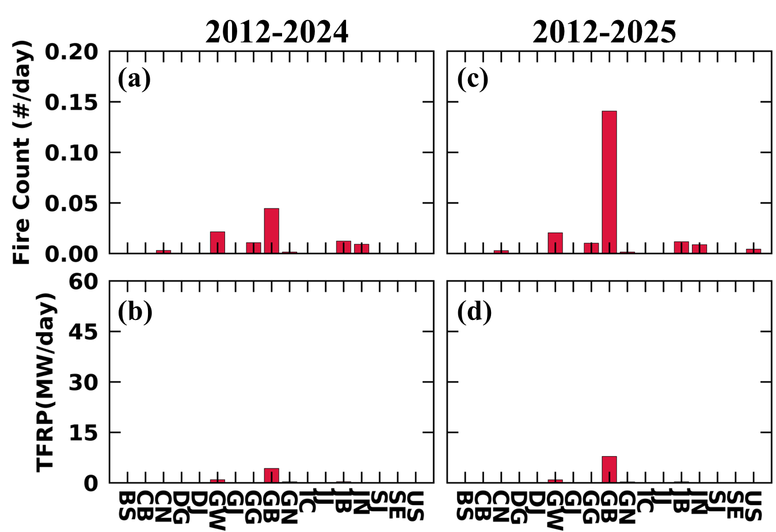
Figure. S1 Same as Fig. 2 but for fire count (FC) and total fire radiative power (TFRP) from VIIRS

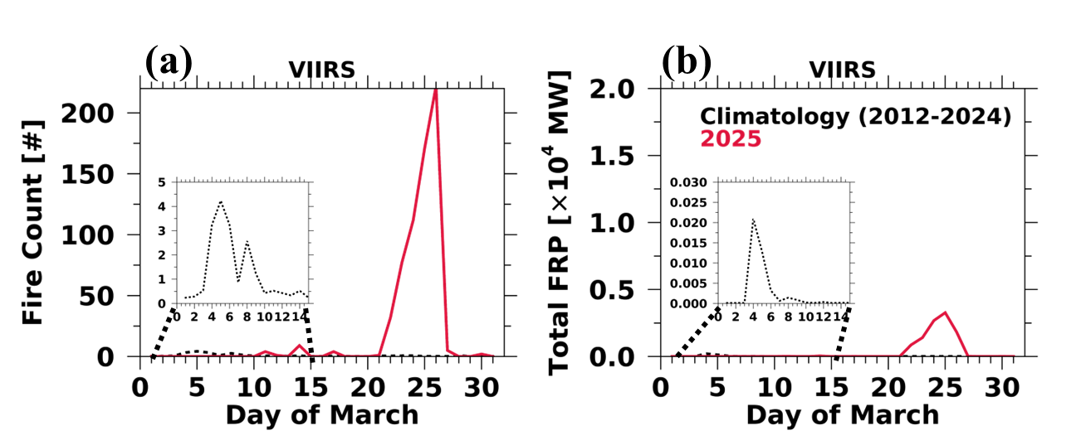
Figure. S2 Same as Fig. 3 but for fire count and TFRP from VIIRS

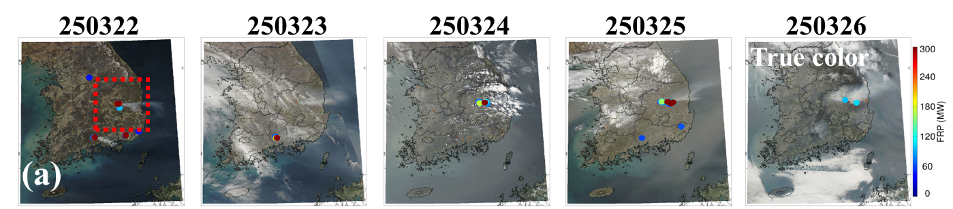
Figure. S3 (a) MODIS true color image and fire location with FRP over South Korea. (b) MODIS AOD during March 22-26 2025 over South Korea.

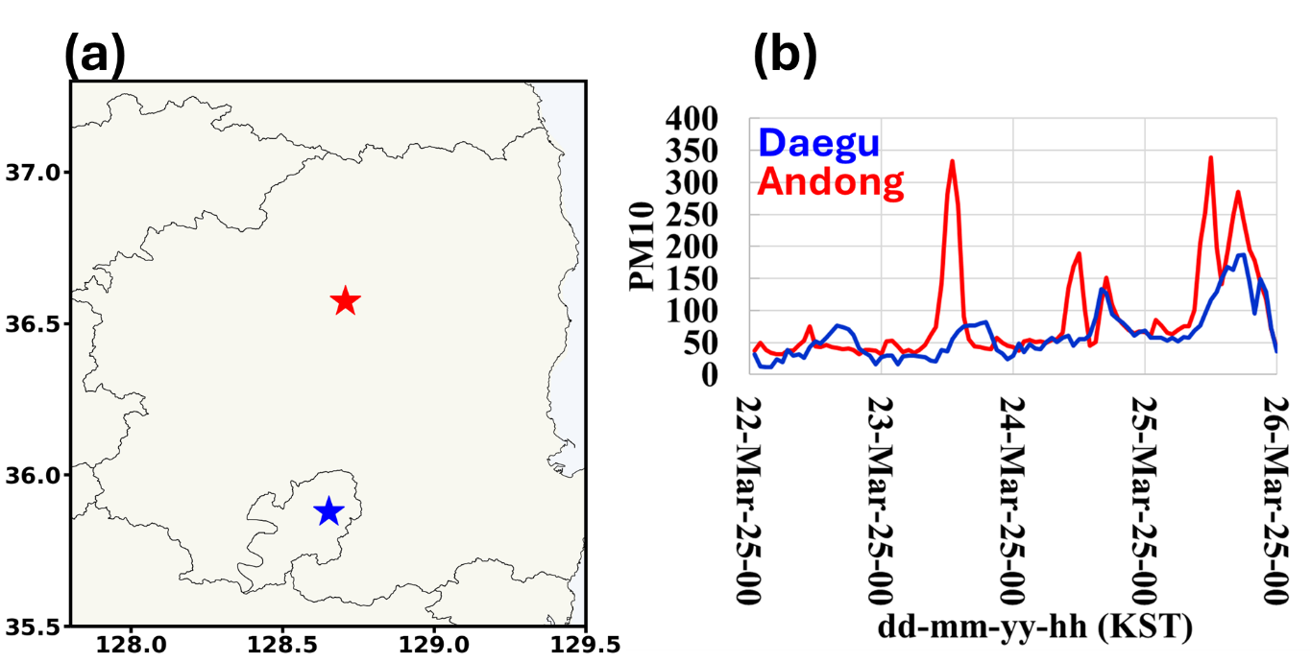
Figure. S4 The location of PM10 observation for dust storm, operated from Korean Meteorological Administration (KMA; https://data.kma.go.kr/resources/html/en/aowdp.html) in GB province. Red and blue stars indicate the Andong and Daegu site, respectively.
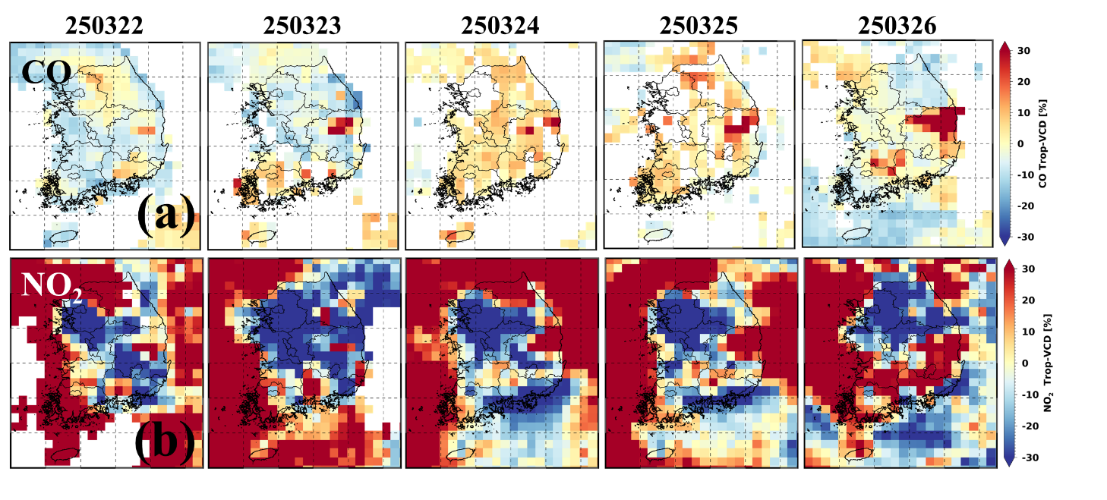
Figure. S5 Spatial distributions of relative differences (%) of TROPOMI (a) CO, (b) NO₂ in troposphere.

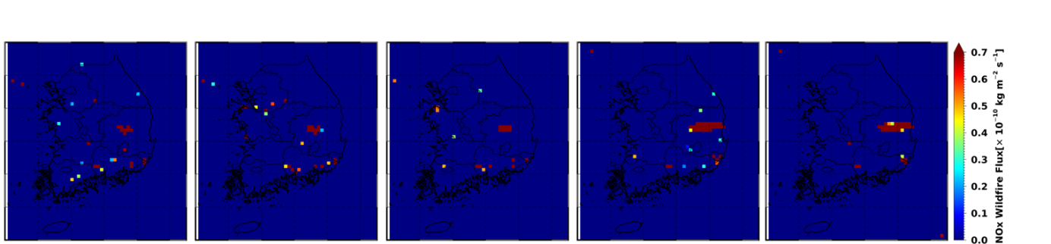
Figure. S6 Same as Fig. 6d-f but for NOx.
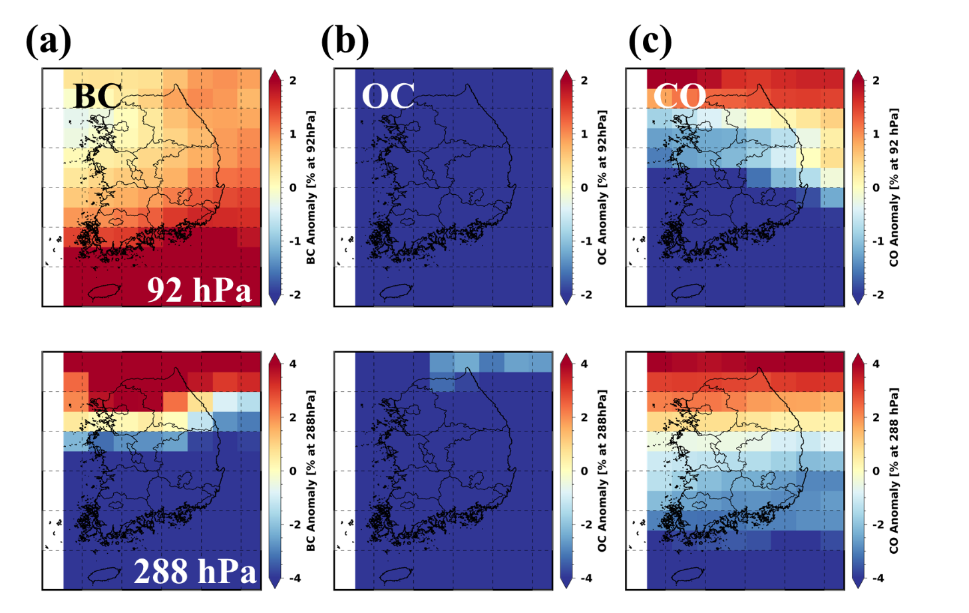
Figure. S7 Spatial distributions of relative differences (%) of MERRA-2 (a) black carbon (BC), (b) Organic carbon (OC), and (c) carbon monoxide (CO) at 288 hPa (bottom) an

