Supplementary Materials

List of Tables
Table S1: COVID-19 related knowledge and perceived worry of SARS-COV2 infection Mixed effect logistic regression (regression coefficient used for COIVD-19 related knowledge -Specific aim2) 8
Table S2: : COVID-19 related knowledge and perceived worry of Severe COVID-19 illness Mixed effect logistic regression (regression coefficient used for COVID-19 related knowledge- Specific aim3) 11

List of Figures
Figure S1: Directed acyclic graph - association between knowledge level of COVID-19 and worry of acquiring SARS-COV2 infection 2
Figure S2: :Directed acyclic graph - association between knowledge level of COVID-19 and worry of acquiring Severe COVID-19 3
Figure S3: Exploring the missing data pattern of missingness and percentage of missingness (R output) 4
Figure S4: Exploring Missing data (R output) 5
Figure S5:. Respondents field of study by country 6
Figure S6: COVID-19 related knowledge by country 7

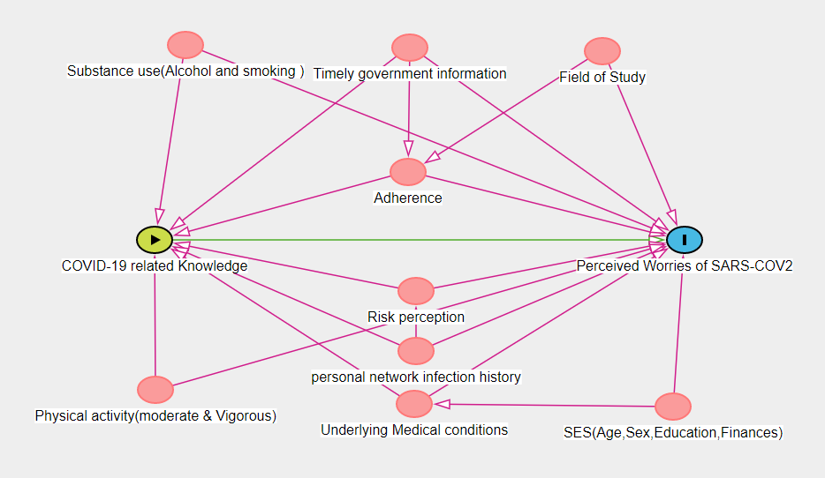
Figure S1: Directed acyclic graph - association between knowledge level of COVID-19 and worry of acquiring SARS-COV2 infection

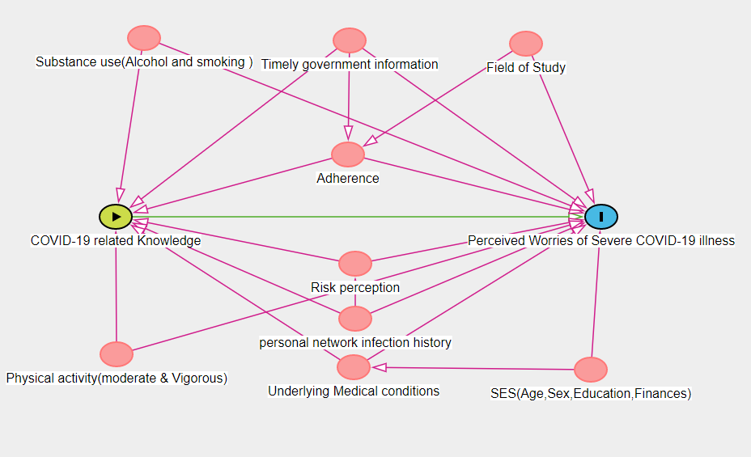
Figure S2: :Directed acyclic graph - association between knowledge level of COVID-19 and worry of acquiring Severe COVID-19

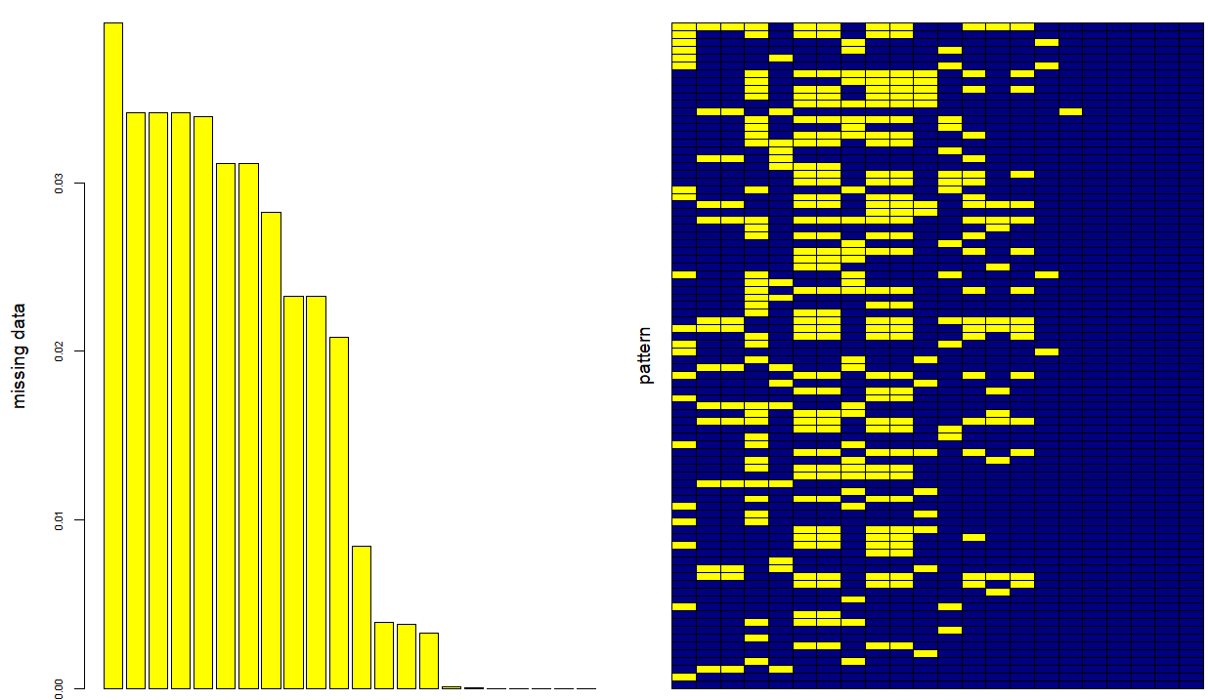
Figure S3: Exploring the missing data pattern of missingness and percentage of missingness (R output)

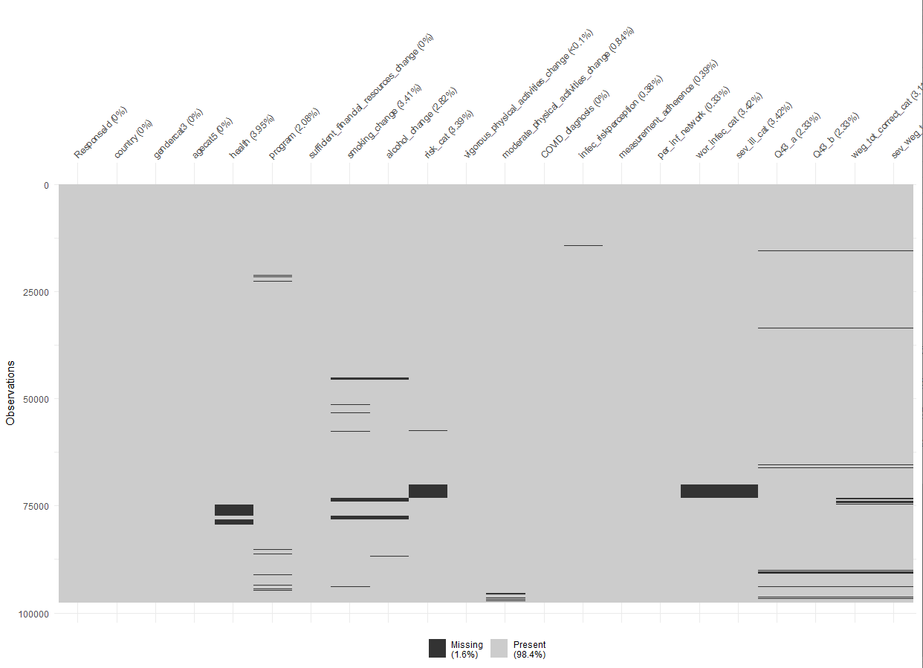
Figure S4: Exploring Missing data (R output)
* Q43_a = “Did The government provided information concerning the COVID-19 outbreak on time”
* Q43_b= “The government provided comprehensive information concerning the COVID-19 outbreak”
* risk_cat= “Do you have any of the following underlying conditions?”
*per_inf_network= “Do you know anyone in your personal network that was or currently is infected with COVID-19?”
*wor_infec_cat= “How worried are you that you will get infected with COVID-19?”
* Sev_ill_cat = “How worried are you that you will get severely ill from a COVID-19 infection?

Figure S5:. Respondents field of study by country

Figure S6: COVID-19 related knowledge by country

Table S1: COVID-19 related knowledge and perceived worry of SARS-COV2 infection Mixed effect logistic regression (regression coefficient used for COIVD-19 related knowledge -Specific aim2)
 |  | Worried | Unworried | P Value | Crude OR | 95%CI lower | 95%CI  upper |  | Adjusted OR* | 95%CI lower | 95%CI upper
Age group  (***) | 17-19 years | 6606 | 8126 | <0.01 | 1*** | ref | ref |  | 1 | ref | ref
Age group  (***) | 20-22 years | 18161 | 22183 | 0.71 | 1.007 | 0.96 | 1.04 |  | 0.97 | 0.92 | 1.01
Age group  (***) | 23-25years | 9534 | 12563 | 0.01 | 0.93 | 0.89 | 0.97 |  | 0.91 | 0.86 | 0.96
Age group  (***) | 26-28 years | 3257 | 4050 | 0.70 | 0.98 | 0.93 | 1.04 |  | 0.96 | 0.90 | 1.03
Age group  (***) | >= 29 years | 4823 | 4860 | <0.01 | 1.22 | 1.15 | 1.28 |  | 1.15 | 1.08 | 1.23
Sex  (***) | Male | 9026 | 16424 | <0.01 | 1 | ref | ref |  | 1 | Ref | ref
Sex  (***) | female | 33071 | 35033 | <0.01 | 1.71 | 1.66 | 1·76 |  | 1.62 | 1.57 | 1.68
Sex  (***) | X | 284 | 325 | <0.01 | 1.59 | 1.35 | 1.86 |  | 1.33 | 1.10 | 1.59
Educational level  (***) | Bachelor | 27883 | 33093 | <0.01 | 1 | ref | ref |  | 1 | ref | Ref
Educational level  (***) | Master | 9365 | 12539 | <0.01 | 0.88 | 0.85 | 0.91 |  | 0.91 | 0.87 | 0.94
Educational level  (***) | PhD | 1746 | 2146 | 0.29 | 0.96 | 0.90 | 1.03 |  | 0.94 | 0.87 | 1.02
Educational level  (***) | other | 2428 | 3040 | 0.06 | 0.94 | 0.89 | 1.002 |  | 0.95 | 0.89 | 1.02
Field of study  (***) | Non- health field | 32530 | 38912 | <0.01 | 1 | ref | ref |  | 1 | Ref | ref
Field of study  (***) | health | 7975 | 10903 | <0.01 | 0.87 | 0.84 | 0.90 |  | 0.76 | 0.74 | 0.79
Underlying medical condition | None | 34319 | 45043 | <0.01 | 1 | ref | ref |  | 1 | ref | Ref
Underlying medical condition | present | 6960 | 5717 | <001 | 1.59 | 1.54 | 1.66 |  | 1.41 | 1.35 | 1.48
Underlying medical condition | Prefer not to say | 1036 | 966 | <001 | 1.40 | 1.29 | 1.54 |  | 1.40 | 1.26 | 1.56
Govt Timely info. | Strongly agree | 4234 | 6187 | <0.01 | ref | ref | ref |  | 1 | ref | ref
Govt Timely info. | agree | 14007 | 18941 | 0.007 | 1.08 | 1.03 |  | 1.12 | 1.16 | 1.10 | 1.22
Govt Timely info. | Neither agree nor disagree | 8947 | 10495 | <0.01 | 1.24 | 1.18 |  | 1.30 | 1.38 | 1.31 | 1.46
Govt Timely info. | disagree | 9688 | 10327 | <0.01 | 1.37 | 1.30 |  | 1.43 | 1.52 | 1.44 | 1.61
Govt Timely info. | Strongly agree | 4543 | 4672 | <0.01 | 1.42 | 1.34 |  | 1.50 | 1.72 | 1.61 | 1.84
Knowledge  question a | Incorrect | 17108 | 19417 | <0.01 | ref | ref |  | ref | 1 | ref | ref
Knowledge  question a | Correct | 24243 | 31179 | <0.01 | 0.88 | 0.85 |  | 0.90 | 0.94 | 0.91 | 0.98
Knowledge  question b | Incorrect | 28061 | 37848 | <0.01 | ref | ref |  | ref | 1 | ref | ref
Knowledge  question b | Correct | 13142 | 12646 | <0.01 | 1.40 | 1.36 |  | 1.44 | 0.76 | 0.73 | 0.78
Knowledge  question c | Incorrect | 6335 | 5168 | <0.01 | ref | ref |  | ref | 1 | ref | ref
Knowledge  question c | Correct | 35089 | 45475 | <0.01 | 0.62 | 0.60 |  | 0.65 | 0.54 | 0.51 | 0.58
Knowledge  question d | Incorrect | 11615 | 16745 | <0.01 | ref | ref |  | ref | 1 | ref | ref
Knowledge  question d | Correct | 29678 | 33811 | <0.01 | 1.26 | 1.23 |  | 1.30 | 0.79 | 0.74 | 0.84
Knowledge  question e | Incorrect | 14791 | 19731 | <0.01 | ref | ref |  | ref | 1 | ref | ref
Knowledge  question e | Correct | 26519 | 30842 | <0.01 | 1.14 | 1.11 |  | 1.17 | 0.88 | 0.84 | 0.92
Knowledge  question f | Incorrect | 1485 | 1700 | 0.01 | ref | ref |  | ref | 1 | ref | ref
Knowledge  question f | Correct | 39965 | 48957 | 0.06 | 0.93 | 0.87 |  | 1.00 | 1.21 | 1.05 | 1.40
Knowledge  question g | Incorrect | 7848 | 8824 | <0.01 | ref | ref |  | ref | 1 | ref | ref
Knowledge  question g | Correct | 33468 | 41755 | <0.01 | 0.90 | 0.87 |  | 0.93 | 1.29 | 1.22 | 1.37
Knowledge  question h | Incorrect  (True) | 1307 | 2113 | <0.01 | ref | ref |  | ref | 1 | ref | ref
Knowledge  question h | Correct (False) | 40144 | 48538 | <0.01 | 1.33 | 1.24 |  | 1.43 | 1.32 | 1.16 | 1.50
Variables | Mean | β | SD | P-value | Crude OR | 95%CI lower |  | 95%CI upper | Adjusted OR* | 95%CI lower | 95%CI upper
Risk perception | 4.14 | 0.18 | 0.002 | <0.01 | 1.197 | 1.190 |  | 1.20 | 1.20 | 1.19 | 1.21
Alcohol use | -0.34 | 0.08 | 0.007 | <0.01 | 1.09 | 1.03 |  | 1.11 | 1.08 | 1.06 | 1.10
Smoking | -0.097 | -0.05 | 0.008 | <0.01 | 0.94 | 0.92 |  | 0.96 | 0.93 | 0.91 | 0.95
Moderate physical activity change | -0.42 | -0.05 | 0.003 | <0.01 | 0.94 | 0.79 |  | 0.94 | 0.94 | 0.93 | 0.95
Vigorous physical activity change | -0.144 | -.005 | 0.004 | 0.147 | 0.99 | 0.98 |  | 1 | 1.01 | 1.00 | 1.02
Sufficient  Financial resources | -0.379 | -0.14 | 0.006 | <0.01 | 0.86 | 0.85 |  | 0.87 | 0.89 | 0.87 | 0.90
Measurement adherance | 8.023 | 0.18 | 0.003 | <0.01 | 1.20 | 1.19 |  | 1.21 | 1.20 | 1.19 | 1.21

Table S2: : COVID-19 related knowledge and perceived worry of Severe COVID-19 illness Mixed effect logistic regression (regression coefficient used for COVID-19 related knowledge- Specific aim3)
 |  | Worried | Unworried | P Value | Crude OR | 95%CI lower | 95%CI  upper |  | Adjusted OR* | 95%CI lower | 95%CI upper
Age group  (***) | 17-19 years | 7293 | 7439 | 0.22 | 1 | ref | ref |  | 1 | ref | ref
Age group  (***) | 20-22 years | 18713 | 21631 | <0.01 | 0.88 | 0.84 | 0.91 |  | 0.86 | 0.83 | 0.90
Age group  (***) | 23-25years | 9631 | 12466 | <0.01 | 0.78 | 0.75 | 0.82 |  | 0.80 | 0.76 | 0.85
Age group  (***) | 26-28 years | 3239 | 4068 | <0.01 | 0.81 | 0.76 | 0.85 |  | 0.84 | 0.79 | 0.90
Age group  (***) | >= 29 years | 4926 | 4757 | 0.03 | 1.05 | 1.003 | 1.11 |  | 1.04 | 0.98 | 1.11
Sex  (***) | Male | 9305 | 16145 | <0.01 | 1 | ref | ref |  | 1 | Ref | ref
Sex  (***) | female | 34216 | 33888 | <0.01 | 1.75 | 1.70 | 1.80 |  | 1.66 | 1.61 | 1.72
Sex  (***) | X | 281 | 328 | <0.01 | 1.48 | 1.26 | 1.74 |  | 1.27 | 1.06 | 1.52
Educational level  (***) | Bachelor | 29272 | 31704 | <0.01 | 1 | ref | ref |  | 1 | ref | Ref
Educational level  (***) | Master | 9483 | 12421 | <0.01 | 0.82 | 0.80 | 0.85 |  | 0.88 | 0.84 | 0.91
Educational level  (***) | PhD | 1690 | 2202 | <0.01 | 0.83 | 0.77 | 0.88 |  | 0.85 | 0.79 | 0.92
Educational level  (***) | other | 2446 | 3022 | <0.01 | 0.87 | 0.82 | 0.92 |  | 0.88 | 0.82 | 0.94
Field of study  (***) | Non- health field | 33534 | 37908 | <0.01 | 1 | ref | ref |  | 1 | Ref | ref
Field of study  (***) | health | 8070 | 10908 | <0.01 | 0.84 | 0.81 | 0.87 |  | 0.77 | 0.74 | 0.80
Underlying medical condition | None | 34459 | 44903 | <0.01 | 1 | ref | ref |  | 1 | ref | Ref
Underlying medical condition | present | 1082 | 920 | <001 | 2.38 | 2.28 | 2.47 |  | 2.29 | 2.19 | 2.40
Underlying medical condition | Prefer not to say | 8192 | 4485 | <001 | 1.53 | 1.4 | 1.67 |  | 1.51 | 1.36 | 1.58
Govt Timely info. | Strongly agree | 4186 | 6235 | <001 | ref | ref | ref |  | 1 | ref | ref
Govt Timely info. | agree | 14341 | 18607 | <001 | 1.08 | 1.03 |  | 1.12 | 1.21 | 1.15 | 1.27
Govt Timely info. | Neither agree nor disagree | 9533 | 9909 | <001 | 1.24 | 1.18 |  | 1.30 | 1.51 | 1.42 | 1.59
Govt Timely info. | disagree | 10015 | 10000 | <001 | 1.37 | 1.30 |  | 1.43 | 1.58 | 1.49 | 1.67
Govt Timely info. | Strongly agree | 4748 | 4467 | <001 | 1.42 | 1.34 |  | 1.50 | 1.76 | 1.64 | 1.88
Knowledge  question a | Incorrect  (True) | 9285 | 9590 | 0.02 | ref | ref |  | ref | 1 | ref | ref
Knowledge  question a | Correct (False) | 24919 | 30503 | <0.01 | 0.84 | 0.81 |  | 0.87 | 0.94 | 0.91 | 0.98
Knowledge  question a | Don’t Know | 8554 | 9096 | 0.16 | 0.97 | 0.93 |  | 1.01 | 1.008 | 0.96 | 1.05
Knowledge  question b | Incorrect  (True) | 13329 | 12459 | <0.01 | ref | ref |  | ref | 1 | ref | ref
Knowledge  question b | Correct (False) | 18773 | 24205 | <0.01 | 0.72 | 0.70 |  | 0.74 | 0.79 | 0.76 | 0.82
Knowledge  question b | Don’t Know | 10516 | 12415 | <0.01 | 0.79 | 0.76 |  | 0.82 | 0.81 | 0.78 | 0.85
Knowledge  question c | Incorrect  (True) | 4271 | 2606 | 0.01 | ref | ref |  | ref | 1 | ref | ref
Knowledge  question c | Correct (False) | 35923 | 44641 | 0.01 | 0.49 | 0.46 |  | 0.51 | 0.45 | 0.42 | 0.48
Knowledge  question c | Don’t Know | 2634 | 1992 | 0.01 | 0.80 | 0.74 |  | 0.87 | 0.80 | 0.73 | 0.88
Knowledge  question d | Correct  (True) | 30116 | 33373 | <0.01 | ref | ref |  | ref | 1 | ref | ref
Knowledge  question d | Incorrect (False) | 2608 | 3393 | <0.01 | 0.85 | 0.80 |  | 0.89 | 0.87 | 0.82 | 0.93
Knowledge  question d | Don’t Know | 9978 | 12381 | <0.01 | 0.89 | 0.86 |  | 0.92 | 0.84 | 0.81 | 0.87
Knowledge  question e | Correct  (True) | 26749 | 30612 | <0.01 | ref | ref |  | ref | 1 | ref | ref
Knowledge  question e | Incorrect (False) | 5152 | 6306 | <0.01 | 0.93 | 0.89 |  | 0.97 | 0.99 | 0.95 | 1.04
Knowledge  question e | Don’t Know | 10814 | 12250 | 0.51 | 1.01 | 0.97 |  | 1.04 | 1.03 | 0.99 | 1.07
Knowledge  question f | Correct  (True) | 41284 | 47638 | <0.01 | ref | ref |  | ref | 1 | ref | ref
Knowledge  question f | Incorrect (False) | 603 | 572 | <0.01 | 1.21 | 1.08 |  | 1.36 | 1.36 | 1.18 | 1.56
Knowledge  question f | Don’t Know | 964 | 1046 | 0.17 | 1.06 | 0.97 |  | 1.16 | 1.09 | 0.98 | 1.23
Knowledge  question g | Correct  (True) | 34509 | 40714 | <0.01 | ref | ref |  | ref | 1 | ref | ref
Knowledge  question g | Incorrect (False) | 3628 | 3548 | <0.01 | 1.20 | 1.14 |  | 1.26 | 1.22 | 1.16 | 1.30
Knowledge  question g | Don’t Know | 4591 | 4905 | <0.01 | 1.10 | 1.05 |  | 1.15 | 1.11 | 1.06 | 1.17
Knowledge  question h | Incorrect  (True) | 618 | 1049 | <0.01 | ref | ref |  | ref | 1 | ref | ref
Knowledge  question h | Correct (False) | 41512 | 47170 | <0.01 | 1.49 | 1.35 |  | 1.65 | 1.51 | 1.32 | 1.72
Knowledge  question h | Don’t Know | 724 | 1029 | 0.01 | 1.19 | 1.04 |  | 1.37 | 1.00 9 | 0.84 | 1.20
Variables | β | SD | P-value | Crude OR | 95%CI lower | 95%CI upper |  | Adjusted OR* | 95%CI lower | 95%CI upper
Risk perception | 0.18 | 0.002 | <0.01 | 1.197 | 1.190 | 1.20 |  | 1.21 | 1.20 | 1.22
Alcohol use | 0.08 | 0.007 | <0.01 | 1.09 | 1.03 | 1.11 |  | 1.09 | 1.07 | 1.11
Smoking | -0.05 | 0.008 | <0.01 | 0.94 | 0.92 | 0.96 |  | 0.96 | 0.95 | 0.98
Moderate physical activity change | -0.05 | 0.003 | <0.01 | 0.94 | 0.79 | 0.94 |  | 0.97 | 0.96 | 0.98
Vigorous physical activity change | -.005 | 0.004 | 0.147 | 0.99 | 0.98 | 1 |  | 0.99 | 0.98 | 1.00
Sufficient  Financial resources | -0.14 | 0.006 | <0.01 | 0.86 | 0.85 | 0.87 |  | 0.88 | 0.87 | 0.90
Measurement adherance | 0.18 | 0.003 | <0.01 | 1.20 | 1.19 | 1.21 |  | 1.17 | 1.16 | 1.18

