Supplementary Information
1. Construction of PPIGi-shHIF-1α plasmid
Table S1 shRNA primer sequences
Primers | Sequences
shHIF-1a-1 oligoT | TGCTGATATGATTGTGTCTCCAGCGGGTTTTGG  CCACTGACTGACCCGCTGGACACAATCATAT
shHIF-1a-1 oligoB | CCTGATATGATTGTGTCCAGCGGGTCAGTC  AGTGGCCAAAACCCGCTGGAGACACAATCATATC
shHIF-1a-2 oligoT | TGCTGAATATTCATAAATTGAGCGGCGTTTTGGC  CACTGACTGACGCCGCTCATTATGAATATT
shHIF-1a-2 oligoB | CCTGAATATTCATAATGAGCGGCGTCAGTCAGTGGC  CAAAACGCCGCTCAATTTATGAATATTC
shHIF-1a-3 oligoT | TGCTGTTAATAGCGACAAAGTGCATAGTTTTGGCCACT  GACTGACTATGCACTGTCGCTATTAA
shHIF-1a-3 oligoB | CCTGTTAATAGCGACAGTGCATAGTCAGTCAGTGGCCA  AAACTATGCACTTTGTCGCTATTAAC

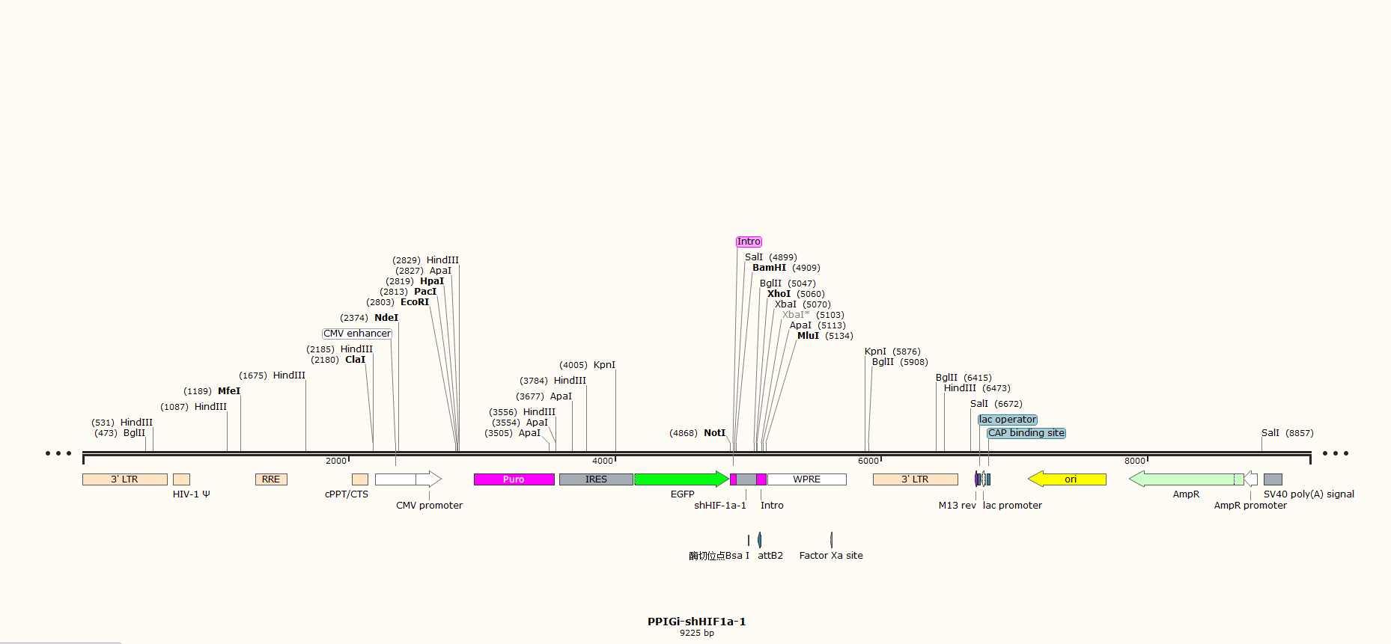
Figure S1-1 Plasmid map of PPIGi-shHIF-1α-1

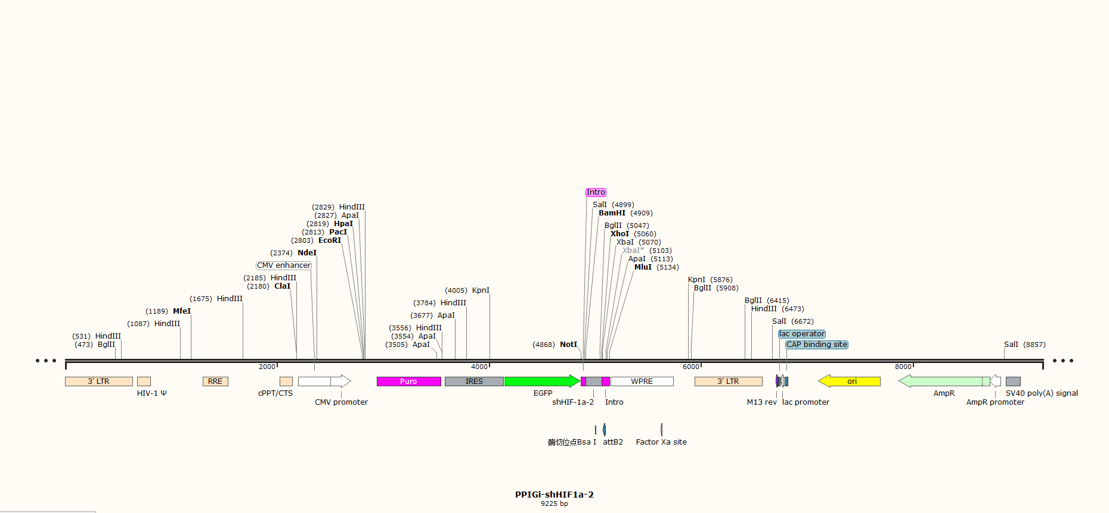
Figure S1-2 Plasmid map of PPIGi-shHIF-1α-2

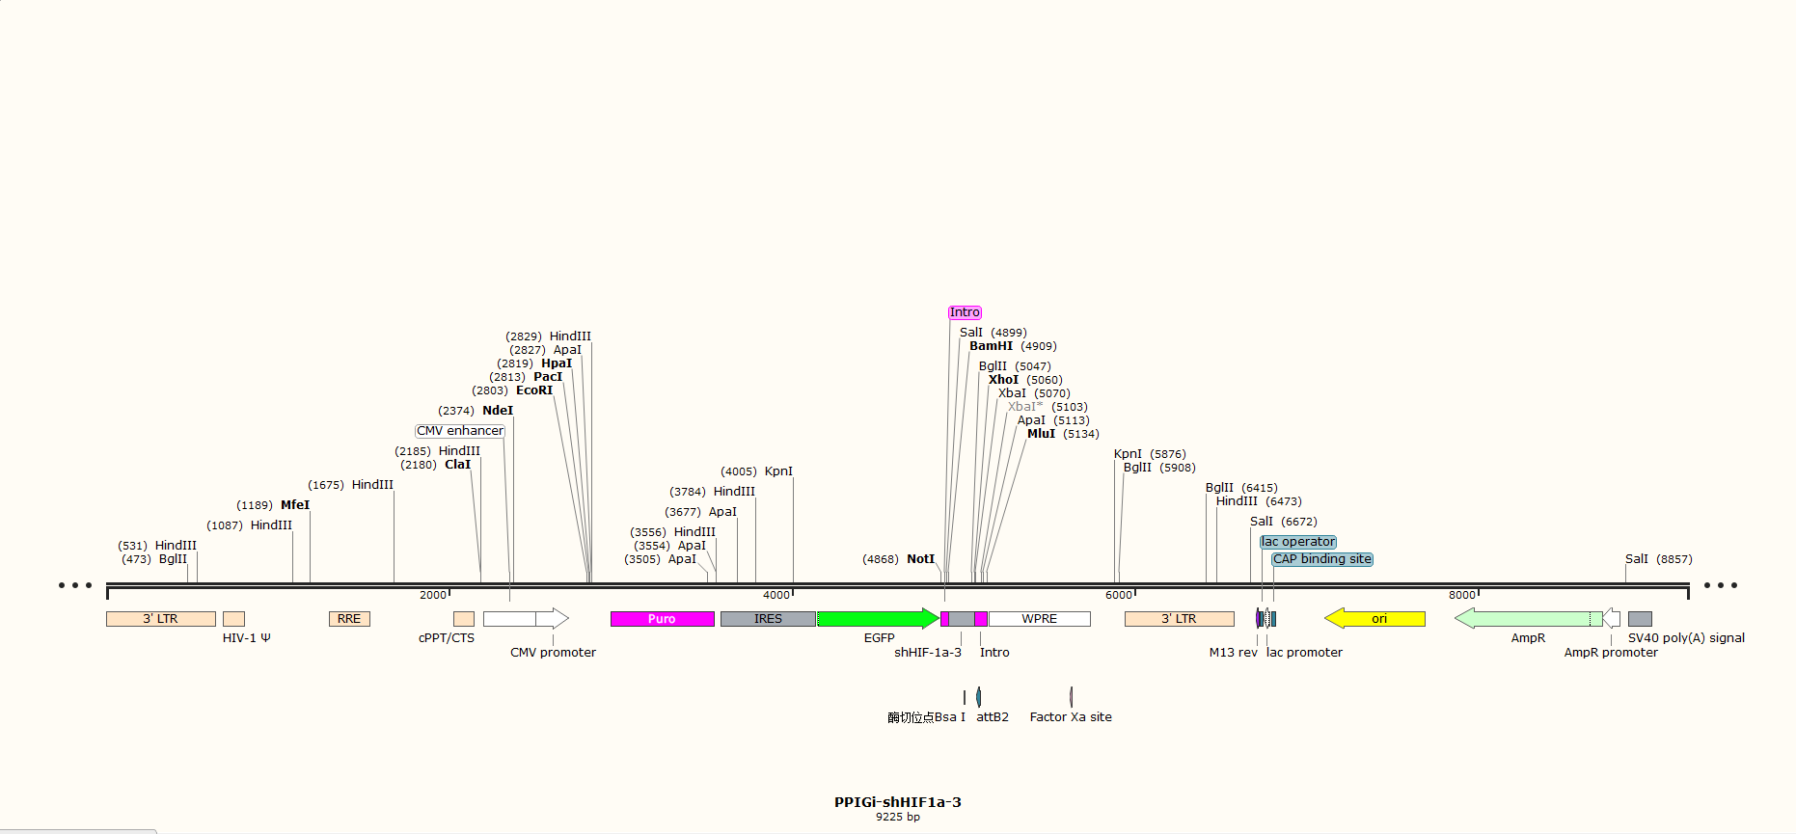
Figure S1-3 Plasmid map of PPIGi-shHIF-1α-3

2. PCR primer sequences
Table S2 Primer sequences used in HK-2 cells
Primer | Sequence (5’ to 3’) | Amplicon length
Hu-GAPDH-F | GGGGCTCTCCAGAACATC | 123
Hu-GAPDH-R | TGACACGTTGGCAGTGG
Hu-HIF1α-F | GACAGTACAGGATGCTTGCCA | 100
Hu-HIF1α-R | ACAATGCACTGTGGTTGAGAA
Hu-PPARγ-F | CCAGAAGCCTGCATTTCTGC | 138
Hu-PPARγ-R | GTGTCAACCATGGTCATTTCGTT

Table S3 Primer sequences used in mouse model
Primer | Sequence (5’ to 3’) | Amplicon length
Mu-GAPDH-F | AGGTCGGTGTGAACGGATTTG | 123
Mu-GAPDH-R | TGTAGACCATGTAGTTGAGGTCA
Mu-HIF1α-F | TCTGCCAGTTTTCTGGGCAA | 154
Mu-HIF1α-R | GGGGAAGTGGCAACTGATGA
Mu-PPARγ-F | TGTGAGACCAACAGCCTGAC | 111
Mu-PPARγ-R | TCAGTGGTTCACCGCTTCTT

3. Molecular docking Ligplot 2D schematic diagram
Figure S2 Protein-protein interaction 2D schematic diagram. The green lines in the diagram represent hydrogen bonds, while the red lines represent other interactions.

4. Photographs of as-prepared CCDs

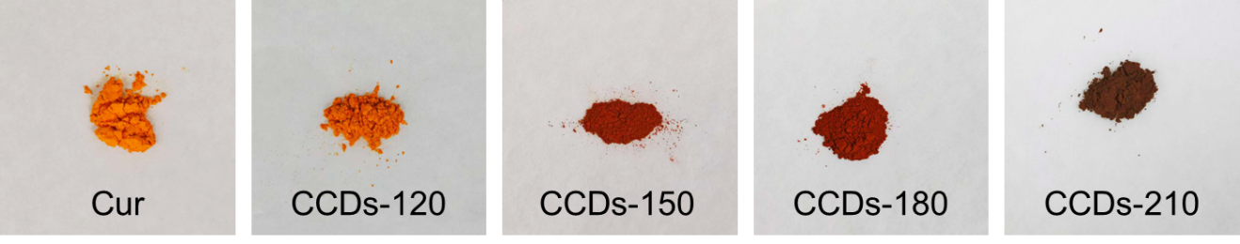
Figure S3 The photographs of CCDs powders.

5. Transcriptomic analysis heatmap
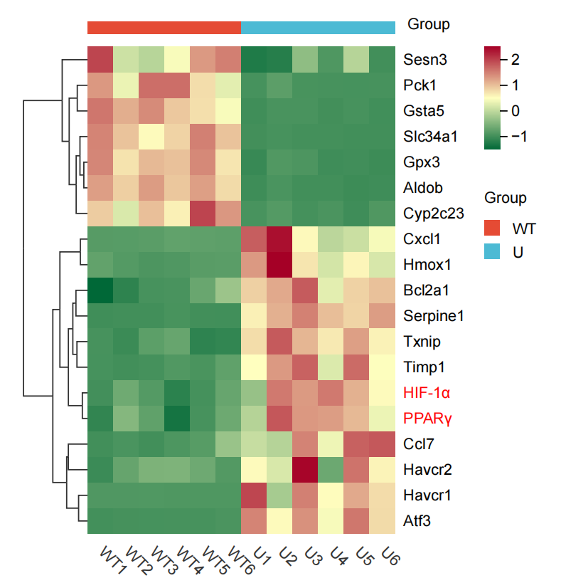
Figure S4 Preliminary transcriptomic heatmap results from the research group revealed that HIF-1α and PPARγ expression was synchronously up-regulated in mouse kidney tissue following uranium exposure.

6. Carbon dots biocompatibility experimental results
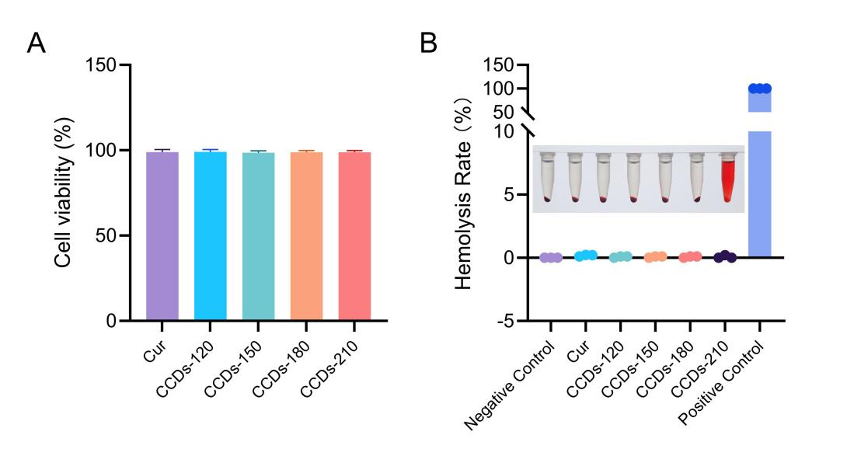
Figure S5 A. Effects of curcumin and curcumin carbon dots (CCDs-120, CCDs-150, CCDs-180, CCDs-210) on the viability of HK-2 cells; B. In vitro hemolysis assay of curcumin and curcumin carbon dots (CCDs-120, CCDs-150, CCDs-180, CCDs-210). The results show that the hemolysis rates in all groups are significantly lower than 5%, indicating excellent biocompatibility.

