Supplementary Information

Memristive Motion-Streak Neuron for Spatiotemporal Multiple Object Detection
Hyungjun Park^{1†}, Jin Hong Kim^{1†}, Hyun Wook Kim^{1†}, Néstor Ghenzi¹, Sung Keun Shim¹, Joon-Kyu Han¹, Min Chung Jung¹, Dong Hoon Shin¹, Kyung Seok Woo^{2,3}, and Cheol Seong Hwang^{1*}

¹Department of Materials Science and Engineering and Inter-University Semiconductor Research Center, Seoul National University, Seoul 08826, Korea
²Graduate School of Semiconductor Materials and Devices Engineering, Ulsan National Institute of Science and Technology (UNIST), Ulsan 44919, Republic of Korea; Department of Materials Science and Engineering, Ulsan National Institute of Science and Technology (UNIST), Ulsan 44919, Republic of Korea
³Department of Materials Science and Engineering, Ulsan National Institute of Science and Technology (UNIST), Ulsan 44919, Republic of Korea

*Correspondence: C.S.H. (cheolsh@snu.ac.kr)

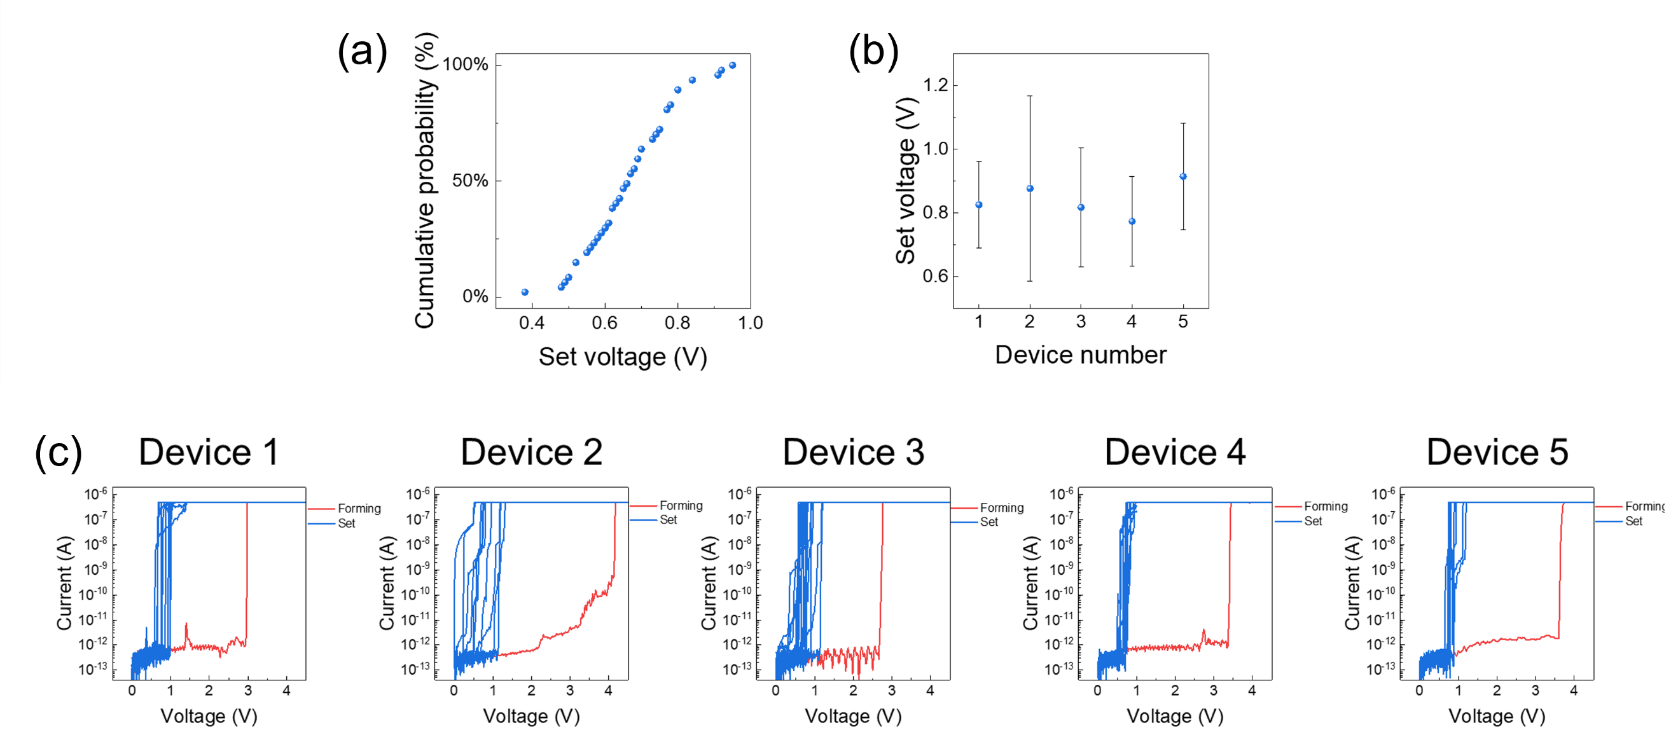

Supplementary Fig. 1. Current-voltage (I-V) characteristics of Ag/HfO₂/Pt dynamic memristor. (a) cumulative probability of set voltages. (b) Set voltages of five devices, each swept over 20 cycles, and (c) their experimental data.

Supplementary Fig. 2. Relaxation dynamics in the dynamic memristor with varying pulse lengths. (a) Output current and (b) relaxation behavior of the dynamic memristor with varying pulse lengths under a fixed pulse voltage of 2.8 V and a load resistance of 10 MΩ.

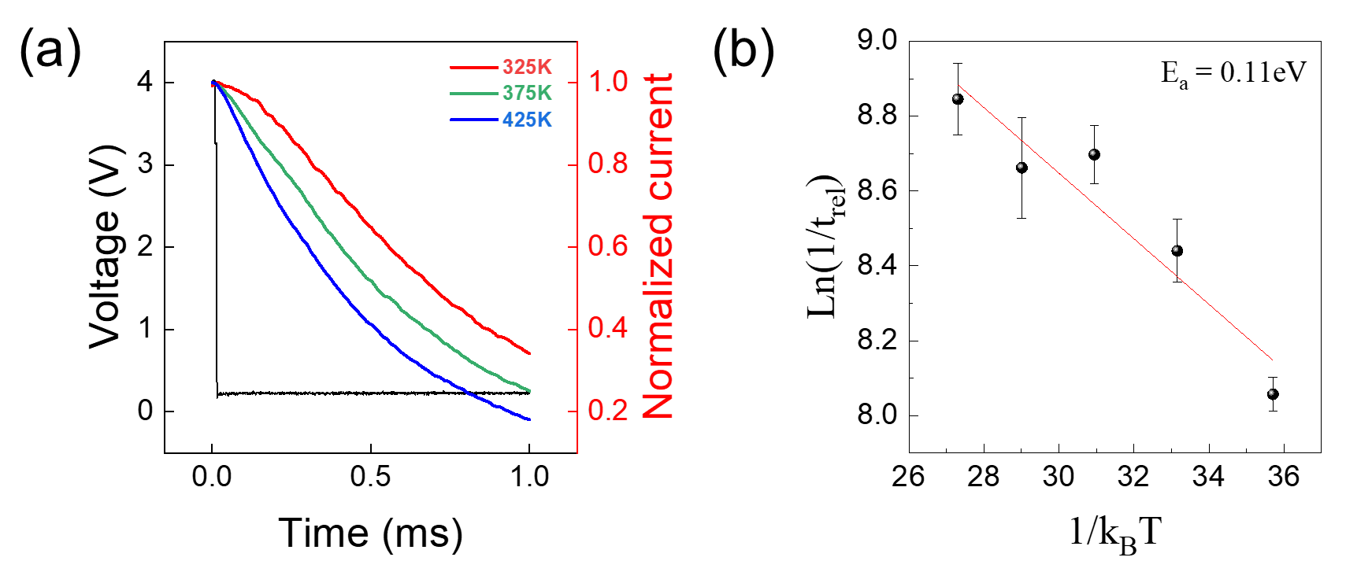
Supplementary Fig. 3. Relaxation dynamics in the dynamic memristor with varying ambient temperatures. (a) Relaxation behavior of the dynamic memristor at various ambient temperatures under a fixed pulse voltage condition (2.8 V and 2.5 ms) and a load resistance of 10 MΩ. (b) Derivation of activation energy from relaxation times at different ambient temperatures.

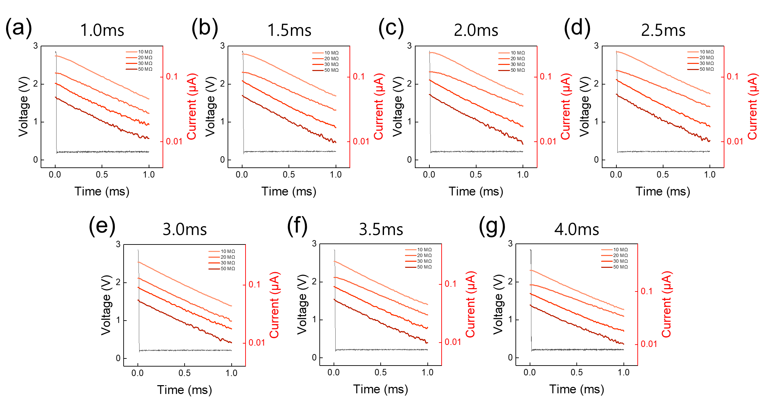
Supplementary Fig. 4. Relaxation dynamics in the dynamic memristor under varying serial resistances. Relaxation behavior of the dynamic memristor at different pulse lengths: (a) 1.0 ms, (b) 1.5 ms, (c) 2.0 ms, (d) 2.5 ms, (e) 3.0 ms, (f) 3.5 ms, and (g) 4.0 ms. The pulse amplitude was fixed to 2.8 V.

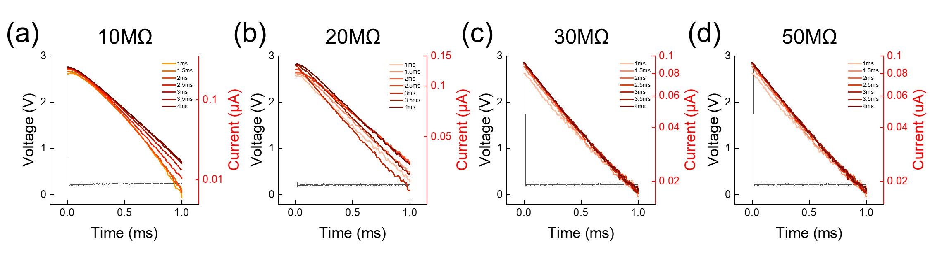
Supplementary Fig. 5. Relaxation dynamics in the dynamic memristor under varying pulse lengths. Relaxation behavior of the dynamic memristor at different serial resistances: (a) 10 MΩ, (b) 20 MΩ, (c) 30 MΩ, and (d) 50 MΩ. The pulse amplitude was fixed to 2.8 V.

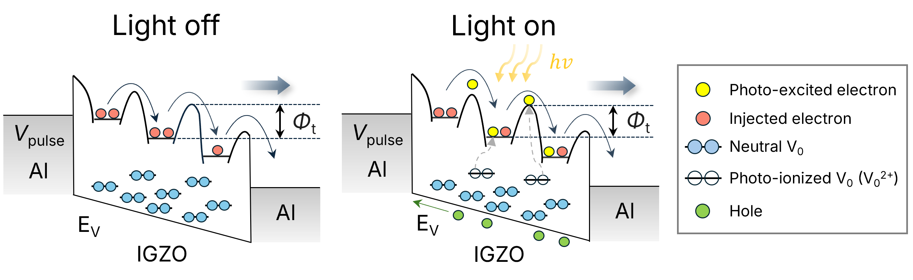
Supplementary Fig. 6. Band diagrams of AIA optomemristor. Trap energy levels at light-off and light-on conditions are 0.56 ± 0.02 eV and 0.57 ± 0.02 eV, respectively. The unchanged $qϕ_{T}$ indicates that these traps act as stable centers for capturing photo-excited electrons, hindering recombination of the electron-hole pair and generating increased photocurrent.

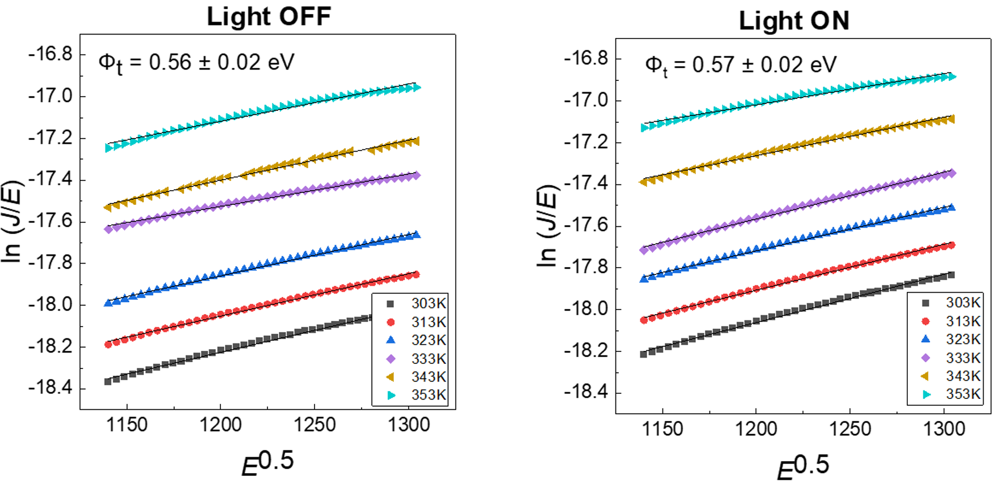
Supplementary Fig. 7. Temperature dependence of AIA optomemristor. Ln (J/E) vs E^{0.5} plot at various temperatures on light-off and light-on conditions. Trap energy levels at light-off and light-on conditions are 0.56 ± 0.02 eV and 0.57 ± 0.02 eV, respectively.

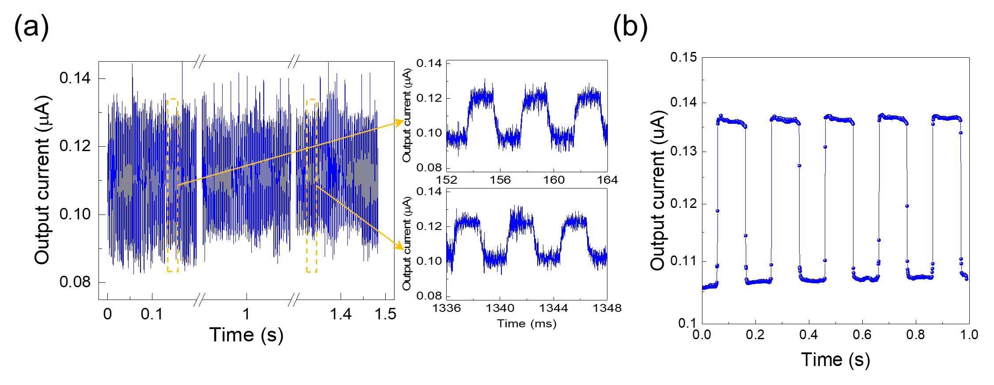
Supplementary Fig. 8. Long-term stability of Al/IGZO/Al optomemristor. (a) Endurance test of light response for 1.5 seconds. Light pulse is applied at fixed intensity and pulse length of 12.35 mW/cm² and 2 ms, respectively, under an applied voltage of 2.8 V. (b) Stability test of light response. Light-on and light-off states are maintained for 100 ms under a fixed voltage of 2.8 V.

Supplementary Fig. 9. Output current levels measured during repeated light switching cycles for the light-on and light-off states. The distinct separation of current levels under illumination and in the dark confirms the device's stable and reliable optical switching behavior.

Supplementary Note 1. Electrical conduction mechanism of the Al/IGZO/Al optomemristor with and without light

Supplementary Figs. 6 and 7 present the band diagrams of the Al/IGZO/Al optomemristor and the corresponding conduction mechanisms derived from the fitting results. To further analyze the effect of light, temperature-dependent measurements were conducted under light-off and light-on conditions over the temperature range 303 K to 353 K and the voltage range 2.8 to 3.4 V.
The experimental data follow the log (J/E vs. E^{0.5}) relationship, indicating that Poole-Frenkel (P-F) emission is the dominant conduction mechanism in this region¹. The following equation describes P-F emission:

$J=qμN_{c}Eexp\left[\frac{-q(ϕ_{T}-\sqrt{qE/πε_{r}ε_{0}})}{kT}\right]$ (S1)

, where $q$ is the electronic charge, $μ$ is the electronic drift mobility, $N_{c}$ is the density of states in the conduction band, $E$ is the electric field across the dielectric film, $k$ is Boltzmann’s constant, $qϕ_{T}$ ($Φ_{T}$) is the trap energy level, $ε_{0}$ is the permittivity in a vacuum, and $ε_{r}$ is the optical dielectric constant². The extracted trap energy levels were 0.56 ± 0.02 eV and 0.57 ± 0.02 eV under light-off and light-on conditions, respectively. The unchanged $qϕ_{T}$ indicates that these traps act as stable centers for capturing photo-excited electrons, hindering recombination of the electron-hole pair and generating increased photocurrent^{3,4}.

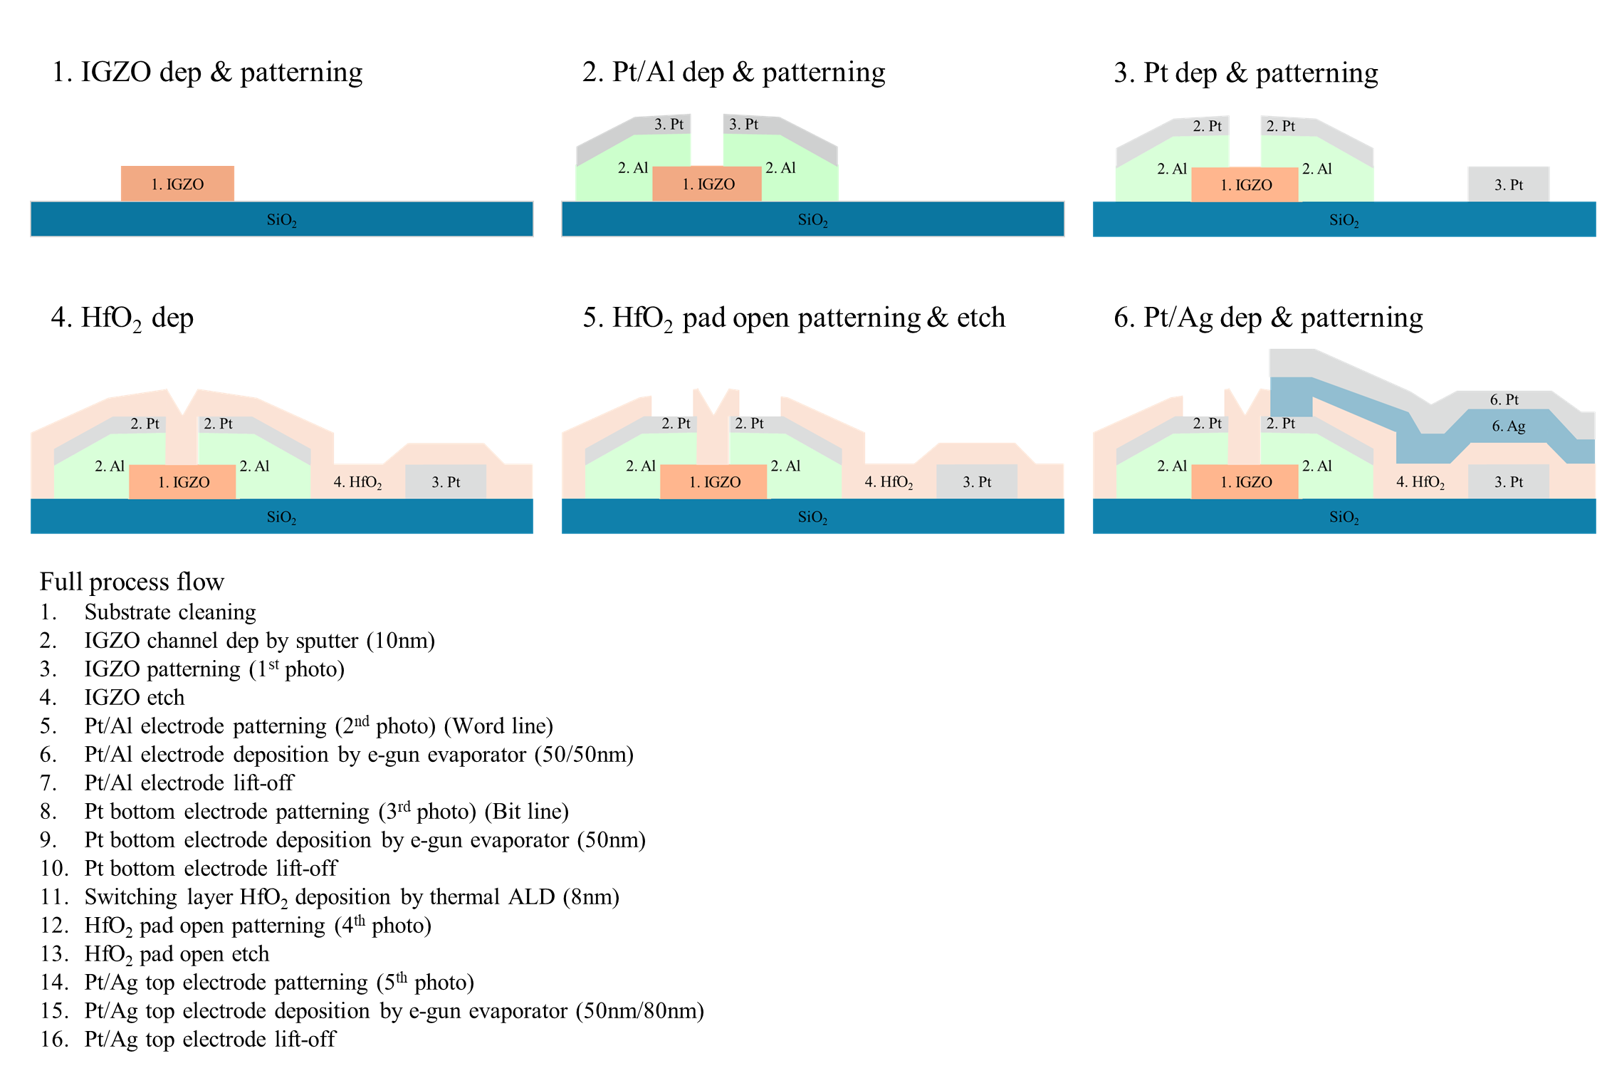

Supplementary Fig. 10. Fabrication process flow of the integrated motion streak neuron.

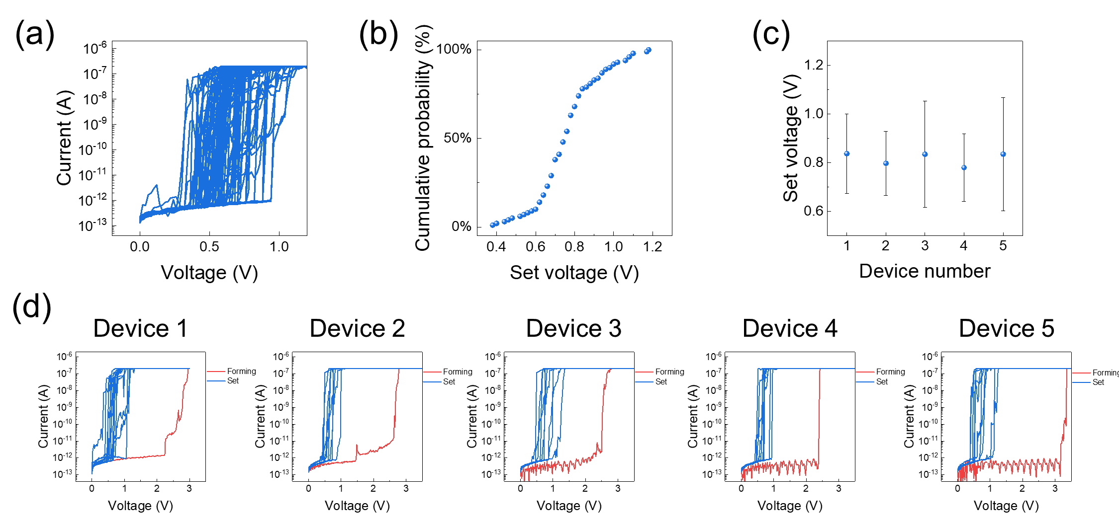
Supplementary Fig. 11. I-V characteristics of Ag/HfO₂/Pt dynamic memristor in an integrated structure. (a) I-V curves of the dynamic memristor and (b) cumulative probability of set voltages. (c) Set voltages of five devices, each swept over 20 cycles, and (d) their experimental data.

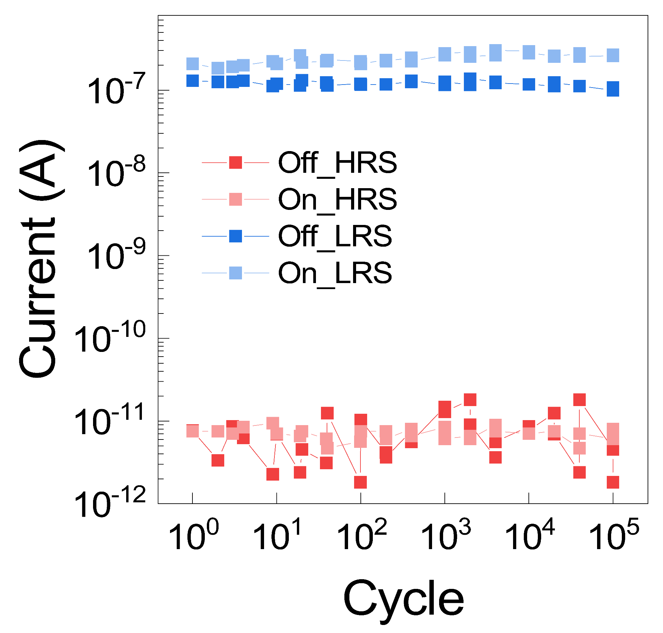
Supplementary Fig. 12. AC endurance of the integrated Ag/HfO₂/Pt dynamic memristor and Al/IGZO/Al optomemristor.

Supplementary Fig. 13. Device-to-device variation of relaxation dynamics in the motion streak neuron with varying pulse lengths. The voltage pulse was set to 4 V during the light-on condition. (a) Output current at varying pulse lengths across 16 pixels. (b) Relaxation time at varying pulse lengths across 16 pixels.

Supplementary Fig. 14. Output current variations in motion streak neurons with varying pulse lengths. The voltage was set to 4 V during the light-on condition.

Supplementary Fig. 15. Relaxation time variation in motion streak neurons with varying pulse lengths. The voltage was set to 4 V during the light-on condition.

Supplementary Note 2. GPIB-based Laser Module Driving and Timing Control Scheme

In this study, a general-purpose interface bus (GPIB)-controlled laser-driving scheme was employed to precisely control the optical stimulation conditions for the memristive motion-streak neuron. A high-power laser module was driven through a bipolar junction transistor (BJT) configured as a current-switching element. In this configuration, a bias voltage was applied to the laser module's anode to provide a stable voltage source suitable for laser illumination, while the collector terminal was connected to the laser module's cathode. The transistor's base terminal was driven by digital output signals from a microcontroller unit (MCU). By modulating the pulse length and timing of the optical stimulation, the transistor was selectively switched between the on and off states, enabling precise control of the laser emission. The laser output was directed toward the device under test (DUT) via a multilayer reflective-optics assembly. By adjusting the optical path and reflection geometry, both the incidence direction and scanning trajectory of the laser could be systematically modulated.

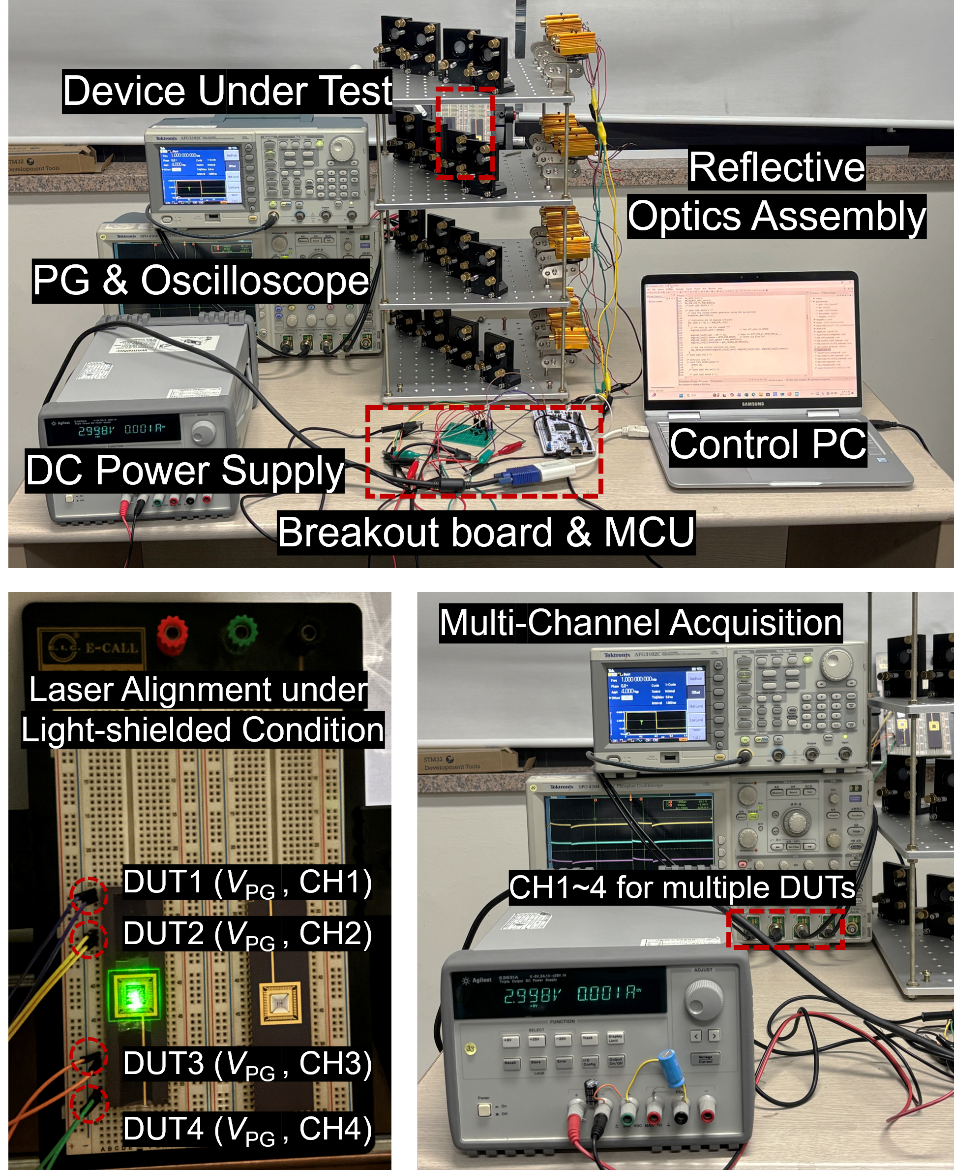
Supplementary Fig. 16. Optical board setup for motion streak neuron hardware.
Optical and electrical pulses were applied synchronously via a GPIB-controlled pulse generator. The reflected laser beams from the multilayer optics assembly were directly applied to the wire-bonded motion-streak neurons (device under test). The oscilloscope captured relaxation responses from multiple DUTs under sequential optical stimulation.
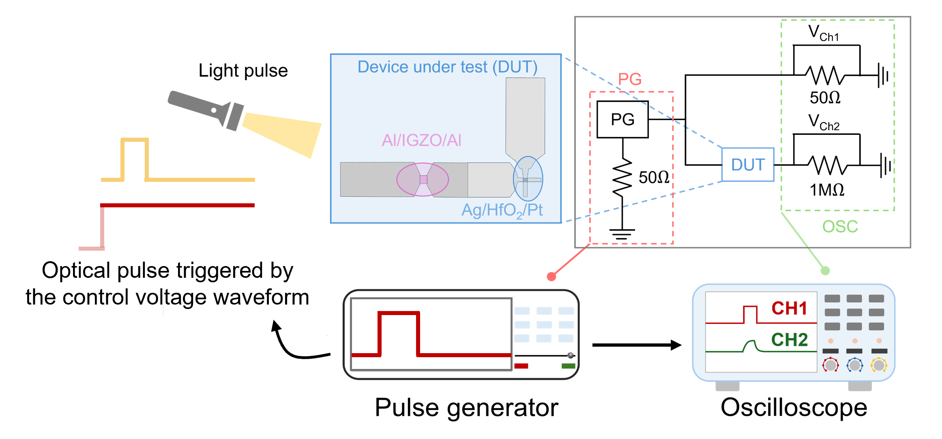
Supplementary Fig. 17. A light pulse measurement system for observing the relaxation time of motion streak neuron based on the pulse length. A light pulse is triggered when a voltage pulse is applied to channel 1, and the measured current is read from channel 2 of the oscilloscope.

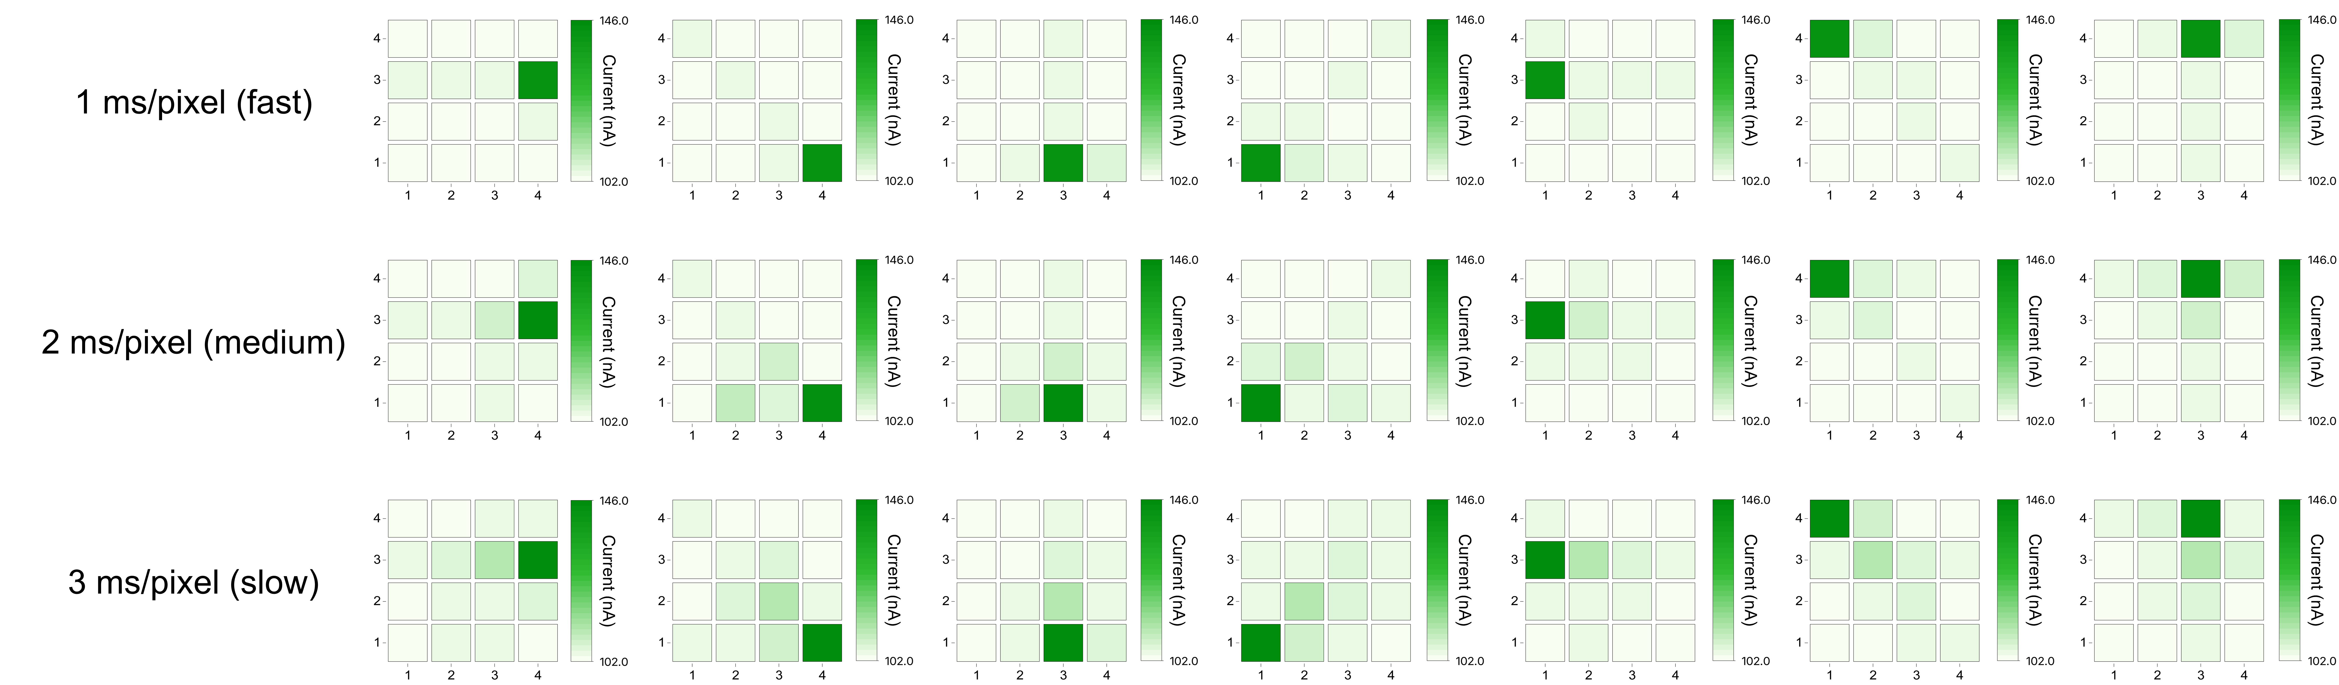
Supplementary Fig. 18. Measured optical responses of multiple motion streak neurons stimulated by light pulses moving in left, right, and diagonal directions.

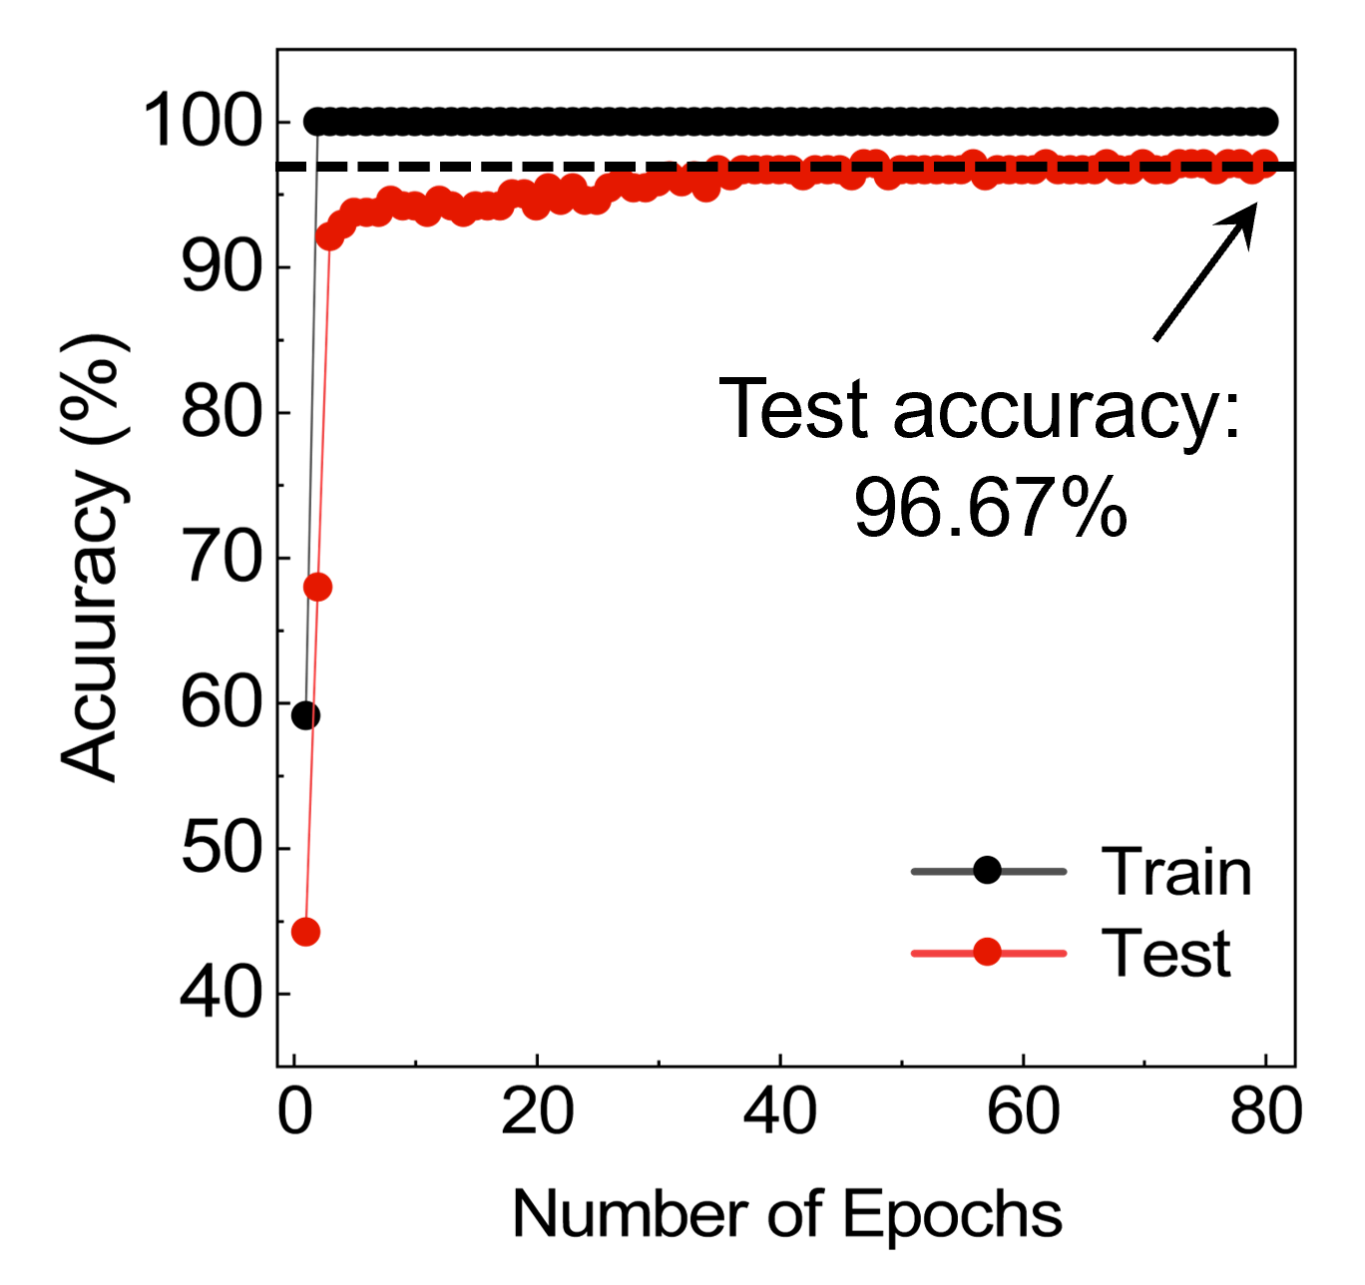
Supplementary Fig. 19. Single object movement classification using reflective optics assembly.
The test accuracy saturates at 96.67%, demonstrating the motion-streak neuron's ability to reliably distinguish arbitrary motion velocities and directions.

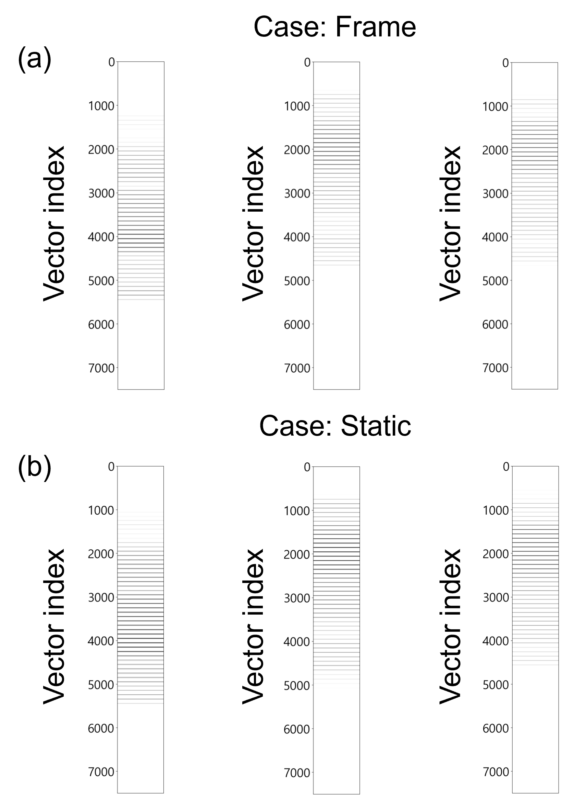
Supplementary Fig. 20. Flattened output vectors (7500 × 1) derived from motion streak neuron responses for three visual scenarios.
The results are shown for both the frame-based and static relaxation–based cases, where the responses of motion streak neurons are rearranged into a one-dimensional form for comparison.

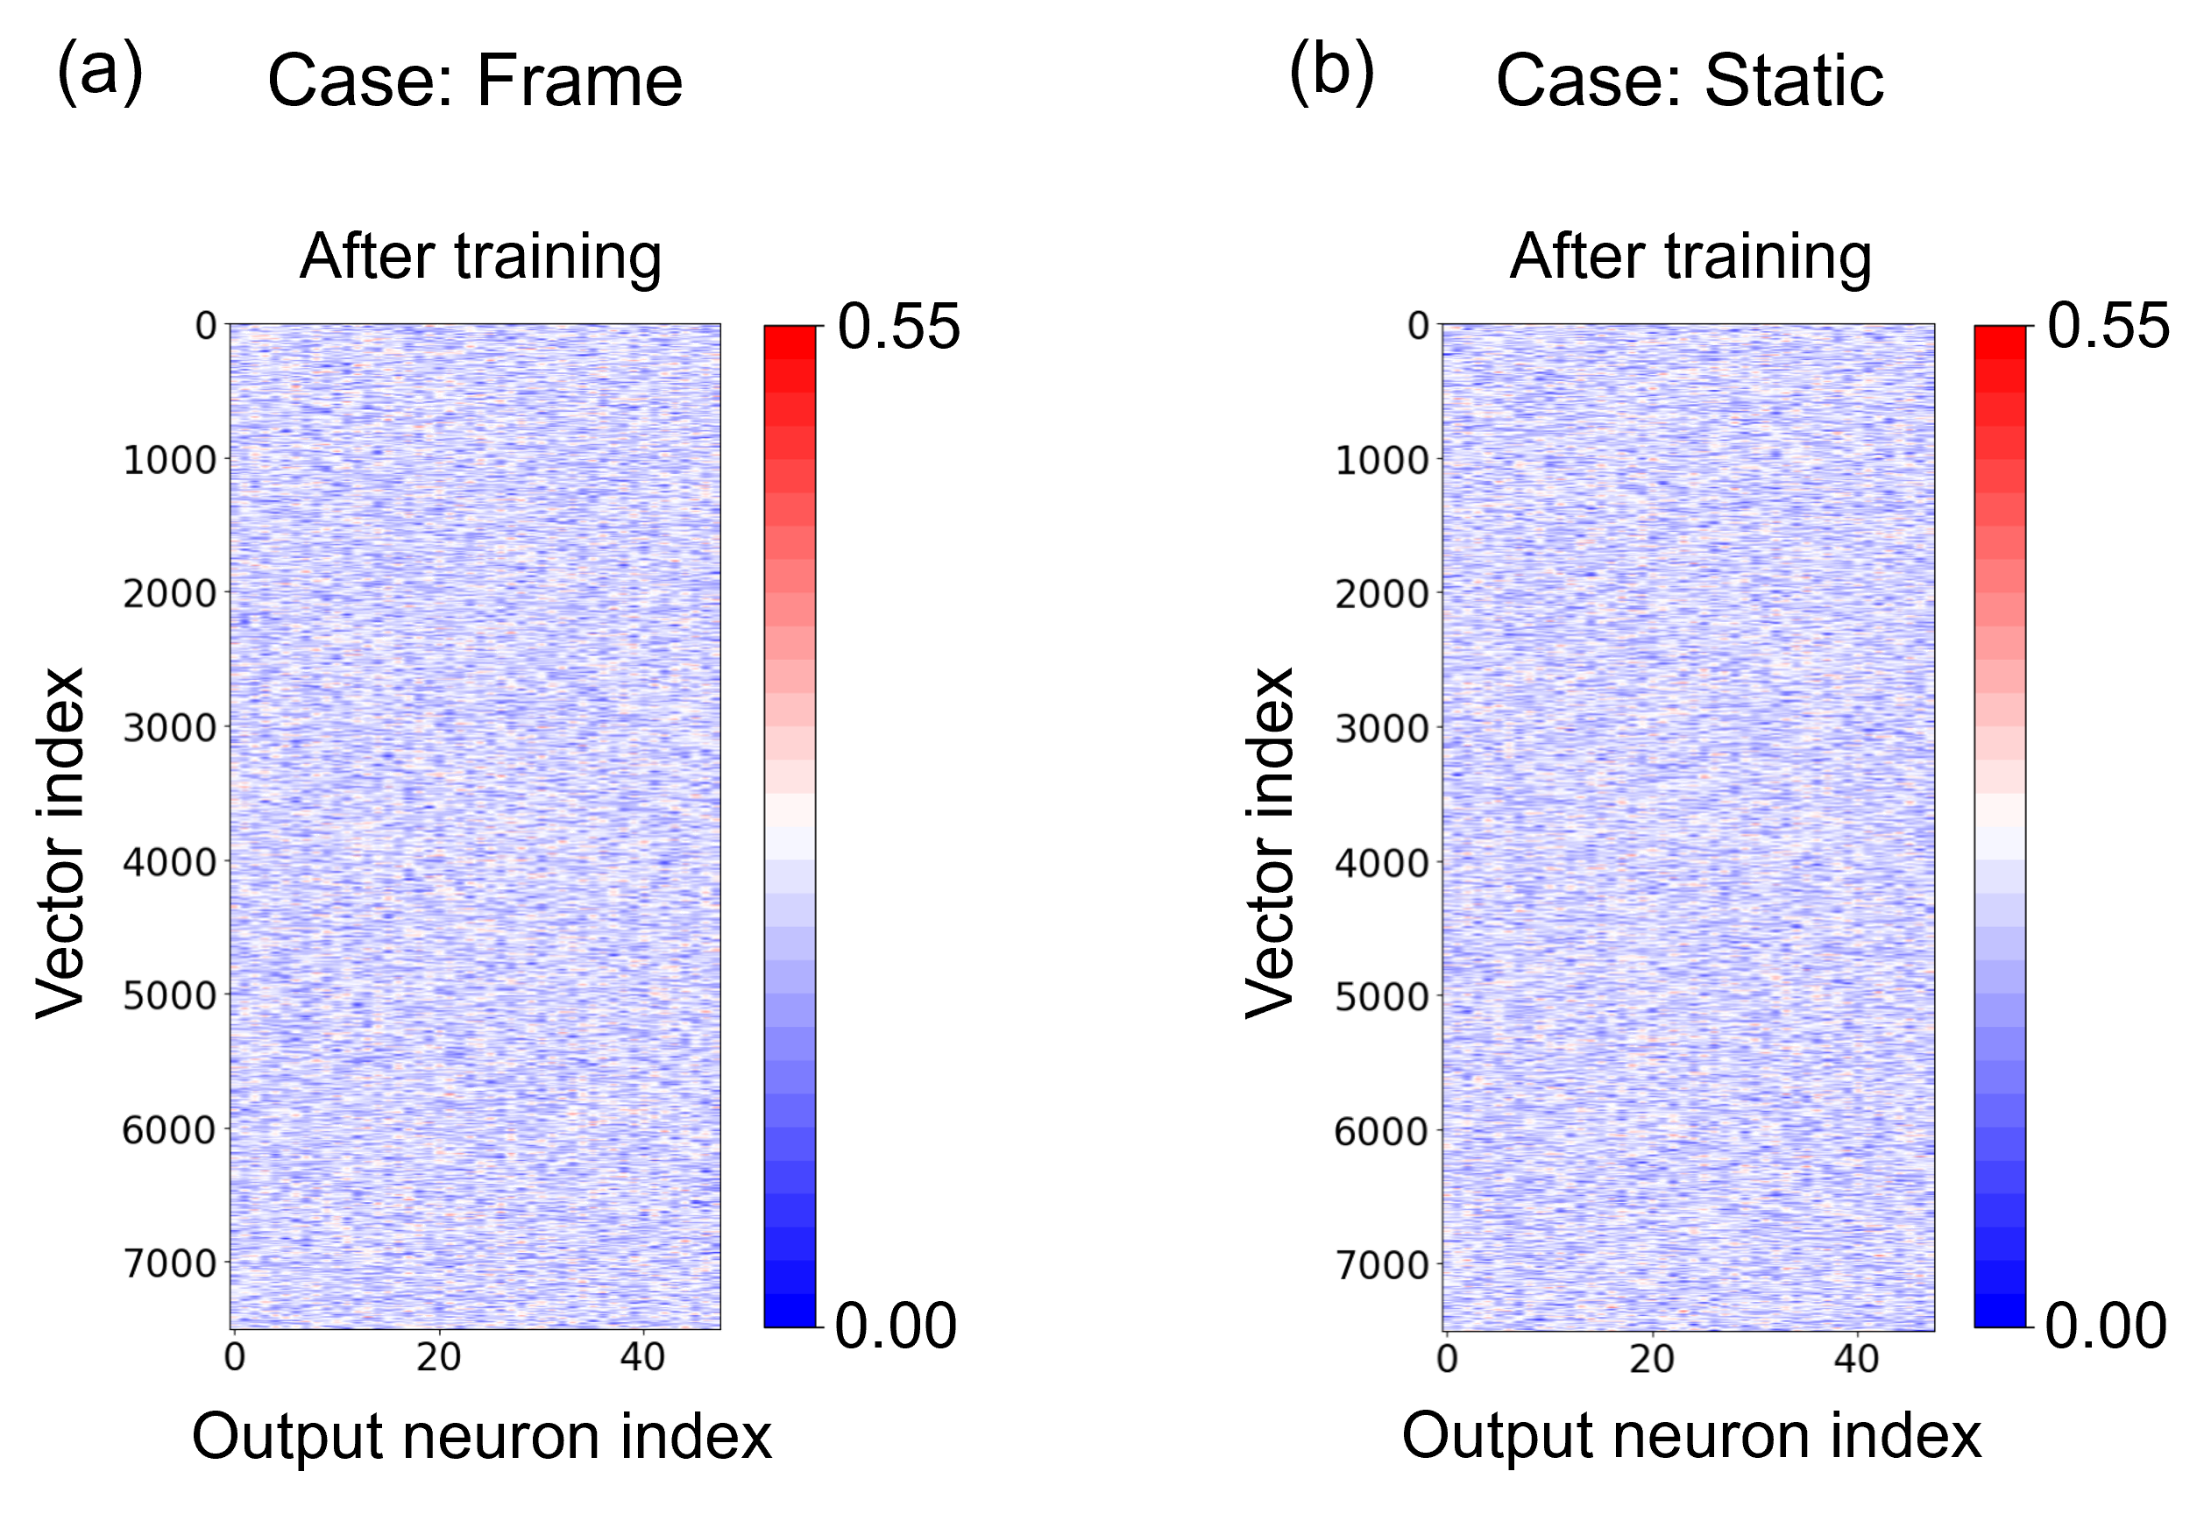
Supplementary Fig. 21. Visualization of the learned weight distributions across output neuron indices after training for (a) the frame-based and (b) static relaxation–based processing.
Each heatmap shows the magnitude of the weight assigned to each output neuron for each vector.

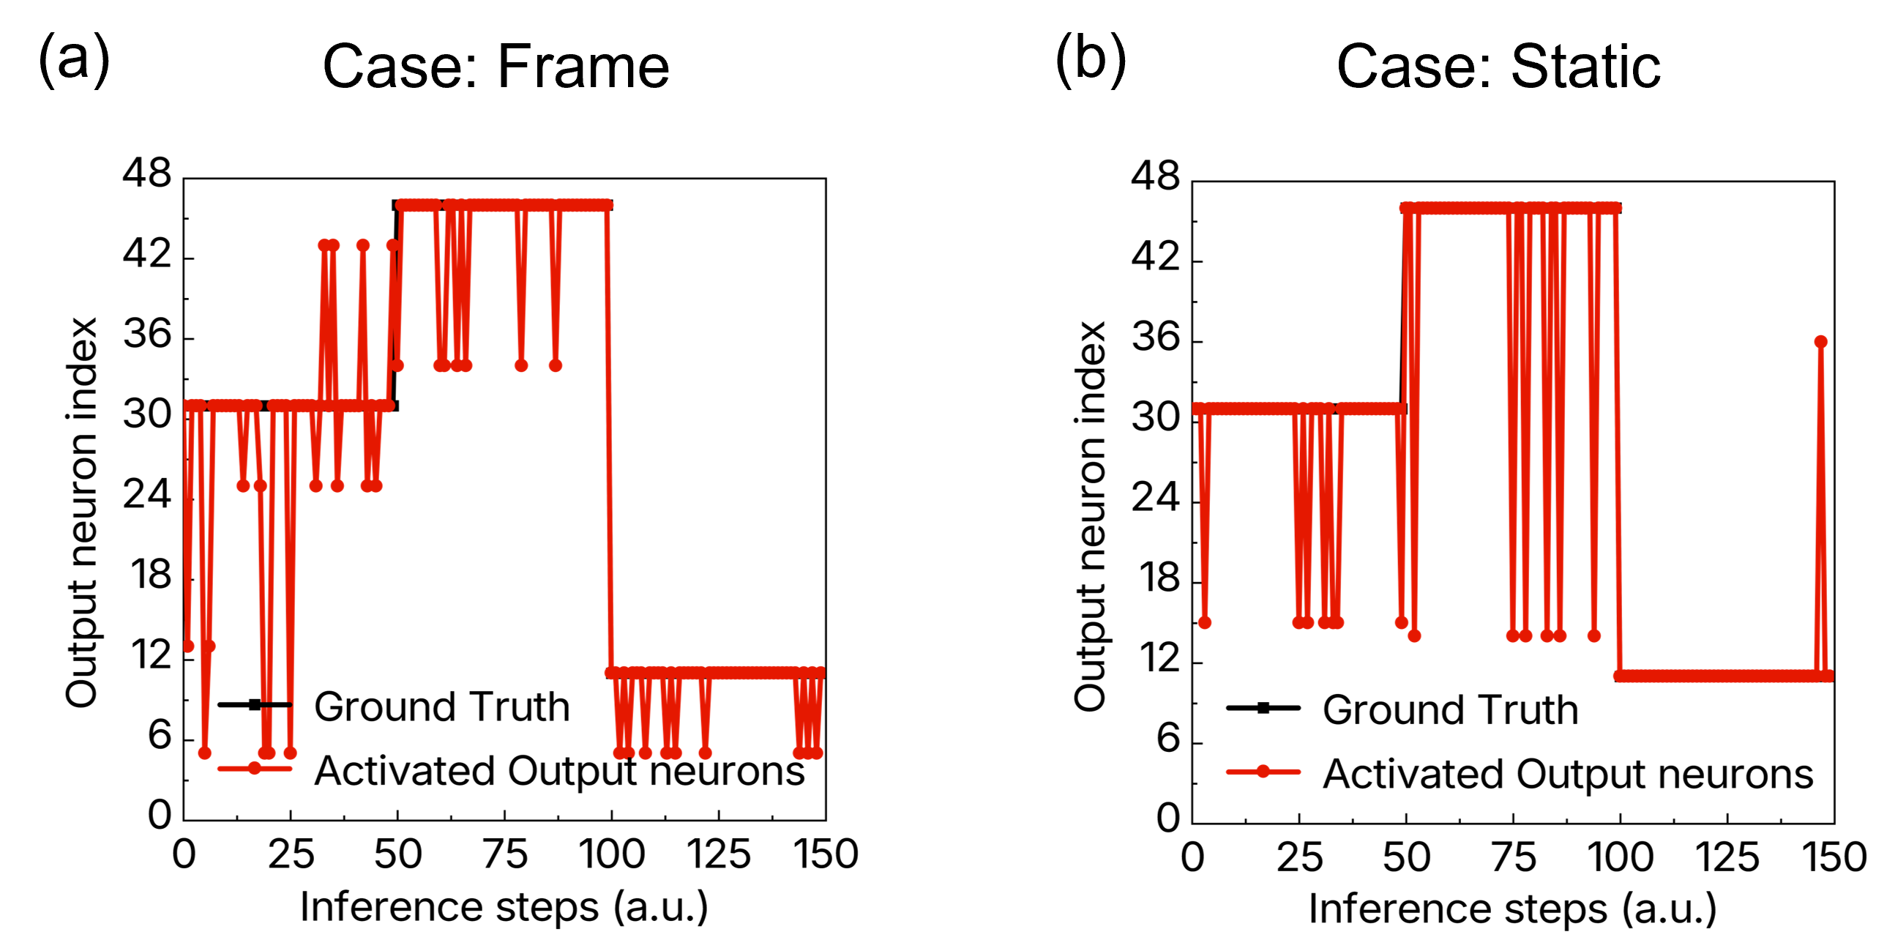
Supplementary Fig. 22. Flattened output vectors (7500 × 1) derived from three arbitrary visual scenarios, where the output neuron index encodes object identity, motion direction, and speed. The resulting activation patterns represent the classification outcome for the frame-based and static relaxation–based processing schemes.
Supplementary Fig. 23. Confusion matrix illustrates the classification results for multiple moving-object scenarios (two object identities (O1, O2), eight motion directions, and three distinct speed levels). The diagonal structure confirms high classification fidelity, demonstrating that the proposed system effectively resolves object identity, directionality, and dynamic motion speeds across arbitrary visual conditions.

Supplementary Fig. 24. Variation in test accuracy over ten trials with respect to the coefficient of variation for 48 labels (2 object identities, 8 directions, 3 movement speeds). Despite the increasing standard deviation relative to the average current value, test accuracy is mostly unaffected. This suggests that the motion streak neuron is resilient to current variations.
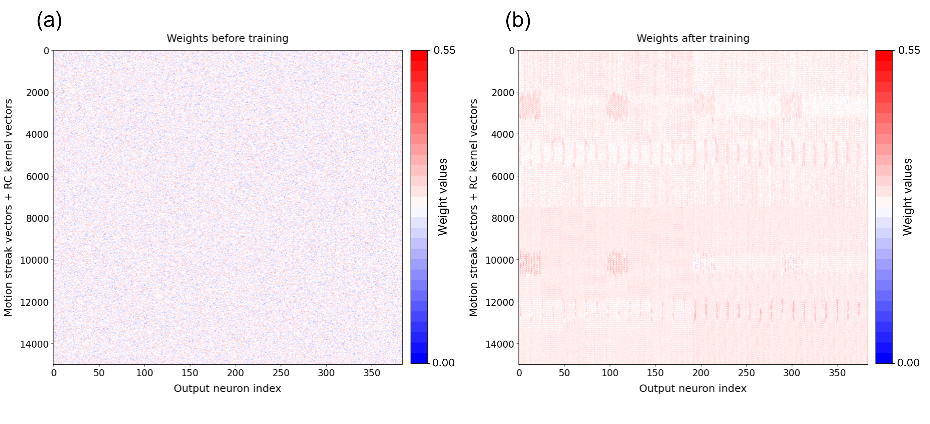
Supplementary Fig. 25. Visualization of the learned weight distributions across output neuron indices after training for arbitrary complex visual scenarios.
Each heatmap shows the magnitude of the weights assigned to individual output neurons for motion streak and RC kernel vectors.

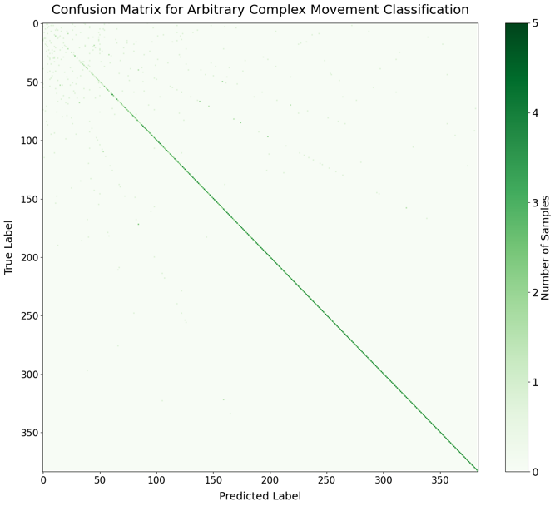
Supplementary Fig. 26. Confusion matrix illustrates the classification results for complex visual scenarios (two object identities (O1, O2), eight motion directions for trajectory 1 and 2, and three distinct speed levels). The diagonal structure demonstrates that the integrated motion streak neuron and RC kernel effectively resolve object identity, complex trajectory, and dynamic motion speeds across arbitrary visual conditions.

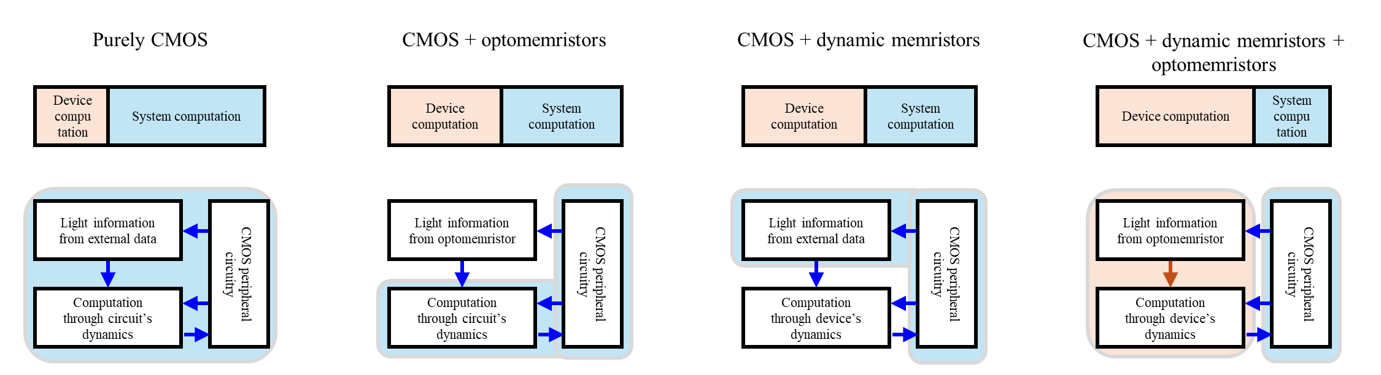
Supplementary Fig. 27. Schematic representation of the transition from simulating biological mechanisms using a purely CMOS approach to emulating them with dynamic memristor and optomemristor.

References
[1] H.-W. Yeon, S.-M. Lim, J.-K. Jung, H. Yoo, Y.-J. Lee, H.-Y. Kang, Y.-J. Park, M. Kim, Y.-C. Joo, NPG Asia Mater. 8, e250 (2016).
[2] F.-C. Chiu, C.-M. Lai, J. Phys. D: Appl. Phys. 43, 075104 (2010).
[3] H. Wei, X. Ji, J. Cao, W. He, H. Liu, Z. Pan, X. Song, Q. Sun, J. Li, C. Wu, ACS Nano 18, 26643 (2024).
[4] M. D. Ward, A. J. Bard, J. Phys. Chem. 86, 3599 (1982).

