Supplementary Materials for

Toll-like Receptor 2 Exerts Oligodendrocyte Protection in White Matter Stroke Through Downstream NF-κB-cIAP2

Hanki Kim^{1,2,6,7†}, Xuelian Jin^{1,8†}, Jun Young Choi^{1,3,6†*}, Samma Tasneem Chowdhury¹, Yue-Xian Cui^{1,9}, Hyo Jin Cho¹, Bum Jun Kim¹, Seungyon Koh^{1,4}, Seung Eun Lee¹⁰, Su Bin Lim⁵, Byung Gon Kim^{1,3,6*}

Correspondence to: taz312@gmail.com, kimbg@ajou.ac.kr

This PDF file includes:

Materials and Methods
Supplementary Text
Figures. S1 to S5
Table S1

Other Supplementary Materials for this manuscript include the following:

Uncropped raw immunoblot images

Materials and Methods
Primary oligodendrocyte culture
Primary OPCs were isolated from cerebral cortices of postnatal day 1 Sprague-Dawley rats, following a method utilizing differential centrifugation with density gradient-forming agent OptiprepTM, developed in this laboratory. The obtained OPCs were seeded onto Poly-D-Lysine (PDL, Gibco, #A3890401)-coated T75 flasks (Corning, #430641 U) at a density of 1 × 10⁴ cells/cm² and allowed to proliferate for five days in a 37°C/5% CO₂ culture incubator, in OPC medium; Dulbecco’s Modified Eagle Medium/Ham’s F12 (DMEM/F12, Thermo Fisher Scientific, #11320033) with 1% GlutaMAXTM (Thermo Fisher Scientific, #35050-061), 1% penicillin/streptomycin (Cytiva, #SV30010), 2% B-27 supplement (Thermo Fisher Scientific, #17504-044), 30 ng/mL platelet-derived growth factor-AA (PDGF-AA, PeproTech, #100-13A), 10 ng/mL fibroblast growth factor (FGF, PeproTech, #100-18B), 10 ng/mL epidermal growth factor (EGF, PeproTech, #AF-100-15). At day five, OPCs were washed with phosphate buffered saline (PBS), passaged with Accutase® (Thermo Fisher Scientific, #A11105-01), pelleted at 200 × g/3 min/room temperature (RT = ~23°C), re-seeded onto desired culture surfaces at 1 × 10⁴ cells/cm², and differentiated for 24 hours in OL differentiation medium; Neurobasal medium (NBM, Thermo Fisher Scientific, #21103049) with 1% GlutaMAX, 1% penicillin/streptomycin, 2% B-27 supplement, 1% N2 supplement (Thermo Fisher Scientific, #17502048) and 40 ng/mL triiodothyronine (thyroid hormone T3, Sigma Aldrich, #T6397).

Transfection of siRNA and overexpression plasmids to primary OLs
The Amaxa Nucleofector® electroporation system and basic Nucleofector® kit for primary mammalian glial cells (Lonza, #VPI-1006) was used to transfect siRNAs and overexpression plasmids for each candidate protein; siRNA for ERK1/2 (Santa Cruz, #sc156030 & #sc156031), p38 (Santa Cruz, #sc156091), CREB (Santa Cruz, #sc72030), cIAP2 (Thermo Fisher Scientific, #s134950) or p65 (Santa Cruz, #sc61876), and overexpression plasmids for IKK2 (Addgene, #11105), MKK6 (Addgene, #13518), and cIAP2 (Origene, #RC207764). Briefly, OPCs, detached and pelleted after five days of proliferation, were resuspended with Nucleofector® solution with the designated siRNA/plasmid or corresponding control siRNA (Santa Cruz, #sc37007)/control plasmid (Origene, #PCMV-6XL4). Resuspended OPCs were transferred into an electroporation cuvette and were electroporated using the Nucleofector® II machine (program number for OLs/glia: A-033 or O-017). OL differentiation medium was added immediately after electroporation. OPCs were seeded onto designated culture surfaces at 3 × 10⁴ cells/cm² in OL differentiation medium and cultured for 24 hours before OGD exposure.

Immunoblotting
Cultured OLs were washed twice with PBS and harvested with a lysis buffer containing 20 mM Tris-HCl (pH 7.5), 1 mM EDTA, 5 mM MgCl₂, 1 mM dithiothreitol, 0.1 mM phenylmethylsulfonyl fluoride, and a protease/phosphatase inhibitor cocktail. Cell lysates were centrifuged at 20,000 × g/20 min/4°C. Protein concentration was quantified by the Bradford assay (Bio-Rad, #5000205). Sodium dodecyl sulfate polyacrylamide gel electrophoresis (SDS-PAGE) was done with 10 % or 4-20 % gradient gels (Bio-Rad), and the proteins on the gels were transferred to polyvinylidene fluoride (PVDF) membranes. The membranes were blocked with 5% nonfat milk or 5% bovine serum albumin for 1 hours at room temperature and then incubated with the following primary antibodies; anti-phospho-AKT (Cell Signaling Technology, #9271S, 1:1000), anti-total-AKT (Cell Signaling Technology, #9272L, 1:1000), anti-phospho-CREB (Cell Signaling Technology, #9198S, 1:1000), anti-total-CREB (Cell Signaling Technology, #9197S, 1:1000), anti-phospho-ERK1/2 (Cell Signaling Technology, #9101S, 1:1000), anti-total-ERK1/2 (Cell Signaling Technology, #4695S, 1:1000), anti-phospho-JNK (Cell Signaling Technology, #9251S, 1:1000), anti-total-JNK (Cell Signaling Technology, #9252S, 1:1000), anti-phospho-p38 (Cell Signaling Technology, #9211S, 1:1000), anti-total-p38 (Cell Signaling Technology, #9212S, 1:1000), anti-phospho-p65 (Cell Signaling Technology, #3033, 1:1000), anti-total-p65 (Abcam, #ab16502, 1:1000), anti-Bcl2 (Santa Cruz, #sc-7382, 1:1000), anti-cIAP2 (Abcam, #ab23423, 1:1000), anti-IκB-ɑ (Santa Cruz, #SC-371, 1:1000), anti-FLAG (Abcam, #F1804, 1:1000), anti-Myc (Cell Signaling Technology, #2278T, 1:1000), anti-ɑ-tubulin (Abcam, #ab40742, 1:20,000), anti-β-Actin (Abcam, #ab8227, 1:1000). After repeated washing with 0.05% TBST, the membranes were incubated at RT with horse radish peroxidase-conjugated secondary antibodies. Finally, the membranes were visualized using enhanced chemiluminescence detection (Pierce).

Animals and surgical procedures
C57BL/6 male mice (Orient Bio, Republic of Korea) or TLR2 (-/-) male mice (on a C57BL/6 background; 25–28 g, generated by Takeuchi, O., et al.), were used. Mice were housed four or five per cage in a temperature- and humidity-controlled facility under a 12-hour light/dark cycle with ad libitum access to food and water. All procedures adhered to ethical guidelines to minimize animal suffering and the number of animals used, reviewed and approved by the Institutional Animal Care And Use Committee of Ajou University. The optimal number of animals was determined based on prior studies.
The focal internal capsule WMS model was established as previously described with slight modifications. Mice were anesthetized via intraperitoneal injection of ketamine (90 mg/kg) and xylazine (10 mg/kg), and the head was secured to a stereotaxic frame. A craniotomy was performed using a drill. The stereotaxic coordinates were: -1.0 mm posterior to the bregma, -2.8 mm lateral to the midline, and -4.3 mm ventral from the skull surface. The needle was angled at 20° from the midline, away from the injection site, to minimize damage to overlying cortical and hippocampal structures. Three weeks before L-NIO injection, 1 μL of AAV9-mMBP-mCherry or AAV9-mMBP-IKK2-FLAG was injected into the right internal capsule. Three weeks after viral injection, focal WMS was induced by the administration of L-NIO dihydrochloride (Tocris, #0546, 10 mg/mL, 500 nL) into the same location. For both injections, the flow rate was 100 nL/min, and the needle was left in place for 10 minutes post-injection before being slowly retracted, to prevent overflow or regurgitation. Based on previous studies and preliminary data, animals were sacrificed seven days after WMS induction for analysis. Animals were excluded if they showed no grossly visible L-NIO-induced WMS lesion or died prior to the end of the experiment. A total of 24 animals were used for the final analysis, with no animals excluded.

Tape removal test
To quantify motor-sensory deficits following right internal capsular infarction, we performed a tape removal test, according to a previously described protocol with minor changes. Briefly, easily-removable rectangular color tape strips, 3 mm × 4 mm, were attached to the hairless part of the forepaws. After tape placement, mice were observed in the testing box by two experimenters, and the session was video recorded. The maximum observation time was ninety seconds. Tape removal time was quantified as the duration required for the mouse to remove the tape from the affected (left) forepaw after being placed in the testing box. We measured tape removal time on three occasions; one day before, three days after, and seven days after L-NIO injection. After the last measurement, the animals were sacrifice and perfused for tissue processing.

Tissue processing and immunohistochemistry
After transcardiac perfusion with 4% paraformaldehyde in 0.1 M phosphate buffer (pH 7.4), brains were removed, post-fixed for 2 hours, and then immersed into a graded series of sucrose solutions for cryopreservation. Coronal sections (30μm thick) of the brain were obtained with a cryostat (Leica). To quantify the area of demyelination, coronal brain sections were stained with eriochrome cyanine, a dye that stains myelinated white matter. The eriochrome cyanine solution was composed as such; 24:1 (volume:volume) of 0.2% eriochrome cyanine RC (Sigma Aldrich):10% FeCl₃·6H₂O (Sigma Aldrich) in 3% HCl. For immunofluorescent staining, brain sections were incubated overnight at 4°C with the following primary antibodies: anti-cleaved-caspase 3 (Cell Signaling Technology, #9664S, 1:200), anti-cIAP2 (Abcam, #ab23423, 1:200), anti-GFAP (Dako, #Z033429-2, 1:500), anti-Iba1 (Wako, #019-19741, 1:500), anti-MBP (Abcam, #ab7349, 1:200), anti-NeuN (Merck Millipore, #MAB377, 1:200), anti-Olig2 (Merck Millipore, #AB15328 & #MABN50, 1:200), anti-phospho-p65 (Invitrogen, #MA5-15160, 1:200). Sections were washed with PBS and then incubated with appropriate Alexa Fluor 488-, 594-, 647, and 680-tagged secondary antibodies (Invitrogen). Slides were mounted with an aqueous mounting medium (Biomeda, #M01) and visualized with a confocal microscope (Carl Zeiss, LSM800).

Figure. S1.
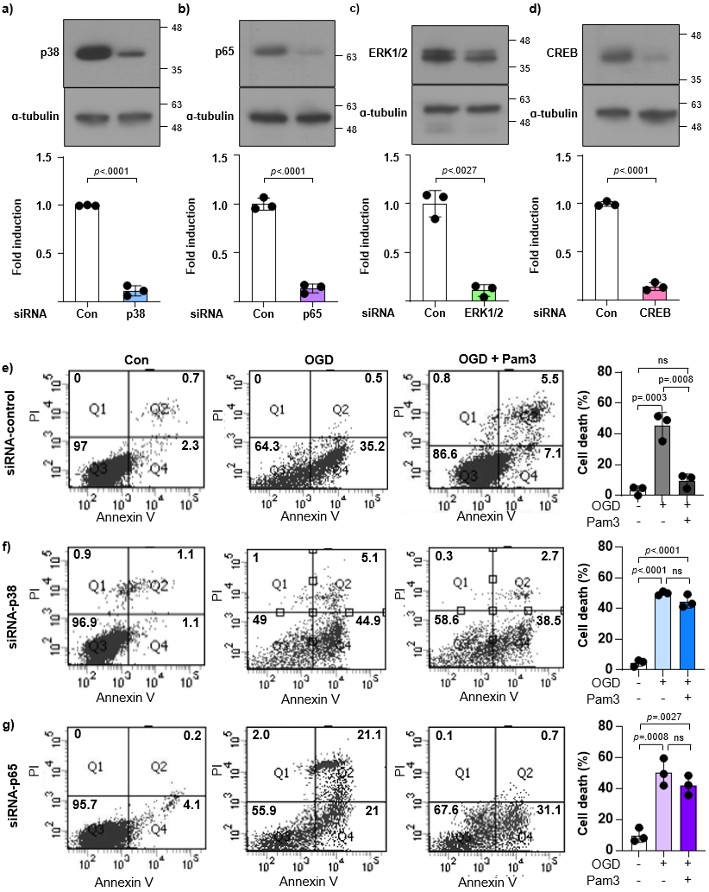
Fig.S1. siRNA knock-down of target genes in primary OLs and its effect on OL death. a-d Immunoblots and corresponding quantification of target genes before and after siRNA knock-down (n=3 biologically independent samples/experiments. Welch’s t-test, two-sided. Data presented as mean values ± SEM). e-g Fluorescence associated cell sorting (FACS) for cell death markers propidium iodide and Annexin V, with corresponding quantification graphs. Cell death (%) = (Number of cells in Q1, Q2, Q4)/(Number of cells in all quadrants) × 100 (n=3 biologically independent samples/experiments. One-way ANOVA and Tukey’s post hoc test, two-sided. Data presented as mean values ± SEM). CREB = cAMP Response Element-Binding protein; ERK = Extracellular signal-Regulated Kinase; OGD = Oxygen-Glucose Deprivation; Pam3 = Pam3CSK4

Figure. S2.
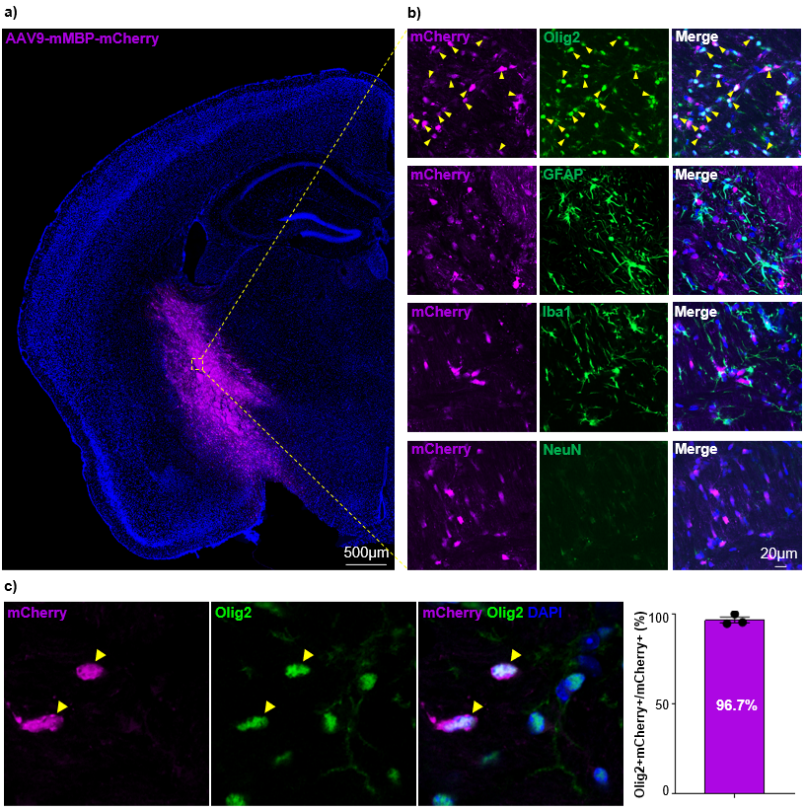
Fig.S2. Oligodendrocyte-specific viral transduction in the mouse internal capsule. a-c Representative images of the mouse internal capsule following viral transduction of mCherry through AAV9-mMBP-mCherry and corresponding quantification graph. Immunostaining for Olig2, GFAP, Iba1 and NeuN (n=3 biologically independent samples/experiments). DAPI = 4′,6-diamidino-2-phenylindole; GFAP = Glial Fibrillary Acidic Protein; MBP = Myelin Basic Protein.

Figure. S3.
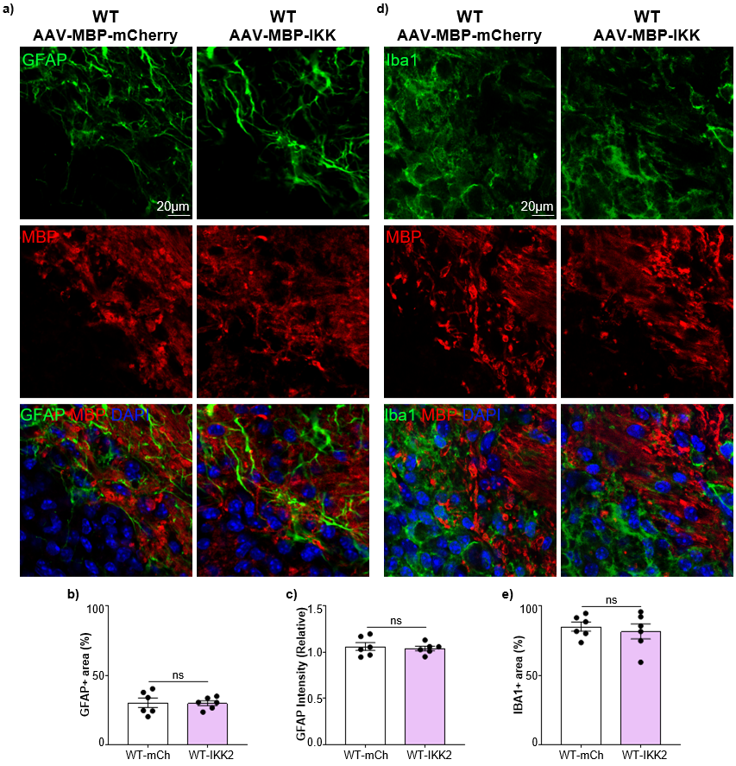
Fig.S3. Effect of IKK activation on astroglial/microglial activation. a-c Representative images of L-NIO induced ischemic lesion borders in the mouse internal capsule following viral transduction, and corresponding quantification graphs. Immunostaining for GFAP and MBP (n=6 biologically independent samples/experiments. Welch’s t-test, two-sided. Data presented as mean values ± SEM). d-e Representative images of L-NIO induced ischemic lesion borders in the mouse internal capsule following viral transduction, and corresponding quantification graphs. Immunostaining for Iba1 and MBP (n=6 biologically independent samples/experiments. Welch’s t-test, two-sided. Data presented as mean values ± SEM). DAPI = 4′,6-diamidino-2-phenylindole; GFAP = Glial Fibrillary Acidic Protein; MBP = Myelin Basic Protein.

Figure. S4.
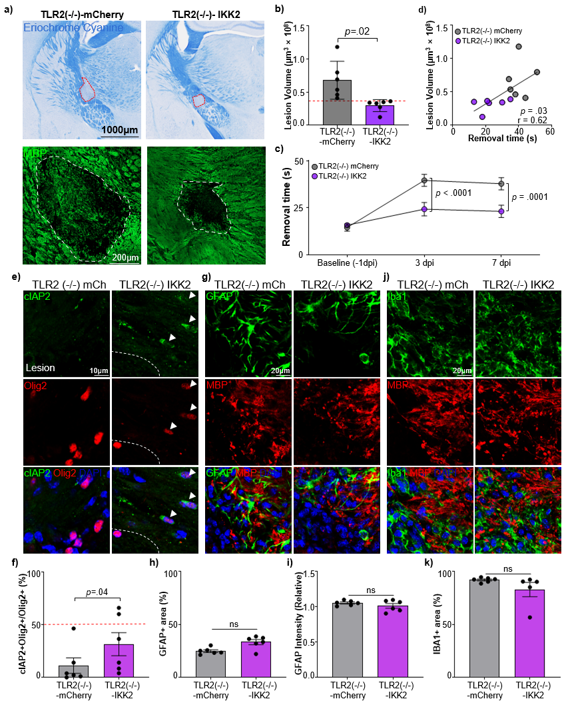
Fig.S4. In vivo oligodendrocyte protection by the NF-κB -cIAP2 axis in the TLR2-deficient L-NIO demyelination model. a Representative images of L-NIO-induced demyelinating lesions in the right internal capsule of the TLR2(-/-) murine brain, stained with eriochrome cyanine or anti-MBP antibodies. b Quantification of lesion volume based on eriochrome cyanine staining in a (n=6 biologically independent samples/experiments. Welch’s t-test, two-sided. Data presented as mean values ± SEM). Red dotted line = average lesion volume of wildtype-mCherry mice. c Quantification of tape removal test results (removal time) by days after L-NIO-induced demyelination (n=6 biologically independent samples/experiments. Two-way ANOVA with Šídák's multiple comparisons test, two-sided). d Correlation between lesion volume and tape removal time (n=6 biologically independent samples/experiments, Pearson’s correlation). e-k Representative images of immunostaining for cIAP2, Olig2, GFAP, MBP and Iba1 with corresponding quantification graphs (n=6 biologically independent samples/experiments. Welch’s t-test, two-sided. Data presented as mean values ± SEM). Red dotted line = average cIAP2+Olig2+/Olig2+ cell percentage of wildtype-mCherry mice. cIAP2 = Cellular Inhibitor of Apoptosis Protein 2; DAPI = 4′,6-diamidino-2-phenylindole; dpi = Days Post-injection; GFAP = Glial Fibrillary Acidic Protein; IKK = IκB Kinase; MBP = Myelin Basic Protein; mCh = mCherry; TLR = Toll-like Receptor

Figure. S5.
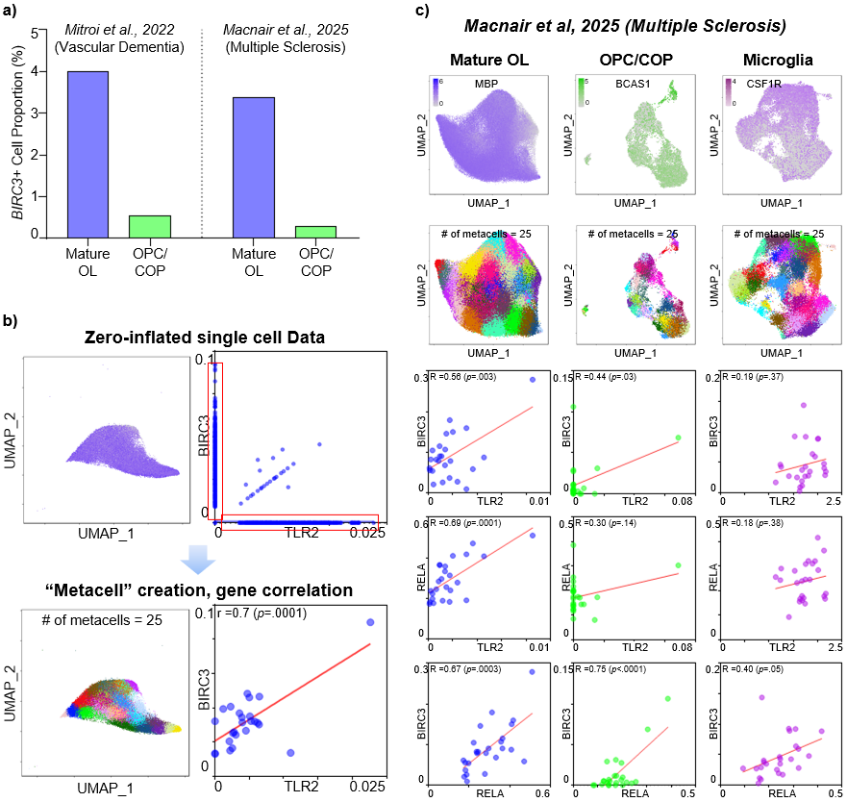
Fig.S5. Generation of “metacells” to evaluate gene-correlation in zero-inflated transcriptome data. a BIRC3+ cell proportions for mature OLs and OPC/COPs in two human brain transcriptome datasets. b Schematic of the generation of “metacells”, aggregations of cells with similar expression profiles (adjacent to each other on UMAP plots) to overcome zero inflation in single-cell level transcriptome data. c UMAP plot of the human multiple sclerosis dataset (Macnair et al., 2025), generation of metacells, and Pearson’s correlation between the three genes TLR2, RELA, and BIRC3 for three cell types; mature OLs, OPCs/COPs, and microglia after generation of metacells. BCAS1 = Breast Carcinoma Amplified Sequence 1; BIRC3 = Baculoviral IAP Repeat Containing 3; CSF1R = Colony stimulating factor 1 receptor; MBP = Myelin basic protein; OPC/COP = Oligodendrocyte progenitor cell/committed oligodendrocyte progenitor; RELA = RELA proto-oncogene, NF-kB subunit; TLR = Toll-like receptor

Table S1.
Gene | Log₂(Fold Change) | Average expression | p | Adjusted p
Cdkn1a | 0.578032276 | 6.749243868 | 6.00E-09 | 2.96E-06
Cdkn2b | 0.458087486 | 4.232676851 | 1.48E-05 | 0.001412399
Cdkn1b | 0.29276531 | 7.345973025 | 0.001212295 | 0.027803897

Table.S1 Expression of cyclin-dependent kinase inhibitor genes in Pam3-treated OLs compared to controls.

