Supplementary Figure 1

Supplementary Figure 2
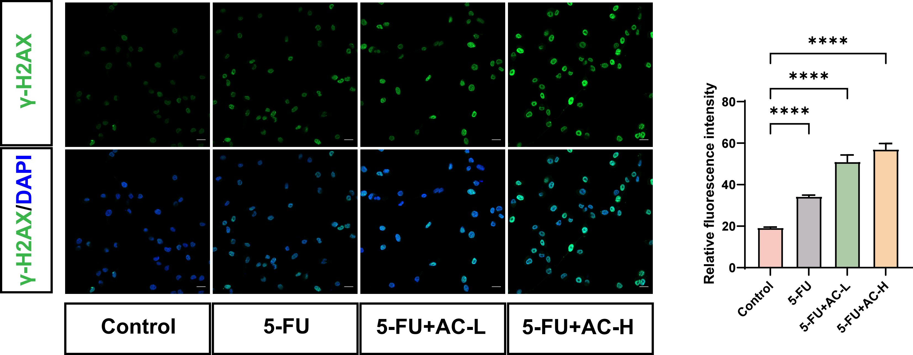

Supplementary Figure 3
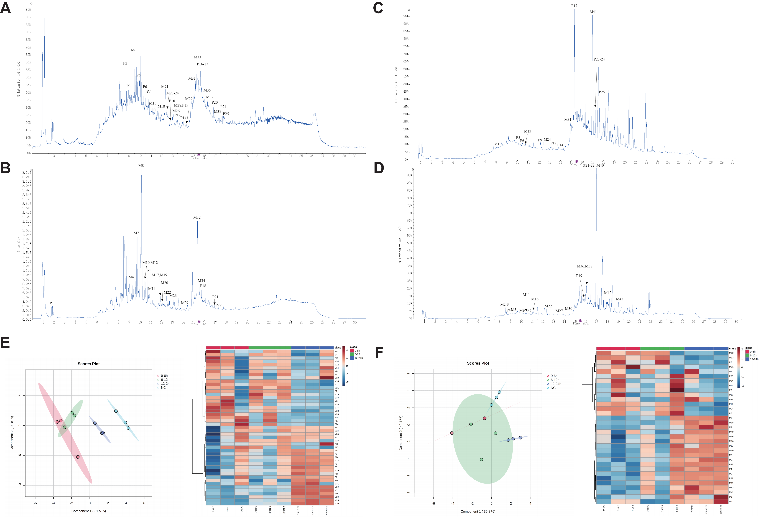

Supplementary Figure 4
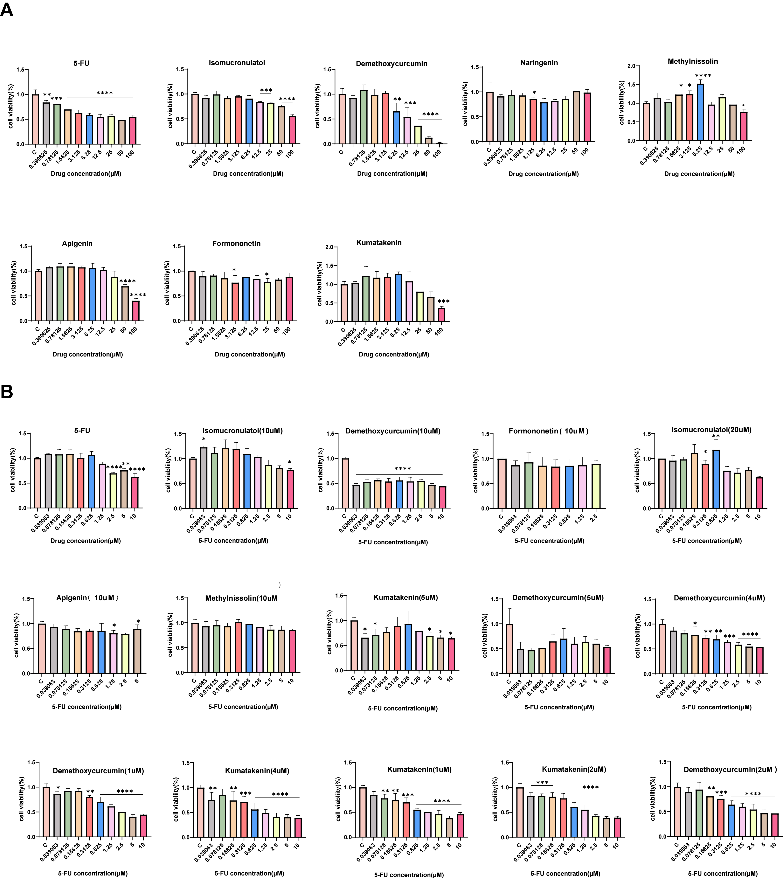

Supplementary Figure 5
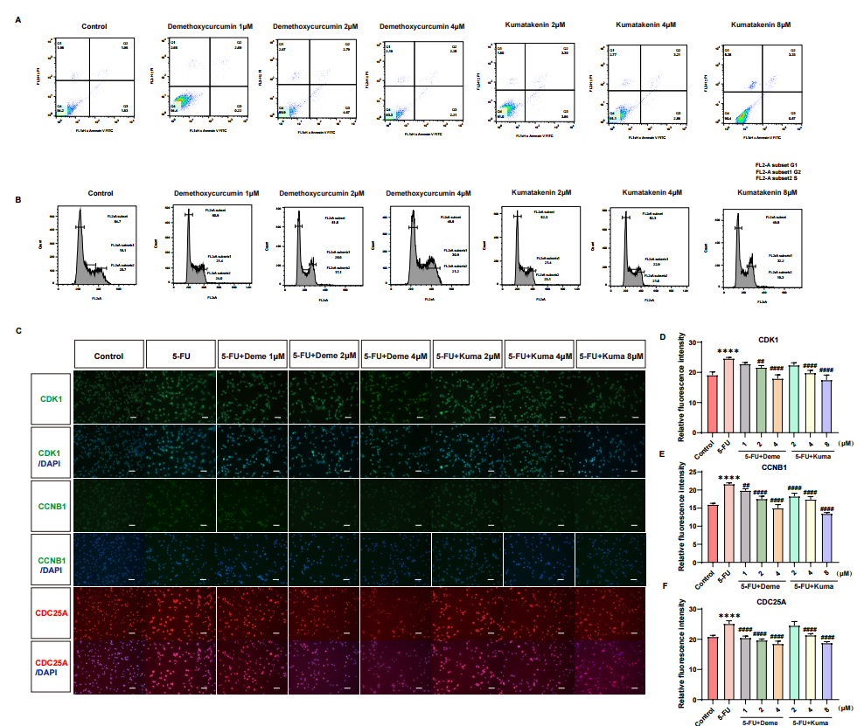

Supplementary Figure 1. The typical overlaid extracted ion chromatograms of 44 identified constituents from the aqueous extract of AC herbal pairs in positive (A) and negative (B) ion mode. Red label means the identification was confirmed by comparison with reference standards. These 44 constituents contribute to the major chemical composition of AC herbal pairs are listed as follow (the compound corresponds to the serial number in Fig. 2)
Supplementary Figure 2. The combined administration of AC with 5-FU significantly increased expression of γ-H2AX. (n = 3). (Scale bar: 20 μm). Data are presented as the mean ± SD. (Compared with the control group, *p < 0.05, **p < 0.01, ***p < 0.001, ****p < 0.0001)
Supplementary Figure 3. Identification of AC Metabolites in vivo. (A) The urine samples in positive ion mode. (B) The urine samples in negative ion mode. (C) The feces samples in positive ion mode. (D) The feces samples in negative ion mode. (E) The PLS-DA score plot and heatmap of the metabolites identified the AC in rat urine samples after gavage of the aqueous extract of AC. (F) The PLS-DA score plot and heatmap of the metabolites identified the AC in rat feces samples after gavage of the aqueous extract of AC.
Supplementary Figure 4. Using CCK8 assay, we evaluated the effects of selected compounds with higher Degree scores from Figure 7 on the viability of HCT116 cells. (A)CCK8 results for HCT116 cells treated with 5-FU alone versus Isomucronulatol, Demethoxycurcumin, Naringenin, Methylnissolin, Apigenin, Formononetin, and Kumatakenin. (B)CCK8 assay results for HCT116 cells treated with 10 μM 5-FU in combination with various concentrations of Isomucronulatol, Demethoxycurcumin, Naringenin, Methylnissolin, Apigenin, Formononetin, and Kumatakenin. (n = 3). Data are presented as the mean ± SD. (Compared with the control group, *p < 0.05, **p < 0.01, ***p < 0.001, ****p < 0.0001)
Supplementary Figure 5. Validation of the effects of different concentrations of Demethoxycurcumin and Kumatakenin on apoptosis, cell cycle progression, and related proteins in CT26 cells. (A-B) Flow cytometry analysis of the effects of different doses of Kumatakenin and Demethoxycurcumin on apoptosis and cell cycle progression in CT26 cells. (C-F) Immunofluorescence images show the expression levels of CDK1, CCNB1, and CDC25A in CT26 cells treated with 5-FU alone and with 5-FU combined with different concentrations of Kumatakenin and Demethoxycurcumin. (n = 3). (Scale bar: 200 μm). Data are presented as the mean ± SD. (Compared with the control group, *p < 0.05, **p < 0.01, ***p < 0.001, ****p < 0.0001; compared with the 5-FU group, #p < 0.05, ##p < 0.01, ### p< 0.001, #### p< 0.0001).

