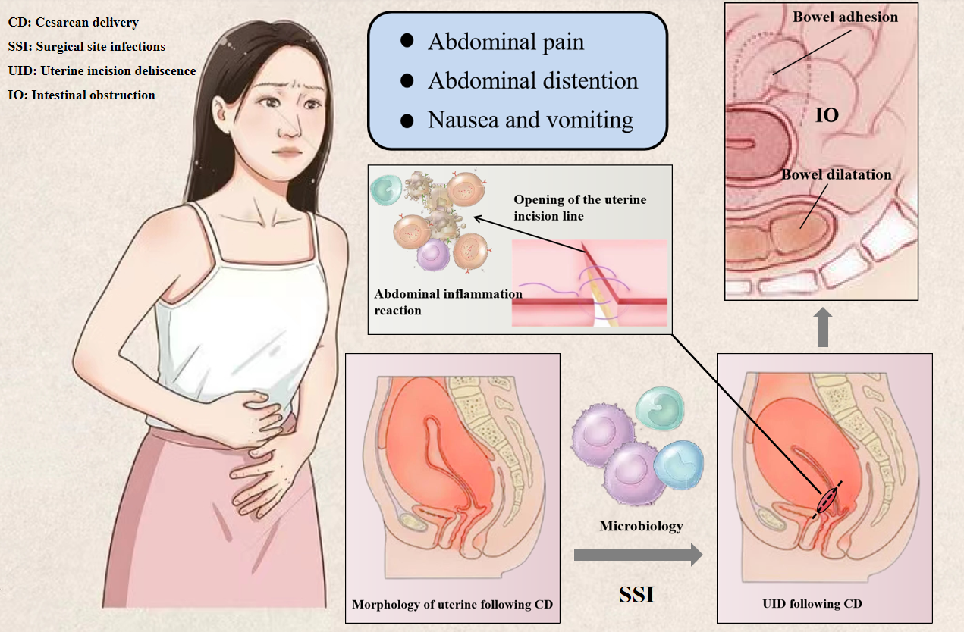
Figure S1. The pathogenesis of UID mimic postoperative ileus following CD. Microbiology led to SSI. Infections was the key trigger to make UID that posed abdominal pain. The UID complicated abdominal inflammation reaction to make bowel adhesion and dilatation that exhibited IO features. UID, uterine incision dehiscence; CD, cesarean delivery; SSI, surgical site infections; IO, intestinal obstruction

