Supplementary Material

Effect of sizes on the lung-targeting and biocompatibility of intravenously administered biodegradable PLGA microspheres

Fengting Lang‡†, Shaoqi Qu†, Kang Li‡, Muqi Zhong ‡, Cuncai Wang†, Zhihui Hao*‡

† Chinese Veterinary Medicine Innovation Center, College of Veterinary Medicine, China Agricultural University, Beijing 100193, China.
‡ Agricultural Bio-pharmaceutical Laboratory. College of Chemistry and Pharmaceutical Sciences, Qingdao Agricultural University, Qingdao 266109, China.

*Corresponding authors: Zhihui Hao, Center of Research and Innovation of Chinese Traditional Veterinary Medicine, China Agricultural University, Beijing, 100193, China. e-mail: haozhihui@cau.edu.cn.

Supplementary Material containing the following:
Supplementary methods
Supplementary figures 1–13
References

Supplementary Methods

PLGA microspheres preparation
Cephalosporin-loaded PLGA microspheres were prepared using a water-in-oil-in-water (w/o/w) double emulsion method [1, 2, 3, 4]. Briefly, gelatin (60 mg) and cephalosporin (20 mg) were dissolved in 400 μL water then added into 5 mL dichloromethane containing PLGA (600 mg). The mixture was sonicated at 4℃ then added into 35 mL 4% PVA solution and homogenized at a rate of 10000, 8000, 6000, and 2000 rpm for 1 min. The solution was then poured into a 0.4% PVA solution (250 mL) and stirred for 4 h to remove the organic solvent. The microspheres were screened by ultrasonic vibration screen with different specifications of screens (mesh size: 5, 25, and 40 μm) and collected by centrifugation at 10000 rpm for 10 min, washed five times with distilled water, and lyophilized for 2 days. For microspheres loaded with fluorescent, Rhodamine B (2 mg) was added to the gelatin solution before addition of PLGA solution [5].

Size analysis
To evaluate the size distribution of PLGA microspheres, it was dispersed in deionized water (1 mg/ml) and the size were measured using particle size analyzer (Zetasizer Nano ZSE, Malvern, UK) [6].

Cytotoxicity study
The cytotoxicity of PLGA microspheres to Raw 246.7 cells was evaluated using the MTT assay. First, the cells were seeded into a 96-well plate at a density of 1×10⁴ cells/well in 200 μL of medium (dulbecco's modified eagle medium, DMEM) containing 10% FBS. The cells were exposed to 200 μL of medium containing PLGA microspheres with different concentrations (20, 40, 60, 80, and 100 μg/mL) for 24 h, 20 μL of MTT solution was added to each well and plates were incubated at 37°C in the dark for 4 hours. After carefully removing the medium from each well, 150 μL DMSO was added to dissolve formazan crystals, and the absorbance of the resulting solutions was measured at 570 nm using a microplate reader (SpectraMax® M2e, Thermo Scientific, USA). Cells without treatment were used as a control.

Hemolytic activity test
Hemolytic activity of PLGA microspheres was investigated with the hemolysis assay, following a method described by Qiao et al. [7, 8, 9]. Blood from healthy mouse was collected and 200 μL of blood was added to PBS (800 μL, pH 7.4) containing PLGA microspheres with different concentrations (0.05, 0.1, 0.5, 1, and 2 mg mg/mL), and incubated at 37°C for 3 h. Blood (200 μL) was mixed with PBS and TritonX-100 (800μL) served as negative and positive controls, respectively. All solutions were centrifuged at 3000 rpm for 5 min, 200 μL of supernatants were placed in a 96-well plate, and the released hemoglobin was analyzed by measuring the absorbance at 540 nm using a microplate reader.

Supplementary Figure 1

Size distribution of PLGA microspheres. The average particle size of the four kinds of PLGA microspheres are 3, 10, 25, and 40 μm, respectively.

Supplementary Figure 2

Western blot analyses of inflammatory factors in lung tissues. PLGA microspheres promoted expression of P38, TNF-α, and IL-1β in lung tissues. All data were presented as mean ± SD. Significance was determined by one-way ANOVA. ***P < 0.001.

Supplementary Figure 3

Cytotoxicity of PLGA microspheres. Cell viability of RAW 246.7 treated with various concentrations of PLGA microspheres (20, 40, 60, 80, and 100 μg/mL) by MTT assay for 24 h. All groups of PLGA microspheres (3, 10, 25, and 40 μm) did not show cytotoxic to RAW 246.7 cells.

Supplementary Figure 4

Blood compatibility evaluation of PLGA microspheres. Visual observation of hemolysis caused by PLGA microspheres in PBS (pH 7.4) and hemolytic activity test of PLGA microspheres at different concentrations in the mice blood. All PLGA microspheres groups (3, 10, 25, and 40 μm) did not show hemolysis.

Supplementary Figure 5

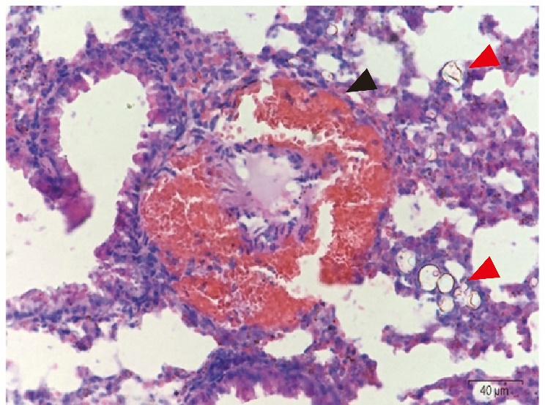

Representative image of pulmonary embolism treated with PLGA microspheres (25 μm) by H&E staining. The black arrow indicates the accumulation of blood in the blood vessel caused by pulmonary thrombosis, and the red arrows indicate the deformed PLGA microspheres. Scale bar: 40 μm.

Supplementary Figure 6

Changes in SpO₂ of mice under the treatment of PS microspheres with different doses. The maximum tolerable dose of PS microspheres with different particle size (3, 10, 25, and 40 μm) were 125, 75, 75, and 25 mg/kg, respectively.

Supplementary Figure 7

Levels of SpO₂ in mice under treatment of PLGA microspheres with different doses within 10 days. The level of SpO₂ of mice from all dose groups had recovered to normal after injected PLGA microspheres (3, 10 ,25, and 40 μm) within 10 days.

Supplementary Figure 8

Levels of SpO₂ in mice under treatment of PS microspheres with different doses within 10 days. The level of SpO₂ of mice from all dose groups had recovered to normal after injected PS microspheres (3, 10 ,25, and 40 μm) within 10 days.

Supplementary Figure 9

Expression levels of cytokines in mice lung tissue after injected with 10 μm PLGA microspheres. PLGA microspheres upregulated expression of IL-1β in lung tissues. Expression levels of TNF-α and SOD recovered to normal of all dose groups (75, 150, 225, and 300 mg/mL) by ELISA kits. All data were presented as mean ± SD. Significance was determined by one-way ANOVA. **P < 0.01.

Supplementary Figure 10

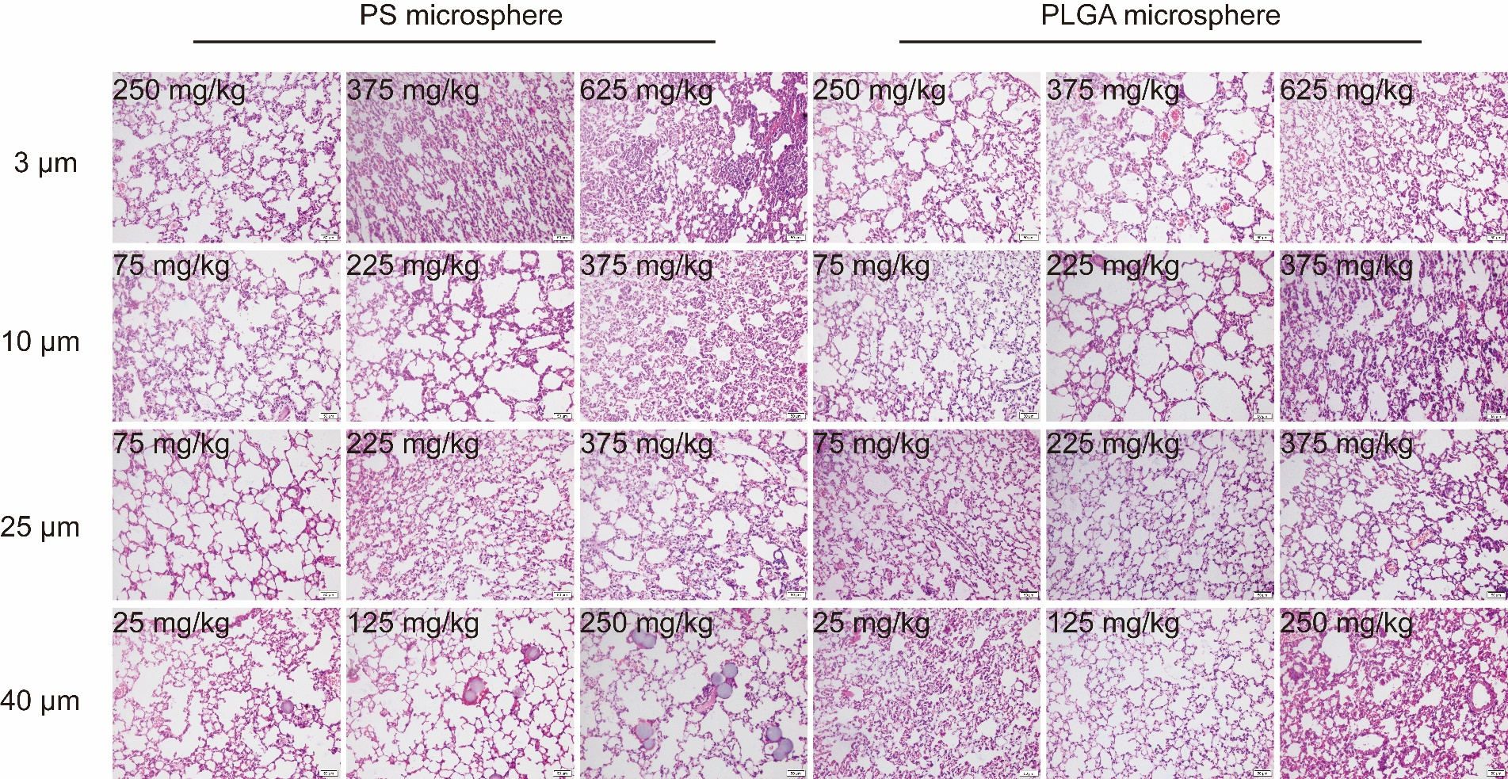

H&E staining of lung tissues of the mice from different PS and PLGA microspheres groups (3, 10, 25, and 40 μm). Lung tissues of mice were obviously damaged when dose higher than maximum tolerable dose after injected with different doses. Scale bar = 40 μm.

Supplementary Figure 11

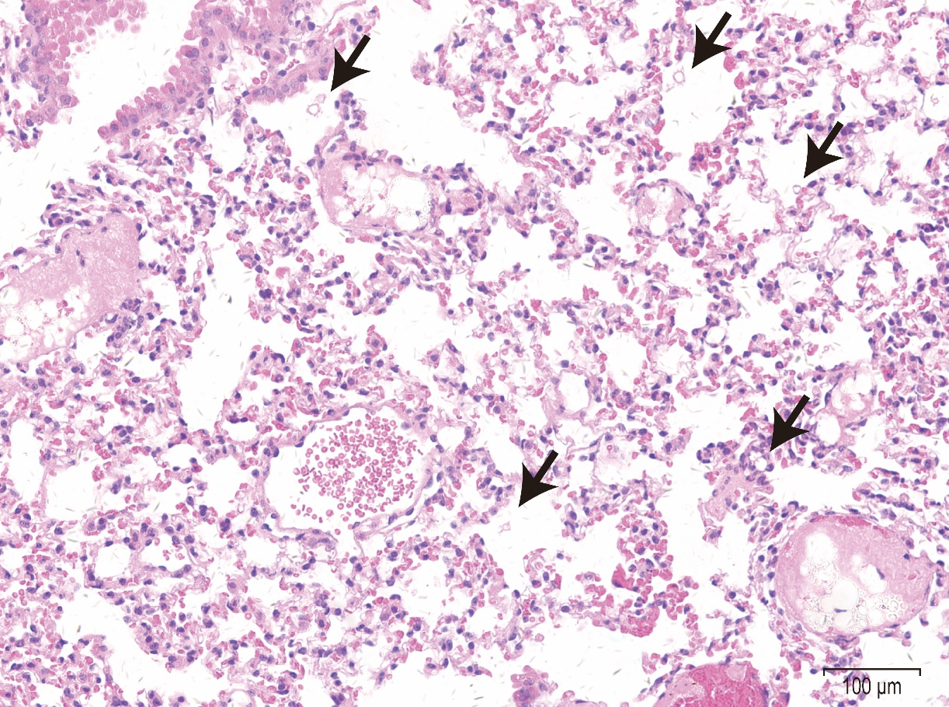

Representative image of PLGA microspheres in alveoli and interstitium by H&E staining. Black arrows indicate PLGA microspheres in alveoli and interstitium. Scale bar = 100 μm.

Supplementary Figure 12

Body weight changes of mice over 14 days post injection of various 10 μm PLGA microspheres at indicated doses. All doses groups (75, 150, and 225 mg/mL) showed no significant difference in growth rate from PBS group within 14 days.

Supplementary Figure 13

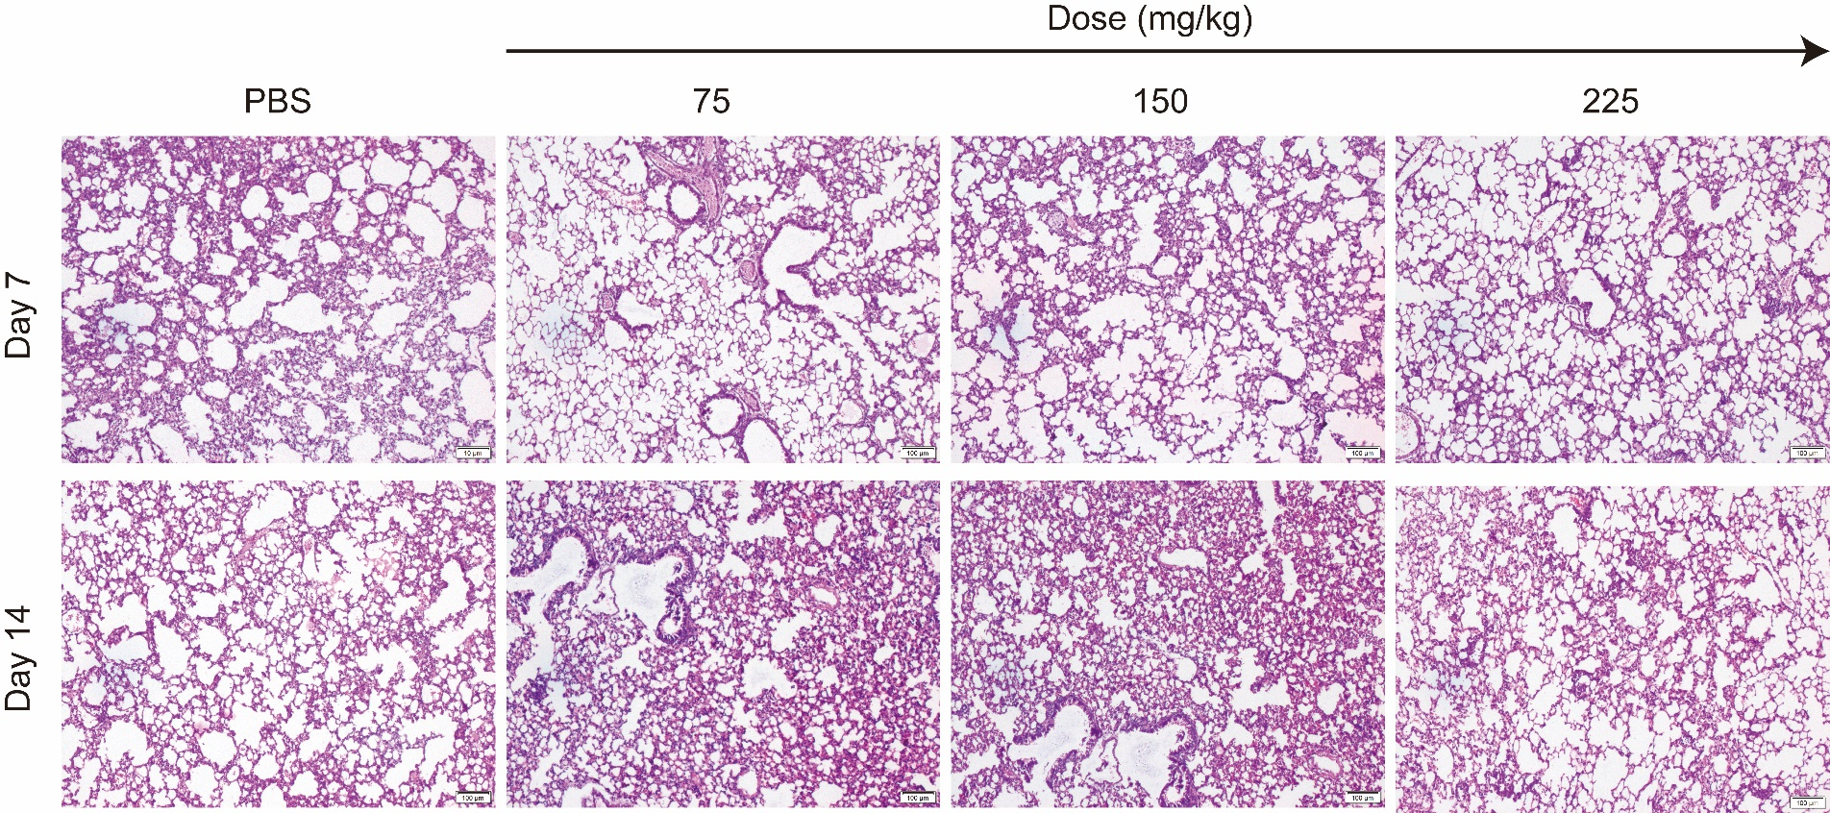

Representative histology images of lungs exposed to PLGA microspheres (10 μm) with different dose at 7 and 14 day. Lung tissues of the mice revealed no noticeable tissue damage and changes in morphology after treated with different doses (75, 150, and 225 mg/kg) by H&E staining. Scale bar = 100 μm.

References
1. Doan TV, Couet W, Olivier JC. Formulation and in vitro characterization of inhalable rifampicin-loaded PLGA microspheres for sustained lung delivery. Int J Pharm. 2011;414 1-2:112-7; doi: 10.1016/j.ijpharm.2011.05.007. https://www.ncbi.nlm.nih.gov/pubmed/21596123.
2. Oh YJ, Lee J, Seo JY, Rhim T, Kim SH, Yoon HJ, et al. Preparation of budesonide-loaded porous PLGA microparticles and their therapeutic efficacy in a murine asthma model. J Control Release. 2011;150 1:56-62; doi: 10.1016/j.jconrel.2010.11.001. https://www.ncbi.nlm.nih.gov/pubmed/21070826.
3. Qu S, Zhao L, Zhu J, Wang C, Dai C, Guo H, et al. Preparation and testing of cefquinome-loaded poly lactic-co-glycolic acid microspheres for lung targeting. Drug Deliv. 2017;24 1:745-51; doi: 10.1080/10717544.2017.1321058.
4. Qu S, Dai C, Zhu J, Zhao L, Li Y, Hao Z. Cefquinome-loaded microsphere formulations against Klebsiella pneumonia infection during experimental infections. Drug Deliv. 2018;25 1:909-15; doi: 10.1080/10717544.2018.1461958.
5. Qu S, Liu Y, Hu Q, Han Y, Hao Z, Shen J, et al. Programmable antibiotic delivery to combat methicillin-resistant Staphylococcus aureus through precision therapy. J Control Release. 2020;321:710-7; doi: 10.1016/j.jconrel.2020.02.048.
6. Shim MK, Na J, Cho IK, Jang EH, Park J, Lee S, et al. Targeting of claudin-4 by Clostridium perfringens enterotoxin-conjugated polysialic acid nanoparticles for pancreatic cancer therapy. J Control Release. 2021; doi: 10.1016/j.jconrel.2021.01.031.
7. Qiao JB, Fan QQ, Xing L, Cui PF, He YJ, Zhu JC, et al. Vitamin A-decorated biocompatible micelles for chemogene therapy of liver fibrosis. J Control Release. 2018;283:113-25; doi: 10.1016/j.jconrel.2018.05.032. https://www.ncbi.nlm.nih.gov/pubmed/29857004.
8. Dobrovolskaia MA, Clogston JD, Neun BW, Hall JB, Patri AK, McNeil SE. Method for analysis of nanoparticle hemolytic properties in vitro. Nano Lett. 2008;8 8:2180-7; doi: 10.1021/nl0805615.
9. Neun BW, Dobrovolskaia MA. Method for analysis of nanoparticle hemolytic properties in vitro. Methods Mol Biol. 2011;697:215-24; doi: 10.1007/978-1-60327-198-1_23.

