Supplementary Data

Figure S1.
Table S1, S2, S3, S4 and S5.
Supplementary Materials and Methods.

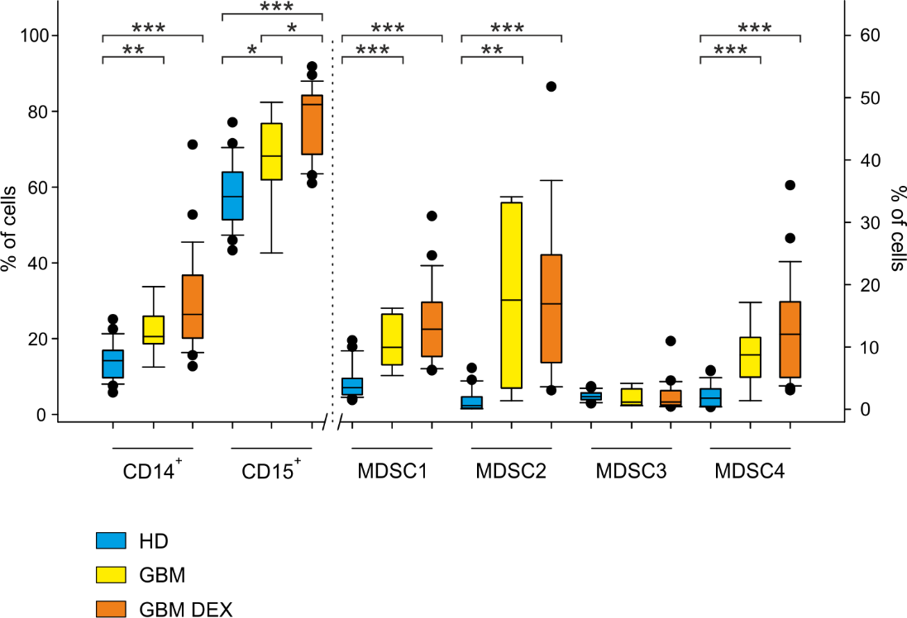
Figure S1. Distribution of circulating myeloid cells in GBM patients treated preoperatively with dexamethasone. Orange boxes indicate patients treated with dexamethasone (GBM DEX), yellow boxes refer to untreated patients (GBM). Box Plots show the median, 25th and 75th percentile of the percentage of monocytes (27 HDs, 8 GBM and 25 GBM DEX), granulocytes (26 HDs, 8 GBM and 25 GBM DEX), MDSC1, (27 HDs, 8 GBM and 25 GBM DEX), MDSC2 (27 HDs, 6 GBM and 19 GBM DEX), MDSC3 in CD15⁻ cells (27 HDs, 8 GBM and 22 GBM DEX), MDSC4 (27 HDs, 8 GBM and 24 GBM DEX). Whiskers extend to 1.5 inter-quartile range and outliers are shown by dots. Signiﬁcance levels evaluated by t-test: <0.001: ***; <0.01: **; <0.05: *.

Table S1. Immunological variables analyzed in the study

Variable | Cohort | Determination | Source
CD14⁺ cells | 1 | FCM, morphological gate (FSC/SSC) on PBMC | WB
CD15⁺ cells | 1 | FCM, morphological gate (FSC/SSC) on PBL | WB
MDSC1 | 1 | FCM, CD14⁺/CD124⁺ cells with morphological gate (FSC/SSC)  on PBMC | WB
MDSC2 | 1 | FCM, CD15⁺/CD124⁺ cells with morphological gate (FSC/SSC)  on PMN | WB
MDSC3 | 1 | FCM, Lin⁻/HLA-DR⁻/CD11b⁺/CD33⁺ gated on CD15- cells among PBL | WB
MDSC4 | 1 | FCM, CD14⁺/HLA-DR^{-/low} with morphological gate (FSC/SSC)  on PBMC | WB
CD14⁺/PD-L1⁺ cells | 2 | FCM, morphological gate (FSC/SSC) on PBMC  followed by a gate on CD14⁺ cells | WB
p-STAT3 (%) | 2 | FCM, percentage of p-STAT3⁺ cells among CD14⁺ cells | PBMC
p-STAT3 (geo MFI) | 2 | FCM, geo MFI of p-STAT3 in CD14⁺ cells | PBMC
ARG1 | 3 | ELISA assay | Plasma
Urea pH.7.2 | 3 | ARG1 activity based on urea determination at pH 7.2 | Plasma
Urea pH 9.5 | 3 | ARG1 activity based on urea determination at pH 9.5 | Plasma

Table S2. Factors for glioma risk (univariate analysis with logistic regression model).
 |  | E/N | OR (95%CI) | p-value
Cohort 1
CD14⁺ | Low | 15/38 | Ref
 | High | 89/102 | 10.5 (4.4─25.1) | <0.001
CD15⁺ | Low | 16/39 | Ref
 | High | 88/101 | 9.7 (4.1─23.1) | <0.001
MDSC1 | Low | 12/40 | Ref
 | High | 92/100 | 26.8 (10.0─72.2) | <0.001
MDSC2 | Low | 13/39 | Ref
 | High | 91/101 | 18.2 (7.2─46.2) | <0.001
MDSC3 | Low | 89/105 | Ref
 | High | 15/35 | 0.1 (0.1─0.3) | <0.001
MDSC4 | Low | 13/36 | Ref
 | High | 91/104 | 12.4 (5.1─30.3) | <0.001
Cohort 2
CD14^{+/}PD-L1⁺ | Low | 15/21 | Ref
 | High | 48/65 | 1.1 (0.4─3.3) | 0.83
p-STAT3 (geo MFI) | Low | 13/31 | Ref
 | High | 50/55 | 13.8 (4.3─44.3) | <0.001
p-STAT3 (%) | Low | 19/23 | Ref
 | High | 44/63 | 0.5 (0.1─1.6) | 0.24
Cohort 3
ARG1 | Low | 19/20 | Ref
 | High | 45/62 | 0.14 (0.02─1.12) | 0.064
Urea pH 7.1 | Low | 4/21 | Ref
 | High | 60/61 | 255 (26.71─2434) | <0.001
Urea pH 9.5 | Low | 10/19 | Ref
 | High | 54/63 | 5.4 (1.72─16.95) | 0.004
OR, odds ratio; 95%CI, 95% confidence interval; E, number of glioma patients; N, total number of subjects.

Table S3. Factors for glioma grade risk (univariate analysis with multinomial logistic regression model).
 |  | OR (95% CI) | OR (95% CI) | OR (95% CI)
 |  | GBM | GII | GIII
Cohort 1
Age | Cont. | 1.02 (0.99─1.05) | 0.91 (0.87─0.96)*** | 0.95 (0.91─1.0)
CD14⁺ | Low | Ref | Ref | Ref
 | High | 17.19 (6.12─48.3)*** | 3.24 (0.97─10.82) | 8.85 (1.68─46.69)*
CD15⁺ | Low | Ref | Ref | Ref
 | High | 31.4 (9.32─105.88)*** | 2.53 (0.78─8.24) | 2.48 (0.65─9.4)
MDSC1 | Low | Ref | Ref | Ref
 | High | 34.0 (11.25─102.73)*** | 16.33 (3.74─71.31)*** | 17.5 (3.17─96.7)**
MDSC2 | Low | Ref | Ref | Ref
 | High | 25.26 (8.69─73.37)*** | 19.5 (3.76─101.1)*** | 5.2 (1.28─21.18)*
MDSC3 | Low | Ref | Ref | Ref
 | High | 0.1 (0.04─0.26)*** | 0.17 (0.04─0.7)* | 0.4 (0.1─1.57)
MDSC4 | Low | Ref | Ref | Ref
 | High | 20.35 (6.94─59.69)*** | 13.27 (2.61─67.37)** | 2.48 (0.65─9.4)
Cohort 2
Age | Cont. | 1.07 (1.02─1.12)** | 0.91 (0.84─0.98)* | 0.98 (0.91─1.06)
CD14⁺/PD-L1⁺ | Low | Ref | Ref | Ref
 | High | 1.22 (0.39─3.84) | 0.59 (0.11─3.24) | 1.76 (0.17─18.32)
p-STAT3 (geo MFI) | Low | Ref | Ref | Ref
 | High | 12.4 (3.76─41.15)*** | 25.2 (2.48─255.9)** | 18.0 (1.69─191.5)*
p-STAT3 (%) | Low | Ref | Ref | Ref
 | High | 0.53 (0.15─1.83) | 0.35 (0.06─2.11) | 0.42 (0.06─3.15)
Cohort 3
Age | Cont. | 1.06 (1.02─1.11)** | 0.95 (0.9─1.01) | 1.0 (0.95─1.06)
ARG1 | Low | Ref | Ref | Ref
 | High | 0.15 (0.02─1.26) | 0.24 (0.02─2.54) | 0.06 (0.01─0.63)*
Urea pH 7.1 | Low | Ref | Ref | Ref
 | High | 645.7 (38.1─10939)*** | 238.2 (13.62─4164)*** | 67.99 (5.35─864.8)**
Urea pH 9.5 | Low | Ref | Ref | Ref
 | High | 8.75 (2.19─35.02)** | 2.75 (0.63─11.97) | 4 (0.66─24.3)
OR, odds ratio; 95%CI, 95% confidence interval. Signiﬁcance levels: <0.001: ***; <0.01: **; <0.05: *

Table S4. Factors for glioblastoma patients’ survival (univariate analysis with Cox proportional hazards model).
 |  | E/N | median (95% CI) | HR (95% CI) | p-value
Cohort 1
Age | Cont. | 56/67 | 12.6 (10.6,17.7) | 1.02 (1,1.04) | 0.128
Sex | F | 18/21 | 12 (5.75,17.7) | Ref
 | M | 38/46 | 14.4 (8.34,20.0) | 0.86 (0.49,1.51) | 0.598
ECOG PS | 0-1 | 32/41 | 18.33 (13.96,22.1) | Ref
 | 2-3 | 24/26 | 5.96 (4.24,10.6) | 2.9 (1.68,5) | < 0.001
Surgery | Other | 47/53 | 11.2 (6.37,14.4) | Ref
 | Radical | 9/14 | 25.9 (11.99,NE) | 0.32 (0.15,0.67) | 0.002
Stupp’s regimen | No | 13/13 | 5.59 (2.27,11.3) | Ref
 | Yes | 43/54 | 16.03 (11.47,20.4) | 0.25 (0.13,0.49) | < 0.001
MGMT promoter | No | 28/30 | 11.3 (6.47,13.0) | Ref
methylation | Yes | 28/37 | 18.0 (10.78,22.8) | 0.52 (0.3,0.89) | 0.016
CD14⁺ | Low | 33/37 | 10.6 (6.18, 16) | Ref
 | High | 23/30 | 18 (12.22, 28.5) | 0.59 (0.34,1) | 0.051
CD15⁺ | Low | 29/35 | 10.6 (5.88, 17.7) | Ref
 | High | 27/32 | 14 (11.27, 20.4) | 0.89 (0.52,1.5) | 0.651
MDSC1 | Low | 26/30 | 12.4 (8.34, 20) | Ref
 | High | 30/37 | 13 (6.47, 18.2) | 1.06 (0.63,1.8) | 0.828
MDSC2 | Low | 15/21 | 20 (11.27, 31) | Ref
 | High | 41/46 | 11.4 (7.23, 16) | 2.03 (1.11,3.7) | 0.021
MDSC3 | Low | 23/27 | 11.3 (5.72, 17.6) | Ref
 | High | 33/40 | 16.4 (10.81, 20) | 0.65 (0.38,1.13) | 0.126
MDSC4 | Low | 43/49 | 11.7 (7.23, 16.7) | Ref
 | High | 13/18 | 17.6 (11.24, NA) | 0.66 (0.35,1.23) | 0.19
Cohort 2
Age | Cont. | 32/45 | 13.04 (7.7,19.9) | 1.04 (1,1.08) | 0.039
Sex | F | 14/18 | 11.1 (4.5,19.9) | Ref
 | M | 18/27 | 15.2 (5.7,28.5) | 0.68 (0.33,1.4) | 0.291
ECOG PS | 0-1 | 14/25 | 21.6 (15.2,NE) | Ref
 | 2-3 | 18/20 | 5.7 (2.9,8.7) | 3.79 (1.82,7.88) | < 0.001
Surgery | Other | 31/39 | 10.6 (5.9,16.0) | Ref
 | Radical | 1/6 | - | 0.13 (0.02,0.97) | 0.046
Stupp’s regimen | No | 8/9 | 2.7 (1.8,8.2) | Ref
 | Yes | 24/36 | 15.5 (9.2,22.8) | 0.24 (0.11,0.55) | < 0.001
MGMT promoter | No | 16/18 | 8.5 (3.1,13.0) | Ref
methylation | Yes | 16/27 | 21.6 (6.2,NE) | 0.33 (0.16,0.71) | 0.005
CD14⁺/PD-L1⁺ | Low | 19/24 | 9.1 (5.7, 15.2) | Ref
 | High | 13/21 | 21.6 (4.5, NE) | 0.52 (0.25,1.08) | 0.078
p-STAT3 (geo MFI) | Low | 22/30 | 15.4 (8.7, 21.6) | Ref
 | High | 10/15 | 6.2 (2.7, NE) | 1.16 (0.54,2.48) | 0.698
p-STAT3 (%) | Low | 11/17 | 16.7 (5.9, NE) | Ref
 | High | 21/28 | 8.9 (4.2, 14) | 1.68 (0.8,3.5) | 0.168
Cohort 3
Age | Cont. | 23/32 | 12.52 (6.47-31.34) | 1.03 (0.99,1.06) | 0.12
Sex | F | 6/10 | 23.03 (0.62-NE) | Ref
 | M | 17/22 | 9.46 (6.37-28.5) | 1.49 (0.58,3.83) | 0.403
ECOG PS | 0-1 | 11/18 | 28.48 (7.75-NE) | Ref
 | 2-3 | 12/14 | 8.23 (2.27-13) | 2.69 (1.16,6.23) | 0.021
Surgery | Other | 21/27 | 8.34 (5.88-22.8) | Ref
 | Radical | 2/5 | - | 0.26 (0.06,1.13) | 0.072
Stupp’s regimen | No | 5/5 | 2.27 (0.62-NE) | Ref
 | Yes | 18/27 | 19.98 (8.21-33) | 0.1 (0.03,0.31) | <0.001
MGMT promoter | No | 12/14 | 8.23 (2.63-31.3) | Ref
methylation | Yes | 11/18 | 21.39 (5.88-NE) | 0.54 (0.23,1.22) | 0.138
ARG1 | Low | 14/17 | 8.34 (4.93-28.5) | Ref
 | High | 9/15 | 22.80 (5.72-NE) | 0.52 (0.22,1.22) | 0.132
Urea pH 7.1 | Low | 6/8 | 8.23 (0.62-NE) | Ref
 | High | 17/24 | 18.0 (7.75-33) | 0.64 (0.25,1.62) | 0.344
Urea pH 9.5 | Low | 7/16 | - | Ref
 | High | 16/16 | 7.98 (5.72-13) | 4.52 (1.78,11.47) | 0.002
HR, hazard ratio; 95%CI, 95% confidence interval; E, number of deaths; N, total number of glioblastoma patients; NE, not estimable.

Table S5. Characteristics of GBM patients considered in survival analysis
 |  | Participant characteristics
 |  | GBM |  | Cohort 1 | Cohort 2 | Cohort 3
Total number |  | 92 |  | 67 | 45 | 32
Sex
Male (n) |  | 59 |  | 46 | 27 | 22
Female (n) |  | 33 |  | 21 | 18 | 10
Median Age |  | 64 |  | 65 | 66 | 65
Range |  | 27-80 |  | 27-80 | 28-79 | 28-79
ECOG PS
0-1 |  | 59 |  | 41 | 25 | 18
2-4 |  | 33 |  | 26 | 20 | 14
Surgery
Other |  | 74 |  | 53 | 39 | 27
Radical |  | 18 |  | 14 | 6 | 5
Stupp’s regimen
No |  | 17 |  | 13 | 9 | 5
Yes |  | 75 |  | 54 | 36 | 27
IDH status
WT |  | 88 |  | 64 | 44 | 28
Mutated |  | 4 |  | 3 | 1 | 4
MGMT status
Methylated |  | 49 |  | 37 | 27 | 18
Not methylated |  | 43 |  | 30 | 18 | 14

Supplementary Materials and Methods
MGMT methylation status and IDH mutational status analyses
IDH 1-2 mutational status was analyzed by Sanger sequencing. MGMT methylation status was performed by pyrosequencing and a cut-off of 7% was considered for assessing as unmethylated and methylated.
Multiparametric flow cytometry
To analyze expression of myeloid cell subsets, 50 µl of fresh blood were washed with PBS plus 1% fetal bovine serum (FBS, Gibco Thermo Fisher Scientific) and subsequently incubated with Fc-Receptor Blocking reagent (Miltenyi Biotec) at 4°C for 10 minutes. Afterwards cells were stained with mAbs and, at the end of incubation, cells were washed with PBS plus 1% FBS and centrifuged at 1300 rpm for 6 min at 4°C. Red blood cells were lysed using Cal-Lyse whole blood lysing solution (Life Technologies) according to manufacturer's instructions and as previously described (7).
Data were acquired using a LSRII flow cytometer (BD Biosciences) equipped with 4 lasers (405nm, 488nm, 561nm, 640nm) and analysis was performed by FlowJo software v 7.6.5 (Three Star Inc). Fluorescence minus one (FMO) for HLA-DR, IL4Rα and PD-L1 were used as negative controls.
To acquire cells stained with ARG1, a FACSCelesta flow cytometer (BD Biosciences) was used, equipped with 3 lasers (405nm, 488nm, 640nm) and analysis was performed by FlowJo software v 7.6.5. FMO for ARG1 was used as negative control.
As positive control for p-STAT3 staining, a homogeneous batch of HepG2 cell line was used, treated with 80 ng/ml rhIL-6 (Thermo Scientific) for 10 minutes to induce STAT3 phosphorylation and then cells were fixed, permeabilized and frozen. Single aliquots of HepG2 were thawed and p-STAT3 staining was run in parallel to patient’s samples to check antibody performance. All antibodies used for flow cytometry were titrated in a lot-dependent manner.
Determination of ARG1 activity
To eliminate residual cells potentially present in the plasma, samples were treated with 50 μl of lysis buffer (0.1% Triton X-100, 100 μg/ml pepstatin, 100 μg/ml aprotinin, and 100 μg/ml antipain) and shacked at 37°C for 30 minutes. Then, 60 μl of 25 mM Tris-HCl and 2 mM MnCl₂ were added, and the solution was heated for 10 min at 56°C. The solution was hydrolyzed with 100 μl of 500 mM l-arginine dissolved in either carbonate buffer (pH 9.5) or phosphate buffer (pH 7.2), incubated at 37°C for 60–120 min and the reaction was stopped with 800 μl of H₂SO₄ (96%)/H₃PO₄ (85%)/H₂O. The urea concentration was measured at 540 nM after addition of 40 μl of α-isonitrosopropiophenone (dissolved in 100% ethanol), followed by heating at 95°C for 15–40 min. Samples were assayed in duplicates and urea concentration was derived from a standard cur

