Fig.S2
(a)
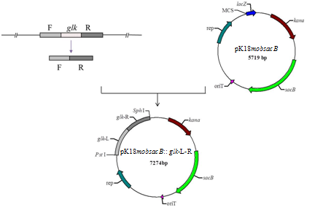
(b)
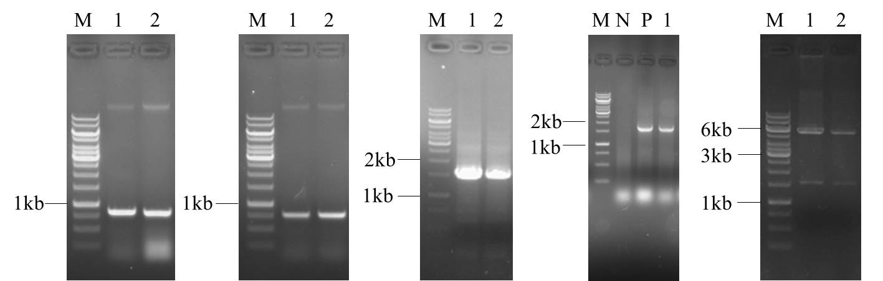
(c)
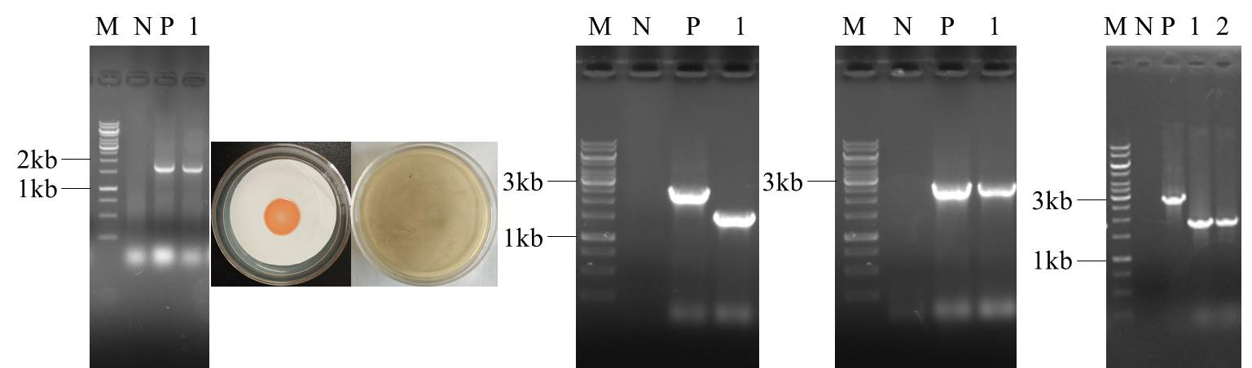

Fig.S2 (a) Construction flowchart of the glk gene deletion vector pK18mobsacB:: glk-L-R; (b) Construction of glk gene deletion vector pK18mobsacB:: glk-L-R; and (c) Filtration and verification of △glk

