Fig. S4
(a)
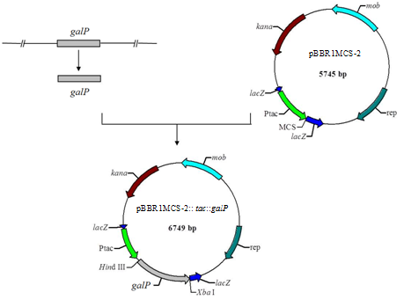
(b)
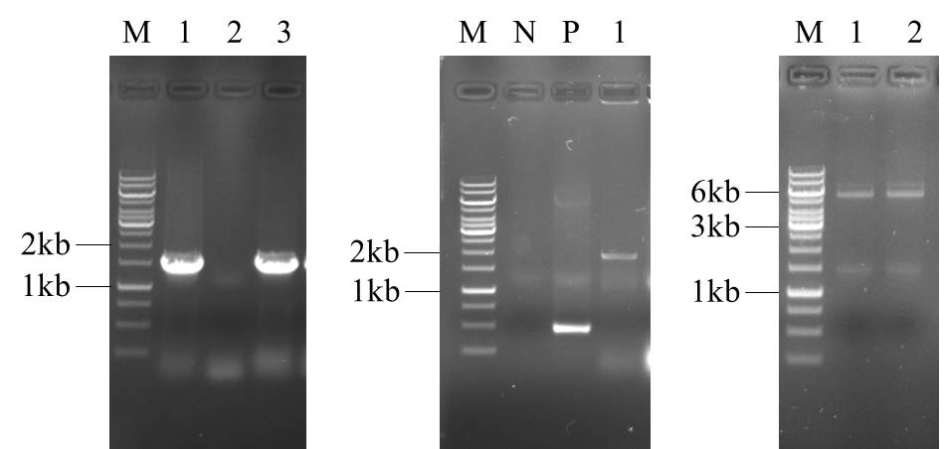

(c)
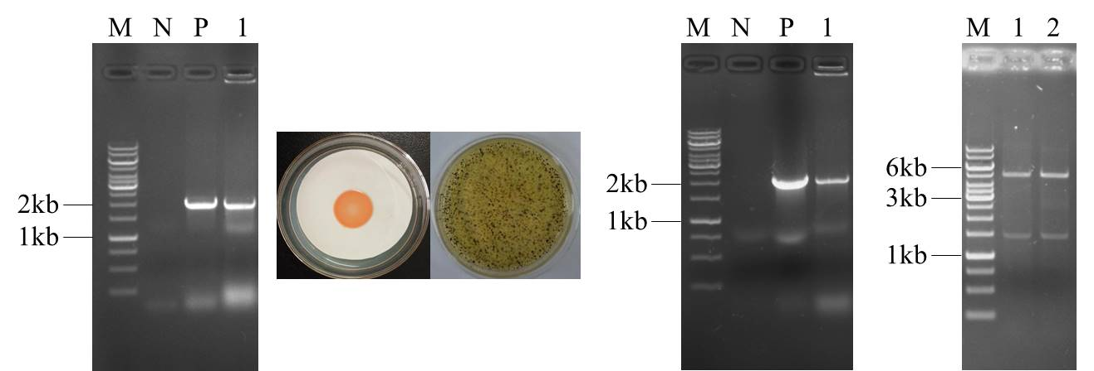

Fig.S4 (a) Construction flowchart of the galP gene overexpression vector pBBR1MCS-2::tac:;galP; (b) Construction of he galP gene overexpression vector pBBR1MCS-2::tac:;galP; and (c) Filtration and verification of the △fruA△fruB/tac::galP_{OP} .

